Naburn Flood Alleviation Scheme



**November 2020**

**Project update**

We are planning an event to provide information about Property Flood Resilience (PFR) measures available for homes at risk of flooding in Naburn and to give an opportunity for the community to ask us questions. If you would like to receive future updates, you can join our mailing list by sending us an email at

[yorkfloodplan@environment-agency.gov.uk](mailto:yorkfloodplan@environment-agency.gov.uk)

# Background

Following the floods of December 2015, the government allocated an additional £45.2 million to the Environment Agency to better protect 2,000 properties in York. Since 2015, a significant amount of work has been undertaken to identify an economically viable, large-scale engineered flood defence scheme for Naburn which would qualify for the additional funding that was made available. Throughout this process we have been in communication with Naburn Flood Action Group.

We have looked to address a range of challenges including the nature of the flood risk to the village, the value of available benefits and the technical challenges of a large engineered scheme in that area. Unfortunately, there is no option where the benefits of constructing a large flood defence for Naburn would exceed the costs. As such, any large scale scheme would not meet the strict government spending criteria we need to meet to allow the spending of public money.

While we appreciate this is disappointing for members of the community, we are able to offer the Property Flood Resilience (PFR) Scheme to owners of properties at risk which will better protect them against flooding. Measures on offer can include providing flood doors, temporary barriers, pumps and valves which reduce the chance of flood water getting into a property. This newsletter provides an overview of what the PFR scheme can provide, and details of an online public meeting planned to provide the community with further information and to answer questions.

## What is PFR?

Property Flood Resilience involves modifying existing properties to reduce the chance of water entering the building. Our PFR scheme looks at individual properties, to identify the best solution for reducing the risk of flood water entering your home.

Under the PFR scheme, an eligible property would be offered advice and fitting of resistance measures up to a value of £7,500. These are measures that help to keep water out of or away from properties and include flood doors, temporary barriers, pumps and valves.

The scheme can also provide advice on resilience measures that help reduce the impact if water enters and speed up the time it takes to return to normal. Measures include waterproof flooring, removable carpet, raised white goods and flood-proof storage. It should be noted that resilience measures are not offered under the PFR scheme, but advice on such measures is included in the property survey. Please see Figure 1 for further examples of resistance and resilience measures.

A property is eligible for our PFR scheme if:

* It is situated within a flood risk area and the property thresholds (the point above which flooding happens) are lower than the predicted water level during extreme flood events and where the property doesn’t benefit from a formal flood defence such as a flood wall;
* It has experienced river flooding in the past; or
* Has eligible properties next door.

We are offering PFR according to principles defined nationally, following government rules on funding. Under this scheme, we are able to offer a free initial survey to eligible properties to assess their suitability for PFR. Following the survey, a report will be produced recommending appropriate resistance measures for the individual property and shared with the homeowner. If homeowners wish to proceed, we can install resistance measures costing up to £7,500 per property which can help prevent water from entering the property.

Residents are also strongly advised to sign up to our free flood warning service.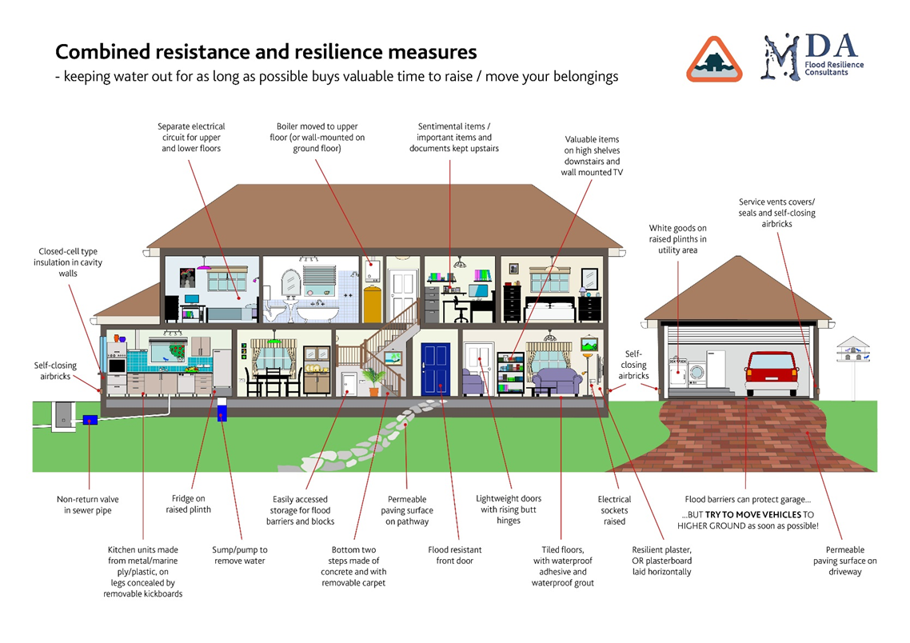

Figure 1 - Illustration showing various resistance and resilience measures

# Public Event

It was the aim of the Environment Agency and the Naburn Flood Action Group to hold a public meeting in the Village Hall in March of this year to provide an update on the latest situation regarding flood protection for Naburn. This was not able to go ahead because of restrictions put in place for the COVID health emergency.

We then hoped to re-schedule for the autumn but, as this is no longer possible, we now propose to hold a meeting online. This will involve a presentation about PFR and give residents an opportunity to ask us questions. To help us prepare, we have developed a quick survey to gather information on the topics you feel require further information. You can access the survey via this [link](https://forms.office.com/Pages/ResponsePage.aspx?id=UCQKdycCYkyQx044U38RAl8qES82m4RKug-9fO-2ec9UOUFGNk1RUldaRk9GUkEyOFJMUjk3TVk1Sy4u).

We will take the responses to this survey into consideration when preparing the event. The event will be held via Zoom, with details to be shared via our mailing list, our social media and via the Village Flood Action Group.

# Where can I find out more about PFR?

You can find out more information about PFR on the National Flood Forum website. They have also developed a directory, the Blue Pages, of property flood products and services to advise and inform you of what is available to help reduce the risk of flooding to your home.

* National flood forum: <https://nationalfloodforum.org.uk/about-flooding/reducing-your-risk/protecting-your-property/>
* Blue Pages: <http://bluepages.org.uk/>



These links provide a great opportunity to learn more about PFR from an independent source. To view real life examples of how PFR can be used, including examples in York, please click on this [link](http://edition.pagesuite-professional.co.uk/html5/reader/production/default.aspx?pubname=&edid=659cb024-a5d5-4004-acbf-1d9236228817).

# How can I contact the Environment Agency?

If you have any questions about any information in this update, or any other aspect of the scheme please contact us via email. You can also sign up to our mailing list to get future correspondence via email. We will be sharing updates on our scheme via our website, email newsletters and social media pages.

* Email: [yorkfloodplan@environment-agency.gov.uk](mailto:yorkfloodplan@environment-agency.gov.uk)
* Webpages: <https://consult.environment-agency.gov.uk/yorkshire/yorkfas/>
* Facebook: search for ‘York Flood Alleviation Scheme’
* Twitter: @EnvAgencyYNE