Oxford Flood Alleviation Scheme: Preliminary WFD Assessment

|  |  |  |
| --- | --- | --- |
| PREPARED FOR: | Environment Agency |  |
| COPY TO: |  | |
| PREPARED BY: | Judith Cudden | |
| DATE: | January 2017 | |
| PROJECT NUMBER: | 661656 IMSE500177 | |
| REVISION NO.: | 3 | |
| APPROVED BY: | Rebecca Westlake | |

### Background

The Water Framework Directive (WFD)[1] requires all natural water bodies to achieve both good chemical status and good ecological status. For each River Basin District, a River Basin Management Plan (RBMP) outlines the actions required to enable natural water bodies to achieve this. Water bodies that are designated in the RBMP as Heavily Modified Water Bodies (HMWB) or Artificial Water Bodies (AWB) may be prevented from reaching good ecological status by the physical modifications for which they are designated or purpose for which they were constructed (e.g. navigation, flood defence, urbanisation). Instead they are required to achieve good ecological potential, through implementation of a series of mitigation measures outlined in the applicable RBMP (and in some cases updated since the publication of the RBMP).

As part of the Environment Agency’s flood risk management activities, there is a requirement to assess the impact of planned works on the associated WFD water bodies. The following preliminary assessment identifies the likely impacts on the water body based on outline designs for the Oxford Flood Alleviation Scheme, and identifies potential impacts which may require further assessment during detailed design.

### Introduction

The Environment Agency commissioned CH2M to undertake the outline design for a Flood Alleviation Scheme at Oxford. The concepts and key decisions underpinning the outline design are documented in the Outline Design Report, reference number IMSE500177-HGL-00-ZZ-RE-C-000127. This is appended separately to the Outline Business Case so is not appended directly to this document. The reader is advised to read the rest of this report in conjunction with the Outline Design Report.

The scheme was initially split into seven areas, running from upstream of Botley Road to Sandford. After the consultation period and detailed assessment, the final scheme has been refined down to four study areas starting from upstream of Botley Road and finishing at the confluence of Hinksey Stream with the River Thames downstream of Munday’s Bridge. Refer to Figure 1 overleaf for an overview plan of the areas.



Figure 1: Overview of the four site areas

#### Existing Site Conditions

The majority of the route proposed for the Scheme is through relatively undeveloped open land. Significant sections of the route are used predominantly for agricultural purposes, with some recreational access. The proposed channel for the Scheme crosses a number of existing engineered features; and it also crosses several footpaths and bridleways which need new bridges to maintain access.

### Water body existing status

The Oxford FAS Scheme relates directly to one surface water body which will be affected. This is:

* Thames (Evenlode to Thame) (Water body ID: GB106039030334).

The following water bodies are located upstream and downstream of the proposed FAS scheme. They have been included for completeness.

* Downstream water body: Thames Wallingford to Caversham (Water body ID: GB106039030331).
* Upstream water body: Cherwell (Ray to Thames) and Woodeaton Brook (Water body ID: GB106039029800).

In addition, the following groundwater bodies are within the study area:

* Headington Corallian (Water body ID: GB40602G600700)
* Shrivenham Corallian (Water body ID: GB40602G600600)

Following geo-environmental assessment of the Scheme, potential impacts on groundwater have been scoped in.

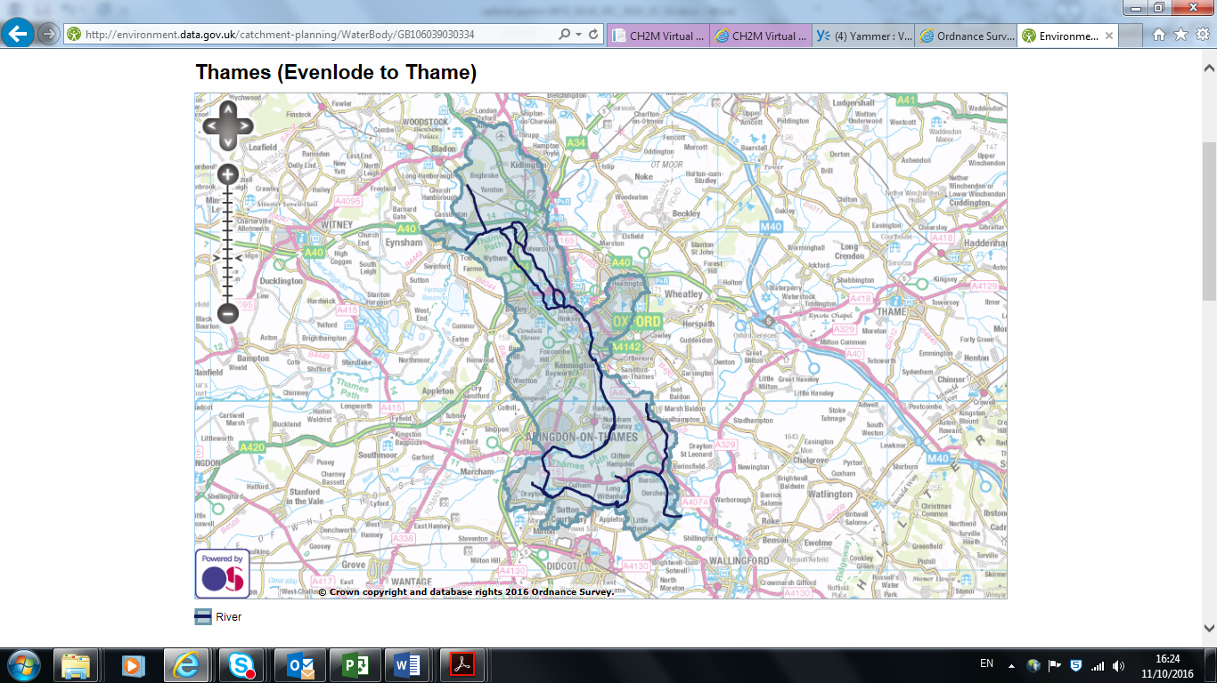

Figure 2: Thames (Evenlode to Thame) WFD water body.

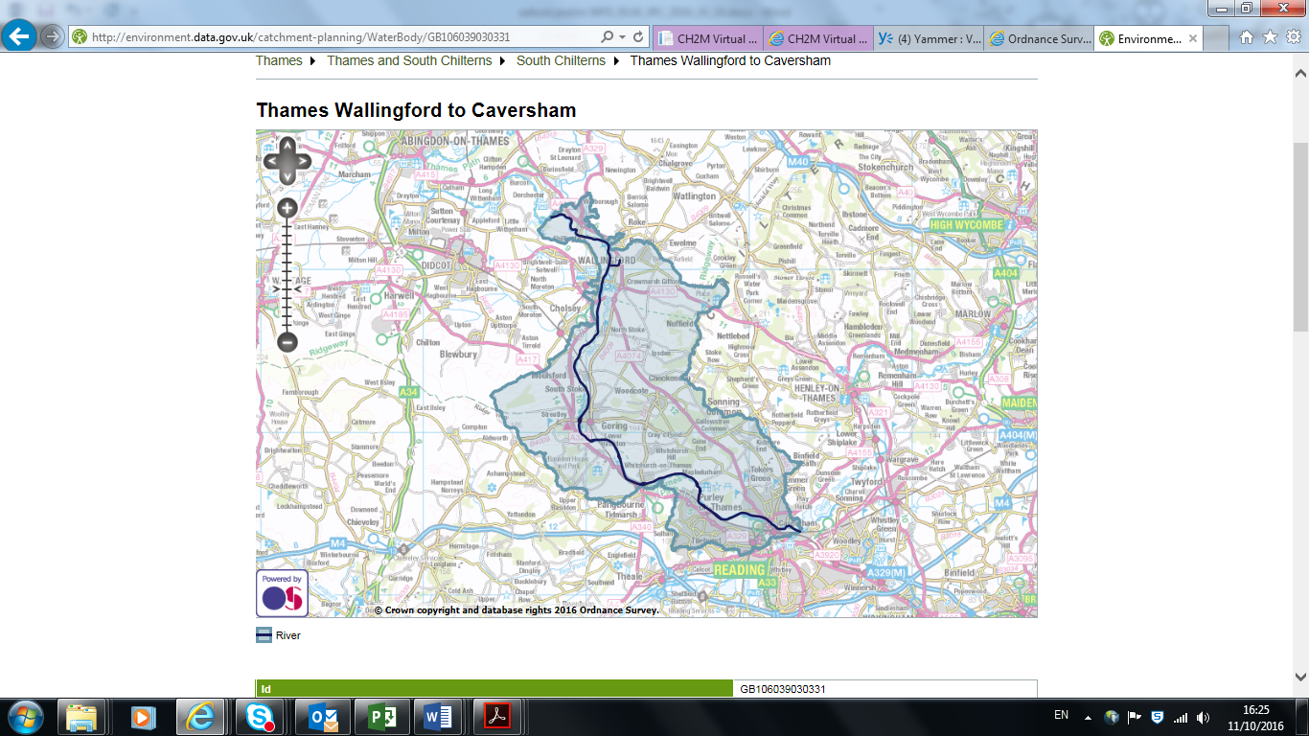Figure 3: Thames Wallingford to Caversham WFD water body

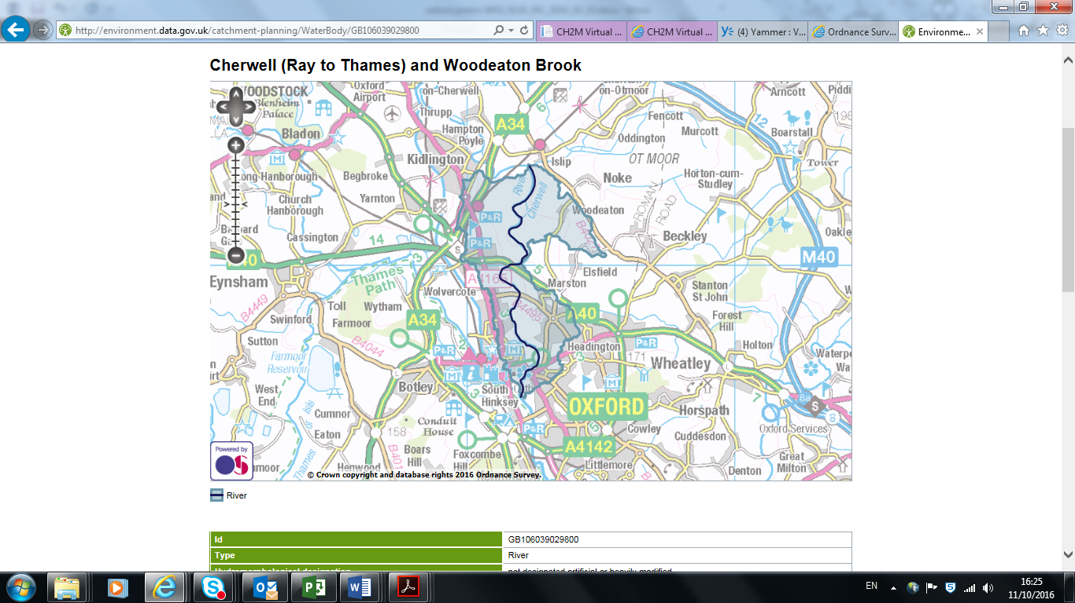Figure 4: Cherwell (Ray to Thames and Woodeaton brook WFD water body

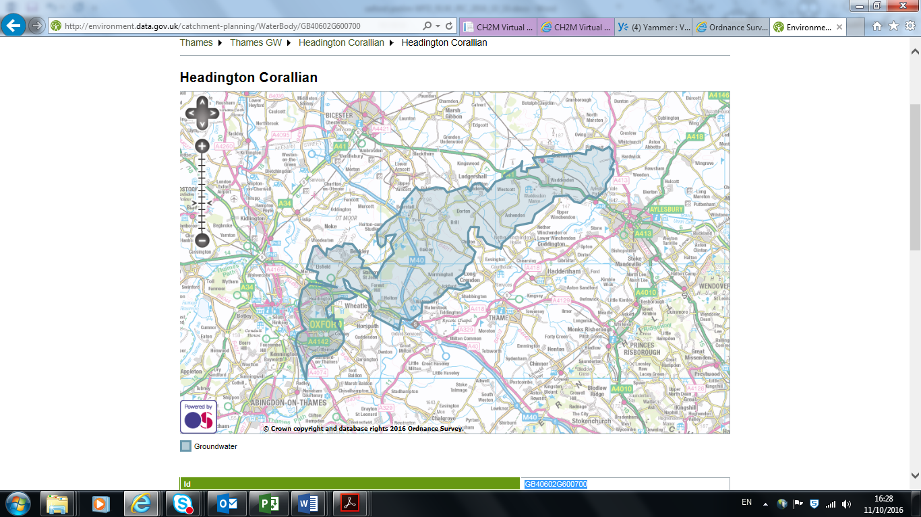

Figure 5: Headington Corallian WFD groundwater body

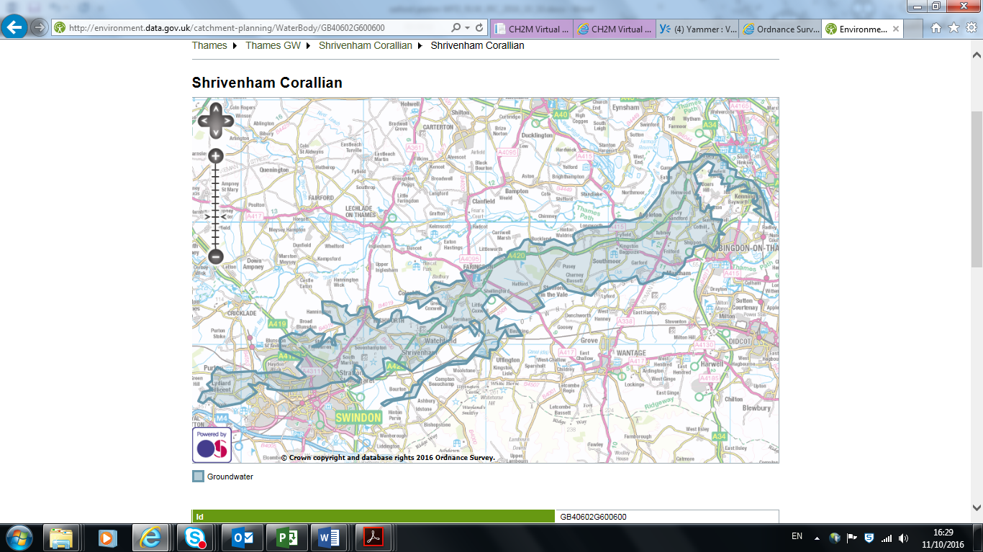

Figure 6: Shrivenham Corallian WFD groundwater body

### Water body WFD parameters

The following quality elements tables contain summaries of data from the cycle 2 river basin management plans published in 2016.

|  |  |
| --- | --- |
| Water body ID | GB106039030334 |
| Water body name | Thames (Evenlode to Thame) |
| NGR | SP4574111361 |
| Length (km) | 63.863 Distance (km) |
| Catchment area (km2) | 149.591 Area (km2) |
| Catchment area (ha) | 14959.089 Area (ha) |
| Hydromorphological designation | Not designated artificial or heavily modified |
| Current overall status | Moderate |
| Status objective (overall) | Moderate by 2015 |
| Reasons for not achieving good status: | Unfavourable balance of costs and benefits   * Disproportionately expensive * Technically infeasible   No known technical solution is available   * Disproportionately expensive * Technically infeasible   Disproportionate burdens   * Disproportionately expensive * Technically infeasible |
| Protected area designation | Drinking Water Directive  Habitats Directive  Nitrates Directive  Urban Waste Water Treatment Directive |
| Hydromorphological supporting elements | Supports Good.  Hydrological Regime: supports good  Morphology: supports good |
| Current ecological status (and status objective) | Moderate. Good by 2015. |
| Biological quality elements | Moderate. Good by 2027.  Fish: moderate  Invertebrates: moderate |
| Physico-chemical quality elements | Moderate. Moderate by 2015.  Ammonia (phys-chem) – High  Biological Oxygen Demand – High  Dissolved Oxygen - high  pH – High  Phosphate – Moderate  Temperature - High |
| Chemical quality elements | Fail. (Good by 2027) |

### Downstream water Body

|  |  |
| --- | --- |
| Water body ID | GB106039030331 |
| Water body name | Thames Wallingford to Caversham |
| NGR | SU5975592031 |
| Length (km) | 39.401 Distance (km) |
| Catchment area (km2) | 186.481 Area (km2) |
| Catchment area (ha) | 18648.061 Area (ha) |
| Hydromorphological designation | Heavily modified |
| Current overall status | Moderate |
| Status objective (overall) | Moderate by 2015 |
| Reasons for not achieving good status: | Cause of adverse impact unknown   * Disproportionately expensive * Technically infeasible   No known technical solution is available   * Disproportionately expensive * Technically infeasible   Disproportionate burdens   * Disproportionately expensive * Technically infeasible |
| Protected area designation | Habitats Directive  Nitrates Directive  Urban Waste Water Treatment Directive |
| Hydromorphological supporting elements | Supports Good.  Hydrological Regime: Does not support good |
| Current ecological status (and status objective) | Moderate. Good by 2015. |
| Biological quality elements | Overall: Moderate. Good by 2027.  Invertebrates: moderate  Macrophytes and Phytobenthos combined: good |
| Physico-chemical quality elements | Moderate. Moderate by 2015.  Acid neutralising capacity – high  Ammonia (phys-chem) – High  Biological Oxygen Demand – High  Dissolved Oxygen - high  pH – High  Phosphate – Moderate  Temperature - High |
| Chemical quality elements | Good |

### Upstream water body

|  |  |
| --- | --- |
| Water body ID | GB106039029800 |
| Water body name | Cherwell (Ray to Thames) and Woodeaton Brook |
| NGR | SP5120909547 |
| Length (km) | 12.153 Distance (km) |
| Catchment area (km2) | 23.765 Area (km2) |
| Catchment area (ha) | 2376.51 Area (ha) |
| Hydromorphological designation | Not designated artificial or heavily modified |
| Current overall status | Moderate |
| Status objective (overall) | Moderate by 2015 |
| Reasons for not achieving good status: | No known technical solution is available   * Technically infeasible |
| Protected area designation | Nitrates Directive |
| Hydromorphological supporting elements | Supports Good.  Hydrological Regime: Support good  Morphology: supports good |
| Current ecological status (and status objective) | Moderate. Moderate by 2015. |
| Biological quality elements | Moderate. Moderate by 2015.  Fish: good  Invertebrates: moderate |
| Physico-chemical quality elements | Moderate. Moderate by 2015.  Acid neutralising capacity – high  Ammonia (phys-chem) – High  Biological Oxygen Demand – High  Dissolved Oxygen - good  pH – High  Phosphate – Moderate  Temperature - High |
| Chemical quality elements | Good |

### Groundwater bodies

|  |  |
| --- | --- |
| Water body ID | GB40602G600700 |
| Water body name | Headington Corallian |
| NGR | SP6644812148 |
| Surface area (km2) | 167.74 Area (km2) |
| Groundwater area (ha) | 16774.3 Area (ha) |
| Current overall status | Good |
| Status objective (overall) | Good by 2015 |
| Protected area designation | Drinking Water Directive |
| Quantitative status | Good. Good by 2015. |
| Chemical Status | Good. Good by 2015. |

|  |  |
| --- | --- |
| Water body ID | GB40602G600600 |
| Water body name | Shrivenham Corallian |
| NGR | SU3467195246 |
| Surface area (km2) | 197.641 Area (km2) |
| Groundwater area (ha) | 19764.111 Area (ha) |
| Current overall status | Good |
| Status objective (overall) | Good by 2015 |
| Protected area designation | Drinking Water Directive, Nitrates Directive |
| Quantitative status | Drinking Water Directive |
| Chemical Status | Good. Good by 2015. |

### Assessment of Proposed Scheme on WFD Elements

The proposed various elements of the scheme are considered in terms of their potential impact on the current watercourse as well as the current WFD status of the downstream water body using River Basin Management Plan (RBMP) cycle 2 data on the Environment Agency’s Catchment Explorer website. Where possible, potential ways of mitigating the identified potential impacts have also been suggested (Table 1 to Table 4).

Each Area of the scheme is considered in a separate table.

Table 1: Design elements taken forward and their impact on WFD elements at Area 1

|  |  |
| --- | --- |
| **Key** | |
| Negative Impact |  |
| Negligible Impact |  |
| Positive Impact |  |
| Proposed options | | WFD element likely to be impacted (and description of impact) | Possible ways to mitigate impact |
| Two-stage channel along reach of Seacourt Stream upstream of Botley Road. | | Increased in-stream vegetation habitat due to diverse flow conditions and creation of marginal berms. Low / flows within the two-stage channel will allow diverse habitat | Positive impact no mitigation required. |
| Lower area by 1m and create backwater and environmental features. | | Increased diverse wetland habitat. | Positive impact no mitigation required. |
| Constriction or weir on entrance to Botley Stream to ensure low flows pass down Seacourt Stream. | | Reduction in water depth, width and velocity within Botley Stream channel due to flow being routed down Seacourt Stream. | Reduced flows in Botley Stream will lead to new dynamic equilibrium under the altered flow regime, and compensated for by improved flow regime on Seacourt Stream. |
|  | | Fish - Risk of fish stranding during low flows. Quality of habitat for fish along Botley Stream section reduced. | Design Seacourt Stream channel and improve Botley Stream channel to have variety of flows and features for fish refuge. |
|  | | Invertebrates – loss of bed habitat as flows and flow width reduced in Botley Stream. | Habitat in Botley Stream will re-adjust over time to changes in flow depth and width, as currently has been receiving more flow under low flow conditions due to restrictions in the channel of the Seacourt downstream of the difluence. Improved Seacourt Stream channel will provide additional habitat for invertebrates and macrophytes. |
| Increased habitat along Seacourt Stream as flows routed along this channel. |
|  | | Macrophytes – reduction in habitat on Botley Stream channel as flow width and depth reduced. | Habitat in Botley Stream will re-adjust over time to changes in flow depth and width. Improved Seacourt Stream channel will provide additional habitat for invertebrates and macrophytes. |
| Increased habitat on Seacourt Stream during low flows. |
|  | | Sedimentation – possible sedimentation during low flows in Botley Stream channel. | Majority of the sediment is likely to be flushed out at higher flows as both channels are operational at higher flows, and under low flows there is little sediment in transport. |
| Botley Road bund – earth embankment from Seacourt park and ride to Botley Road allotments constructed mainly from site won material. | | No working in watercourse. | Required as part of the scheme |
| Raised wall defence along northern side of properties along Botley Road. | | Not adjacent to watercourse. | Negligible impact. |
| Provide hard invert to provide protection to existing foundations. Concrete with inset rock to create more interesting bed than plain concrete. | | Positive. Create more diverse flow condition by providing small-scale variations in water depth. | Positive impact no mitigation required. |
| Bed deepening to improve conveyance requirement | | Possible sedimentation during low flows – localised impact to sediment, water quality and fish habitat/fish passage particularly if it creates a knick point | Negligible impact. Needs appropriate design consultation and also monitoring post-construction |
| Consideration of low flow channel through Botley Road bridge to aid fish passage during low flows and reduce risk of sedimentation. | | Improved fish passage and habitats during low flows. | Ensure low flow channel contains places for fish to rest. |
| Flood gate, flood boards at footbridge on Henry Road. | | No working within the watercourse (Osney Ditch). | Negligible impact. |
| New flood wall at Helen Road (10m). | | No working within the watercourse (Osney Ditch). | Negligible impact. |

Table 2: Design elements taken forward and their impact on WFD elements Area 2

|  |  |
| --- | --- |
| **Key** | |
| Negative Impact |  |
| Negligible Impact |  |
| Positive Impact |  |
| Proposed options | | WFD element likely to be impacted (and description of impact) | Possible ways to mitigate impact |
| Two-stage channel along reach of Seacourt Stream downstream of Botley Bridge to Willow Walk. | | Increased in-stream vegetation habitat due to diverse flow conditions and creation of marginal berms. Low / flows within the two-stage channel will allow diverse habitat and clean gravels | Positive impact no mitigation required. |
| Tree removal on left hand bank of two-stage channel. | | Decreased shading of channel may lead to increased water temperatures. | Encourage marginal and submerged aquatic vegetation to grow. |
| Extra light at the water margin would encourage marginal and submerged aquatics to grow and increase diversity of habitat. | Positive impact no mitigation required. |
| Potential destabilisation of banks depending on tree location | May need bank protection or rapid vegetation establishment. |
| New reinforced spillway and new scrape channel. | | Potential for new wetland habitats to establish within scrape channel depending on how frequently it is flooded. | Positive impact |
| Potential for fish stranding in new scrape channel when in use and mortality due to inability to get back into the main channel. | Small ponds to be created in scrape channel.  Design scrape channel so water levels reduce slowly to avoid fish stranding. |
| New two stage channel from Spillway to Willow Walk Bridge. Loss of trees on left hand bank. | | Increase of in-stream vegetation habitat due to diverse flow conditions and creation of marginal berms. Low / flows within the two-stage channel will allow diverse habitat and good quality gravels to be established. | Positive impact no mitigation required. |
| Loss of trees could result in destabilisation of banks and loss of shade and increased water temperatures. | May need bank protection or rapid vegetation establishment.  Encourage marginal and submerged aquatic vegetation to grow. |
| Shallow gradient on second stage to allow MG4 grassland to re-establish if hydrological conditions are suitable. | | Positive impact (partly offsetting a larger negative impact due to initial loss of MG4 where the channel is created) | Positive impact no mitigation required. |
| Minor modifications to existing channel to provide environmental improvements. | | Environmental improvements. | Positive impact no mitigation required. |
| Replacement of Westway Cycle Bridge with a longer clear span bridge. | | Localised erosion protection required on bank. | Limit works in first stage channel. Works to be carried out from banks wherever possible. |
| New bridge at Willow Walk – single span bridge with raised deck. | | Localised scour protection required. | Scour protection works to have a natural design where possible. |

Table 3: Design elements taken forward and their impact on WFD elements Area 3

|  |  |
| --- | --- |
| **Key** | |
| Negative Impact |  |
| Negligible Impact |  |
| Positive Impact |  |
| Proposed options | | WFD element likely to be impacted (and description of impact) | Possible ways to mitigate impact |
| Two-stage channel along 2km reach downstream of Willow Walk Bridge to the Devil’s backbone. | | Increased in-stream vegetation habitat due to diverse flow conditions and creation of marginal berms. Low / flows within the two-stage channel will allow diverse habitat | Positive impact no mitigation required. |
| Gravel bed in first stage channel. | | Increased in-stream habitat diversity (e.g. for fish spawning). | Positive impact no mitigation required. |
| Connecting field drain system into new first stage channel. | | Increased and more diverse wetland habitat as a result of connecting drains through facilitating natural development of habitat. | Positive impact no mitigation required. |
| Clear span footbridge at Monk’s Causeway south of Willow Walk. | | Localised rock scour protection required. | Scour protection works to have a natural design where possible. |
| Footbridge at the Devil’s backbone. | | Localised rock scour protection required. | Scour protection works to have a natural design where possible. |
| Flow control structure on the Eastwyke Ditch on eastern side of railway. Automated penstock housed in new concrete structure. | | Ditch is minor watercourse and not directly assessed as a waterbody in its own right under WFD. | Negligible impact |
| Training banks alongside Eastwyke Ditch back to railway to prevent the structure being bypassed. | | Ditch is minor watercourse and not directly assessed as a waterbody in its own right under WFD | Negligible impact |
| Low level control structures (reinforced earth or concrete weir or flume) in locations where proposed conveyance channel crosses existing channels. | | New channel will create more wetland / aquatic habitat. Majority of flow will be conveyed along new channel and the isolated sections of the Bulstake Stream and Hinksey Stream will be used as backwater channels and only convey flow at high flows. | Habitat in Bulstake and Hinksey Streams will re-adjust over time to changes in flow depth, velocity and width. New conveyance channel will provide additional habitat for invertebrates and macrophytes. and should more than compensate for the loss of flow to sections of the existing reaches of these two watercourses |
| Sedimentation in Bulstake and Hinksey streams as flow is reduced. | Sediment may be flushed out as channels convey water at higher flows; habitat loss will be compensated for as above. |
| Low level structures may inhibit or create a barrier to fish movement. | Negligible impact as it is considered that the removal of Towles Mill weir will offset any impacts at these and fish movement to Bulstake Stream will be possible through the new channel. |

Table 4: Design elements taken forward and their impact on WFD elements Area 4

|  |  |
| --- | --- |
| **Key** | |
| Negative Impact |  |
| Negligible Impact |  |
| Positive Impact |  |
| Proposed options | | WFD element likely to be impacted (and description of impact) | Possible ways to mitigate impact |
| Two-stage channel from the Devil’s backbone across farmland proposed to run east to connect to lakes at Hinksey culverts below the railway. | | Increased in-stream vegetation and flow-dependent habitat due to diverse flow conditions and creation of marginal berms. Low / flows within the two-stage channel will allow diverse habitat | Positive impact; no mitigation required. |
| Clear Hinksey culverts of debris and silt. | | Improve conveyance and longitudinal connectivity. | Positive impact; no mitigation required. |
| Low weir with manual sluice to control lake levels. | | Maintains lake levels and fish habitat. | Negligible impact. |
| Remove blockage in culvert. | | Improve conveyance and longitudinal connectivity. | Positive impact; no mitigation required. |
| Single stage channel below Old Abingdon Road. | | Designed due to constricted area. | Negligible impact. |
| Enlarged Hinksey Drain channel – sheet piles along east side of channel. | | Designed due to constricted area. | Negligible impact. |
| Widened Hinksey Drain channel cuts through landfill site. Reinforced earth and sealed liner to create barrier between landfill material and widened channel. | | Potential for pollution incident if not designed appropriately. | Ensure sealed liner and barrier used. Minimal habitat value but will not be primary channel under low flows. |
| Kennington pond to be made smaller. | | Decreased wetland habitat. | Mitigated by increased wetland habitat created elsewhere. Consider using a sheet pile channel to mitigate the loss of pond. |
| Clear obstructions and soft material back to hard bed in Hinksey Stream from railway at Hinksey Culverts to confluence with the Thames. | | Improved longitudinal connectivity.  Improved fish passage.  Improved sediment transport. | Negligible impact. Improvement in gravel bed habitat may be possible. |
| Remove Tower Mill Weir and fish pass rock ramp. Removal of trees to facilitate this work. | | Improved longitudinal connectivity.  Improved fish passage.  Improved sediment transport. | Negligible impact, improved fish passage and reduction in impoundment effect. |
| Removal of trees could destabilise banks. | Bank protection or rapid vegetation establishment may be required. |
| Raised defences at South Hinksey – earth embankments and flood walls. | | Sheet piles and earth embankment | Scour protection works to have a natural design where possible. |
| New raised defences at new Hinksey (earth embankments). | | Embankment is set back from watercourse. | Minimise working within watercourse. |
| Two groundwater pumping stations. | | Ensure no pollution into groundwater | Pumping station design to be sealed to prevent ingress of surface water into groundwater. |
| New bridge south of the Devil’s backbone. | | Localised erosion protection required on bank. | Scour protection works to have a natural design where possible. |
| New ford crossing. | | Potential for bank poaching. | Bank protection may be required. |
| A423 bypass. New large culvert to convey flood flows below the bypass. Dry during low flows. | | Ensure culvert does not become “dark barrier” which inhibits fish movement. | Culvert only in use at high flows.  Use splayed wingwalls to maximise light into culvert and consider introducing solar-powered lighting in the culvert.  Culvert length to be determined at detailed design stage. |
| Munday’s bridge modification- clearance and connecting channel downstream of the bridge widened and deepened to match cross-section of the bridge. | | Increased longitudinal connectivity. | Positive impact; no mitigation required. |
| New Culvert at Old Abingdon Road. Three parallel culverts with centre one depressed to aid fish passage. Grouted rock bed rather than plain concrete. | | Grouted rock bed creates more diverse flow condition by providing small-scale variations in water depth. | Positive impact; no mitigation required. |

### Conclusion

This WFD assessment report has been prepared for the Oxford FAS Scheme. The proposed various elements of the scheme were evaluated in terms of their impact on the current WFD status of the water body using RBMP cycle 2 data on the Environment Agency’s Catchment Explorer website. As a result of assessing the scheme elements, it is anticipated that as a result of the proposed works, there will be a requirement for a detailed assessment due to the range of potential impacts to the water body. This is likely to entail the undertaking of River Corridor Surveys and River Habitat Surveys; fish and macro-invertebrate surveys, and other ecological studies as required.

1. Water Framework Directive (Directive 2000/60/EC), implemented in England by the Water Environment (Water Framework Directive) (England and Wales) Regulations (SI 3242/2003).