Response form
Park Wood Path Consultation

About you
Privacy and keeping in touch
We, the Environment Agency, will keep your details until we have notified you about publication of the response document.
We will not share your details with any other third party without your explicit consent unless required to by law.
You can withdraw your consent at any time by contacting us at: park.wood@environment-agency.gov.uk
We are the data controller for the personal data you provide.
For further information on how we deal with your personal data please see our Personal Information Charter or contact our Data Protection team at DataProtection@environment-agency.gov.uk
How we will use your information

We will publish a summary response on Citizen Space within 2 weeks of this consultation closing and before we implement any changes. It will include a summary of the comments and queries we received. It will not include individual comments. We will outline our recommendations that will have taken the comments into account. We will circulate a link to our response to all consultees and other interested parties who have asked to be kept informed.
In line with the Freedom of Information Act 2000, we may be required to publish your response to this consultation, but will not include any personal information. If you have requested your response to be kept confidential, we may still be required to provide a summary of it. For more information see our Personal Information Charter.
We are running this consultation in accordance with the guidance set out in the government's consultation principles.
If you have any questions or complaints about the way this consultation has been carried out, please contact consultation.enquiries@environment-agency.gov.uk

Returning your response

Your response to this consultation needs to be returned by 11.45pm, 27 January 2022.
We would like you to use this form if you are not submitting your response online. You can return it by email to park.wood@environment-agency.gov.uk

Or by post to:
Environment Agency
Pevensey Office
Coast Road
Pevensey
East Sussex
BN24 6ND

If you have any questions specifically about this consultation, please email
park.wood@environment-agency.gov.uk

We welcome your views on the proposed paths at Park Wood

1. What is your name?

Name:

2. What is your email address?

By providing us with your email address you consent for us to email you about the consultation, and you will also receive an email acknowledging your response
Email:

3. Please tell us if you are responding as an individual or on behalf of an organisation or group.

Responding as an individual
Responding as an organisation or group
Other

If you are responding on behalf of an organisation or group, please tell us who you are responding on behalf of and include its type, for example, business, environmental group.

If you selected 'other' please provide further explanation to support your answer.

4. Can we publish your response?

This is a required question to enable us to analyse your response.
Yes
No
Yes but not my name
Yes but not my email
Yes but not my name and email

If you do not want us to publish your response, please indicate the reason.

5. How often do you visit Park Wood?

Once a day
Several times a day
Once a week
Several times a week
Once a month
Several times a month
2-3 times a year
Never
Other

If other, please state how frequently.

6. When you visit Park Wood, is it to:

Walk
Walk the dog
Horse ride
Watch wildlife
Cycle
Run
Other

If other, please state what activity you do when you visit the wood.

7. When do you usually visit Park Wood?

Weekends
Week days
Both

8. What time of day do you visit?

Morning
Afternoon
Evening

As part of our ongoing work to improve Park Wood, we will be installing new way markers on the footpaths within the wood.

Below is the current path network.

Our proposed path network is as follows:
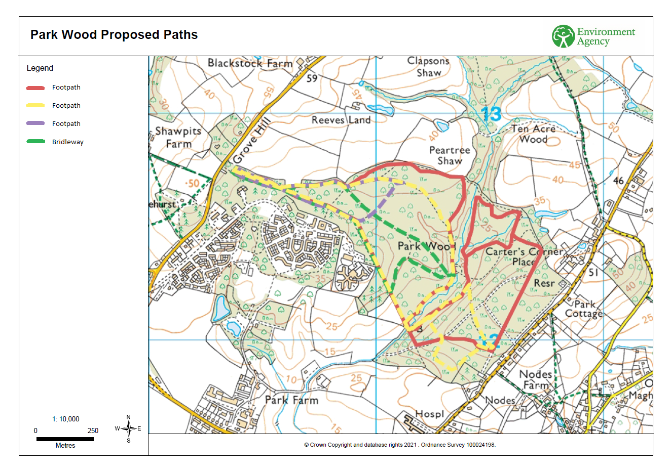

9. Will you use any of the paths proposed?

Yes
No

10. Are you aware of any paths on this proposal which are not suitable, or are inaccessible?

Yes
No

If yes, which paths and why.

11. Do you have any other feedback about this proposal?

