- Objective:

To describe the process of alcoholic fermentation and distillation at Sedamyl UK ltd.

- Scope:

This document covers a general description of the fermentation, distillation and all utilities related to it (cooling towers, steam, turbines, compressed air, heat recovery, water treatment). This guideline can be used as process training for new starters and it is available to all operators for reference purposes at any time.

- Related documents:

All of the documents beginning with:
- SED DISSOP
- SED DISRA
- SED DISF

- Responsibilities:

  - Operator: responsible for reading and understanding the document and make use of the gained knowledge in the plant.
  - Area manager: responsible for updating the document as per site expansion or significant changes.

- Process/Procedure:

Table of contents:

Starch cooking principle…………………………………………………………………………………….....3
Enzymes………………………………………………………………………………………………………………..4
Cooking: gelatinisation and liquefaction………………………………………………………….……5
Alcoholic fermentation general overview………………………………………………………………6
Fermentation…………………………………………………………………………………………………….....8
Cleaning (C.I.P.) overview ……………………………………………………………………………………11
Grain natural alcohol production unit …………………………………………………………………13
Mechanical vapour re-compression…………………………………………………………………....28
Steam and compressed air………………………………………………………………………………....29
Cooling towers………………………………………………………………………………………………..….31
MVR heat recovery loop………………………………………………………………………………..……32
Scrubber………………………………………………………………………………………………………….….33
Water treatment (ozone and reverse osmosis) …………………………………………………..35
Gas turbines and boilers……………………………………………………………………………………..37
CHP heat recovery loop.………………………………………………………………………………………41

45 °C
35 °C
Cooling towers
Condensate to WWTP

Condensate to Wet mill

45 °C
45 °C
58 °C
Pre-Heating
Tanks 40tk1 /2
Cooling water
25 °C
60 °C
Starch from Wet mill
35°C
58 °C
Sulphuric acid & enzyme LPHera (alpha amylase)

80 °C
95 °C
Condensate from storage tank 10tk1

105 °C
Starch cooking tank
50tk1
Heating with jet cooker
80 °C
70 °C
Starch cooking tank
40tk1
95 °C
95 °C
Heating with jet cooker
95 °C
Enzyme Saczyme (glucoamylase)
95 °C
Heat recovery water loop
80 °C
85 °C
Cooling towers
35 °C

Cooling water
Heat recovery water loop
55 °C
25 °C
Yeast propagation tank 60TK1 or 70TK1 (Recirculating through a heat exchanger to keep the temperature at 34°)

Fermenter 10TK1 or 20TK1
34°C
Fermenter 30TK1
Addition of:
- Yeast
- Enzyme Optimash (cellulase)
- Enzyme Deltazyme (protease)
- Nutrients (ammonium sulphate/phosphate)
- Antifoam
- Air
34°C

Fermenter 40TK1
34°C

Feed to Distillery
Fermenter 50TK1
34°C
C
STARCH COOKING PRINCIPLE
Starch cooking is the process of gelatinisation and liquefaction through which we get hydrolysed starch for the fermentation.
During the liquefaction the alpha-amylase enzyme (LPHera) cuts the long chains of starch down to dextrins.
The product subject to gelatinisation and liquefaction comes from the wet mill and is composed of:
- 50% of starch
- Fibres (cellulose and pentosans)
- Salts
- Protein, etc

Starch consists of:
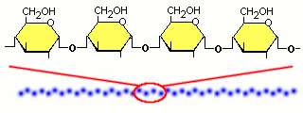

20% of amylose molecules (linear form)

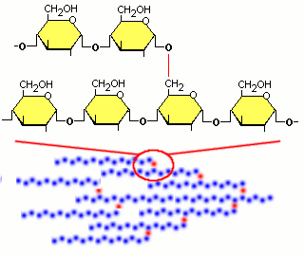

80% of amylopectin molecules (branched form)

Both of them are composed in their turn by many units of glucose, also known as dextrose.
Glucose is a simple molecule of sugar that is composed by 6 atoms of carbon, 12 of hydrogen and 6 of oxygen.
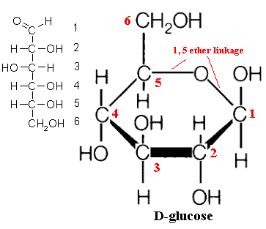

ENZYMES
Enzymes are large molecules (Proteins most of all) with cell form that perform (catalyse) chemical reactions necessary for the metabolism, the maintenance, the growth and the reproduction of living beings.
Enzymes have a particular concavity called the active site where the molecules (substrate) fit and a reaction will occur, quickly forming new products.
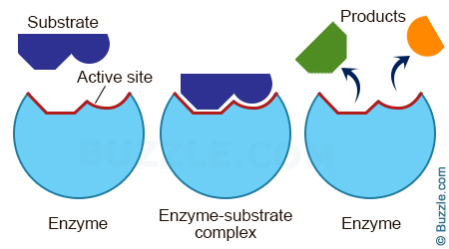

Enzymes used in the food industries are produced and extracted industrially by microorganisms, in particular bacteria (Bacillus) and fungi (Aspergillus).
There are many enzymes and a lot of reactions catalysed by enzymes, and each enzyme catalyses one reaction only. To act, enzymes need certain conditions like temperature, pH, etc.
Also, the fermentation of sugars occurs through a series of chemical reactions catalysed by specific enzymes which are produced by the yeast strain ‘Saccharomyces Cerevisiae’.

COOKING: GELATINISATION AND LIQUEFACTION
- In the wet mill, alpha amylase enzyme (LPHera) is added to the starch that is to be used for fermentation.
- The starch from the wet mill is first sent into a tank (Pre – heating tank 40TK1/2) passing through 2 heat exchangers, to increase its temperature up to 58°C. Between 60°C and 78°C starch granules swell, increase in viscosity and have a gelatinous consistency. The maximum viscosity is reached between 68 + 72°C.
(Only after gelatinisation, can the starch be converted by the alpha-amylase enzyme). The starch used for the fermentation has very small granules (C starch), so a lower viscosity.
- From the Pre – Heating tank, the starch is sent to the starch cooking plant where it is mixed with a certain amount of cooked starch, to raise the temperature again. The mixture then goes through a heat exchanger to increase its temperature, past the gelatinisation range, up to 80°C.
- The starch then flows into the cooking tank, where it is kept at 95°C by passing through a jet cooker, which injects steam into the product stream.
During the reaction (Liquefaction or enzymatic hydrolysis) the alpha-amylase enzyme cuts the long chains of starch into shorter molecules called dextrin. As a result of this, the product viscosity is reduced.
- The starch liquefaction ends in the residence tank.
- Both the cooking and residence tanks should be above 95 degrees to allow the alpha-amylase to convert the starch molecule chains to dextrins. For more information on this, refer to the LPHera technical data sheet.

Moreover, it will be necessary to control:
- the hydrolysed starch temperature, that must be 95°C minimum.
- the enzymatic hydrolysis conditions (i.e. PH, retention time and temperature)
- the sufficient enzyme dosage. (the enzyme dosage rates can be found in the monthly log book).

ALCOHOLIC FERMENTATION GENERAL OVERVIEW
Fermentation is the process that converts glucose into ethanol, also known as ethyl alcohol, through a chain of reactions. These reactions also produce CO2.
The simplified reaction is:
C6H12O6 (Glucose) 2CH3-CH2-OH (Ethanol) + 2CO2 (Carbon dioxide)
  - RAW MATERIALS
The starch that comes out from starch cooking is not ready for the fermentation yet. It needs to be converted into glucose. To achieve that, after cooking, the starch is dosed with a gluco-amylase enzyme (Saczyme). This enzyme breaks the dextrin’s chains (already cut starch) in monomer units, obtaining glucose, also known as dextrose.
The starch with this enzyme added is directed in part to yeast propagation tanks and in part to the fermenters.

  - YEAST AND FERMENTATION
Alcoholic fermentation is a metabolic process that occurs in some yeast in the absence of oxygen. It is responsible for several phenomena that we can see every day, such as the bread leavening. Fermentation is achieved by a particular class of microorganisms, the yeasts Saccharomyces, of which the most common is certainly cerevisiae that can be found on grape skin and it is also used in the brewing industry.
Generally, yeasts are a group of fungi composed by a single type of cell, which can have an elliptical or spherical form. More than one thousand yeast species have been discovered.
Some yeasts can survive only with oxygen present, others like Saccharomyces cerevisiae can live either with or without consuming oxygen, getting energy directly from sugar molecules through fermentation process.
Yeasts produce energy from sugars such as glucose, maltose, fructose and sucrose.
The characteristics required for a good industrial yeast are:
- Fast growth;
- High resistance to produced alcohol (8-9% minimum);
- Possibility to ferment in a concentrated mash (+- 20° Bx);
- Good yield in alcohol (+- 62 cm³ of alcohol per 100 g of sugars).
Alcoholic fermentation occurs, more precisely, due to different Enzymes, which convert glucose into alcohol and CO2 through the following series of chemicals reactions:
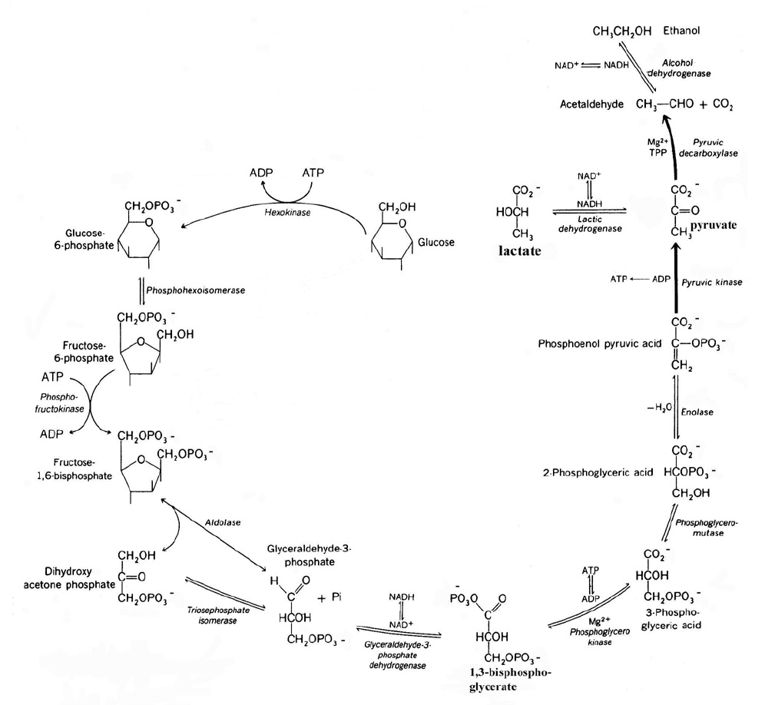

  - YEAST PROPAGATION
To obtain a significant production of alcohol, a great number of yeast cells are necessary. These are produced starting from an inoculum of yeast in the yeast propagation process. In this phase there is the presence of oxygen which let the yeast breathe. By breathing, yeast converts more sugars than in the fermentation obtaining more energy to grow and reproduce.
In the propagation process, the alcohol production is rather limited because breathing converts sugars (glucose) into carbon dioxide and water instead of ethanol.

The large amount of yeast produced in the

YEAST PROPAGATION
- PARAMETERS
- Oxygen, carried from the air. It allows the production of ergosterol and certain fatty acids which are essential for the functionality of cellular membranes;
- Carbon, carried from carbon hydrates (carbohydrates or sugars);
- Nitrogen, from the feeding of ammonium sulphate/phosphate (SED DISSOP-006);
- Phosphorus, already present in the starch coming from the wet mill;
- Other growth supplements, already present in the mash, as minerals, trace-elements, vitamins.
- pH: 3.2-3.3
- Temperature: 34°C
- Feed concentration: 20-22Bx

  - PROCESS
Once the propagator tank has had a full CIP, the preparation of the yeast propagation begins with adding to the tank:
- A small amount of starch coming from the starch cooking. It must be diluted to about 10 Brix for the first yeast reproduction;
- Dry yeast;
- Deltazyme (protease enzyme);
- Optimash (cellulase enzyme);
- Antifoam;
- Ammonium sulphate/phosphate.

The recirculation allows the air to be pulled in through the venturi nozzle (a short piece of narrow tube between wider sections for exerting suction). The air will supply the oxygen necessary for the yeast reproduction.
A heat exchanger is located in the recirculation line in order to maintain the ideal temperature for yeast propagation. This is because the breathing reactions produce heat. The exchange happens with water coming from the cooling towers.
Sugar consumption indicates the correct yeast growth, to ensure this is happening satisfactorily the sugar concentration (Brix) should be reduced 4-5Bx. At this point it is possible to feed the yeast propagation gradually.
Further information on making yeast propagation can be found on SED DISSOP-007.

FERMENTATION
- PARAMETERS
- Cooked starch temperature at about 34°C;
- pH between 3.2 and 3.5. pH higher than 3.5 promotes bacterial infections (lactic acid bacteria). pH lower than 3.0 tends to inhibit the yeast;
- Presence of oxygen in the yeast propagation tank, which allows the yeast to have a higher vitality and therefore a good yield in fermentation;
- No oxygen present in the fermenters.
- Low concentration of ethanol because, over 14% vol, it inhibits the yeast by modifying the functions of their cellular membrane;
- Low concentration of non-fermentable solid materials;
- Low salt content;
- Agitation of the mash in order to allow the yeast to circulate in the viscous mass.
Approximately 10% of the flour processed consists of non-fermentable components, i.e. non-fermentable sugars, fibres, pentosans etc. The Optimash enzyme cuts down the string of molecules into smaller chains, which reduces the viscosity of the mash. It is important to remember that not all of the starch produced comes to fermentation some goes to other parts of the plant, but all of the non-fermentable components go to the fermentation. The higher the flour rate, the more non-fermentable components go to fermentation. If the concentration of non-fermentable components is too high in the fermentation, the viscosity will increase to a level where it prevents the yeast from moving around the starch and therefore reduces the effectiveness of the fermentation process, resulting in a lower alcohol yield from the mash.
Elevated levels of salt produced by the starch treatment processes in the wet mill (use of Sulphuric acid, sodium hypochlorite and caustic soda) will slow down the yeast activity in fermentation. This is why regular C.I.P cleaning schedules are followed.
- PROCESS
The flow of mash from the starch cooking is sent both to the yeast propagation tank and to the first fermentation tank (10TK1 or 20TK1) for the primary fermentation. The first fermentation tank is also fed with product from the yeast propagation tank.
In the first fermenter, the yeast is at its most active. This is due to the presence of high levels of glucose and oxygen form the propagation resulting in a high conversion from glucose to ethanol. This means that the jump in ethanol level between the 1st and 2nd fermenter will be a lot higher than that in the last 2 fermenters. This reaction is exothermic (generates heat) so you will see the heat exchanger on the first fermenter is the largest, then they reduce in size sequentially through the fermentation process.
After the 1st fermenter the product is sent to the other three fermenters progressively, where it continues to ferment. Through these fermentation tanks, sugars will decrease while the ethanol concentration increases up to about 11-13% vol. The fermented mash is called wine, which should have no fermentable glucose left. The wine produced will feed the distillery.
Each fermentation tank has got an agitator and a recirculation system where the mash goes through a heat exchanger in order to keep it at the desired temperature of 30-35°C. Temperatures higher than 35°C can reduce the yeast activity and also promote contaminations.
The extraction from one fermentation tank to the next is regulated to keep the level in the tank constant, with the exception of the last fermenter, in which the level is regulated by the feed to the first distillation column.
- FERMENTATION SECONDARY PRODUCTS
In addition to alcohol and CO2, fermentation produces a wide range of secondary products. Their formation depends on environmental conditions during fermentation such as pH, temperature, fermentation steps, aerobic and anaerobic phases, yeast vitality etc.
A lot of secondary compounds are unwanted because they decrease the yield in ethanol or inhibit the yeasts and also because they give substances that influence the final alcohol organoleptic characteristics. Moreover, some of these products must remain under certain limits by law.
In the following table are summarized the main compounds produced during fermentation:

Name | Effect | Prevention measures
Glycerol (or glycerine):  The medium concentration is between 0.5% and 0.6% at the end of fermentation. It is always present. | None.
Acids (acetic acid, lactic acid, propionic acid):  Produced by microorganisms that compete with the yeast in certain conditions. | Reduction of the alcohol yield;  Deceleration of the yeast growth and, if the concentration becomes high, complete yeast inhibition . | - Keep the pH under 3.5;  - Control the temperature of starch cooking and fermentation;  - Regular cleaning of all the plant’s parts that come into contact with the starch.
Higher alcohols (as n-propanol, isobutanol, amyl alcohol, isoamyl alcohol):  They are eliminated through the extraction of tails, high oils and low oils in the distillation process. | They alter the organoleptic characteristics of the grain nautral alcohol; therefore, they must be eliminated. | - Temperature control during fermentation (to not promote the increase of bacteria that produce higher alcohols)  - Cleaning of all the plant’s parts  - Avoid lack of nutrients (nitrogen):  If the yeast can’t find nitrogen it will convert amino-acids into nitrogen with a reaction that produces higher alcohols
Methyl alcohol (methanol):  It is the main secondary alcohol produced during fermentation | It is toxic for humans and must be eliminated. The lethal dose varies between 0.3g and 1g per kg of body weight. | It is eliminated during the distillation, through the head of the demethylation column 4530_50DC1
Esters (main esters are ethyl acetate, propyl acetate, isoamyl acetate):  Most are produced during the fermentation by synthesis between alcohol and acetic acid. | These compounds have a bad odour and they have a negative impact on the organoleptic quality of the grain natural alcohol. | - Temperature control  - Cleaning procedures  - Avoid lack of nutrients fed into the propagation.
Acetaldehyde:  It is a normal product of fermentation before the ethanol formation. Otherwise it can derive from unwanted acetic fermentation. | It gives negative organoleptic characteristics to the grain natural alcohol. | - Temperature control  - Cleaning procedures  It is eliminated with methanol and ethyl acetate through extractions from the head extraction of columns 4530_20DC1 + 4530_40DC1.

CLEANING (C.I.P) OVERVIEW
Cleaning with condensate and disinfection with water and caustic soda are periodically done in order to eliminate product deposits and formation of microorganisms inside pipes, tanks and various parts of the plant.
The first condensate rinse (water extracted by the stillage MVR) flushes out the remaining product into the process stream to avoid it being wasted.
The caustic wash is done after the first rinse. It eliminates any contamination, attacks organic parts as soluble protein compounds and avoids the formation of oxalates.
The caustic comes from the CIP station, through the CIP line and through the plant item, it is then sent back to the caustic tank in the CIP station via the CIP return line. The caustic soda in the caustic tank (20TK1) is diluted with condensate to reduce the strength to around 10 Baume.
The final rinse is done after the caustic wash. Condensate from the C.I.P station is pumped through the same paths (including spray balls, heat exchangers etc.) as the caustic soda to remove any caustic residue in the plant items and to neutralize the equipment before re-use. The condensate from the final rinse will have a small amount of caustic mixed in after cleaning the plant item but no product, so it will be pumped out through the C.I.P return line, not into the process. The condensate is not returned to the caustic tank like the caustic soda, but is sent to tank 4610 40TK1 where it is stored and gradually fed to the effluent (waste process products) tank to neutralize the effluent pH prior to the effluent being sent the waste water treatment plant (WWTP).
  - YEAST PROPAGATION TANKS
As soon as a yeast propagation tank has been emptied it is cleaned. This is to sterilize the tank, pipes and heat exchanger. The first rinse pushes the remaining mash into the first fermenter.
The caustic wash of a propagation tank has 2 stages. In the first stage, the caustic wash sends caustic soda into the spray ball on the top of the tank, which sprays the walls of the tank. The caustic gathers at the bottom of the tank and when there is a sufficient level in the tank, the recirculation will start. This recirculation pumps caustic through the recirculation pipes, heat exchanger, venturi nozzle and through the agitation system, back into the tank. Once the recirculation time elapses the recirculation pump will stop and stage 2 will begin. The extraction pump will start and the caustic soda will be pumped through the 2 dilution heat exchangers that service the respective propagation tank and into C.I.P return line, back to the caustic tank and the caustic will simultaneously be pumped back into the propagation tank from the C.I.P station to create a loop. Once the set time has elapsed, the caustic will stop pumping into the propagation tank and the tank will empty, sending all the caustic back to the C.I.P caustic tank.
The final rinse takes the same paths as the caustic wash to neutralize all equipment cleaned by the caustic soda. The condensate is then pumped through the respective heat exchangers, into the C.I.P return line and into 4610 40TK1.
  - HEAT EXCHANGERS STARCH COOKING TO YEAST PROPAGATION AND FERMENTATION
The starch cooking heat exchangers require cleaning at least once every shift or more frequently if flow of mash from starch cooking to yeast propagation and fermentation is reduced due to the heat exchanger blocking.

  - FERMENTERS
The plant has 5 fermenters, but only 4 are used at any one time. This is to allow 1 to be cleaned without disruption to the fermentation process. Fermenter 10 and 20 typically alternate, so whilst one is online, the other is being cleaned. This is because the first fermenter in the process (tank 10 or 20) is on a much more frequent C.I.P schedule than the others, due to an increased level of non-fermentable components (i.e. fibre) in the early stages of fermentation. The other fermenters are cleaned following a less frequent C.I.P schedule. If any fermenter is showing signs of requiring a C.I.P before it is scheduled, then this will be planned ASAP.
The cleaning of fermenters is necessary either to eliminate any contaminations to avoid the formation of oxalates fouling on both the tanks and pipes surface. The presence of deposits and fouling in a fermenter heat exchanger is indicated by;
- An increase of the pressure, measured upstream of the heat exchanger;
- Reduced efficiency of the heat exchanger (inlet and outlet temperatures are similar);
- A decrease in flow, caused by an obstruction in the heat exchanger;
- The presence of foam in the fermenter.

GRAIN NATURAL ALCOHOL PRODUCTION UNIT
- PRINCIPLES
Distillation is based on the fact that vapour, obtained through the boiling of a several liquid mixtures, contains a greater percentage of the more volatile element compared to the starting mixture. For example; if you heat a 50/50 mixture of ethanol and water, the liquid that evaporates into vapour will contain a higher percentage of ethanol than water. This is due to the boiling point of ethanol being lower than water at the same pressure and therefore has a higher vapour pressure and is more volatile.
Vapour pressure is the tendency of a liquid to change into the gaseous or vapour state, and it increases with temperature, until reaching the boiling point of the liquid, where its vapour pressure becomes equal to the pressure exerted above the liquid surface.

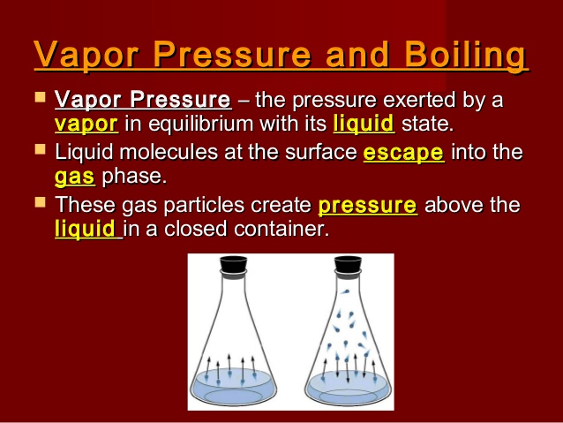
The higher the vapour pressure of a liquid is, the lower the boiling temperature of that liquid will be. Liquids with a greater tendency to evaporate have a higher vapour pressure and therefore less heat will be required to reach the atmosphere pressure above it.
A distillation stage consists of the boiling and evaporation of a mixture and subsequently the liquefaction (condensation) of the obtained vapour. The degree of separation obtained from the mixture with a single stage of distillation (one tray of a distillation column) depends exclusively on the difference between vapour pressures of pure components, therefore, as we just said, on the difference between their boiling points.
In particular, with a single stage of evaporation and liquefaction, the lower the difference between the boiling points of pure substances is, the lower the obtainable separation will be.
By distilling a solution of a non-volatile substance (for example salt) to recover the solvent, it’s possible to get a complete separation with a single stage; contrariwise if the difference between boiling points is minimum, is impossible to separate the mixture components with one distillation. For example, if you heat a mixture of water (boiling point 100°C) and alcohol (boiling point 78.5°), you get vapour rich in alcohol, but still containing water. In order to get alcohol solutions at 50% starting from one at 10%, it is necessary to distil the vapours collected during the first distillation two or three more times. To get alcohol at 96% it’s necessary to repeat the process a great number of times.
The more plates a distillation column contains, the more distillation stages there are. Each distillation stage consists of two phases: liquid and steam.
Each tray has got a weir that holds a layer of boiling liquid, the tray is fed by the liquid descending from the tray above, the level of liquid exceeds the weir and descends on the plate below.
The boiling liquid on a tray forms a vapour that is richer in ethanol than the liquid; the vapour rises and enters in the openings of the tray above. These openings (see details in the figure) are small tubes topped by a bubble cap, with slits, that make the vapour gurgle causing the formation of small bubbles with the increase of vapour surface in contact with the boiling liquid.
Therefore, you have a good mix of vapour and liquid with the exchange of heat and matter. The vapour gives heat to the liquid, so cools slightly and condenses the water and the less volatiles components; the liquid in turn acquires heat from the vapour, boils and evaporates mostly the most volatile component (ethanol). Ethanol is carried to the top by the vapour that goes up. So, as you go up in the column the ethanol content, which has a lower boiling point, increases (enrichment). Going up through each plate, the boiling temperature of the liquid solution will decrease. As you go down on the column the ethanol content decreases more and more (exhaustion), there is an increase of less volatile and heavier components and consequently the boiling temperature increases.
The liquid that reaches the base of the column passes through a reboiler, it is vaporized and re- introduced to the column base in order to exchange further matter and heat: the vapour can therefore climb the column, becoming richer in ethanol, releasing less volatile substances and providing heat in order to allow the liquid on the plates to boil.
The vapour that is still in a gaseous state at the top of the column will rise into the Head of the column. The vapour will then pass through a condenser (to return it to liquid form). Once liquid, a small amount of the head will be extracted and the rest will be pumped back into the column to once again fall down the trays and go through the distillation process. The liquid that is pumped back into the column it came from is called a reflux.
Four of our distillation columns work under vacuum (pressure lower than atmospheric pressure), therefore the boiling temperature will be lower, and in fact less heat will be required to ensure that the vapour pressure of the mixture matches the column pressure (boiling point). Besides, the difference of boiling temperature between single components of the mixture will be higher, therefore there will be a better separation.
The most important thing about working under vacuum is the energy saving because less heat is required, therefore less steam for boiling the liquid inside the column.
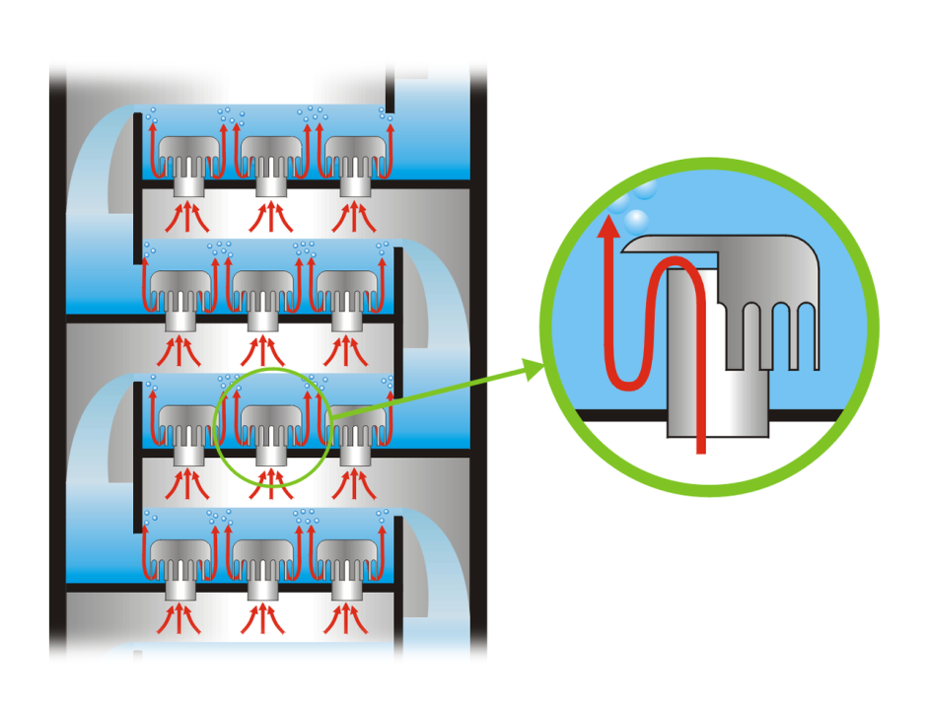
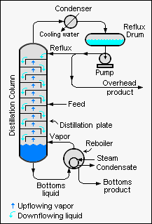
- DISTILLATION COLUMNS
The Sedamyl distillery produces a high-quality rectified Grain Natural Alcohol starting from a fermented wine at a minimum of 10% ABV (alcohol by volume). With an optimized energy consumption, it is capable of producing 1500hl/24h of pure alcohol.
This distillation process consists of 6 phases:
Phase | Tag column | Number of columns
Degassing and distillation | 11DC1-10DC1 | 1
Concentration | 20DC1 | 1
Hydro Selection | 30DC1 | 1
Rectification | 40DC1-41DC1 | 2
demethylation | 50DC1 | 1
Heads & Tails | 60DC1 | 1
 | TOTAL | 7

Compared to a traditional distillery, this unit has the advantage of reducing the energy consumption, maximizing the multiple effect techniques to heat the columns.
- Distillation (10DC1), degassing (11DC1) and concentration (20DC1) columns; this stage is under high vacuum (about -0.70 bar(g) on Head of column 20DC1). The wine is fed into column 10DC1 and falls to the bottom (as previously explained). Here it is separated into alcoholic vapour and bottom still. The bottom still passes through the tube side of 2 reboilers (shell and tube heat exchangers) in order to increase its temperature, before it is fed back into the column. On the shell side of the reboilers there are head vapours from other columns (10HE1 has vapour from 41DC1 and 10HE2 has vapour from 60DC1).
- Hydro Selection column 30DC1; this stage is under slight vacuum (-0.35bar (g) on head) and is heated 2 ways. Firstly, it is heated by the liquid at bottom of the column passing through the tube side of a boiler (shell and tube heat exchanger) which receives heat from the head vapours from 41DC1 on the shell side. The second way is by recovering heat from the condensed steam from columns 40DC1 and 60DC1. The condensed steam is collected in 35TK1. As it is still at a high temperature, a small amount of evaporation occurs in the tank and the vapours are sucked, by the columns slight vacuum, back into the column (the liquid is pumped back out to the hot well).
- Demethylation column 50DC1; this stage is under high vacuum (about -0.6 bar (g) and 54°C on the head), it is heated by the liquid at bottom of the column passing through the tube side of a boiler (shell and tube heat exchanger) which receives heat from the head vapours from 30DC1 on the shell side 50HE1 (about -0.35 bar (g) and 85°C).
- Rectification column 40/41DC1; This stage is split in two columns in order to reduce environmental impact. It is under pressure (about 0,8 bar (g) and 93°C on the head) and is heated by saturated steam at 3.3 bar (g) at 138°C through the reboiler 40HE1. The steam passes through the shell side of the boiler (shell and tube heat exchanger) and the liquid at the bottom of column 40DC1 passes through the tube side.
- Heads & tails concentration column 60DC1; This stage is under pressure (0.9 bar (g) and 93.5°C on the head of column 60DC1) and is heated by saturated steam at 3.3 bar (g) at 138°C through the reboiler 60HE1. The steam passes through the shell side of the boiler (shell and tube heat exchanger) and the liquid at the bottom of column 60DC1 passes through the tube side.

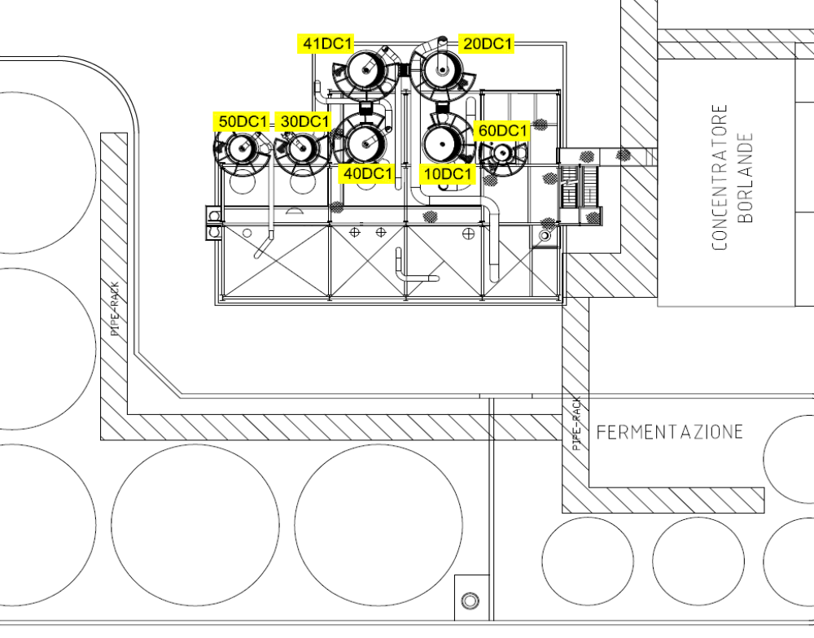

SOUTH VIEW
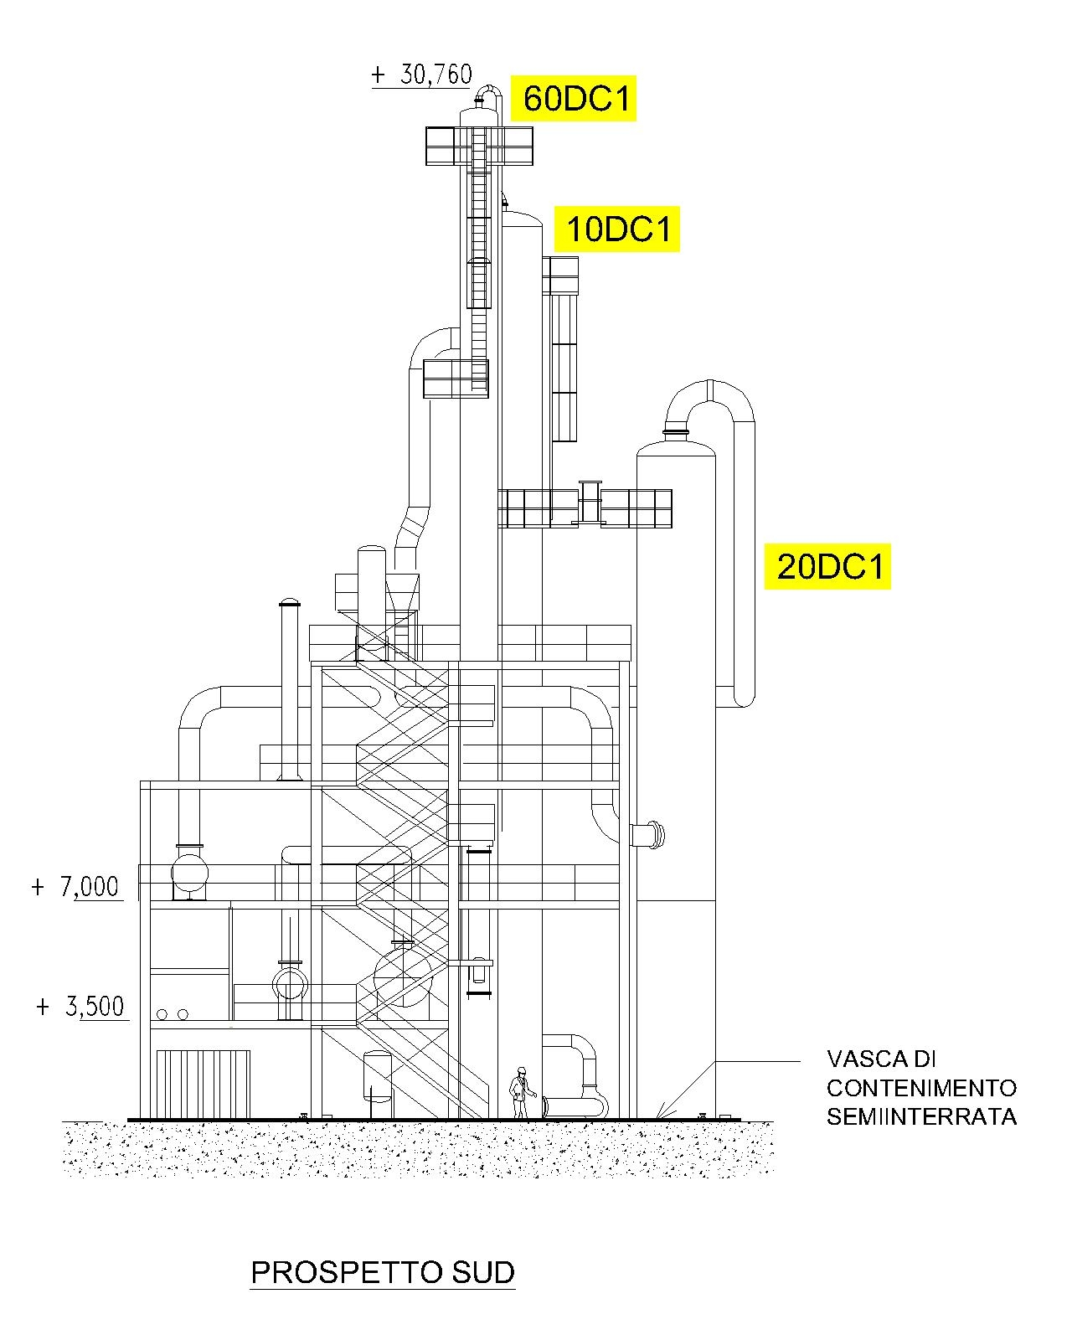
Distillery bund

NORTH VIEW
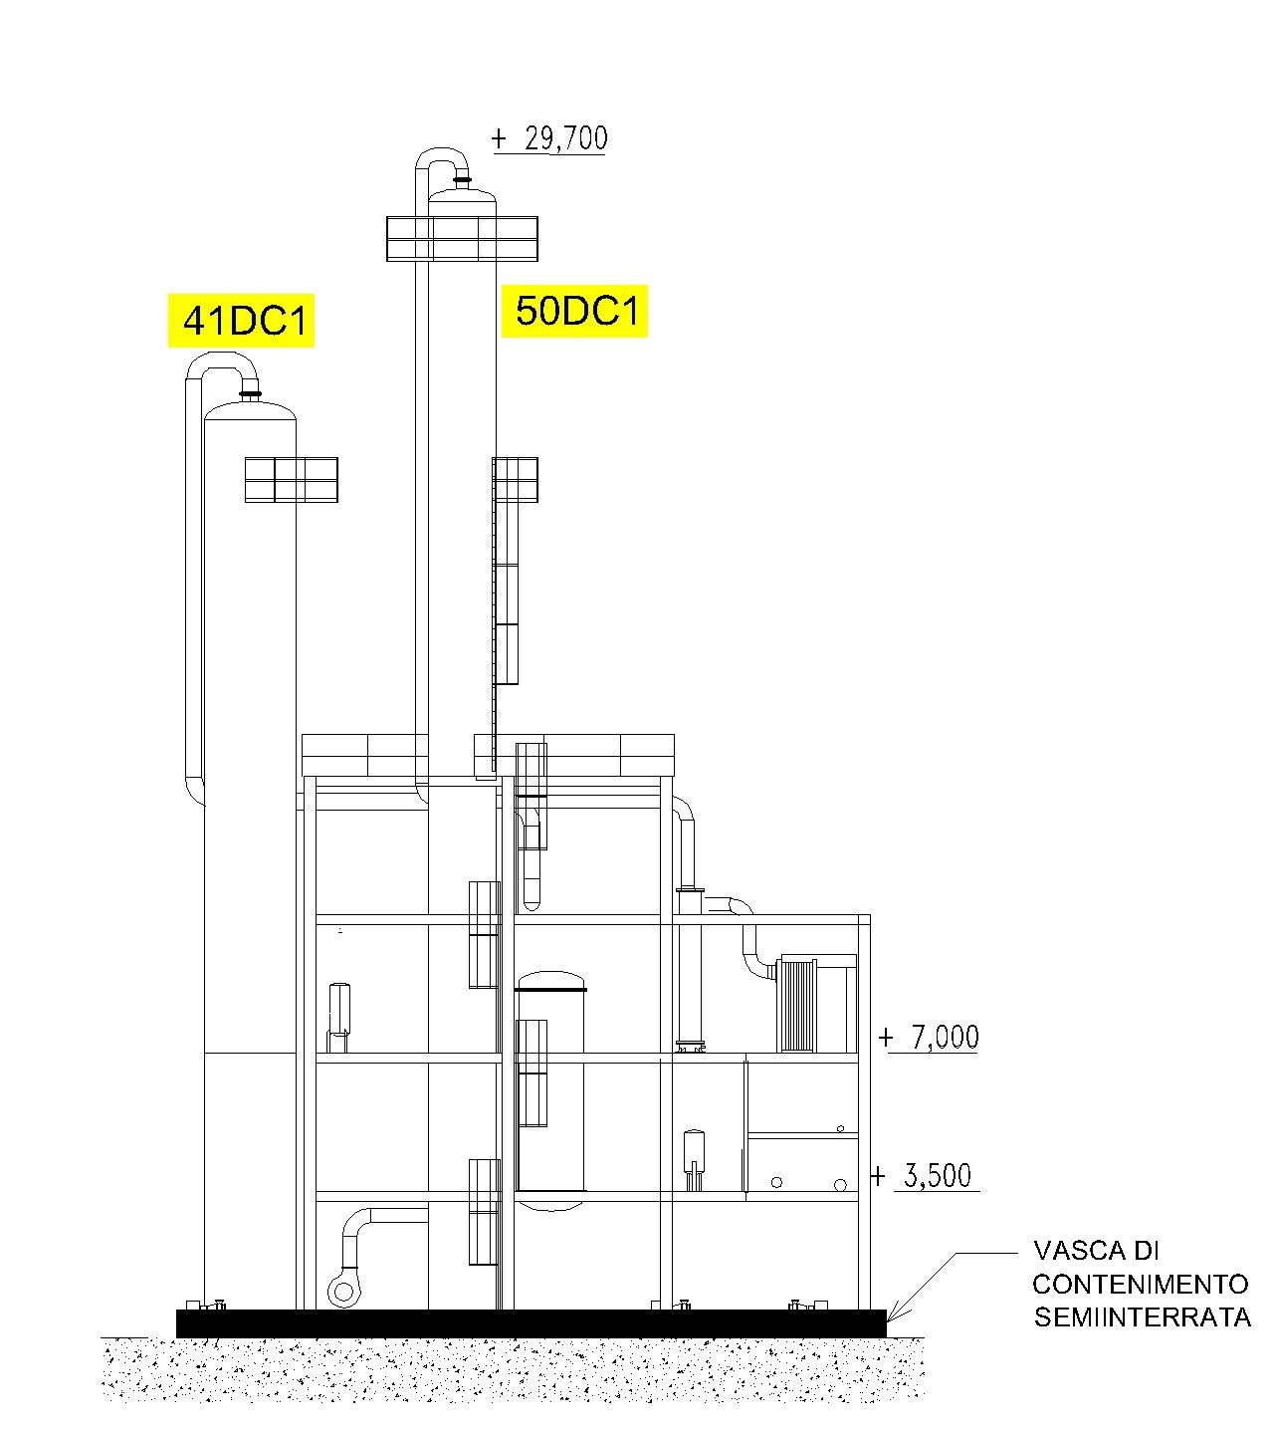
Distillery bund

- DISTILLERY FLOW-CHART
Wine from the fermentation tanks
Bottom still
Alcohol
Water
Diluted alcohol
Alcohol
Extraction
High oils, low oils, heads
Heads
Heads, tails, high oils
Column 60DC1 (Heads and Tails)
Column 50DC1 (Demethylation)
Grain alcohol storage
Column 40DC1 - 41DC1 (Rectification)
Column 10DC1 - 11DC1 (Distillation and Degassing)
Column 30DC1 (Hydro Selection)
Column 20DC1 (Concentration)
Bottom still to MVR
Alcoholic vapour
Incondensable to the vacuum pumps
Heads & tails storage
Heads
Fusel oils to storage
Tails, heads, oils

Liquid reflux

LP steam 3.3 Bar

- PROCESS DESCRIPTION
- Exhaustion/degassing and concentration (10DC1/11DC1 and 20DC1) → production of raw alcohol.
The aim of distillation columns 10DC1 (distillation), 11DC1 (degassing), and 20DC1 (concentration) is:
- 10DC1: exhaustion of alcohol from the fermented wine (maximum residual value allowed in the bottom still is: 0,03% vol);
- 11DC1: remove a part of the non-condensable products (air, CO₂, SO₂…);
- 20DC1: alcohol concentration up to about 94% volume (raw alcohol).
The fermented wine is approximately 11-13% ABV (alcohol by volume), which comes from the fermentation at about 34 °C, feeds degassing column 11DC1, after being preheated through the heat exchanger 20HE1 (by the vapours from the head of column 20DC1), and heat exchanger 10HE3 (by condensate from the MVR), to around 50°C.
Head vapours 11DC1. The column 11DC1 is designed to eliminate the non-condensable content of the wine (CO2, air, SO2 ...). The vapours from the head of the column are condensed in a shell and tube heat exchanger 11HE1 and sent back into the column through the pumps 11P1A/B (Reflux). A small extraction is also sent to the tank 62TK1 (column 60DC1 feed tank). The gases that cannot be condensed are removed through the vacuum system.
The wine, after passing on these degassing plates, feeds the distillation columns 10DC1, equipped with 25 trays, which exhausts the wine of alcohol until it has a concentration of no more than 0.03% ABV.
Bottom. The bottom still is extracted at about 87 °C in the bottom of the column 10DC1, it is sent by the pumps 10P1A/B to the tank 12TK1 (MVR feed). Not all of the bottom still is extracted straight away, most is used to recover heat to the column, see page 17 for full description.
The alcohol vapour extracted from 10DC1 is about 60% ABV. It is then sent for concentration in the column 20DC1, up to 94% ABV, in order to remove some impurities (fusel oils, higher alcohols).
Head vapours 20DC1. The alcohol vapours at 94% ABV from the head of column 20DC1 are condensed in the plate heat exchangers 20HE1, 20HE2, shell and tube heat exchanger 20HE3, 20HE4. The condensed vapours are collected in the vessel 20TK1 and sent back into the column through the pumps 20P1A/B (Reflux). A small extraction from this reflux is sent in the tank 62TK1 (column 60DC1 feed) .The extraction of the alcohol at 94% ABV is removed from several trays below the head by pumps 20P2A/B .The volatile impurities concentrate in the head of the column 20DC1, therefore there is the need of a small extraction on the reflux. The high concentration in the top of the column 20DC1 acts as a barrier to some impurities (fusel oils, propanol and butanol) which concentrate on several trays just above the feed.
Base 20DC1. The condensed liquid on the bottom of 20DC1 is refluxed through the pumps 20P4A/B back to the column 10DC1.
On the concentration column 20DC1 the PH is neutralised with sodium bicarbonate.
The raw alcohol (also known as pasteurized) at 94% ABV, is extracted just under the head of the column. It is then sent to the hydro selection column 30DC1. This extraction is controlled by temperature control system installed on the low oil tray. Maintaining a constant temperature on the plate allows for a stable load in the column and consequently a stable alcohol concentration on the head of column 20DC1.
Heating. See page 17.

- Hydro selection (column 30DC1)
The raw alcohol, at 94% ABV, from the concentration column 20DC1, feeds the hydro selection column 30DC1 through pumps 20P2A/B, in order to remove impurities, thus purifying the alcohol.
Heating. See page 17.
Base. Ethanol is selectively directed toward the base of the column, along with dilution from 40DC1, to help further remove impurities. The solution in the bottom of the column will be about 10-15% ABV. The diluted alcohol is extracted from the base of the column by pumps 30P2A/B to feed the column 40DC1. The impurities contained in the solution of dilution and alcohol have a lesser affinity with water than ethanol, therefore, in order to remove them easier, a low ABV solution is required. They are concentrated at the top of column 30DC1.
Vapour head. The head vapours are about 30-40% ABV and rich in impurities. They are condensed in the boiler 50HE1 to heat demethylation column 50DC1. Most of the condensate collected in the tank 30TK1 are sent into the reflux of the column 30DC1 through the pumps 30P1A/B but a small amount is extracted to 62TK1.

- Rectification (columns 40DC1/41DC1)
The purpose of the rectification column 40DC1/41DC1 is to concentrate the alcohol up to min. 96% by volume, eliminating some head products. This column is provided with trays of exhaustion (below the feed point) and concentration trays.
Heating. See page 18.
Base. Most of the spent feints (water in the bottom of the column) at 0.03% ABV (maximum) are extracted from the base of the column 40DC1 through the pumps 40P1A/B where they are sent through 2 plate heat exchangers 30HE2 (giving heat to 40DC1 feed) and 30HE3 (giving heat to 30DC1 demi water dilution) and then onto the head of the column 30DC1 along with a small amount of demi water. The small remainder of spent feints is sent to the WWTP.
Vapour head. The alcohol is concentrated in the top of the column 41DC1 up to 96% ABV minimum. The alcohol vapours in the head of 41DC1 are under pressure (0.9 bar (g) and 95 °C) and they are split into 2 lines. 1 line goes to 10HE1 and the other goes to 30HE1, where they travel through the shell side of the boilers and are condensed (10HE1 condenses into 41TK1 and 30HE1 condenses into 41TK2). They are then pumped back (41P1A/B from 10HE1 and 41P2A/B from 30HE1 where a small amount is extracted to 62TK1) into 41DC1 near the top of the column.
The rectified alcohol condenses a few plates from the top of the column 41DC1 and is sent directly to demethylation column 50DC1.
This extraction is controlled by temperature control system installed on the low oil tray. Maintaining a constant temperature on the plate allows for a stable load in the column and consequently a stable alcohol concentration on the head of column 41DC1.
On columns 40DC1+41DC1 we have 4 extractions of impurities. They are low oil, high oil, low tails and high tails which we extract to eliminate the heavy impurities contained in spent feints and to prevent the accumulation of these impurities on trays which can act like a barrier and affect the columns’ efficiency. The product condensed at the base of the column 41DC1 is sent at the top of the column 40DC1 by pumps 41P3A/B.

- Demethylation (column 50DC1)
The purpose of column 50DC1 is to eliminate the last head impurities and methanol.
Heating. See page 17.
Vapour head. The head vapours of the column 50DC1 are condensed in the plates heat exchangers 50HE2 (which is cooled by the heat recovery loop), 50HE3 and 50HE4 (which is cooled by cooling water). The condensed vapours are then collected in 50TK1 and are refluxed back into 50DC1 by pumps 50P1A/B (a small amount of the condensates are sent directly into 63TK1, heads and tails tank, as they contain high levels of impurities, primarily methanol).
Base. The grain neutral alcohol (GNA), extracted from the base of the column 50DC1 by pumps 50P2A/B, is sent to the alcohol storage after being cooled by two plate heat exchangers 50HE5 (cooled by cooling water) and 50HE6 (cooled by well water).

- Heads and tails (column 60DC1)
The tank 62TK1 collects all extractions that are made from different columns;
- reflux head column 20DC1;
- reflux head column 11DC1;
- reflux head column 40DC1/41DC1;
- reflux head column 30DC1;
- oils and tails column 40DC1/41DC1;
- oils column 20DC1;
- dilution water decanter 65TK1/65TK2;
- water washing column 00DC1 and exchanger 20HE4;
- drain from the water circuit of the vacuum pump.
These are then pumped (by pumps 62P1A/B) through a plate heat exchanger 60HE2 (heated by 60DC1 extraction to WWTP) and then fed into column 60DC1.
The column 60DC1 functions under pressure and acts as a rectifying column (exhaustion trays and concentration trays). The heads and tails is at about 46% ABV when it is fed into the column, it is exhausted at the bottom where the concentration is 0.03% ABV and concentrated at the top to 95%ABV.
Base. The spent feints extraction from the base, after cooling in plate heat exchanger 60HE2, is sent to the WWTP.
Head. The alcoholic vapours in the head are under pressure (0.9 bar (g) and 95 °C). They are condensed in the shell of boiler 10HE2 and then the liquid flows into 60TK2. They are then refluxed (by pumps 60P1A/B) back into column 60DC1 (a small amount of the reflux is extracted to 63TK1).
From 63TK1 the heads and tails are pumped (by pumps 63P1A/B) through 63HE1 (cooled by cooling water) and 63HE2 (cooled by well water) and then into the heads and tails tank in alcohol storage.
Fusel oils are concentrated on a few trays above the feed. They are extracted and passed through plate heat exchanger 65HE1 (cooled by cooling water) then they are decanted in the decanter 65TK1, then into decanter 65TK2.
The dilution water from the decanter is sent to distillation column 10DC1 or to the tank 62TK1.
On some trays below the head tray, there is an area where alcohol is relatively pure and can be recovered. This alcohol is then recycled in the concentration column 20DC1.
Heating. See page 18.

- Fusel oils decanter 65TK1
Fusel oils are extracted from columns 20DC1 and 60DC1
- Fusel oils from column 20DC1 are sent into the column 60 feed tank 62TK1 by pumps 20P3A /B;
- Fusel oils from column 60DC1 are extracted and sent in the decanter 65TK1.
Before being decanted in 65TK1, fusel oils are cooled down through the plate heat exchanger 65HE1 and diluted with demineralized water.
This dilution allows the physical separation of water-alcohol solution: the oil, lighter, will form a supernatant layer, extracted and collected into the tank 65TK3. From this tank fusel oils are sent to the fusel oils storage tank through an air pump controlled by a valve (65EV2) with timed opening and closing.
The water-alcohol mixture (dilution water) can be sent to the column 10DC1 or to the collection tank 62TK1.

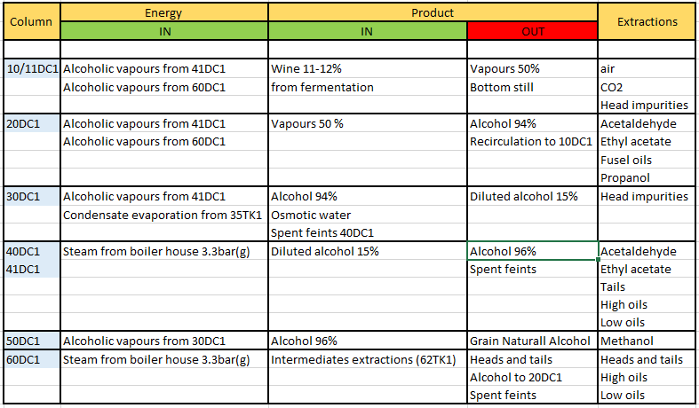

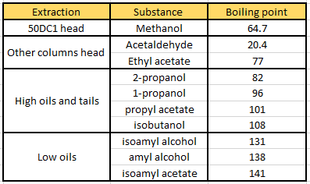

- Vacuum system
As mentioned before, 4 of our columns work under vacuum with the aim of saving energy because by reducing the pressure less heat is required, therefore less steam, for boiling the liquid inside the column. Non-condensable gases need to be extracted in order to create the vacuum. At this stage, non-condensable gases are bonded to alcohol, this is why they are sent into a washing column in order to be scrubbed by demineralised water descending from the top of the column. The water bonds to the alcohol and moves to the bottom of the column where it is then sent back to the tank 62TK1 (column 60 feed). Gases move to the top of the column and then are drawn into the vacuum pump (liquid ring).
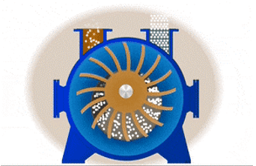
The liquid-ring pump compresses gases by rotating a vaned impeller located eccentrically within a cylindrical casing. Liquid (water) is fed into the pump and, by centrifugal acceleration, forms a moving cylindrical ring against the inside of the casing. This liquid ring creates a series of seals in the space between the impeller vanes, which form compression chambers. Gas is drawn into the pump through an inlet port in the end of the casing. The gas is trapped in the compression chambers formed by the impeller vanes and the liquid ring. The reduction in volume caused by the impeller rotation, which compresses the gas, which is discharged through the port in the end of the casing. Compressed gas is sent to the scrubber columns in fermentation to be washed in order to reduce the Volatile Organic Compounds down to acceptable levels regulated by law.

Further information can be found on the following documents:
- SED DISSOP-010.
- SED DISSOP-011.
- SED DISSOP-013.
MECHANICAL VAPOUR RE-COMPRESSION (MVR)
- PRINCIPLE
Mechanical Vapor Re-compression (MVR) is a proven energy-saving evaporative technology, using low-value waste steam and heat.
Evaporation is a process where water is removed from a feed stream to produce a concentrated discharge stream and a separate water stream. Our MVR works under vacuum created by multistage vacuum pumps, like the distillery plant (see page 27).

- PROCESS
In our application water (used earlier in the process) is removed from the bottom still.
The bottom still is extracted at about 87 °C from the bottom of the column 10DC1, is sent by the pumps 10P1A/B to the tank 12TK1 (MVR feed).
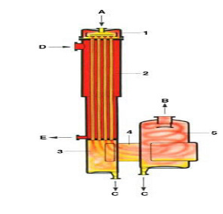
The liquid to be concentrated (A) is supplied to the top of the main heat exchanger (1) and distributed in such a way as to flow down the inside of the tube walls as a thin film. The liquid film starts to boil due to the external heating of the tubes (D). This heating is provided by the fan compressor. The liquid continues to boil inside the tubes, releasing water, incrementing its concentration and reducing its volume. When the liquid and vapour come out from the tubes(3), we have the separation between liquid and vapours: the liquid falls in the bottom (C) where the recycle pumps are (to be sent to the top of the heat exchanger for a further evaporation) and where the extraction pumps are (to be sent to the stillage storage), the vapours are dragged (4) to the main fan via separator(5), where there is again a further separation, liquid to the bottom (C), vapours to the top(B). In order to have more evaporation and therefore more liquid concentration, it is necessary to increase temperature and pressure of the vapours produced inside the tubes. This is done by the main fan. The recompressed vapours provide energy to the liquid film which evaporates further, generating more vapours to be then recompressed by the main fan, incrementing the liquid concentration more and more. By giving energy to the tubes, recompressed vapours condense along the outside of the tubes, they fall down and they are extracted at the bottom of the heat exchanger (E). Further information can be found on SED DISSOP-009

- CONDENSATE
Condensates from MVR are sent to the storage tank 10TK1. This storage tank can hold 350 m ³ and acts as a buffer for rinsing equipment such as lines, tanks and heat exchangers. Condensates from 10TK1 are then sent by the pump 10P3 to the WWTP tank passing through some heat exchangers in order to be cooled down and to transfer their thermal energy to other part of the plant, more precisely to:
- Wine entering in column 10DC1 (heat exchanger 10HE3);
- Starch from wet mill (Pre-heating HE);
These temperature exchanges give the following benefit:
- Less steam usage in starch cooking;
- Less steam usage in distillery;
- Less energy usage from the cooling towers.
STEAM AND COMPRESSED AIR
- STEAM
The plant requires both low pressure (3.3 Bar) and high-pressure steam (15-21 Bar).
High pressure steam is produced by boiler 9 and 10 (capacity 35 ton/h each). The high-pressure steam feeds the following plants:

- Starch dryer battery;
- Gluten dryer battery;
- Elliott turbine;
- Steam control valve HP-LP.

The steam control valve HP-LP reduces the steam pressure down to 3.3 bar (Low pressure steam at 148°C). It is dry, de-oiled and does not contain any impurities likely to result in equipment corrosion or to impair the alcohol quality. The low-pressure steam feeds the following plants:

- Starch cooking (jet cookers);
- MVR C starch (separator);
- Stillage MVR (separator);
- Distillery (10DC1, 40DC1, 60DC1).

- COMPRESSED AIR
Compressed air can be produced by:

- Elliott turbine compressor (cost free, primary use);
- Electric compressors (used as spare when the Elliott Turbine is off).
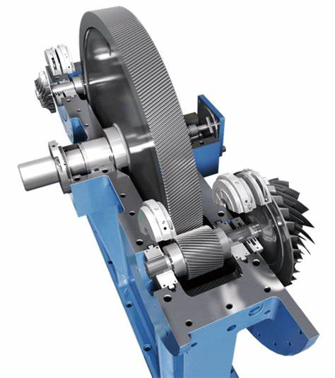
The Elliott receives high pressure steam from boiler 9 /10. The high-pressure steam drives the turbine, which drives the shaft, which drives the compressor. The compressor sucks air in from the atmosphere and compresses it (3 stages of compression). The compressed air is then distributed around the site (for valve actuators, pulse jet etc.). During this process, the steam loses pressure and will be reduced from around 15 bar to around 3 to 3.5bar, which is then distributed around the plant (for jet cookers, MVR’s, distillery, wet mill etc.). There are also back up compressors to service the plants compressed air requirements when the Elliott is not running.
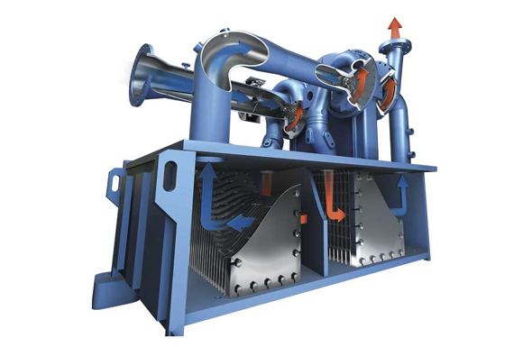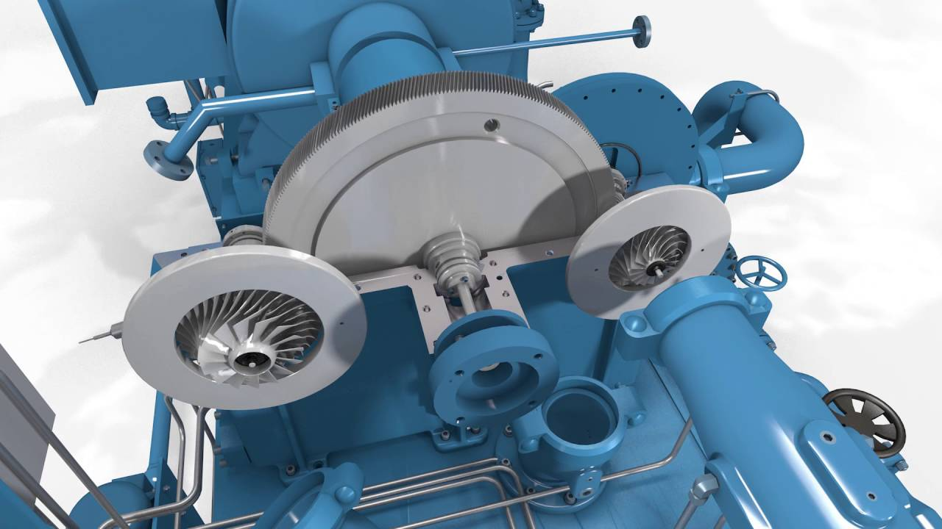
COOLING TOWERS
- PRINCIPLE
A cooling tower is a specialized heat exchanger in which air and water are brought into direct contact with each other in order to reduce the water's temperature. As this occurs, a small volume of water is evaporated, reducing the temperature of the water being circulated through the tower.

- PROCESS
Water, which has been heated (35°C) by the process (heat exchangers), is pumped to the cooling tower through pipes. The water sprays through nozzles onto banks of material called "fill", which slows the flow of water through the cooling tower, and exposes as much water surface area as possible for maximum air-water contact. As the water flows through the cooling tower, it is exposed to air, which is being pulled through the tower by the electric motor-driven fan.
When the water and air meet, a small amount of water is evaporated, creating a cooling action. The cooled water is then pumped back to the condenser or process equipment where it absorbs heat. It will then be pumped back to the cooling tower to be cooled once again. The speed of the fan is controlled by a variable speed drive that looks at the temperature’s set point of the cooled water (26°C).
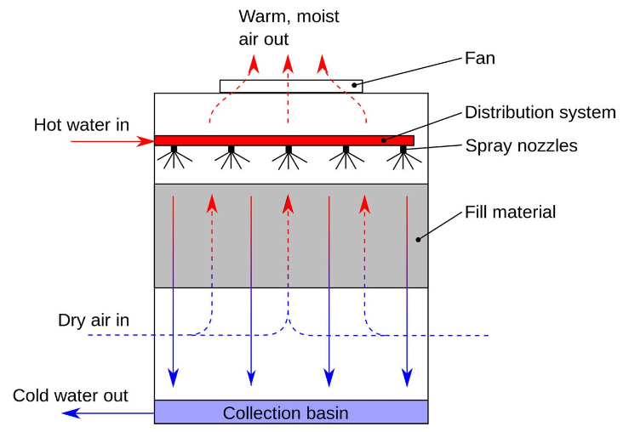
Due to evaporation, the water level in the collection basin drops. For this reason, osmotic water 1st pass is continuously supplied to maintain the level near the set point.
Based on the water conductivity in the collection basin, a purge valve opens and drains water out. Also in this case the water level in the basin drops and it is therefore topped up with osmotic water 1st pass.
In line with AcoP L8, a hypochlorite dosing system is in place to control legionella bacteria in the water systems and free chlorine concentration is checked twice a day.

MVR HEAT RECOVERY LOOP
The heat recovery plant is a closed loop in which the osmotic water flows and exchange thermal energy with various heat exchangers:
- MVR 4610 50HE1: in this heat exchanger the water (75°C) cools non-condensable gases down extracted from the MVR H.E. and directed to the vacuum pumps. The non-condensable gases transfer heat to the water which increases its temperature (85°C);
- UNIGLAD AND OFFICES: after the MVR heat exchanger, a small part of hot water is diverted to a plate heat exchanger for providing heat to the Uniglad water loop (used for warming up glucose). Afterwards the water heads to the offices heat exchanger, loses heat (50°C) and returns to the heat recovery pumps;
- GLUTEN DRYER 4310 30HE1 and STARCH DRYER 4230 90HE4: the hot water flow from 4610 50HE1 splits into two and transfers heat to the air flow in the starch dryer and gluten dryer batteries. This exchange increases the air flow temperature and reduces the water temperature (25-30°C);
- DISTILLERY 4530 50HE2: after losing its temperature, the water from starch dryer and gluten dryer heads to the distillery heat exchanger 50HE2 with the purpose of condensing the alcoholic vapours from the column 50, therefore the water gains heat again from the vapours (50°C);
- STARCH COOLING 4505 20HE2-30HE2: the water from the distillery cools the cooked starch down through a plate heat exchanger and takes heat from it (75°C);
- YEAST PROPAGATION 4510 120HE1-120HE2: the hot water from starch cooling transfers heat to the well water used for making the yeast propagator. When there’s no need for that, the hot water flows through a bypass line (to avoid the heat exchanger scaling up) and returns to the heat recovery pumps;

All the temperatures above are purely indicative, the water temperature can significantly change for many reasons, the most common are:

- MVR is on its weekly wash → non-condensable gases aren’t produced;
- Starch dryer or/and gluten dryer are off →water temperature higher than column 50 vapours.
- The opening of the distillery bypass 4530 50VR6;
- The performance of the starch cooling heat exchangers;
- The starch flow from starch cooking through the heat exchanger;
- The loss of flow within the water loop.

SCRUBBER
- PRINCIPLE
A scrubber is a waste gas treatment installation in which a gas stream is brought into intensive contact with a liquid, with the aim of allowing certain gaseous components to pass from the gas to the liquid. During scrubbing there is a transfer of components from the gas phase to the liquid phase. The level of gaseous components that can pass to the liquid phase is determined by the ability of these components to dissolve in the liquid.

- PROCESS
Sedamyl’s scrubber consists of 2 scrubber columns (this is because removal efficiency of pollutants is improved by increasing residence time in the scrubber), a collection tank and a fan.
- Collection tank (90TK1): its purpose is to collect CO2 from the fermenters and the distillery vacuum pumps; it also collects possible starch spillages from the fermenters or yeast propagator tanks. A piston pump under the tank, automatically managed by level probes, sends any spillages back to fermenter 30/40/50TK1.The CO2 comes out from the top of the tank and is pulled to the first scrubber column.
- The first scrubber column is very similar to a distillation column, made of trays with a weir that holds a layer of liquid (water) descending from the tray above. The level of liquid exceeds the weir and descends to the plate below. The CO2 enters inside the column through the bottom and raises up to the top. At this stage the CO2 flow makes contact the water flow through bubble caps, loses its contaminant products, is cleaned and goes to the second scrubber column for further treatment. The water flow falls down to the bottom of the column and it is sent to the fermenter 30/40/50TK1 or propagator 60/70TK1 by the pump 90P2. It is sent back to the fermentation because it bonds with alcoholic vapours dragged into the column, therefore the water has some alcohol content which is recovered in the fermentation. A control valve after this pump manages the water level at the bottom of the column, which has to be set below the CO2 inlet pipe so as not to cause obstruction to the incoming gas.
- The second scrubber column is a packed column filled with packing material. The purpose of the packing column is to improve the contact between the ascending gas (from the first column) and the descending water (from the top of the packed column). The CO2 from the first scrubber column raises to the top of the second column and gets rid of volatile organic compounds which bond to the water. The water falls down to the bottom of the column and it is sent to the WWTP tank 30TK1 (the water from this column is not sent to the fermentation as all of the alcohol is recovered in the first scrubber column).
- The fan draws the CO2 (free of VOC) from the second column into the atmosphere. The fan is responsible for making the vacuum in the whole scrubber system.
According to the environmental permit, it is required to carry out a periodical emission monitoring survey in order to control the volatile organic compounds (VOC) released to the atmosphere. The VOC emission control is important for limiting the odorous nuisance.

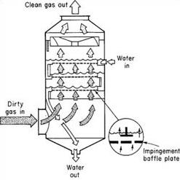
1st column

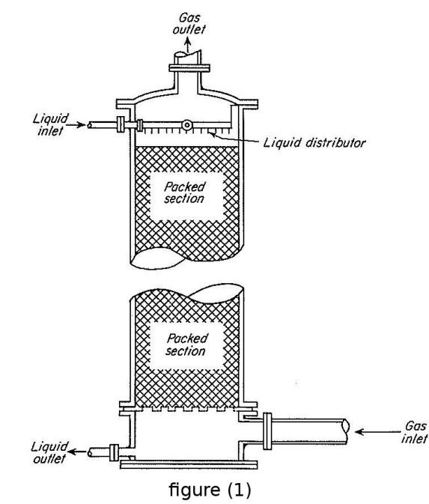
2nd column

WATER TREATMENT
- OZONE TREATMENT
- PRINCIPLE
Ozone is an unstable gas comprising of three oxygen atoms. Ozone oxides the iron, manganese, and sulphur in the water to form insoluble metal oxides or elemental sulphur. These insoluble particles are then removed by post-filtration.
The formation of oxygen into ozone occurs with the use of energy. This process is carried out by an electric discharge field as in the CD-type ozone generators (corona discharge simulation of the lightning). Ozone generators produce ozone by breaking apart oxygen (O₂) molecules into single atoms, which then attach to other oxygen molecules in the air to form ozone (O₃).

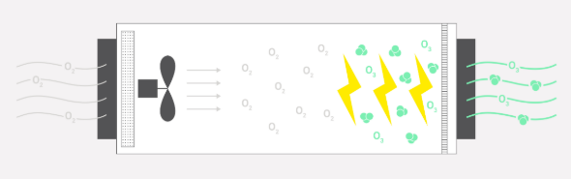

- PROCESS
From the generator, ozone is injected into 15TK1 and 16TK1 through a distribution pipe with nozzles at the bottom of each tank. Although ozone molecules are unstable in water (decaying to ordinary oxygen molecules), ozone is thermally and catalytically destroyed (reduced to oxygen), inside the ozone destroyer.
The water to be treated comes from the boreholes, feeds the tanks 15TK1 and 16TK1 where it gets treated by the ozone. The pumps 16P1/2 control the water level of the tank 16TK1 and send the treated water to the sand filters 16SF1/2 to remove any insoluble metals, which are sent to the tank 18TK1 through daily back flushes and disposed when is needed.
The water flow heads to the well water tank 20TK2 for further treatment (reverse osmosis).

- REVERSE OSMOSIS
- PRINCIPLE
Water treatment process improves the quality of water by removing contaminants and undesirable components, or reducing their concentration, therefore reducing the water conductivity. Conductivity is a measure of water's capability to pass electrical flow. This ability is directly related to the concentration of ions in the water. These conductive ions come from dissolved salts and inorganic materials such as alkalis, chlorides, sulphides and carbonate compounds. In reverse osmosis, an applied pressure is used to overcome the osmotic pressure. In the normal osmosis process, the solvent naturally moves from an area of low solute concentration (high water potential), through a membrane, to an area of high solute concentration (low water potential). The driving force for the movement of the solvent is the reduction in the free energy of the system when the difference in solvent concentration on either side of a membrane is reduced, generating osmotic pressure due to the solvent moving into the more concentrated solution. Applying an external pressure to reverse the natural flow of pure solvent, thus, is reverse osmosis.
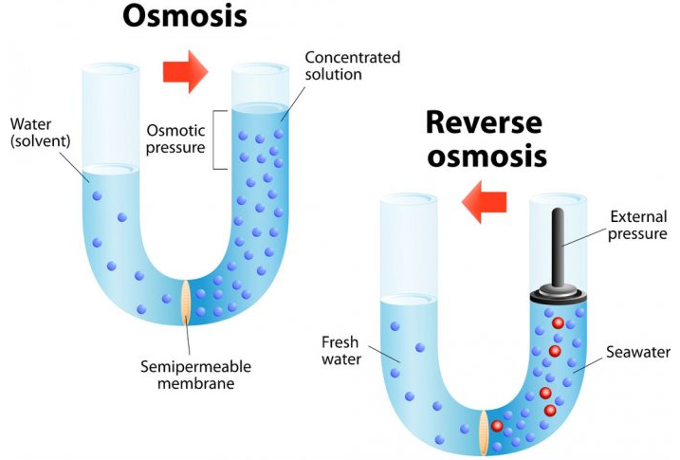
- PROCESS
The first pass reverse osmosis 10/20RO1 is fed by the pump 20P3. The water flow is split in two and feeds 10RO1 and 20RO1. As there is need to overcome the osmotic pressure, a vertical multistage pump (10P1/20P1) increases the water pressure to 12 bar before entering in each RO stream. The first pass reverse osmosis reduces the conductivity of the well water tank 20TK2 (2000 µS), producing permeate water (osmotic water 50 µS) headed to the osmotic water tank 30TK1 and retentate water headed to the drain (river). Other than to the 10/20RO1, the well water is also sent directly to the plant through the pump 20P1.
The second pass reverse osmosis 30RO1 is fed by the pump 30P2. A vertical multistage pump increases the osmotic water pressure to 15bar before entering in the RO stream. The second pass reverse osmosis reduces the conductivity of the osmotic water tank 30TK1 (50 µS), producing permeate water (demineralised water 5 µS) headed to the demineralised water tank 40TK1 and permeate water headed to the cooling towers’ basin. Other than 30RO1, the osmotic water is also sent directly to the plant by the same pump that feeds 30RO1 (30P2), primarily to the cooling tower basin as automatic level control.
The demineralised water tank supplies water to the hot well (40P3), MVR, distillery and boiler house (40P4/5).
Each water treatment pump has a spare one, tested monthly.
There is also a spare reverse osmosis unit (40RO1) that can be used as first pass RO or second pass RO.

GAS TURBINES AND BOILERS
- PRINCIPLE
A gas turbine engine is a type of internal combustion engine. Essentially, the engine can be viewed as an energy conversion device that converts energy stored in the fuel to useful mechanical energy in the form of rotational power. The term “gas” refers to the ambient air that is taken into the engine and used as the working medium in the energy conversion process.
This air is first drawn into the engine where it is compressed, mixed with fuel and ignited. The resulting hot gas expands at a high velocity through a series of air foil-shaped blades transferring energy created from combustion to turn an output shaft. The residual thermal energy in the hot exhaust gas can be harnessed for a variety of industrial processes.
Basic Gas Turbine Components:
Compressor - Takes in outside air and compresses it.
Combustor - Fuel is added to the pressurized air and is ignited.
Turbine - Converts the energy from high velocity gas into rotational power through expansion.
Output Shaft and Gearbox - Delivers rotational power to the driven equipment.
Exhaust - Directs the low emission spent gas out of the turbine section.

- PROCESS
Sedamyl has two gas turbines, both fed by high pressure natural gas and high-pressure air. The natural gas is supplied to the site at 7 bars. The main gas line splits in two and feeds two gas skid. One of them feeds the burners of the boilers and its composed of a pressure reducer to reduce the gas pressure to 0.7 bars (required pressure for gas burners of boilers 7,9,10) and a gas counter after the pressure reducer.
The other gas skid is composed of a gas counter only, without pressure reducer as it feeds the screw gas compressors (GC2 and GC3) where the natural gas pressure is increased further up to 25 bar (required fuel pressure for the gas turbines).
Gas compressor 2 (GC2) increases the fuel pressure for the gas turbine 2 (GT2), gas compressor 3 (GC3) increases the fuel pressure for the gas turbine 3 (GT3).

Excess power to grid

Y
G
Electricity to building
air
compressor
turbine
Gear box
shaft
͠
6000 V
11000 V
combustor
Exhaust
Steam
air
Exh.Bypass
Gas 25 Bars
Exhaust
To other gas turbine
fan

boiler
Gas compressor
Gas compressor
Fuel (natural gas 7 Bars)
Gas burners

Gas skid

Gas skid
Natural gas at 0.7 Bars

The pressurised natural gas is added to the pressurised air and is ignited. The high velocity gas resulting from this combustion delivers rotational power to the turbine and the driven current generator connected to the output shaft. Each gas turbine can generate a maximum power of 7.5MW. Depending on the plant power absorption, the excess electric power produced is exported to the grid. However, if the gas turbine produces less power than the power absorbed by the plant, the electrical power needed will be imported from the grid.
Load shedding: the maximum electric power the plant can absorb from the grid is 7.1 MW. In the event that the power absorbed by the plant is greater than the power permitted by the grid (loss of the gas turbine), some loads must be cut off. Since the maximum current allowed by the grid is 420 A, the load shedding program establishes the maximum current above which loads will be cut off (maximum set current: 365 A). It also provides the estimated current the plant would absorb without the gas turbine running. Therefore, if the estimated current is lower than the maximum set current, no loads will be cut off and the plant will run as per normal. If the estimated current is greater than the maximum set current, loads will be cut off based on the following priority:
- Stillage MVR
- Starch MVR
- Dry Mill
- Wet Mill
Island mode: in the event of an external power failure the circuit between the plant and the grid will be interrupted and the gas turbine will supply the power the plant needs without exporting to the grid. However, in the event of loss of the gas turbine while in island mode, no power will be supplied to the plant causing a plant shut down. It is therefore good practice to reconnect the plant to the grid after the external power failure has been fixed.
The thermal energy of the residual hot exhaust gases out of the turbine section heads to the boilers (boiler 9 harness GT2 exhaust, boiler 10 harness GT3 exhaust). Boiler 9 and 10 are single pass fire-tube boilers in which hot gases pass through many tubes running through a sealed container of water. The heat of gases is transferred through the walls of the tubes by thermal conduction, heating the water and ultimately creating steam. When starting or stopping the gas turbine, exhaust gases are diverted to the exhaust bypass chimney. In this situation the steam production won’t be interrupted as hot gases can still be produced and sent in the boiler tubes by the combustion between fuel from gas burners and air drawn in through a fan (fresh air mode). Once the turbine is up to speed the hot exhaust gases must be diverted to the boiler

Exhaust

Heat recover CHP
Heat recover CHP
Feedwater
Steam
air
Exh.Bypass
fan
Exhaust
Exhaust

Gas burner

As the spent gasses’ temperature out of the boiler tubes is over 200 °C, the exhaust gases thermal energy is recovered inside two coil heat exchangers. The first one (economizer) transfers the exhaust gases heat to the water feeding the boiler. The second one transfers the exhaust gases heat to the CHP heat recovery. The steam present in the combustion gases combines with compounds from other combustions and when it’s condensed it forms mixtures of water, carbonic acid, nitric and in some cases even sulfuric. Such acids are particularly aggressive towards metals. This is why it is important to not remove too much heat from the exhaust gases leaving the boiler stack. The stack temperature must never drop below 58 °C
The boiler feed water system is mainly composed by two parts: hot well tank and deaerator tank. The hot well is a reservoir that collects the condensate formed after the steam performed its work. It is fed by the condensate line from the low-pressure steam, the condensate line from the high-pressure steam and demineralised water line that controls the hot well tank level through a control valve. From the hot well, two independent lines feed the deaerators 20D1 and 30D1. In our application the deaerator is used to remove dissolved gases in feedwater for steam-generating boilers 9 and 10. Dissolved oxygen in feedwater will cause serious corrosion damage in the boilers by attaching to the walls of metal piping and other equipment and forming oxides (like rust). Dissolved carbon dioxide combines with water to form carbonic acid that may cause further corrosion. Deaerators relies on the principle that the solubility of a gas in water decreases as the water temperature increases and approaches its boiling point. Deaeration is done by spraying feedwater into a chamber to increase its surface area, and may involve flow over multiple layers of trays. This scrubbing (or stripping) steam is fed to the bottom of the deaeration section of the deaerator. When steam contacts the feedwater, it heats it up to its boiling point and dissolved gases are released from the feedwater and vented from the deaerator through the vent. The treated water falls into a storage tank below the deaerator.
The feedwater from the hot well, passes through a plate heat exchanger where is heated up by the output water from the deaerator. The level of the deaerator is controlled by a control valve on the feedwater line, the pressure of the deaerator is controlled by a control valve on the steam line. The output water from the deaerator heats up the feedwater through a plate heat exchanger and it is pumped to the boilers. A control valve after the boiler feed pump, controls the water level inside the boiler.
The steam generated by the boilers feed the plant and the deaerators. A control valve release steam to the atmosphere if the steam pressure is greater than 19 bar.
CHP HEAT RECOVERY LOOP
The CHP heat recovery plant is a closed loop in which the osmotic water flows and exchange thermal energy with various heat exchangers:
- BOILER 9 STACK 4733 HAC11: the pumps 4733 10P1/2 send the water (55°C) into the coil heat exchanger on the boiler 9 stack, where the exhaust gases out of the boiler transfer heat to the water of the CHP heat recovery (75°C).
- BOILER 10 STACK 4734 HAC11: the relaunching pump 4733 10P3 sends the water (75°C) out of the boiler 9 stack heat exchanger to the coil heat exchanger on the boiler 10 stack, where the exhaust gases out of the boiler transfer heat to the water of the CHP heat recovery (85°C).
- GLUTEN DRYER 4310 30THE2 and STARCH DRYER 4230 90HE3: the hot water flow (85°C) from 4734 HAC11 splits into two and transfers heat to the air flow in the starch dryer and gluten dryer batteries. This exchange increases the air flow temperature and reduces the water temperature (60°C);
- WET MILL 4210 150HE4 & 150HE5: after losing its temperature, the water flow from the gluten dryer, heads to the wet mill heat exchangers 150HE4/5 with the purpose of warming up the water in the wet mill roof tank. The water comes out the heat exchangers, joins the water out of the starch dryer battery and returns to the pumps 4733 10P1/2.

6.0 Quality Records:
Records to be kept for a minimum of 5 years.

