**J A Fry Ltd Manor Farm**

**N**

**Cranswick DRIFFIELD East Yorkshire**

**Farm plan including drainage**

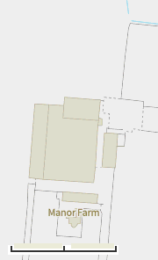

DW2

DW1 

Borehole

**B**

Deadstock store

**D**

Generator (tractor run)

Operator residence

|  |  |  |  |  |  |
| --- | --- | --- | --- | --- | --- |
| Building | Places | Building | Places | Building | Places |
| 1 | 935 | 4 | 1200 | 7 | 500 |
| 2 | 1840 | 5 | 1500 | 8 | 500 |
| 3 | 1200 | 6 | 1500 | 9 | 500 |
| Casualty | 125 |  |  | **TOTAL** | **9800** |

Key

Clean water

Wash water/effluent

Installation Boundary

Clean water discharge

Sediment traps

Casualty pens

2

3

4

9

8

7

6

5

S

S

D2

D1

Fuel store

1

Feed Bins

m

Manure store

Dirty Water Tank

0

110

55