Noise Management Plan

Farm name: Moorside Farm
Operator PA & S Copeland
Permit number: EPR/New
Date: April 2023
Prepared by: L Bentley

Introduction
This bespoke Noise Management Plan (NMP) has been prepared to support the overall Environmental Management System in place at Moorside Farm. The overriding principle of this NMP is to ensure the day-to-day activities are carried out in accordance with this document to help minimise the overall environmental impact. There is one sensitive receptor within 100m distance from the installation boundary, with one other residential receptor within 400m. Both houses are owned and resided in by the operators and their families.
There have been no previous noise complaints related to Moorside Farm.

Setting
The surrounding area is mainly large arable fields, field boundary hedgerows and pockets of woodland. The landscape is flat to gently undulating. Catfoss industrial estate is within 600m distance at the nearest point, to the South East of the installation. The nearest village, Brandesburton, is just within 2km at its nearest point.
Please refer to Appendix 4 for the site plans.
Figure 1 shows the location of the installation and of the receptors within 400m which have been considered in this noise management plan.

Figure 1: Sensitive receptors
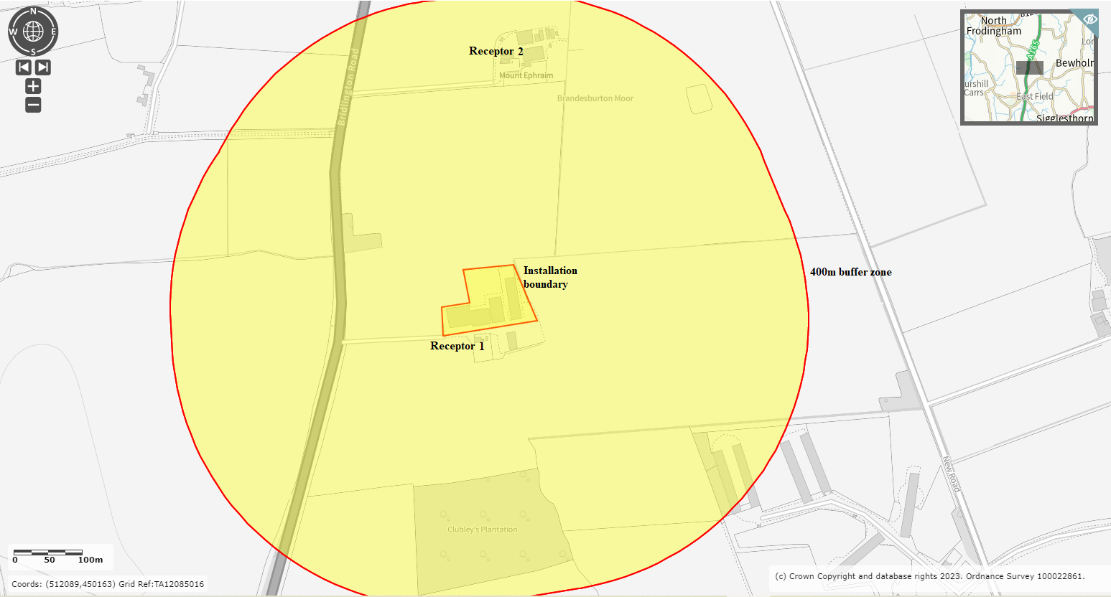

Table 1: Locations of Sensitive Receptors
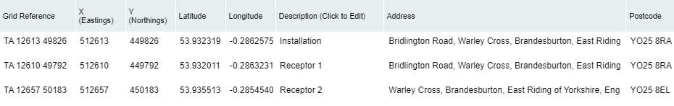
UK Grid Reference Finder

Table 2: Distances from installation boundary to nearest points of domestic curtilage
Receptor | Description | Distance (m)
1 | Moorside Farm (farmhouse residence) | 0
2 | Mount Ephraim Farm (farmhouse residence) | 262

The purpose of this Noise Management Plan is to:
- Establish the likely source of noises arising from the farm
- Set out procedures at the farm in order to mitigate or minimise the risk of noise
- Formalise an effective method of dealing with any noise complaints quickly and efficiently.

This plan will be reviewed in the light of any building and management changes, and on the outcome of investigations into the cause of any future noise complaints, if any occur.

Any noise complaints will be recorded and investigated using the Noise Complaint Report Form contained within Technical Guidance Note IPPC SRG 6.02 (Farming) Noise Management at Intensive Livestock Installations.

No. ref | Noise Problem | Actions taken to prevent or minimise noise | Completion Date
1 | Feeding Pigs | Ad-lib system, so no spikes in noise and pig activity due to feeding times. | In place.
2 | Feed delivery | Blower and vacuum type delivery vehicles fitted with low noise units. | In place
3 | Feed preparation | No milling and mixing operations carried out on site. All bought-in feed. | In place
4 | Pig moving | Pigs only moved during the day and maintained in stable batches | In place
5 | Pig loading, in and out | Few movements as possible. Short duration. Aim to minimise animal stress. All-in-all-out batch system means that loading in and out is not on a continuous basis through the year. | In place
6 | Bedding pens | Loader used for transport, engine revs kept low, effective silencer. Mainly during working day, limited at weekends/bank holidays. | In place
7 | Mucking out | Loader used for scraping and transport, engine revs kept low. Mainly during working day, limited at weekends/bank holidays. | In place
8 | Slurry/Dirty water tanker filling and emptying | Dirty water stores located at furthest points from nearest receptors. Tanker filling only when necessary and appropriate. All equipment regularly serviced and operated to current standards and optimum efficiency. | In place
9 | Manure loading/transport and spreading | High output equipment reduces working hours. Engine revs kept low where possible. All equipment regularly serviced and operated to current standards. | In place
11 | Delivery of supplies and materials | Typically small deliveries during normal working hours by arrangement. Low perceived impact. | In place
12 | Ventilation | No fans. All natural ventilation. | N/A
13 | Vehicles operating within installation boundary | Operations mainly carried out during normal working hours. Vehicles maintained in accordance with manufacturer's recommendations, and defective silencers replaced. Audible reversing signals required for safety purposes.  Yards maintained to repair holes. | In place
14 | Alarms | No audible alarms. | In place
Last reviewed April 2023

Summary
Noise levels are assessed daily by operators or their staff. One operator lives on site.

We have always worked hard to minimise our impact on our closest receptors and as a result have not had any complaints about noise in relation to Moorside Farm. We continually assess management techniques to improve our control of noise pollution.

This plan will be reviewed in the light of any building and management changes, and on the outcome of investigations into the causes of any future complaints, if any occur.

Any noise complaints will be reported to the operators who will log and investigate causes of all complaints; identifying the source of the noise issue and monitoring noise levels at the site boundary as part of the investigation. The complaint details and subsequent investigation will be recorded on the site complaint form and a copy will be kept in the site office.

This document has been prepared by the applicant using the AHDB template. While the Agriculture and Horticulture Development Board, seeks to ensure that the information contained within this document is accurate at the time of printing, no warranty is given in respect thereof and, to the maximum extent permitted by law, the Agriculture and Horticulture Development Board accepts no liability for loss, damage or injury howsoever caused (including that caused by negligence) or suffered directly or indirectly in relation to information and opinions contained in or omitted from this document.

Appendix 1
