Bioaerosols and Dust Management Plan
Farm name: Moorside Farm Operator PA & S Copeland Permit number: EPR/New
Date: April 2023 Prepared by: L Bentley

This bespoke Bioaerosols and Dust Management Plan has been prepared to support the overall Environmental Management System in place at Moorside Farm. The overriding principle of this plan is to ensure the day-to-day activities are carried out in accordance with this document to help minimise the overall environmental impact. There is one sensitive receptor within 100m distance from the installation boundary, with one other residential receptor within 400m. Both houses are owned and resided in by the operators and their families.
There have been no previous issues relating to odour, dust, noise or flies in relation to the farm.
Setting
The surrounding area is mainly large arable fields, field boundary hedgerows and pockets of woodland. The landscape is flat to gently undulating. Catfoss industrial estate is within 600m distance at the nearest point, to the South East of the installation. The nearest village, Brandesburton, is just within 2km at its nearest point.
Please refer to Appendix 4 for the site plans.
Figure 1 shows the location of the installation and of the receptors within 400m which have been considered in this bioaerosols and dust management plan.

Figure 1: Sensitive receptors
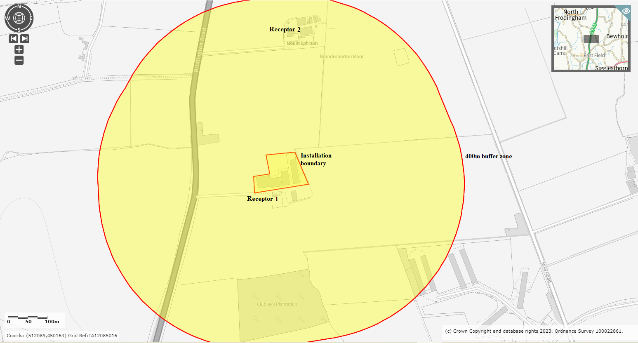
Table 1: Locations of Sensitive Receptors (all adjacent to Installation Boundary at nearest point of domestic curtilage)
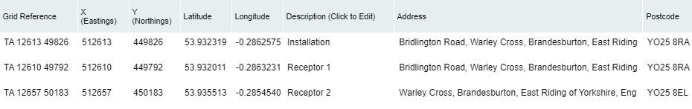
UK Grid Reference Finder
Table 2: Distances from installation boundary to nearest points of domestic curtilage
Receptor | Description | Distance (m)
1 | Moorside Farm (farmhouse residence) | 0
2 | Mount Ephraim Farm (farmhouse residence) | 262

The purpose of this Management Plan is to:
- Establish the likely sources of Bioaerosols and Dust arising from the farm
- Set out procedures at the farm in order to mitigate or minimise the risk of Bioaerosols and Dust emissions
- Formalise an effective method of dealing with any complaints quickly and efficiently.

Potential Bioaerosols and Dust sources
In accordance with Section 3 of H4 guidance, a risk assessment of pollution was performed (Appendix 5).
As a result, the following sources have been identified as contributing to a potential medium risk Bioaerosols and Dust emissions:

- Bioaerosols and Dust emissions from feed selection
- Bioaerosols emissions from muck store and dirty water storage (dirty water tanks enclosed and underground.)
- Bioaerosols and Dust emissions from yard areas
- Bioaerosols and Dust emissions from housing
- Bioaerosols emissions from drinking water systems
- Bioaerosols and Dust emissions from natural ventilation
- Bioaerosols and Dust emissions from cleanout
- Bioaerosols and Dust emissions from carcase storage and disposal
- Bioaerosols and Dust emissions from feed storage (delivered in; no mill or mix on site)
- Bioaerosols and Dust emissions from manure and dirty water spreading (Around 75% of muck is exported to a neighbour (3rd party) and the remaining 25% is applied to land owned and managed by the operators)
- Dust emissions from dust build up

Pathways and receptors
The pathway for all of the above sources is via the atmosphere. The wind direction will significantly influence how receptors are affected. We have not received any complaints from neighbours relating to Bioaerosols or Dust from the farm.

Odour related issues | Actions taken to minimise odour | Completion date
Effects of diet on Bioaerosols and Dust and ammonia emissions (feed selection) | - Feed composition is closely matched to pigs’ requirements, especially protein  - Diets are ad-lib dry pelleted feed with minimal falls into troughs to reduce dust emissions  - Diets are continually reviewed with a professional nutritionist to ensure good performance  - Records of crude protein levels and diet formulation are kept in the site office.  - Feed is only supplied by a UFAS accredited feed mill, so that only approved raw materials are utilised in production. | On-going
Manure storage | - Manure is scraped from passages frequently (where applicable) to ensure that the pens remain dry and clean. Wet areas are routinely removed as needed.  - Gradient of the passages prevents ponding of dirty water, draining to the wash water tanks  - Midden for manure storage is adjacent to the pig buildings, minimising distance to move manure from buildings to storage and reducing area of contaminated concrete, and is located on the opposite side of the farm buildings to the nearest sensitive receptor. This store is currently not roofed. All effluent is captured to the below ground, covered, store.  - Increased potential for fugitive emissions are expected when out-loading the manure store. Timing is planned to avoid weekends and bank holidays wherever cropping, weather and soil conditions allow this flexibility. And wind direction is monitored and taken into consideration also. Removal is as efficient as possible to ensure increased bioaerosol production is as short-lived as it can be.  - Wash water and lightly contaminated water is captured directly into the wash water stores. Effluent production from buildings is minimal due to the muck being removed so frequently, and through sufficient use of straw to help retain nutrients and liquids.  - The dirty water stores are covered. | On-going
Slurry/Dirty water storage | - Dirty water stores sited as far as possible from nearest receptors. Underground, enclosed tanks, compliant with SSAFO regulations.  - Unnecessary running of pumps avoided.  - Increased bioaerosols emissions to be expected when store out-loaded, so observe wind direction if cropping/soil constraints allow.  - Water is prevented from stagnating in the dirty water tank and pipes through frequent removal, and flushing where necessary. Dirty water is removed from site using vacuum tankers on a routine basis, with all removals documented.  - Vehicle washing will take place on concrete floor/pads where the water drains directly to the dirty water tanks. | On-going
Cleanliness of yard areas | - Yard surfaces are properly maintained. Areas around the houses are kept clean at all times.  - The drainage system works effectively to prevent ponding of dirty water, which may otherwise release bioaerosols.  - Yard areas and open surfaces are designed to ensure effective separation of uncontaminated surface water and dirty water through impermeable surfacing, where appropriate, and the curbing and gradients thereof. Clean yard areas, at significantly low risk of contamination, are surfaced with hardcore and are free-draining, whereas potentially contaminated yard areas (e.g. around feed bins and entrances to buildings) are impermeable and designed to protect clean water drainage through ability to shut-off surface drainage points in case of contamination (e.g. until feed/muck spill was cleaned up completely.  - The direct removal of muck from buildings to trailer minimises the area of contaminated concrete, with no muck scraped across outside areas.  - All feed systems are fully enclosed and automated, and feed blown in through sealed pipe, thus reducing risk of spillage when filling or emptying.  - Foot baths are covered (preventing rainwater ingress and overflow) and are located on concrete areas which drain ultimately to the dirty water store.  - Roofs are kept clear of dust build-up, reducing risk of contamination of roof water to clean water drainage. | On-going as part of the inspection and maintenance programme
All housing and management | - New builds and refurbishments are all in line with BAT requirements  - All pens and stock are checked for cleanliness as part of daily welfare checks  - All pens and buildings are cleaned out in accordance with written cleaning plan  - Potentially dusty or odorous spillages (feed ingredients, manure, etc.) are cleaned up promptly  - Stocking density maintained at or below levels set out in Defra Welfare Regulations  - Ventilation corresponds to animals’ requirements to optimise the housed environment for the pigs and air quality conditions. Air quality is checked as part of minimum twice daily checks on stock.  - Build-up of waste feed in front of feeders is prevented and waste feed is removed from pens  - Feeders and drinkers have been designed to prevent wastage and leaks  - Pen and wall surfaces are constructed from non-porous smooth surfaces  - Troughs and feeders are constructed and arranged to minimise feed waste and prevent pigs from climbing in or wallowing. | On-going
Emissions from housing (all straw based) | - Pens well bedded with clean, dry bedding to ensure clean animals and to bind ammonia  - All scraped areas within buildings are maintained and managed to prevent ponding  - Bedding material is stored under cover to ensure it is kept clean and dry to prevent wastage and deterioration. | On-going
Cleaning out | - Cleaning out occurs as soon as possible after destock to allow maximum time for the building to dry before restocking.  - FYM is removed efficiently to minimise the period of time where bioaerosols/dust emissions are likely to be elevated, with due consideration given to neighbours and wind direction wherever possible.  - Only Defra approved disinfectants and detergents are used on site and are applied by trained personnel, in accordance with the manufacturer’s guidance. | On-going
Animal carcases | - Pig carcases are kept in covered storage and disposed of promptly by licenced deadstock collector  - Storage container is sealed preventing leaks  - No incinerator.  - Carcasses are to be removed from site as part of a regular schedule. Additional ad hoc removals can be arranged in the case of increased mortality and/or necessity to cull larger numbers on farm. If for any reason the regular deadstock collector for the site was not able to attend the site within the required timeframe (i.e. storage capacity was in danger of being overtaken and/or unacceptable odour increases were likely) then a number of back-up collectors are available. | On-going
Feed delivery and storage | - Dry feeds are stored in silos. No liquid feed storage.  - Dry pelleted feed is distributed to feed bins via a blower wagon (enclosed system), minimising the opportunity for dust/bioaerosol release  - The feed storage is checked by the site manager in accordance with the site’s maintenance schedule. Any leaks are repaired quickly and any spillage cleaned up  - All spillages are cleaned up and disposed of promptly | On-going
Spreading dirty water and manure | - Around 75% of muck is exported and the other 25% is applied to land owned and managed by the operators and in compliance with a manure and nutrient management plan and all relevant legislation and codes of good practice. | On-going
Ventilation techniques | - No mechanical ventilation.  - Yorkshire boarding, curtains (if applicable) and roofs maintained in good condition and free of dust build up. | On-going
Dust | - All dry feed ingredients are stored in covered bins and fed via contained delivery system to feeders  - Fed pelleted diet, minimising dust.  - Feed system enclosed through to troughs in pens.  - Free fall of pellets in to the internal feeders in the pens is at a small drop height to reduce the plume effect of dust.  - Open surface of troughs/feeders kept to a minimum consistent with purpose in order to minimise exposed feed surface.  - Waste feed removed and not allowed to accumulate.  - Bedding types and quality chosen to minimise dust creation. | On-going
Dealing with complaints | - Any bioaerosol/dust complaints will be reported to the operator who will log and investigate causes of all complaints; identifying the source of the issue and monitoring emission levels at the site boundary as part of the investigation.  - The complaint details and subsequent investigation will be recorded on the site general complaint form and a copy will be kept in the site office.  - The complaints procedure will follow the requirements set out in the Environment Agency’s H4 Odour management guidance:  - “Investigate any complaints promptly and take appropriate remedial action.  - You should tell the complainant and anyone else likely to have been affected by what you have done.  - You should record the details of the complaint and the actions you have taken. An example of complaint recording is given in Appendix 1.  - If you need to substantiate the [emission/nuisance], a record form and advice for sniff testing are also given [in Appendix 1 of the H4 Odour management guidance]. However, if you and your staff have become accustomed to the [emission/nuisance] through exposure the results may be unreliable. (see adaptation in Appendix 2 [of the H4 Odour management guidance])”.  - In this case, ensure that the person monitoring [emissions] is not associated with the day-to-day running of the farm and is therefore not immune to the [emissions].  When investigating a complaint you should work through the following questions:  - 1) Is the process under control?  - 2) Have containment measures failed?  - 3) Have treatment/mitigation measures failed?  - 4) Have dispersion methods failed?  - 5) If the emissions are associated with hazards, such as treatment of hazardous materials, is there any possibility of health risk to the local community?  - We will keep auditable records of any investigations we carry out. These records will be invaluable to us in analysing incidents and stopping them from happening again, as well as being a requirement of this management plan and to meet permit conditions. | On-going
Bioaerosols and Dust monitoring | - The permit holders include one operator who lives on site, and the operators or their delegates manage the pigs day to day, so they are able and responsible for checking emissions daily; checking for any abnormal levels or potential for increased bioaerosols/dust production. Site tours will be undertaken daily to ensure emissions and risks of emissions are assessed. Where there is potential for abnormal elevated bioaerosols/dust emissions, control measures will be put in place to mitigate the risk.  - The next nearest receptor residence is also owned and occupied by the operators. The road into the farm passes the closest receptors enabling staff/operators to also notice if there is an elevated bioaerosol/dust emission at that point. Staff know to report promptly any such occasions.  - If a problem arises, monitoring will be carried out to establish what needs to be done.  - If we have put a solution in place, we will monitor to confirm that it has resolved the problem.
General comments | - Neighbours will be informed (where necessary) prior to activities which may cause bioaerosols/dust  - Bioaerosols/dust levels will be monitored on site by all staff. The source of abnormal emissions will be identified and appropriate action will be taken to reduce levels back to normal  - The effectiveness of control measures will be reviewed at least once a year or sooner in the event of any complaint or relevant changes to operations.

Contingency Plan

Abnormal Scenario | Remedial Action | Time Limit
Damage to building | Damage would be repaired asap and, depending on nature of damage, area made safe and covered/contained in the meantime to prevent increased odour emissions and/or destocked in the immediate area if necessary. | Depends on severity of damage and whether environment or animals are at risk.  Immediate action required to make safe.  Mitigation measures will continue until the damage is repaired and it is assessed as safe to revert to normal practice. This will be recorded in the inspection and maintenance records.
Dirty water store damage or overflow | Contingency margin in store capacity so overflow risk low.  Lagoon on separate site can take the contents at short notice – involving removal by tanker.  Tank should be repaired immediately and any contaminated water held or collected in the meantime. | If any risk of pollution, immediate action must be taken to remove risk.  Mitigation measures will continue until the damage is repaired/situation remedied and it is assessed as safe to revert to normal practice. This will be recorded in the inspection and maintenance records and/or incident records.
Pipework damage | Immediately stop use of the pipe.  Replace/repair pipe. Immediately install additional containment measures in the meantime if needed (e.g. using straw/sand or bucket brush) | Immediately stop potential for leak.  Replace/repair pipe - Time frame depends on dependency on pipe.  Mitigation measures will continue until the damage is repaired and it is assessed as safe to revert to normal practice. This will be recorded in the inspection and maintenance records and/or incident records.
Livestock illness | Fieldsman and veterinary advice and treatment plan would be referred to and additional measures taken where necessary; i.e. more frequent removal of FYM from pens where e.g. gastrointestinal illness or behaviour problems is leading to increased mucking of the pens. Where pigs need removing from their peers, hospital pens are included within each building – but these are managed exactly the same as the other pens, with dirty areas removed frequently, preventing elevated odour levels. A decision making protocol is also in place regarding acceptable treatment windows and when to make the decision to euthanise. This reduces the risk of animals which aren’t recovering in an acceptable timeframe for high welfare, or aren’t likely to be ultimately fit for transport, being kept on in hospital pens indefinitely.  In the case of a notifiable disease outbreak, the site is designed for accommodating pigs to their full adult size so the feed, water and space requirements are correct for an extended housing period if required. The nature of the muck management system means that pens can be cleaned regularly throughout the batch. We would not expect an increased daily odour output for these reasons. In the instance that it is not possible to remove FYM from the site at all, advice would be sought regarding location for a temporary field heap and a tanker would be deployed to increase the dirty water holding capacity on the site. Advice from the EA and APHA would be sought. | Immediate referral to veterinary/fieldsman advice for prompt treatment and management plans.  Assess the risk for increased odour production, and adjust bedding and mucking out schedules accordingly.  Mitigation measures will continue until the situation is under control and it is assessed as safe to revert to normal practice. This will be recorded in the animal management records and/or incident records as applicable.
Fire | Control the fire as quickly as possible.  If the fire is not immediately possible to extinguish and is spreading, contact fire brigade immediately and remove at-risk animals if safely possible, also remove animals from nearby buildings. Unless there is sufficient, and safe, accommodation available on site at the correct stocking densities - arrange for removal of these animals from the site within 8 hours maximum. There is contingency margin for housing available within the local supply chain, run by the relevant pig group.  All firewater will be draining to the dirty water tank, so this will need frequent emptying and appropriate disposal/removal to other storage tanks/tankers. Contact Environment Agency for advice on disposal.  Follow fire brigade advice regarding creation of fire breaks/protection and removal of flammable materials (e.g. straw bales),  Once the fire is under control and it is safe to do so, remove all burnt material within 24 hours and thoroughly clean and decontaminate the area. | Ring fire brigade immediately  Refer to Emergency Action Plan – Fire section  Ring haulier/pig group (see Emergency Contacts) to arrange for movement of stock, if necessary, within 8 hours maximum.  Mitigation measures will continue until the damage is repaired/situation remedied and it is assessed as safe to revert to normal practice. This will be recorded in the inspection and maintenance records and/or incident records.
Diet problems | In the case of a diet issue (e.g. where feed quality was below standard or feed type was incorrect), we have the capacity to remove and replace feed in the bins.  Diets are continually reviewed by a professional nutritionist and feedback on feed quality and requirements given via the pig group and veterinary practice.  N.B. Diets are only sourced from UFAS accredited mills. | Contact pig group/owner immediately (and vet if applicable).  Mitigation measures will continue until the situation is remedied. This will be recorded in the inspection and maintenance records and/or incident records.
Failure of containment of food | In the case that a feed pipe leaks within the pig buildings, the system should be stopped and leaked feed cleared up promptly. No potential for contamination of clean water system.  In the case that the feed bin leaks or the blow pipe fails and feed is spilled on to an outdoor area, the surface water drainage point should be immediately protected to prevent contamination of clean water systems. Any and all spillages should be cleaned up immediately. For uncontaminated feed fit for animal consumption, it can be transported by teleporter bucket to the feeders in pens or blown into another silo by the feed company vehicle (dependent on biosecurity risk). For any major spillage greater than 500kg that is unfit for animal consumption the spillage will be cleared up in to skips and removed from site for disposal via the appointed waste contractor within 24 hours of the incident. For any spillage less than 500kg, feed would be cleared up using bags and placed in the onsite general waste container for disposal. | Stop the potential for leaks immediately.  Protect clean water inlet immediately by shutting it off or containing the spillage area through use of e.g. straw/sandbags. Protect from rainfall and pests if it is not possible to remove the spilled feed, or feed from a damaged bin, within a few hours. The affected area/feedbin should be free of feed within 24 hours.  Mitigation measures will continue until the damage is repaired/situation remedied and it is assessed as safe to revert to normal practice. This will be recorded in the inspection and maintenance records and/or incident records.
Carcass disposal route failure | In the case of increased mortality or/and culling of large numbers, the deadstock collector must be able to collect all deadstock immediately or within short timescale. Where immediate collection is not possible, all carcases must be stored in sealed, locked containers capable of retaining all effluents and of reducing risk of odours.  In the case of normal contracted deadstock collector being unable to collect the carcases within the required timeframe, there are multiple other collectors used within the wider supply chain which can be called on. | Immediate communication with deadstock collector(s) and/or pig group/owner.  Mitigation measures will continue until the situation is concluded/remedied and it is assessed as safe to revert to normal practice. This will be recorded in the animal management records and/or incident records as appropriate.
Temporary storage and disposal of any wastes arising from incidents | Used sand, straw bales, and other waste materials arising from containing pollutants should be stored on an impermeable surface protected from drainage routes. | Where applicable, the waste contractor (see emergency contacts) should be contacted within 24 hours of an incident and arrangements made for safe disposal.  Mitigation measures will continue until the situation is remedied. This will be recorded in the incident records.

To ensure remedial action has been completed successfully, the operators are responsible for inspecting the situation or equipment/infrastructure and assessing whether it is made safe and can operate in compliance with the permit and other regulatory requirements. Inspection and monitoring schedules may be revised to monitor the specific situation more frequently/closely thereafter, as appropriate.

Summary

Potential for emissions of bioaerosols or dust is assessed daily by operators. Air quality within the buildings is also assessed (sensory assessment). Weather monitoring/forecasting helps the operators to assess the risks and take additional actions to mitigate them if necessary.

We have always worked hard to minimise our impact on our closest receptors and as a result have not had any complaints about emissions from Moorfield Farm. We continually assess management techniques to improve our control of emissions.

This plan will be reviewed at least annually and in the light of any building and management changes, and on the outcome of investigations into the causes of any future complaints, if any occur.

Any complaints will be recorded and investigated using the guidance from EPR 6.09 3.1 and 3.2 odour and emissions management on intensive livestock installations.

This document has been prepared by the applicant using the AHDB template. While the Agriculture and Horticulture Development Board, seeks to ensure that the information contained within this document is accurate at the time of printing, no warranty is given in respect thereof and, to the maximum extent permitted by law, the Agriculture and Horticulture Development Board accepts no liability for loss, damage or injury howsoever caused (including that caused by negligence) or suffered directly or indirectly in relation to information and opinions contained in or omitted from this document.

