National Consultancy, Locally Delivered

ODOUR MANAGEMENT PLAN
BURTON AGNES ANAEROBIC DIGESTION PLANT

REC REFERENCE: AQ100044R3

REPORT PREPARED FOR: BROWN AND CO

DATE: 24TH AUGUST 2015

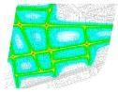

www.recltd.co.u
k

REPORT ISSUE

Issue/revision | Issue 1 | Revision 2 | Revision 3
Remarks | Draft for comment | Draft for comment | -
Date | 13/08/2015 | 19/08/2015 | 24/08/2015
Prepared by | Charlotte Smith | Charlotte Smith | Charlotte Smith
Signature
Position | Air Quality Consultant | Air Quality Consultant | Air Quality Consultant
Checked by | Sarah Naylor | Sarah Naylor | Sarah Naylor
Signature
Position | Principal Air Quality Consultant | Principal Air Quality Consultant | Principal Air Quality Consultant
Verified by | Sarah Naylor | Sarah Naylor | Sarah Naylor
Signature
Position | Principal Air Quality Consultant | Principal Air Quality Consultant | Principal Air Quality Consultant
Project number | AQ100044 | AQ100044 | AQ100044

Osprey House, Pacific Quay, Broadway, Manchester, M50 2UE Tel – 0161 868 1300 Fax – 0161 868 1301 www.recltd.co.uk
TABLE OF CONTENTS
1.0 INTRODUCTION 1
1.1 Background 1
1.2 Site Location and Context 1
1.3 Limitations 2
2.0 PROCESS DESCRIPTION 3
2.1 Management 3
2.2 Operation 3
2.3 Digestate 3
3.0 METHODOLOGY 5
3.1 Overview 5
3.2 Sources 5
3.3 Location 6
3.4 Prevailing Meteorological Conditions 6
3.5 Risk Assessment 7
3.5.1 Receptor 8
3.5.2 Harm 8
3.5.3 Probability of Exposure 8
3.5.4 Magnitude of Risk 8
3.6 Assessment 8
3.7 Odour Monitoring 14
3.7.1 Procedure 14
3.7.2 Reporting 15
3.7.3 Remedial Actions 15
3.8 Process Conditions Monitoring 16
3.9 Meteorological Conditions Monitoring 16
3.10 Odour Complaint Procedure 16
3.11 Odour Diary 18
3.12 Odour Plan Review Procedure 18
4.0 ABBREVIATIONS 19

APPENDICES

Appendix I Figures
Appendix II Reporting Forms

1.0 INTRODUCTION

1.1 Background

Resource and Environmental Consultants (REC) Ltd was commissioned by Brown and Co to produce an Odour Management Plan (OMP) to control potential impacts associated with a proposed anaerobic digestion (AD) facility located on land off Rudston Road, Burton Agnes.

The purpose of this OMP is to:

- Establish the likely sources of odour arising from the AD plant;
- Set out the procedures followed at the plant in order to prevent or minimise odour emissions; and,
- Formalise the procedures for dealing with any odour complaints.

In accordance with Environment Agency (EA) guidance H4: Odour Management, this OMP has been designed to:

- Employ appropriate methods, including monitoring and contingencies, to control and minimise odour pollution;
- Prevent unacceptable odour pollution at all times; and,
- Reduce the risk of odour releasing incidents or accidents by anticipating them and planning accordingly.

This OMP has considered sources, releases and impacts, and used these to identify opportunities for odour management.

1.2 Site Location and Context

The proposed AD plant is located on land off Rudston Road, Burton Agnes, at approximate National Grid Reference (NGR): 509300, 464100. Reference should be made to Figure 1 for a map of the site and surrounding area and Figure 2 for a layout plan.

It is proposed to construct and operate an AD plant that will be fuelled by approximately 56,000 tonnes of feedstock per annum. Food waste will not be utilised on the site. Biogas produced by the AD process will be injected into the national gas distribution network, or combusted to generate electricity for the site and export to the National Grid. The process can be briefly described as:

- Feedstock - The site will operate using agricultural feedstocks in the form of energy crops, slurry and manure. Energy crops will be delivered to site and weighed. The energy crops will be stored in six silage clamps. Manure will be delivered as produced and stored for a maximum of 3 days (to cover weekend requirement). If the manure is being stored it will be sheeted to reduce odour emissions. Slurry will be delivered daily to the site and fed straight into the system. Digestate will be stored in a large tank and the gas captured effectively acting as a second digester;
- AD operation - The feedstock will be digested within the plant in completely sealed tanks. The biogas produced (a mixture of methane (CH₄) and carbon dioxide (CO₂)) will be stored in the digesters and storage tanks prior to use in a combined heat and power plant (CHP) where it will be combusted for the generation of electricity. The remainder of the biogas will be cleaned and injected into the national distribution network. Exhaust gases will be released through two dedicated stacks; and,
- Digestate - The process will create digestate which can be used as a high quality fertiliser. Sealed tankers will be used to transport the material off-site for final utilisation.

A flare is also included at the plant for emergency venting of biogas during abnormal operation.

The operation of the plant may result in odour emissions from a number of activities. These have the potential to cause adverse effects at sensitive locations within the vicinity of the site. The residential and recreational amenity is integral to the community of Burton Agnes. As such, impacts were assessed by REC and reported in an Odour Assessment (ref: 34347-2r1). Although this indicated impacts were not likely to be significant, suitable control measures to ensure impacts are effectively controlled have been formalised within this OMP.

1.3 Limitations

This report has been produced in accordance with REC's standard terms of engagement. REC has prepared this report solely for the use of the Client and those parties with whom a warranty agreement has been executed, or with whom an assignment has been agreed. Should any third party wish to use or rely upon the contents of the report, written approval must be sought from REC; a charge may be levied against such approval.

2.0 PROCESS DESCRIPTION

The process is briefly summarised in the following Sections.

2.1 Management

The overall management responsibility for the plant will lie with Burton Agnes Renewables Ltd. The day to day facility management will be undertaken by an appointed Site Manager who will deal specifically with the operation of the AD plant. Training will be provided by the technology provider in the operation of all aspects of the facility.

A service contract will be entered into for the plant and biogas engine with the technology provider. Daily checks and maintenance will be undertaken by the Site Manager who can rely on assistance from the technology provider when required. A range of spare parts will be kept on site. If additional items are required these will be available within a 24-hour period. In addition there is certain amount of redundancy factored into the plant operation which allows for some items to be out of action temporarily but for the remainder of the facility to continue operating normally.

2.2 Operation

The feedstock will be digested within the AD plant in completely sealed tanks. These include all necessary non-return valves and pumps to ensure there are no losses from any part of the process. The facility will be fully automated to maintain maximum efficiency at all times.

The biogas produced within the digestion process (a mixture of CH₄ and CO₂) will be piped to a biogas dome prior to combustion within an engine for the generation of electricity. Exhaust gases will be dispersed via a dedicated stack. The remainder of the biogas will be cleaned and injected into the national gas distribution network. Gas production and engine capacity are matched so that the store provides temporary balancing storage.

An emergency flare is also provided for the combustion of biogas during periods of over pressure or operational issues associated with the biogas engine. This will be utilised very rarely as it is in the operator's best interests to minimise use and ensure the maximum amount of biomethane is exported.

2.3 Digestate

The process will create digestate in liquid and solid form which can be used as a high quality fertiliser. Animal manures and slurries, as well as many other types of AD feedstock, including energy crops, are rich in plant nutrients. These remain within the material throughout the process, making digestate a valuable biofertiliser. By making the best possible use of digestate as a biofertiliser, nutrients are returned to the land through natural cycles to replace the input of inorganic fertiliser. Recycling in this way closes a loop to create more sustainable agricultural production systems.

Digestate will be divided into solid and liquid fractions using a screw separator. Solid digestate will be stored in a clamp and covered with protective sheeting, similar to the feedstock, whilst the liquid digestate will be stored in a sealed tank prior to transfer into a dedicated tanker for land application during the spring, summer and autumn as part of the agricultural cycle. Odour emissions from this source are associated with the air being expelled from the tanker during filling. As such, the actual odour depends on the material previously being transported within the tanker rather than the liquid digestate. The process will be supervised by the Site Manager to ensure no spillage of material when loading the tankers at the AD plant.

Digestate will be removed throughout the year to be stored in existing slurry tanks off-site but will only be spread during permitted periods of the year in accordance with the Nitrate Pollution Prevention Regulations (2008) (as amended) and the Code of Good Agricultural Practice for Farmers, Growers and Land Managers produced by the Department for Environment, Food and Rural Affairs (DEFRA). As such, odours will not be emitted from this source for the majority of the operational period. It should be noted that spreading of digestate will not occur on the two fields shown in Figure 3.

3.0 METHODOLOGY

3.1 Overview

The OMP for the AD plant follows and addresses the various activities which have the potential to create odour. Reference should be made to the Odour Assessment undertaken by REC (ref: 343472r1) which provides further information on potential impacts associated with the plant.

The following steps were undertaken in order to produce the OMP:

- Identification of odour sources;
- Consideration of site location and sensitive locations potentially affected by odour emissions;
- Risk assessment of potential issues and identification of control measures as necessary;
- Production of odour monitoring procedure;
- Production of complaints handling procedure; and,
- Production of OMP modification procedure.

The results are detailed in the following Sections.

3.2 Sources

Potential odour sources were identified from the proposed process. These included:

- Emissions from the silage clamps;
- Emissions from manure storage;
- Emissions from the silage and manure transfer routes;
- Emissions from the reception pit;
- Emissions from the separator; and,
- Emissions from expelled air during the filling of the digestate tanker.

Further information on the anticipated operation of the facility was provided through discussions with the plant operator in order to define emissions from each source in more detail.

The actual AD process itself is sealed and therefore does not form a source of odour, or other emissions such as CH₄ or hydrogen sulphide (H₂S) under normal operation. Should releases of these species occur then this would indicate a fault with the plant and immediate remedial measures would be taken to eliminate the problem to avoid seriously affecting the AD process, with associated financial consequences for the operator. As such, they have not been considered as potential sources in the context of this OMP.

3.3 Location

The facility is located on land off Rudston Road, Burton Agnes. A desk-top study was undertaken in order to identify any sensitive receptor locations in the vicinity of the site that required specific consideration during the assessment. Receptors are summarised in Table 1.

Table 1 Sensitive Receptors
Receptor |  | NGR (m) |  | Distance from  Facility (m) | Direction from Facility
 |  | X | Y
R1 | Rectory Lodge, Rudston Road (Residential) | 510067.3 | 463288.1 | 952 | South-east
R2 | Rectory, Rudston Road (Residential) | 510058.6 | 463221.3 | 1,018 | South-east
R3 | Westways, Rudston Road (Residential) | 510052.8 | 463143.4 | 1,054 | South-east
R4 | 24 St. Martins Drive (Residential) | 510065.1 | 463084.8 | 1,118 | South-east
R5 | The Barn, Main Street (Residential) | 509946.5 | 462872.7 | 1,222 | South-east
R6 | Harpham Grange (Residential) | 509429.2 | 462746.6 | 2,383 | South
R7 | 7 East End (Residential) | 507461.2 | 464583.2 | 1,798 | North-west
R8 | Mt Pleasant Farm (Residential) | 507168.9 | 464384.7 | 2,067 | North-west

As shown in Table 1, there are few sensitive locations in the vicinity of the site. Reference should be made to Figure 4 for a graphical representation of receptor locations.

3.4 Prevailing Meteorological Conditions

The potential for odour to impact at sensitive locations depends significantly on the meteorology, particularly wind direction, during emissions. In order to consider prevailing conditions at the site review of meteorological data was undertaken. The closest observation station to the facility is Leconfield airport at NGR: 502548, 443168 which is approximately 21.9km south-west of the proposed facility. It is considered that conditions are likely to be reasonably similar over a distance of this magnitude and the information is a suitable source of data for an assessment of this nature.

Meteorological data over the period 1st January 2007 to 31st December 2011 (inclusive) was obtained. The frequency of wind from the eight sectors which best describe the directions which may cause impact at the site is shown in Table 2. The direction which has the potential to impact at the closest receptor is shown in bold text. Reference should be made to Figure 5 for a wind rose of the meteorological data.

Table 2 Wind Frequency Data
Wind Direction | Wind Direction (˚) | Total Frequency of Wind (%)
North | 337.5 - 22.5 | 8.37
North-east | 22.5 - 67.5 | 7.08
East | 67.5 - 112.5 | 7.12
South-east | 112.5 - 157.5 | 6.10
South | 157.5 - 202.5 | 14.15
South-west | 202.5 - 247.5 | 18.52
West | 247.5 - 292.5 | 25.70
North-west | 292.5 - 337.5 | 8.30
- | Sub-Total | 95.33
- | Calms | 1.53
- | Missing/Incomplete | 3.15

All meteorological data used in the assessment was provided by Atmospheric Dispersion Modelling Ltd, which is an established distributor of meteorological data within the UK.

As shown in Table 2, the frequency of wind from the north-west, which is most likely to cause impacts at the closest receptors, only occurs for 8.3% of the year. The prevailing wind direction at the AD plant is from the south and south-west. Furthermore, winds from the north and east are relatively infrequent, which is indicative of conditions throughout the UK. None of the identified receptors are located down-wind of the AD plant therefore it is unlikely that they will receive a significant amount of odour as a result of the proposed development.

3.5 Risk Assessment

The Risk Assessment has been undertaken in accordance with the general principles of EA document 'Horizontal Guidance Note H1: Environmental Risk Assessment for Permits' and associated annexes. This included consideration of the following:

- Receptor - what is at risk? What do I wish to protect?
- Source - what is the agent or process with potential to cause harm?
- Harm - what are the harmful consequences if things go wrong?
- Pathway - how might the receptor come into contact with the source?
- Probability of exposure - how likely is this contact?
- Consequence - how severe will the consequences be if this occurs?
- Magnitude of risk - what is the overall magnitude of the risk? and,
- Justification for magnitude - on what did I base my judgement?

Based on the Risk Assessment outcomes potential mitigation and control options were identified.

Further explanation for the key assessment areas is provided below.

3.5.1 Receptor

The first step was to consider how the activity could harm the environment. This involved identifying 'receptors' that may be affected and included people, property, and the natural and physical environment.

3.5.2 Harm

The severity of harm from a risk depends on:

- How much a person or part of the environment is exposed; and,
- How sensitive a person or part of the environment is.

Some parts of the environment can be very sensitive. For example, serious health effects can occur if humans are exposed to certain chemicals for only short periods of time.

3.5.3 Probability of Exposure

The probability of exposure was defined based on the likelihood of exposure of the specific receptor to the identified source. This depended on several factors, such as:

- Distance between source and receptor;
- Dispersion potential of emission;
- Duration of emission; and,
- Frequency of emission.

3.5.4 Magnitude of Risk

The level of risk is a combination of: :

- How likely a problem is to occur; and,
- How serious the harm might be.

Risk is highest where both the likelihood of a problem is high and the potential harm is severe. Risk is lowest where a problem is unlikely to occur and the harm that might result is not serious.

3.6 Assessment

The risk assessment of potential odour impact is provided in Table 3.

Table 3 Odour Risk Assessment
Data and information |  |  |  | Control Measures | Judgement
Receptor | Source | Harm | Pathway |  | Probability of exposure | Consequence | Magnitude  of risk | Justification for magnitude
What is at risk? What do I wish to protect? | What is the agent or process with potential to cause harm? | What are the harmful consequences if things go wrong? | How might the receptor come into contact with the source? |  | How likely is this contact? | How severe will the consequences be if this occurs? | What is the overall magnitude of the risk? | On what did I base my judgement?
Receptors as outlined in Table 1 | Odour from silage storage | Loss of amenity | Wind-blown emissions | Silage will be stored under sealed sheeting  The area of uncovered silage  will be kept to a minimum  Clamp management will ensure a tightly packed clamp face to control odour and material decomposition  Clamps will be inspected on a daily basis to ensure the sheeting is covering the largest area possible | Low due to distance between source and receptor and proposed control measures | Medium if odour can be detected regularly at the receptors  Odour would be agricultural in nature, reducing impact severity | Negligible | The proposed abatement and distance from source to receptor are considered to result in negligible risk of odour impact occurring  The results of the Odour Assessment undertaken by REC also indicates impacts will not be significant

Data and information |  |  |  | Control Measures | Judgement
Receptor | Source | Harm | Pathway |  | Probability of exposure | Consequence | Magnitude  of risk | Justification for magnitude
What is at risk? What do I wish to protect? | What is the agent or process with potential to cause harm? | What are the harmful consequences if things go wrong? | How might the receptor come into contact with the source? |  | How likely is this contact? | How severe will the consequences be if this occurs? | What is the overall magnitude of the risk? | On what did I base my judgement?
Receptors as outlined in Table 1 | Odour from manure storage | Loss of amenity | Wind-blown emissions | Manure will only be stored in the designated area  The area of uncovered manure will be kept to a minimum  The amount of manure stored on site will be limited as far as possible | Low due to distance between source and receptor and proposed control measures | Medium if odour can be detected regularly at the receptors  Odour would be agricultural in nature, reducing impact severity | Negligible | The short activity period and distance from source to receptor is considered to result in negligible risk of odour impact occurring  The results of the Odour Assessment undertaken by REC also indicates impacts will not be significant

Data and information |  |  |  | Control Measures | Judgement
Receptor | Source | Harm | Pathway |  | Probability of exposure | Consequence | Magnitude  of risk | Justification for magnitude
What is at risk? What do I wish to protect? | What is the agent or process with potential to cause harm? | What are the harmful consequences if things go wrong? | How might the receptor come into contact with the source? |  | How likely is this contact? | How severe will the consequences be if this occurs? | What is the overall magnitude of the risk? | On what did I base my judgement?
Receptors as outlined in Table 1 | Odour from reception pit | Loss of amenity | Wind-blown emissions | The reception pit will be only be filled for a short period per day - approximately one hour during site operational period (daytime) | Low due to distance between source and receptor and short activity period | Medium if odour can be detected regularly at the receptor locations | Negligible | The short activity period and distance from source to receptor is considered to result in negligible risk of odour impact occurring  The results of the Odour Assessment undertaken by REC also indicates impacts will not be significant

Data and information |  |  |  | Control Measures | Judgement
Receptor | Source | Harm | Pathway |  | Probability of exposure | Consequence | Magnitude  of risk | Justification for magnitude
What is at risk? What do I wish to protect? | What is the agent or process with potential to cause harm? | What are the harmful consequences if things go wrong? | How might the receptor come into contact with the source? |  | How likely is this contact? | How severe will the consequences be if this occurs? | What is the overall magnitude of the risk? | On what did I base my judgement?
Receptors as outlined in Table 1 | Odour release  during filling of digestate tanker | Loss of amenity | Wind-blown emissions | Digestate will only be removed during certain periods when field spreading is acceptable  Emissions depend on the material previously stored in tanker rather than digestate itself  The tanker will only be filled for a short period per day- approximately 1- hour during site operational period  (daytime) | Low due to distance between source and receptor and short activity period | Medium if odour can be detected regularly at the receptor locations | Negligible | The short activity period and distance from source to receptor is considered to result in negligible risk of odour impact occurring  The results of the Odour Assessment undertaken by REC also indicates impacts will not be significant
Data and information |  |  |  | Control Measures | Judgement
Receptor | Source | Harm | Pathway |  | Probability of exposure | Consequence | Magnitude  of risk | Justification for magnitude
What is at risk? What do I wish to protect? | What is the agent or process with potential to cause harm? | What are the harmful consequences if things go wrong? | How might the receptor come into contact with the source? |  | How likely is this contact? | How severe will the consequences be if this occurs? | What is the overall magnitude of the risk? | On what did I base my judgement?
Receptors as outlined in Table 1 | Odour from separator | Loss of amenity | Wind-blown emissions | Feedstock will be only be loaded for a short period per day - approximately two hours during site operational period (daytime)  Full training will be provided to the tractor operative to avoid material spillage | Low due to distance between source and receptor and short activity period | Medium if odour can be detected regularly at the receptor locations | Negligible | The short activity period and distance from source to receptor is considered to result in negligible risk of odour impact occurring  The results of the Odour Assessment undertaken by REC also indicates impacts will not be significant

3.7 Odour Monitoring

In order to ensure significant odour impacts do not occur as a result of normal operations periodic monitoring will be undertaken in accordance with the following methodology.

3.7.1 Procedure

Sniff testing is a common form of odour monitoring that can be undertaken for relatively low cost with little formal training. While a number of factors need to be taken into account in order to minimise inconsistencies, it can provide good evidence of odour conditions in the vicinity of industrial facilities.

Sniff testing will be undertaken around the facility boundary on a daily basis. This will allow any issues to be quickly identified and will also provide an evidence base of odour emissions for verification of complaints etc.

A sniff test consists of the assessor standing at the monitoring position for a specific period of time and recording any odour experienced at the survey location during this time. Notes on odour frequency, intensity, duration and offensiveness are recorded, as well as the prevailing meteorological conditions. The test is then repeated at a number of monitoring points around the site to determine the extent of odour impact. The results can be analysed in association with operating conditions during the survey in order to consider the most significant odour sources, how these may affect sensitive receptors around the facility and help inform any necessary mitigation.

Ambient sniff testing will be undertaken by the Site Manager on a daily basis to determine odour impacts in the vicinity of the site. Surveys will be undertaken for a period of 5-minutes at a number of locations around the boundary and the following parameters will be scored:

- Odour detectability / intensity;
- Odour extent and persistence;
- Odour offensiveness; and,
- Meteorological conditions.

Categories for the recording of odour intensity and extent are summarised in Table 4.

Table 4 Odour Scoring System
Category | Intensity Description | Extent and Persistence Description
1 | No detectable odour | Local & transient (only detected during brief periods when wind drops or blows)
2 | Faint odour (barely detectable, need to stand still and inhale facing into the wind) | Transient as above, but detected for approximately 50% of survey period
3 | Moderate odour (odour easily detected while breathing normally) | Persistent, detected for approximately 75% of survey period
Category | Intensity Description | Extent and Persistence Description
4 | Strong odour | Persistent and pervasive, detected for approximately 90% of survey period
5 | Very strong odour (possibly causing nausea) | Persistent and widespread, detected for entire survey period

The offensiveness of any odour will be recorded in accordance with the categories shown in Table 5.

Table 5 Odour Offensiveness Scoring System
Category | Offensiveness Description
1 | Potentially offensive
2 | Moderately offensive
3 | Very offensive

Meteorological conditions during the survey, including wind speed and direction, cloud cover, temperature and precipitation will be noted, as well as assessor name, process conditions, any deliveries received and any specific material being treated at the facility.

The surveys will be undertaken by the same individual as far as practicable to minimise errors when comparing results. Consideration will also be provided to the sensitivity of the assessor, with anyone with a poor sense of smell excluded from monitoring. The person undertaking the assessment will avoid strong food or drinks, including coffee, for at least half an hour before undertaking the survey. Strongly scented toiletries will be avoided. Colds, sinusitis or sore throat can affect the sense of smell. Planned assessments will be re-scheduled if possible or undertaken by someone else, otherwise the fact will be clearly stated on the reporting form.

3.7.2 Reporting

One survey will be undertaken per day and the results logged using the form provided in Appendix II. It is noted that the assessor may suffer from olfactory fatigue due to constant exposure to odour from the facility. However, it is considered that the information gathered during the survey may still be used to provide an indication of odour impacts within the vicinity of the site.

3.7.3 Remedial Actions

Should significant impacts be noted then the odour source will be investigated and suitable measures put in place to ensure emissions do not cause adverse effects at any sensitive locations in the vicinity of the site. These may include removal or covering of material, changes to operational procedures, cessation of activities during designated winds or other appropriate actions deemed necessary by the Site Manager.

The determination of a significant impact will take into account the following factors:

- Odour intensity (scores of less than 3 are unlikely to be considered significant);
- The odour extent and persistence (scores of less than 3 are unlikely to be considered significant);
- Activities being undertaken on site;
- Meteorological conditions; and,
- Location of sensitive receptors.

Any remedial measures will be recorded using the form provided in Appendix II.

3.8 Process Conditions Monitoring

The electronic monitoring and measuring systems with various sensors probes and transducers are continually monitored by the computer systems and are programmed to alert the Plant Operator and BAR engineers if any part of the system goes out of the normal working range.

The systems will be checked each day by the operator and there will be a routine for daily and weekly visual inspections of the mechanical systems and checks made to determine any fugitive biogas escape.

3.9 Meteorological Conditions Monitoring

The following meteorological conditions will be monitored daily using web-based resources:

- Wind speed;
- Wind direction;
- Temperature
- Atmospheric pressure; and,
- Rainfall.

In the event that substantiated complaints are received in relation to odour emissions from the facility, there may be the requirement for site specific monitoring of meteorological conditions using a weather station which displays in real time and has logging capability. Should there be any changes to the stated monitoring methods, the OMP will be updated accordingly.

3.10 Odour Complaint Procedure

Any received odour complaints will be dealt with by the Site Manager in the first instance. The complaints procedure will be followed, responding to the event within 24-hours and investigating the incident to determine the nature of the complaint. Where such an investigation identifies an odour issue, remedial action will promptly be implemented. The exact measures will be determined based on the odour source and likelihood of incident reoccurrence.

If a complaint is made, the form included at Appendix II of the OMP will be completed and this will be available for inspection by the appropriate regulator.

Information will normally be collected by visiting the complainant, although in some cases, contact may be made by telephone. After details of the complaint have been compiled, the cause(s) will be investigated, with reference to:

- The activities taking place on the plant and farm during the incident;
- The timing of the complaint and whether weekday, weekend etc;
- The prevailing meteorological conditions;
- Likely reasons for the complaint will be added to the form and the complainant will be contacted as appropriate; and,
- The feasibility of making changes to the activities responsible for the complaint will be considered.

If changes are made, Improvement Programmes will be recorded in the format shown in Appendix II and the OMP will be amended accordingly.

It should be noted that under the Environmental Permitting (England and Wales) Regulations 2010 the AD Plant will be required to hold an Environmental Permit. This outlines conditions which must be adhered to in accordance with relevant UK and European legislation. As part of the permit complaints must be taken seriously and necessary actions must be taken to investigate the complaint. In the first instance complaints should be addressed to the Operator to ensure swift and immediate action is taken. If complaints are not readily resolved the complainant should contact the EA as the regulator of the facility.

A number of trigger points for action on complaints have been agreed with the Parish Council in order to reduce the potential for prolonged exposure to odour. The triggers and actions are summarised in Table 6.

Table 6 Complaints Triggers and Actions
Trigger | Action
1) 5 or more residents complain about problem odour on a particular day or at a particular time | Review and record activities which were undertaken on that day / at that time and follow complaints procedure, as described in Section 3.8
2) 5 or more residents complain as at (1) above on 4 occasions or more in a 4 week period | Carry out reviews of activities as in (1) and ascertain whether it is the same activity or activities causing the problem. Investigate possibility of modifying operation or introducing new procedures to solve the problem
3) 5 or more residents report problem with odour for 3 or more consecutive days | Visit location(s) where problem is experienced. Review site operation to identify cause and take preventative measures

The triggers and corresponding actions identified within Table 6 will limit the potential for sensitive receptors to be impacted by potential odour emissions from the proposals for an extended period of time. However, any odour complaints that are received must be substantiated by the regulator (the EA) in accordance with the permit for the site.

The DEFRA document: 'Odour Guidance for Local Authorities' (March 2010) details the process in which a complaint is dealt with should odour from the AD plant become significant.

When an odour complaint is received, there should be close co-operation between the operator, regulator and resident as well as good co-operation between the relevant regulators, in particular, the Local Planning Authority (LPA), the Environmental Health Department and the EA.

Following this, the DEFRA guidance states that it is usual practice for a liaison group to form which is an 'effective vehicle for ensuring that the concerns of the community are addressed on an ongoing basis by providing an effective two-way flow of information'. A liaison group would usually include a local authority Planning Officer, an Environmental Health practitioner, Elective Members whom are considered representative of the local residents as well as neighbouring residents and/or businesses.

The operator of the AD plant is proposing to establish a community liaison group which would include members recommended in the DEFRA guidance. In order for the group to be most effective, it is proposed that meetings are held once every three months during construction to ensure that concerns, expectations and constraints are discussed prior to operation. Once the AD plant has been constructed, the community liaison group will continue with meetings to be held once every three months for the first year of operation.

3.11 Odour Diary

All sniff testing results and associated reporting forms will be filed within an Odour Diary. This will form a permanent record of odour issues associated with the site and can be used should investigation of complaints or other concerns be necessary. Details of any received complaints and associated remedial actions will also be archived. The Odour Diary will be kept on-site at all times and will be available for inspection by the relevant regulator.

3.12 Odour Plan Review Procedure

The OMP shall be reviewed at least every three years or as soon as practicable after a complaint (whichever is the earlier) and changes recorded in the format shown in Appendix II.

4.0 ABBREVIATIONS

AD Anaerobic Digester
CH₄ Methane
CO₂ Carbon dioxide
DEFRA Department for Environment, Food and Rural Affairs
EA Environment Agency
H₂S Hydrogen sulphide
NGR National Grid Reference
OMP Odour Management Plan
REC Resource and Environmental Consultants

APPENDIX I

FIGURES

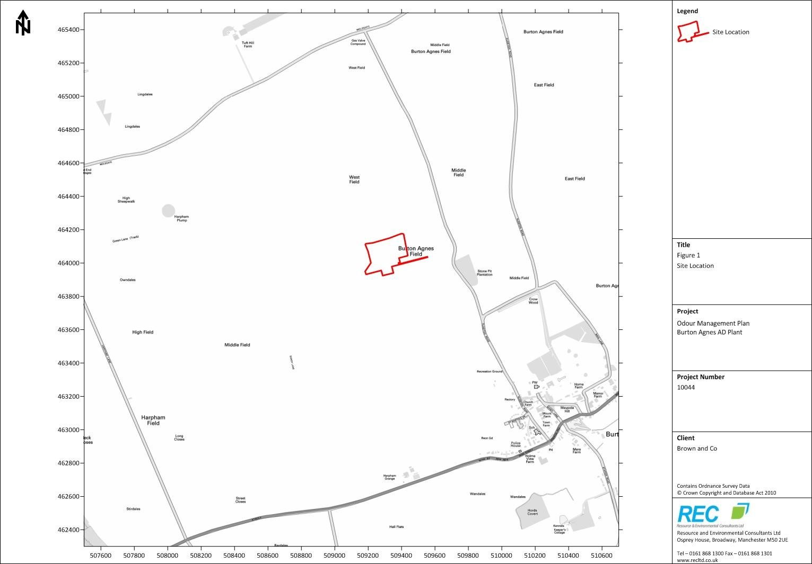
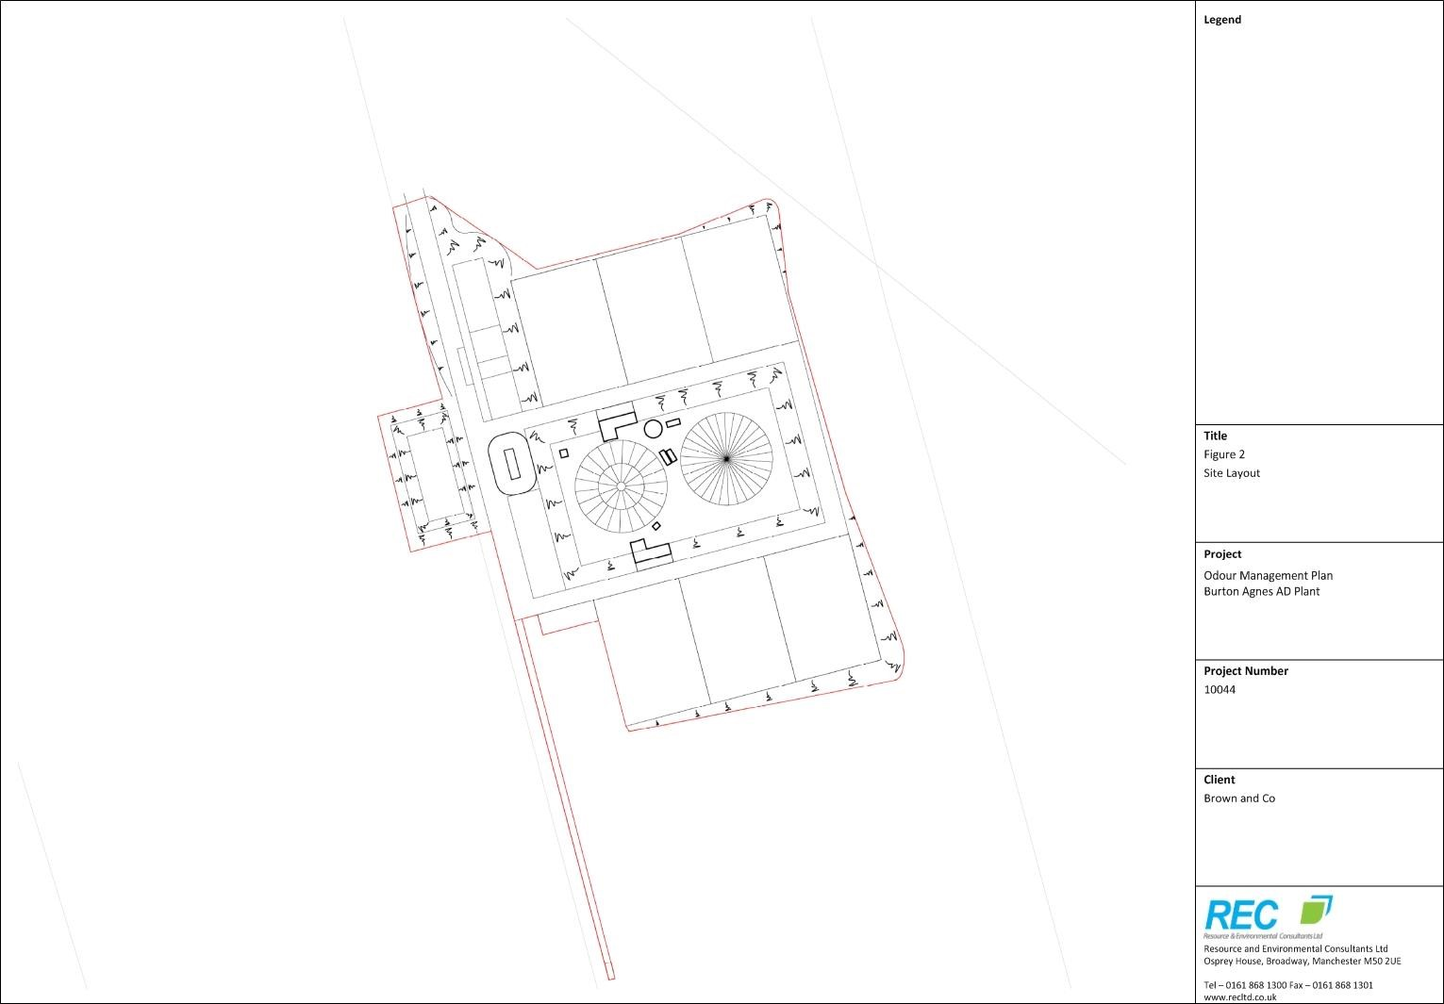
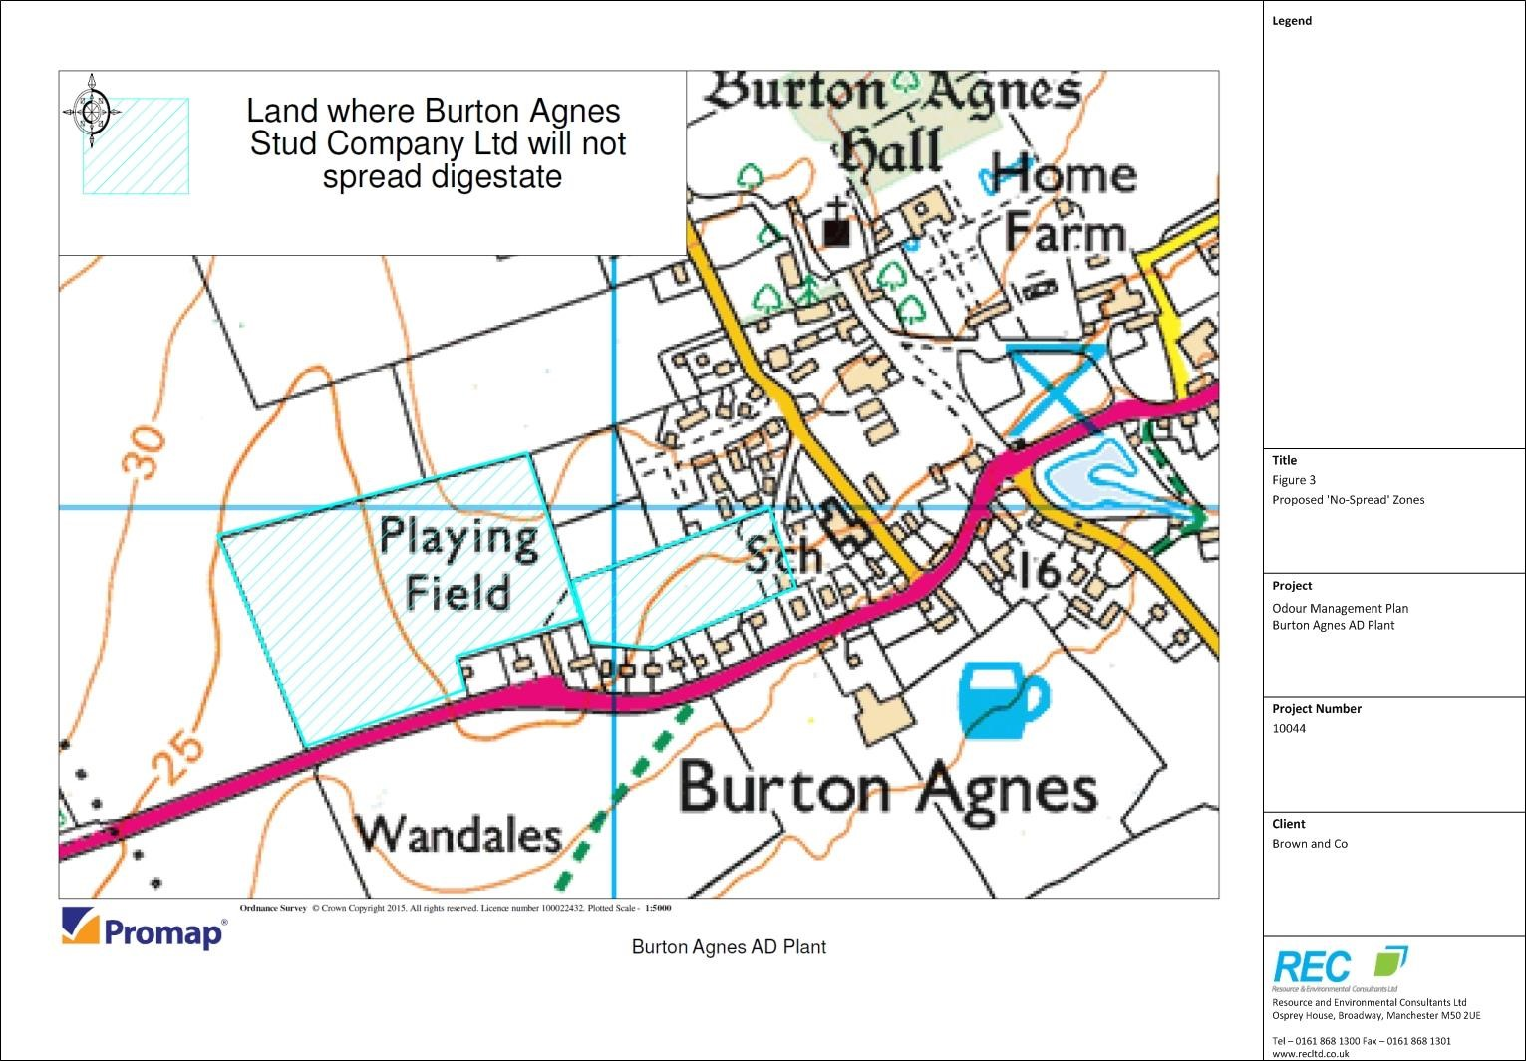
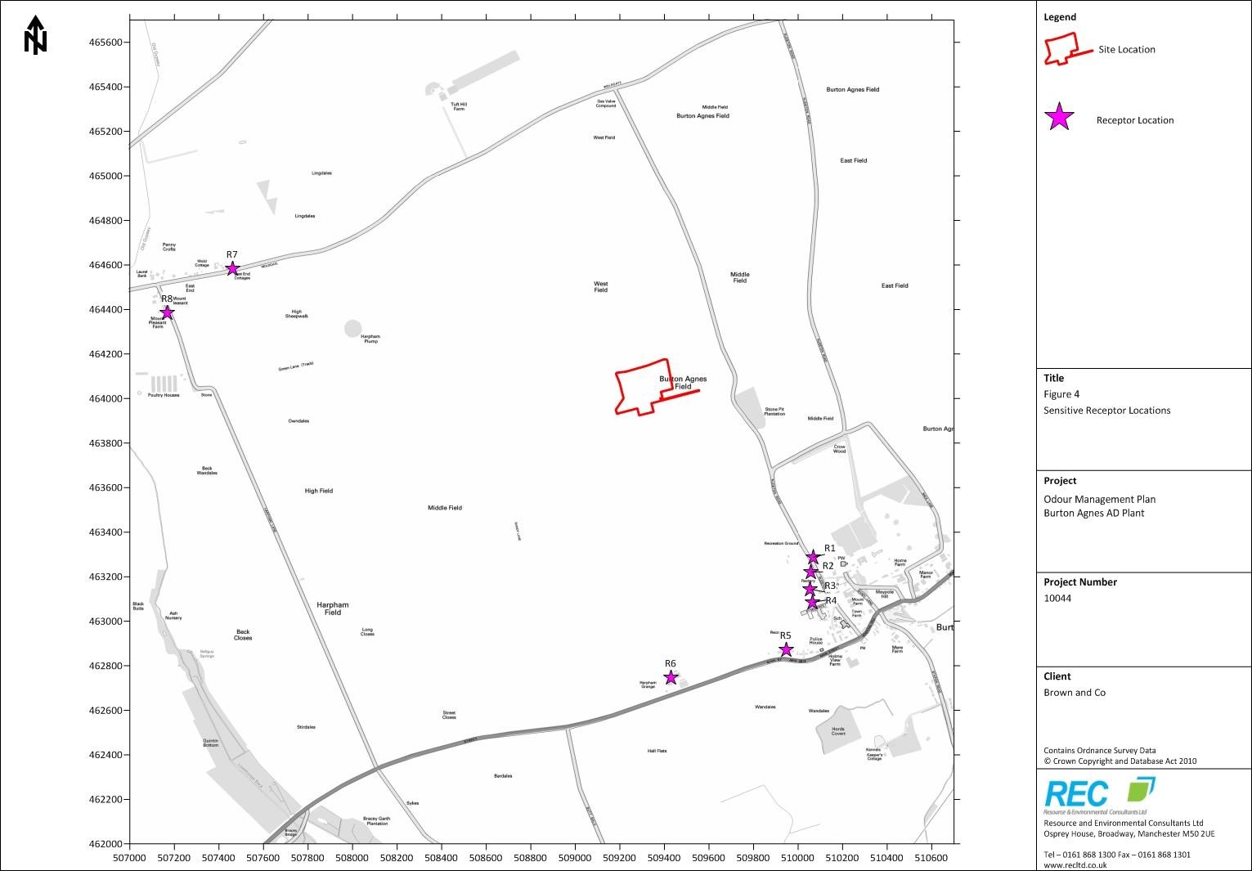
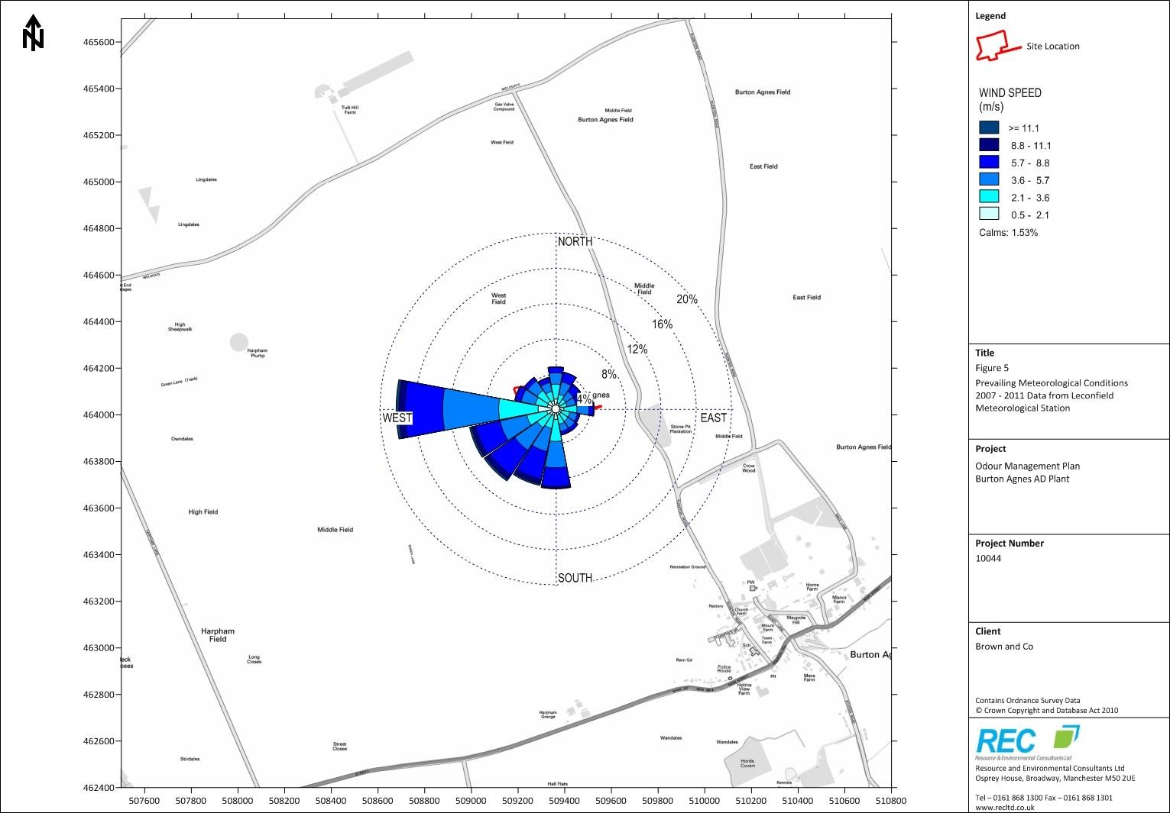

APPENDIX II

REPORTING FORMS

REPORTING FORM: ODOUR 1 - AMBIENT SNIFF TESTING
NOTE: This form should be used for recording results from ambient sniff testing surveys. All fields should be completed in full.

Reporting of odour level on (date):

Table 1 Ambient Sniff Testing Monitoring Results
Survey Location | Time of Survey | Odour  Intensity  (1- 5) | Odour  Persistence  (1- 5) | Odour  Offensiveness  (1- 3) | Meteorological Conditions | Notes

Monitoring undertaken by:

Observations from monitoring team during testing:

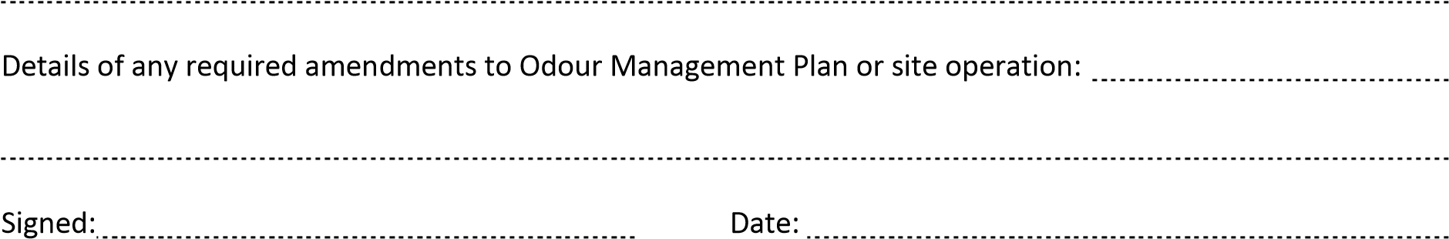

(authorised to sign as representative of Burton Agnes Renewables Ltd.)
REPORTING FORM: ODOUR 2 - COMPLAINT REPORTING FORM
NOTE: This form should be used for recording odour complaints. All fields should be completed in full.

Reporting of odour complaint on (date):

Details of complaint:

Date, time and duration of odour:

Description of odour:

Meteorological conditions during incident:

Potential sources or activities that could give rise to odour during incident:

Operating conditions at time of incident:

Date and time of complaint follow up call:

Action taken:

Details of any required amendments to Odour Management Plan or site operation:

(authorised to sign as representative of Burton Agnes Renewables Ltd.)

REPORTING FORM: ODOUR 3 - ODOUR MANAGEMENT PLAN AMENDMENT FORM

NOTE: This form should be used for recording details of any amendments to the Odour Management Plan. All fields should be completed in full.

Date of Review | Detail of Amendment | Signature
August 22nd 2022 | Change of roles and responsibilities to reflect new management structure. Process condition monitoring and meteorological conditions monitoring sections added. | P. Britt

H4: Odour Management, Environment Agency, 2011.
Figure 1 and Figure 2 show one lagoon to the south of the site, as per the original draft plan. There are now to be two lagoons, this change has no significant impact on this report.
Protecting our Water, Soil and Air: A Code of Good Agricultural Practice for Farmers, Growers and Land Managers, DEFRA, 2009.

