SITE CONDITION REPORT

John Tindall and Son

COMPLETE SECTIONS 1-3 AND SUBMIT WITH APPLICATION

DURING THE LIFE OF THE PERMIT: MAINTAIN SECTIONS 4-7

AT SURRENDER: ADD NEW DOC REFERENCE IN 1.0; COMPLETE SECTIONS 8-10; & SUBMIT WITH YOUR SURRENDER APPLICATION.

1.0 SITE DETAILS

Name of the applicant | John Tindall and Son
Activity address | Field House Farm, Yedingham, Malton, North Yorkshire, YO17 8SS
National grid reference | SE 90440 78629

Document reference and dates for Site Condition Report at permit application and surrender | Appendix 7  January 2025: permit application submission

Document references for site plans (including location and boundaries) | Appendix including:  - Site Location  - Site Layout  - Site drainage  - Emission points

Note:
In Part A of the application form you must give us details of the site’s location and provide us with a site plan. We need a detailed site plan (or plans) showing:

- Site location, the area covered by the site condition report, and the location and nature of the activities and/or waste facilities on the site.
- Locations of receptors, sources of emissions/releases, and monitoring points.
- Site drainage.
- Site surfacing.

If this information is not shown on the site plan required by Part A of the application form then you should submit the additional plan or plans with this site condition report.

2.0 Condition of the land at permit issue

Environmental setting including:  - geology  - hydrogeology  - surface waters |  | The installation at Field House covers approximately 1.2 hectares with pigs on the site. The site and surrounding area present a relatively flat or gently undulating with surrounding land being arable and grass fields.  The approximately central grid reference for the installation is SE 90440 78629  The village of Yedingham is located 1.4 kilometres to the North West and the village of West Heslerton is 2.8 kilometres to the North of the site.  The site is remote from any centre of population and benefits from an exiting farm access road from the public highway. The remote nature of the site and existing trees and hedgerows provide cover, so the site is not excessively visually prominent within the landscape.  The site surfacing is a currently a mixture of stone but there are grants in place to concrete the yard where the existing sheds are.  Contaminated water from the washing out of the buildings and dirty water will be transferred to a dirty water store. There are plans for two dirty water stores, one for the existing sheds and another located within the muck pad of the proposed new sheds.  Clean water and roof water on the site of the existing naturally ventilated sheds will be transferred to a common point on the yard and into a ditch (at point D1 on Appendix 4b), via a silt trap tank. This tank will also have a stop to enable capture of wash water from buildings 1-4 when required, whereafter the contents will be immediately tankered to one of the two dirty water stores.  Clean roof water from the new fan-ventilated sheds (5-8) will be piped to an attenuation pond to the West of the new buildings, before discharge to a ditch located to the South of the installation (at point D2 on Appendix 4b). Rainwater falling on to the stone-surfacing between buildings will drain direct to land. These areas will remain uncontaminated, as all wash water and effluent is captured via the new roofed FYM store to the South of buildings 5-8.  The muck from the new sheds (5-8) will be transferred directly to the adjacent muck pad and muck from the existing sheds will be trailered over.  Search results have been collated using the Defra website “Magic Maps”, the “Geology of Britain Viewer”, LandIS Soilscapes viewer and the Defra Flood Map.  1:50 000 scale bedrock geology description. Ampthill Clay Formation and Kimmeridge Clay Formation – Mudstone. Sedimentary bedrock formed between 163.5 and 152.1 million years ago during the Jurassic period.  1.50 scale superficial deposits description: Lacustrine Deposits – Clay, silt and sand. Sedimentary superficial deposits formed between 2.588 million years ago and present during the Quaternary period.  The site has freely draining slightly acidic loamy soil. The water drains to local groundwater and rivers. Certain areas of this soils suffer from groundwater contamination with nitrate and siltation and nutrient enrichment of streams from soil erosion.  The nearest Site of Special Scientific Interest is East Heslerton Brow, which is located 3.4km to the south. The next closest Site of Special Scientific Interest is Sked Dale which is located 7.2km to the South East. There are no statutory designations within 2km of the installation.  There are no local Nature Reserves within a 5km radius.  The installation is not within a Nitrate Vulnerable Zone.  The site is mainly located in Flood Zone (low probability of flooding from rivers and the sea). All buildings and storage areas are within Zone 1.  Part of the site – an area of the hardstanding at the North end of the installation falls within flood zone 2 (medium probability of flooding).  Part of the site also falls within a source protection zone (Zone 1, Inner Protection Zone, shown in red circle in image below).  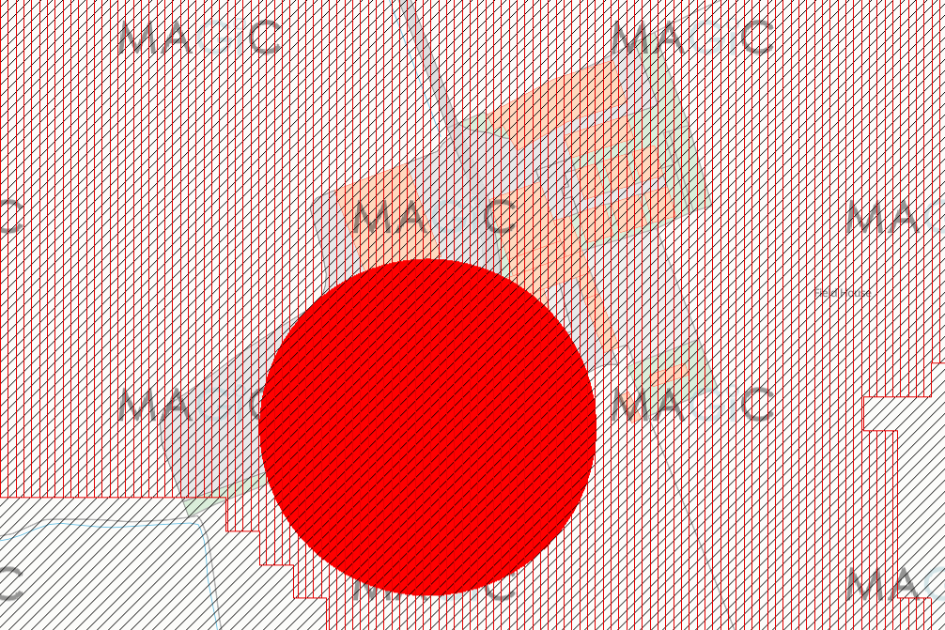
Pollution history including:  - Pollution incidents that may have affected land  - Historical land-uses and associated contaminants  - Any visual/olfactory evidence of existing contamination  - Evidence of damage to pollution prevention measures |  | None known  None known  None known  None known
Evidence of historic contamination, for example, historical site investigation, assessment, remediation and verification reports (where available) |  | There have been no previous land site investigations or assessments at the site
Baseline soil and groundwater reference data |  | None
Supporting information | - Source information identifying environmental setting and pollution incidents  - Historical Ordnance Survey plans  - Site reconnaissance  - Historical investigation / assessment / remediation / verification reports  - Baseline soil and groundwater reference data

3.0 Permitted activities

Permitted activities | - 7600 >30kg pigs  - Solid floor- straw system  - Buildings 1-4 are naturally ventilated  - Proposed buildings 5-8 are high speed fan ventilated (approx. 11m/sec; 5.5 m high vents)  The system will be FYM based. The muck produced will be exported. There will be capacity for up to 200 t of FYM to be stored on site in a roofed and bunded muck store adjacent to buildings 5-8. There will be two dirty water tanks to capture wash water and effluent. This product will also be exported to a third party.  Feed rations are dry, delivered in, diets are formulated to match the growth stage of the pigs and fed ad lib, distributed through sealed systems.  Water for the existing sheds is currently provided by mains but, to enable a sufficient supply of water to the new sheds, a borehole will be needed. The borehole will be located within the installation boundary and measures will be taken to protect it.  All deadstock is disposed of via a licenced deadstock collector and stored in a lockable container. Location of the container is shown on the site plan. It will be moved to the installation entrance at collection for biosecurity.  There is no incinerator.  No agrochemicals stored on site. Veterinary medicines will be kept in the locked office.  There is no fuel store. There is an alarm system in case of power cuts.  Electricity for pigs is sourced from the grid.  Pigs will arrive at circa 30kg and will be kept through to finish weight (approx. 110kg).  There will be 2.2 batches per year (24 week cycle). With 3 weeks downtime between batches, there will be a 12% annual downtime on average.  There are no planned changes to pollution prevention measures anticipated to occur within six months of submitting this Site Condition Report to comply with BAT requirements.
Non-permitted activities undertaken | Not applicable
Document references for:  - plan showing activity layout; and  - environmental risk assessment | Appendix 4 : Site Location Plan and Site Layout Plans  Appendix 5 : H1 Environmental Risk Assessment

Note:

In Part B of the application form you must tell us about the activities that you will undertake at the site. You must also give us an environmental risk assessment. This risk assessment must be based on our guidance (Environmental Risk Assessment - EPR H1) or use an equivalent approach.

It is essential that you identify in your environmental risk assessment all the substances used and produced that could pollute the soil or groundwater if there were an accident, or if measures to protect land fail.

These include substances that would be classified as ‘dangerous’ under the Control of Major Accident Hazards (COMAH) regulations and also raw materials, fuels, intermediates, products, wastes and effluents.

If your submitted environmental risk assessment does not adequately address the risks to soil and groundwater we may need to request further information from you or even refuse your permit application.

4.0 Changes to the activity

Have there been any changes to the activity boundary? |  | If yes, provide a plan showing the changes to the activity boundary.
Have there been any changes to the permitted activities?

Have any ‘dangerous substances’ not identified in the Application Site Condition Report been used or produced as a result of the permitted activities?

Checklist of supporting information | - Plan showing any changes to the boundary (where relevant)  - Description of the changes to the permitted activities (where relevant)  - List of ‘dangerous substances’ used/produced by the permitted activities that were not identified in the Application Site Condition Report (where relevant)

5.0 Measures taken to protect land

Inspection and maintenance records collected during the life of the permit

Use records that you collected during the life of the permit to summarise whether pollution prevention measures worked. If you can’t, you need to collect land and/or groundwater data to assess whether the land has deteriorated.

Checklist of supporting information | - Inspection records and summary of findings of inspections for all pollution prevention measures  - Records of maintenance, repair and replacement of pollution prevention measures

6.0 Pollution incidents that may have had an impact on land, and their remediation

Summarise any pollution incidents that may have damaged the land. Describe how you investigated and remedied each one. If you can’t, you need to collect land and /or groundwater reference data to assess whether the land has deteriorated while you’ve been there.

Checklist of supporting information | - Records of pollution incidents that may have impacted on land  - Records of their investigation and remediation

7.0 Soil gas and water quality monitoring (where undertaken)

Provide details of any soil gas and/or water monitoring you did. Include a summary of the findings. Say whether it shows that the land deteriorated as a result of the permitted activities. If it did, outline how you investigated and remedied this.

Checklist of supporting information | - Description of soil gas and/or water monitoring undertaken  - Monitoring results (including graphs)

8.0 Decommissioning and removal of pollution risk

Describe how the site was decommissioned. Demonstrate that all sources of pollution risk have been removed. Describe whether the decommissioning had any impact on the land. Outline how you investigated and remedied this.

Checklist of supporting information | - Site closure plan  - List of potential sources of pollution risk  - Investigation and remediation reports (where relevant)

9.0 Reference data and remediation (where relevant)

Say whether you had to collect land and/or groundwater data. Or say that you didn’t need to because the information from sections 3, 4, 5 and 6 of the Surrender Site Condition Report shows that the land has not deteriorated.

If you did collect land and/or groundwater reference data, summarise what this entailed, and what your data found. Say whether the data shows that the condition of the land has deteriorated, or whether the land at the site is in a “satisfactory state”. If it isn’t, summarise what you did to remedy this. Confirm that the land is now in a “satisfactory state” at surrender.

Checklist of supporting information | - Land and/or groundwater data collected at application (if collected)  - Land and/or groundwater data collected at surrender (where needed)  - Assessment of satisfactory state  - Remediation and verification reports (where undertaken)

10.0 Statement of site condition

Using the information from sections 3 to 7, give a statement about the condition of the land at the site. This should confirm that:

- the permitted activities have stopped
- decommissioning is complete, and the pollution risk has been removed
- the land is in a satisfactory condition.

