Dust and Bioaerosol Management Plan

Farm name: Field House Farm
Operator John Tindall and Son
Permit number: EPR/AP3727SU/A001
Date: 2025
Prepared by: L Bentley

Introduction
This bespoke Dust and Bioaerosol Management plan has been prepared to support the overall Environmental Management System in place at Field House Farm. The overriding principle of this plan is to ensure the day-to-day activities are carried out in accordance with this document to help minimise the overall environmental impact. There is one sensitive receptor within 100m distance of the installation boundary which is a farmhouse residence, and agricultural buildings owned by the operators of the site. There are also two other sensitive receptors within 400m distance of the installation boundary which are both residential properties.
There have been no previous issues relating to dust and bioaerosols in relation to the farm.
Setting
The installation is approximately 1.3 ha is size, located at National Grid Reference SE 90440 78629. The surrounding area is mainly large arable fields, field boundary hedgerows and pockets of woodland. The landscape is relatively flat to gently undulating. The installation is approximately 1.4km from the village of Yedingham and the Village of West Heslerton is approximately 2.8km from the installation.

Figure 1 shows the location of the installation and of the receptors within 400m which have been considered in this odour management plan.
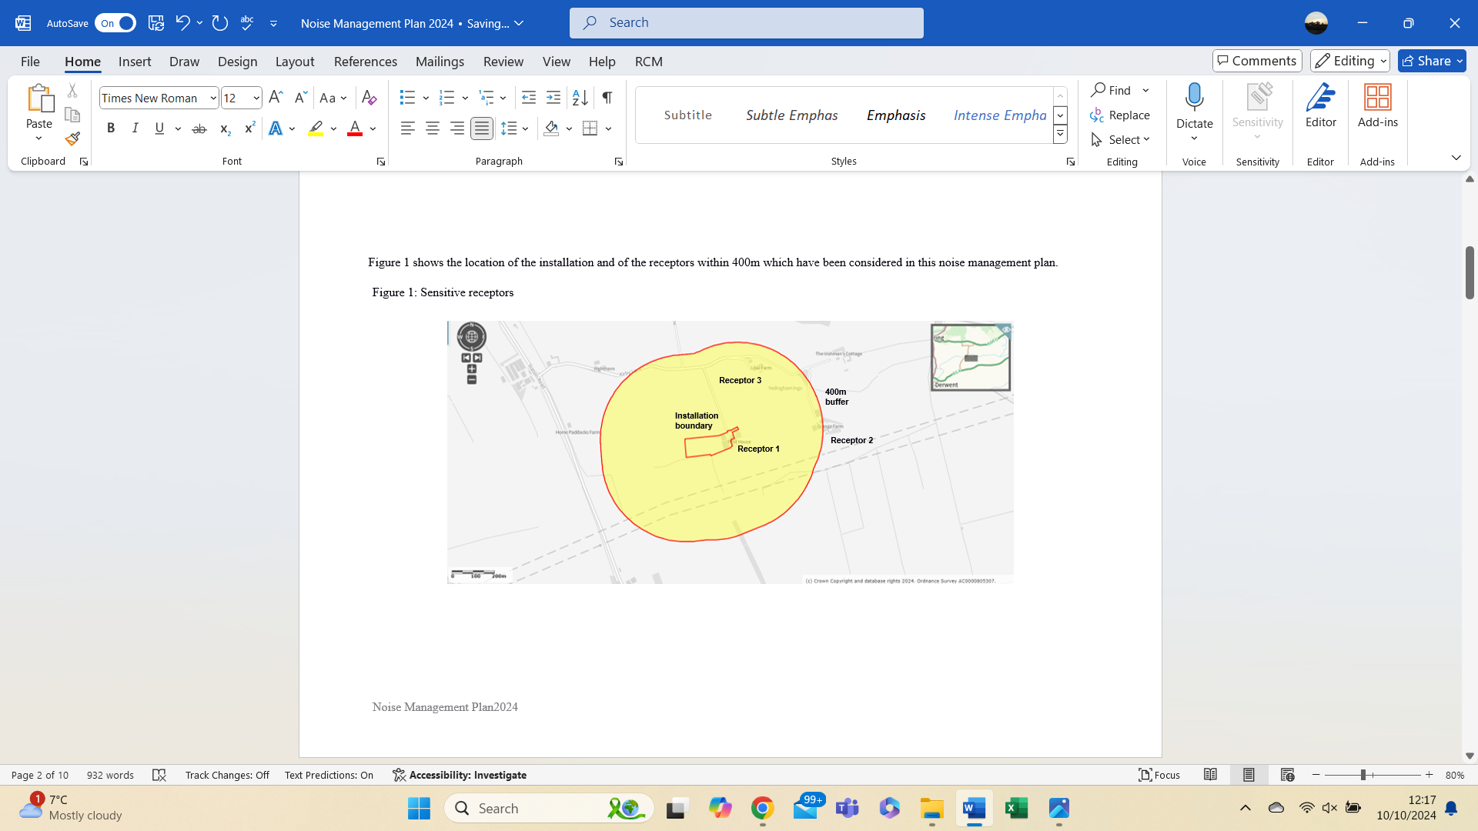
Figure 1: Sensitive receptors

Table 1: Location of Sensitive Receptors
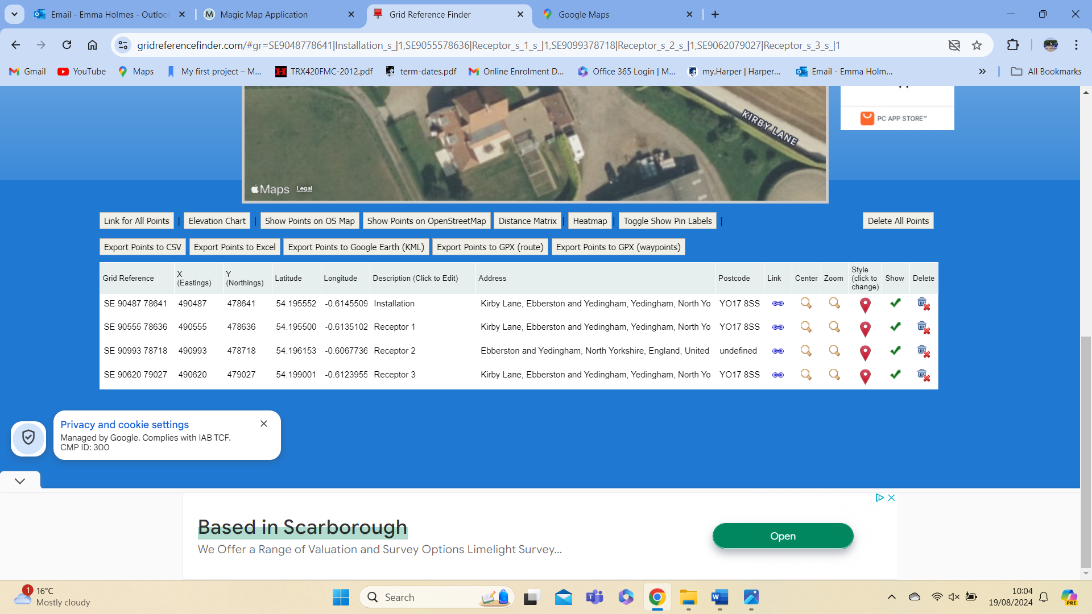

Table 2: Distances from the installation boundary to nearest point of domestic curtilage
Receptor | Description | Distance (metres)
1 | Field House Farm (farmhouse residence) | 27
2 | Grange Farm | 384
3 | Lilac Farm | 282

The purpose of this Dust and Bioaerosol Risk Management Plan is to:
- Establish the likely source of dust and bioaerosol arising from the farm
- Set out procedures at the farm to mitigate or minimise the risk
- Formalise an effective method of dealing with any complaints quickly and effectively

Potential Sources
In accordance with the document, ‘How to comply with your environmental permit for intensive farming’, Appendix 11 Assessing dust control measures on intensive poultry installations, a risk assessment of dust and bioaerosol pollution was performed.

As a result, the following sources have been identified as contributing to a potential low risk dust/bioaerosol source:
- Dust and bioaerosol emissions from feed selection
- Dust and bioaerosol emissions from bedding material
- Dust and bioaerosol emissions from manure storage
- Dust and bioaerosol emissions ventilation
- Dust and bioaerosol emissions cleanout
- Dust and bioaerosol emissions housing
- Dust and bioaerosol emissions

Pathway and receptors
The pathway for all of the above sources is via the atmosphere. The most sensitive receptors will be inhabitants of nearby residential dwellings. Wind direction will significantly influence how receptors are affected. We have not received any complaints from neighbours relating to dust and bioaerosol from the farm.

Table 3: Pig dust and bioaerosol management
Dust and bioaerosol related issues | Actions taken to minimise dust and bioaerosol | Completion date
General such as the day to day activities | - Weekly inspections of the site by the operator  - Looking for signs of dust which could leave the installation boundary or be a hazard to staff and visitors
Pig feed | - Dust from silos minimised by using covers over feed pipes such as bags or containers on the silo exhaust to catch any excess feed and dust  - The feed is not milled on site so this is not an issue  - Storage of feed will cause some dust build up, having covered feed containers should reduce this and improve biosecurity  - Feed spillages will be swept up and collected immediately to avoid dust being generated. This will also prevent possible pollution from entering the watercourse  - Feeding method will also impact dust emissions so the internal feed bin is covered with a plywood constructed top, and the auger pipe is fitted through the cover and fitting a material sock to the end of the pipe which delivers feed directly to the bin may reduce feed dust that is created by freefalling into the bin.
Bedding material | - Application of the straw bedding will happen regularly. Straw will be applied internally to the buildings rather than being blown in. The bedding is supplied as bales which will be opened inside the housing to reduce dust  - The straw is applied carefully to minimise dust and weekly inspections will take place by the operator
Manure removal system | - Solid floored buildings and dust monitored during removal of muck to the muck pad and trailered from existing sheds to the muck pad.
Ventilation | - Ventilation is carefully controlled, maintained and monitored to meet animal welfare requirements and ensure efficient productivity.  - High speed roof fans will be used as the pigs will require airflow control as they can be unsettled by draughts and may need increased ventilation during the summer.  - Weekly inspections by the operatory will happen and any visible dust on the fans and vents will be removed
Housing cleaning | - The housing is thoroughly cleaned between batches which is essential to reducing the volume and potential for air contamination with the house and via the exhaust system.  - Dust accumulation around the exhaust vents is avoided and cleaning takes place to avoid releasing dust to the air or water
Building layout and design | - Artificial ventilation used in the new sheds and natural ventilation in the existing sheds  - The design of the ventilation will provide good air quality to animals and staff

Summary

Dust and bioaerosol is assessed daily by the operators or their delegates.
We have always worked hard to minimise our impact on our closest receptors and as a result have not had any complaints about dust and bioaerosols in relation to Field House Farm. We continually assess management techniques to improve our control of dust and bioaerosols.
This plan will be reviewed at least annually and in the light of any building and management changes, and on the outcome of investigations into the causes of any future complaints, if any occur.
Any dust and bioaerosol complaints will be reported to the operators who will log and investigate causes of all complaints; identifying the source of the dust and bioaerosol issue and monitoring dust and bioaerosol levels at the site boundary as part of the investigation. The complaint details and subsequent investigation will be recorded on the site complaint form and a copy will be kept in the site office.

This document has been prepared by the applicant using the AHDB template. While the Agriculture and Horticulture Development Board, seeks to ensure that the information contained within this document is accurate at the time of printing, no warranty is given in respect thereof and, to the maximum extent permitted by law, the Agriculture and Horticulture Development Board accepts no liability for loss, damage or injury howsoever caused (including that caused by negligence) or suffered directly or indirectly in relation to information and opinions contained omitted from this document.

Appendix 1: Dust, bioaerosol and fugitive emissions complaint form
Date | Name and details of person making the complaint | Nature of complaint | Action taken

