

A Report on the Modelling of the Dispersion and Deposition of Ammonia from the Existing and Proposed Free Range Egg-Laying Chicken Houses at Butterwick Whins, Butterwick, near Malton in North Yorkshire

AS Modelling & Data Ltd.
www.asmodata.co.uk

Prepared by Joseph Tebay  Joseph@asmodata.co.uk  07931 583872  30th July 2026 | Reviewed by Sally Young  sally@asmodata.co.uk  07483 345124  4th August 2026

This report has been prepared by AS Modelling & Data Ltd. on behalf of the Client, based on the information provided by the client and/or agent. In preparing this report, AS Modelling & Data Ltd. has exercised all reasonable skill and care, taking into account the agreed scope of works with the Client. AS Modelling & Data Ltd. does not accept any liability in negligence for any matters arising outside of the agreed scope of works, or for changes that may be required due to omissions in the information provided.

Unless otherwise agreed, this document and all other Intellectual Property Rights remain the property of AS Modelling & Data Ltd. When issued in electronic format, AS Modelling & Data Ltd. does not accept any responsibility for any unauthorised changes made by others. This document may not be copied in whole or in part without the prior written consent of AS Modelling & Data Ltd.

© AS Modelling & Data Ltd. 2026.

Introduction
AS Modelling & Data Ltd. has been instructed by Mr. Steve Raasch, on behalf of Mason Farming Ltd., to use computer modelling to assess the impact of ammonia emissions from the existing and proposed free range egg-laying chicken houses at Butterwick Whins, Butterwick, near Malton, in North Yorkshire. YO17 8HF.

Ammonia emission rates have been assessed and quantified based upon the Environment Agency standard ammonia emission factors. The emission rates have then been used as inputs to an atmospheric dispersion and deposition model which calculates ammonia exposure levels and nitrogen and acid deposition rates in the surrounding area.

This report is arranged in the following manner:

- Section 2 provides relevant details of the farm and potentially sensitive receptors in the area.

- Section 3 provides some general information on ammonia; details of the method used to estimate ammonia emissions; relevant guidelines and legislation on exposure limits and where relevant, details of likely background levels of ammonia.

- Section 4 provides some information about ADMS, the dispersion model used for this study and details the modelling procedure.

- Section 5 contains the results of the modelling.

- Section 6 provides a discussion of the results and conclusions.

Background Details
The site of the existing and proposed poultry houses is in a rural area approximately 500 m to the south-east of Butterwick in North Yorkshire. The site of the existing poultry houses is in a shallow valley at an elevation of around 100 m with the land falling gently toward the site of the proposed poultry houses to the north-north-west and rising to higher ground to the north and south.

There are two existing houses at Butterwick Whinns accommodating up to 64,000 free range egg-laying chickens. The houses are ventilated by wall mounted fans on the gable ends. Manure is removed from the houses using a belt system twice weekly before being removed from the site. The chickens have daytime access to outside ranging areas via a series of pop holes on the sides of the houses.

It is proposed that two new poultry houses be constructed on arable land approximately 700 m to the north-north-west of the existing houses. The proposed poultry houses would provide accommodation for an additional 64,000 free range egg-laying chickens. The houses would be ventilated by wall mounted fans on the gable ends. Manure would be removed from the houses using a belt system twice weekly before being removed from the site. The chickens would have daytime access to outside ranging areas via a series of pop holes on the sides of the houses.

At the Environment Agency’s request, only wildlife sites identified in the pre-application report (EPR/EP3509SG/P001) have been considered in this report.

A map of the surrounding area showing the positions of the existing poultry houses (outlined in red), proposed poultry houses (outlined in blue) and the Local Wildlife Sites (LWSs)/Site of Importance in Nature Conservation (SINC) (shaded in yellow).

Figure 1. The area surrounding the existing and proposed poultry houses
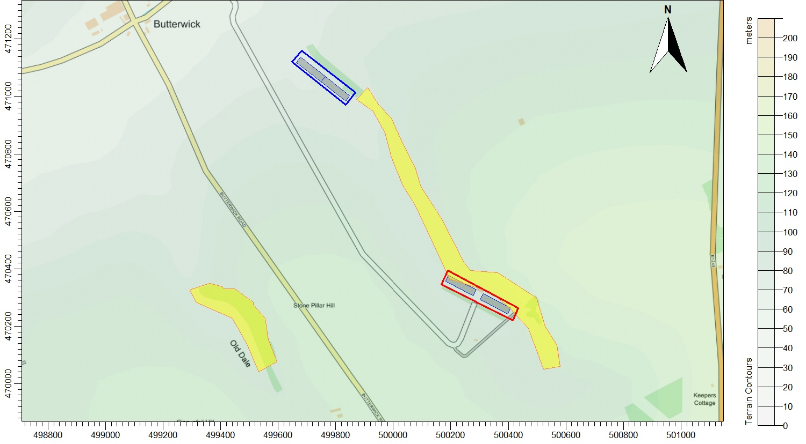
© Crown copyright and database rights. 2026.

Ammonia, Background Levels, Critical Levels & Loads & Emission Rates

3.1 Ammonia concentration and nitrogen and acid deposition
When assessing potential impact on ecological receptors, ammonia concentration is usually expressed in terms of micrograms of ammonia per metre cubed of air (µg-NH₃/m³) as an annual mean. Ammonia in the air may exert direct effects on the vegetation, or indirectly affect the ecosystem through deposition which causes both hyper-eutrophication (excess nitrogen enrichment) and acidification of soils. Nitrogen deposition, specifically in this case the nitrogen load due to ammonia deposition/absorption, is usually expressed in kilograms of nitrogen per hectare per year (kg-N/ha/y). Acid deposition is expressed in terms of kilograms equivalent (of H⁺ ions) per hectare per year (keq/ha/y).

3.2 Background ammonia levels and nitrogen and acid deposition
The source of the background figures is the Air Pollution Information System (APIS, July 2026). It should be noted that the 1 km APIS database background levels are extrapolated from 5 km modelled data. Ammonia levels may vary markedly over relatively short distances and the APIS website itself notes that, the background values should be used only to assist the user in obtaining a broad indication of the likely pollutant impact at a specific location and cannot be considered representative of any particular location within the 5 km grid square; extrapolation to a 1 km grid does not alter this.

The APIS figures for background ammonia concentration (2023) in the area around the site is 2.09 µg-NH₃/m³. The background nitrogen deposition rate to woodland is 30.62 kg-N/ha/y and to short vegetation is 18.95 kg-N/ha/y. The background acid deposition rate to woodland is 2.21 keq/ha/y and to short vegetation is 1.36 keq/ha/y.

The APIS background figures are subject to correction and revision and appear to change fairly frequently, the latest figures can be obtained at https://www.apis.ac.uk/app.

In most cases, the APIS background figures, which are modelled, extrapolated and statistically manipulated figures, nevertheless, are the only figures available and although it is noted that the background values should be used only to assist in obtaining a broad indication of the likely pollutant impact, it is also noted that across the majority of the UK the lower bounds of the Critical Level and Critical Load are already exceeded.

3.3 Critical Levels and Critical Loads
Critical Levels and Critical Loads are a benchmark for assessing the risk of air pollution impacts to ecosystems. It is important to distinguish between a Critical Level and a Critical Load. The Critical Level is the gaseous concentration of a pollutant in the air, whereas the Critical Load relates to the quantity of pollutant deposited from air to the ground.

Critical Levels are defined as, "concentrations of pollutants in the atmosphere above which direct adverse effects on receptors, such as human beings, plants, ecosystems or materials, may occur according to present knowledge" (UNECE).

Critical Loads are defined as, “a quantitative estimate of exposure to one or more pollutants below which significant harmful effects on specified sensitive elements of the environment do not occur according to present knowledge” (UNECE). However, AS Modelling & Data Ltd. would note that effects have been shown to occur at loads that are well below existing Critical Loads (as currently defined) and that these effects are likely to adversely impact the most sensitive species first. Furthermore, recent research suggests that responses are far from linear and where background levels are high and sensitive species that may be associated with the habitat have already been negatively impacted, or indeed are now absent, responses to changes in nitrogen load (in terms of biodiversity) are relatively limited compared to where background levels are low. Therefore, what is deemed significant (in terms of a percentage of Critical Load), where background levels are low, is not necessarily significant where background levels are high.

For ammonia concentration in air, the Critical Level for higher plants is 3.0 µg-NH₃/m³ as an annual mean. For sites where there are sensitive lichens and bryophytes present, or where lichens and bryophytes are an integral part of the ecosystem, the Critical Level is 1.0 µg-NH₃/m³ as an annual mean.

Critical Loads for nutrient nitrogen are set under the Convention on Long-Range Transboundary Air Pollution. They are based on empirical evidence, mainly observations from experiments and gradient studies. Critical Loads are given as ranges (e.g. 10-20 kg-N/ha/y); these ranges reflect variation in ecosystem response across Europe.

The Critical Levels and Critical Loads at the wildlife sites assumed in this study are provided in Table 1. N.B. Where the Critical Level of 1.0 µg-NH₃/m³ is assumed, it is usually unnecessary to consider the Critical Load as the Critical Level provides the stricter test. Normally, the Critical Load for nitrogen deposition provides a stricter test than the Critical Load for acid deposition.

Table 1. Critical Levels and Critical Loads at the wildlife sites
Site | Critical Level  (µg-NH₃/m³) | Critical Load Nitrogen  (kg-N/ha/y) | Critical Load Acid  (keq/ha/y)
Butterwick Whins LWS/SINC | 3.0 ¹ | 10.0 ² | 4.856
Old Dale LWS | - | 10.0 ^{2 & 3} | -
- Critical Level/Load given in Environment Agency pre-application report (EPR/EP3509SG/P001).

3.4 Guidance on the Significance of Ammonia Emissions

3.4.1 Environment Agency Criteria
The Environment Agency and Department for Environment, Food & Rural Affairs published guidance “Intensive farming risk assessment for your environmental permit” (last updated August 2025) applies to ammonia emitting developments requiring a permit. The Environment Agency ammonia screening thresholds for designated nature conservation sites are given in Table 2.

Table 2. Environment Agency Screening Thresholds
Nature conservation site designation | Distance from site (km) | Lower threshold % | Upper threshold %
Special Protection Areas (SPAs), Special Areas of Conservation (SACs), Ramsar sites | 5 | 1 | No upper threshold
Sites of Special Scientific Interest (SSSIs) | 5 | 20 | 50
Local nature sites  (National Nature Reserves, Local Nature Reserves, Local Wildlife Sites, Ancient Woodlands) | 2 | 100 | 100

If the predicted process contributions to Critical Level or Critical Load are below the lower threshold percentage, the impact is usually deemed acceptable.

If the predicted process contributions to Critical Level or Critical Load are in the range between the lower and upper thresholds, whether or not the impact is deemed acceptable is at the discretion of the Environment Agency. In making their decision, the Environment Agency will consider whether other farming installations might act in-combination with the farm and the sensitivities of the wildlife sites. In the case of LWSs and AWs, the Environment Agency do not usually consider other farms that may act in-combination and therefore a Process Contribution of up to 100% of Critical Level and/or Critical Load is usually deemed acceptable for permitting purposes and therefore the upper and lower thresholds are the same (100%).

3.5 Quantification of Ammonia Emissions
Ammonia emission rates from poultry housing depend on many factors and are likely to be highly variable. However, the benchmarks for assessing impacts of ammonia and nitrogen deposition are framed in terms of an annual mean ammonia concentration and annual nitrogen deposition rates. To obtain relatively robust figures for these statistics, it is not necessary to model short term temporal variations, and a steady continuous emission rate can be assumed. In fact, modelling short term temporal variations might introduce rather more uncertainty than modelling continuous emissions.

The emission factors used have been obtained from: https://www.gov.uk/guidance/ammonia-emission-factors-for-pig-and-poultry-screening-modelling-and-reporting#ammonia-emission-factors-for-poultry.

Details of the poultry numbers and types, emission factors used and calculated ammonia emission rates are provided in Table 3.

Table 3. Details of poultry numbers and ammonia emission rates
Housing Type | Bird numbers | Housing emission Factor¹  (kg-NH₃/place/y) | Housing emission rate  (g-NH₃/s) | Ranging emission Factor¹  (kg-NH₃/place/y) | Ranging emission rate  (g-NH₃/s)
Existing egg-laying chickens in multi-tier system with belt removal of manure | 64,000 | 0.0657 | 0.133242 | 0.0239 | 0.048470
Proposed egg-laying chickens in multi-tier system with belt removal of manure | 64,000 | 0.0657 | 0.133242 | 0.0239 | 0.048470
- The Environment Agency’s standard emission factors of 0.073 and 0.239 for free range egg-laying chickens are scaled by factors of 0.9 and 0.1, respectively, to reflect housing and ranging usage. It should be noted that this is a regulatory practice that assumes 20% range usage and 50% range availability and that in reality, for large flocks, actual range usage is usually somewhat lower due to both lower range usage and more importantly considerably lower range availability.

The Atmospheric Dispersion Modelling System (ADMS) and model parameters
The Atmospheric Dispersion Modelling System (ADMS) ADMS 6 is a new generation Gaussian plume air dispersion model, which means that the atmospheric boundary layer properties are characterised by two parameters; the boundary layer depth, and the Monin-Obukhov length rather than in terms of the single parameter Pasquill-Gifford class.

Dispersion under convective meteorological conditions uses a skewed Gaussian concentration distribution (shown by validation studies to be a better representation than a symmetrical Gaussian expression).

ADMS has a number of model options, that include: dry and wet deposition; NO_{x} chemistry; impacts of hills, variable roughness, buildings and coastlines; puffs; fluctuations; odours; radioactivity decay (and γ-ray dose); condensed plume visibility; time varying sources and inclusion of background concentrations.

ADMS has an in-built meteorological pre-processor that allows flexible input of meteorological data both standard and more specialist. Hourly sequential and statistical data can be processed and all input and output meteorological variables are written to a file after processing.

The user defines the pollutant, the averaging time (which may be an annual average or a shorter period), which percentiles and exceedance values to calculate, whether a rolling average is required or not and the output units. The output options are designed to be flexible to cater for the variety of air quality limits, which can vary from country to country and are subject to revision.

4.1 Meteorological data
Computer modelling of dispersion requires hourly sequential meteorological data and to provide robust statistics the record should be of a suitable length; preferably four years or longer.

The meteorological data used in this study is obtained from assimilation and short-term forecast fields of the Numerical Weather Prediction (NWP) system known as the Global Forecast System (GFS)¹.

The GFS is a discrete model. The physics/dynamics model has a resolution or had a resolution of approximately 7 km over the central UK; terrain is understood to be resolved at a resolution of approximately 2 km, with sub-7 km terrain effects parameterised. Site specific data may be extrapolated from nearby archive grid points or a most representative grid point chosen. The GFS resolution adequately captures major topographical features and the broad-scale characteristics of the weather over the UK. Smaller scale topological features may be included in the dispersion modelling by using the flow field module of ADMS (FLOWSTAR²). The use of NWP data has advantages over traditional meteorological records because:

- Calm periods in traditional observational records may be overrepresented; this is because the instrumentation used may not record wind speeds below approximately 0.5 m/s and start up wind speeds may be greater than 1.0 m/s. In NWP data, the wind speed is continuous down to 0.0 m/s, allowing the calms module of ADMS to function correctly.

- Traditional records may include very local deviations from the broad-scale wind flow that would not necessarily be representative of the site being modelled; these deviations are difficult to identify and remove from a meteorological record. Conversely, local effects at the site being modelled are relatively easy to impose on the broad-scale flow and provided horizontal resolution is not too great, the meteorological records from NWP data may be expected to represent well the broad-scale flow.

- Information on the state of the atmosphere above ground level which would otherwise be estimated by the meteorological pre-processor may be included explicitly.

A wind rose showing the distribution of wind speeds and directions in the GFS derived data is shown in Figure 2a. Wind speeds are modified by the treatment of roughness lengths (see Section 4.7) and where terrain data is included in the modelling, the raw GFS wind speeds and directions will be modified. The terrain and roughness length modified wind rose for the site is shown in Figure 2b. Please note that FLOWSTAR² is used to obtain a local flow field, not to explicitly model dispersion in complex terrain as defined in the ADMS User Guide; therefore, the ADMS default value for minimum turbulence length has been amended ³.

- The GFS data used is derived from the high-resolution operational GFS datasets, the data is not obtained from the lower resolution (0.5 degree) long-term archive.
- Note that FLOWSTAR requirements are for meteorological data representative of the upwind flow over the modelling domain and that single site meteorological data (observational or from high resolution modelled data) that is representative of the application site is not generally suitable (personal correspondence: CERC 2019 and UK Met O 2015). If data are deemed representative of a particular application site, either wholly or partially, then these data cannot also be representative of the upstream flow over the modelling domain. Furthermore, it would be extremely poor practice to use such data as the boundary conditions for a flow-solver, such as FLOWSTAR.
- When modelling complex terrain with ADMS, by default, the minimum turbulence length has 0.1 m added to the flat terrain value (calculated from the Monin-Obukhov length). Whilst this might be appropriate over hill/mountain tops in terrain with slopes > 1:10 (and quite possibly only in certain wind directions) in lesser terrain it introduces model behaviour that is not desirable where FLOWSTAR is simply being used to modify the upwind flow. Specifically, the parameter sigma z of the Gaussian plume model is overly constrained, which for elevated point sources emissions, may on occasion cause over prediction of ground level concentrations in stable weather conditions and light winds (Steven R. Hanna & Biswanath Chowdhury, 2013), conversely for low level emission sources, this will cause gross under prediction. Note that this becomes particularly important overnight and if calm and light wind conditions are not being ignored, as they often are when using traditional observational meteorological datasets. To reduce this behaviour, where terrain is modelled, AS Modelling & Data Ltd. have set a minimum turbulence length of 0.025 m in ADMS. This approximates the normal behaviour of ADMS with flat terrain.

Figure 2a. The wind rose. Raw GFS derived data for 54.122 N, 0.47 W, 2022-2025

Figure 2b. The wind rose. FLOWSTAR modified GFS derived data for NGR 500050, 470600, 2022-2025

4.2 Emission sources
Emissions from the gable end fans that would be used for the ventilation of the existing and proposed poultry houses are characterised by volume sources within ADMS.

The poultry houses would have ranging areas, which are represented by area sources within ADMS. Note that the area sources cover the parts of the range most likely to be used frequently and not the whole of the ranging areas.

Details of the emissions source parameters are shown in Tables 4a and 4b. The positions of the volume and area sources are shown in Figures 3a (existing) and 3b (proposed), marked by blue rectangles, and red shaded polygons, respectively.

Table 4a. Volume source parameters
Source ID | Length (m) | Width  (m) | Depth (m) | Base height  (m) | Emission temperature (°C) | Emission rate per source  (g-NH₃/s)
EX1_32KGAB and EX2_32KGAB | 23.67 | 10.0 | 4.0 | 1.0 | Ambient | 0.066621
PR1_32KGAB and PR2_32KGAB | 23.67 | 10.0 | 4.0 | 1.0 | Ambient | 0.066621

Table 4b. Area source parameters
Source ID | Base Height  (m) | Emission temperature (°C) | Area  (m²) | Emission rate  (g-NH₃/m²/s)
EXRAN64K | 0.0 | Ambient | 38,408.1 | 0.048470
PRRAN64K | 0.0 | Ambient | 31,300.2 | 0.048470

4.3 Modelled buildings
Buildings not modelled.

4.4 Discrete receptors
Seventeen discrete receptors have been defined at the nearby wildlife sites, however only results are provided for receptors 1 to 15 at the LWSs as requested by the Environment Agency. These receptors are defined at ground level within ADMS. The positions of the discrete receptors may be seen in Figure 4 (marked by enumerated pink rectangles).

4.5 Cartesian grids
To produce the contour plots presented in Section 5 of this report and to define the spatially varying deposition velocity field, a regular Cartesian grid has been defined within ADMS. The individual grid receptors are defined at ground level within ADMS. The position of the Cartesian grid may be seen in Figure 4 (marked by grey lines).

4.6 Terrain data
Terrain has been considered in the modelling. The terrain data are based upon the Ordnance Survey 50 m Digital Elevation Model. A 10.0 km domain has been resampled at 100 m horizontal resolution for use within ADMS for the detailed modelling. The resolution of FLOWSTAR is 64 x 64 grid points; therefore, the effective resolution of the wind field for the terrain runs is approximately 150 m.

4.7 Roughness Length
In this case, a spatially varying roughness length file has been defined, this is based upon the Defra Living England 25 m land use database. The GFS meteorological data is assumed to have a roughness length of 0.09 m (arithmetic average of the spatially varying roughness over the modelling domain). A sample of the central area of the spatially varying roughness length field is shown in Figure 5.

Figure 3a. The positions of the modelled sources – Existing house and range
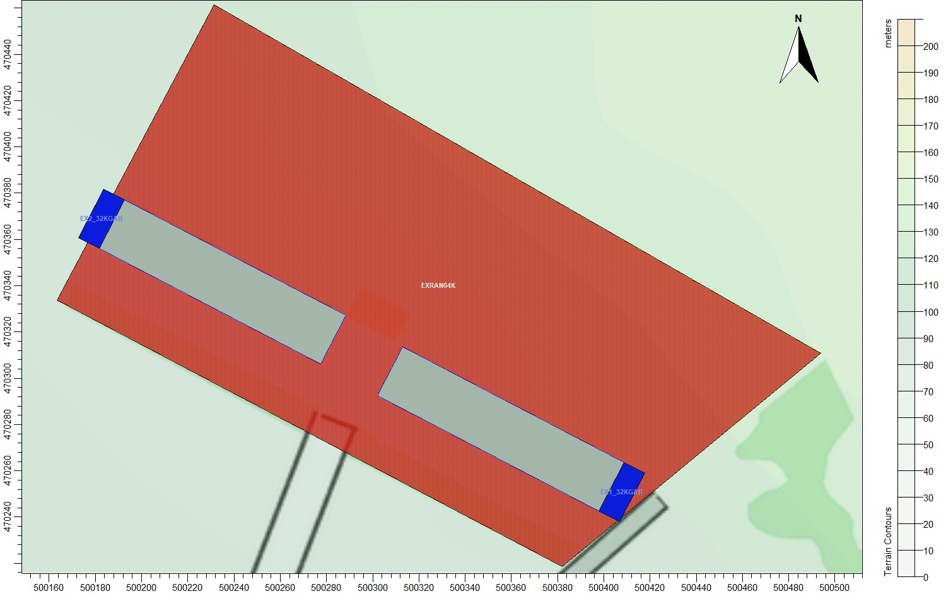
© Crown copyright and database rights. 2026.
Figure 3b. The positions of the modelled sources – Proposed house and range
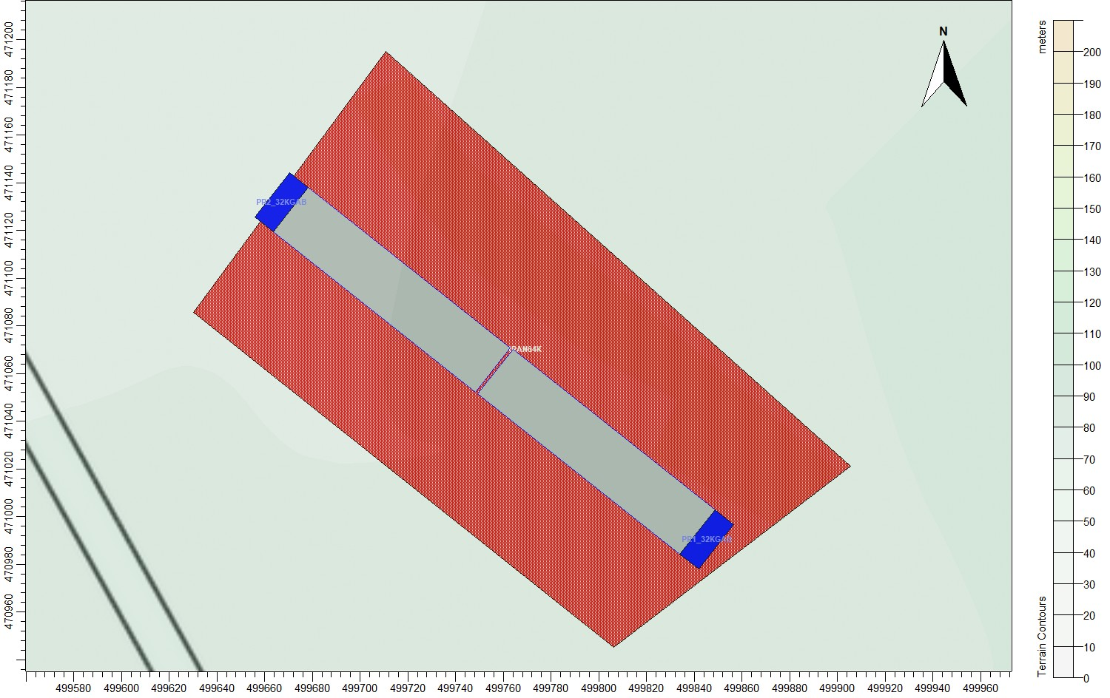
© Crown copyright and database rights. 2026.

Figure 4. The discrete receptors and regular Cartesian grid
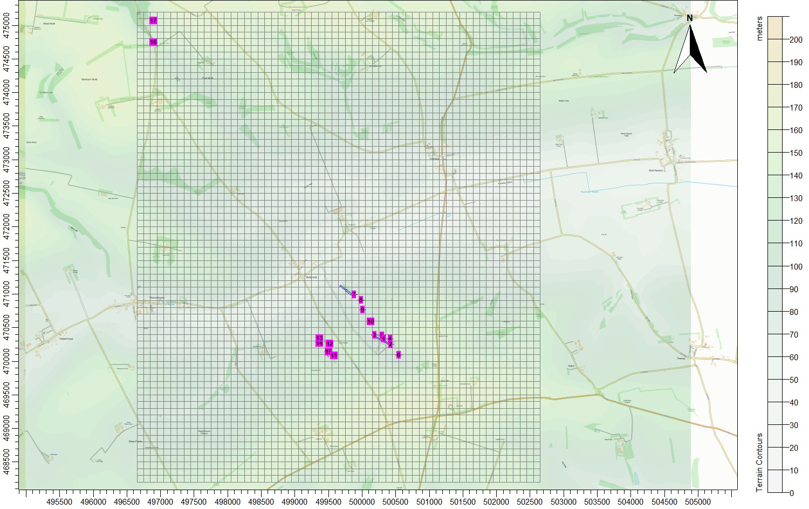
© Crown copyright and database rights. 2026.
Figure 5. The spatially varying surface roughness field (central area)
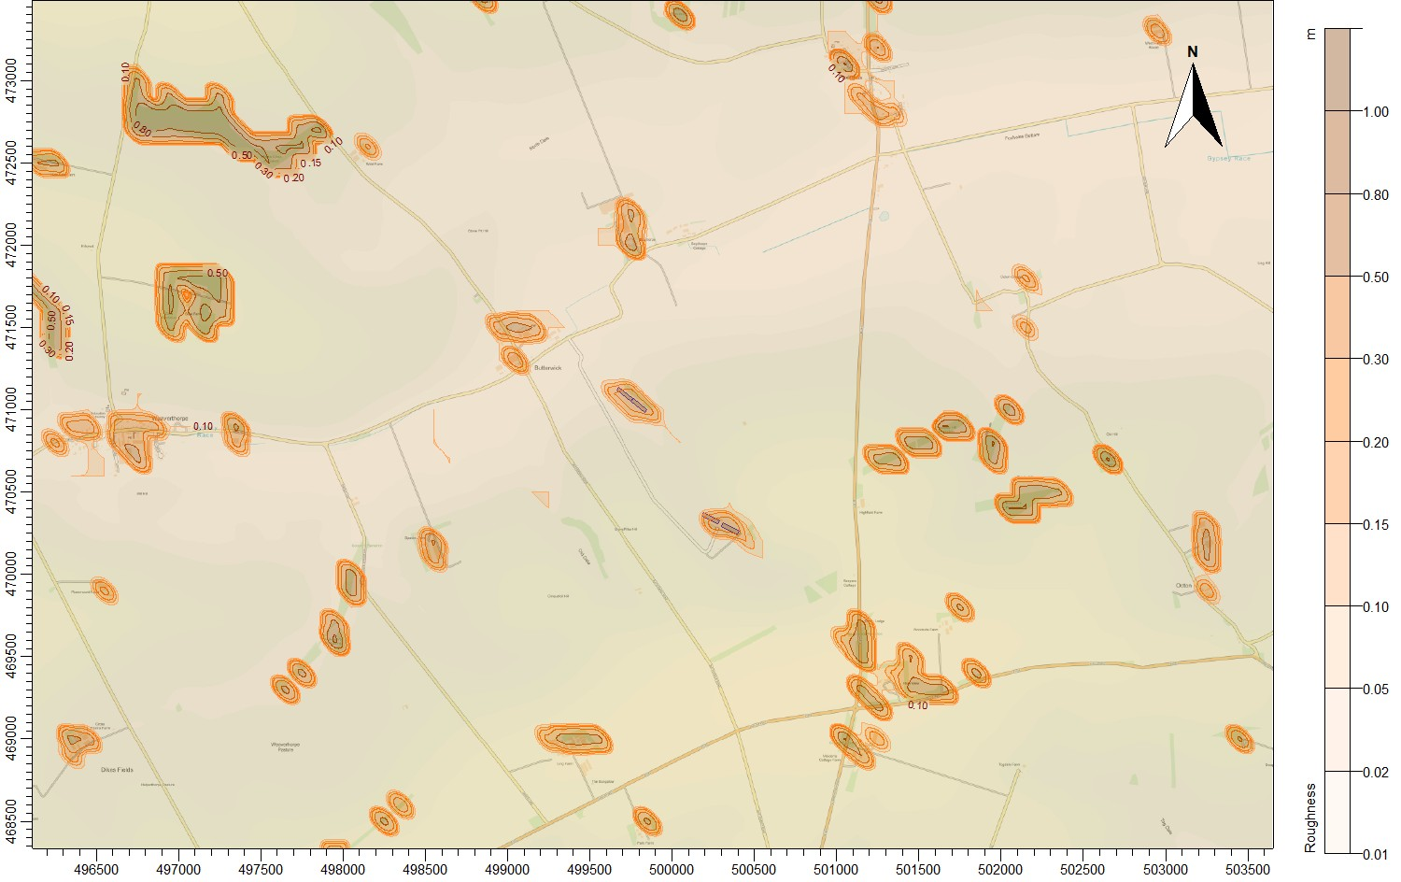
© Crown copyright and database rights. 2026.

4.8 Deposition
The method used to model deposition of ammonia and consequent plume depletion is based primarily upon Frederik Schrader and Christian Brümmer. Land Use Specific Ammonia Deposition Velocities: a Review of Recent Studies (2004-2013). AS Modelling & Data Ltd. has restricted deposition over arable farmland and heavily grazed and fertilised pasture; this is to compensate for possible saturation effects due to fertilizer application and to allow for periods when fields are clear of crops (Sutton), the deposition is also restricted over areas with little or no vegetation and the deposition velocity is set to 0.002 m/s where grid points are over the poultry housing and 0.010 m/s to 0.015 m/s over heavily grazed grassland. Where deposition over water surfaces is calculated, a deposition velocity of 0.005 m/s is used.

In summary, the method is as follows:

- A preliminary run of the model without deposition is used to provide an ammonia concentration field.
- The preliminary ammonia concentration field, along with land usage, has been used to define a deposition velocity field. The deposition velocities used are provided in Table 5.

Table 5. Deposition velocities
NH₃ concentration  (PC + background) (µg/m³) | < 10 | 10 - 20 | 20 - 30 | 30 - 80 | > 80
Deposition velocity - woodland  (m/s) | 0.03 | 0.015 | 0.01 | 0.005 | 0.003
Deposition velocity - short vegetation  (m/s) | 0.02 (0.010 to 0.015 over heavily grazed grassland) | 0.015 | 0.01 | 0.005 | 0.003
Deposition velocity - arable farmland/rye grass  (m/s) | 0.005 | 0.005 | 0.005 | 0.005 | 0.003

- The model is then rerun with the spatially varying deposition module.

A contour plot of the spatially varying deposition field is provided in Figure 6.

Figure 6. The spatially varying deposition field
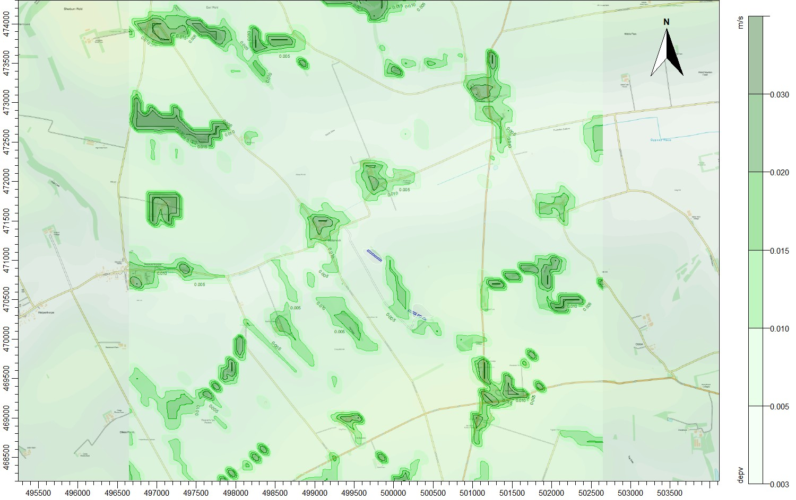
© Crown copyright and database rights. 2026.

Details of the Model Runs and Results

5.1 Preliminary modelling and model sensitivity tests
ADMS was run a total of eight times, once for each year of the meteorological record and in the following modes:

- In basic mode without calms, or terrain – GFS data.
- With calms and without terrain – GFS data.

For each mode, statistics for the maximum annual mean ammonia concentration at each receptor were compiled. Details of the predicted annual mean ammonia concentrations at each receptor are provided in Table 6. The primary purpose of the preliminary modelling is to assess the effect of calms on the results.

Table 6. Predicted maximum annual mean ammonia concentration at the discrete receptors – preliminary modelling
Receptor number | X(m) | Y(m) | Name/Designation | Maximum annual mean ammonia concentration  (µg/m³)
 |  |  |  | Existing |  | Proposed
 |  |  |  | GFS  No Calms  No Terrain | GFS  Calms  No Terrain | GFS  No Calms  No Terrain | GFS  Calms  No Terrain
1 | 500325 | 470330 | Butterwick Whins SINC | 53.363 | 53.883 | 0.589 | 0.661
2 | 500422 | 470252 | Butterwick Whins SINC | 95.915 | 97.326 | 0.486 | 0.544
3 | 500189 | 470388 | Butterwick Whins SINC | 75.945 | 78.636 | 0.681 | 0.780
4 | 500419 | 470335 | Butterwick Whins SINC | 54.644 | 55.059 | 0.547 | 0.609
5 | 500296 | 470384 | Butterwick Whins SINC | 55.896 | 55.691 | 0.665 | 0.745
6 | 500545 | 470090 | Butterwick Whins SINC | 3.524 | 3.997 | 0.360 | 0.403
7 | 499880 | 470991 | Butterwick Whins SINC | 0.790 | 0.877 | 47.435 | 49.835
8 | 499987 | 470910 | Butterwick Whins SINC | 1.041 | 1.158 | 6.263 | 7.074
9 | 500010 | 470769 | Butterwick Whins SINC | 1.519 | 1.684 | 2.636 | 2.935
10 | 500130 | 470587 | Butterwick Whins SINC | 3.728 | 4.108 | 1.208 | 1.354
11 | 499583 | 470084 | Old Dale LWS | 0.591 | 0.712 | 0.377 | 0.449
12 | 499517 | 470264 | Old Dale LWS | 0.577 | 0.691 | 0.550 | 0.644
13 | 499366 | 470342 | Old Dale LWS | 0.422 | 0.511 | 0.656 | 0.753
14 | 499366 | 470266 | Old Dale LWS | 0.424 | 0.510 | 0.563 | 0.648
15 | 499499 | 470139 | Old Dale LWS | 0.542 | 0.646 | 0.426 | 0.501

5.2 Detailed modelling
In this case, detailed modelling has been carried out over a high resolution 6.0 km x 7.0 km domain surrounding the site. The primary purpose is to determine the magnitude of deposition of ammonia and consequent plume depletion close to the sources where it is of the greatest importance. Outside of this domain, a fixed deposition velocity of 0.005 m/s is assumed (with appropriate deposition velocities applied post-modelling at the discrete receptors).

The predicted maximum annual mean ground level ammonia concentrations and maximum nitrogen deposition rates at the discrete receptors are shown in Tables 7a (Existing), 7b (Proposed) and 7c (Existing and Proposed). In the Tables, predicted ammonia concentrations and nitrogen and acid deposition rates that exceed the Environment Agency’s lower/upper threshold of 100% for a non-statutory site are in red.

The detailed deposition run was made with terrain. Calms cannot be used with terrain or spatially varying deposition; therefore, calms have not been included in the detailed modelling. In this case, the results of the preliminary modelling indicate that the effects of calms are significant, therefore a correction based on the results in Table 6 has been applied to the results in Tables 7a, 7b and 7c.

Contour plots of the predicted ground level maximum annual mean ammonia concentration and maximum annual nitrogen deposition rates for the existing and proposed houses and ranges are shown in Figures 7a and 7b.

Table 7a. Predicted maximum annual mean ammonia concentrations and nitrogen deposition rates – Existing
Receptor number | X(m) | Y(m) | Name | Site Parameters |  |  |  | Maximum annual ammonia concentration |  | Maximum annual nitrogen deposition rate |  | Maximum annual H+ deposition rate
 |  |  |  | Deposition Velocity | Critical Level  (µg/m³) | Critical Load  (kg/ha) | Critical Load H+  (kg/ha) | Process Contribution  (µg/m³) | %age of Critical Level | Process Contribution  (kg/ha) | %age of Critical Load | Process Contribution  (kg/ha) | %age of Critical Load
1 | 500325 | 470330 | Butterwick Whins LWS/SINC | 0.02 | 3.0 | 10.0 | 4.856 | 26.233 | 874.43 | 136.253 | 1362.53 | 9.732 | 200.42
2 | 500422 | 470252 | Butterwick Whins LWS/SINC | 0.02 | 3.0 | 10.0 | 4.856 | 98.253 | 3275.11 | 510.328 | 5103.28 | 36.452 | 750.66
3 | 500189 | 470388 | Butterwick Whins LWS/SINC | 0.02 | 3.0 | 10.0 | 4.856 | 68.523 | 2284.10 | 355.908 | 3559.08 | 25.422 | 523.52
4 | 500419 | 470335 | Butterwick Whins LWS/SINC | 0.02 | 3.0 | 10.0 | 4.856 | 29.184 | 972.82 | 151.584 | 1515.84 | 10.827 | 222.97
5 | 500296 | 470384 | Butterwick Whins LWS/SINC | 0.02 | 3.0 | 10.0 | 4.856 | 29.946 | 998.20 | 155.540 | 1555.40 | 11.110 | 228.79
6 | 500545 | 470090 | Butterwick Whins LWS/SINC | 0.02 | 3.0 | 10.0 | 4.856 | 1.834 | 61.15 | 9.528 | 95.28 | 0.681 | 14.02
7 | 499880 | 470991 | Butterwick Whins LWS/SINC | 0.02 | 3.0 | 10.0 | 4.856 | 0.234 | 7.80 | 1.215 | 12.15 | 0.087 | 1.79
8 | 499987 | 470910 | Butterwick Whins LWS/SINC | 0.02 | 3.0 | 10.0 | 4.856 | 0.359 | 11.96 | 1.864 | 18.64 | 0.133 | 2.74
9 | 500010 | 470769 | Butterwick Whins LWS/SINC | 0.02 | 3.0 | 10.0 | 4.856 | 0.563 | 18.77 | 2.925 | 29.25 | 0.209 | 4.30
10 | 500130 | 470587 | Butterwick Whins LWS/SINC | 0.02 | 3.0 | 10.0 | 4.856 | 2.081 | 69.35 | 10.806 | 108.06 | 0.772 | 15.90
11 | 499583 | 470084 | Old Dale LWS | 0.02 | - | 10.0 | - | 0.268 | - | 1.391 | 13.91 | 0.099 | -
12 | 499517 | 470264 | Old Dale LWS | 0.02 | - | 10.0 | - | 0.194 | - | 1.007 | 10.07 | 0.072 | -
13 | 499366 | 470342 | Old Dale LWS | 0.02 | - | 10.0 | - | 0.115 | - | 0.598 | 5.98 | 0.043 | -
14 | 499366 | 470266 | Old Dale LWS | 0.02 | - | 10.0 | - | 0.126 | - | 0.653 | 6.53 | 0.047 | -
15 | 499499 | 470139 | Old Dale LWS | 0.02 | - | 10.0 | - | 0.216 | - | 1.124 | 11.24 | 0.080 | -

Table 7b. Predicted maximum annual mean ammonia concentrations and nitrogen deposition rates – Proposed
Receptor number | X(m) | Y(m) | Name | Site Parameters |  |  |  | Maximum annual ammonia concentration |  | Maximum annual nitrogen deposition rate |  | Maximum annual H+ deposition rate
 |  |  |  | Deposition Velocity | Critical Level  (µg/m³) | Critical Load  (kg/ha) | Critical Load H+  (kg/ha) | Process Contribution  (µg/m³) | %age of Critical Level | Process Contribution  (kg/ha) | %age of Critical Load | Process Contribution  (kg/ha) | %age of Critical Load
1 | 500325 | 470330 | Butterwick Whins LWS/SINC | 0.02 | 3.0 | 10.0 | 4.856 | 0.232 | 7.75 | 1.207 | 12.07 | 0.086 | 1.78
2 | 500422 | 470252 | Butterwick Whins LWS/SINC | 0.02 | 3.0 | 10.0 | 4.856 | 0.173 | 5.76 | 0.898 | 8.98 | 0.064 | 1.32
3 | 500189 | 470388 | Butterwick Whins LWS/SINC | 0.02 | 3.0 | 10.0 | 4.856 | 0.284 | 9.47 | 1.476 | 14.76 | 0.105 | 2.17
4 | 500419 | 470335 | Butterwick Whins LWS/SINC | 0.02 | 3.0 | 10.0 | 4.856 | 0.194 | 6.46 | 1.007 | 10.07 | 0.072 | 1.48
5 | 500296 | 470384 | Butterwick Whins LWS/SINC | 0.02 | 3.0 | 10.0 | 4.856 | 0.252 | 8.40 | 1.309 | 13.09 | 0.093 | 1.92
6 | 500545 | 470090 | Butterwick Whins LWS/SINC | 0.02 | 3.0 | 10.0 | 4.856 | 0.124 | 4.15 | 0.646 | 6.46 | 0.046 | 0.95
7 | 499880 | 470991 | Butterwick Whins LWS/SINC | 0.02 | 3.0 | 10.0 | 4.856 | 44.323 | 1477.45 | 230.216 | 2302.16 | 16.444 | 338.63
8 | 499987 | 470910 | Butterwick Whins LWS/SINC | 0.02 | 3.0 | 10.0 | 4.856 | 3.980 | 132.67 | 20.672 | 206.72 | 1.477 | 30.41
9 | 500010 | 470769 | Butterwick Whins LWS/SINC | 0.02 | 3.0 | 10.0 | 4.856 | 1.331 | 44.37 | 6.914 | 69.14 | 0.494 | 10.17
10 | 500130 | 470587 | Butterwick Whins LWS/SINC | 0.02 | 3.0 | 10.0 | 4.856 | 0.486 | 16.20 | 2.524 | 25.24 | 0.180 | 3.71
11 | 499583 | 470084 | Old Dale LWS | 0.02 | - | 10.0 | - | 0.145 | - | 0.755 | 7.55 | 0.054 | -
12 | 499517 | 470264 | Old Dale LWS | 0.02 | - | 10.0 | - | 0.222 | - | 1.154 | 11.54 | 0.082 | -
13 | 499366 | 470342 | Old Dale LWS | 0.02 | - | 10.0 | - | 0.281 | - | 1.461 | 14.61 | 0.104 | -
14 | 499366 | 470266 | Old Dale LWS | 0.02 | - | 10.0 | - | 0.234 | - | 1.216 | 12.16 | 0.087 | -
15 | 499499 | 470139 | Old Dale LWS | 0.02 | - | 10.0 | - | 0.171 | - | 0.886 | 8.86 | 0.063 | -

Table 7c. Predicted maximum annual mean ammonia concentrations and nitrogen deposition rates – Existing and Proposed
Receptor number | X(m) | Y(m) | Name | Site Parameters |  |  |  | Maximum annual ammonia concentration |  | Maximum annual nitrogen deposition rate |  | Maximum annual H+ deposition rate
 |  |  |  | Deposition Velocity | Critical Level  (µg/m³) | Critical Load  (kg/ha) | Critical Load H+  (kg/ha) | Process Contribution  (µg/m³) | %age of Critical Level | Process Contribution  (kg/ha) | %age of Critical Load | Process Contribution  (kg/ha) | %age of Critical Load
1 | 500325 | 470330 | Butterwick Whins LWS/SINC | 0.02 | 3.0 | 10.0 | 4.856 | 29.333 | 977.78 | 152.358 | 1523.58 | 10.883 | 224.11
2 | 500422 | 470252 | Butterwick Whins LWS/SINC | 0.02 | 3.0 | 10.0 | 4.856 | 109.169 | 3638.96 | 567.023 | 5670.23 | 40.502 | 834.05
3 | 500189 | 470388 | Butterwick Whins LWS/SINC | 0.02 | 3.0 | 10.0 | 4.856 | 76.299 | 2543.30 | 396.298 | 3962.98 | 28.307 | 582.93
4 | 500419 | 470335 | Butterwick Whins LWS/SINC | 0.02 | 3.0 | 10.0 | 4.856 | 32.569 | 1085.64 | 169.164 | 1691.64 | 12.083 | 248.83
5 | 500296 | 470384 | Butterwick Whins LWS/SINC | 0.02 | 3.0 | 10.0 | 4.856 | 33.472 | 1115.74 | 173.854 | 1738.54 | 12.418 | 255.73
6 | 500545 | 470090 | Butterwick Whins LWS/SINC | 0.02 | 3.0 | 10.0 | 4.856 | 2.159 | 71.98 | 11.216 | 112.16 | 0.801 | 16.50
7 | 499880 | 470991 | Butterwick Whins LWS/SINC | 0.02 | 3.0 | 10.0 | 4.856 | 44.583 | 1486.09 | 231.563 | 2315.63 | 16.540 | 340.61
8 | 499987 | 470910 | Butterwick Whins LWS/SINC | 0.02 | 3.0 | 10.0 | 4.856 | 4.378 | 145.94 | 22.740 | 227.40 | 1.624 | 33.45
9 | 500010 | 470769 | Butterwick Whins LWS/SINC | 0.02 | 3.0 | 10.0 | 4.856 | 1.956 | 65.19 | 10.159 | 101.59 | 0.726 | 14.94
10 | 500130 | 470587 | Butterwick Whins LWS/SINC | 0.02 | 3.0 | 10.0 | 4.856 | 2.794 | 93.13 | 14.512 | 145.12 | 1.037 | 21.35
11 | 499583 | 470084 | Old Dale LWS | 0.02 | - | 10.0 | - | 0.442 | - | 2.298 | 22.98 | 0.164 | -
12 | 499517 | 470264 | Old Dale LWS | 0.02 | - | 10.0 | - | 0.437 | - | 2.271 | 22.71 | 0.162 | -
13 | 499366 | 470342 | Old Dale LWS | 0.02 | - | 10.0 | - | 0.409 | - | 2.124 | 21.24 | 0.152 | -
14 | 499366 | 470266 | Old Dale LWS | 0.02 | - | 10.0 | - | 0.374 | - | 1.940 | 19.40 | 0.139 | -
15 | 499499 | 470139 | Old Dale LWS | 0.02 | - | 10.0 | - | 0.411 | - | 2.133 | 21.33 | 0.152 | -

Figure 7a. Maximum annual mean ammonia concentration – Existing and Proposed
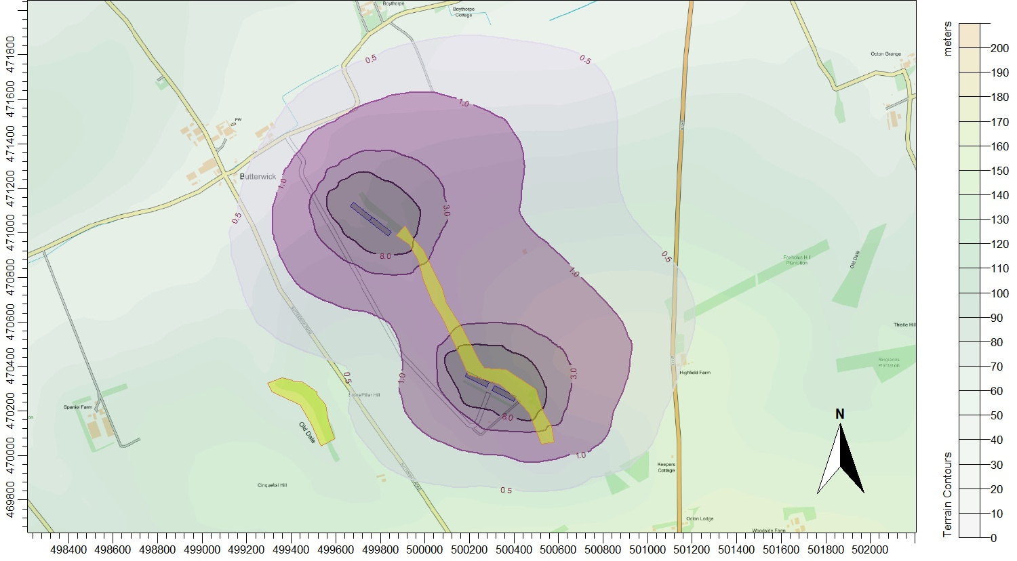
© Crown copyright and database rights. 2026.

Figure 7b. Maximum annual nitrogen deposition rates – Existing and Proposed
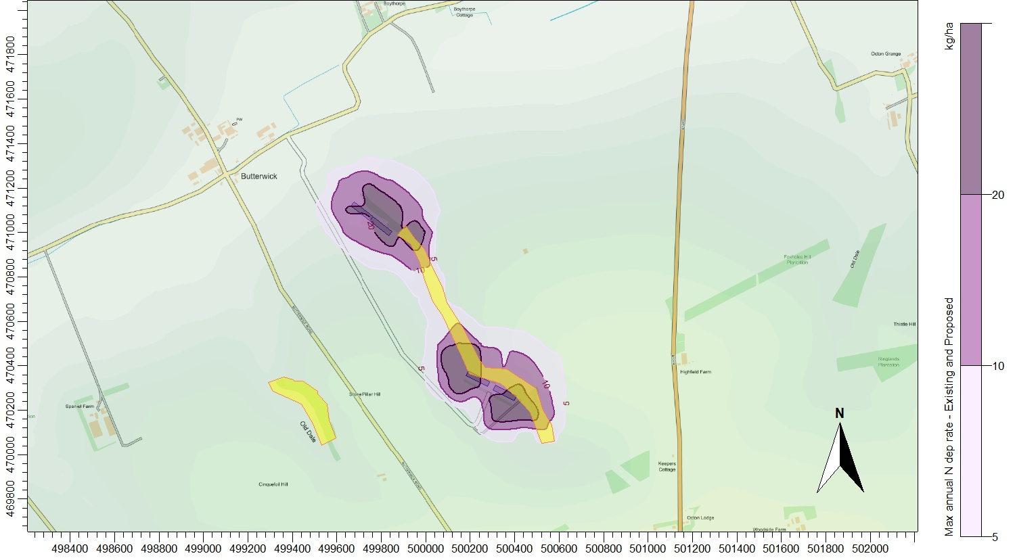
© Crown copyright and database rights. 2026.

Summary and Conclusions
Ammonia emission rates have been assessed and quantified based upon the Environment Agency standard ammonia emission factors. The emission rates have then been used as inputs to an atmospheric dispersion and deposition model which calculates ammonia exposure levels and nitrogen and acid deposition rates in the surrounding area.

The modelling predicts that, should the development proceed:

- Ammonia concentrations and nitrogen deposition rates are currently and would continue to be above the Environment Agency’s threshold percentage of 100% of the relevant Critical Level and Critical Loads at Butterwick Whins LWS/SINC.
- Process contributions to annual nitrogen deposition rates at Old Dale LWS are currently and would remain below the Environment Agency’s threshold percentage of 100% of the relevant Critical Load.

References
Cambridge Environmental Research Consultants (CERC) (website).

Chapman, C. and Kite, B. Joint Nature Conservation Committee. Guidance on Decision-making Thresholds for Air Pollution.

Environment Agency and Department for Environment, Food & Rural Affairs “Intensive farming risk assessment for your environmental permit”, last updated August 2025 (website).

Steven R Hanna, & Biswanath Chowdhury. Minimum turbulence assumptions and u* and L estimation for dispersion models during low-wind stable conditions.

M. A. Sutton et al. Measurement and modelling of ammonia exchange over arable croplands.

Frederik Schrader and Christian Brümmer. Land Use Specific Ammonia Deposition Velocities: a Review of Recent Studies (2004-2013).

United Nations Economic Commission for Europe (UNECE) (website).

UK Air Pollution Information System (APIS) (website).

