Odour Management Plan

Farm name: Scampston Pig Unit Operator: JSR Farms Permit number: EPR/GP3101LS/A001
Introduction
This Odour Management Plan (OMP) has been prepared to support the overall Environmental Management System in place at Scampston Pig Unit. The overriding principle of this OMP is to ensure the day-to-day activities are carried out in accordance with this document to help minimise the overall environmental impact. There is one residential sensitive receptor which is over 100m within 400m of the installation boundary (location used is the grid reference allocated in the pre-application) to the North of the site and is a neighbouring farm. There is no history of complaints.
Setting
The installation is located at National Grid Reference 486626, 476984 (with a 200m buffer used in the pre-application). Please refer to Site Plans and Supporting Information Document for further maps and diagrams.
Figure 1 shows the location of the farm and of the receptor within 400m (with grid references SE99755376, postcode YO25 9AF) which have been considered in this odour management plan.

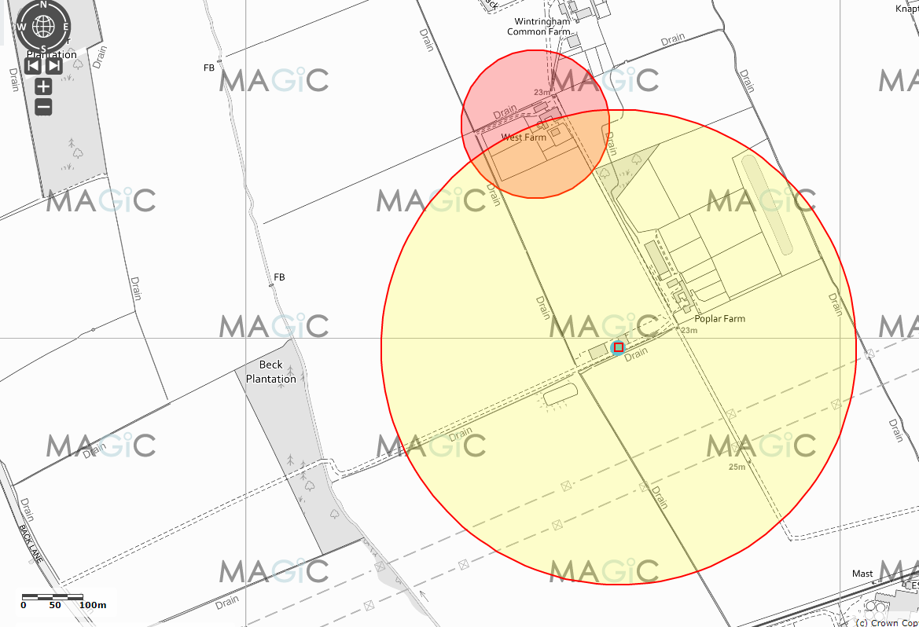

Scampston Receptor Location Details:
Westland Farm:
Easting = 486510
Northing = 477374
Grid Ref = SE86507737
National Grid Field No = SE 8677 5137
Latitude = 54°11'4.79"N
Longitude = 0°40'27.12"W
Latitude = 54°11.0799'"N
Longitude = 0°40.4520'"W
Latitude = 54.184665
Longitude = -0.674201
Postcode = YO17 6RN

Wintringham Common Farm:
Easting = 486559
Northing = 477551
Grid Ref = SE86557755
National Grid Field No = SE 8677 5555
Latitude = 54°11'10.48"N
Longitude = 0°40'24.20"W
Latitude = 54°11.1747'"N
Longitude = 0°40.4034'"W
Latitude = 54.186246
Longitude = -0.673389
Postcode = YO17 6RL

Distance of Sensitive Receptors from Installation Boundary to nearest point of domestic curtilage.
Figure 2 shows the distance of 337m from the application allocated grid reference to the neighbouring West Farm.
Figure 3 shows the distance of 209.1m from the gilt unit to the nearest receptor, West Farm.
Figure 4 shows the distance of 306.6m from the new finisher unit to the nearest receptor, West Farm.
Figure 5 shows the distance of 390.5m from the gilt unit to Wintringham Common Farm (the finisher unit is not within 400m of this receptor).
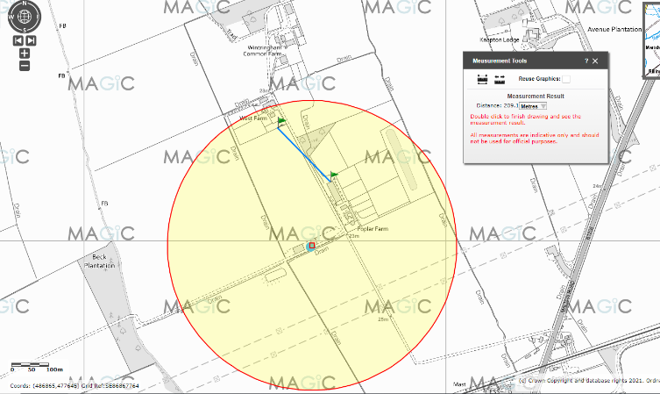
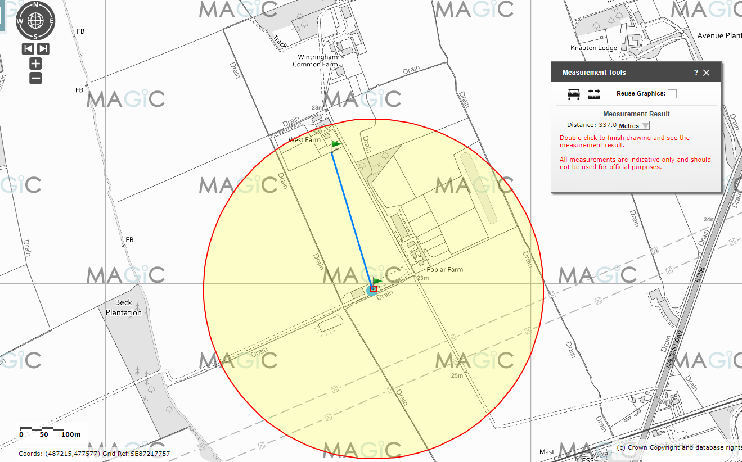

Figure 2 Figure 3
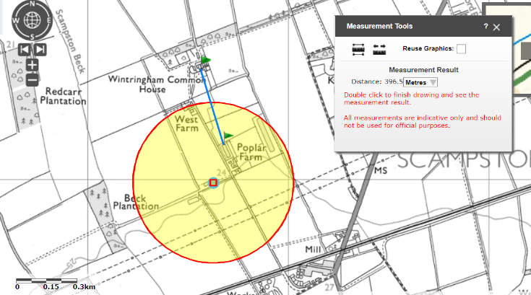
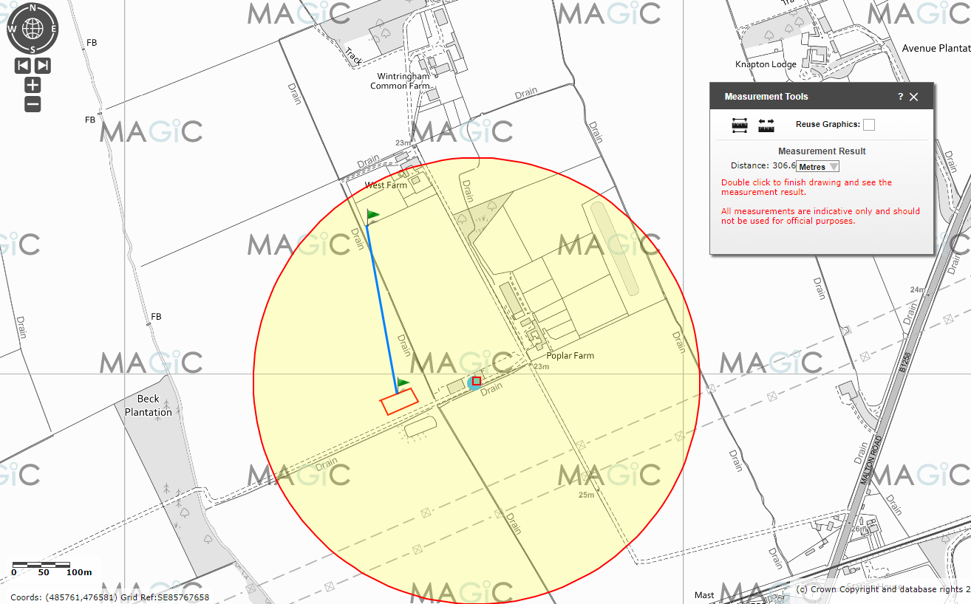 Figure 4 Figure 5
The purpose of this Odour Management Plan is to:
- Establish the likely source of odours arising from the farm
- Set out procedures at the farm in order to mitigate or minimise the risk of odour
- Formalise an effective method of dealing with any odour complaints quickly and efficiently.
Potential odour sources
In accordance with Section 3 of H4 guidance, a risk assessment of odour pollution was performed.
As a result, the following sources have been identified as contributing to a potential medium risk odour source:
- Odour emissions from feed selection
- Odour emissions from slurry storage (under-slats, slurry separation system, slurry tank and solids storage on concrete midden) and removal
- Odour emissions from yard areas
- Odour emissions from housing
- Odour emissions from drinking water systems
- Odour emissions from ventilation
- Odour emissions from cleanout
- Odour emissions from carcase storage and disposal (incinerator)
- Odour emissions from feed storage
- Odour emissions from slurry spreading
- Odour emissions from dust build up

Pathways and receptors
The pathway for all of the above sources is via the atmosphere. With the most sensitive receptors being inhabitants of nearby residential dwellings the wind direction will significantly influence how receptors are affected. We have not received any complaints from neighbours relating to odour in general. The topography of the site and significant tree planting in the surrounding area and the hedgerows contribute to mitigating the risk of bioaerosols reaching the receptors.

Odour related issues | Actions taken to minimise odour | Completion date
Effects of diet on odour and ammonia emissions (feed selection) | - Feed composition is closely matched to pigs’ requirements, especially protein  - Diets are fed to appetite meal or pellet feed, via sealed systems, reducing potential for dust release to the atmosphere  - Gilts are fed two diets, through separate feed bins  - Growing and finishing pigs are fed three different diets, through ad-lib dry system.  - Diets are continually reviewed with a professional nutritionist to ensure good performance  - Records of crude protein levels and diet formulation are kept in the site office. | On-going
Manure storage | - Manure is removed from the site on a monthly basis by 3rd party business. Increased odour emissions are expected when store is out-loaded.  - Yard areas are scraped and cleaned down on a weekly basis to prevent the build-up of dirty water
Slurry/Dirty water storage | - Slurry is exported by 3rd party business to utilise (where necessary will be stored in JSR arable business if it cannot be utilised).  - No separate dirty water storage for the finisher unit  - Unnecessary running of vacuum pumps avoided.  - Slurry piped in enclosed systems from underground pits. Agitation of slurry minimised.  - Increased odour emissions to be expected when store out-loaded, so observe wind direction if cropping/soil constraints allow. Sealed system reduces bio-aerosol creation.  - Slurry removed from buildings frequently to meet BAT standards. | On-going
Cleanliness of yard areas | - Manure from gilt housing is temporarily stored on the impermeable muck pad to be removed frequently by 3rd party business.  - Yards and open surfaces are designed to ensure effective separation of uncontaminated rainwater from slurry and manure  - The slurry collection system works effectively to prevent ponding of slurry, which may release strong odours. | On-going as part of the inspection and maintenance programme
Gilt housing | - Pens well bedded with clean, dry bedding to ensure clean animals and to bind ammonia, scraped out several times a week, and manure is transferred to impermeable muck pad  - All scraped areas within buildings are maintained and managed to prevent ponding  - Bedding material is stored to ensure it is kept clean and dry to prevent wastage and deterioration
New finisher housing / management | - New build is all in line with BAT requirements, as will any future refurbishments  - All pens and stock are checked for cleanliness as part of daily welfare checks  - Potentially odorous spillages (e.g. feed ingredients) are cleaned up promptly  - Stocking density maintained at or below levels set out in Defra Welfare Regulations  - New buildings will be ventilated by high speed roof fans, running at least 7m/sec. These all have chimneys to bring the emission points to >5.5m above ground level. This optimises the ventilation and dispersion (and therefore dilution) of emissions/odours.  - Feeders and drinkers have been designed to prevent wastage  - Pen and wall surfaces are constructed from non-porous smooth surfaces  - Slats maintained in good condition and kept clean of manure build up.  - Temperature and humidity in animal housing is monitored daily and controlled manually to optimise the housed environment for the pigs, and air quality conditions | On-going
Cleaning out | - Cleaning out occurs as soon as possible after destock  - Yards and open surfaces designed to ensure effective separation of uncontaminated rainwater from slurry and manure  - The slurry collection system works effectively to prevent ponding of slurry, which may release strong odours  - Slurry is removed from site on a regular basis | On-going
Ventilation | - Ventilation corresponds to animals’ needs and is checked to be functioning correctly  - Air outlets positioned to optimise dispersion to atmosphere  - Buildings insulated and insulation kept in good order
Animal carcases | - Pig carcases are kept in covered and secured storage and to be collected and disposed of off-site. | On-going
Feed delivery and storage | - Dry feeds are stored in silos. No liquid feed storage.  - The feed storage is checked by the site manager in accordance with the site’s maintenance schedule. Any leaks are repaired and any spillage cleaned up.  - All spillages are cleaned up and disposed of promptly | On-going
Spreading slurry | - Applied to land in the locality owned and managed by the operator (JSR)  - Slurry is exported off site by Scampston Farming Co Ltd and spreading the slurry is their responsibility.  - Spreading is co-ordinated with local weather forecasts and follows NVZ regulations and Defra Code of Good Agricultural Practice.  - Slurry is applied by dribble bar, trailing shoe or injection to reduce creation of bioaerosols.
Dust (especially as an odour vector) | - Unit is relatively isolated so there is minimal risk of dust causing direct odour nuisance  - All dry feed ingredients are stored in covered hoppers/bins | On-going
Dealing with odour complaints | - Any odour complaints will be reported to the Farm Manager who will log and investigate causes of all odour complaints; identifying the source of the odour issue and monitoring odour levels at the site boundary as part of the investigation  - The complaint details and subsequent investigation will be recorded on the site complaint form and a copy will be kept in the site office. | On-going
General comments | - Neighbours will be informed (where necessary) prior to activities which may cause odour  - The effectiveness of odour control measures will be reviewed at least once a year or sooner in the event of any complaint or relevant changes to operations.

Contingency Plan

Abnormal Scenario | Remedial Action | Time Limit
Damage to building | Damage would be repaired asap and, depending on nature of damage, area made safe and covered/contained in the meantime to prevent increased odour emissions and/or destocked in the immediate area if necessary. | Depends on severity of damage and whether environment or animals are at risk.  Immediate action required to make safe.
Slurry store damage or overflow | Significant contingency margin available in JSR stores for exporting slurry so overflow risk low.  If risk of leak/overflow identified and a) can’t be made safe immediately or b) slurry can’t be applied to land due to time of year, weather, ground conditions or other factors; then the slurry will be removed by tanker and exported to nearest alternative stores/lagoons. | If any risk of pollution, immediate action must be taken to remove risk.
Pipework damage | Stop or prevent flow of slurry/contaminated water and repair/replace damaged pipe.  Contain any leak as far as possible.  Contact the Environment Agency if there is any risk of pollution identified. | Immediately stop potential for leak.  Replace/repair pipe asap. Time frame depends on dependency on pipe.

Summary

Odour are assessed daily by operators. Air quality within the buildings is also assessed. Weather monitoring/forecasting, also help to assess the risks and take additional actions to mitigate them if necessary.

We have always worked hard to minimise our impact on our closest receptors and as a result have not had any complaints about bio-aerosol/odour emissions. We continually assess management techniques to improve our control of odours and emissions.

In accordance with H4 Odour Management guidance, we will review the effectiveness of our odour control measures at least once a year and in the light of any building and management changes and on the outcome of investigations into the causes of any future complaints, if any occur.

Any complaints will be recorded and investigated using the guidance from EPR 6.09 3.1 and 3.2 odour and emissions management on intensive livestock installations.

