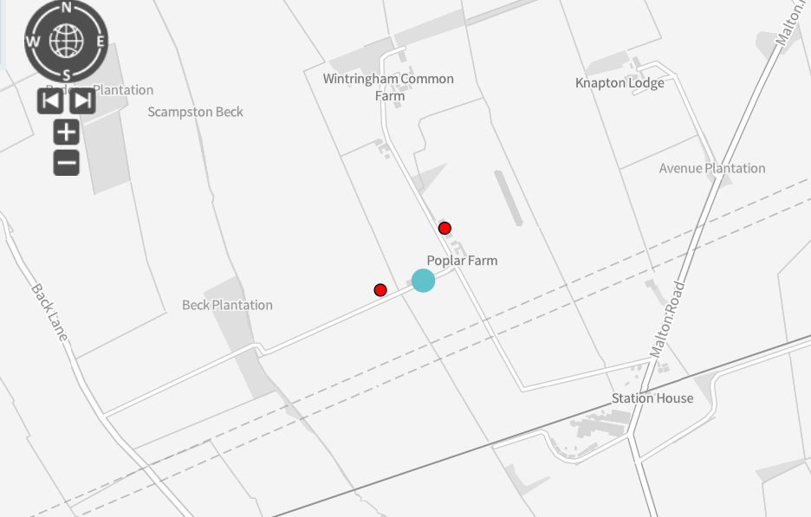
Please see below the two red circles indicate the location of the two units (gilts and finisher) within the Scampston permit which demonstrates both have roads leading to the unit for access for any emergency services if required.

