Scamptson Pig Unit

Dust and Bioaerosols Management Plan

Farm name: Scampston Pig Unit Operator: JSR Farms Permit number:

Date: 22/06/2022 Prepared by: Ellie Stephenson

Introduction
This bespoke dust and bioaerosol risk assessment/management plan has been prepared to support the overall Environmental Management System in place at Illustrative Farm. The overriding principle is to ensure that the day-to-day activities are carried out in accordance with this document to help minimise the overall environmental impact. There is one receptor within 100m of the units and that is Poplar Farm.

Setting
The installation is located at National Grid Reference 486626, 476984 (with a 200m buffer used in the pre-application). Please refer to Site Plans and Supporting Information Document for further maps and diagrams.

Figure 1: Location of both units within the permit (red circles), (blue circle is the grid reference location for the permit).
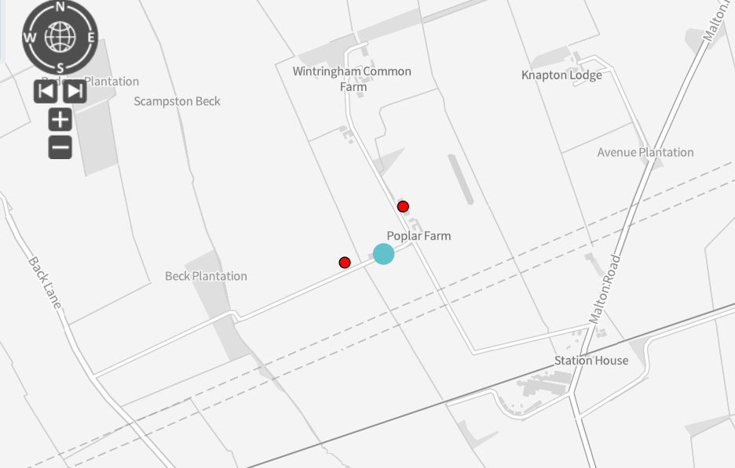

Gilt Unit

Finisher Unit

Figure 2: Receptors within 100m of the gilt and finisher units
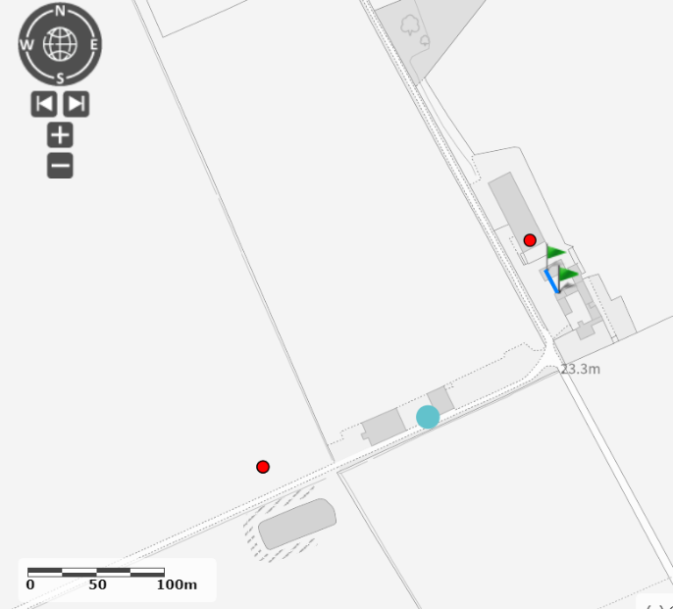

Receptor 1

Receptor locations:

Receptor | Distance from site | Direction | Type of receptor
Receptor 1: Poplar Farm | 20 m | South | Residential / Farm

The purpose of this assessment and Dust and Bioaerosol Risk Management Plan is to:
- Establish the likely source of dust and bioaerosols arising from the farm
- Set out procedures at the farm to mitigate or minimise the risk
- Formalise an effective method of dealing with any complaints quickly and efficiently

Potential sources
In accordance with the document, ‘How to comply with your environmental permit for intensive farming’, Appendix 11 Assessing dust control measures on intensive poultry installations, a risk assessment of dust and bioaerosol pollution was performed.

As a result, the following sources have been identified as contributing to a potential low risk dust/bioaerosol source:

Pathways and receptors
The pathway for all of the above sources is via the atmosphere. With the most sensitive receptors being inhabitants of nearby residential dwellings, the wind direction will significantly influence how receptors are affected. We have not received any complaints from neighbours relating to odour from the farm. The prevailing wind direction is west to east and, therefore, means there isn’t significant risk of odour emissions blowing towards poplar farm and there are control measures in place to minimise

Although the prevailing wind is in the direction of the receptors, there are control measures in place to ensure the minimisation of risk.

Table 2 gives a summary of some of the main at-source and exhaust control methods for particulate reduction from pig farms. In addition, all staff will receive training on all aspects of the farm operation which could lead to pollution, including the odour, noise and dust management plans, dealing with accidents and our general responsibilities under the permit.

Table 2: A summary of at-source and exhaust control methods for particulate reduction from pig farms

Weekly inspection of the site by the operator for any signs of dust, which may leave the installation boundary or be a hazard to staff or visitors.

Source of dust | Example | How is reduction achieved? | Comments
General | Day-to-day activity | Weekly inspection of the site by the operator. | Look for any signs of dust, which may leave the installation boundary or be a hazard to staff or visitors.
Pig feed | Dust from silos | Covers put over feed silo pipes. | Bags or containers would be placed on silo exhausts where necessary to catch any excess feed and dust.
 | Storage of feed | Use of covers for feed containers. | All feed bins have tops on to prevent
 | Feed spill control | Collection of any spilt feed is undertaken to avoid dust being generated.
 | Farm uses dry feed (in form of meal) |  | Good management practice and avoids possible pollution into a watercourse.
 | Feeding method | Pigs are on an ab lib system in the finisher units – there is no peak time of feeding which will avoid excess dust.  Gilts fed several times a day within working hours.  Hoppers are filled carefully to minimise dust emissions.  A material sock is fitted to the end of the auger pipe that delivers the feed directly into the bin where necessary. | Wet feed is becoming more common (not used at Scampston pig unit)
 | Spilled feed is swept up | Any spillages are cleaned up immediately. | The feed delivery into the bin is effectively sealed by the cover.
 | Application of bedding: Straw is added regularly as a manipulable material to the gilt unit | Bedding is applied internally to the building rather than being blown in.  Bedding is stored under cover to maintain quality.  Any visible bedding/dust is swept up.
Bedding material | Slatted, part-slatted or straw-based systems in use | Although dust emissions may be higher from houses using straw-based systems, straw is applied carefully to minimise dust. | Bedding is supplied in bales rather than in bulk.  Bales are opened inside the housing rather than blown in to reduce dust.  Wet straw may contain fungal spores.  Weekly inspection by the operator.
 | Ventilation is carefully controlled, maintained and monitored to meet animal welfare requirements and to ensure efficient productivity
Type of slurry/manure removal system | General management | Weekly inspection by the operator and any visible dust on fans, vents, etc. is removed. | Pigs require careful control of airflow over them as they can be easily disturbed by draughts.  Increased ventilation with fans is often used in summer months.
Ventilation | General management | Good house cleaning between batches is essential to reduce the volume and potential for air contamination within the house and via exhaust system.
House cleaning | Natural and artificial ventilation | Specification and design of ventilation system to provide good air quality for the animals and staff. | Care is taken to avoid dust accumulation around exhaust vents. Cleaning takes place in such a way that does not cause a release of dust to air or water, e.g. dust is not blown off site or washed into surface water drains.
Building layout and design | Housing is designed to minimise the effect of high winds | Screens and windbreaks are used, where possible. | Natural screens also reduce odour, noise and visual impact on the local environment.

Checklist
Options for dust and bioaerosol control at source and exhaust

Source of dust | Example | How is reduction achieved? | Achieved  Yes/No | Comments
Feed | Dust from silos | Covers put over feed silo pipes where appropriate.
 | Storage of feed | All feed silos have lids on top as covers.
 | Feed spill control | Collection of any feed spill is undertaken to avoid dust being generated.
 | Feeding method  Over-administration of feed  Weekly inspection  Application of bedding | Avoidance of spilled feed crushed on the floor by carefully monitoring the process.
 |  | Dust that is in danger of leaving the perimeter is swept up.
 |  | Bedding is applied internally, rather than being blown in.
 | Storage of bedding | Bedding is stored under cover.
 | Weekly inspection | Any stray bedding is swept up.
Bedding material | Part- or fully slatted systems | Slatted systems are used, where possible.
 | Natural or fan ventilated | Ventilation is carefully controlled, maintained and monitored.
 | Weekly inspection | Any visible dust on fans and exhaust outlets is removed.
Slurry/manure removal systems | Good management | Thorough cleaning between batches.
Ventilation | Artificial ventilation | Artificial ventilation is carefully controlled, maintained and monitored.
 | Natural ventilation | Screens and windbreaks kept in good order.

Appendix 1: Dust, bioaerosol and fugitive emissions complaint form
Introduction
Date | Name and details of person making the complaint | Nature of complaint | Action taken

Complaints will be responded to within ….. days (or, refer to standard complaints procedure for the installation, staff training, etc.)

