Noise Management Plan

Farm name: Scampston Pig Unit
Operator: JSR Farms
Permit number: EPR/GP3101LS/A001
Introduction
This Noise Management Plan (NMP) has been prepared to support the overall Environmental Management System in place for the new Scampston Pig and Gilt Unit. The overriding principle of this NMP is to ensure the day-to-day activities are carried out in accordance with this document to help minimise the overall environmental impact and nuisance factor to nearby residents.
There is one agriculturally based sensitive receptor over 100m within 400m of the installation boundary to the North of the site which is a neighbouring farm. There is no history of complaints.
Setting
The installation is located at National Grid Reference 486626, 476984 (with a 200m buffer used in the pre-application). Please refer to Site Plans and Supporting Information Document for further maps and diagrams.
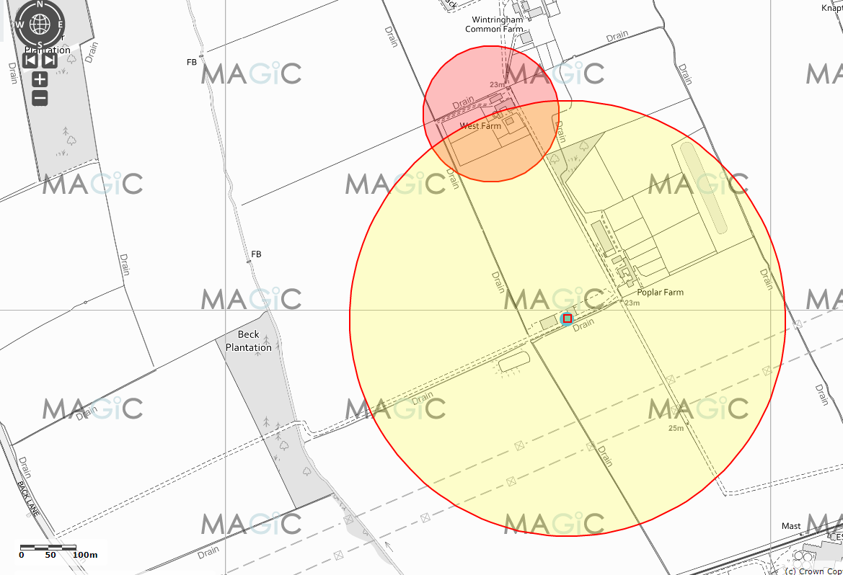
Figure 1 shows the location of the farm and of the receptors (with grid references SE99755376, postcode YO25 9AF) which have been considered in this noise management plan with 400m buffer from the grid reference used in the preapplication.

Scampston Receptor Location Details:
Westland Farm:
Easting = 486510
Northing = 477374
Grid Ref = SE86507737
National Grid Field No = SE 8677 5137
Latitude = 54°11'4.79"N
Longitude = 0°40'27.12"W
Latitude = 54°11.0799'"N
Longitude = 0°40.4520'"W
Latitude = 54.184665
Longitude = -0.674201
Postcode = YO17 6RN

Wintringham Common Farm:
Easting = 486559
Northing = 477551
Grid Ref = SE86557755
National Grid Field No = SE 8677 5555
Latitude = 54°11'10.48"N
Longitude = 0°40'24.20"W
Latitude = 54°11.1747'"N
Longitude = 0°40.4034'"W
Latitude = 54.186246
Longitude = -0.673389
Postcode = YO17 6RL

Distance of Sensitive Receptors from Installation Boundary to nearest point of domestic curtilage.
Figure 2 shows the distance of 337m from the application allocated grid reference to the neighbouring West Farm.
Figure 3 shows the distance of 209.1m from the gilt unit to the nearest receptor, West Farm.
Figure 4 shows the distance of 306.6m from the new finisher unit to the nearest receptor, West Farm.
Figure 5 shows the distance of 390.5m from the gilt unit to Wintringham Farm (the finisher unit is not within 400m of this receptor).
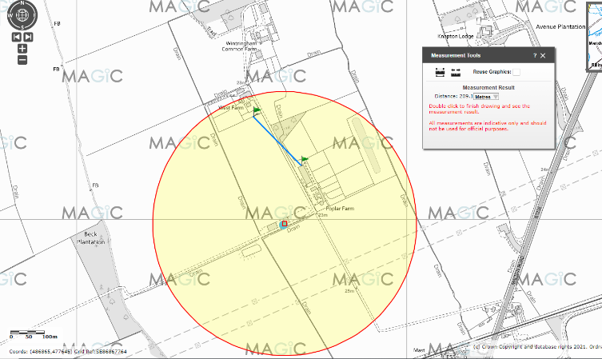
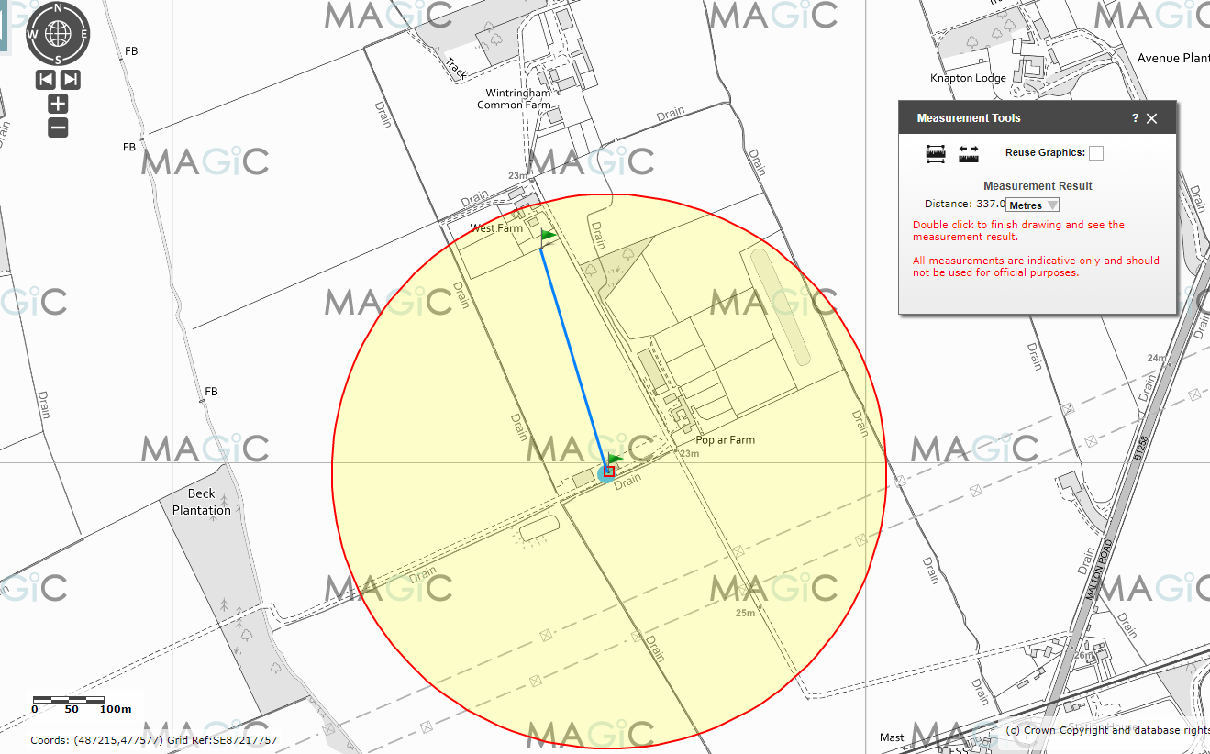

Figure 2 Figure 3
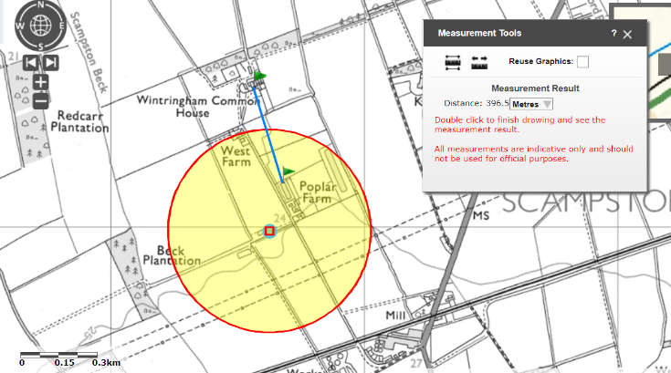
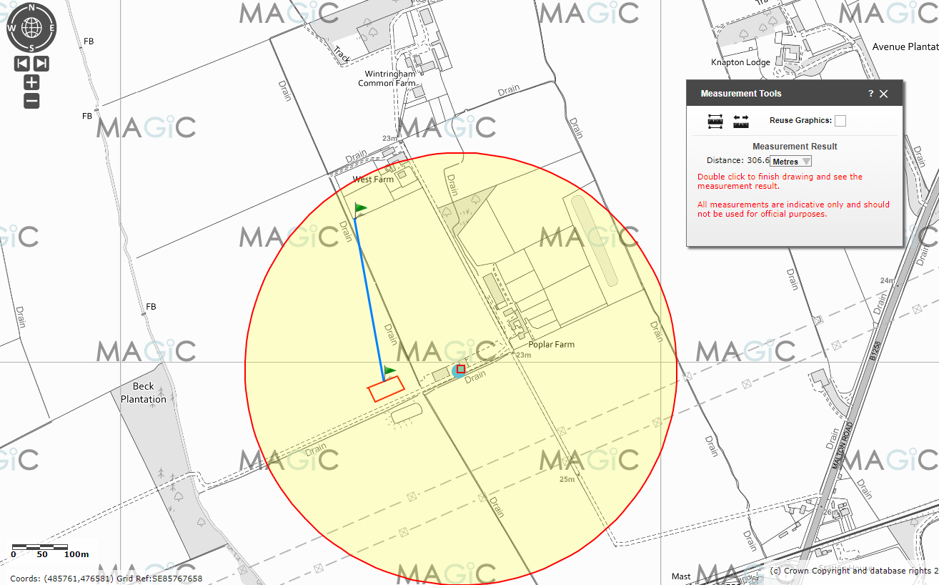 Figure 4 Figure 5
The purpose of this Noise Management Plan is to:
- Establish the likely source of noises arising from the farm
- Set out procedures at the farm in order to mitigate or minimise the risk of noise
- Formalise an effective method of dealing with any noise complaints quickly and efficiently.
This plan will be reviewed in the light of any building and management changes, and on the outcome of investigations into the cause of any future noise complaints, if any occur.
Any noise complaints will be recorded and investigated using the Noise Complaint Report Form Document (also attached).

No. ref | Noise Problem | Actions taken to prevent or minimise noise | Completion Date
1 | Feeding Pigs | Ad-lib system, so no spikes in noise and pig activity due to feeding times within finisher unit.  Gilt feeding is restricted to working day. | In place.
2 | Feed delivery | Blower and vacuum type delivery vehicles fitted with low noise units. | In place
3 | Feed preparation | No milling and mixing on farm. | N/A
4 | Pig moving | Pigs moved during the working hours and maintained in stable batches / age groups for the gilts. | In place
5 | Pig loading, in and out | Few movements as possible. Short duration. Aim to minimise animal stress. | In place
6 | Bedding pens | Loader used for transport, engine revs kept low, effective silencer  Mainly carried out during working day, limited at weekends/bank holidays | In place
7 | Mucking out | Loader used, engine revs kept low, effective silencer  Mainly during working day, limited at weekends/bank holidays | In place
8 | Slurry transfer pump | Gravity for channels out of the underslat pits, underslats pumped emptied frequently. | In place
9 | Slurry tanker filling and emptying | Intermittent activity.  High output equipment  reduces working hours.  Engine revs kept low  where possible. All  equipment regularly  serviced and operated to current standards. | In place
10 | Manure loading/transport and spreading | Intermittent activity  High output equipment reduces working hours  Engine revs kept low, where possible  All equipment regularly serviced and operated to current standards | In place
11 | Delivery of supplies and materials | Typically small deliveries during normal working hours by arrangement. Low perceived impact. | In place
12 | Ventilation fans (for finisher unit) | Fans with automatic controllers set to maintain optimum environmental conditions within buildings. Efficient, quiet, fan types selected. Regular maintenance and cleaning takes place. Natural ventilation at gilt growout. | In place
13 | Vehicles operating within installation boundary | Operations mainly carried out during normal working hours. Vehicles maintained in accordance with manufacturer's recommendations, and defective silencers replaced. Audible reversing signals required for safety purposes.  Yards maintained to repair holes.  Minimal and infrequent use of heavy vehicles on site, due to the system type. | In place
14 | Alarms | Alarm system rings key personnel as well as emitting audible alarm on site. This increases the likelihood of prompt action should the alarm system be triggered. And the fact that off-site personnel are also contacted, reduces the chance of continual sounding of the alarms when staff are not present on site e.g. overnight. | In place
Summary
Noise levels are assessed by Estate Office staff/permit operators and pig unit staff.
We have always worked hard to minimise our impact on our closest receptors and as a result have not had any complaints about noise. We continually assess management techniques to improve our control of noise pollution.
This plan will be reviewed in the light of any building and management changes, and on the outcome of investigations into the causes of any future complaints, if any occur.
Any noise complaints will be reported to the unit manager who will log and investigate causes of all complaints; identifying the source of the noise issue and monitoring noise levels at the site boundary as part of the investigation. The complaint details and subsequent investigation will be recorded on the site complaint form and a copy will be kept in the site office.

