Revision | 1.0 | Approved by: | Diane Rainsford
Date Revised | September 2022 | Authorised by | Steve Andrew
Environmental Risk Assessment
Libatt Recycling Limited
Diane Rainsford
2022
Contents
1. Introduction 2
2. Potential Hazards 2
2.1 Pathways 2
2.2 Receptors 3
3. Risk Assessment 3
4. Summary 3

Introduction
Libatt Recycling Ltd have documented this environmental risk assessment to support the application of a significant variation of the permit for their Lincoln Street site from oil storage activities to a multi process site to include the storage and recycling of Lithium-Ion Batteries.
This Environmental Risk Assessment (ERA) is limited to qualitative assessment of the potential risks to the environment and human health specifically related to the planned activities to be undertaken by Libatt Recycling Ltd.
Environmental Risk Assessment
Methodology
This risk assessment addresses the above risks and is based on the following methodology:
- Identification of potential risks
- Identification of all potential receptors to these risks
- An assessment of each risk type.
The Environmental Risk Assessment (Appendix A) assesses the risks to the environment and human health from activities carried out at the John Jones site and identifies the pollutant linkage
i.e. source – pathway – receptor for each risk type.

2. Potential Hazards
- Odour:
  - Waste materials
- Noise and vibration:
  - Engine noise from vehicles
  - Use of reverse vehicle warnings
  - Use of plant and machinery
- Fugitive emissions:
  - Particulate matter i.e. dust
- Accidents
  - Fire
  - Leaks and spillages
  - Flooding
  - Unauthorised access

2.1 Pathways
The pathways identified for each risk type are shown in table 1 below
Table 1: Potential Pathways
Risk Type | Pathway
Odour | Air
Noise and Vibration | Air
Fugitive Emissions | Air
Accidents | Air
 | Surface water run-off
 | Infiltration
 | Percolation

2.2 Receptors
Receptors within 1km of the application site have been identified and are shown in Table 2 below and in the Sensitive Receptor Plan (Appendix B). The main pathway for the identified sources is the air and as such, atmospheric conditions can affect dispersion rates and the potential risk. Therefore, the location of each receptor in relation to the site may influence the potential impact of the risk, as summarised in Table 2.
Table 2: Location of potential receptors in relation to waste operations
Sensitive Locations
Boundary | Closest property | Approximate distance to site boundary (m)
North | Flats and Residential Housing | 100
East | Flats and Residential Housing | 200
North | 2 Sisters Food Group | 100
South | Flats and Residential Housing | 600
South | East Field Junior School | 1000
North | St Stephens Primary School | 1000
North | Woden Primary School | 1000
West | University of Wolverhampton | 1000
South | Birmingham Canal | 600

3. Risk Assessment
The Environmental Risk Assessment (Appendix A) looks at each specific hazard identified and assesses the likelihood of those hazards impacting on nearby receptors. This is achieved by fulfilling the following objectives:
- Identify the location and nature of each hazard
- Identify the specific receptors potentially at risk and assess the sensitivity of each receptor
- Provide an assessment of the risk posed to each sensitive receptor
- Identify management and monitoring techniques to remove or mitigate the risk
- Provide recommendations for more detailed assessments where necessary.

4. Summary
The Environmental Risk Assessment indicates that if the appropriate outlined management techniques are implemented at the site to protect nearby sensitive receptors, the proposed activities as part of the permit application will have no significant impacts in terms of odour, noise and fugitive emissions, and the likelihood of accidents is minimal

Appendix A: Risk Assessment
What is the risk? |  |  | Managing the risk | Assessing the risk
Hazard | Receptor | Pathway | Risk Management Techniques | Probability of exposure | Consequence | Overall risk
Airborne lead dusts from the process | Workforce  Nearby Business  Local Flora/Fauna | Air | Lithium Battery processing contained within the building. Doors will be kept closed except for access/egress to the building | Very Low | Nuisance to local environment if dust is not contained (In the long term, dust has the potential to cause respiratory issues in workforce or people at nearby businesses) | Very Low
 |  |  | The sources of dust emissions to air have been identified and a Dust Management Plan has been prepared to capture dust within the process and to prevent any potential dust emissions from leaving the processing building and reaching nearby receptors
 |  |  | Maintenance and thorough examination of the LEV system which has been designed to collect the dust created during the recycling process.
 |  |  | Annual air monitoring
Flooding: waste washed oﬀ site because of a ﬂood | Local area | Flood | Waste stored in secure containers, and site is protected by drainage system which collects all run oﬀ and diverts it to a specialist oil/sludge interceptor | Low  Local ﬂood risk is 1 so it is an unlikely scenario | If waste is washed off site it may contaminate buildings / gardens / natural habitats | Low
Release of Bulk Liquids from primary containment (Oil stored as bulk liquid) | Land and surface water | Surface water drains and ground | Bulk liquids are stored within the operational plant which is bunded suﬃcient to contain >110% of the contents of the primary bunding.  Maintenance of plant and equipment and secondary containment | Very Low if control measures are adhered to and any escape from primary containment would be contained within secondary containment. | Liquid would spill into the secondary containment | Very Low
Noise & Vibration from the battery recycling process | Local population in residential dwellings and sensitive land uses listed in Table 2.  Nearby Businesses | Air and vibration | Al noise generating activities will be undertaken between the hours of 8:00 to 17:00 Monday to Friday and occasional 08:00 to 13: on Saturdays, except for emergency repairs. No operations would take place on Sundays or recognised Bank Holidays.  All plant and machinery will have effective silencers where practicable and will be maintained in accordance with the manufacturers recommendations and observing the guidance of PUWER to minimise the risk of mechanical failure which could result in increased noise emissions.  The loading and unloading of wastes will be undertaken in a controlled manner to keep noise/vibration to a minimum.  All noise and vibration generating activity will be monitored closely and site operatives will be vigilant and report excessive noise or vibration issues to the Site Manager.  Noise and Vibration will be managed in accordance with the Noise and Vibration plan which will be documented once the site enters a testing phase and before it is operational.  The recycling operation is situated in an enclosed building which will act as a barrier and prevent noise from travelling off site. The Site Manager will monitor noise levels at the boundary | Intermittent noise disturbance | Noise annoyance and complaints | Low
Vehicle Movements on site | Local population in residential dwellings and sensitive land uses listed in Table 2.  Nearby Businesses | Air | Loads will only be delivered to site during working hours (08:00 to 17:00 Monday to Friday and occasional 08:00 to 13: on Saturdays)  Deliveries and collections will take place in a controlled manner to keep noise to a minimum  An anti-idling policy ensures that all equipment and vehicles when not in regular use shall be switched off. The Site Manager will be responsible for ensuring the above measures are implemented.  All noise generated by vehicle movements will be monitored closely and site operatives will be vigilant and report any excessive noise issues to the Site Manager  Vehicle Movements will be managed in accordance with the Noise and Vibration plan which will be documented once the site enters a testing phase and before it is operational. | Intermittent during operating hours | Intermittent noise and vibration disturbance | Low
Noise from reversing vehicle warnings. | Local population in residential dwellings and sensitive land uses listed in Table 2.  Nearby Businesses | Air | Vehicle movements on site will be limited to working hours (08:00 to 17:00 Monday to Friday and occasional 08:00 to 13: on Saturdays) except for emergency repairs.  Deliveries and collections will take place in a controlled manner to keep noise to a minimum  The site will be organised in a way which minimises the reversing of vehicles. There is only one entrance/exit to the site but a road exists around the site to allow vehicles to pull off the weighbridge and drive around the site to exit.  All noise and vibration generating activity will be monitored closely and site operatives will be vigilant and report any excessive noise or vibration issues to the Site Manager | Intermittent during operating hours | Intermittent noise disturbance | Low
Dust emissions from vehicle movements | Local population in residential dwellings and sensitive land uses listed in Table 2.  Nearby Businesses  Site Staff  Users of roads listed in Table 2 | Air transport then deposition | Wastes delivered to site (Batteries/Oil) are not considered to emit dust.  Wastes collected from site will be covered or sheeted to prevent the generation of dust while the waste is in transit  Vehicle speeds will be limited onsite and the access road to  5mph to prevent re-suspension and movement of dust.  All equipment and vehicles when not in regular use shall be  switched off to minimise the risk of dust emissions that may  arise from idling.  The site benefits from concrete surfaces so there is no requirement for a dust suppression system but the site will be swept by external contractors periodically or as required to minimise any dust build up.  The Site Manager undertakes a daily visual assessment of dust  levels and all site operatives will be vigilant and report any problems to the site manager. | Unlikely due to measures in place | Local nuisance  i.e. dust on cars, clothing, and vegetation.  Nutrient enrichment. | Low
Release of particulate matter (dusts), vapours and polluting gases | Local population in residential dwellings and sensitive land uses listed in Table 2. | Air transport then inhalation | The potential sources of fugitive emissions to air have been identified and a Dust Management Plan has been prepared to prevent any potential dust emissions from reaching nearby receptors  Air monitoring will be carried out annually to measure the levels of dust and vapours on the site taking into consideration the WEL of particulates identified.  The Site Manager undertakes visual assessment of dust levels, and all site operatives will be vigilant and report any problems to the Site Manager | Unlikely due to measures in place | Respiratory Illness | Low
Contaminated rainwater run-off | Surface water and groundwater  Waterways listed in Table 2 | Water | The potential sources of fugitive emissions to ground and water through spills or leaching have been identified as oil from the oil storage activities and electrolyte which is a waste product generated in the recycling of Li-Ion Batteries. Controls have been put in place for the storage of these 2 types of liquids in bunds.  Bunds are periodically inspected and maintained by external contractors  The site manager undertakes a weekly visual assessment of the bunds, and all site operatives will be vigilant and report any problems to the Site Manager immediately. | Unlikely due to measures in place | Contamination of groundwater surface water bodies | Low
Litter | All receptors listed in Table 2 | Air transport then deposition | Waste types received by the site generally do not contain litter. Operatives will be vigilant, and any litter reported will be removed immediately.  There are strict waste acceptance procedures in place at the  site to prevent the acceptance of non-conforming waste types.  Details of the waste acceptance procedures are provided in the  EMS.  Any waste containers containing waste which has the potential to escape as litter will be covered.  All waste collected from site will be covered or sheeted to prevent the escape of waste  Working areas will be regularly cleared and inspected to  minimise litter. Housekeeping measures are in place during  operating hours. | Unlikely due to measures in place | Local nuisance | Low
Fire or failure to contain firewater | Air transport then  inhalation or deposition  Groundwater and surface  water.  Local residents listed in Table 2 | Air/wind & materials can spread ﬁre, and ﬁrewater run-oﬀ can transport potentially contaminated water via watercourse | The risk of fire is considered to be medium as the waste types have the potential to be combustible when they arrive on site as unsafe batteries.  Consultation with waste carriers to ensure that battery chemistries are packaged and transported correctly.  There are strict waste acceptance procedures in place to ensure that these batteries are identified and made safe immediately to prevent the risk of fire.  Separation of incompatible / combustible materials and ignition sources to remove potential ignition sources  The risk of fire has been identified and suitable controls for the detection and suppression of fire have been put in place and documented in the Fire Management Plan.  All site operatives are required to recognise signs of fire potential at the point of reception. such wastes shall remain or be placed in fire safe battery boxes and removed to a safe area and the Site Manager shall be informed.  Fuel is stored in a double bunded and locked secure tanks so  leaks from fuel which may contribute to a fire on site are  unlikely  Site notices and training will be undertaken regarding fire hazards  The Site Manager will be responsible for actions in the event of a fire.  No smoking policy on-site  Minimise stockpile, incorporate ﬁre-breaks in material storage | Unlikely due to measures in place | Contamination of local groundwater and or surface water | Low
Leaks and spillages of oil or fuel | Ground water and surface water  Waterways listed in Table 2 | Infiltration | There are procedures in place for the receipt, storage, and collection of waste oil  The oil tanks are maintained and inspected periodically and are situated in a bund with the capacity to store 110% of the tank capacity.  Operatives competent in the oil acceptance and transfer procedures are always on site  Fuel is stored in a double bunded and locked secure tanks so  leaks from fuel are unlikely.  Daily vehicle / plant checks to ensure any fuel/oil leaks etc.  are repaired as soon as possible  The site manager makes daily visual checks of the fuel storage areas and the oil storage tank farm.  The site will follow secondary risk management provisions  such as spill kits, emergency response procedures as  detailed in the site EMS and staff training to manage spills.  The Site Manager will be responsible for ensuring effective  remediation and documenting any incident | Unlikely due to measures in place | Contamination of land and watercourses | Low
Flooding | Ground water | Infiltration and percolation | The site is not located in an area at risk of flooding from rivers or surface waters.  Waste stored on site is unlikely to cause contamination of groundwaters through infiltration as they will be covered or protected from the ingress of water. | Unlikely due to the location of the site | disruption to works operations  Contamination of local groundwater and or surface water | Very Low
Vandalism | Groundwater  All receptors listed in Table 2 | Unauthorised entry to site | The site has site security measures in place starting at the gate which is locked at all times and access is only granted to visitors and contractors who are expected/permitted on site.  Access to the waste and other process areas will be restricted to trained operatives and other permitted employees of the company  Contractors on site will either be accompanied and supervised or be working in accordance with a Permit to Work.  Procedures are in place which require all visitors to the site to  sign in on arrival and sign out on departure. | Unlikely due to measures in place | Release of polluting materials to air, water or land | Low
All on-site hazards from  wastes; machinery and vehicles | Local human population gaining unauthorised entry to the site, site staff and contractors. | direct physical contact | Activities are managed and operated in accordance with the integrated management system which include measures to prevent unauthorised access. Wastes, machinery and vehicles will be handled by trained site operatives | Unlikely due to measures in place | Injury or ill health effects | Low

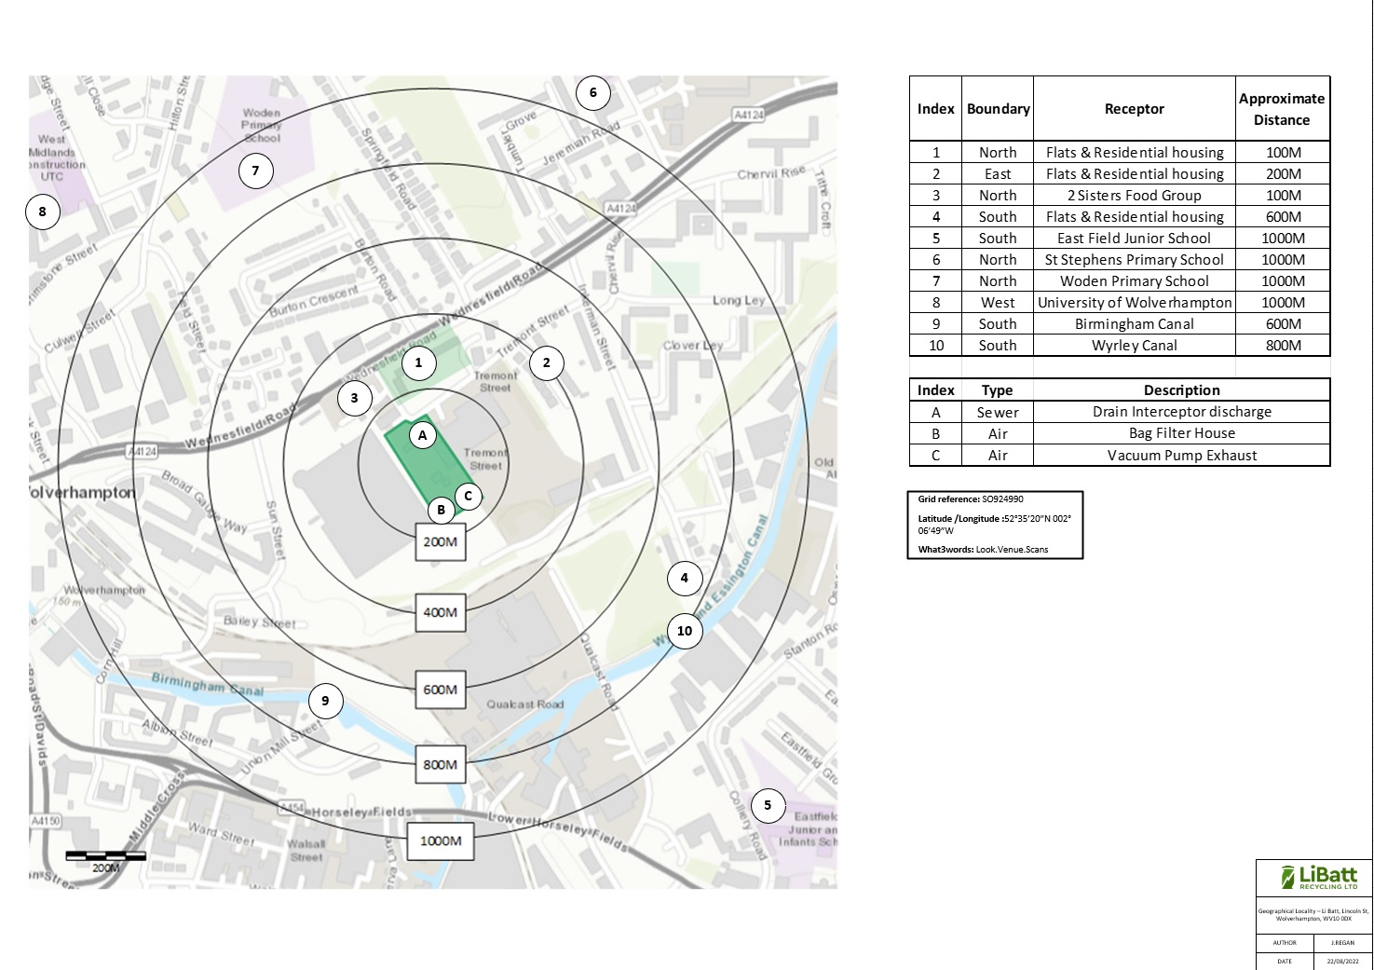
Appendix B

