Accident Management, Fire Prevention & Emergency Response Plan

Prepared to support Environmental Permit application

Applicant Name: LiBatt Recycling Limited

DOCUMENT CONTROL SHEET

Author | Steve Andrew
Signed
Date | 25th September 2022
Reviewer
Signed
Date
Approver
Signed
Date
EA Approver
Signed
Date
To be reviewed | Annually or upon changes to site

Distribution List
Environment Agency (EA)

Site details
Site name: LiBatt Recycling Ltd
Site address: Lincoln Street, Wolverhampton, WV10 0DX
Operator name: Recyclus Group
Grid reference: SO924990
Latitude/ Longitude: 52°35’20”N 002°06’49”W
What3words: Look.Venue.Scans

Key Site Information
Environmental Permit No: EPR/BP3949QN
Permit Holder: LiBatt Recycling Limited
Responsible Person: Jon Regan
Emergency Contact Numbers:
Police, Fire, Ambulance: 999
Environment Agency: 0370 850 6506
Local Environmental Health Authority:

Operator Contacts
Site Contact: Jon Regan
Out of Hours:

Security Contractors – N/A

This plan is to be read by all staff members, fire officers and contractors working on site.

Introduction 1
Activities at the Site & Operational Process 1
Explanation of Process Steps 1
Consultation 1
Collection 2
Quarantine 2
Safe Storage (Pre-Processing Storage) 2
Disassembly 2
Re-Certification 2
Material Processing 3
Material Storage 3
Transport 3
Delivery 3
Waste Acceptance procedures 5
Acceptance of batteries deemed safe at point of production 8
Acceptance of batteries deemed unsafe at point of production 8
Hot Loads 8
Pre-Processing Storage 9
EV Power Unit Processing 9
Site Context & Sensitive Receptor Plan 10
Site Layout 10
Managing the Common Causes of Fire 10
Arson 11
Plant & Equipment 12
Electric Faults 12
Discarded Smoking Materials 12
Hot Works 12
Industrial Heaters 13
Hot Exhaust 13
Leaks & Spillage of Oils and Fuel 13
Build-up of loose and combustible waste, dust and fluff 13
Combustible Non-Waste 13
Reaction Between Wastes 13
Waste Storage 15
Waste storage, segregation and handling 15
HSG51 Storage of flammable liquids in containers 15
HSG71 Chemical warehousing: storage of packaged dangerous substances 15
HSG76 Warehousing and storage: a guide to health and safety 15
HSG140 Safe use and handling of flammable liquids 15
HSG176 Storage of flammable liquids in tanks 15
Guidance: Fire prevention plans: environmental permits (updated 11 January 2021) 15
9. Manage waste piles 15
9.1 Maximum pile sizes 15
Preventing Self-Combustion 16
Actions to Prevent External Heating from Direct Sunlight 16
Manage Waste Piles 16
Maximum Pile Sizes 16
EV Power Unit Storage 17
Battery Cell Storage 18
Preventing Fire Spreading 18
Guidance: Fire prevention plans: environmental permits (updated 11 January 2021) 18
11. Prevent fire spreading 18
11.1 Separation distances 18
11.2 Fire walls and bays 18
Legato Blocks 20
Quarantine Facilities Area - Batteries 20
Fire Detection 21
Fire Fighting Techniques 21
Guidance: Fire prevention plans: environmental permits (updated 11 January 2021) 21
14. Suppressing fires 21
16. Water supplies 22
Fire Water Containment 23
Guidance: Fire prevention plans: environmental permits (updated 11 January 2021) 23
17. Managing fire water 23
Accidental Release Management Plan 24
Contingency Planning 28
Prevailing Wind Direction 29
Appendix I - Sensitive Receptors within 1km of the Site & Contact Details 30
Appendix 31
Appendix III Storage Building Layout Plan 32
Appendix IV Site Maintenance Checklist 33
Appendix V - Vermiculite Safety Data Sheet 19
Emergency Response Plan 26
SECTION R1 – Introduction 26
SECTION R2 – Scope 27
SECTION R3 – Emergency Declaration 28
CHECKLIST INFORMATION 30
Emergency Plan Zone Allocations 31
SECTION R4 – Key Roles for Emergency Response 33
SECTION R5 – Roles & Responsibilities 33
INCIDENT CONTROLLER 34
SITE CONTROLLER 35
EVACUATION MARSHALL 37
ROLL CALLER 38
SITE CONTROLLER SUPPORT 39
SECTION R6 – Immediate Action to Be Taken In Response To An Emergency Situation 40
SECTION R7 – Follow Up Action 42
SECTION R8 – Out of Normal Hours Emergency Incidents. 43
SECTION R9 – Other Information 45

Introduction

This Accident Management, Fire Prevention & Emergency Response Plan (FPRP) has been produced to support permit variation application EPR/BP3949QN for a Bespoke Rules Permit, allowing the storage and treatment of waste Lithium-Ion batteries and/or their material components.

The main feed input to the site is Lithium-Ion Batteries, however the site also stores waste oil. The processing plant recycles batteries and produces a number of products, each with their own inherent hazards.

The plan is designed to address the issues of waste containment, waste storage, fire, and other accidental emissions.
The fire prevention measures in this plan have been designed to meet these objectives:
  - Minimise the likelihood of a fire happening
  - Aim for any fire to be extinguished within 4 hours
  - Minimise the spread of fire within the site and to neighbouring sites
  - Communicate to the local authorities
Environment Agency guidance¹ for producing a Fire Prevention Plan (FPP) has been used to inform the production of this FPRP. Where any part of this Agency FPP guidance is deviated from, alternative measures suggested will still meet the 4 objectives.

Activities at the Site & Operational Process

Activities to be undertaken at the site will consist of the acceptance, storage, discharge, testing and dismantling, and recycling of various types of lithium-ion battery including automotive, industrial and portable batteries from various sources into their material components and materials for onward refining or testing and approving for re-use.

The site also operates a waste oil storage facility for collection, bulking and redistribution of waste oils.

Explanation of Process Steps

Consultation

New and Existing customers will be subject to due diligence checks and given the appropriate level of ongoing support to comply with all legislation, compliance and best practice.

This gains the company confidence in transporting and receiving correctly identified goods in accordance with high safety expectations.

Collection
Both Customers and Drivers will be given support and training specific to the expectations of packaging and compliance for lithium-ion batteries.
Drivers will be offered additional support in the event of emergencies.
Figure 1 below shows the high-level battery recycling process at the site.

Quarantine
There are two separate quarantine areas for this site. One deals with unexpected waste and the other deals with issues arising from the storage and treatment of the hazardous wastes, namely Lithium-Ion batteries.
Any battery transported as RED or YELLOW under the classification in the waste acceptance procedures will be immediately inspected and quarantined on site until directly recycled.
Additionally, batteries that are classified either on collection or first inspection on arrival as RED or YELLOW will be quarantined and their recycling path updated.
The batteries will be stored in UN approved storage containers specific to the type of material contained and it is intended to install ‘LEGATO’ style concrete block bays with lockable steel gates.

Safe Storage (Pre-Processing Storage)
Batteries classified as GREEN will be stored in the inbound processing area in dedicated bays formed of ‘LEGATO’ style concrete blocks as firewalls, with 1.5M of freeboard space above. Additionally employing standard industry practices of separation distances.

Disassembly
Any item requiring dismantling or reduction for recycling will be disassembled appropriately, in addition some items may require investigatory work as requested by the client to determine the root cause of the product failure.

Re-Certification
Some of the inbound batteries may be eligible for a ‘Second-Life’ opportunity, this will be carried out in a separate controlled area and the process will explore the battery health; thus collecting data and determining the safest approach for ensuring the battery is appropriate for another application.

Material Processing
Batteries, Modules and Cells are processed through a unique plant that LiBatt has developed itself in a controlled atmosphere. This takes the 3 varieties of battery construction and recovers the materials and constituent parts for further refining.

Material Storage
The safe storage of processed products and their separation. Similar to the practices of the pre-processing storage, the material storage despite being considered less hazardous than the pre-processing product will still employ the same safety architecture of ‘LEGATO’ style block bays and separation distances.

Transport
Outbound materials will be routinely packaged into UN compliant and standardised packaging, and in line with ADR regulations.

Delivery
Outbound whole battery products will be routinely packaged into compliant and standardised packaging for ADR transport as all products will be applicable as UN3480.

1 Fire Prevention Plans: Environmental Permits Environment Agency Guidance Published 29 July 2016

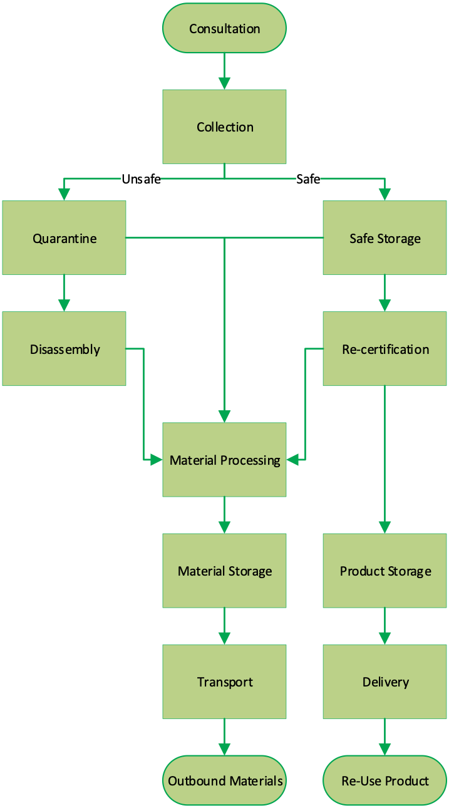
  - Figure 1: Basic Recycling Process Map

Waste Acceptance procedures

The only materials that are intentionally delivered to site are Lithium batteries and waste oil. All other types of waste that arrive on site are classified as unexpected waste and dealt with as per the unexpected waste procedure which is part of the management system.

The pre-acceptance of waste allows the company to vet the supplier and the supplier is under an obligation to supply only what is shown on the waste transfer or duty of care notice which accompanies the delivery.

Unexpected waste can include non-Lithium Batteries. This is normally due to poor practice and poor identification protocols at the supplier end.

The company does not accept any gas cylinders, radioactive materials, asbestos products or chemical wastes. Nor does it accept untreated, un-depolluted end-of-life vehicles (ELV’s).

As all deliveries to site are inspected prior to, and during, unloading, there is a protocol to ensure that any of these unexpected wastes are left on the lorry and returned to the supplier. This procedure is discussed in the document titled Appendix 6 Best Available Techniques Explanation.pdf

All batteries received will have undergone diagnostics checks before the point of collection by a suitable competent and trained technician who will identify and classify as either safe or unsafe, this assessment applies a traffic light system. For example, if the battery is deemed to be safe the traffic light system would indicate green. If the client does not have access to a suitably competent person, then LiBatt will provide consultation.
If the battery unit is deemed safe, then the waste producer will package the battery as per ADR compliant packaging and the customer will deliver in line with contractual obligations.

If the battery is determined to be unsafe, then a form as shown in Figure 2 will be completed and LiBatt will deliver appropriate packaging for the unit to be transported in.
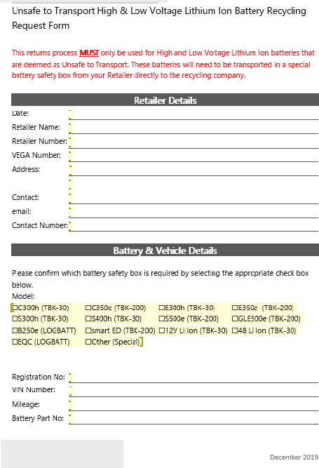

  - Figure 2 An example of a notification of unsafe EV power unit form

Classification | Details | Collection
 | Red Classification: Any Battery that has suffered a partial thermal event, or deemed at risk of a thermal event by a suitably qualified operative | Collection will be by ADR regulations utilising approved Group I packaging employing suitable packaging methods:  - Vermiculite  - Pyro Bubble  - Dry Ice
 | Yellow/Amber Classification: Any Battery that cannot be confirmed as safe to transport, this could be due to instrumentation failure but will be classified by a suitable qualified operative | Collection will be by ADR regulations utilising approved Group I packaging employing suitable packaging methods:  - Vermiculite  - Pyro Bubble  - Dry Ice
 | Green Classification:  Any Battery that has been assessed and proven to be safe to transport. All safety mechanisms and instrumentation is proven functional and is reporting the battery capacity is no longer suitable for the design application (fair wear and tear) | Collection will be by a minimum of ADR Group II packaging employing and adhering to the relevant packaging instruction.

The above pre acceptance procedures ensure that LiBatt has full knowledge of the condition of each unit coming to the site, each having been assessed as required contractually ensuring units arrive in the correct packaging for their specification size and condition.

Acceptance of batteries deemed safe at point of production

The waste products will arrive at the site either as individual units in containment boxes, or individually packaged and stored on pallets. Other batteries may arrive packaged together on a pallet. Some traction batteries may be oversized so suitable safe packaging will be provisioned either by LiBatt or the Client.

On arrival at the site each package is visually inspected and scanned using a calibrated thermal imaging camera to ensure the unit is still safe after transport and therefore safe for storage.

Acceptance of batteries deemed unsafe at point of production

Any battery found to be unsafe will be transported in approved Group I packaging, and in line with the relevant ADR packaging instruction. These will be isolated in quarantine upon arrival before being transferred to recycling at the earliest operational opportunity.

For units requiring assessment on the customers behalf, a minimum period of 24 hours before opening the unit will be required and then the unit will be either re-checked, triaged or made safe immediately after being removed from the box.

LiBatt will assign each package a unique ticket number when the customer raises a collection request. Any automotive or industrial power unit is physically labelled when the unit is removed from transport at the LiBatt depot and weighed. This ticket will stay with the unit until it has been completely dismantled ore recycled and the materials have been transferred into designated bins with their own unique identifiers. This will ensure each unit received can be tracked through the process and back to source customer, thus facilitating effective stock control and there is an audit trail back to source.

Hot Loads

In order to classify a load as Hot it necessary to designate a warning temperature level. A battery or cell that is showing critical is widely determined as 80°C, as these units will be disconnected from their equipment they should not see temperature at all unless subject to an issue, so the warning temperature level will be set at 50°C to avoid ambiguity and altering weather influences.

The handling procedure for any battery units found to be excessively hot depends on the stage of the process on which the unit or package achieved the excessively hot state. This could be either:
  - Upon arrival at site
  - In storage
  - During disassembly
  - During handling or transfer.

The checking of incoming EV power units will be conducted as described above therefore this section addresses the risk of temperature elevation when undergoing discharge. The temperature of EV unit power units will be monitored from the surface of the box containing the unit during the course of discharge.

If the EV power unit achieves 50ºc then any discharge will stop and the EV power unit will then be monitored every 5minutes for a decreasing temperature. If the EV power unit continues to increase in temperature and passes 60ºc, the unit will immediately be put into an incident control box and removed from the building and placed outside within the covered isolation facility and monitored until the temperature drops below 30 ºc.

Upon arrival at the site the delivery vehicle will be directed to the EV battery processing building. When they enter the building the boxes/ pallets will be offloaded from the delivering vehicle using horizontal roof cranes installed within the building. They will be placed in reception areas pending assessment.

The preliminary assessment will be undertaken by a specially trained Technician as follows.
  - Undertake a visual assessment of each EV power unit to ensure it has not been compromised in transit and also it has been described correctly.
  - Assess the EV power unit temperature using a thermal imaging camera and a gas monitor worn at all times.

EV power units identified as having elevated temperature will be placed immediately into a incident control box and then moved to the covered isolation facility in the external yard where its condition will be monitored. EV power units deemed to be in safe condition will be stored pending processing.

Pre-Processing Storage

EV power units will be stored within fireproof bays constructed from concrete Legato blocks in quantities no greater than 8m³ per stack, no more than 3 stacks per bay.
Any EV power unit in armoured packaging due to instability but now regarded as safe will be placed in a separate bay awaiting further assessment prior to processing once rendered safe.

EV Power Unit Processing

Prior to discharge each EV power unit will be subject to assessment via routine voltage measurement. Once the safety has been proven the pack can be discharged at module level. This will involve the following steps:

- removal of cables to reduce the energised components which reduces the risk of electrical exposure. This stage of the process is undertaken using insulated manual tools.
- Attach each EV power unit to the discharge unit. It takes around 2 hours to undertake a deep cycle and render each unit safe.

If any issues arise during the course of the process, it will be brought to the attention of the management or a senior technician who will assess the risk.

Once discharged the EV Power Unit will be moved to the dismantling area where it will be disassembled, and the elements removed for onward recycling. This will leave the discharged power module or cell which will undergo a voltage measurement to establish their suitability for reuse.

EV Power Units will be processed on a batch basis. At the start of each day’s operation the EV power units to be processed will be moved from the fireproof storage bay to the discharge area and hooked into the electrical discharge unit.

The number of EV power units to be processed will be determined by the capacity of each discharge unit. Normally up to 7 EV power units might be discharged at any one time. It is anticipated that a single discharge unit will operate at the site.

On removal from the discharge unit another batch will be removed from the storage bay to hook up to the discharge unit. An end of the day batch will be discharged and left ready for dismantling the following day and although fully safe post discharge will be stored overnight in a dedicated pre-processing bay on a precautionary basis.

Site Context & Sensitive Receptor Plan

Appendix I shows sensitive receptors within 1km of the site and provides the names of the sensitive receptors and contact details.

Site Layout

Appendix II shows the proposed site layout plan. Appendix III shows the layout of the EV power unit processing building. Appendix IV shows the drainage arrangements at the site as a whole. The entire site surface is concrete including the floors of the buildings.

Managing the Common Causes of Fire

This section addresses common causes of fire at the site and identifies measures to reduce this risk.

Arson

The site has full CCTV. The CCTV is cloud based allowing access to key personal remotely.
The site boundary is protected by steel fence approximately 2.2 to 2.7 metres high with palisade tips and or razor wire.
The gate at the site entrance is electrically controlled, and the pedestrian gate is padlocked using a high tensile and high security padlock.
Out of hours the CCTV and alarm system is monitored 24/7 and linked to an app that will notify the emergency services as necessary and alert key personnel who will attend site in the event of untoward activity being detected. LiBatt Recycling Limited designates a first responder who, at worst, lives approximately 60 minutes’ drive from site.

Plant & Equipment

Business critical plant & equipment is shown in Table 1 below. All plant & equipment is maintained as per the manufacture's guidelines.
Table 1 Plant & Equipment at the site

Item | Description
Forklift | To transport waste around the site. Can be used in the  event of a fire to move waste to the quarantine area.  Either electrically powered or by LPG with spark arrestors.
Pallet Truck | As above.
A-Frame and Gantry Cranes | Used to unload EV power units from delivery vehicles.
Discharge Equipment | Used to discharge the electrical charge from the EV  power units.
Manual Disassembly Tools | Used to disassemble EV power units. into component  parts
Fire proof incident control boxes | 8 proprietary incident control boxes will be available onsite to contain any EV power unit found to be in an  unstable condition. These boxes have integral lids.

Mobile plant will be parked separately overnight as shown in Appendix III.

Electric Faults

All electrical work will be carried out by a qualified and competent electrician.

Discarded Smoking Materials

A 'no naked flame' policy will be applied within the permitted area. Smoking will be prohibited within the permitted area.

Hot Works

No routine hot works are required within the permitted area. If hot works are required, then this will be subject to a permit, and any flammable or explosive materials removed from the vicinity.

Firewatchers are to be employed and named on the documentation under permit requirements. Regardless of time frame or hour of the day, adequate planning of the task is required to ensure that the firewatcher remains in position for 30 minutes after hot works has ceased.

Industrial Heaters

No industrial heaters used within the permitted area.

Hot Exhaust

The only plant used regularly within the permitted area that may have a hot exhaust will be the forklift. The exhaust will be inspected to ensure that there is no dust/ fluff build up on the exhaust that may cause a fire before and after use. It should be noted that the nature of the waste to be received i.e. EV power units means that little or no dust or debris will be present on the site.

Leaks & Spillage of Oils and Fuel

The only liquids that may pose a risk of spillage is engine coolant present within some of the EV power units. This is present in trace amounts only. This coolant will be blown or vacuumed from the units using compressed air/vacuum into a self-bunded storage tank. Spill kits will be available to clean any spillage or leakage that may arise.

Build-up of loose and combustible waste, dust and fluff

The nature of the waste to be received i.e. EV power units means that little or no dust or debris will be present on the site. However, a maintenance checklist will be used as shown in Appendix 5 to ensure the site is kept clean of any accumulations of dust, fluff or debris that might present a fire risk.

Combustible Non-Waste

Fuel for the LPG powered forklift is the only combustible non-waste kept on the site. This fuel will be stored in an approved locked steel cage away from heavily trafficked areas.

Reaction Between Wastes

For the purposes of commissioning, only lithium-ion batteries (EV power units) will be accepted at the site. Therefore, there will be no risk of adverse reactions between different waste types or batteries on the site.

If there is a case of unexpected waste, this will be addressed using the Unexpected Waste protocol. If a situation arises where mixed battery types are found, they will be quarantined prior to their disposal as per the protocol.

Waste is to be separated in accordance with this fire prevention plan either by physical approved fire barrier or by a distance separation of no less than 6 metres. The same measures will be applied to any combustible wastes and potential ignition sources as recorded in the Fire Risk Assessment document. No ignition sources will be allowed within 6 metres of any combustible waste.

Waste Storage

LiBatt uses a ‘first in, first out’ stock control policy to minimise the amount of time any material is held on site. Using the Quick Consign Waste Management Process allows each delivery to be traceable throughout its life on site prior to disposal.

As the company is adopting the guidance for treatment and storage of WEEE waste, and the guidance for Metal Shredding in the absence of an existing guidance for Lithium Batteries, those guidelines for the prevention of fire have been used for this plan.

The company also uses the following HSE guidelines for the storage of flammable liquids and other wastes.

Waste storage, segregation and handling | HSG51 Storage of flammable liquids in containers
 | HSG71 Chemical warehousing: storage of packaged dangerous substances
 | HSG76 Warehousing and storage: a guide to health and safety
 | HSG140 Safe use and handling of flammable liquids
 | HSG176 Storage of flammable liquids in tanks

Guidance: Fire prevention plans: environmental permits (updated 11 January 2021)

9. Manage waste piles

9.1 Maximum pile sizes

Waste type | Loose and more than 150mm | 30 to 150mm or baled | Less than 30mm
WEEE containing plastics, including fridges, computers and televisions | 450 cubic metres | 450 cubic metres | 450 cubic metres
Metals other than WEEE (including crushed ELVs, which are classed as ‘baled’ waste for the purpose of this table - for whole ELVs see the section ‘Whole end of life vehicles’) | 750 cubic metres | 450 cubic metres | 450 cubic metres

For all waste piles, the maximum height allowed on the LiBatt facility is 4 metres.

Preventing Self-Combustion

The stock control system with unique codes assigned to each EV power unit will ensure that units are kept onsite no longer than necessary. The waste materials that result from the battery dismantling operation present no risk of self-combustion.
Therefore, no extra measures are required to prevent self-combustion.

Actions to Prevent External Heating from Direct Sunlight

All at risk waste will be stored within a building and the building fabric will act as a barrier between direct sunlight and the at-risk waste. Therefore, there will be no external heating.

Manage Waste Piles

Accumulations of at-risk waste will not exceed 8m³ and will be stored within fire -roof bays. This will limit the scale and spread of a fire if one breaks out.

Each bay will contain no more than 4 sets of 8m³ in each bay, with a minimum of 1 metre between piles to reduce propagation and to allow adequate detection.

Maximum Pile Sizes

The maximum waste piles at the site are shown in Table 2 below. The height of the waste accumulation will not exceed 4m.

  - Table 2 Maximum Single Accumulation of Waste

Waste Material | Max. Single  Accumul-ation | Storage Arrangement | Risks Associated with Waste
EV Power units | 8m³ | Stored on pallets within bay formed of legato concrete blocks. | Fire, Toxic Gas Emissions, Toxic/Acid Combustion Fumes, Electrocution
Battery Cells | 8m³ | Stored on pallets within bay formed of legato concrete blocks. | Fire, Toxic Gas Emissions, Toxic/Acidic Combustion Fumes Electrocution
Aluminium Case | 30m³ | Stacked on a pallet and banded. | Fire
Copper Cable | 3m³ | Stripped and placed in a pallet box. | Personal Injusry (Manual Handling issues such as Cuts, Crush Injuries)
Copper bus bar | 3m³ | Placed in a pallet box. | Personal Injusry (Manual Handling issues such as Cuts, Crush Injuries)
Printed Circuit  Bored | 3m³ | Placed in pallet box (WEEE Regs) | WEEE hazards including Mercury Toxicity
Stainless steel | 30m³ | Placed in a skip in the yard. | Personal Injusry (Manual Handling issues such as Cuts, Crush Injuries)
Rubber sealants/  gromets | 3m³ | Placed in a skip in the yard which includes any unrecyclable  items. | Fire, Toxic Combustion Fumes
Plastic | 40m³ | Placed in a skip in the yard | Personal Injusry (Manual Handling issues such as Cuts, Crush Injuries)
Coolant | 1000litres | Placed in 50l drums on a bunded pallet (4 to a pallet), or in a IBC on a bunded pallet | Antifreeze Hazards (Ethylene Glycol Toxicity)
Other items such as  small amount of rubber hose | Combined will not  exceed the volume of a standard skip. | Stored within a skip. | Fire, Toxic Combustion Fumes

EV Power Unit Storage

The maximum quantity of pre-processed EV power units that will be stored within each bay will be 5m³. This allows for full 360-degree surveillance of each pallet and maximum access in the event of an incident. Each storage bay will have space for an operative to walk down the bay for both assessment and firefighting purposes.

The pre-processed EV power units will be stored within bays formed of concrete legato blocks. These bays are shown in Appendix 3. Each bay will be 7.2m x 4.8m and 4m in height.

Approximately 90% of the EV power units stored within these bays will also be contained within armoured packaging meaning that they will be individually isolated within each 5m³ accumulation.

Battery Cell Storage

The maximum quantity of post-discharge modules/cells that result from the battery dismantling process stored in quantities no greater than 5m³. These cells are bagged and packed individually for further processing or sold on for reuse. These cells will be stored on pallets in fireproof bays within the processing shed as shown in Appendix 3. The size of the storage bays for cells is 12.8 x 3.2m and 4m high.

Preventing Fire Spreading

Guidance: Fire prevention plans: environmental permits (updated 11 January 2021)

11. Prevent fire spreading

11.1 Separation distances

You must:

- store your combustible waste piles with a separation distance of at least 6m
- have a separation distance of at least 6m between waste (whether in piles or containers) and the site perimeter, any buildings, or other combustible or flammable materials

If our piles are 8 m² and only separated by a walking aisle or pallet space (1.0 to 1.5 m), then we assume one continuous pile. And with a maximum 4x 8 m² piles, we assume our maximum pile size is 32 m².

11.2 Fire walls and bays

You can reduce separation distances by using fire walls and bays. Fire walls and bays must be designed to:

- resist fire (both radiative heat and flaming)
- have a fire resistance period of at least 120 minutes to allow waste to be isolated and to enable a fire to be extinguished within 4 hours

Legato block fire walls will be used to construct the bays to store the EV power units and modules/cells. Therefore, separation distances are not required for these wastes.

Furthermore, the storage & processing building in which the EV power units are to be processed and stored is of brick construction with one wall partial brick (8ft high) and the remained single sheet cladding. The floor is sealed concrete. The following considerations have been made when storing waste within a bay (shown in Table 3).

  - Table 3 Considerations for waste stored in bays

Consideration | FPP Comment
Ensure frequent stock rotation | Items are to be processed within 36hrs of delivery on site on a ‘first in, first out’ principle where possible.  Items exceeding 36hrs are to be reported as an operational non-conformance.
Temperature Checks | EV power units will be routinely inspected by operatives. This will both be visually and using a thermal camera to detect any hot spots.
The specification and construction of the  walls | Concrete legato blocks to appropriate fire standard
Flame height taken into consideration | EV power units are stored within fireproof  casing. Therefore, flame height will be low.
Freeboard | There is a free board space between the top of each accumulation of EV power units and the top of the bay walls of at least 1m
Quickly and effectively remove waste from bays and isolate it during an incident | The forklift will be used to move at risk EV power units if required and place it into an incident control box or the quarantine area in the event of an incident.

Legato Blocks

LiBatt have to ensure our ‘Legato’ blocks have at least 120 minutes (2 hours) fire resistance to ensure adjacent bays with additional piles of material are not considered part of the same pile.

In order to create the fire wall segregation for the quarantine areas and storage bays Legato blocks are selected as a suitable medium. The model LG8 is suitable by manufacturer definition to provide safe storage and segregation up to the desired heights.

Manufactured to concrete grade A1 fire resistance in accordance with clause 4.3.4.4 of EN13369 with a 28-day cube strength equivalent to 50 N/mm², the blocks are safe to construct up to a maximum of 4.8 metres high with no requirement for an extended foot plate.

Quarantine Facilities Area - Batteries

In the event of any EV power units displaying abnormal temperatures. the following facilities are available on the site:

  - 8x fireproof wheeled incident control boxes.
  - isolation facility formed of concrete legato blocks and steel roof (at 6m).

Once placed within a box, the box will be moved and stored within the waste isolation facility to cool down. Given any EV power unit placed within the isolation facility will be within an incident control box, the risk to the roof structure of this facility area is negligible.
In addition, a quarantine area of 50% of the largest single accumulation of combustible waste (5m3 of EV power units or module/cells) will be kept clear & available for use at all times in the external yard. However, due to the size of the yard an area of up to 100 m2 could be used as a quarantine area if needed. An indicative location is shown in Appendix II.

Fire Detection

The incidence of fire will be monitored for on an ongoing basis by site personnel during working hours and by CCTV out of hours. Smoke detectors are installed within the EV power unit processing building.

Thermal imaging cameras are integral to the safe loading of the recycling process and all batteries and modules placed on the feed belt are temperature monitored. Any item deemed at risk of a thermal event will be removed from the belt and paced in a specially constructed incident control box and removed from the area. A map of the CCTV coverage and Thermal Imaging is shown in Appendix V.

Fire Fighting Techniques

Guidance: Fire prevention plans: environmental permits (updated 11 January 2021)

14. Suppressing fires

If you store waste in a building, you must install a fire suppression system. This system should be proportionate to the nature and scale of waste management activities you carry out and the associated risks.

LiBatt are only storing end-of-life batteries in piles no bigger than 32 m2. Fire suppression must be proportionate to this.

Fires will, in general be left for the professional services to tackle, but where possible, after risk assessment, be tackled using specialist fire extinguishers as these are suited to extinguish lithium-ion unit-based fires. There are a number of possibilities, but specialist foam extinguishers are currently the fire-fighting choice for very small fires within the site. The Vermiculite Safety Data Sheet is shown Appendix VI.

Water is not suitable for use to tackle oil fires. Therefore, calculating the available water supply at the site for this purpose has been deemed not necessary. However, as the current abilities of the Fire Brigade are dependent on usage of water for Lithium fires, the amount of water is calculated as per current guidance.

16. Water supplies

You must have enough water available for firefighting to take place and to manage a reasonable worst case scenario. Depending on your site this could be water in storage tanks or lagoons on site, or access to hydrants or mains water supply.

A reasonable worst case scenario will typically be your largest waste pile catching fire.

If you do not take any other actions (such as creating a f ire break) for a 300 cubic metre pile of combustible material you must have a water supply of at least 2,000 litres a minute for a minimum of 3 hours. You must show your calculation for the water supply required and confirm the source of water in your plan.

In the case of LiBatt, the maximum isolated pile size of Lithium batteries will be 32 m3, so the worst case is 32 m² pile catching fire, which is (32/300) of the size of a 300 m² pile.

Proportionately, this requires a supply of at least 2,000 * 32/300 litres a minute for a minimum of 3 hours (180 minutes) = 38,400 litres (38.4 m³).

Fire Water Containment

Guidance: Fire prevention plans: environmental permits (updated 11 January 2021)

17. Managing fire water

You must be able to contain the run-off from fire water to prevent it reaching sensitive receptors and causing pollution of the environment.

Read Containment systems for the prevention of pollution (C736F) to help you find out what facilities and equipment you need for your site.

You must take all the steps that are reasonably practicable to minimise pollution from fire water. For example, preventing fire water entering:
- surface waters, for example rivers, streams, estuaries, lakes, canals or coastal waters
- into the ground

Secondary and tertiary containment facilities for fire water run-off include:
- impermeable bunds
- storage lagoons
- shut-off valves
- isolation tanks
- modified areas of your site such as a car park
- pollution control equipment such as fire water booms and drain mats to block drains or divert fire water

LiBatt must contain up to 37,400 litres of fire water in way that prevents it from polluting the surface waters or ground. And there is guidance (C736F) for helping us find out what facilities and equipment we need.

Accidental Release Management Plan

In addition to the Fire Emergency Response Plan, there are risks associated with the operation of the plant which will result in possible fugitive emissions which are not directly responsible for causing fires.

These include:

- vessels overfilling
- failure of plant and equipment (for example over-pressure of vessels and pipework, blocked drains)
- failure of containment (for example, bund failure, or drainage sumps overfilling)
- failure to contain firefighting water
- making the wrong connections in drains or other systems
- preventing incompatible substances coming into contact with each other
- unwanted reactions and runaway reactions
- checking the composition of an effluent before emission
- vandalism
- extreme weather conditions, such as flooding or very high winds

The process at LiBatt is a dry process which relies on Anoxic conditions; therefore, the most significant risk is from pipeline failures. This will result in the release of dry dusts. The composition and risk response to these dusts is mentioned in the documents

- LiBatt Hazardous Emissions Calculations Oct 2022 V5.pdf,
- Appendix 8 Li-Batt Environmental Risk Assessment.pdf
- Appendix 10 Risk Assessment Procedure.pdf

All operations are normally carried out in sealed units therefore any power loss to the system will result in settlement of dust and larger solids inside the equipment.

Issue | Likelihood | Severity | Failure Response
Dust Extraction - Bag-house failure | 1 | 3 | Shut Down Process, Maintain Unit, Spill Managemen
Dust Extraction - Fan Failure | 1 | 2 | Shut Down Process, Maintain Unit, Spill Management
Dust Extraction - Filter Failure | 1 | 3 | Shut Down Process, Maintain Unit, Spill Management
Dust Extraction - Pipe Failure | 1 | 2 | Shut Down Process, Maintain Unit, Spill Management
Electrolyte Storage - Container Liquid Leak | 1 | 4 | Shut Down Process, Stop Deliveries of Feed, Quarantine Container, Spill Management
Electrolyte Storage - Nitrogen Blanket Failure | 1 | 5 | Shut Down Process, Stop Deliveries of Feed, Fire Management
Electrolyte Storage - Vapour Escape | 1 | 3 | Quarantine Container, Spill Management
Firewater Tank Failure | 1 | 5 | Shut Down Process, Stop Deliveries of Feed, Contain Firewater
Gas System - Breaker Gas Supply Failure | 1 | 3 | Shut Down Process, Maintain Unit
Gas System - Breaker Gas Supply Leak | 1 | 3 | Shut Down Process, Maintain Unit
Gas System - Compressed Air failure | 1 | 2 | Shut Down Process, Maintain Unit
Gas System - Compressed Air leaks | 1 | 2 | Shut Down Process, Maintain Unit
Gas System - Nitrogen feed tank leak | 1 | 5 | Shut Down Process, Stop Deliveries of Feed
Gas System - Over Pressure | 1 | 2 | Shut Down Process, Maintain Unit
Incompatible Material Contact | 1 | 4 | Shut Down Process, Fire Management Plan, Quarantine Material

Table 4: Basic Risk Analysis of Operations

In the event of an event with a severity rating of 4 or 5, the plant will be closed to new deliveries of feed materials, and where possible, any stock of product materials will be removed for disposal as per the planned shipment schedule.

The entire system is due to be analyzed in a full HAZOP, which will be concluded at the end of the installation phase and prior to the commissioning phase. Additional environmental risks can be found in the document Appendix 8 Li-Batt Environmental Risk Assessment.docx

A catastrophic failure of the firewater tank will cause excessive run-off from the site unless it is controlled. The only action to be taken is to start the firewater pump located alongside the site drains and the site interceptor, and pump any water which flows into the site drains back into the bunded area which surrounds the firewater tank. In an extreme emergency, the bund which surrounds the oil storage tanks will contain the firewater. Both of these bunds have sufficient capacity to accept the entire contents of the firewater tank.

In normal operation, the firewater tank will be empty.

A catastrophic failure of an oil tank will be dealt with by the bund in which they sit. The total volume of the bund is designed to be 115% of the total storage capacity of the entire tank farm. The volume of one tank in comparison is only 10% of the total volume of the bund. Once the emergency leak has been allowed to finish into the bund, the oil will be pumped from the bund into a spare oil storage tank, or, in the event of insufficient space, a tanker will be requested from Slicker Recycling Ltd to pump out the waste oil.

A catastrophic failure in the electrolyte collection tank will be controlled by its integral bund. The cessation of all processes will be necessary if the plant is running at the time. Since the electrolyte is a flammable liquid with a highly volatile component, it will be stored in accordance with the HSE guidance for flammable liquids, including the bunding and inert gas systems.

The unintentional release of certain elements contained in the dust could, in the event of a major failure of all the control systems, could generate an atmosphere which requires an analysis under the DSEAR and ATEX regulations. Once the system is operational, the final analysis of the composition and concentration of the actual products of the full process will inform the decision to carry out these examinations. For the possible components of the dust, see document LiBatt Hazardous Emissions Calculations Oct 2022.pdf

In normal operation, the doors to the process building will be closed and the dust abatement system will be inside the building with no outside emissions. In all events of a breakdown or accidental emission, the dust should be contained in the building and the actions required are the cessation of the process, using a controlled shutdown where possible.

Contingency Planning

Fire drills are to be undertaken every six months.

Firefighting equipment will be checked/ inspected as per industry standards.

In the event of an uncontained thermal incident the following actions may be taken:
  - EV power units will be stopped from coming into the site.
  - Specialist contractors will be used to clear and decontaminate the site (if required).
  - Receptors that may be impacted by the fire will be alerted using the contact list in Appendix I.

Refer to LiBatt Contingency Plan Document.pdf for full response in the event of an emergency which requires the closure of the site.

Prevailing Wind Direction

According to the Met Office, the main prevailing wind direction is from the SSE of the site considering averages for the last 5 years.

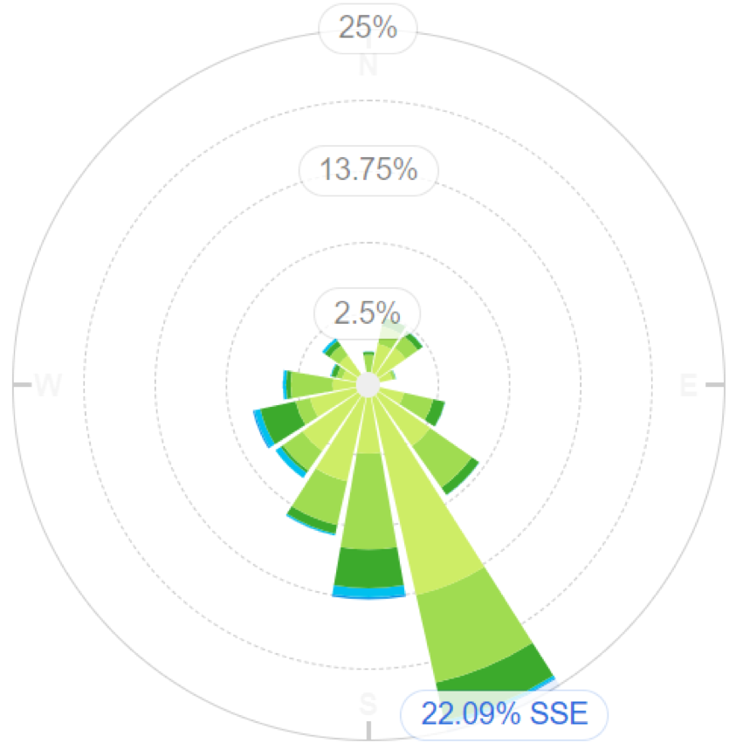

This would therefore project the position of the Site Boundary Monitoring Device into the NNW corner of the site.

Appendix I - Sensitive Receptors within 1km of the Site & Contact Details
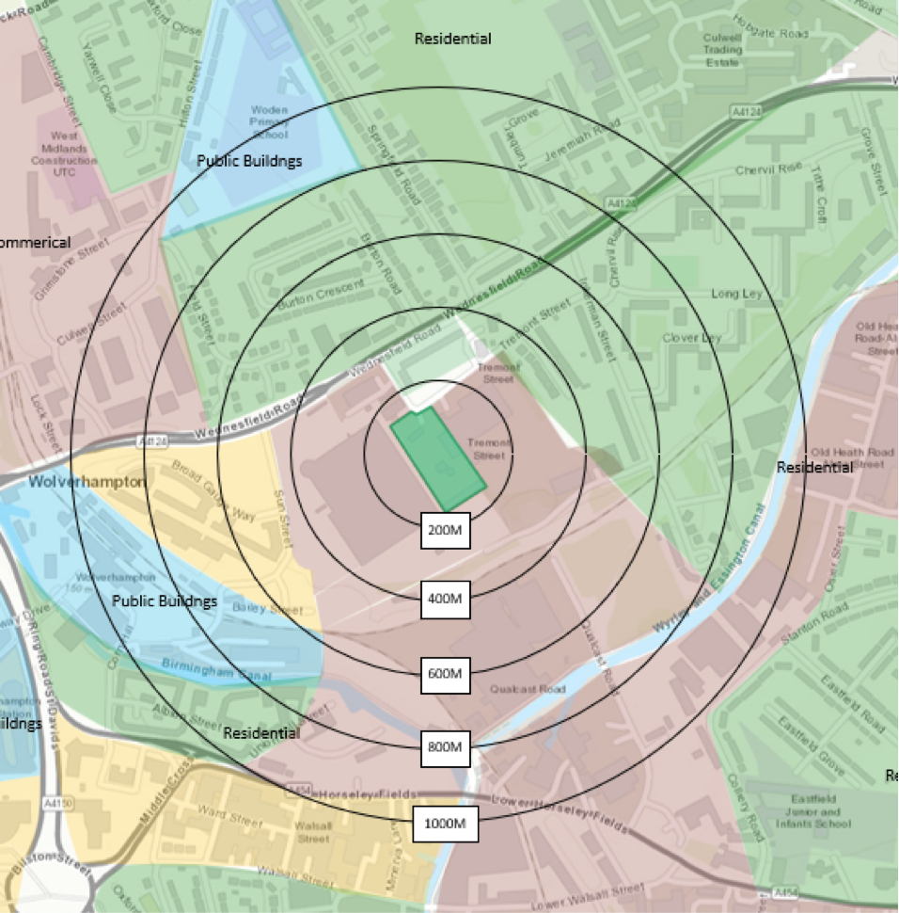
Boundary | Closest property | Approximate distance to LIBATT site boundary (m)
North | Flats and Residential Housing | 100
East | Flats and Residential Housing | 200
North | 2 Sisters Food Group | 100
South | Flats and Residential Housing | 600
South | East Field Junior School | 1000
North | St Stephens Primary School | 1000
North | Woden Primary School | 1000
West | University of Wolverhampton | 1000
South | Birmingham Canal | 600

Appendix

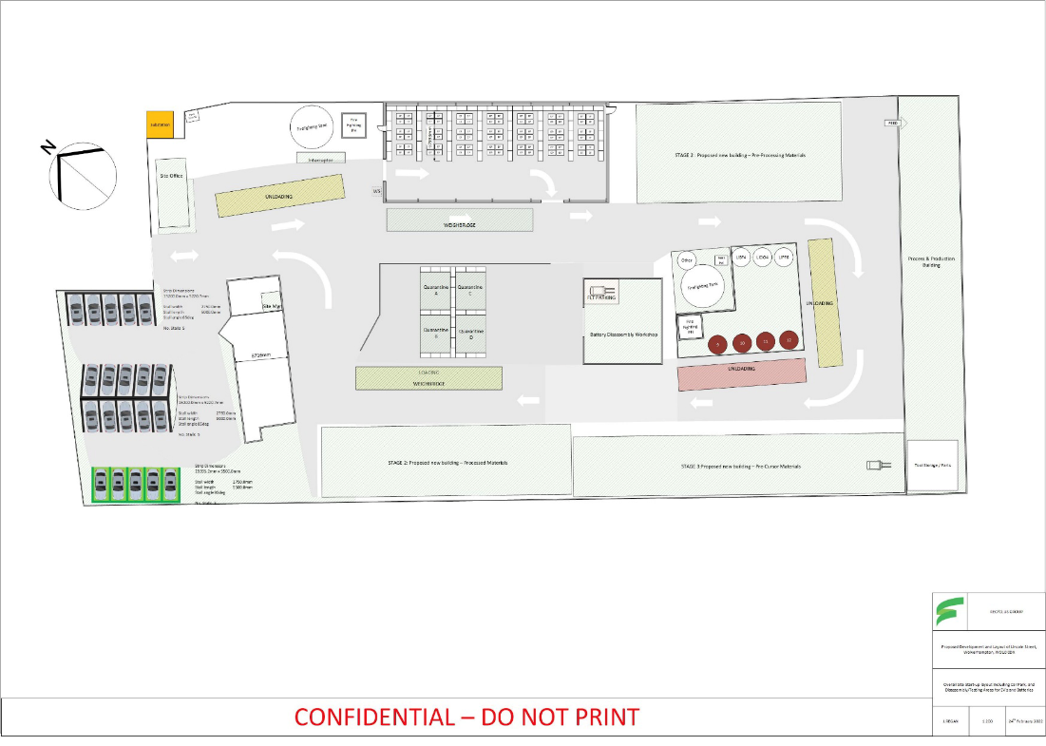

Figure 1: Site Layout Plan (original Scale 1:200)

Appendix III Storage Building Layout Plan

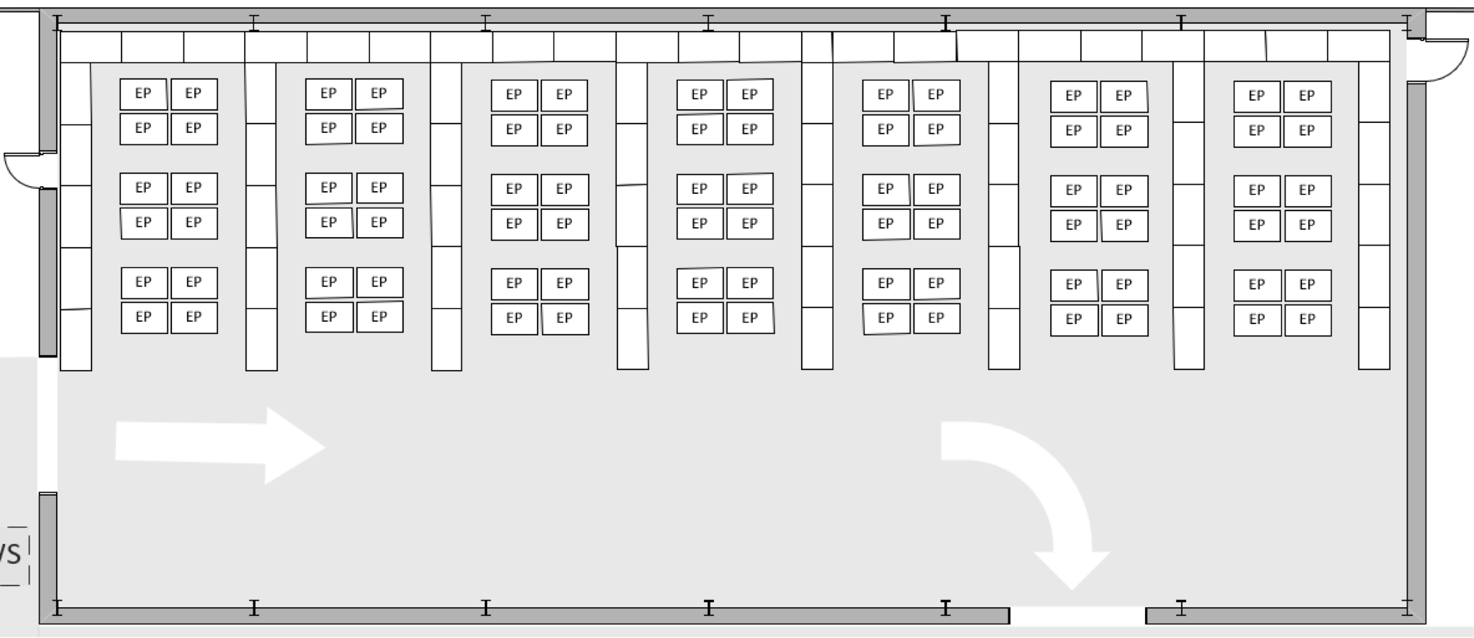
  - Figure 2: Building 1 Interim Layout - Storage (Original Scale 1:200)

Appendix IV Site Maintenance Checklist

Daily Monitoring (Ongoing) | M  (AM/PM) |  | T  (AM/PM) |  | W  (AM/PM) |  | T  (AM/PM) |  | F  (AM/PM) |  | S  (AM/PM) |  | Comments (detail remedial action taken)
 | (Tick for 'Yes', Cross for 'No')
CCTV operational?
Fire Quarantine Area accessible & clear?
Processing & Storage building intact?
Fuel Storage Cage intact & secure?
Site perimeter secure? (note any damage found).
Waste Isolation Facility clear?
Dust, debris or litter build up within the
Processing building?
If so, ensure prompt cleanup.
Site Plant & Equipment operational with no
noticeable signs of defects/ leakages.
Electrical fittings (operational & fit for purpose
with no signs of corrosion/ wear).
Emergency provisions checked and in the correct
positions. (Spill Kits Replenished)
Fire extinguishers (present and in working order with no noticeable signs of corrosion or damage and the pressure bar within the green area of the
gauge) & located correctly.
Any leakage/ spillage identified
Ensure prompt clean up.

Appendix V - Vermiculite Safety Data Sheet

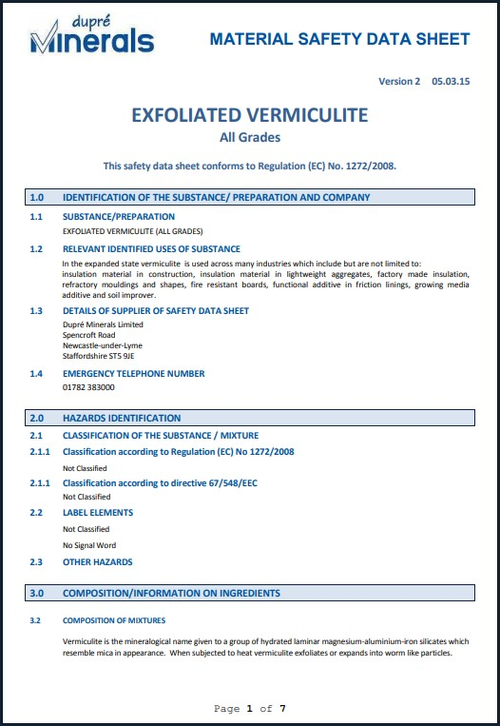

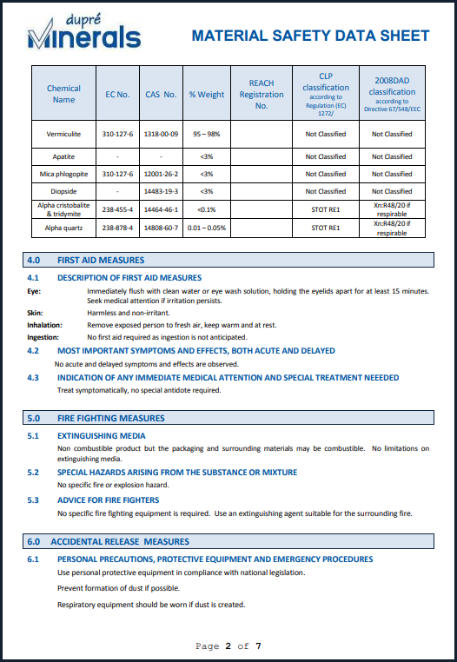

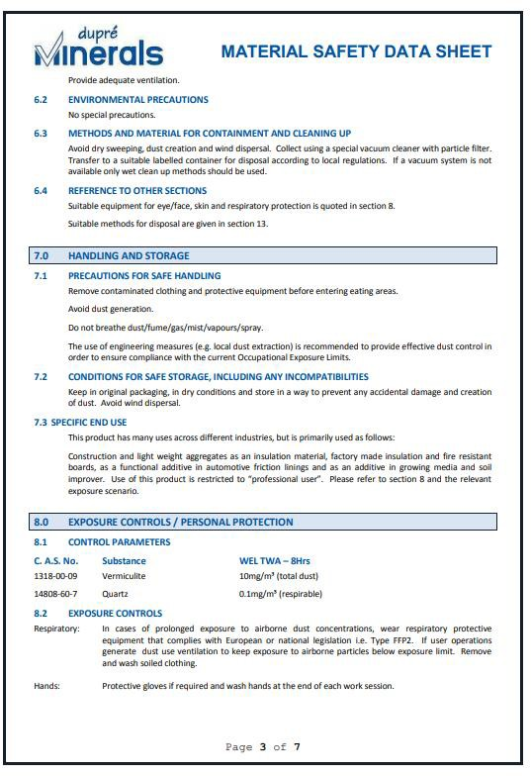

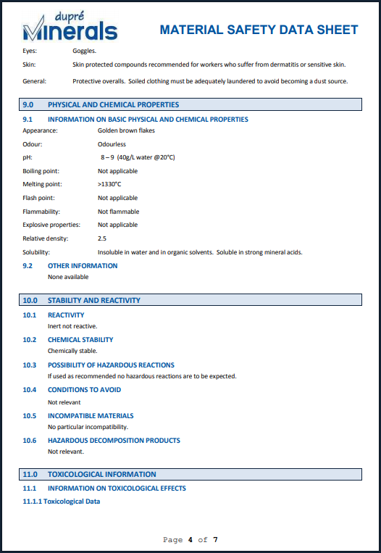

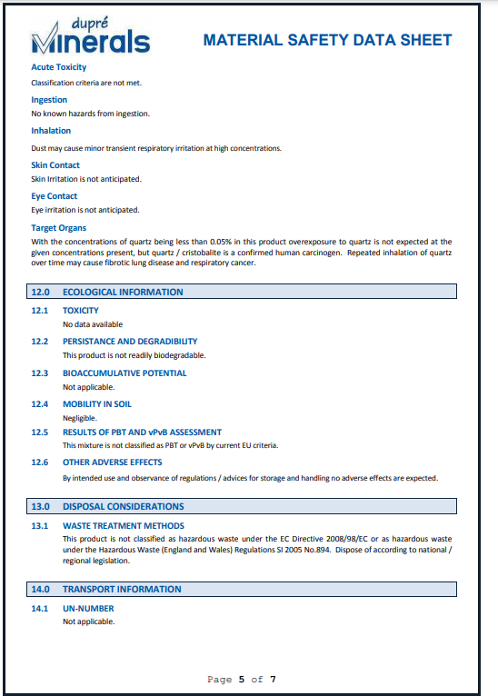

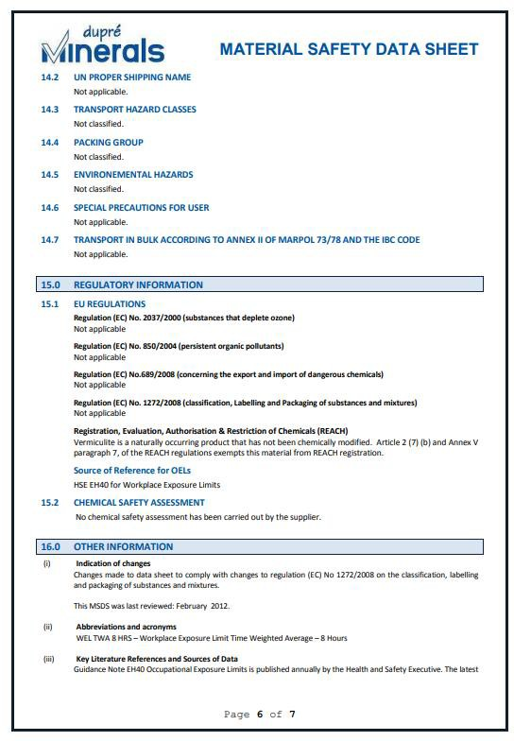

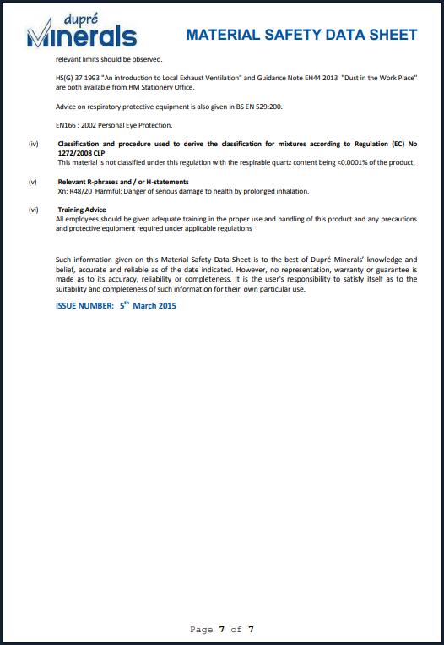

Emergency Response Plan

SECTION R1 – Introduction

1.1 The aim of the Site Emergency Plan is to ensure that the site’s response to any emergency is as efficient and effective as possible.

1.2 It is intended that the Site Emergency Plan will facilitate best use of the combined resources of the site, LiBatt Recycling Personnel and Emergency Services in connection with any emergency at the site and, where applicable, to;

- effect the recovery and treatment of casualties

- safeguard other individuals (on and off site)

- minimise health impacts, damage to property and the environment (on and off site)

- prevent escalation and ultimately bring the incident under control

- identify all injuries (on site)

- provide counselling and support where necessary

- provide authoritative information to the news media

- restore the site to normal operation as quickly as possible

- preserve relevant records and equipment for any subsequent enquiry

1.3 The Site Emergency Plan is primarily intended for use by individuals based at the site that may become involved in dealing with or be directly affected by an on-site emergency.

The document is also intended for use by any other LiBatt Recycling personnel who may be involved in any capacity in dealing with an emergency at the Lincoln Street site.

SECTION R2 – Scope

2.1 The Site Emergency Plan will be initiated in all cases when an emergency, as defined at 2.2 below exists on site as declared by sounding of the Site Emergency Alarm. The on-site alarm is given by sounding (an) air klaxon(s).

2.2 The Site Emergency Alarm will be triggered in any situation where one or more of the following criteria are satisfied;

- an incident which causes injuries to several individuals.

- a fire which cannot or, in the judgement of site personnel, is unlikely to be controlled using first action level fire-fighting equipment, (e.g. fire extinguishers), and which threatens the safety of personnel on site.

NOTE: If you do not consider that you can extinguish any fire easily and quickly using such equipment, you must ensure that the Emergency Services are called without delay.

- a release of any flammable, toxic or corrosive substance or substances which threaten the safety of, or in the judgement of site staff, are likely to affect site personnel, members of the public or neighbours or cause serious environmental impact, which cannot be controlled by on-site site staff using readily available resources

- any other situation which threatens the safety of site staff, neighbours and/or the public or the environment and which cannot be controlled by on-site staff using readily available resources

2.3 All site personnel have the authority to raise the emergency alarm if, in their judgement, it is appropriate to do so.

2.4 The Emergency Plan fulfils part of the duties required under the Management of Health and Safety at Work Regulations 1999.

SECTION R3 – Emergency Declaration

- Raising the alarm.

Upon discovery of;

- fire

- release of flammable, toxic or corrosive substances

- any other situation which threatens the safety of site personnel, neighbours, the public or the environment

activate the nearest emergency alarm (fire alarm) call point then inform a member of the site management team by;

- Telephone: Leigh Davies 07850 033741

- runner.

All site personnel have the authority to sound the emergency alarm if, in their judgement, it is appropriate to do so.

NOTE: The Emergency Services must be informed of ANY incident on site which involves an emergency response and the implementation of this Emergency Plan.

            - Once the emergency alarm is sounded, the Site Emergency Plan will be initiated in all cases.

Emergency shutdown procedures will be followed for all operations on site on every occasion that the emergency alarm is sounded.

The site, including on-site service and office buildings will be evacuated on every occasion that the Site Emergency Plan is initiated, unless instructions to the contrary are issued by the Incident Controller either directly or via the Evacuation Marshalls.

3.3 The normal evacuation assembly point is located next to the pedestrian entrance of the site, opposite the main office block.

The Site Controller will advise evacuated personnel of alternative assembly point arrangements if the normal assembly point is affected by the circumstances of the emergency in progress. The assembly point may be indoors or outdoors depending upon the circumstances.

The most likely alternative assembly point is outside the access gate, across the road located on the green next to the residential building.

The Incident Controller will advise the Evacuation Marshalls of an alternative safe route to the assembly point if the most direct route is affected by the circumstances of the emergency in progress. This may include an instruction for evacuees to report to the nearest safe haven or to remain indoors. The locations of the safe havens are shown on the Site Plan at Attachment 2 to this document.

The Evacuation Marshalls will direct evacuees to follow the most appropriate safe route to the assembly point.

Assembly point locations are shown on the Site Plan at Attachment 2 to this document.

3.4 The Incident Controller, in conjunction with the Site Controller, will assess the emergency situation to determine the appropriate message to give to the Emergency Services.

If on initial assessment it is decided that attendance by all Emergency services is not required, the Incident Controller and Site Controller will review the assessment whilst the emergency is still in progress to determine whether or not the situation has escalated to a point where attendance by other Emergency Services are required.

3.5 The Emergency Services will be contacted by the Site Controller or by the Site Controller Support, as instructed by the Site Controller except in circumstances when these individuals are incapacitated or otherwise prevented from contacting the Emergency Services when contact will be made by the Office Supervisor.

3.6 The Emergency Services will be contacted as follows;

Dial 999 and ask for

Ambulance/Police/Fire Service as appropriate

State: An emergency is in progress/has occurred at the site.

LiBatt Recycling Ltd.
Lincoln Street
Wolverhampton
WV10 0DX

Brief details of the nature and extent of the incident must then be given using the checklist included overleaf (Attachment 3 to this document) as a guide.

Stay on the phone and ask the operator to connect you to the Police so can inform them of the incident.

CHECKLIST INFORMATION

Number of casualties requiring ambulance: ..........................

Number of casualties not breathing: …………………

FIRE: Yes c No c

CHEMICAL RELEASE: Yes c No c

LOCATION OF FIRE OR RELEASE AND/OR AREAS OF SITE AFFECTED:

Zone 1 - c Zone 5 - c
Zone 2 - c Zone 6 - c
Zone 3 - c Zone 7 - c
Zone 4 - c Zone 8 - c
NATURE OF FIRE: Flammable Liquid c
Combustible Liquid (OIL) c
Other c
Quantity of flammable liquid involved: ...........................
Number of drums involved: ...........................
Nature of release (smoke, chemical vapour, gas, etc): .....................................
Extent of release: ..................................
Wind direction: ..................................
Smoke/fumes affecting people off site: Yes c No c

Materials involved: -
Name(s) ………………………..

Volume(s)/Concentration(s) ………………………..

UN No(s). ………………………..

Hazards ……………………….

Emergency Plan Zone Allocations

ZONE 3 (A)
ZONE 3 (C)
ZONE 3(B)
ZONE 2
ZONE 4
ZONE 5
ZONE 7
ZONE 8
ZONE 6
ZONE 1
ZONE 1 | Production Area Including Weighbridge
ZONE 2 | Storage Tank Farm Including Filter Press
ZONE 3 (A) | Empty Drum Store
ZONE 3 (B) | Hazardous Waste Storage Area
ZONE 3 (C) | Flammable Store
ZONE 4 | Product Tank Farm
ZONE 5 | Acumen Waste Storage Building (inc Battery Store)
ZONE 6 | RO/RO Skip Bay
ZONE 7 | Office Building & Laboratory
ZONE 8 | RO/RO Skip Bay

tion 3 – Declaring an Emergency

3.7 The Site Controller or Site Controller Support, under instruction from the Site Controller, will contact the following individuals/Authorities/ other organisations in turn, at the earliest opportunity (if they are not already on site).

Key Company Personnel
Name | Title | Contact No. | Contacted Y/N
Jon Regan | Site Manager | 07551 042928
Leigh Davies | Plant & Lab Manager | 07850 033741
Steve Andrew | Chief Technology Officer | 07521 053375

Regulatory Bodies/Authorities/Security
Body | Contact No. | Contacted Y/N
Environment Agency (Lichfield Office) | 0370 8506506
Health and Safety Executive | 01256 404000
Severn Trent Water (Emergency) | 0800 783 4444
Wolverhampton District Council (Switchboard) | 01902 556556
SwaLec Electricity (only if their service is likely to be affected) | 08000 727282 (Emergency Number)
Site 24 Hour Emergency Telephone Number (OHES Environmental Ltd) | 0333 333 9908
Classic Dispense Equipment (only if their site is likely to be affected) | 01902 451154
Post Office Sorting (only if their site is likely to be affected) | 01902 877333
Soho Cash & Carry (only if their site is likely to be affected) | 01902 870200
Recycled Plastics (only if their site is likely to be affected) | 01902 458111

3.7 Once the On-site emergency plan has been initiated, the procedure must be followed at least until the roll call is completed including in cases when the alarm has been raised but the incident in question is brought under control very quickly. Authorisation to return to work must not be given before the roll call is completed and all individuals accounted for.

SECTION R4 – Key Roles for Emergency Response

4.1 The following key roles will be fulfilled by nominated site personnel or their nominated deputy in response to any emergency requiring initiation of the Site Emergency Plan. The individual(s) fulfilling each of the roles is/are identified as shown in the table below.

Key Role | Identification
Site Controller | High Visibility Tabard
Incident Controller | High Visibility Tabard
Site Controller Support | High Visibility Tabard
Evacuation Marshalls | High Visibility Tabard
Roll Call | High Visibility Tabard

Note High visibility tabards and emergency grab bags are located in the:
- Reception Area (Office Building)
- Plant/Production Office

The grab kits are collected, if possible, and delivered to the evacuation assembly point by the relevant individuals.

SECTION R5 – Roles & Responsibilities

5.1 It is the responsibility of the Managing Director to ensure that all personnel based at the site receive appropriate training and are fully conversant with the requirements of the Site Emergency Plan.

5.2 It is the responsibility of every individual based at the site to follow the requirements of the Site Emergency Plan in any situation where the site emergency alarm is sounded and the Site Emergency Plan initiated. Further, it is the responsibility of every individual present at the site when an emergency is in progress, to follow any instructions given by those assigned specific responsibilities via the Site Emergency Plan.

5.3 It is the responsibility of any individual receiving visitors at the site (e.g. customer audits) to ensure that these visitors are accompanied on site and, should an emergency situation arise, that they are accompanied to the assembly point.

It is the responsibility of the Site Manager to ensure that any contractors working at the site are formally inducted, including appropriate training in emergency procedures.

All casual visitors who enter the site (e.g. delivery drivers, excluding waste deliveries), report and deliver all items to reception

Note The principle duties of the key role holders as set out below are reproduced as laminated cards contained in the Emergency Plan Grab Packs for quick and easy reference. The Site Plan which appears at Attachment 1 of this document is reproduced on the back of each laminated card.

INCIDENT CONTROLLER

This role will normally be fulfilled by the Site Manager. The nominated deputy will be the Plant Supervisor.

The principle duties of the Incident Controller are as follows;

DUTIES | COMPLETED  Y / N
In charge of the response to the emergency incident on site
In control of all individuals required to assist directly in controlling the emergency incident on site
Assess and monitor the emergency incident and liaise with the Site Controller to ensure that response requirements are satisfied, and to ensure that the most appropriate message is given when calling in the Emergency Services using the checklist provided. The Incident Controller must maintain contact with the Site Controller mobile telephone or by runner
Direct the shut down of operations in accordance with the relevant emergency shut down procedures
Liaise with the Emergency Services on site and assist where appropriate to bring the incident under control
Inform the Site Controller and the Evacuation Marshalls when the normal safe route to the assembly point is affected by the emergency incident, and advise of a safe alternative route and/or assembly point.
Work with the Emergency Services in the search for casualties on site
Liaise with the Site Controller to draw up an Emergency Response Team from any suitably trained and experienced site staff present on the site or at the assembly point
Liaise with the Site Controller to ascertain the wind direction and decide the path and affected areas as a result of the wind dispersing the release.
Assist the Site Controller in providing the following information to the Emergency Services;
- A safe route to the emergency incident location on site
- Site areas which require cordoning off
- Whether or not the site access roadway is affected or likely to be affected

SITE CONTROLLER

This role will normally be fulfilled by the Laboratory Manager. The nominated deputy will be the Laboratory Chemist. The Site Controller is in overall charge of the emergency situation working from the designated assembly point/Emergency Control Centre.

The principle duties of the Site Controller are as follows;

DUTIES | Completed (Y/N)
Act as the point of contact for the Incident Controller and liaise with the Incident Controller to ensure that the emergency situation is dealt with effectively and efficiently (the Site Controller must maintain contact with the Incident Controller via Mobile Telephone, by runner or by any combination of such means)
Ensure that all operations have been shut down in accordance with the relevant emergency shutdown procedures
Ensure that the Emergency Services are contacted as required
Ensure that key company personnel, Regulators, Authorities and any other bodies are contacted as required.
Receive and provide appropriate information to the Emergency Services on their arrival at the site and direct them to the incident location on site via the most appropriate route
Decide if weather conditions are likely to inhibit dispersion of the release.
Liaise with the Incident Controller to ascertain the wind direction and decide the path and affected areas as a result of the wind dispersing the release.
Liaise with the Site Controller Support to confirm the extent of the release by monitoring down wind as soon as possible and if appropriate.
In conjunction with the Incident Controller provide the following information to the Emergency Services on initial contact or on route;
- A safe route to the emergency incident location on site
- Site areas which require cordoning off
- Whether or not the site access roadway is affected or likely to be affected
Advise the Emergency Services of any missing persons.
Prevent the unnecessary arrival of delivery vehicles, visitors or any other scheduled arrivals at the site.
At a time considered appropriate liaise with the Emergency Services to give the order to cancel the on-site emergency alarm and to sound the off-site emergency all clear.
Only when satisfied that it is safe to do so, instruct evacuated personnel to return to work
Ensure that casualties are receiving adequate attention and, if appropriate arrange for additional assistance.
Provide for the welfare need of the establishment personnel, for example the provision of food and drinks, relief and the means to keep relatives informed

EVACUATION MARSHALL

This role will be allocated at the time of the incident by the Incident Controller.

The principle duties of the Evacuation Marshall are as follows;

DUTIES | COMPLETED  Y / N
On hearing the on-site emergency alarm and, after safely shutting down any plant or equipment on which he/she is working, the Evacuation Marshall will, provided it is safe to do so, check the following areas on site and ensure that all individuals present, except those directly involved with the emergency incident, make their way to the assembly point by the most appropriate route in accordance with the Incident Controller
Laboratory
Office Building
Report to the Roll caller to confirm that evacuation of the site is completed (except for those involved in dealing directly with the incident in progress)

ROLL CALLER

This role will normally be fulfilled by the Site Manager. The nominated deputy will be the Office Administrator.

The principle duties of the Roll Caller are as follows;

DUTIES | COMPLETED  Y / N
On hearing the on-site emergency alarm, the Roll Caller will, provided it is safe to do so, collect the site visitors book, emergency response equipment bag and staff attendance records from the office reception area en route to the assembly point
Liaise with the Evacuation Marshalls to confirm that evacuation of the site has been completed
Carry out the roll call referring to the drivers log, check in board and visitors book
Report to the Site Controller accordingly, including providing the details of any individual(s) not accounted for

SITE CONTROLLER SUPPORT

This role will be assigned at the time of the incident.

The principle duties of the Site Controller Support are as follows;

DUTIES | COMPLETED  Y / N
Collect the Emergency Grab Pack and high visibility tabards from the laboratory
Collect technical information which is likely to be relevant from the production building & laboratory.
Report to the Site Controller and provide support in the form of relevant materials information, monitoring and assessment of the emergency incident, contacting key personnel/Regulators/other bodies etc, as required by the Site Controller
Liaise with the Site Controller to confirm the extent of the release by monitoring down wind as soon as possible and if appropriate
Make a chronological record, using the template, of the emergency incident as it progresses

SECTION R6 – Immediate Action to Be Taken In Response To An Emergency Situation

The general immediate actions to be taken in response to an emergency as set out in below are applicable under all circumstances.

6.1 FIRE

The Incident Controller, assisted by emergency team members (emergency team members will be selected by the Incident Controller/Site Controller and may include any site personnel present and not having specific duties defined in the Site Emergency Plan) and provided it is safe to do so, will;

ACTIONS | COMPLETED  Y / N / NA
Shut down operations in accordance with the plant emergency shutdown procedure
Use appropriate equipment to prevent the spread of fire to other areas until such time as the Emergency Services arrive at the site
Isolate electrical supplies to plant and equipment which may be affected by or contributing to the emergency incident
Close isolation valves on storage tanks and/or pipelines which may be affected by or contributing to the emergency incident
Fasten closures on containers and/or consider the relocation of containers including pressurised gas cylinders, which may be affected by or have the potential to contribute to the emergency incident
Ensure, in conjunction with the Site Controller communicating by runner), that any information likely to be required by the Emergency Services is readily available (see overleaf and attachment 4)

Containerised and bulk materials inventory logs.
Held in Plant Operations office

Identification labels.
Attached to individual containers displaying material classification and associated hazards.

Manufacturers/producers material health and safety data sheets and general hazardous substances reference publications.
Held in site laboratory and/or site office.

Plant Operations Logs.
Held in Plant Operations office.

6.2 ACCIDENT INJURY

Any accident injury which occurs as a direct result of an event leading to initiation of the On-site Emergency Plan, or which occurs on site during the course of and/or as a result of the response to the emergency incident, will be dealt with as instructed by the Incident Controller.
Any accident injury which occurs at any other time, depending upon the severity of the injury, may be dealt with as follows;

- Without personal risk, go to the assistance of the casualty.

Do not attempt to move an immobilised casualty, except for removal from a toxic vapour hazard or removal from an area under threat from fire

- Call for assistance from a site first aider to apply basic first aid measures

- Ensure that the Incident Controller is informed without delay

- Call the Emergency Services if necessary

SECTION R7 – Follow Up Action

7.1 It is the responsibility of the Site Controller, in conjunction with the Incident Controller and the Emergency Services where appropriate, to determine when the emergency incident has been brought under control and it is safe for evacuated personnel to return to site and/or for the site to resume normal operation.

7.2 It is the responsibility of the Site Controller, in conjunction with the Incident Controller, to ensure that any evidence connected with the emergency incident is preserved. In particular, any plant and equipment involved in the incident must not be moved or removed unless it represents an immediate health and safety risk.

7.3 It is the responsibility of the Site Controller, in conjunction with key company personnel called to the emergency incident, to collect witness statements relevant to the incident at the earliest opportunity.

7.4 It is the responsibility of the Site Controller in conjunction with key company personnel called to the emergency incident, to contact the Health and Safety Executive at the earliest opportunity and, if appropriate to do so, to report in accordance with the Reporting of Injuries, Diseases and Dangerous Occurrences Regulations 1995.

7.5 It is the responsibility of the key company personnel called to the emergency incident, in conjunction with site personnel, the Emergency Services, Regulatory Authorities and any other bodies as appropriate, to make suitable arrangements to deal with the aftermath of the incident in order to minimise possible safety, health and environmental effects.

7.6 It is the responsibility of the key company personnel called to the emergency incident, in conjunction with site personnel, to carry out a full investigation into the incident and report its findings to all relevant parties.

7.7 It is the responsibility of the key company personnel called to the emergency incident to contact all other relevant company personnel.

7.8 It is the responsibility of the key company personnel involved in the emergency to arrange provision of counselling and support where necessary.

SECTION R8 – Out of Normal Hours Emergency Incidents.

8.1 The site is normally fully staffed between the hours of 0600 and 1800 Monday to Friday and manned by at least one operator between the hours of 0800 and 1300 on Saturday, only by prior arrangement. The Site is closed at all other times. Offloading will only be permitted by a driver trained in relevant offloading procedures and the driver must be supplied with a mobile telephone programmed with the telephone numbers of the Plant and Operations Managers.

8.2 Should an emergency incident occur at a time when the site is operational but not fully staffed, it is the responsibility of the senior member of staff on site to decide whether or not the incident can be controlled.

It is the responsibility of the individual in charge to ensure that the Managing Director & Site Manager are contacted immediately.

If it is decided that the incident can be controlled, it is the responsibility of the individual in charge to initiate those elements of the Site Emergency Plan which are appropriate to the situation in hand.

The senior member of staff will assume the role of Incident Controller and assign roles according to the Emergency Plan to other individuals present.

If it is decided that the incident cannot be controlled, it is the responsibility of the individual in charge to ensure that the Emergency Services are called. The most senior staff member on site will assume the role of Site Controller until relieved.

8.3 It is unlikely that a major incident will occur whilst the site is not manned since any such situation is likely to arise as a result of operational activities.

It is however, conceivable that an emergency situation may arise as a result of off-site events which impact on the site, vandalism, or the failure of storage tanks or containers leading to the uncontrolled release of hazardous substances.

Information regarding such a situation may reach site personnel by way of a number of available routes:-

- Via remote security/surveillance company’s emergency contact list

- Via the company’s 24 hour emergency telephone service

- Directly from the Environment Agency or any other Regulatory Body or Authority

- Directly from the Emergency Services

- Directly from a site neighbour or member of the public

- Via local radio or television news broadcasts

Any member of site staff receiving information regarding an emergency at the site when the site is unattended must, in the first instance, contact the Site Manager or Managing Director or, if neither of these are contactable, any of the other key company personnel identified in Section 3.6 of the On-site Emergency Plan.

8.4 The Site Manager or Managing Director must attend site and contact or arrange for other members of the site emergency response team to be contacted and to wait on standby for further information/instructions.

8.5 On arrival at the site, the Site Manager/Managing Director must assess the situation and arrange for other members of the site emergency response team to attend site if appropriate.

8.6 If the Emergency Services are present at the site on arrival of the Site Manager/Managing Director, the Site Manager/Managing Director must provide, as far as possible, any assistance which the Emergency Services require and contact other members of the site emergency response team to attend site.

Under such circumstances, the Site Manager/Managing Director will assume the role of Site Controller and, upon arrival of other members of the site emergency response team, will implement those elements of the On-site Emergency Plan which in his/her opinion, are appropriate to the circumstances.

SECTION R9 – Other Information

9.1 The On-site Emergency Plan must be read in conjunction with the Attachments listed below:

ATTACHMENT R1 – Emergency Equipment Locations
ATTACHMENT R2 – Emergency Zone Allocations
ATTACHMENT R3 – Checklist
ATTACHMENT R4 – Information Sources

ATTACHMENT R5 – Emergency Register
ATTACHMENT R6 – Threatening Phone calls/Letters
ATTACHMENT R7 – Media Contact

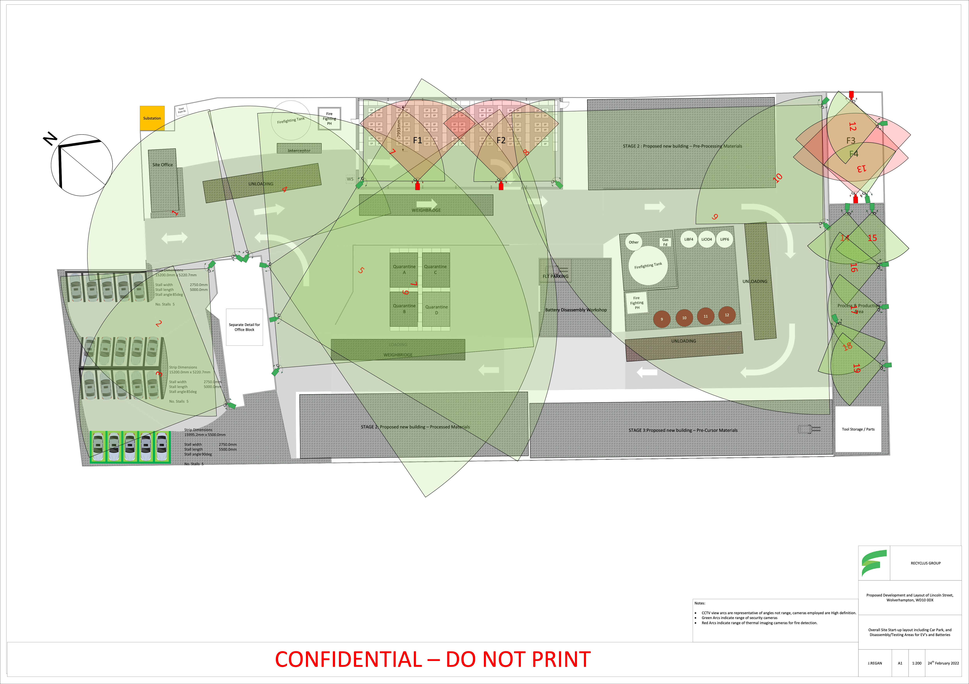
Caption

