LiBatt Recycling limited
Lincoln Street
Lincoln Street
Heathtown
Wolverhampton
Wv10 0dx

DUST & Emission management plan
(DEMP)

Version Number: 8
Date: 20 OCT 2022
Issue and Revision Record

Revision | Date | Originator | Checker | Company Approver | Description of Changes

Contents Page

1. Introduction

1.1 Sensitive Receptors

2. Operations at LiBatt Recycling Limited

2.1 Waste Deliveries to LiBatt Recycling Limited
2.2 Overview of Waste Processing, Dust, and other Emission Controls
2.3 Mobile Plant and Equipment

3. Dust and Particulate Management

3.1 Responsibility for Implementation of this Plan
3.2 Sources and Control of Fugitive Dust & Other Emissions
3.3 Enclosure of waste processing & storage areas
3.4 Visual Dust Monitoring

4. Particulate Matter Monitoring

6. Reporting and Complaints Response

6.1 Engagement with the Community
6.2 Reporting of Complaints
6.3 Management Responsibilities
6.4 Summary

Appendices

Appendix A: Site Process Locations
Recycling Process Diagrams
Appendix B: Dust Complaint Form

1. Introduction

The installation operated by LiBatt Recycling (LBR) is a hazardous waste installation, primarily involved in the treatment and processing of lithium batteries and a secondary operation for the storage and transfer of waste oil.

Lithium batteries are a ubiquitous form of waste, classed as hazardous due to the Lithium compound content of the battery, which is highly reactive with Oxygen and/or water, and because of the electrolyte in the battery, which is an organic volatile liquid which in some cases contains Hydrofluoric compounds.

The installation is designed to house a discharging facility, an inert atmosphere breaking phase for the battery recycling process, and the separation equipment to sort the broken fractions of the breaking process. This means that the final products are metal fractions (Iron, Copper, Aluminium), plastic/paper, electrolyte and black mass (a mixture of activated carbon, transition metal oxides and traces of lithium-based compounds).

The process diagrams will provide a more detailed description of the process.

The site is located in Wolverhampton where the local authority is the City of Wolverhampton Council and is an Air Quality Management Area (AQMA) which is declared for nitrogen dioxide NO2 and particulate matter PM10. As the site is located within an AQMA, there will be a need for boundary air quality monitoring once the plant is operational. This must provide long term measurement of PM10 for data to be added to the AQMA set of results.

Any dust or emissions generated throughout the process occur in the battery recycling process which is located in an enclosed building and will be fitted with local exhaust ventilation (LEV) to capture dusts and prevent them being released to atmosphere. These dusts are likely to contain residues of heavy metals and activated carbon.

All LEV equipment must be fitted with appropriate filters, which in the case of the black mass would be HEP filters as a minimum,

The LiBatt system would use H-Type filters, which are 99.5% efficient at removal of extremely toxic dusts such as asbestos, and therefore suitable for the removal of less dangerous dusts as produced by the breaker system. The processing building and plant for the battery recycling process has been specifically designed to reduce emissions.

This document has been created to support the application of IPPC Permit Variation to allow the recycling of Li-ion batteries and was requested by the EA as part of the application process.

The purpose of the document is to demonstrate the controls in place to identify, reduce and control dust produced through the Li-ion battery recycling process and forms part of the organisations integrated HSEQ Management System and is intended to be read and understood by the operational management team of LiBatt Recycling Ltd.

1.1 Sensitive Receptors

In table 1.1 we have listed the most significant sensitive receptors with a 1km radius of the site which could potentially be affected by fugitive emissions and in table 1.2 we have listed other activities within the same radius which are likely to generate emissions to air. We have added a map of the area below.

A wind rose diagram for the site is shown below which advises the position of the boundary monitoring system. All operations take place in an enclosed building with dust control measures.

According to the Met Office, the main prevailing wind direction is from the SSE of the site considering averages for the last 5 years.

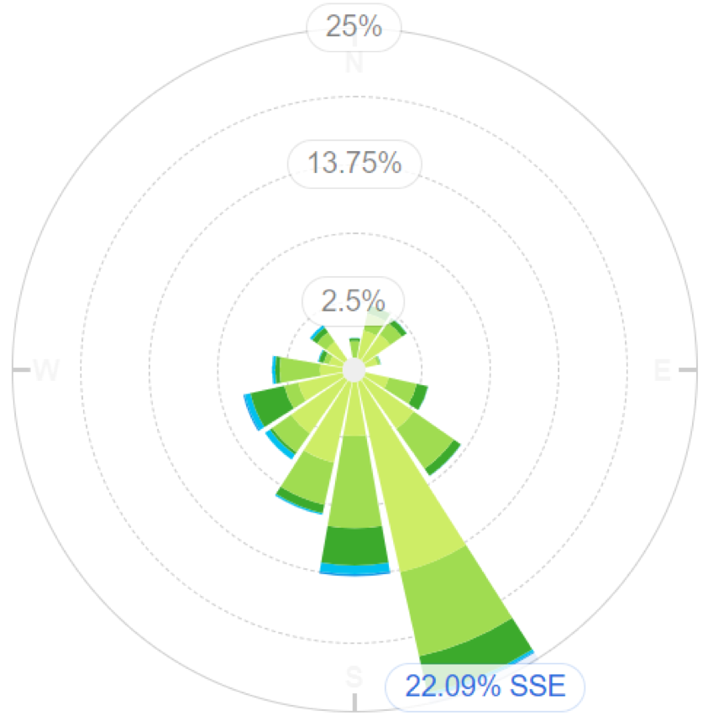

Figure 1.1 Wind rose for LiBatt site

This would therefore project the position of the Site Boundary Monitoring Device into the NNW corner of the site.

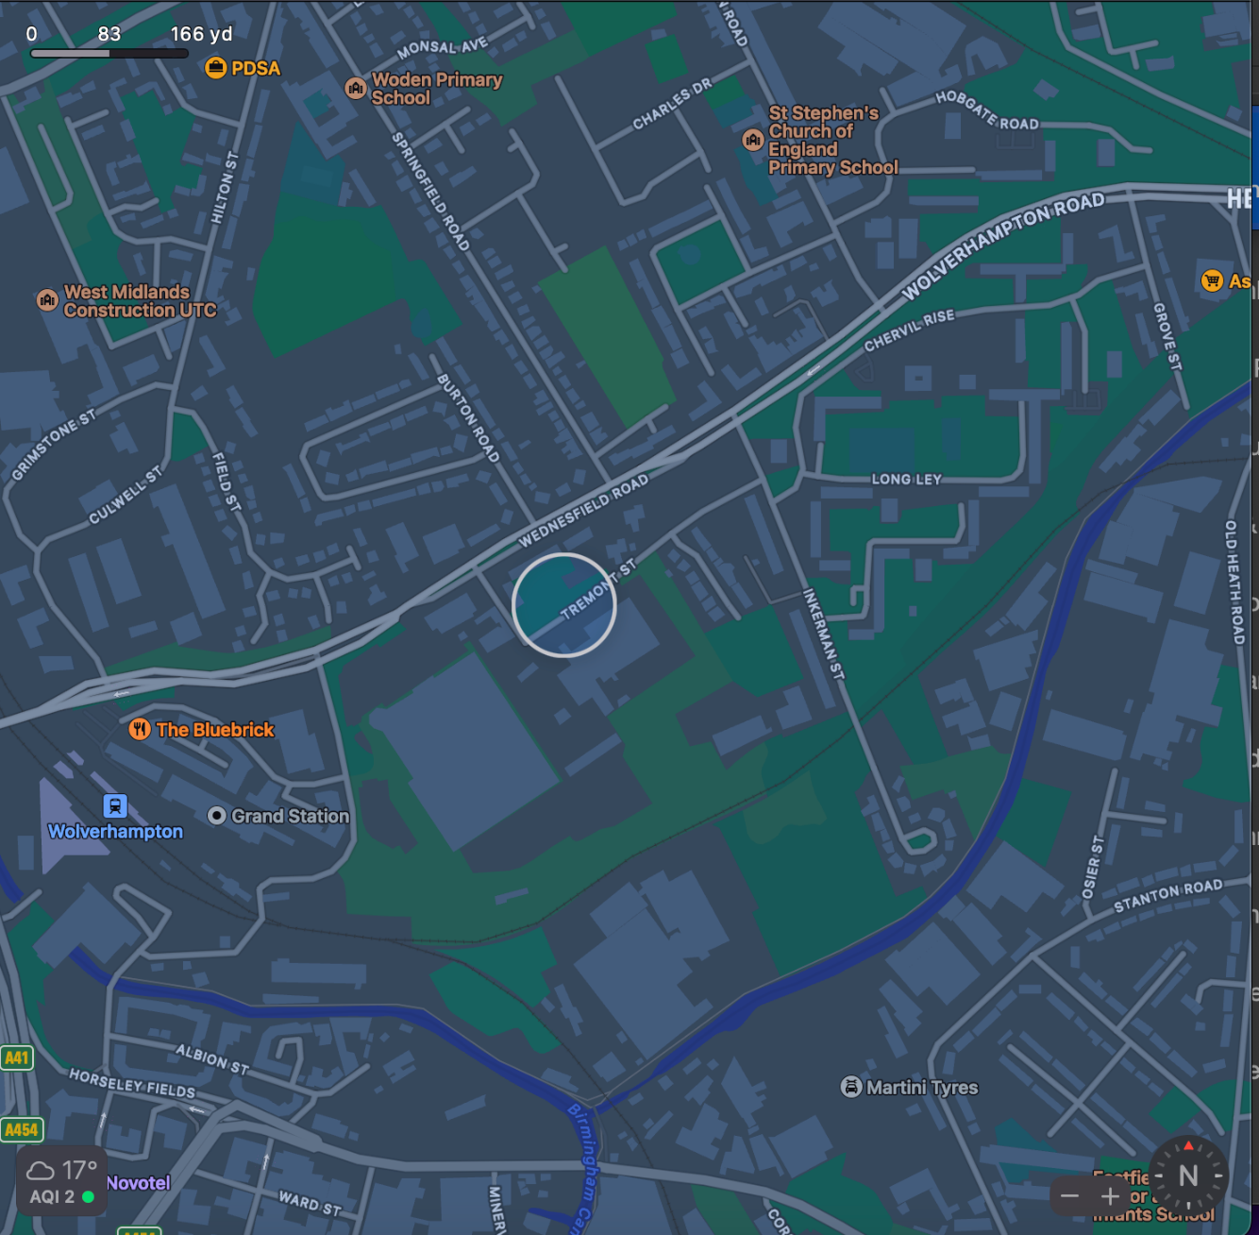

Figure 1.2 Sensitive receptors within 1 km of LiBatt site

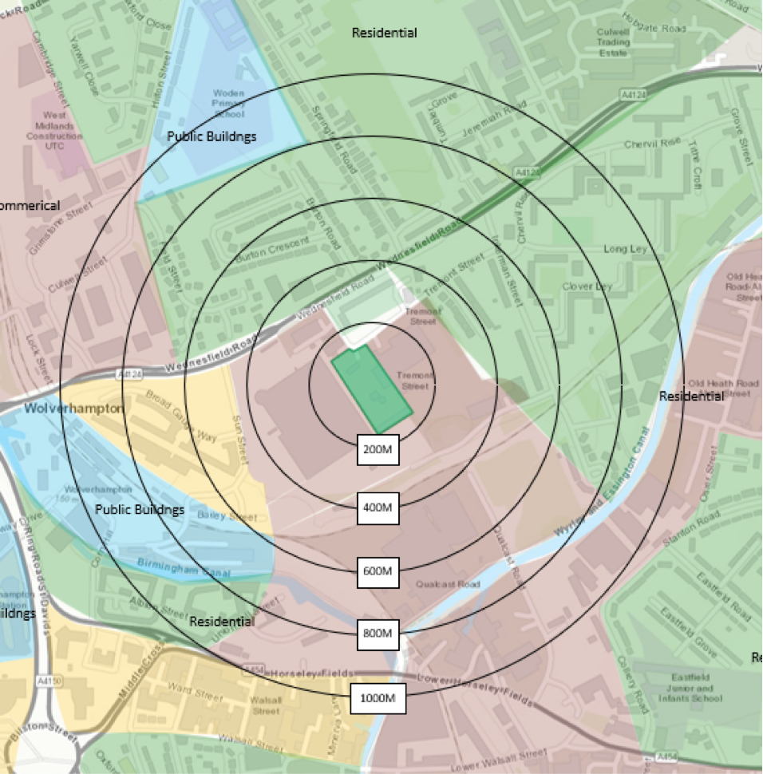

Figure 1.3 Distance to sensitive receptors

Boundary | Closest property | Distance from LIBATT site boundary (m)
North | Flats and residential housing | 100
East | Flats and residential housing | 200
North | 2 Sisters Food Group | 100
South | Flats and residential housing | 600
South | East Field Junior School | 1000
North | St Stephens Primary School | 1000
North | Woden Primary School | 1000
West | University of Wolverhampton | 1000
South | Birmingham Canal | 600

Table 1.1 Distances to selected, representative sensitive locations

Company | Address | Type of Business | Distance from LIBATT site boundary (m)
Recycled Plastics UK | Inkerman Street | Waste Transfer Station | 50
Royal Mail | Wednesfield Road | Mail Sorting Office | 50
- | Wednesfield Road | Main Road | 100
2 Sisters Food Group | Lincoln Street | Food Processing & Distribution | 50
Network Rail |  | Railway Line | 400

Table 1.2 Sources of dust and other emissions

2. Operations at LIBATT Recycling

2.1 Waste Deliveries to LIBATT

Waste is delivered by road in curtain sided vehicles. We would expect approximately 3 to 4 deliveries and approximately 3 to 4 collections per day at full capacity. LiBatt do not have their own transport so the emission rating for the vehicles is unknown.

Deliveries and collections for the oil storage process are approximately 4 vehicles per day.

Batteries will be received in ADR approved packaging and depending on the condition and safety of the batteries being delivered this will range from palletised loads to ADR Boxes specifically designed for the transport of unsafe Li-ion batteries.

All deliveries will be received with consignment notes and dangerous goods notes if required. All deliveries will be pre-planned by LiBatt. The materials being delivered will not be dusty or have any emissions.

2.2 Overview of Waste Processing, Dust, and Other Emission Controls

There is a detailed site layout and processing plan which is shown in Appendix 1.

All materials are stored in sealed boxes or shrink-wrapped pallets prior to processing which are stored in a covered building. The recycling process also operates in a covered building.

The site surface is impermeable concrete therefore easy to clean and prevents dust and particulate generation.

The site operates a 500 kVa mobile generator which is located outside building 3 and will be used to commission the processing plant. The site will operate 2 diesel forklift trucks.

 |  |  | Destination within facility
European Waste Code (EWC) | Product Description | Tonne / Week | Screen  (Shed 1) | Storage  (Shed 1) | Recycle  (Shed 3) | Storage  (Shed 2) | Oil Tanks
16 06 05 | Other batteries and accumulators (Li-ion batteries) | 200
13 02 05 | Mixed oil | 125
Total |  | 325

Table 2.1 Typical waste types brought to LIBATT

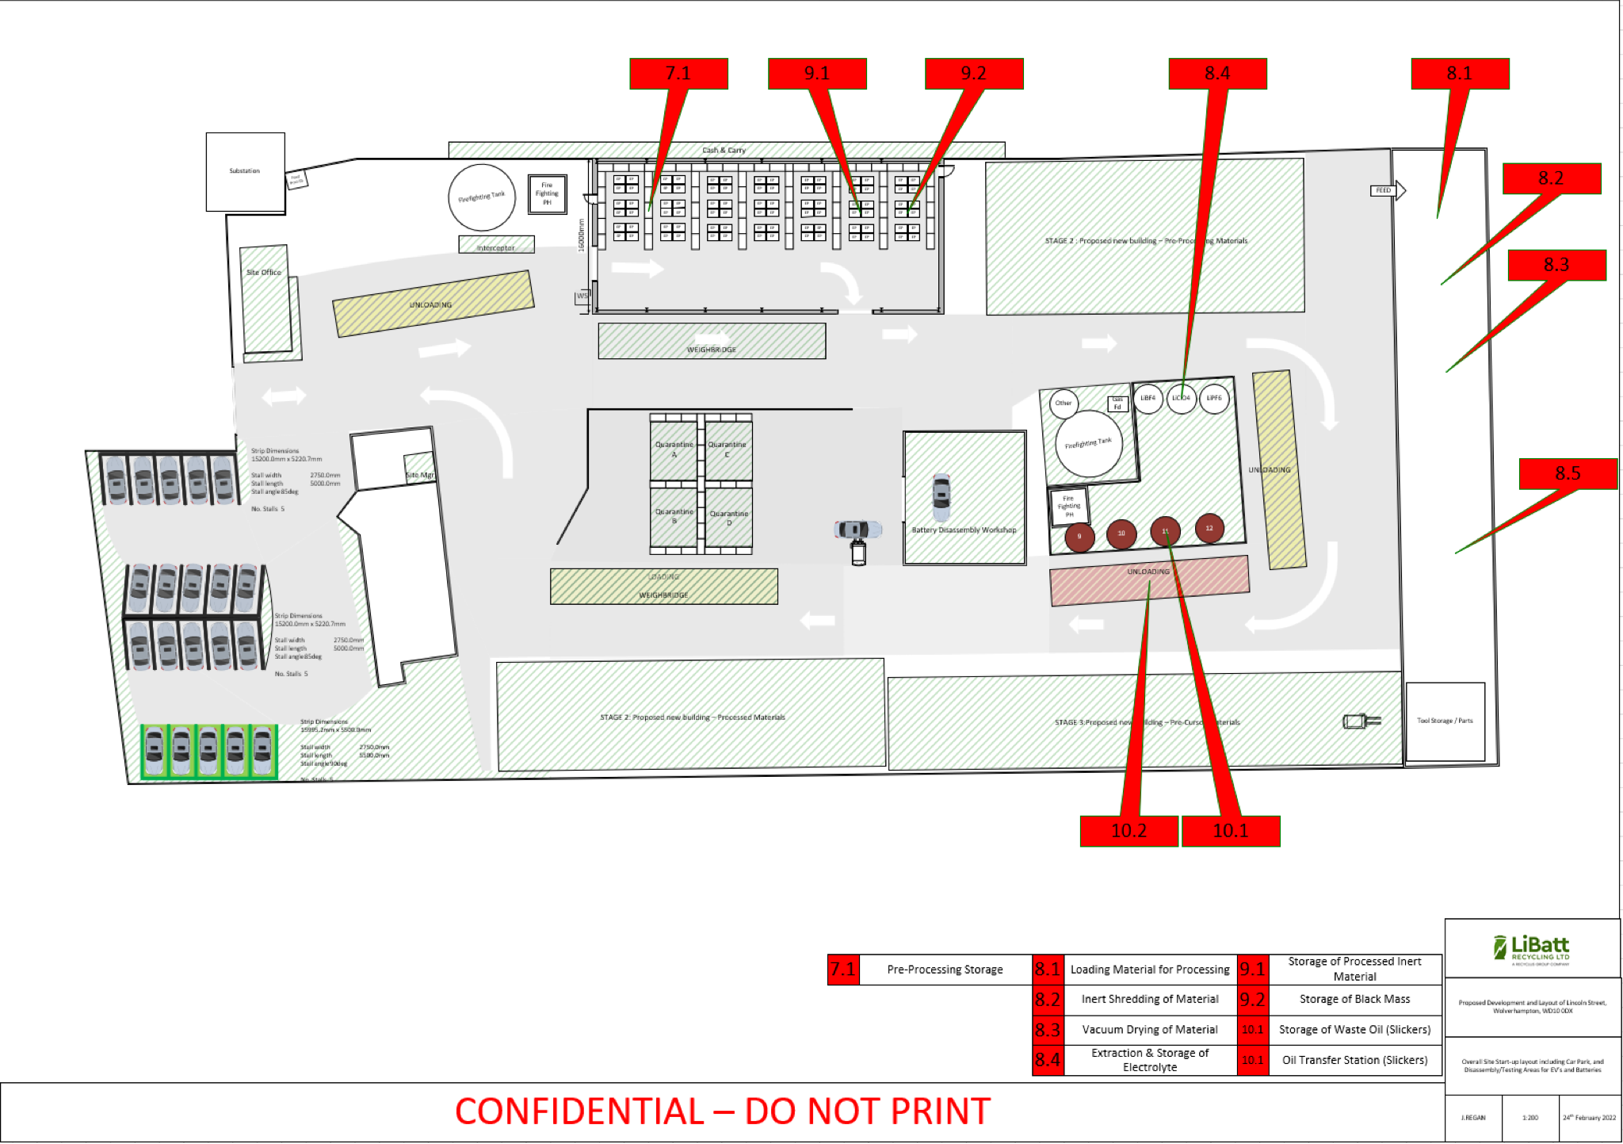

Figure 2.1: Site layout plan
SITE ACTIVITIES.

The overall site layout is shown in Appendix 1 along with basic process diagrams for each of the recycling steps within the buildings. The various areas have a purpose as follows:

- Delivery Area - Sealed boxes and shrink-wrapped pallets are removed from curtain-sided vehicles

- Storage Area 1 - Sealed boxes and shrink-wrapped pallets are placed inside a building prior to processing or repacking

- Process Area 1 – Lithium-ion batteries are removed from transportation packaging and sent to a bespoke, gas-controlled crusher

- Process Area 2 - Broken lithium-ion batteries are discharged via a sealed conveyor into a vacuum drier to remove electrolyte and water vapour. The electrolyte in the vacuum pump exhaust is condensed to give a liquid product which is collected in a temperature and atmosphere-controlled tank system. The remaining vacuum exhaust gas is passed through a carbon filter to remove odour and any remaining fine particulate matter.

- Process Area 3 - Dry product is conveyed via a sealed unit to a magnet where ferrous materials are discharged into seals bags. The non-ferrous remainder is passed over an enclosed vibrating screen.

- Process Area 4 - Material greater than 2mm is passed into a series of air separators to remove plastic and paper into sealed bags. All operations are connected to the main enclosed dust extraction system which in turn is connected to a bag house to remove particulate matter from the air stream.

- Process Area 5 - Material less than 2mm is screened at 250um to remove fine ‘black mass’ (which is primarily activated carbon and heavy metal oxides) into a sealed collection system.

- Process Area 6 - The remainder of the material greater than 2mm from Process Area 4 is passed over an eddy current separator to extract copper and aluminium foil into a sealed bagging system.

- Process Area 7 - If the ‘black mass’ from Process Area 5 is found to have too high a residual electrolyte content, it can be washed with water in a closed system. The resulting slurry can be then pressed in a plate filter press which gives a ‘cake’ of damp material (non-dusty) and a wash water which needs to be collected and disposed of at a suitable facility.

- Storage Area 2 - All products of the process are collected and stored in sealed bags inside a separate building prior to loading onto curtain-sided vehicles for dispatch to onward processing facilities.

Due to this being an existing permitted site, the plant operational areas were designed to utilise existing buildings and to provide a one directional through flow of material to minimise handling and transport distances.

In order to minimise fugitive emissions during the process, the following considerations were made:

- Doors on all buildings/bays
- Covered conveyors and enclosed transportation of broken material at all stages
- Dust extraction on each process step
- Size of fans and airflow to ensure all respirable dust captured

2.3 Mobile Plant and Equipment.

Nitrogen Dioxide gas is a by-product of internal combustion engines and the site uses several items of plant with internal combustion engines. The following table lists the type, mobile and emission ratings for the mobile plant and equipment used on site:

Description | Make | Model | Emission Rating
Generator for Processing Plant | TBC
Diesel Forklift 1 | Hyster
Diesel Forklift 2 | TBC

All diesel equipment is leased/hired.

The maintenance schedule used to keep the plant running for all machines is as per manufacturers recommended frequency.

Where diesel is used, ultra-low/low sulphur fuel is the preferred option, and a supply is maintained on site.

The company has controls which are in place to reduce emissions. These include anti-idling site rules and oil tanker loading procedures.

3. Dust and Particulate (PM₁₀) Management

The amount of dust generated is a function of the control measures for hazardous dust generation.

There are no significant dust emissions according to the calculations shown in the document LiBatt Hazardous Emissions Calculations Oct 2022 V5.pdf which is attached with this application.

The calculations were performed in accordance with the AIR EMISSIONS RISK ASSESSMENT FOR YOUR ENVIRONMENTAL PERMIT guidance as per the government website.

The environmental concentrations of each substance released into the air,
known as the process contribution (PC) were calculated and all the components were shown to be ‘insignificant’ based on the process assumptions for this new process system.

3.1 Responsibility for Implementation of the DEMP

The responsible person for the DEMP and making sure it works is Jon Regan, Site Manager who will be assisted by a deputy site manager, to be appointed upon award of the permit variation.

The DEMP is reviewed annually or as necessary due to changes in site operations or conditions.

The DEMP has been prepared by the Technical and HSEQ Specialists for the Recylcus Group and will continue to maintain and ensure controls are in place. Controls which have been identified as being required by the DEMP will be monitored through site inspections which will be the responsibility of the Site Manager and compliance with these controls and site inspections will be monitored and assessed through internal audits as part of the integrated management system.

Management controls required as part of the DEMP will be communicated through training and toolbox talks which will be delivered by the Technical and HSEQ Specialists

3.2 Sources and Control of Fugitive Dust/Particulate Emissions

Sources

Details of all the operations at Lincoln Street that have the potential to produce dust and particulates are as follows.

- Plant treating waste is internally situated process plant and all operations have dust controlled by extraction fans to filtration and dust collection units
- Waste is stored internally and not exposed to prevailing winds
- All site surfaces are concrete and do not generate their own particulate emissions
- All materials are in either sealed boxes or bags with no concern about dust generation unless a bag or box is dropped and a spillage occurs. At which point the company spill containment protocol will be used.
- All emissions generated by vehicles would be via diesel exhaust as vehicles travel around the one-way system in the yard which has a concrete surface.
- The single site generator is located outside Process Building 3. The engine is contained in a sound-proofed cabinet to minimise noise emissions.

Breaking the source-pathway-receptor model for each of the identified sources.

All operations including delivery are not susceptible to dust generation, primarily because all deliveries are in sealed packaging and all operations are undertaken within buildings with associated dust prevention.

The site speed limit is 5mph and all site vehicles are subject to maintenance and inspection as required. Delivery and dispatch vehicles are not owned or controlled by the organization but as part of our supplier controls transport companies will be required to demonstrate that their vehicles road legal and as a result must pass national emissions limits.
Normally, when an issue of emissions is identified, the primary course of action is to temporarily cease operations, correct any issues with the control systems and inform the regulator of any potential problems.

Source | Pathway | Receptor | Type of impact | Where relationship can be interrupted
Debris | falling off lorries | N/A. Minor impact on receptors within 200m | Visual soiling, also consequent resuspension as airborne particulates (inconsequential compared to main road) | Cover lorries before leaving site.
Tipping, storage and sorting of waste inside buildings | Escape from buildings and subsequent atmospheric dispersion | Depends on the prevailing wind conditions at the moment of escape. May spread up to affect receptors up to 1km if plant not shut down in timely manner. | Visual soiling and airborne particulates; only a major failure in a bagging facility would generate an impact and only if the doors were open. The size of the discharge and the wind direction may affect the closest receptors. | Maximise containment, open doors only for entry of vehicles.
Vehicle exhaust emissions | Atmospheric dispersion | Depends on the prevailing wind conditions at the moment of escape. Minor impact on receptors within 200m | Airborne particulates (inconsequential compared to main road) | Regulatory controls and best-practice measures to minimise source strength
Non-road-going machinery exhaust emissions | Atmospheric dispersion | Depends on the prevailing wind conditions at the moment of escape. Minor impact on receptors within 200m | Airborne particulates (inconsequential compared to main road) | Regulatory controls and best-practice measures to minimise source strength

Table 3.1 Source-pathway-receptor routes

Abatement Measure | Description / Effect | Overall consideration and implementation | Trigger for implementation
Preventative Measures
Enclosure within a building  (This option is relevant to LiBatt) | Creating a solid barrier between the source of dust and particulates and receptors is likely to be the most effective method of control, provided that the building entrances and exits are well managed. | New sites so strongly recommended to fully enclose from the outset.  This is a required ‘standard design feature’ by Office of the Deputy Prime Minister (ODPM) guidance.  If your site is in a sensitive location then you are likely to be required to fully enclose your activities in a building.  Ensure that procedures are in place to manage the building and its integrity. | Will this be used all the time the site is operational? Yes  Are there any situations that this abatement measure will not be used or areas of the site that this won’t be used on? No  Are there any limitation to this abatement measure? No
Dust extraction systems | These include wet scrubbers, baghouses (bag filters), filters and gravitational settling. These are effective when coupled with local exhaust extraction, ventilation to remove dust and particulates from the process airstreams. | The process contains a baghouse dust collection system in combination with local dust extraction for all process steps.  Note: sites in Air Quality Management Areas (AQMA) are finding this the only effective way to control dust and particulate emissions so point sources at waste transfer stations are becoming more common now. | Will this be used all the time the site is operational? Yes  Are there any situations that this abatement measure will not be used or areas of the site that this won’t be used on? No  Are there any limitations to this abatement measure? No
Site / process layout in relation to receptors | Locating particulate emitting activities at a greater distance and downwind from receptors may reduce receptor exposure, provided that emissions from the source are not dispersed over significant distances. | As an existing site, the plant layout takes into consideration the size of the buildings and the shortest route through the process to minimise handling and vehicle movements. | Will this be used all the time the site is operational? Yes  Are there any situations that this abatement measure will not be used or areas of the site that this won’t be used on? No  Are there any limitations to this abatement measure? No
Site speed limit, ‘no idling’ policy and minimisation of vehicle movements on site | Reducing vehicle movements and idling should reduce emissions from vehicles. Procurement policy to only purchase clean burn road vehicles and non-road going mobile machinery. Enforcement of a speed limit may reduce re-suspension of particulates by vehicle wheels. | Easy to implement as part of good practice.  Should be identified clearly in the site management system and implemented as appropriate measures.  Site speed limit is set at 5mph  No Idling is the default position for vehicles when delivering or collecting batteries.  PTO on lorry is required to collect oil | Will this be used all the time the site is operational? Yes  Are there any situations that this abatement measure will not be used or areas of the site that this won’t be used on? No  Are there any limitations to this abatement measure? No
Good housekeeping | Having a consistent, regular housekeeping regime that is supported by management, will ensure site is regularly checked and issues remedied to prevent and remove dust and particulate build up. | Easy to implement and requires minimal equipment.  Encourages a sense of pride and satisfaction amongst the staff which promotes vigilance and a positive culture.  Staff should target the areas not caught by the road sweeper and other cleaning apparatus.  Details on the frequency, job roles and areas covered should be documented here. | Will this be used all the time the site is operational? Yes  Are there any situations that this abatement measure will not be used or areas of the site that this won’t be used on? No  Are there any limitations to this abatement measure? No
Easy to clean concrete impermeable surfaces  (This is the case at LiBatt - All roads are concrete) | This should reduce the amount of dust and particulate generated at ground level by vehicles and site activities. | For sites that have concrete surfaces ensure there are maintenance and cleaning procedures in the management system and they are implemented. | Will this be used all the time the site is operational? Yes  Are there any situations that this abatement measure will not be used or areas of the site that this won’t be used on? No  Are there any limitations to this abatement measure? No
Reduction in operations (waste throughput, vehicle size, operational hours) | Reducing the amount of activity on site during windy weather as well as associated traffic movements should result in reduced emissions and reduced re-suspension of dust and particulates from a site. | Effective in terms of dust and particulate reduction but unlikely to be popular/implemented by operators. It may be the only option when other steps fail. Ensure the site has procedures to reduce activity on site if required through complaints or known issues, or adverse weather conditions. This may include installing a weather station to alert the site to windy weather and when they need to reduce agreed activities. | Will this be used all the time the site is operational? Yes  Are there any situations that this abatement measure will not be used or areas of the site that this won’t be used on? No  Are there any limitations to this abatement measure? No
Remedial Measures
On-site sweeping  (Hired in option during spillage protocol only) | Sweeping may be used in managing larger debris, dust and particulates but this may also cause the mobilisation of smaller particles.  Road sweeping vehicles damp down dust and particulates whilst brushing and collecting dust and particulates from the road surface, particularly at the kerbside.  This may generate dust and particulate movement that may become a health and safety issue if the filters and spray bars on the sweepers are not maintained. | Easy to apply but less effective than other measures.  Should be covered in the management system and procedures and implemented thoroughly.  Be specific and consider including photos of the apparatus. The range of road sweeping equipment is very broad and you should detail what is being used.  We would expect to see training procedures to ensure that staff are clear on what needs to happen and when.  We would expect to see maintenance schedules detailing when consumable items on road sweepers are replaced (filters, brushes etc). | Will this be used all the time the site is operational? Yes  Are there any situations that this abatement measure will not be used or areas of the site that this won’t be used on? No  Are there any limitations to this abatement measure? No
Dust and particulate monitor with trigger alarm  (This option will be investigated completely when the site is operational) | Installation of a dust and particulate monitor with specified alarm trigger level can alert site staff when short-term particulate concentrations are elevated in order that site practices can be reviewed or application of mitigation measures increased. | Worthwhile installing as a real-time tracker of dust and particulate concentrations. Helpful to monitor environmental performance and also to track the effectiveness of improvements made at the site.  Note - The alarm trigger isn’t set in permit conditions as a “compliance limit” but by the operator in the Dust Management Plan as an “action level” to alert the operator that they may be generating dust. The operator should stop once the alarm sounds and if they believe they are the source then they should modify their operations and report to the EA. If the dust isn’t coming from their operations then they should note it down and continue with their operations. Experience has shown us that a limit of less than 75 ug/m3 (over a 5 min average) for PM10 should be considered by operators initially and reviewed down after the system has been in place for some time. NOTE - Regulatory emphasis should NOT be placed on the exceedance but instead on the action the operator takes, if they are the source, to prevent a re-occurrence. | Will this be used all the time the site is operational? TBA  Are there any situations that this abatement measure will not be used or areas of the site that this won’t be used on? No  Are there any limitations to this abatement measure? No
Table 3.2 Measures that will be used on site to control dust/particulates (PM₁₀) and other emissions

This is not an exhaustive list of all abatement options, and there may be other technology and abatement options that exist to achieve the same or a greater outcome in reducing the risk of pollution.

3.3 Other considerations

Water usage/ availability:

One issue is the company does not possess its own mobile washing facility, so one option is to hire in a road sweeper which has been ready filled at the hire company depot. If a hire vehicle is not available, the company possesses a jet washer which can be used to damp down minor spillages from product storage bags.

In the event of a drought:

Where water may be in short supply, or a hired-in vehicle is not available fully loaded, then vacuum cleaners for dust spillage from storage containers is a viable option for spillage control.

3.4 Enclosure of Waste Processing & Storage Areas

Using the information provided by the Environment Agency in the table below, it is entirely consistent with best practice that all operations and storage occurs inside buildings as per the intended operations at Lincoln Street.

Waste Weight | All waste material is stored in enclosed covered buildings and is not susceptible to becoming wet from weather conditions
Water Saving | Water is not used in our process
Management Savings | It is much easier to control dust inside a building without wind affecting the emissions. It is a passive control measure and will work with limited staff and management oversight therefore the operation has been designed for all materials and processes to controlled inside a building
Odour & Noise Control | Storage of material and processing are maintained inside a building in order to reduce/control odour and noise

3.5 Visual Dust Monitoring

Dust (PM10 and PM2.5) measurements will be completed by an approved contractor/laboratory with appropriate MCERTS etc to measure a baseline dust level once the site is operational. From this the organisation will agree with the Environment Agency any requirements for dust monitoring equipment as required.

Visual dust monitoring will be carried out by the company, which ensures the business is being pro-active to ensure it isn’t affecting local neighbours.

Site walking includes visual checks on buildings and doors, these sites are shown on the site plan in the document named Appendix 2d Emission Points with LEV Drawings.pdf. All abnormal observations are recorded in the site log, whether generated on site or by outside locations.

All storage is internal, therefore there is no plan for out of hours monitoring.

If dust is detected then the primary response is to carry out the following actions.

- Ensure all doors are shut.
- Shut Down operation
- Correct broken ducting, clean up spills, check integrity of dust extraction filters etc.

4. Particulate Matter Monitoring
As above, particulate matter monitoring will be completed by an external organsiation with appropriate MCERTS to assess the levels and agreement will be made with the EA once this has been completed. Until the process is operational it is not expected that the process will create significant particulates.

As the LiBatt facility lies within the Wolverhampton AQMA, there will be a requirement for site boundary air quality monitoring, which provides long-term data recording for use in the AQMA. The position of the site boundary monitoring equipment will be influenced by the prevailing wind data as shown in the wind rose diagram, and the location of the majority of the significant sensitive receptors.

Figure 4.1 Location of PM monitoring equipment at Lincoln Street

6. Reporting and Complaints Response

The existing permit does not have a dust emissions plan since the only allowable operation is the treatment and storage of waste oils. Therefore the reporting of dust is currently untested.
6.1 Engagement with the Community

The company will be proactive in dealing with the local community. Whilst it is not anticipated that the process will cause any issues of noise, odour or dust, it will take positive steps to visit the neighbours and explain the operational processes and try to alleviate any concerns by in-person visits on a regular basis.

If necessary, the company will hold open meetings to show that there is a safe operational system in place.

The company has already engaged with the local fire station and senior officers to explain the process and any foreseeable issues which may occur in the event of a failure in any of the control systems.

6.2 Reporting of Complaints

Any complaints, either by phone, email, or in person, will be dealt with in an open and professional manner.

Using the form shown in Appendix B, all complaints will be investigated, and once signed off by the site management, a copy of the form will be sent to the complainant to show that the issue has been taken seriously.

All reports should be dealt with and a response issued within 2 working days where at all possible.
6.3 Escalation and Management Responsibilities

Complaints are handled by the site manager or deputy within 2 working days of being received.

There is a sign on the main gate with both an office number and an emergency contact number which will be manned 24 hours a day, 7 days a week.

6.4 Summary
The DEMP is a document within the ISO management system and so will be reviewed on an annual basis unless a developing need arises.

Whilst the process has been designed to eliminate dust emissions by complete enclosure and dust collecting systems, the chances of fugitive emissions have been addressed within the DEMP.

Constant vigilance by the employees of the company will be key in minimising the chances of potential emissions and this document will help in maintaining an understanding of the company’s responsibilities.

APPENDICES
Appendix A - Site Location plans
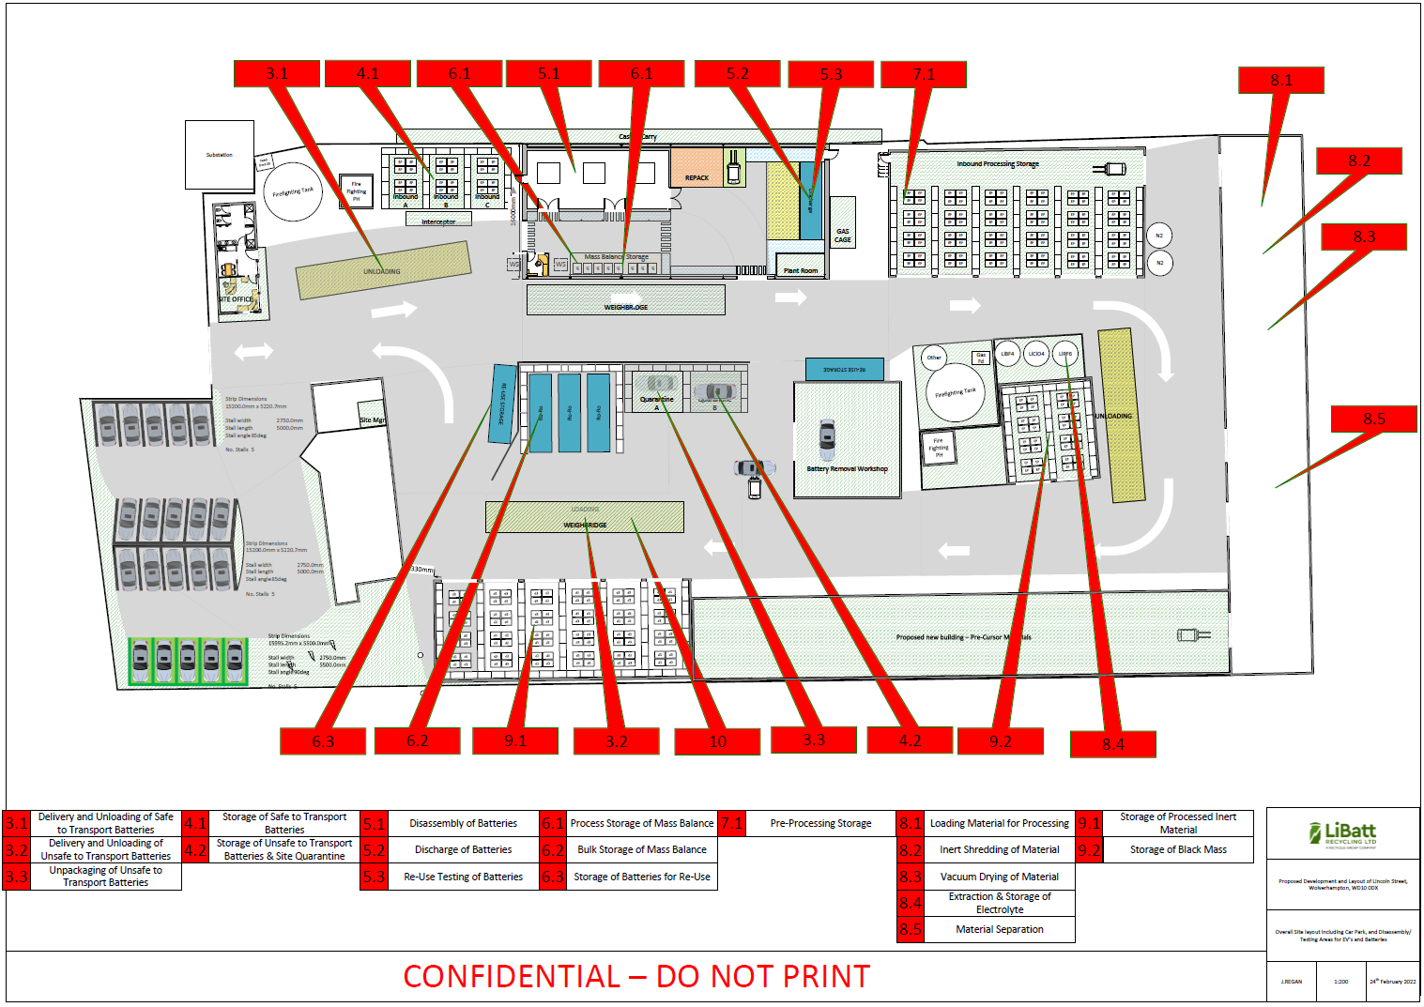
Figure A1 - Location plan showing the position of process steps

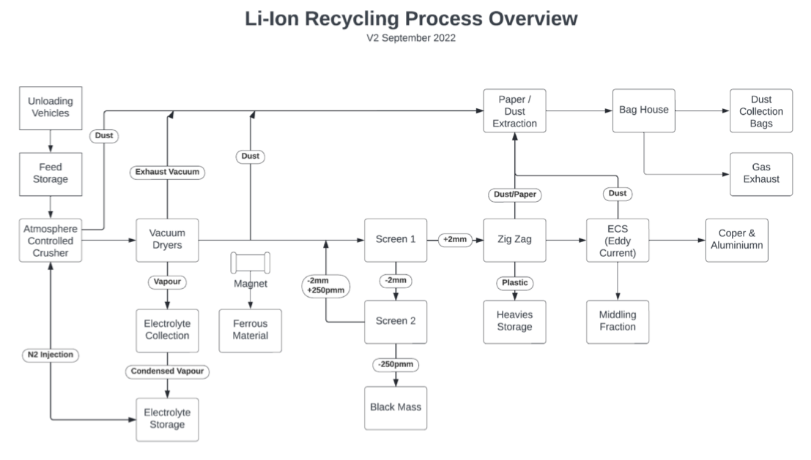
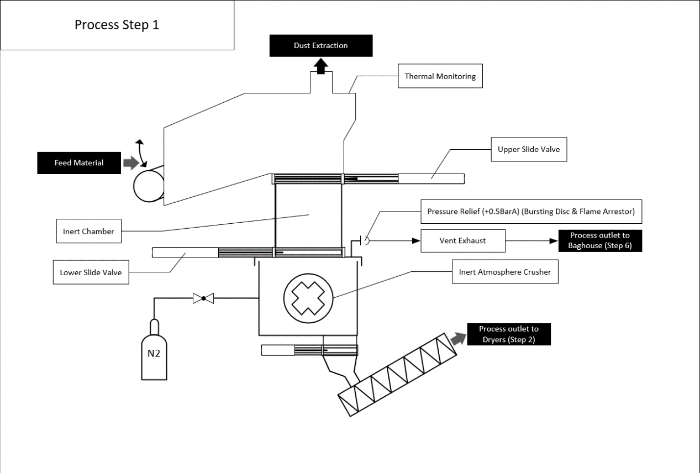

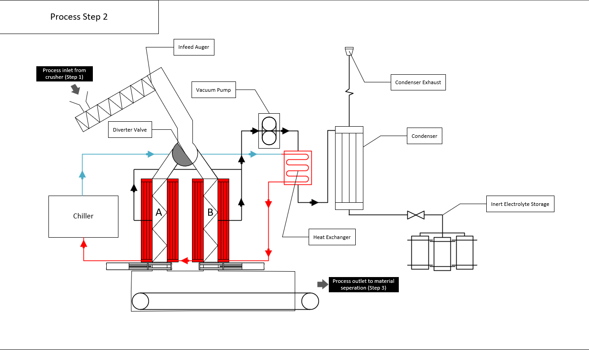
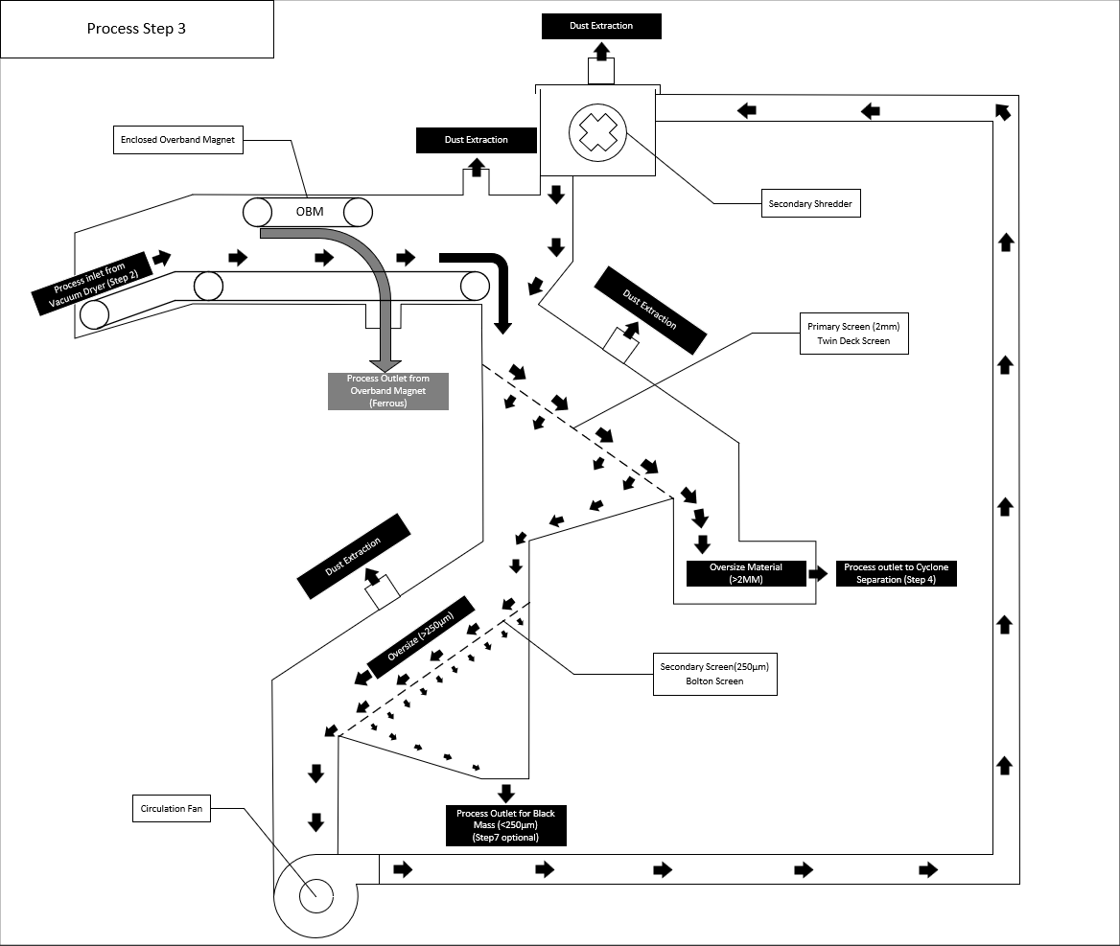

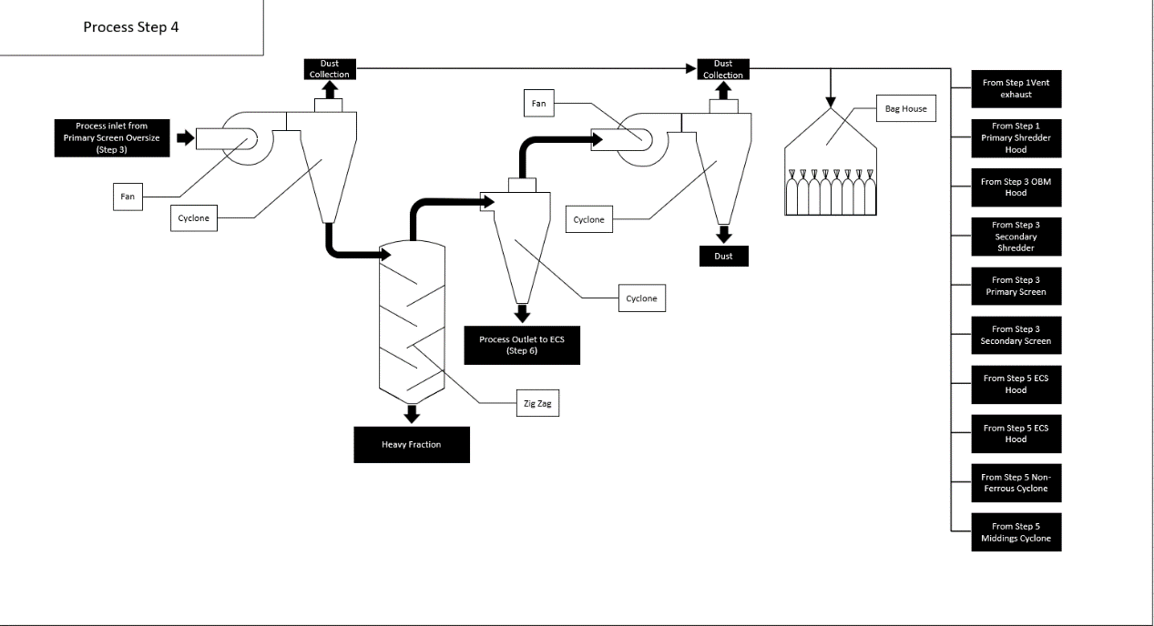

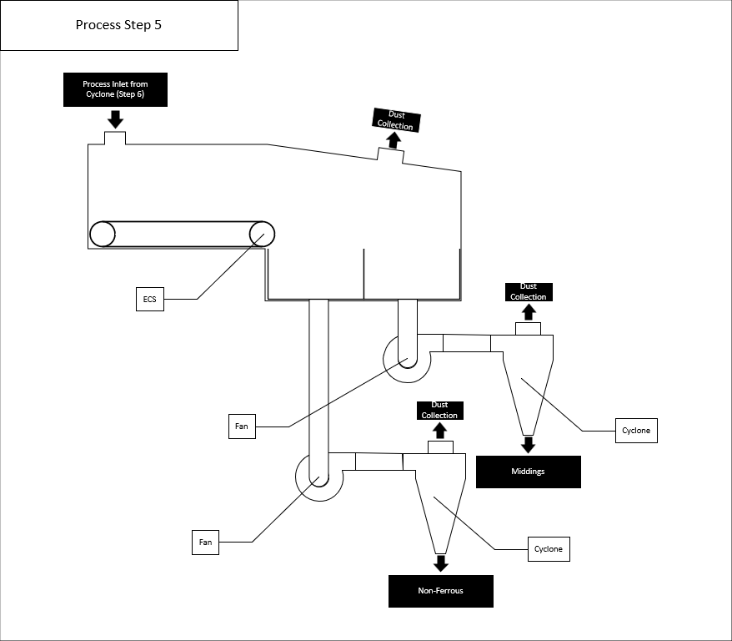

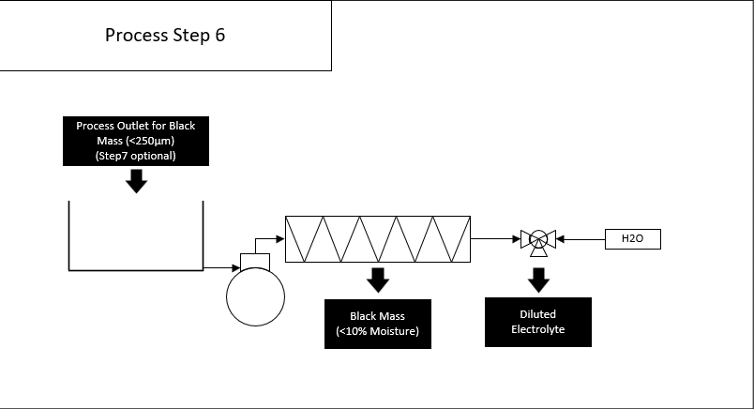

Appendix B - Dust Complaint Form

Customer Details
Customer Name -
Address –

Postcode -
Customer Contact Details -
Tel -
Email -
Date -
Complaint Ref Number -
Complaint Details -
Investigation Details
Investigation carried out by -
Position -
Date & time investigation carried out -
Weather conditions -
Wind direction and speed -
Investigation findings -
Feedback given to Environment Agency and/or local authority -
Date feedback given -
Feedback given to public -
Date feedback given -
Review and Improve
Improvements needed to
prevent a reoccurrence -
Proposed date for completion of the improvements -
Actual date for completion -
If different insert reason for delay -
Does the dust management plan need to be updated -
Date that the dust management plan was updated -
Closure
Site manager review date
Site manager signature to confirm no further action required

