ECOBAT Solutions UK
Crescent Works, Willenhall Road
Darlaston, Wednesbury
WS10 8JR
West Midlands
[ECOBAT Document 8]
Environment Risk Assessment
The Recupyl Unit will operate under the current well developed ECOBAT systems for management and environmental control. The operation increases the safety and efficiency of recovery and recycling of Lithium-Ion Batteries.
The Recupyl Unit operates, at ambient temperature and pressure and under a reduced pressure inert CO2 atmosphere, contra-rotating shredders that reduce Lithium-Ion Batteries into three fractions of solids. Each fraction is packed into UN complaint drums and shipped off site to licenced/permitted recovery operations.
Emissions to Land
The Recupyl machine when in operation has no direct or indirect emissions to land. It will operate inside a building. The inputs are solid entire Lithium-Ion Batteries.
These are shredded and separated by physical methods in a ferrous fraction, non-ferrous fraction, and a plastic/paper fraction. Each fraction is discharged into its specific UN compliant drum, fitted with a secure lid, and transported off-site for recovery.
Emissions to Water
The Recupyl machine has no direct emissions into the aquatic environment.
The vent scrubber attached to the Recupyl unit removes any entrained particulate matter or droplets of liquids. The scrubber has water circulating as the scrubbing medium. The scrubber is operated at a rate built in by the manufacturer.Scrubber liquor is tankered away for off-site disposal by a registered mode of transport and to a suitably permitted site.
Emissions to Air
The Recupyl machine has a vent scrubber with water as the scrubbing liquor. Given the operating conditions of ambient temperature and pressure, any air emissions for the shredding process are expected to be minimal with respect to quantity and environmental effect.ECOBAT recognises that the scrubber performance requires characterising, and this will be conducted during commissioning.
No emissions of any significant adverse effects into any compartment of the environment are envisaged from the operation of the Recupyl machine.
Throughputs will remain within current permitted quantities in Permit EPR/DB3704FG.
UPDATED AUGUST 2022
Local Habitats
Within 2km of Ecobat site Darlaston the below are a list of Local Wildlife Sites:
- Anson Branch Canal
- Anson Road
- Bentley Mill Lane
- Fibbersley
- Hadley’s Brickworks
- Hawkswell Drive Pool
- Heathfield Lane West Pond
- James Bridge Gasworks
- Land east of Dale Street
- Land east of Poplar Avenue
- Pouk Hill Quarry
- Walsall Canal
- Ward’s Pool
- Wolverhampton Road
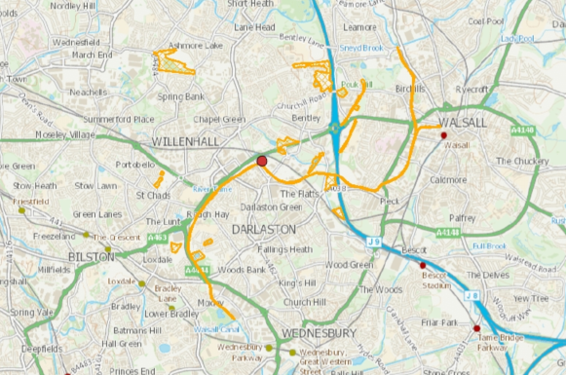

Sensitive Receptors

Sensitive Receptors
N

1km

Site Boundary Residential Area
Road Place of worship
Railway Schools
Walsall Canal Healthcare
Darlaston Brook Industrial Area
Residential area: Distance 450meters North
Place of worship: Distance 650meteres North
School: Distance 500meters Northeast
Canal: 5meters from site for 40meters South
Brook/River: 115meters Northeast
Emissions & Local Wildlife Site Impact Assessment
During the completion of our environmental risk assessment using the H1 assessment tool it highlighted potential emissions from our planned activity, based on emissions data used from our sister plant in Hettstedt Germany. Their plant is on a larger scale with more open processing compartments; therefore, we have used this as an over-estimation and will complete in depth emission testing on commissioning the Recupyl machine. Once complete, another H1 assessment will be completed, and control measures implemented where applicable.
The H1 assessment tool identifies potential significant emissions and insignificant emissions.
Potential Insignificant emissions:
- Hydrogen Chloride
- Sulphur Dioxide
- Manganese
- Benzene (used for VOC’s)
Potential Significant emissions:
- Nickel
- Cadmium

On further assessment of the significant emissions the results are <70% PEC of EAL. It is deemed that additional screening is not necessary at this time.
Furthermore, it is planned for an emission test to be completed on the Recupyl machine with actual readings. Where another H1 assessment will be completed and if further screening / controls are required, this will be completed.

We have considered the local wildlife sites along with local sensitive receptors and have determined the activities conducted on Ecobat’s site will have no impact on these inline with our current control measures as detailed in RA-47 Environmental Risk Assessment & H1 assessment. We have used the emissions data from our sister plant in Hettstedt to ensure the control measures currently are adequate, which include a VOC & CO2 monitoring until we complete a full emissions survey on the plant, prior to it running at capacity.

Noise Impact Assessment
RA-47 Environmental Risk Assessment has identified that there is no additional noise risk from the Recupyl Machine activity. This is based on the below:
- The activity does not involve any noisy plant or machinery such as cooling equipment (fans)
- The activity is enclosed within a building, with all entries being closed during its operations (interlocks on doors, machine cannot run if door is open).
- The buildings’ structure is of 440mm breeze blocks with 200mm of Fire master wall on top, to complete the 4-hour fire walls, where the plant is located within the building. This will in addition will absorb any noise from the machine.
- The activity will take place during our normal operational hours of 0730 – 1530
- The activity is not located in an area sensitive to noise for example a rural area, it will take place in an industrial area
For best practice, a full noise impact assessment will be completed report produced by October 2022. This allows us to ensure our risk assessment and control measure are accurate. Any results can be shared with the Environment agency to support our management of site in the future.

