
WRM
wrm-ltd.co.uk
01943 468138

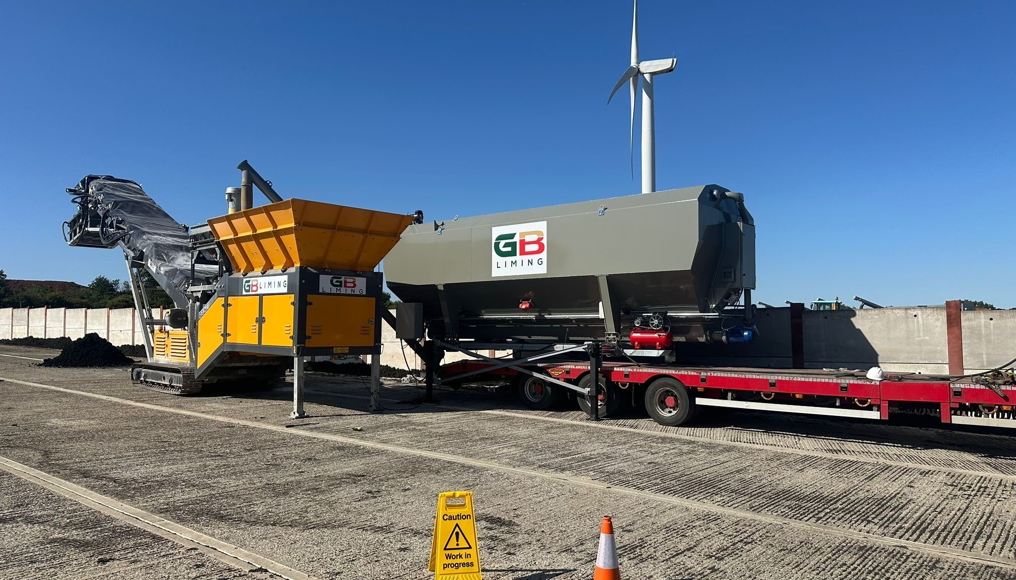

Waste Treatment Procedure
v1.0

Environmental and sustainability solutions provided to
GB Liming Ltd

WRM-LTD.CO.UK
This report was prepared by Walker Resource Management Ltd (WRM’) within the terms of its engagement and in direct response to a scope of services. This report is strictly limited to the purpose and the facts and matters stated in it and does not apply directly or indirectly and must not be used for any other application, purpose, use or matter. In preparing the report, WRM may have relied upon information provided to it at the time by other parties. WRM accepts no responsibility as to the accuracy or completeness of information provided by those parties at the time of preparing the report. The report does not take into account any changes in information that may have occurred since the publication of the report. If the information relied upon is subsequently determined to be false, inaccurate, or incomplete then it is possible that the observations and conclusions expressed in the report may have changed. WRM does not warrant the contents of this report to any party other than the named client, and shall not assume any responsibility or liability for loss whatsoever to any third party caused by, related to, or arising out of any use or reliance on the report howsoever. No part of this report, its attachments or appendices may be reproduced by any process without the written consent of WRM. All enquiries should be directed to WRM.

Document Title | Waste Treatment Procedure
Client | GB Liming Ltd
Revision | v1.0
Date | 07/04/2026
Document Reference | EPR-OP02
Project Reference | 1578/F05
Author: Bryanna Heaton |  | Reviewer: Graeme Kennett
 |  | 

Copyright ©
All material on these pages, including without limitation text, logos, icons and photographs, is copyright material of Walker Resource Management Ltd (WRM). Use of this material may only be made with the express, prior, written permission of WRM. This document was produced solely for use by the named client to whom the document refers. The methodology (if any) contained in this report is provided to you in confidence and must not be disclosed or copied to third parties without the prior written agreement of WRM. Disclosure of that information may constitute an actionable breach of confidence or may otherwise prejudice our commercial interests.

Revision | Details | Date
0.1 | Initial Draft | 12/01/2026
0.2 | Version for operator comment | 17/02/2026
0.3 | Update following client review | 19/02/2026
1.0 | Final version for submission | 07/04/2026

Revision Log

CONTENTS
Contents
1.0 Purpose 1
2.0 Procedure Overview 2
2.1 Delivery of non-compliant biosolids to site 2
2.2 Liming 2
2.3 Pre-operational checks (Appropriate Measures) 2
2.4 The mixing process (the treatment "barrier") 3
2.5 pH verification & retention (CCP2) 3
2.6 Post-treatment storage and traceability 3
2.7 Material storage and despatch 4
2.8 Drainage and Containment 4
3.0 Roles and Responsibilities 4
3.1 Site Manager role 4
3.2 Site Manager/supervisor responsibilities 5
3.3 Weighbridge operator responsibilities 5
3.4 Site staff responsibilities 6

Purpose
This document aims to outline the procedure which must be followed by operatives at GB Liming Ltd (hereon referred to as ‘GBL’) for the processing of non-compliant biosolids from wastewater treatment works via liming.
All on-site agreed process procedures will be checked for compliance and relevance on a daily / weekly ongoing basis.

Procedure Overview
The defined procedures as described in section 1.0 have been dissected into their component parts for ease of reference by site operatives.

Delivery of non-compliant biosolids to site
Non-compliant biosolids delivered to site are delivered initially to the biosolids reception area in the northwestern portion of the site after exiting the weighbridge. Once inspected and accepted, non-compliant biosolids are stored in 4No. of concrete legio bays situated on impermeable concrete hardstanding in the northeastern portion of the site. The legio block ensure that the bays are mobile / interchangeable if necessary.

Liming
To align with both the Biosolids Assurance Scheme (BAS) Standard Issue 5.0 and the Appropriate Measures for Waste Treatment, the liming procedure demonstrates that the Barford BF4048 is being used as a validated chemical reactor, not just a mixer.
The liming treatment is undertaken as an active stabilisation process and does not rely on prolonged storage, passive biodegradation, or dilution. Lime treatment involves adding alkaline materials (typically quicklime or hydrated lime) to biosolids. This raises the pH and temperature of the material for a defined period (raise pH to above 11.5 for at least 2 hours), which:
- Reduces pathogens to safe levels
- Stabilises the material and slows biological breakdown
- Significantly reduces odour potential
- Improves handling characteristics

Pre-operational checks (Appropriate Measures)
Containment: Ensure the mobile Pugmill is situated on an impermeable surface with a sealed drainage system to capture any leachate or "squeeze" during the mixing process.
Calibration: Verify that the Barford’s integrated belt scales and the lime silo’s screw feeder are calibrated. This ensures the Critical Control Point (CCP1)—the lime inclusion rate—is met.
Odour suppression: Activate the misting system or boundary atomisers if the non-compliant material is identified as high-odour risk during the reception phase.

The mixing process (the treatment "barrier")
Controlled Feed: Load the hopper with non-compliant biosolids. The twin-shaft paddle mixer in the BF4048 must be set to a speed that ensures complete homogeneity.
Alkaline Dosing (CCP1): Inject calcium hydroxide (lime) at the validated rate (typically >5% w/w). The intense scrubbing action of the twin shafts ensures every particle of sludge is coated in lime, facilitating alkaline hydrolysis.
Exothermic Reaction: The chemical reaction should ideally generate a temperature rise. While not a standalone CCP in lime-only systems, it supports the pathogen kill required for "Treated" status.

pH verification & retention (CCP2)
Immediate testing: Sample the output from the Barford discharge conveyor. Use a calibrated probe to verify a pH of ≥11.5.
The 2-Hour rule: The treated material must be moved to a "Mellowing Bay." Under BAS guidelines, it must maintain pH 11.5 for at least 2 hours to ensure a 99% reduction in E. coli.
Homogeneity check: The EA requires that Appropriate Measures prevent ‘hot cold spots’. Operators must visually inspect the cake for ‘lime balls’—if found, the throughput speed must be reduced to increase mixing intensity.

Post-treatment storage and traceability
Segregation: Transfer the processed cake to the 8No. limed biosolids storage bays.
Batch coding: Assign a unique ID to the pile that links back to the Barford's tonnage meter and the specific lime delivery batch.
Lab validation: Once the batch has stabilised, take representative samples for BAS-accredited laboratory analysis to confirm it meets the Safe Sludge Matrix standards.

Material storage and despatch
All material that has undergone liming onsite shall be stored separately from the material which is yet to undergo treatment. Storage will be provided until processed material is loaded onto vehicles to be spread to agricultural land or S3 registered storage sites.

Drainage and Containment
All surface water generated on site are managed by the site’s sealed drainage system into aco surface drains into an underground static tank c. 50-60m³ capacity. Rainwater falling on building roofs via gullies and pipework is then directed to the same surface water drainage system.

Roles and Responsibilities

Site Manager role
- Ensuring all staff are inducted and trained in relevant site procedures.
- Ensuring all company H&S protocols are adhered too, keep site compliant with Environment Agency permit.
- Developing and implementing environmental strategies and action plans, to ensure corporate sustainable development.
- Taking the lead on sustainable procurement for all goods and services.
- Coordinating all aspects of pollution control, waste management, recycling, environmental health, conservation and renewable energy.
- Ensuring details and photographs of any non-conforming loads are sent as appropriate.
- Monitoring the amount of non-conforming loads received as appropriate.
- Dealing with suppliers of non-conforming loads.

Site Manager/supervisor responsibilities
- Ensuring all loads received are inspected on arrival.
- Material receiving, inspection and storage.
- Ensuring that any non-conforming material is dealt with.
- Ensuring any discrepancies from the type of material advised are reported back to the Weighbridge Operator.
- Ensuring relevant staff adhere to the standard operating procedure for the treatment (liming) of non-compliant biosolids from wastewater treatment works.
- Ensuring container seal numbers are recorded by weighbridge staff into the tracking system.
- Ensuring photographs are taken of non-conforming product as appropriate.

Weighbridge operator responsibilities
- Ensuring the vehicle driver provides all of the relevant information.
- Ensuring that only the vehicle is located on the weighbridge and that the driver has positioned the vehicle correctly.
- Completing the weighbridge programme with all relevant information.
- Ensuring that they communicate with the site staff about tipping and loading locations for the vehicle in accordance with the company site schematics.
- Ensuring the vehicle driver has the correct personal protective equipment (PPE) when entering the site, issuing where necessary and retrieving when leaving the site.
- Adjusting the weight to account for any deductions or weight anomalies.
- Processing all paperwork related to the delivery as necessary, including the Waste Transfer Note (Duty of Care documentation).
- Maintaining the site diary.
- Ensuring that vehicles go through the wheel washing process before exiting site.
- Ensuring all loads received are inspected on arrival.

Site staff responsibilities
Maintaining strong H&S culture.
- Ensuring that the vehicle driver tips and loads in the correct location in accordance with the company site schematics.
- Ensuring the vehicle driver has located the vehicle correctly on the weighbridge and that no one is standing on the weighbridge.
- Identifying any non-conforming loads.
- Inspecting the load and advising the Weighbridge Operator of any deductions that must be made along with any non-conforming product received.
- Dealing with non-conforming loads in accordance with the site’s Emergency Action Plan.
- Taking photographs of non-conforming loads using the site’s computerised system as appropriate.
- Ensuring all onsite adhere to GBL’s AMP.

