
WRM
wrm-ltd.co.uk
01943 468138

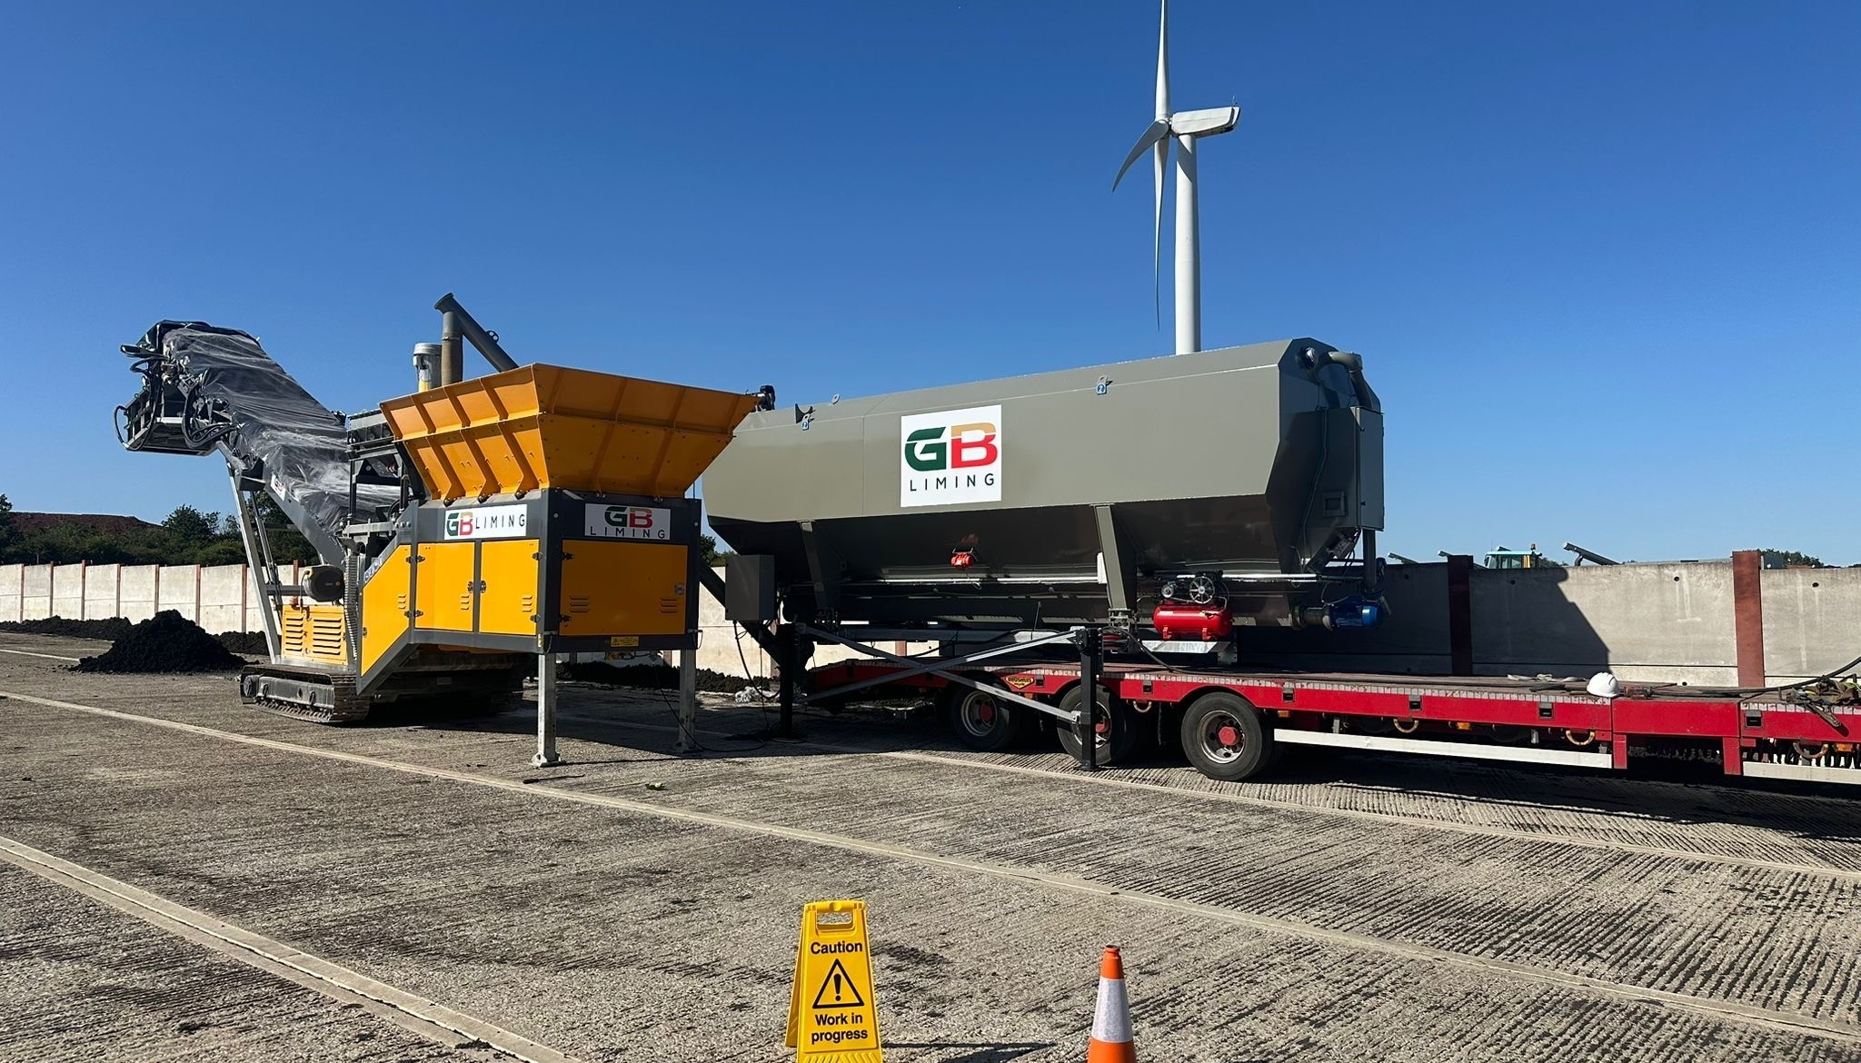

Accident Prevention & Management Plan
v1.0

Environmental and sustainability solutions provided to
GB Liming Ltd

WRM-LTD.CO.UK
This report was prepared by Walker Resource Management Ltd (WRM’) within the terms of its engagement and in direct response to a scope of services. This report is strictly limited to the purpose and the facts and matters stated in it and does not apply directly or indirectly and must not be used for any other application, purpose, use or matter. In preparing the report, WRM may have relied upon information provided to it at the time by other parties. WRM accepts no responsibility as to the accuracy or completeness of information provided by those parties at the time of preparing the report. The report does not take into account any changes in information that may have occurred since the publication of the report. If the information relied upon is subsequently determined to be false, inaccurate, or incomplete then it is possible that the observations and conclusions expressed in the report may have changed. WRM does not warrant the contents of this report to any party other than the named client, and shall not assume any responsibility or liability for loss whatsoever to any third party caused by, related to, or arising out of any use or reliance on the report howsoever. No part of this report, its attachments or appendices may be reproduced by any process without the written consent of WRM. All enquiries should be directed to WRM.

Document Title | Accident Prevention & Management Plan
Client | GB Liming Ltd
Revision | v1.0
Date | 07/04/2026
Document Reference | EPR-C03
Project Reference | 1578/F05
Author: Bryanna Heaton |  | Reviewer: Graeme Kennett
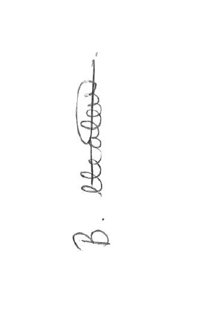 |  | 

Copyright ©
All material on these pages, including without limitation text, logos, icons and photographs, is copyright material of Walker Resource Management Ltd (WRM). Use of this material may only be made with the express, prior, written permission of WRM. This document was produced solely for use by the named client to whom the document refers. The methodology (if any) contained in this report is provided to you in confidence and must not be disclosed or copied to third parties without the prior written agreement of WRM. Disclosure of that information may constitute an actionable breach of confidence or may otherwise prejudice our commercial interests.

Revision | Details | Date
0.1 | Initial Draft | 09/01/2026
0.2 | Draft for client review | 18/02/2026
0.3 | Update following client review | 19/02/2026
1.0 | Final version for submission | 07/04/2026

Revision Log

CONTENTS
Contents
1.0 Emergency 1
1.1 Site location details 1
1.2 Emergency contacts 1
1.3 Out of hours 1
2.0 Accident Prevention and Management Plan 2
2.1 Identified hazards 2
2.2 Assessment of risk 3
2.3 Risk mitigation 9

Emergency

Site location details
Company: GB Liming Ltd
Access via: Stoke Road (///butter.grand.alleyway)
Site Telephone: 07503 596019 (Mark Fowles)
Grid Reference: SP 11152 42124

Emergency contacts
Emergency services: 999
Local Police: 101
Health and Safety Executive: 0345 300 9923
Electricity Supplier (Emergency): TBC
Local Authority: Evesham Town Council – 01386 565700
Gas Supplier: N/A
Sewerage Undertaker: N/A
Fuel Supplier: TBC

Out of hours
Out of hours security contact: 07554991495, email: security@wgilder.co.uk

Accident Prevention and Management Plan
The AMP is a crucial part of the broader Environmental Management System (EMS). Development of this Accident Management Plan (AMP) has been made in line with the requirements set out in Develop a management system: environmental permits - GOV.UK . For accident prevention and management, there are three particular components:
- Identification of the hazards posed by the installation/activity;
- Assessment of the risks (hazard x probability) of accidents and their possible consequences; and,
- Implementation of measures to reduce the risks of accidents, and contingency plans for any accidents that do occur.

Identified hazards
The following hazards have been identified for the facility requiring assessment and management:
- Spills and leaks
- Loss of containment transfer of substances
- Overfilling of storage areas and stockpiles
- Vandalism
- Flooding
- Fire in processing plant
- Plant malfunction
- Electrical equipment that could provide an ignition source
- Failure in the mains services, water or electricity
- Operator error / failure of equipment
- Incompatible material storage
- Unexpected reactions

Assessment of risk
Hazard | Source frequency | Risk evaluation | Emission prediction | Consequences | Risk
Spills and leaks  Loss of containment Transfer of substances  Overfilling of storage areas and stockpiles | Medium - Spillage and leakage could occur during fuel deliveries, vehicle refuelling, vehicle breakdowns/ accidents and or damage to tanks or bunds. | Potentially polluting liquids flow onto impermeable surface area of facility.  Potential risk of fire if a naked flame is present.  Increase risk of slips or vehicles skidding on the spilled fuel if there is a large quantity.  Potential handling hazards if PPE and COSHH risk assessment for the substance is not followed. | Loss of containment could result in potentially polluting liquids (including oils) being discharged in surface water drainage systems and to controlled waters | Damage to human health, local environment and infrastructure. | Low - The site processing areas are located entirely on a sealed surface with fully contained and sealed drainage and therefore considered to have a low potential for impacts to ground water.  A containment system for tanks containing potentially polluting liquids has been constructed so that any leaks / spills are contained.  All stockpiles and bunds have been constructed to an appropriate standard.  Tanks are inspected visually on a regular basis to ensure continued integrity of tanks and identify any necessary remedial action.  Minor spills cleaned up immediately, using proprietary absorbents. Resultant materials placed in container for off-site disposal to appropriate facility.  Immediate action taken in event of major spill which is likely to cause polluting emissions to the environment to prevent liquid from entering surface water drains or any unsurfaced ground. Spillage cleared immediately and placed in containers for offsite disposal.  The company has established accident and emergency procedures.
Vandalism | Medium – fully fenced facility. | Damage to infrastructure and arson. | As per predictions of failure of site infrastructure. | As per consequences of failure of site infrastructure. | Low– Security lighting 24 hours a day; CCTV; security fencing; Gates will be locked whenever the site is closed; Gates and fencing are inspected daily by operations staff to identify deterioration and damage and the need for repair; Fencing and gates are maintained and repaired to ensure their continued integrity. If damage is sustained, repair will be made within the same working day. If this is not possible, suitable measures will be taken to prevent unauthorised access to the site and permanent repairs will be affected as soon as is practicable;  All visitors to the site are required to register in the visitor’s book and sign out again on exit, thereby minimising the risk of unauthorised visitors on the site; and  Operational procedures have been implemented including regular inspections, ensuring continual monitoring of security provision at the site.
Flooding | Medium - The site lies within an area with a very low chance of flooding. | Potentially polluting material flow onto impermeable surface area of facility.  Damage to infrastructure.  The site could be inundated with floodwater that would damage electrical equipment. | Polluting substances could drain into the site’s drainage system, or run-off paved areas onto adjoining land and pollute groundwater, surface water and soils. | Potential for land contamination if not constrained. | Low - Site equipped with a sealed drainage and bunding systems which will prevent the inflow of offsite flood water into critical areas (bunds, tanks, storage etc.).  All materials are stored in bunded areas.
Fire in processing plant:  Plant malfunction;  Electrical equipment that could provide an ignition source; | Low – As there is no storage of combustible materials on site, there is the minimal potential for fires to commence. | Loss of electrical power. | Fugitive emissions to atmosphere.  May interfere with waste treatment process. | Failure of site infrastructure could result in risks of leaks, fire, explosions, gas leaks, or temporary closure of the site. | Low - All machinery is subject to a Planned Preventative Maintenance schedule.  The machinery is flitted with fire suppression to combat fires.  Operators trained and aware of measures to be taken to deal with fires until Fire & Rescue Services are called.  Containment system: all tanks and vessels containing flammable and potentially polluting liquids are constructed so that any leaks/spillages are contained and responded to in accordance with established emergency procedures.  In the event of a fire, the following actions will be taken:  - The Fire & Rescue Service will be notified immediately and EA as soon as practicable.  - All containment valves and systems will be closed.  - The site will be immediately evacuated.  Records of fire incidences will be kept on site together with a summary of remedial action taken.  Smoking not permitted other than in designated areas of the site.
Failure of Mains Services:  Failure in the mains services, water or electricity. | Low – Depending on the time of year that a failure occurs, this will either not affect operations or have a limited impact. | Unable to proceed with waste operations. | N/A | As per consequences of failure of site infrastructure and mains services. | Low - If mains services of water and electricity supplied to the site are unavailable, this would trigger emergency plant shut down. Back-up power is available to ensure continued supply to control equipment.  Water is stored on site, so interruption would not prevent operation.
Operator error / failure of equipment:  The unexpected breakdown of any part of the plant could result in short term build-up of material in the reception area or the incomplete processing of material. | Rare – infrastructure and plant equipment regularly maintained. | Loss of electrical power. | Fugitive emissions to atmosphere.  May interfere with waste treatment process. | Failure of site infrastructure could result in risks of leaks, fire, explosions, gas leaks, odour emissions or temporary closure of the site.  Build-up of waste material on site, exceeding storage limits. | Low probability of event with a high potential consequence. All plant operatives are highly trained and experienced in the roles.  The process capacity is carefully managed via the acceptance process to ensure that there is always sufficient processing capacity.  Production flows are carefully monitored to ensure there is always sufficient capacity.  All equipment is subject to a Planned and Preventative Maintenance schedule (PPM), to minimise unplanned failures.  The plant also has Emergency Shutdown Controls in place to ensure safe shut down in emergency.
Incompatible material storage | Low – pre-acceptance procedure in place | Unsuitable waste entering waste treatment process. | Unsuitable waste entering waste treatment process. | Damage to human health, local environment and infrastructure. | Low probability of event due to well-established acceptance procedures.  Should any unpermitted waste materials be discovered they are segregated immediately and removed from site.

Risk mitigation
Hazard | Equipment at risk | Preventative measures | Who to inform | Monitoring mitigation | Response measures | System procedures
Spills and Leaks  Loss of Containment Transfer of Substances  Overfilling of Storage areas and stockpiles | Process machinery | The site processing areas are located entirely on an impermeable surface with fully contained and sealed drainage and therefore considered to have a low potential for impacts to ground water.  A sealed drainage and containment system for tanks containing potentially polluting liquids has been constructed so that any leaks / spills are contained.  All storage areas and bunds have been constructed to the appropriate British Standard.  Tanks are inspected visually on a regular basis to ensure continued integrity of tanks and identify any necessary remedial action.  Minor spills to be cleaned up immediately, using proprietary absorbents. Resultant materials to be placed in container for off-site disposal to appropriate facility.  Immediate action to be taken in event of major spill which is likely to cause polluting emissions to the environment to prevent liquid from entering surface water drains or any unsurfaced ground. Spillage to be cleared immediately and placed in containers for offsite disposal.  The company has established accident and emergency procedures. | Site Manager  EA (If leading to pollution event). | The condition of any tanks are frequently inspected as part of the standard site checks.  Pre-use checks are undertaken on machinery prior to use to detect any mechanical faults which may result in fuel leaks.  Toolbox Talks are held with staff to ensure everyone is familiar with the refuelling and spillage procedure.  Site Manager periodically observes the refuelling process to ensure safe practices are followed. | Spill kits are available at the point of use and will be used to contain any spillages and cover drains.  Ensure machinery is switched off.  Restrict access to area whilst spill is being dealt with.  Refer to the COSHH risk assessment for the safe handling on the spilled material.  Monitor external areas to ensure no further contamination.  Record and investigate incidents following Management System.  Review Management System within the context of a management review.  Inform the EA of any significant spillages and the fire service if required. | Accident Prevention & Management Plan.  COSHH- MSD Sheets.
Vandalism | Site infrastructure | Security lighting 24 hours a day;  CCTV;  Security fencing;  Gates locked whenever the site is closed;  Gates and fencing are inspected daily by operations staff to identify deterioration and damage and the need for repair;  Fencing and gates are maintained and repaired to ensure their continued integrity. If damage is sustained, repair will be made within the same working day. If this is not possible, suitable measures will be taken to prevent unauthorised access to the site and permanent repairs will be affected as soon as is practicable;  All visitors to the site are required to register in the visitor’s book and sign out again on exit, thereby minimising the risk of unauthorised visitors on the site; and  Operational procedures have been implemented including regular inspections, ensuring continual monitoring of security provision at the site. | Police.  EA (if break-in leads to pollution incident). | During operating hours, 6-days a week during processing and shutdowns. | Assess damage and mitigate any damage / pollution caused (follow management practices).  Inform site management.  Inform Police.  Inform EA if required. | Management System.  Accident Management Plan.  Site Diary.
Flooding | All. | The site located on a bunded, impermeable surface that will prevent the inflow of offsite flood water into critical areas (bunds, tanks, storage etc.). | Environment Agency – Emergency Event.  -In the event of a pollution incident. | The drainage system frequently inspected as part of the standard site checks. | Try to contain liquids, where possible, with bunds.  Ensure machinery is switched off.  Depending on the severity of the failure and timescale to repair, reception or processing of material would not be undertaken until agreed with EA.  Alert supply chain to the issue and cease the acceptance of waste until normal service has resumed. | Accident Management Plan.
Fire in processing plant:  Plant malfunction;  Electrical equipment that could provide an ignition source;  Waste products / raw materials that may support combustion. | All. | All machinery is subject to a Planned Preventative Maintenance schedule.  The machinery is flitted with fire suppression to combat fires.  Operators trained and aware of measures to be taken to deal with fires until Fire & Rescue Services are called.  Containment system: all tanks and vessels containing flammable and potentially polluting liquids are constructed so that any leaks/spillages are contained and responded to in accordance with established emergency procedures.  Smoking will not be permitted other than in designated areas of the site. | Fire Brigade- In the event of a fire.  HSE-In the event of a serious incident.  EA-following a fire event. | Maintenance of vehicles follow strict procedure.  Operators trained in accordance with the on-site fire procedure.  Site checks ensuring fire extinguishers are positioned in the correct location, fire exits are not blocked, and flammable material is not stored in inappropriate locations.  Fire risk assessment carried out for the facility. | Raise alarm on site and contact the fire service immediately.  Ensure personnel are evacuated away from the danger zone and assemble at the designated fire assembly point, as detailed within the site’s fire procedure. Remove the visitor’s book from the site office if safe to do so.  Ensure all staff and visitors are accounted for at the fire assembly point co-ordinated by trained fire marshals.  Liaise with the Senior Fire Officer, providing the following information:  - location of the fire;  - missing employees or visitors;  - location of dangerous chemicals/substances; and,  - location of equipment isolating points.  Full incident investigation undertaken to determine the root cause and necessary corrective action.  Depending on the severity of the fire, site critical equipment may have been damaged, and no further reception or processing of waste would be undertaken until agreed with EA. | Accident Management Plan.
Failure of Mains Services:  Failure in the mains services, water or electricity. | Building(s).  Energy-using equipment.  Water supply. | Infrastructure regularly checked with maintenance programmes. | Service Provider – Inform loss of power.  EA – Inform of any impact on the process. | Routine daily inspections of site integrity. | Inform Site Manager upon detection.  Arrange for remedial works to be carried out immediately.  Inform service provider to identify cause and restore service immediately.  Inform EA of failure and proposed timescale to repair.  Depending on the severity of the failure and timescale to repair, reception or processing of material would not be undertaken until agreed with EA.  Alert supply chain to the issue and cease the acceptance of waste until normal service has resumed. | Management System.  Accident Management Plan.  Maintenance Schedules.  Site Diary.
Operator error / failure of equipment:  The unexpected breakdown of any part of the plant could result in short term build-up of material in the reception area or the incomplete processing of material. | All. | Infrastructure regularly checked with maintenance programmes. | Service Provider – Inform loss of power.  EA – Inform of any impact on the process. | Routine daily inspections of site integrity. | Inform Site Manager upon detection.  Arrange for remedial works to be carried out immediately.  Inform service provider to identify cause and restore service immediately.  Inform EA of failure and proposed timescale to repair.  Depending on the severity of the failure and timescale to repair, reception or processing of material would not be undertaken until agreed with EA.  Alert supply chain to the issue and cease the acceptance of waste until normal service has resumed. | Management System.  Accident Management Plan.  Maintenance Schedules.  Site Diary.
Incompatible material storage | Process machinery | All incoming loads will be pre-booked, and the correct waste acceptance procedure undertaken.  Records of received wastes will be made and retained.  Documentation in accordance with the Duty of Care Regulations will be completed.  Site operatives will be made aware of the permitted waste types. | Site Manager  EA (If leading to pollution event). | A confirmatory check will be undertaken at the offload area.  Additional detailed visual check is undertaken at the corresponding waste reception area | Any non-conforming wastes identified following deposit will be removed from the site back to the supplier or to a suitable permitted facility.  A record will be made of wastes found not be permitted.  Waste rejection procedure in place at site. | OP01 - Waste Acceptance Procedure.
Unexpected reactions | All. | All machinery is subject to a Planned Preventative Maintenance schedule.  The machinery is flitted with fire suppression to combat fires.  Operators trained and aware of measures to be taken to deal with fires until Fire & Rescue Services are called.  Containment system: all tanks and vessels containing flammable and potentially polluting liquids are constructed so that any leaks/spillages are contained and responded to in accordance with established emergency procedures.  Smoking will not be permitted other than in designated areas of the site.  Precise control over all processes is continually maintained. | Fire Brigade- In the event of a fire.  HSE-In the event of a serious incident.  EA-following a fire event. | Maintenance of vehicles follow strict procedure.  Operators trained in accordance with the on-site fire procedure.  Site checks ensuring fire extinguishers are positioned in the correct location, fire exits are not blocked, and flammable material is not stored in inappropriate locations.  Fire risk assessment carried out for the facility. | Raise alarm on site and contact the fire service immediately.  Ensure personnel are evacuated away from the danger zone and assemble at the designated fire assembly point, as detailed within the site’s fire procedure. Remove the visitor’s book from the site office if safe to do so.  Ensure all staff and visitors are accounted for at the fire assembly point co-ordinated by trained fire marshals.  Liaise with the Senior Fire Officer, providing the following information:  - location of the fire;  - missing employees or visitors;  - location of dangerous chemicals/substances; and,  - location of equipment isolating points.  Full incident investigation undertaken to determine the root cause and necessary corrective action.  Depending on the severity of the fire, site critical equipment may have been damaged, and no further reception or processing of waste would be undertaken until agreed with EA. | Accident Management Plan.

