
WRM
wrm-ltd.co.uk
01943 468138

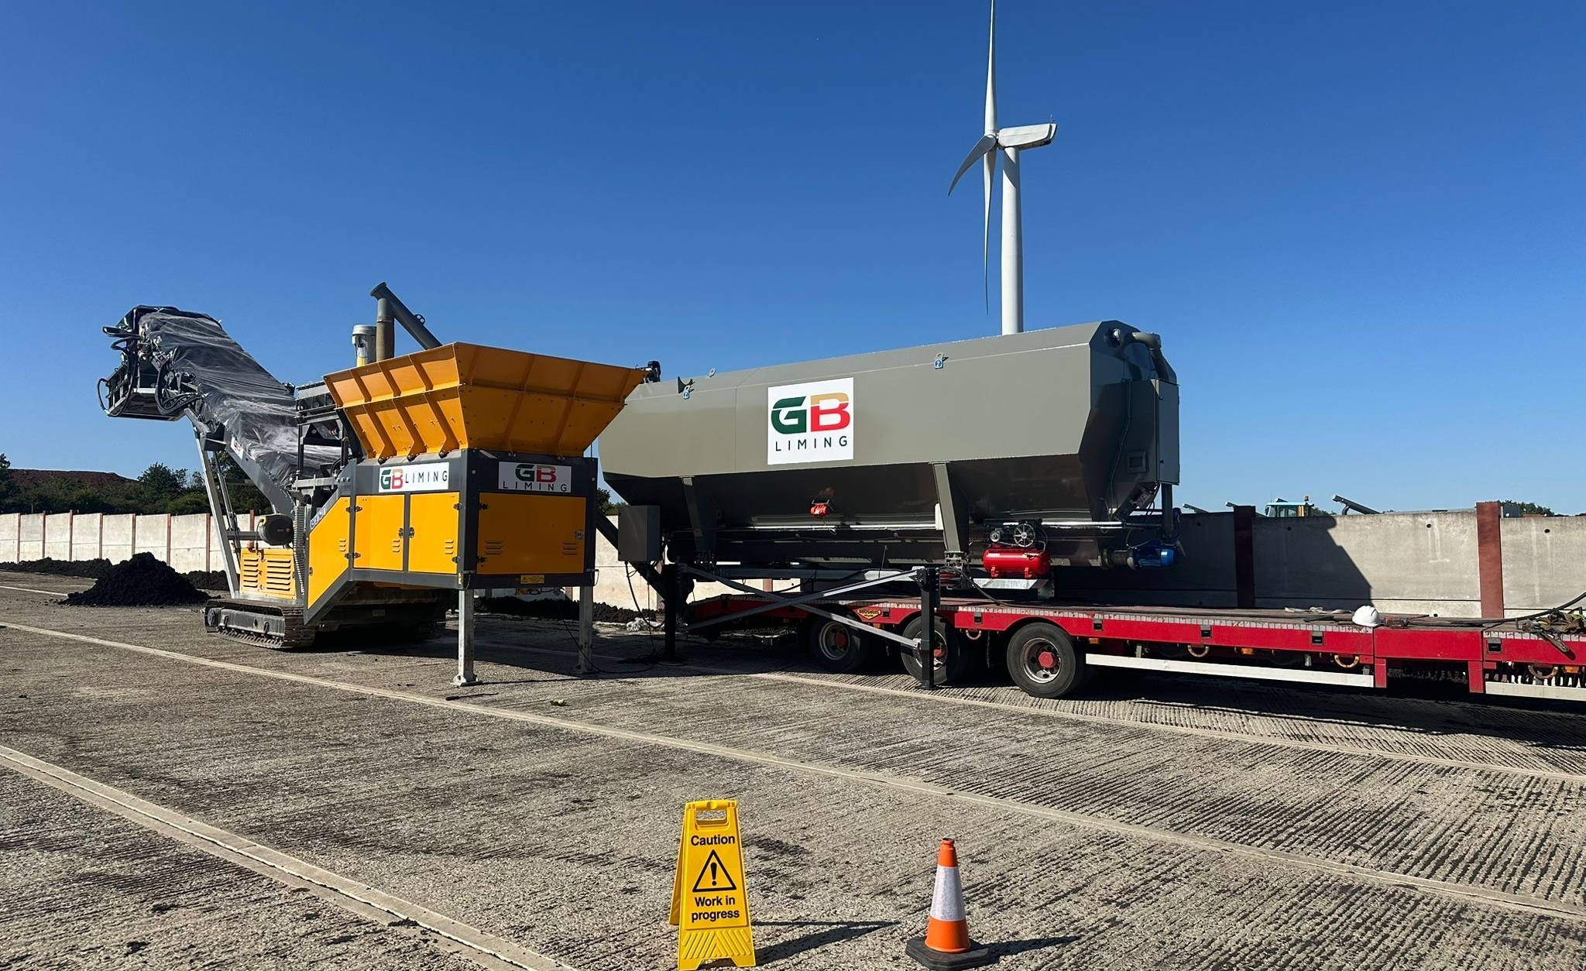

Odour Management Plan (OMP) [Biosolid liming]
v1.0

Environmental and sustainability solutions provided to
GB Liming Ltd

WRM-LTD.CO.UK

This report was prepared by Walker Resource Management Ltd (WRM’) within the terms of its engagement and in direct response to a scope of services. This report is strictly limited to the purpose and the facts and matters stated in it and does not apply directly or indirectly and must not be used for any other application, purpose, use or matter. In preparing the report, WRM may have relied upon information provided to it at the time by other parties. WRM accepts no responsibility as to the accuracy or completeness of information provided by those parties at the time of preparing the report. The report does not take into account any changes in information that may have occurred since the publication of the report. If the information relied upon is subsequently determined to be false, inaccurate, or incomplete then it is possible that the observations and conclusions expressed in the report may have changed. WRM does not warrant the contents of this report and shall not assume any responsibility or liability for loss whatsoever to any third party caused by, related to, or arising out of any use or reliance on the report howsoever. No part of this report, its attachments or appendices may be reproduced by any process without the written consent of WRM. All enquiries should be directed to WRM.

Document Title | Odour Management Plan (OMP) [Biosolid liming]
Client | GB Liming Ltd
Revision | v1.0
Date | 07/04/2026
Document Reference | EPR-C02
Project Reference | 1578/F05
Author: Bryanna Heaton |  | Reviewer: Graeme Kennett
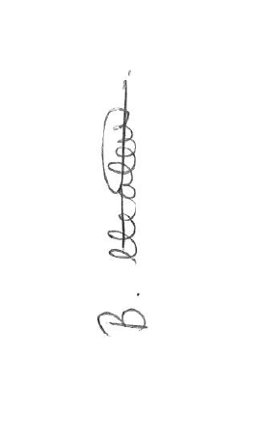

Copyright ©
All material on these pages, including without limitation text, logos, icons and photographs, is copyright material of Walker Resource Management Ltd (WRM). Use of this material may only be made with the express, prior, written permission of WRM. This document was produced solely for use by the named client to whom the document refers. The methodology (if any) contained in this report is provided to you in confidence and must not be disclosed or copied to third parties without the prior written agreement of WRM. Disclosure of that information may constitute an actionable breach of confidence or may otherwise prejudice our commercial interests.

Revision | Details | Date
0.1 | First draft | 09/01/2026
0.2 | Draft for operator review | 18/02/2026
0.3 | Update following client review | 19/02/2026
1.0 | Final version for submission | 07/04/2026

Revision Log

CONTENTS
Contents
1.0 Odour background 1
1.1 Site details 2
1.2 Location 2
1.3 Grid reference 2
1.4 OMP availability 2
2.0 Introduction 3
2.1 Site overview 3
2.2 Site layout and infrastructure 3
2.3 Waste types accepted 4
2.4 Liming process description 4
2.5 Process control and monitoring 5
2.6 Environmental risk controls 5
2.7 Responsibility for the Odour Management Plan and training 7
2.8 Review frequency of the OMP 7
2.9 Training received by site staff 8
2.10 Training frequency and delivery 8
2.11 Relevant sector guidance on which this OMP is based 9
3.0 Receptors 11
4.0 Sources of odour and site processes 16
4.1 Key considerations: 16
4.2 Odorous materials entering and leaving site 17
4.3 Container types for material delivery 18
4.4 Instructions provided to customers/drivers 18
4.5 Protocol for unacceptable or non-conforming materials 18
4.6 Odour release during treatment 19
4.7 Additional relevant information 20
4.8 Overview of odorous processes and emissions 21
5.0 Control measures and process monitoring 26
5.1 Appropriate Measures (AM) 26
5.2 Best Available Techniques (BAT) 26
5.3 H4 guidance 26
5.4 Monitoring and trigger levels 27
6.0 Odour reporting 32
6.1 Complaints reporting 32
6.2 Community engagement 33
6.3 Pro-active odour monitoring 33
6.4 Reactive odour monitoring 34
6.5 Summary 35
7.0 Abnormal events 36
7.1 General principles applied during abnormal events 36
8.0 Summary 42
9.0 Conclusion 44
9.1 Operation overview 44

Table 1: Odour guidance consulted 9
Table 2: Receptor list 12
Table 3: Odorous materials 19
Table 4: Sources of odour and site processes 21
Table 5: Site layout and process description controls 22
Table 6: Sources of odour, processes, and mitigation measures 27
Table 7: Abnormal events and recovery steps 35
Table 8: Abnormal events aligned to Appropriate Measures (non-hazardous and biowaste) 38

Odour background
The Environment Agency has a duty to regulate odour from certain industrial processes and waste sites. This is to protect and improve public health and wellbeing.

The British Standard EN 13725:2022 defines odour as a:
‘sensation perceived by means of the olfactory organ in sniffing certain volatile substances.’

The standard also defines an odorant as a:
‘substance which, when volatilised in neutral gas, has the potential to stimulate the human olfactory system so that an odour is perceived’

The Environmental Permitting (England and Wales) Regulations 2016 define pollution as:
any emission as a result of human activity which may:
(a) be harmful to human health or the quality of the environment,
(b) cause offence to a human sense,
(c) result in damage to material property, or
(d) impair or interfere with amenities or other legitimate uses of the environment

The Environment Agency will treat odorous emissions in the same way as any other polluting emission.

‘If odour pollution is happening and you are not taking appropriate measures, you may be breaching your permit condition, which is a criminal offence.’

Site details
The site, operated by GB Liming Limited (GBL), is a biosolids liming facility located in a rural area of Evesham and is currently seeking a Bespoke Environmental Permit for a sludge liming operation outside of a wastewater treatment facility.

Location
GB Liming Ltd
Weston Road
Honeybourne
Evesham
WR11 7QF

Grid reference
SP 11152 42124

OMP availability
This OMP will be made available to:
- All staff
- Site visitors (incl. Regulators)
- Contractors working at the site

Introduction
Biosolids is the term used to describe sewage sludge that has been through an approved and robustly monitored treatment process allowing it to be recycled to agricultural land.
Non-compliant biosolids is the term used to describe sewage sludge that has failed to meet those strict parameters.
Lime stabilisation, addition of lime to raise pH ≥11.5 for at least 2 hours, is recognised as an example of effective sludge treatment processes.

Site overview
The biosolids liming site undertakes the controlled treatment of dewatered sewage sludge (biosolids) by the addition of alkaline materials (typically quicklime or hydrated lime) to achieve stabilisation, sanitisation, and odour control prior to beneficial use or recovery. The primary objectives of the liming process are:
- Pathogen reduction through elevated pH and temperature.
- Odour suppression during storage, handling, and onward use.
- Improvement of material handling characteristics and stability.
Production of a treated biosolids material suitable for recovery, typically land application in accordance with regulatory controls.
The operation constitutes a waste treatment activity under environmental permitting legislation, with the limed biosolids remaining waste until deployed under an appropriate recovery route.

Site layout and infrastructure
The site is configured to ensure segregation of activities, containment of materials, and protection of sensitive receptors. Key infrastructure elements include:
- Designated reception area for incoming biosolids constructed of impermeable surfacing with sealed drainage.
- Liming and mixing area within a dedicated treatment unit, designed to prevent fugitive emissions.
- Treated biosolids storage area, sized to accommodate operational throughput and contingency storage, with measures to prevent runoff and leachate generation.
- Surface water and foul drainage systems, designed to segregate clean and contaminated waters and prevent uncontrolled discharges.
- Pressure washer and impermeable surfacing to control track-out and maintain site cleanliness.
- All operational surfaces are maintained in good condition and inspected routinely to ensure integrity and containment.

Waste types accepted
The site accepts only pre-approved biosolids streams, generally:
- Dewatered sewage sludge from wastewater treatment works.
- Sludges that have been characterised in accordance with WM3 and meet defined acceptance criteria.
- Each waste stream is subject to a documented waste acceptance procedure, including review of source, treatment history, chemical characteristics, and any contaminants of concern. Non-conforming or unauthorised wastes are rejected.

Liming process description
The liming process involves the controlled addition of alkaline reagent to biosolids using mechanical dosing and mixing equipment. The process typically comprises:
- Reception and verification of incoming biosolids.
- Metered addition of lime, based on sludge dry solids content and process requirements.
- Mechanical mixing to ensure homogeneous distribution of lime throughout the sludge.
- Reaction phase, during which pH is elevated (typically ≥11.5) and temperature increases due to exothermic reactions.
- Verification monitoring, confirming achievement of target pH and residence time.
- Process control parameters (lime addition rate, mixing time, pH) are defined within the OMP and supported by operational records.

Process control and monitoring
Effective control of the liming process is achieved through:
- Routine measurement and recording of treated biosolids pH.
- Periodic verification of temperature and residence time, where applicable.
- The site-specific HACCP as required by the Biosolids Assurance Scheme.
- Visual inspection of mixing quality and material consistency.
- Calibration and maintenance of dosing and monitoring equipment.
- All monitoring results are recorded and retained to demonstrate compliance with permit conditions and operational standards.

Environmental risk controls
Odour management
Odour is controlled through rapid stabilisation of biosolids via liming, minimisation of open handling, and prompt transfer to storage or onward use. Activities are managed to avoid prolonged exposure of untreated material.
Dust and emissions
Dust from lime handling is controlled through enclosed delivery systems and appropriate personal protective equipment (PPE). The site layout minimises wind exposure and fugitive emissions.
Leachate and runoff
The process is designed to minimise free liquids. Any liquids generated are contained within impermeable areas and managed in accordance with site drainage controls.
Noise and visual impact
Plant and equipment are maintained to reduce noise emissions, with operational hours and activity locations selected to minimise off-site impacts.
Storage and material handling
Treated biosolids are stored only within designated areas and for durations consistent with operational need. Storage arrangements ensure:
- Continued containment and stability of material.
- Maintenance of alkaline conditions.
- Prevention of cross-contamination with untreated wastes.
- Stock rotation and capacity limits are defined within the OMP.
Product quality and compliance
Limed biosolids are assessed to confirm that treatment objectives have been met prior to recovery. Where material is destined for agricultural use, deployment is controlled under:
- The Sludge (Use in Agriculture) Regulations.
- Relevant landspreading permits or exemptions.
- Nutrient management planning and soil protection requirements.
- The operator maintains records demonstrating that treated biosolids are suitable for their intended recovery route.
Management systems and competence
The site operates under a documented management system that includes:
- Defined roles and responsibilities for site staff.
- Training in waste handling, liming operations, and environmental protection.
- Procedures for normal operations, maintenance, and abnormal events.
- Competence is maintained through refresher training and supervision.
Incident and contingency management
The OMP includes provisions for managing foreseeable incidents, such as:
- Equipment failure.
- Spillage of biosolids or lime.
- Non-conforming waste deliveries.
- Adverse weather conditions.
Contingency measures are designed to always maintain environmental protection and regulatory compliance.
Record keeping and review
Operational records include waste transfer documentation, monitoring data, maintenance logs, and incident reports. The OMP is reviewed periodically and updated to reflect changes in operations, regulation, or best practice.

Responsibility for the Odour Management Plan and training
Overall responsibility for the preparation, implementation, and ongoing effectiveness of this Odour Management Plan (OMP) rests with the Site Manager.
The Site Manager is responsible for:
- Ensuring the OMP is implemented in full during site operations.
- Ensuring that all site personnel involved in biosolids reception, liming, handling, storage, and dispatch are trained and competent to undertake their duties.
- Reviewing operational performance and initiating updates to the OMP where required.
Day-to-day compliance with the OMP is supported by the Site Supervisor, who is responsible for supervising operational activities and verifying that procedures are followed on site.
This allocation of responsibility satisfies the intent of Appropriate Measures (AM) 5.1–5.3 regarding defined management roles and competence.
Location and availability of the OMP
The OMP is:
- Held electronically within the operator’s document management system; and
- Available in hard copy within the site office.
All operational staff have access to the OMP and are required to be familiar with the procedures relevant to their role. The document is made available to Environment Agency (EA) officers upon request during inspections or audits.
This arrangement aligns with AM 5.9 on document control and accessibility.

Review frequency of the OMP
The OMP is formally reviewed:
- At least annually; and
- Following any of the following triggers:
- Material changes to the liming process or site layout.
- Changes to permit conditions or regulatory guidance.
- Identification of improvements following incidents, complaints, or compliance assessments.
- Introduction of new waste streams or changes to waste acceptance criteria.
Reviews are recorded, and where amendments are required, the updated OMP is re-issued to site staff.
This satisfies AM 5.1.5 regarding periodic review and continuous improvement.

Training received by site staff
All staff involved in site operations have received training appropriate to their role, including:
- Waste acceptance and verification procedures for biosolids.
- Liming process principles, including:
- Safe handling of alkaline materials (lime).
- Process control parameters (including pH verification).
- Environmental protection measures, including odour, dust, and runoff control.
- Spill prevention and response procedures.
- Site-specific health, safety, and emergency arrangements.
Training is designed to ensure staff understand both the operational requirements and the environmental risks associated with biosolids liming.
This meets AM 5.3 on competence and training.

Training frequency and delivery
Training is delivered:
- As part of site induction for new staff.
- Through periodic refresher training, typically on an annual basis or more frequently where operational changes occur.
- Following any incident, non-conformance, or regulatory feedback where learning outcomes are identified.
Training is delivered by:
- The Site Manager or a suitably competent senior member of staff; and/or
- External training providers where specialist instruction is required (e.g. lime handling or health and safety).
- Training records are maintained and made available for inspection.
This approach reflects the proportional, risk-based expectations of AM 5.5.

Relevant sector guidance on which this OMP is based
In developing this OMP the following guidance documents, regulatory frameworks, and best practice references were consulted and applied:
Table 1: Odour guidance consulted
Guidance / document | Source / publisher | Publication date | Relevance to OMP
Odour management: comply with your environmental permit | Environment Agency | Dec 2025 | Defines odour permit condition requirements and outlines how the EA assesses odour pollution and compliance.  Describes the structure and essential content of an OMP, including odour risk assessment, odour source inventory, control measures, monitoring, and contingency planning.  Explains “appropriate measures” and their proportionate application to odour control.  Directly supports the odour risk assessment, appropriate measures selection, and monitoring and review sections of this OMP
OMP template (v2) | Environment Agency | May 2021 | Provides a template for assessment by the EA.
Appropriate Measures for Waste Treatment and Transfer – Non-Hazardous and Inert Waste | Environment Agency | July 2017 (latest revision) | Provides the primary framework for the design, operation, and monitoring of waste treatment sites. AMs were specifically used to structure odour risk controls, staff competence requirements, storage, handling, and process monitoring.
Biological waste treatment: appropriate measures for permitted facilities | Environment Agency | November 2024  (latest revision) | Explains the standards (appropriate measures) that are relevant to permitted waste management facilities that handle organic waste, also known as biowaste.  Sewage sludge means residual sludge from sewage plants treating domestic or urban waste waters. It also includes sewage sludge from other sewage plants treating waste waters that have a similar composition to domestic and urban waste waters.
Waste Management: The Duty of Care – A Code of Practice | Environment Agency | 2016 | Informs site procedures for waste acceptance, segregation, and minimisation of environmental impact, including odour management.
WM3: Waste Classification Technical Guidance | Environment Agency | 2021 | Used to confirm the status of incoming biosolids and ensure that limed sludge meets regulatory standards. WM3 status/details supplied from the relevant water utility co supplying the biosolids.
Sludge (Use in Agriculture) Regulations 1989 (as amended) | UK Government | 1989 | Guidance on safe handling and treatment of biosolids for agricultural recovery, relevant for minimising odour and environmental impact.
Sewage sludge in agriculture: code of practice for England, Wales and Northern Ireland | Environment Agency | 2018 | The code shows the steps have been taken to follow the Sludge (Use in Agriculture) Regulations 1989 Great Britain.  It helps understanding of how to:  - follow good agricultural practice  - look after the land so you can continue to farm it in the future  - avoid public nuisance  - avoid causing pollution  - protect human, animal and plant health
Guidance on Managing Odour from Landspreading of Biosolids | Environment Agency | 2004 | Provided direct operational guidance on odour risk identification and mitigation measures, including site layout and timing considerations.
Health and Safety Executive (HSE) – Safe Handling of Lime and Alkaline Materials | HSE | 2019 | Informs staff training requirements, PPE, and handling practices for liming operations.

Other relevant information
The OMP has been prepared using current and up-to-date guidance to ensure both compliance with regulatory requirements and adoption of proportionate risk-based measures.
Guidance selection was targeted toward non-hazardous biosolids treatment, odour mitigation, and operator competence, aligning with EA expectations for Appropriate Measures.
The OMP integrates these references into a site-specific framework, combining process design, operational control, staff training, and monitoring measures.
Where guidance documents have been superseded, the latest versions have been applied, and any material deviations have been justified in line with risk-based principles.

Receptors
Identification and assessment of sensitive receptors is a fundamental component of effective odour risk management and forms a key part of the Source–Pathway–Receptor (SPR) model applied within this OMP. The purpose of this section is to identify who may be affected by odours arising from the site, to understand the potential pathways by which odour could travel beyond the site boundary, and to inform the selection of appropriate measures and Best Available Techniques (BAT) to prevent or minimise odour pollution.
Receptors are defined as people, property, or locations that may experience adverse effects as a result of odour emissions. These may include residential properties, commercial premises, public buildings, outdoor recreational areas, workplaces, and other locations where people may reasonably be expected to be present for extended periods.
The identification of receptors has been undertaken with reference to:
- the nature of the activities carried out on site;
- the odour potential of materials handled and processes operated;
- the extent to which odorous activities are contained or otherwise controlled;
- prevailing and seasonal meteorological conditions;
- topography and local land use;
- the frequency and duration of site operations.
The distance of receptors from the site boundary has been considered as an indicative screening factor only. Distance alone does not determine odour risk; rather, risk is influenced by a combination of factors including:
- the effectiveness of odour prevention measures at source;
- whether activities are undertaken indoors or outdoors;
- the presence or absence of point source emissions (e.g. stacks);
- the duration, timing, and intensity of odour-generating activities;
- atmospheric dispersion conditions.
Accordingly, receptors located closer to the site boundary are not automatically considered to be at higher risk, nor are more distant receptors excluded from consideration where site characteristics or meteorological conditions could reasonably give rise to off-site odour effects.
Details of identified receptors are provided in Table 2.1, including receptor type, approximate distance and direction from the site boundary, and a qualitative sensitivity assessment. This information is supported by Figure 2.1, a scaled location plan showing the site boundary and the position of each receptor listed.
The receptor assessment presented in this section provides the basis for:
- the odour risk evaluation in Section 3;
- the selection of appropriate odour control measures and BAT in Section 4;
- the design of odour monitoring and complaint response procedures.
Through this structured approach, the Operator ensures that odour risks are assessed proportionately, managed effectively, and reviewed in the context of potential impacts on neighbouring receptors.
The sensitive receptors are based on the following distances from the site:
- landfill – 2km
- biowaste – 1.5km
- farming – 1km
- food – 1km
- waste treatment – 0.5km

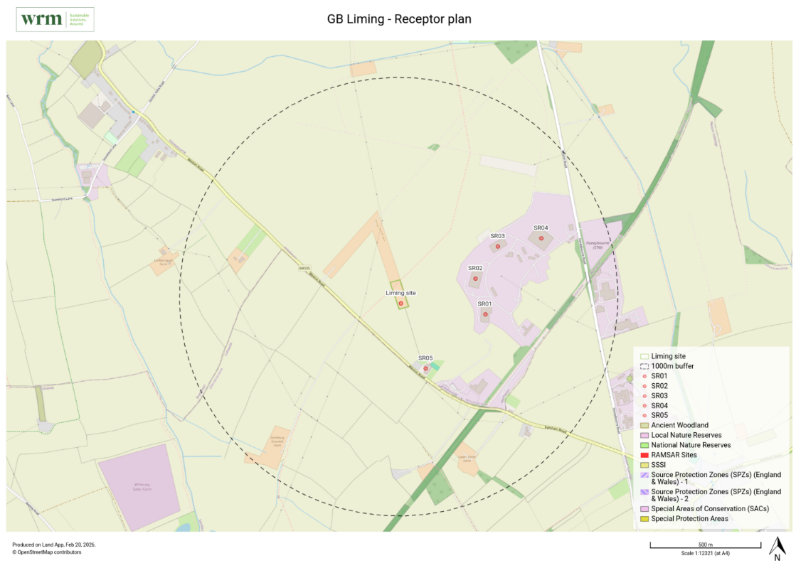
Figure 1: Map of site location and receptors

Table 2: List of Sensitive Receptors
Receptor List (What3Words) | Land Use | Direction | Distrance to Boundary | Sensitivity to Odour | NGR
SR01  (///lock.represent.reports) | Industrial | SE | 300m | Low | SP 11533 42053
SR02  (///rotations.awakening.smuggled) | Commercial / Industrial | E | 260m | Low | SP 11487 42214
SR03  (///repayment.purified.palaces) | Industrial | NE | 390m | Low | SP 11589 42361
SR04  (///extreme.pampering.sheepish) | Industrial | NE | 615m | Low | SP 11788 42398
SR05  (///perfected.stud.hazy) | Agricultural / Residential | S | 250m | Low / Medium | SP 11260 41806

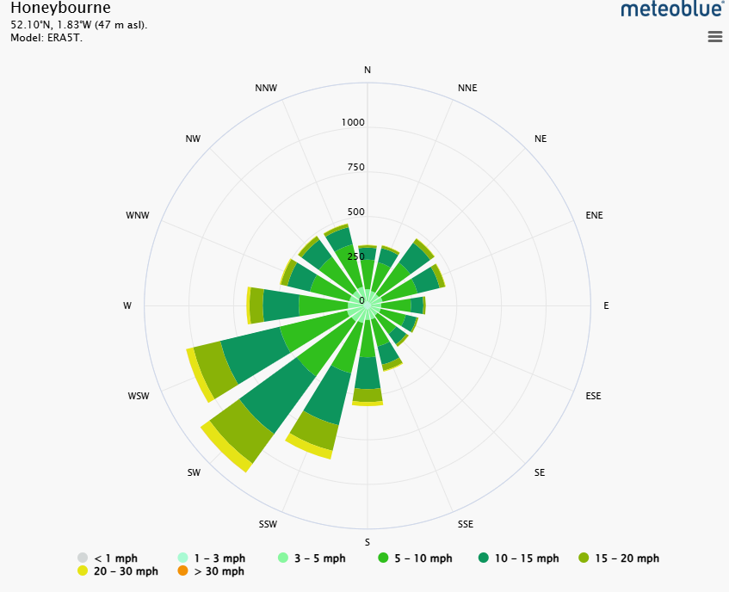
Figure 2: Wind direction data for the local area of Honeybourne

Sources of odour and site processes
The site undertakes the treatment of dewatered non-compliant biosolids through the controlled addition of alkaline reagents (typically quicklime or hydrated lime) to achieve stabilisation, sanitisation, and odour reduction prior to onward recovery. While the liming process itself is an effective odour mitigation measure, odour may arise from specific activities, materials, or operational conditions, particularly during the handling and reception of non-compliant biosolids.
This section identifies the potential sources of odour associated with site operations and provides an overview of the processes through which odour could be generated or released. It forms the foundation for a risk-based assessment of odour impacts and the implementation of proportionate control measures in accordance with EA guidance on odour management and the principles of AM 6.3.1-6.3 and 11.5 (biowaste).

Key considerations:
Incoming biosolids:
- Untreated biosolids received from wastewater treatment works may carry inherent odour due to biological activity, residual organic matter, and microbial decomposition.
- Potential odour generation is highest during transport, unloading, and temporary storage prior to treatment.
Reception and storage areas:
- Areas where biosolids are temporarily held prior to liming are a primary potential source of fugitive odours if material remains exposed or untreated for prolonged periods.
- Site design and operational controls aim to minimise exposure and odour dispersion.
Liming and mixing operations:
- The addition of alkaline material induces chemical reactions that raise pH and temperature, rapidly stabilising the biosolids and suppressing odour.
- Odour release during mixing is reduced when procedures, residence times, and mixing protocols are correctly applied.
Treated material storage:
- Once limed, biosolids are substantially stabilised, and odour potential is greatly reduced.
- Storage areas are designed to prevent dust or fugitive odours, in line with EA guidance on containment and appropriate measures.
External factors:
- Weather, wind direction, and ambient temperature may influence odour dispersion.
- Operational procedures take these factors into account when planning deliveries, unloading, and treatment activities.
The assessment of sources and processes presented in this section supports the proportionate selection of odour control measures, including procedural controls, staff training, containment infrastructure, and monitoring arrangements. It ensures that all reasonably foreseeable odour emissions are identified, managed, and minimised, consistent with the Environment Agency’s expectation for risk-based, proportionate odour management.

Odorous materials entering and leaving site
Biosolids are delivered exclusively by road vehicles directly from Wastewater Treatment Works (WWTW). There is no use of rail or canal transport for this operation.
Biosolids delivery vehicles follow approved access routes to minimise exposure to sensitive receptors and reduce potential odour impacts during transit.
Biosolids to be managed on a campaign type basis. GBL look to avoid stockpiling front end material and aim for supply and processing in a more simultaneous fashion.
Delivery and collection schedules are planned to minimise prolonged storage of untreated biosolids and allow timely treatment via liming.
This ensures that odour risk from prolonged storage of untreated material is minimised, satisfying the proportionality principle under Control and monitor emissions for your environmental permit - GOV.UK guidance.
This arrangement is consistent with Appropriate Measures AM 2.4–3.2, and AM6 (biowaste). which emphasise controlled delivery and prevention of environmental impact from transport.

Container types for material delivery
Biosolids are delivered in dedicated, sealed vehicles specifically designed and constructed for biosolids transport.
The lorry bodies/trailers are designed to maintain material containment and minimise fugitive odour emissions during transit.
This approach directly mitigates odour exposure and aligns with AM 2.4 and 5.1 on containment and odour management.
Vehicle sealing and coverage
All trailers delivering biosolids to site are sealed and sheeted as per statutory and EA requirements. LGV drivers are instructed to maintain vehicle integrity during transit and unloading to prevent odour release. This is consistent with the prevent odour emissions during transfer principle in EA Odour Management guidance and AM 6.3.

Instructions provided to customers/drivers
Drivers are provided with site-specific instructions prior to delivering odorous material, which include:
- Maintaining vehicle seals until material is unloaded.
- Using designated access routes to minimise exposure to off-site sensitive receptors.
- Observing hygiene, health, and safety protocols on site.
- Reporting any leaks, damage, or unexpected odour emissions immediately to the site supervisor.
- Instructions are provided via written site induction, driver briefings, and included on any waste acceptance documentation.
This measure ensures compliance with AM 2.2 (competence and supervision) and EA odour guidance (risk communication and operational control).

Protocol for unacceptable or non-conforming materials
All incoming biosolids are subject to a Waste Acceptance Procedure (WAP) that includes verification against pre-agreed source, quality, and odour characteristics.
Unacceptable or non-conforming deliveries are handled as follows:
- The driver is immediately instructed to return the load to source.
- Waste Rejection Protocol is activated, recording:
- Date and time of delivery.
- Vehicle identification and driver details.
- Reason for rejection (e.g., excessively odorous or contaminated).
- Corrective action taken.
This ensures odorous or otherwise unsuitable material does not enter the treatment area or compromise odour management measures.
This approach is aligned with AM 3.1–3.4 and EA guidance on prevention of odour from incoming waste.

Odour release during treatment
While the chemical reactions induced by adding alkaline materials ultimately stabilize biosolids, the mixing phase triggers a significant short-term release of odorous gases. The primary odours released during mixing include:
Ammonia release
Mixing alkaline materials (like lime) into biosolids causes an immediate spike in pH, which converts dissolved ammonium (NH₄⁺) into volatile ammonia gas (NH₃).
- Concentration: The highest ammonia concentrations in the entire stabilisation process are typically found during the mixing and curing stages.
- Mechanism: Because the pKa of the NH₄⁺/NH₃ equilibrium is approximately 9.26, raising the pH above 10, and especially to 11.5, rapidly forces nitrogen into its gaseous form, which then escapes into the atmosphere.
Decaying Volatile Organic Compounds
The mixing process physically agitates the biosolids, facilitating the release of other trapped volatile organic compounds (VOCs) and volatile sulphur compounds (VSCs).
- Amines: Alkaline addition causes the release of trimethylamine (TMA), which produces a characteristic fishy odour.
- Sulphides: While high pH eventually suppresses hydrogen sulphide, the physical action of mixing can release existing pockets of VSCs, such as dimethyl disulfide (DMDS) and dimethyl trisulfide (DMTS), which have decaying or rotten vegetable odours.
Operational control through mixing quality
The intensity and duration of these odours depend heavily on mixing efficiency:
- Poor mixing: Leads to cold spots or regions with low pH where microbial activity continues, resulting in prolonged and more offensive odours over time.
- Good mixing: While it may increase the initial burst of ammonia, a thorough and uniform mix ensures the pH stays high across the entire mass, preventing the long-term biological production of more offensive sulphur odours.

Additional relevant information
- Scheduled unloading: Deliveries are scheduled during operational hours to allow immediate treatment via liming, further reducing odour potential.
- Segregated reception area: Incoming vehicles are unloaded in a designated reception area with impermeable surfaces and minimal exposure to public areas.
- Contingency measures: Spill kits and temporary covers are available in case of accidental release or containment failure during unloading.
- Records: All deliveries, waste verification, and rejection actions are logged for auditability, as required under AM 3.4 and EA Odour Management guidance.

Table 3: Odorous materials
Odorous and potentially odorous material (any solid, liquid or gas) | Odour potential  High/med/low risk | Maximum quantity on site at any given day (t) | Maximum time held on site (hours or days) | Location of odorous materials on site | Additional comments
Non-compliant biosolids | High |  |  |  | Single source waste with contract in place

Overview of odorous processes and emissions
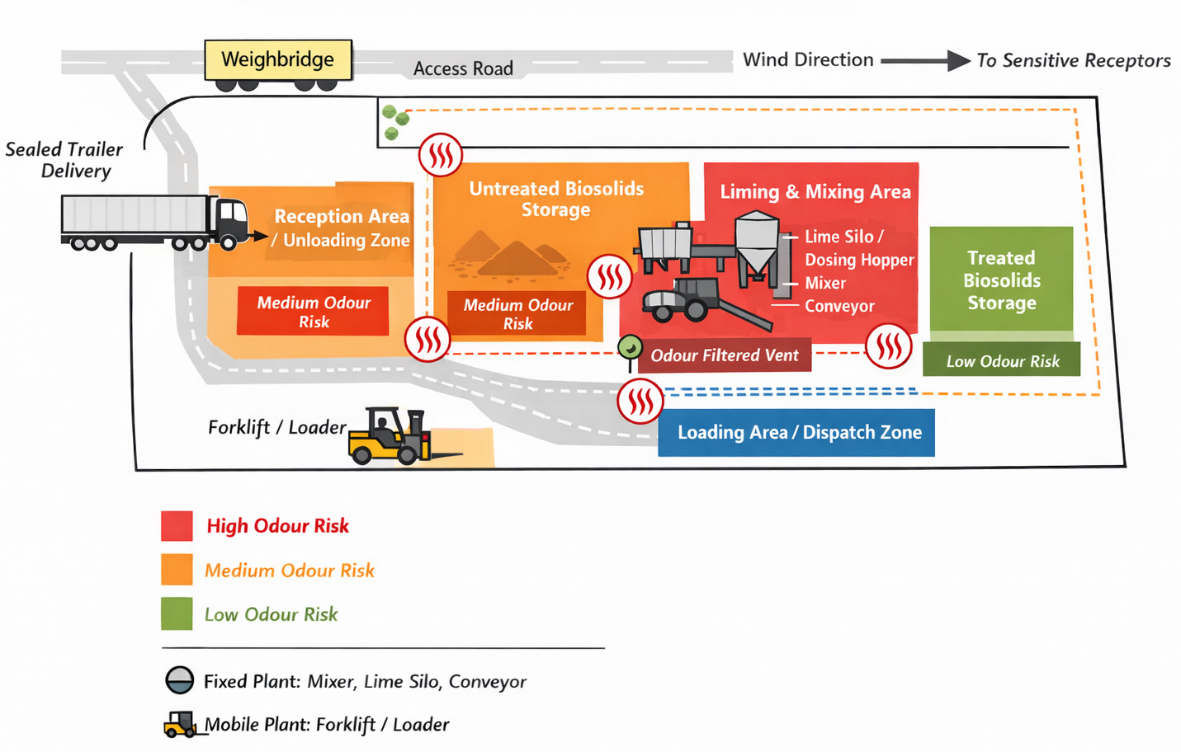
The site is designed for the reception, treatment, and storage of biosolids via controlled lime addition (liming). The layout ensures odour sources are identified, segregated, and managed in accordance with risk-based odour control principles.

Figure 3: Site layout schematic

Table 4: Sources of odour and site processes
Odour source | Process description / how odour arises | Control / mitigation measures | Monitoring / verification
Incoming biosolids | Biological activity in dewatered sludge; residual microbial decomposition; odour may release during unloading | All deliveries sealed or covered; drivers instructed on odour management procedures  Reception area located on impermeable surfacing with minimal exposure to public areas  Scheduled deliveries to minimise storage time prior to treatment  Immediate processing or controlled temporary storage | Visual inspection of incoming loads  pH and moisture verification for batch consistency  Record of vehicle seal integrity and WAP compliance
Reception / temporary storage areas | Untreated biosolids held prior to liming may emit odours if exposed or stored for prolonged periods | Designated, segregated storage areas  Minimised storage duration (rapid transfer to liming area)  Covered storage where necessary  Regular housekeeping to prevent material accumulation | Daily inspection logs of storage areas  Record of storage duration for each batch  Visual and olfactory checks by staff
Liming and mixing operations | Exothermic reactions during lime addition; potential for fugitive odours if mixing incomplete | Metred lime addition based on dry solids content  Mechanical mixing to ensure homogeneity  pH monitoring to confirm adequate treatment  Operations undertaken in partially enclosed area or downwind of sensitive receptors where practicable | Process records (lime dosage, batch ID, pH readings)  Daily operational supervision  Incident log for any odour complaints or deviations
Treated material storage | Treated biosolids can generate minor odour if pH drops or material becomes exposed | Storage area designed for containment and minimal exposure  Stock rotation to prevent prolonged storage  Maintenance of alkaline condition | Periodic inspection of treated material  pH verification for stockpiles if stored longer than operational norm
Spillage or accidental release | Minor spillage during unloading or transfer can lead to odour emissions | Spill kits readily available  Staff trained in immediate containment and clean-up- Procedures for reporting and recording incidents | Incident reporting log  Follow-up inspection to confirm complete remediation  Review of procedures after any event
External factors (weather / wind) | Wind direction, temperature, or inversion conditions can affect odour dispersion | Operational scheduling to avoid unloading/treatment during sensitive conditions where feasible  Monitoring of local wind direction when planning deliveries or outdoor handling | Staff visual/olfactory checks  Incident or complaint log correlated with meteorological conditions

Table 5: Site layout and process description controls
Site area / infrastructure | Description / purpose | Processes carried out | Odour potential | Controls / mitigation | Notes / mobile plant
Reception / delivery area | Open, impermeable area designated for vehicle unloading. | Unloading of non-compliant biosolids deliveries. | Medium (non-compliant biosolids) | Vehicles sealed and covered  Drivers instructed on odour control procedures  Unloading scheduled during operational hours  Spill kits on hand | Loading shovel for transferring biosolids form unload area to treatment area.
Weighbridge & access roads | Site access control and vehicle weighing; access roads lead directly to unloading. | Vehicle movement; tracking of deliveries | Low | Restricted vehicle routes to avoid sensitive receptors  Vehicle hygiene and spill prevention | Mobile plant: loader movement
Storage area (untreated biosolids) | Segregated, impermeable area with limited exposure. | Short-term holding of biosolids prior to liming | Medium | Minimise storage duration  Covered if prolonged storage required  Regular housekeeping and inspection | Mobile plant: loader for stockpile management
Liming area | Open area; impermeable surface.  Includes mechanical mixing equipment. | Addition of quicklime/hydrated lime  Mechanical mixing to ensure homogeneity  pH monitoring | High (during mixing if lime not fully reacted) | Accurate lime dosing  pH verification  Partial enclosure / downwind operations- Staff PPE for dust | Fixed plant: lime dosing hopper, mixer, conveyor  Mobile plant: loader for lime
Treated material storage / stockpiles | Segregated, impermeable area; designated for stabilised biosolids. | - Storage prior to recovery/dispatch | Low | - Maintain alkaline conditions- Stock rotation- Covered if required | Loader for stockpile management
Loading area for recovery / dispatch | Adjacent to treated storage, impermeable surface. | Loading of stabilised biosolids for transport | Low | Sealed vehicles  Minimise exposure time  Staff trained in handling | Mobile loader for vehicle loading
Plant & equipment locations | Fixed plant includes lime dosing hopper, mechanical mixer, conveyors (if used).  Mobile plant: loaders. | Supports liming and material movement | Variable (high during mixing) | Routine inspection and maintenance  Equipment sited away from sensitive receptors | Plant layout designed to minimise odour escape and allow segregation of odorous operations
Odour emission points | Potential odour sources include: Unloading of untreated biosolids  Liming/mixing operations- Short-term storage of untreated material | Temporary odour release during material handling | Medium–High (untreated material);  Low (treated material) | Control measures as above  Partial enclosure for mixing  Monitoring and housekeeping | Emission points mapped in Figure 3.3

Figure 4: Site plan showing odorous process locations / odorous emissions / storage

Control measures and process monitoring

Appropriate Measures (AM)
There are two sets of Appropriate Measures that have been considered in the OMP, namely;
Non-hazardous and inert waste: appropriate measures for permitted facilities - Guidance - GOV.UK, and
Biological waste treatment: appropriate measures for permitted facilities - Guidance - GOV.UK

Best Available Techniques (BAT)
Lime dosing and controlled mixing are BAT for biosolids stabilisation Best Available Techniques (BAT) Reference Document for Waste Treatment Industrial Emissions Directive 2010/75/EU Integrated Pollution Prevention and Control and odour suppression, consistent with EA Odour Management guidance (Dec 2025).

H4 guidance
What the EA expect an operator to do to manage odour from an environmental permit holder.
- a risk assessment and odour management plan for approval
- comply with the odour permit condition
- prevent serious pollution
The EA odour guidance covers:
- what the law says must be done to manage odour
- how the EA assesses odour from regulated activities, including permit compliance
- how to carry out an odour risk assessment
- what must be included in an odour management plan
- what serious odour pollution is
- the best available techniques (BAT) and appropriate measures for activities that are potentially odorous
Odour management: comply with your environmental permit - 6. Writing an odour management plan - Guidance - GOV.UK

Monitoring and trigger levels
pH is used as the key chemical parameter for odour suppression; deviations indicate incomplete treatment.
Duration of storage and exposure is monitored to prevent decomposition-related odour.
Visual and olfactory inspection provides practical early-warning for fugitive emissions.

Table 6: Sources of odour, processes, and mitigation measures
Process / material | Control measures/Appropriate Measures | Frequency of monitoring | Process parameters monitored | Trigger levels / limits | Corrective actions if outside limits
Incoming biosolids (trailer deliveries) | Delivered in sealed trailers Unloading on impermeable, dedicated reception area  Drivers instructed on odorous material handling  Minimise storage duration before treatment  Spill kits available | Visual inspection of trailer integrity upon arrival  Daily inspection of unloading area | Seal integrity  Visual assessment of spills or leaks | Broken seals  Spills observed | Immediate containment and clean-up using spill kit  Record incident and notify site manager
Temporary storage of untreated biosolids | Segregated storage area on impermeable surface  Covered if prolonged storage required  Rapid transfer to liming area  Good housekeeping | Daily inspection of storage area  Weekly review of storage duration | Storage duration Exposure to open air | Material held >24–48h  Odour complaints from site boundary | Immediate transfer to liming  Additional covering if necessary  Review scheduling of deliveries
Liming / mixing operations | Mechanical mixing for homogeneity  Partial enclosure to reduce fugitive emissions  PPE for staff  Lime stored in enclosed silo and doses are made electronically at specifically calculated/set rates. | Continuous operator supervision during mixing  Daily inspection of mixer and lime dosing equipment | pH of material  Lime dosage per tonne  Mixing duration | pH <11.5 or >13 Inconsistent dosing or incomplete mixing | Adjust lime dosage  Extend mixing time  Repeat pH verification  Suspend batch until parameters met
Treated material storage / stockpiles | Segregated stockpiles with alkaline stabilisation  Stock rotation to prevent prolonged storage  Covered if necessary | Weekly visual inspection  pH measurement for stockpiles stored >7 days | Material pH  Stockpile moisture | pH <11.5  Moisture >target range (excess water may cause odour) | Re-mix or re-lime affected material  Remove excess water if required  Update stockpile records
Loading for dispatch | Loading only into designated vehicles  Minimise exposure time  Staff trained in odour handling | Inspection prior to loading each vehicle Spot checks during loading | Vehicle seal/sheet condition  Duration of exposure | Vehicle not sheeted  Loading duration excessive (>20 minutes) | Reject loading or resheet vehicle Reschedule to reduce exposure  Record incident
Spillage / Accidental Release | Spill kits and containment procedures  Staff trained in immediate clean-up  Bunded areas where feasible | Inspection of spill containment areas weekly  Following each incident | Presence of residual material outside containment  Clean-up completion | Material outside containment  Uncontained odour release | Immediate clean-up  Apply corrective containment measures Incident logged and reviewed
Airborne / fugitive odours from liming | Partial enclosure for mixer.  Dampening spray bar and belt/conveyor covers.  Use of odour suppressant cannons can be introduced if required.  Downwind positioning relative to sensitive receptors | Daily visual and olfactory inspection  Maintenance checks monthly | Odour intensity at site boundary (qualitative)  Cover integrity / equipment wear | Odour detected beyond site boundary  Spray bar malfunction / cover damage | Inspect and maintain equipment / cover  Adjust operational schedule based on wind direction  Notify Compliance Manager and log event
Monitoring and records | Maintain odour logbook  Record all inspections, pH measurements, and incidents Cross-reference with standalone AM monitoring plan | Continuous during operations  Weekly review of all records | All process parameters (pH, exposure duration, equipment function, odour intensity) | Any deviation from optimum performance parameters | Implement site corrective action plan  Investigate root cause  Update procedures as necessary

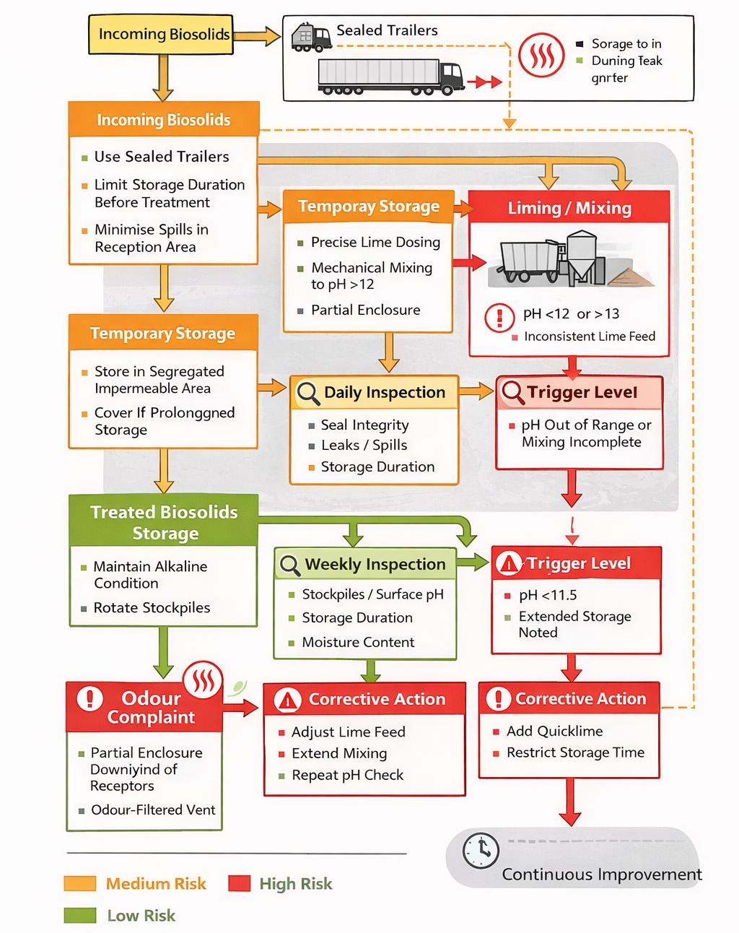

Figure 5: Biosolids odour control process flow chart

Odour reporting
The site is committed to proactive and reactive management of odour in line with its environmental permit and the principle of being a good operator. All odour complaints or observations are taken seriously, investigated promptly, and recorded systematically. Records of complaints are used to review and improve site operations, in line with Develop a management system: environmental permits - GOV.UK guidance.

Complaints reporting
- Procedure:
Receipt of Complaint: Any odour pollution notification, whether by telephone, email, or in-person, is recorded immediately in the site Odour Complaint Log.
- Acknowledgement: The complainant is acknowledged within 24 hours, confirming that the complaint has been received and will be investigated.
- Investigation: The site team will investigate within 48 hours of the notification, in accordance with permit conditions. Investigation includes:
- Inspecting relevant process areas (reception, storage, liming/mixing, treated material stockpiles).
- Reviewing process records (pH, storage duration, lime dosing, odour monitoring logs).
- Conducting olfactory assessment at the site boundary and near sensitive receptors if required.
- Recording and Reporting: The complaint, investigation findings, and actions taken are logged in the Odour Complaint Log, which includes:
- Date/time of complaint
- Complainant details
- Description of odour (source, intensity, duration)
- Investigation steps and results
- Corrective actions implemented
- Follow-up with the complainant
- Review and improvement:
- Complaints are reviewed monthly to identify trends or recurring issues.
- Actions are implemented to prevent recurrence (e.g., scheduling changes, additional containment, process parameter adjustments).
- Findings are incorporated into staff training and OMP updates as part of a continual improvement cycle.
Complaint forms and logs can be cross-referenced to the site’s standard Environmental Incident Reporting Procedure.

Community engagement
Approach:
- The site maintains an open channel with neighbouring businesses, residents, and community representatives.
- Communication methods include:
  - Email or phone contact for complaints or enquiries
  - Periodic updates/newsletters for local stakeholders where appropriate
  - Availability of the site manager for meetings or discussions regarding odour management
- Engagement is proactive and responsive, ensuring community concerns are addressed promptly and respectfully.
- Feedback received is reviewed alongside complaints and odour monitoring records to inform operational adjustments and OMP improvements.
This approach fosters good neighbour relationships and can pre-empt complaints through early notification of operational activities that may result in odour, such as deliveries or large batches of untreated biosolids.

Pro-active odour monitoring
Routine monitoring:
- Daily olfactory inspection (‘sniff test’) of key site locations and downwind boundary points is conducted, regardless of complaints.
- Monitoring points include:
- Reception/unloading area
- Temporary storage of untreated biosolids
- Liming/mixing area
- Treated material stockpiles
- Observations are recorded in the Odour Monitoring Log, including odour intensity, direction of prevailing wind, and any unusual odours.
Additional Checks:
- During periods of high odour risk (hot weather, high wind speeds, backlog of deliveries), additional monitoring rounds are performed.
- Staff are trained to recognise odours associated with incomplete lime treatment or prolonged storage.
Proactive monitoring allows early identification of potential odour events, supporting timely corrective actions before complaints are received.

Reactive odour monitoring
Following a complaint:
- In addition to the investigation described in 5.1, reactive monitoring includes:
- On-site inspection of process areas associated with the suspected source.
- Boundary odour assessment at sensitive receptor locations if accessible.
- Verification of process parameters (e.g., pH, lime dosing, storage time) to identify deviations.
- Recording environmental conditions such as wind speed and direction, temperature, and precipitation.
Post-complaint follow-up:
- Findings are logged and corrective actions implemented immediately (e.g., additional lime, extended mixing, reduced storage duration).
- Follow-up monitoring confirms that corrective actions have resolved the odour issue.
- Results are reviewed alongside the complaint log and inform updates to site procedures and the OMP.

Summary
The site adopts a robust and proactive approach to odour management:
- Complaints are recorded, investigated within 48 hours, and form part of a continuous improvement process.
- Community engagement ensures stakeholders are informed and concerns are addressed.
- Proactive monitoring identifies odour risks before they affect receptors.
- Reactive monitoring ensures complaints are investigated thoroughly, and corrective actions are implemented.
This integrated system ensures compliance with EA permit conditions, odour management guidance.
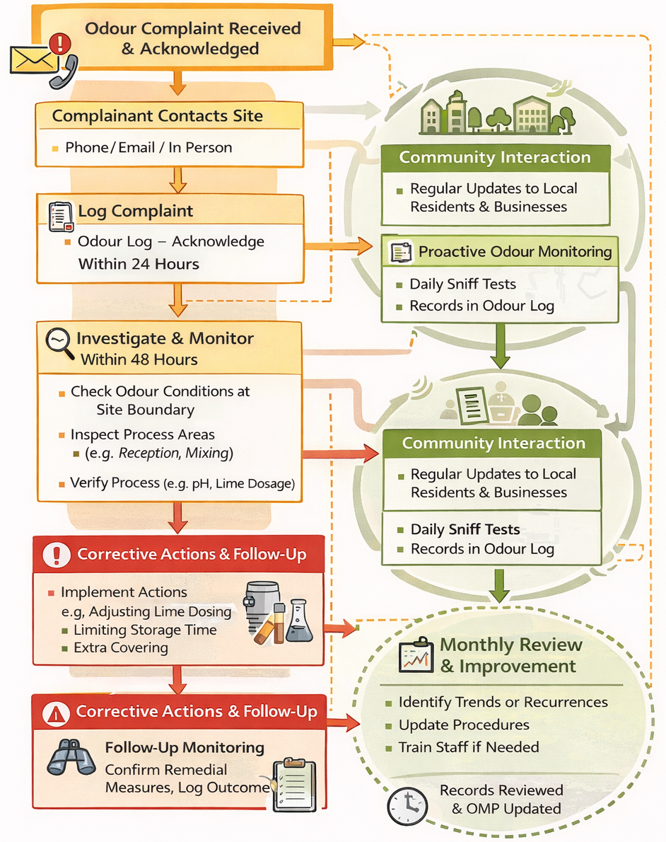

Figure 6: Odour complaints monitoring process flowchart

Abnormal events
This section identifies reasonably foreseeable abnormal events that could place pressure on site operations and increase the risk of odour pollution. For each event, the table below sets out the planned recovery steps and control measures in place to prevent, minimise or mitigate odour impacts should such events occur.
Abnormal events are managed in accordance with the following site procedures:
- Odour Management Plan (this document),
- Site Management System,
- Waste Acceptance Procedures,
- Business Continuity and Emergency Response arrangements.
Where relevant, this section cross-references existing procedures rather than duplicating them. All abnormal events are recorded, reviewed, and used to inform continual improvement of odour control measures.

General principles applied during abnormal events
In all cases, the following principles apply:
- Odour prevention takes precedence over throughput or operational convenience.
- Incoming waste acceptance is restricted or suspended if odour risks cannot be adequately controlled.
- On-site material residence time is minimised.
- Enhanced monitoring (including sniff testing) is implemented.
- Sensitive receptors and prevailing meteorological conditions are considered.
- The EA is notified where required by permit conditions.

Table 7: Abnormal events and recovery steps
Abnormal event | Planned recovery / Mitigation steps
Inability to remove treated material from site (e.g. outlet closure, contractor failure) | Suspend or significantly reduce incoming biosolids deliveries.  Prioritise treatment and dispatch of the most odorous or oldest material first.  Increase lime dosing (within process specification) to maintain elevated pH and suppress biological activity.  Consolidate treated material into the smallest practicable footprint to reduce exposed surface area.  Increase odour inspections and sniff testing frequency.  Notify waste producer and haulage contractors of intake restrictions.  Escalate to management if storage capacity thresholds are approached.
Delayed collections / increased backlog of untreated biosolids | Activate intake control procedures and impose delivery caps.  Reschedule deliveries to avoid adverse meteorological conditions (e.g. low wind, temperature inversions).  Prioritise immediate treatment of untreated biosolids upon arrival.  Reject loads if safe and compliant processing cannot be guaranteed.  Record event and corrective actions in site log.
Failure or breakdown of liming or mixing equipment | Immediately suspend acceptance of untreated biosolids.  Isolate any partially treated material and prevent disturbance until treatment can resume.  Arrange rapid repair or deployment of standby/mobile equipment where available.  Apply interim containment measures (sheeting, sealing, minimising handling).  Increase odour monitoring frequency.  Resume operations only once equipment functionality and odour control are restored.
Power failure | Suspend waste acceptance and processing activities.  Secure untreated and treated materials to minimise exposure and disturbance.  Deploy backup power where available for critical treatment and odour control systems.  Monitor for odour release during outage and record findings.  Resume normal operations only once power is stable and systems are fully functional.
Adverse weather conditions (e.g. high temperature, low wind speed, temperature inversion) | Reduce or pause odorous activities during high-risk meteorological conditions.  Avoid unloading or handling untreated biosolids during calm or inversion conditions.  Increase lime dosing or treatment rate where appropriate to rapidly stabilise material.  Re-schedule non-essential operations to more favourable conditions.  Document decisions and monitoring observations.
Equipment fire (including external fire impacting operations) | Follow site procedures detailed in Emergency Response and Accident Prevention and Management and Plan.  Cease waste acceptance and processing immediately.  Secure odorous materials and prevent disturbance unless required for safety reasons.  Liaise with emergency services and regulators as required.  Conduct post-incident odour risk assessment prior to restarting operations.
Flooding or extreme rainfall | Suspend waste acceptance where floodwater could contact odorous materials.  Prevent mobilisation of contaminated runoff and odorous leachate.  Relocate or secure stored material to higher ground if required.  Inspect site drainage and containment systems following the event.  Resume operations only once odour and pollution risks are demonstrably controlled.
Spillage or accidental release of untreated biosolids | Stop the source of the spillage immediately.  Contain and recover material promptly.  Apply lime to stabilise recovered material where appropriate.  Clean affected surfaces without generating additional odour.  Record incident, root cause and corrective actions.
Receipt of unusually odorous or non-conforming waste | Reject or return waste if it does not meet Waste Acceptance Criteria.  If accepted, treat immediately with enhanced lime dosing.  Notify waste producer and update acceptance controls as necessary.  Record incident and review supplier performance.
Short staffing or absence of key trained personnel | Implement minimum staffing thresholds for odorous activities.  Suspend non-essential or high-risk odorous operations if competence cannot be assured.  Deploy trained backup staff where available.  Prioritise odour-critical activities only.  Record staffing impacts and any operational limitations applied.

Table 8: Abnormal events aligned to Appropriate Measures (non-hazardous and biowaste)
Abnormal event | Relevant EA Appropriate Measures clauses | Compliance explanation / linkage
Inability to remove treated material from site | AM 2.1 & 5.1 (Management systems)  AM 2.4 & 5.10 (Contingency planning)  AM 4.1-13 & 7 (Waste storage – quantities and duration)  AM 6.3 & 11.5 (Odour risk management) | Intake restrictions, prioritisation of oldest material, and suspension of acceptance demonstrate effective contingency planning and control of storage duration. Actions explicitly minimise odour risk at source in line with AM 7.1.
Delayed collections / backlog of untreated biosolids | AM 3.2 & 6.1 (Waste acceptance procedures)  AM 4.0 & 7 (Storage limits)  AM 6.3 & 11.5 (Odour control) | Waste acceptance caps and rejection protocols ensure storage capacity and residence time are not exceeded. Immediate treatment aligns with odour prevention at source rather than reliance on end-of-pipe controls.
Failure or breakdown of liming / mixing equipment | AM 2.4 & 5.10 (Contingency and abnormal operations)  AM 5 & 8 (Process control and monitoring)  AM 6.3 & 11.5 (Odour risk management) | Suspension of acceptance and isolation of untreated material reflect proportionate control during abnormal operations. Restart only after odour risk is demonstrably controlled aligns with BAT expectations.
Power failure | AM 2.3-4 & 5.10 (Emergency and abnormal events)  AM 7.1 & 11.2 (Monitoring and control)  AM 6.3 & 11.5 (Odour risk management) | Immediate cessation of odorous activities and securing of materials demonstrates compliance with emergency planning and odour prevention obligations.
Adverse weather conditions (low wind, inversion, high temperature) | AM 2.3-4 & 5.10 (Contingency and abnormal operations)  AM 7.1 & 11.3 (Odour – consideration of meteorological conditions) | Adjusting or suspending activities during adverse meteorology is explicitly supported by EA odour guidance and reflects BAT for outdoor waste treatment operations.
Fire (on-site or nearby) | AM 2.3 & 5.4 (Emergency planning)  AM 7.1 (Odour management during abnormal events) | Emergency response procedures prioritise safety while preventing unnecessary disturbance of odorous material, consistent with AM expectations.
Flooding or extreme rainfall | AM 2.4 & 5.10 (Contingency planning)  AM 4.0 & 4.2-4.3 (Containment and protection of materials)  AM 6.3 & 11.5 (Odour risk management) | Suspension of acceptance and securing of materials prevents odour generation and uncontrolled emissions during abnormal environmental conditions.
Spillage or accidental release of untreated biosolids | AM 2.3 & 5.4 (Management systems)  AM 4.0 & 5.5 (Containment and housekeeping)  AM 6.3 & 11.5 (Odour risk management) | Rapid containment, recovery, and stabilisation using lime demonstrates BAT and prevents secondary odour impacts.
Receipt of unusually odorous or non-conforming waste | AM 3.3 & 6.3 (Waste acceptance procedures)  AM 6.3 & 11.5 (Odour risk management) | Rejection, or immediate treatment demonstrates effective waste acceptance controls and prevents odour pollution from unsuitable inputs.
Short staffing / absence of trained personnel | AM 2.2 & 5.3 (Competence and training)  AM 2.1 & 5.1 (Operational resilience)  AM 6.3 & 11.5 (Odour risk management) | Minimum staffing thresholds and suspension of high-risk activities demonstrate compliance with competence and odour prevention requirements.

Summary
The Operator has identified all reasonably foreseeable abnormal operating conditions that could increase the risk of odour pollution from the installation. These include, but are not limited to, restrictions on waste removal, equipment or power failure, adverse meteorological conditions, staffing shortages, equipment fire, flood and the receipt of unusually odorous or non-conforming waste.
For each identified abnormal event, proportionate and pre-planned recovery measures are in place. These measures are designed to ensure that odour emissions are prevented where practicable and otherwise minimised, and that the risk of off-site odour impact is controlled at all times.
During abnormal operating conditions, the Operator will:
- Restrict or suspend waste acceptance where odour risks cannot be adequately controlled;
- Limit the quantity and duration of waste storage on site;
- Prioritise the treatment and removal of the most odorous materials;
- Avoid or suspend odour-generating activities during adverse meteorological conditions;
- Implement enhanced odour monitoring, including increased sniff testing and inspections;
- Ensure that only trained and competent personnel undertake odour-critical activities.
The recovery measures set out in Table 8 align with the Environment Agency Appropriate Measures for waste treatment and represent Best Available Techniques (BAT) for the operation of a biosolids liming facility. In particular, the measures demonstrate compliance with requirements relating to:
- effective management systems and contingency planning;
- control of waste acceptance, storage capacity, and residence time;
- prevention of odour emissions at source;
- management of odour risk during abnormal and emergency situations.
Where abnormal events occur, details will be recorded, investigated, and reviewed in accordance with the site management system. The effectiveness of the response actions will be assessed, and the Odour Management Plan will be updated where necessary to reflect lessons learned and to ensure continual improvement.

Conclusion
These measures collectively demonstrate that the site applies proportionate, risk-based controls over odour from deliveries, consistent with EA Odour management: comply with your environmental permit - Guidance - GOV.UK (Dec 2025), WM3 principles, and the relevant sections within Appropriate Measures.

Operation overview
Adding alkaline materials to biosolids induces specific chemical reactions that simultaneously raise the pH and temperature while suppressing odours longer term. When quicklime (calcium oxide) is added to wet biosolids, it reacts with the moisture present in a process known as hydration or slaking. In this reaction, one mole of calcium oxide reacts with one mole of water to produce one mole of calcium hydroxide (slaked lime). The process is highly exothermic, releasing approximately 65kJ of heat per mole of CaO reacted. In the context of biosolid treatment, this heat generation and the resulting increase in pH are critical for pathogen reduction and the stabilisation of organic matter.
This process, known as alkaline stabilisation, is a standard method for treating sewage sludge to meet environmental standards.
- Raising pH: The primary chemical reaction involves the addition of alkaline reagents like lime (calcium oxide or hydrated lime), fly ash, or cement kiln dust.
- Reaction: Reagents like hydrated lime (Ca(OH2)) release hydroxide ions (OH-), directly increasing the alkalinity.
- Result: The pH is raised to ≥11.5 or higher for at least 2 hours, at this level, the environment becomes toxic to pathogens and halts biological activity.
- Raising temperature: The increase in temperature occurs primarily through an exothermic (heat-releasing) reaction when using specific alkaline materials.
- Quicklime reaction: When quicklime (CaO) is added to wet biosolids, it undergoes an exothermic reaction with the water present (slaking) (CaO+H2O → Ca(OH)2)
- Odour suppression: Alkaline treatment suppresses odours through several chemical and biological mechanisms.
- Halting decay: The high pH stops the biological decay (putrefaction) process by killing the odour-producing bacteria.
- Sulphide locking: Raising the pH above 9–10 converts dissolved hydrogen sulphide gas (a "rotten egg" smell) into non-volatile liquid forms, effectively "locking" the odour in the liquid phase.
- Ammonia: While it suppresses sulphur-based odours, the high pH and temperature will increase ammonia odours in the short term by converting organic nitrogen into volatile ammonia gas (NH₃). Proper mixing and stabilisation are required to minimise these nuisance odours over time.
The Operator considers that, with the implementation of the measures described in this section, odour pollution is unlikely beyond the site boundary, including during abnormal operating conditions.

