
WRM
wrm-ltd.co.uk
01943 468138

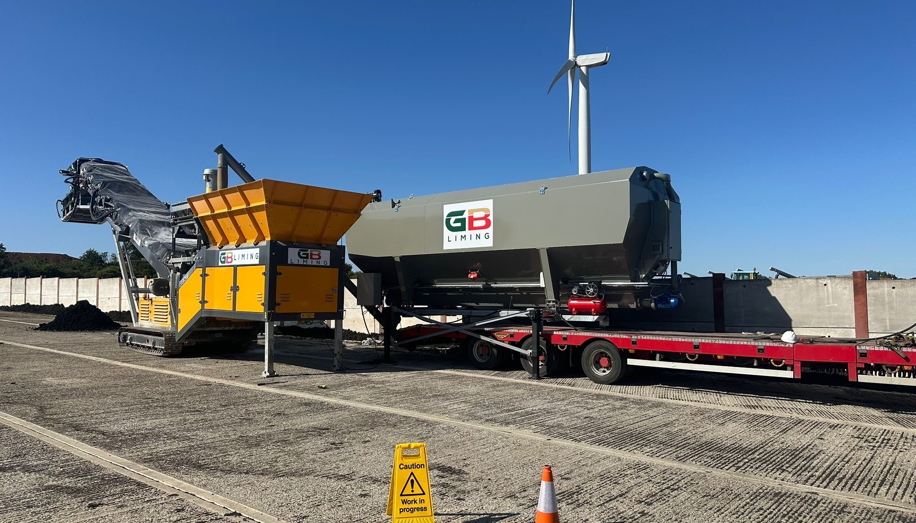

Environmental Risk Assessment
v2.0

Environmental and sustainability solutions provided to
GB Liming Ltd

WRM-LTD.CO.UK
This report was prepared by Walker Resource Management Ltd (WRM’) within the terms of its engagement and in direct response to a scope of services. This report is strictly limited to the purpose and the facts and matters stated in it and does not apply directly or indirectly and must not be used for any other application, purpose, use or matter. In preparing the report, WRM may have relied upon information provided to it at the time by other parties. WRM accepts no responsibility as to the accuracy or completeness of information provided by those parties at the time of preparing the report. The report does not take into account any changes in information that may have occurred since the publication of the report. If the information relied upon is subsequently determined to be false, inaccurate, or incomplete then it is possible that the observations and conclusions expressed in the report may have changed. WRM does not warrant the contents of this report to any party other than the named client, and shall not assume any responsibility or liability for loss whatsoever to any third party caused by, related to, or arising out of any use or reliance on the report howsoever. No part of this report, its attachments or appendices may be reproduced by any process without the written consent of WRM. All enquiries should be directed to WRM.

Document Title | Environmental Risk Assessment
Client | GB Liming Ltd
Revision | v2.0
Date | 26/06/2026
Document Reference | EPR-C01
Project Reference | 1578/F05
Author: Bryanna Heaton |  | Reviewer: Graeme Kennett
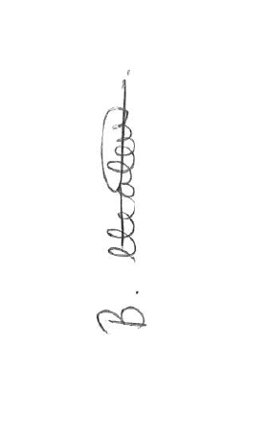 |  | 

Copyright ©
All material on these pages, including without limitation text, logos, icons and photographs, is copyright material of Walker Resource Management Ltd (WRM). Use of this material may only be made with the express, prior, written permission of WRM. This document was produced solely for use by the named client to whom the document refers. The methodology (if any) contained in this report is provided to you in confidence and must not be disclosed or copied to third parties without the prior written agreement of WRM. Disclosure of that information may constitute an actionable breach of confidence or may otherwise prejudice our commercial interests.

Revision | Details | Date
0.1 | Initial Draft | 08/01/2026
0.2 | Draft for operator comment | 17/02/2026
0.3 | Update following client review | 19/02/2026
1.0 | Final version for submission | 07/04/2026
2.0 | Additional; receptors added. NIA findings added. | 26/06/2026

Revision Log

CONTENTS
Contents
1.0 Introduction 1
1.1 Site address 1
1.2 Grid Reference 1
1.3 Assessment process 1
2.0 Assessment 3

Introduction
This Environmental Risk Assessment has been produced in support of a bespoke permit application for GB Liming Ltd (hereon referred to as ‘GBL’), who provide specialist liming services to the wastewater sector. GBL currently provide biosolid liming services on utility company sites and have identified a site at Weston Road, Honeybourne, Evesham, WR11 7QF
for acceptance and treatment of non-compliant sludges and are seeking a bespoke permit application for the operation of a liming facility. This document provides a full environmental risk assessment for the activities associated with the liming operation.

Site address
GB Liming Ltd
Weston Road
Honeybourne
Evesham
WR11 7QF

Grid Reference
SP 11152 42124

Assessment process
The Guidance “Risk assessments for your environmental permit” produced by the Environment Agency and DEFRA outlines a five-step process for assessing the site activity and the risk to local amenity to successfully produce an Environmental Risk Assessment:

- Identify and consider risks for your site, and the sources of the risks.
- Identify the receptors (people, animals, property and anything else that could be affected by the hazard) at risk from your site.
- Identify the possible pathways from the sources of the risks to the receptors.
- Assess risks relevant to your specific activity and check they’re acceptable and can be screened out.
- State what you’ll do to control risks if they’re too high.

This risk assessment will identify the potential human and environmental impacts that could result from the activity of this energy from waste plant. Risk assessments will be carried out for the following hazards:

- Odour;
- Fugitive emissions (including dust and pests);
- Visible plumes;
- Noise;
- Fire.

This risk assessment will identify people or parts of the environment that could be harmed by the activity and carry out risk assessments for these potential sources. Assessment of potential accidents at the facility and the consequential effects on sensitive receptors have been accounted for in a separate Accident Management Plan.

Assessment
P = Possibility C = Consequence M = Magnitude

Pollutant Model |  |  | Judgement |  |  |  | Action
Source | Pathway | Receptor | P | C | M | Justification of Magnitude | Risk Management | Residual Risk
Fugitive emissions of dust, fibres and particulates. | Deposition from air and inhalation. | Local Human Population. | Med | High | Med | Permitted waste types do not include wastes which consist solely of dusts, powders or loose fibres.  Dust from lime handling is controlled through enclosed delivery systems and appropriate personal protective equipment (PPE). The site layout minimises wind exposure and fugitive emissions.  Activities on site have the potential to produce dust and so a medium magnitude risk is estimated. | - The site will be kept clean and dust suppression will be used on the site when required.  - The site layout minimises wind exposure and fugitive emissions.  - In dry weather, site access and internal roads will be swept manually or mechanically when necessary.  - Road sweeper present on site if necessary.  - Mixing of material is undertaken within the mixing plant which has no point source emissions to air.  - The site has an Environmental Management Plan and an Appropriate Measures Assessment. | Low
Airborne particulates generated during the physical treatment of Non-Hazardous Waste: treatment of residual sludge from sewage plants treating domestic or urban waste waters. | Inhalation and ingestion. | Human Health | Low | High | Med | Potential for frequent and long-term exposure to sensitive receptors (apart from licence holder/operator and employees).  Dust from lime handling is controlled through enclosed delivery systems and appropriate personal protective equipment (PPE). The site layout minimises wind exposure and fugitive emissions. | - The site will be kept clean and dust suppression will be used on the site when required.  - In dry weather, site access and internal roads will be swept manually or mechanically when necessary.  - Road sweeper present on site if necessary.  - Mixing of material is undertaken within the mixing plant which has no point source emissions to air.  - Daily site inspections.  - The site has an Environmental Management System and an Appropriate Measures Assessment. | Low
Airborne dust particulates. | Deposition from air. | Human Health | Med | Low | Med | Potential for frequent and long-term exposure to sensitive receptors (apart from permit holder/operator and employees). | - The site will be kept clean and dust suppression will be used on the site when required.  - In dry weather, site access and internal roads will be swept manually or mechanically when necessary.  - Road sweeper present on site if necessary.  - Mixing of material is undertaken within the mixing plant which has no point source emissions to air.  - Daily site inspections.  - The site has an Environmental Management System and an Appropriate Measures Assessment. | Low
Noise from machinery. | Air transport. | Human Health | Med | High | Med | Neighbouring residents and businesses often sensitive to noise and likely to complain. | - Machinery maintenance schedule.  - All machinery is designed to work efficiently and not produce excessive noise.  - All machinery is switched off when not in use.  - Plant and equipment are maintained to reduce noise emissions, with operational hours and activity locations selected to minimise off-site impacts.  - Reversing bleepers set to a level to minimise distraction at adjacent properties without compromising safety.  - The location of the site in a largely rural area means the likelihood of causing noise nuisance is unlikely.  - Environmental Management System and Appropriate Measures Assessment.  - Appropriate PPE provided to staff.  - NMP in place | Low
Fugitive releases of litter. | Air transport. | Human Population | Med | Low | Med | Local businesses sensitive to litter and likely to complain. | - Wastes are inspected on arrival and turned away if contamination levels exceed maximum permissible levels.  - Liming processing operation shall not accept wastes with significant presence of paper, plastic etc.  - Mixing of material is undertaken within the mixing plant which has no point source emissions to air therefore minimising the external release of windblown litter.  - Containers that hold light materials such as paper and plastic are sheeted for transport and if held on site.  - Daily inspection of site and removal of litter.  - Food waste packaging is removed with purpose designed equipment wholly within the building. | Low
Fugitive releases waste, litter and mud on local roads. | Vehicles entering and leaving site. | Human Population | Med | Med | Med | Local residents often sensitive to mud on roads and likely to complain. | - Daily inspection of site roads and surrounds for debris.  - No domestic residences within 5000m of the site  - Wheel wash facilities are in place on entrance / exit to site to prevent the tracking of solid biodegradable organic and liquid wastes off site.  - Access road swept when required. | Low
Odour from recovery operations. | Air transport. | Human Population | Low | Med | Med | Local businesses and residents often sensitive to odour and likely to complain if unpleasant odour. | - Sealed trailers, controlled unloading, minimised exposure time, staff supervision.  - Storage duration limits, containment on engineered pads, rapid progression to liming, runoff control.  - Lime dosing under documented process plan, target pH, controlled mixing, minimum residence time; operator competence training.  - Maintain elevated pH, stock rotation, covering if required.  - Trained operators, good housekeeping, minimised handling of odorous material.  - Pre-acceptance checks, waste characterisation, rejection; post-liming verification if required.  - Suspension of acceptance, isolation of untreated sludge, rapid repair or restoration of operation, enhanced monitoring.  - Operational curtailment, schedule adjustments, enhanced monitoring during adverse conditions.  - Minimum staffing thresholds, suspension of high-risk activities, operator training.  - Containment, recovery, lime stabilisation, operational procedures for emergency response.  - Odour Management Plan.  - Appropriate Measures Assessment. | Low
Fire. | Spontaneous combustion of dry materials. | Site operators and assets | Low | High | Med | Lots of different waste types may be accepted on to site with differing levels of combustibility. | - The site operates with an approved Accident Management Plan.  - Appropriate Measures Assessment.  - Fire extinguishers are located across site to fight fires in site buildings, site office, weighbridge and in vehicles and machinery.  - Residual sludge from sewage plants treating domestic or urban waste waters has high moisture content. | Low
Smoke from a fire. | Air transport. | Human Population | Low | Med | Med | Local businesses often sensitive to odour and likely to complain. Fires can be deliberate or accidental. | - Permitted activities do not authorise burning of waste.  - Accident Management Plan details consequences and control of fires.  - Fire suppression equipment located on site.  - Appropriate Measures Assessment. | Low
Scavenging birds and animals. | Air transport and over land. | Human Population | Low | Low | Low | Scavenging birds and vermin attracted to site and affecting neighbouring businesses. | - No history of significant problems with rodents or flies.  - EMS details management of pests.  - Visual inspection for signs of pests is carried out as part of site walkover.  - Contractual arrangement with professional pest controller for regular checks can be arranged if required.  - Housekeeping. | Very Low
Pests e.g. flies. | Air transport and over land. | Human Population | Low | Low | Low | Insect pests can multiply on some permitted waste types particularly in summer months. | - No history of significant problems with rodents or flies.  - Visual inspection for signs of pests is carried out as part of site walkover.  - Contractual arrangement with professional pest controller for regular checks can be arranged if required.  - Housekeeping. | Low
All on-site hazards: wastes; machinery and vehicles. | Direct physical contact. | Human population.  Local environment. | Med | High | High | Delivery vehicles and mobile plant actively moving around the site. | - No public access to the site.  - CCTV covering the site.  - Palisade fencing around the perimeter of the site.  - Signs onsite outlining risks.  - Wastes will be accepted under the supervision of a technically competent manager.  - Wastes will be stored within designated waste storage area.  - Traffic management flows.  - Reversing sounds on vehicles and mobile equipment. | Low
Leachate with high organic content | Surface runoff | Surface Water | Med | Low | Med | Waste types that could generate leachate are non-hazardous. | - All leachate generating material stored inside on impermeable concrete with a sealed drainage system.  - Accident Management Plan and emergency procedures outline a methodology for loss of site liquid wastes/leachate to surface waters. | Low
Leachate from material with high organic content. | Direct surface run off from site pad. | Surface Water | Med | Med | Med | Waste types that could generate leachate are non-hazardous. Potential leachate spill into foul sewer. | - All material stored on an impermeable pavement with sealed drainage system.  - Rainwater falling on the treatment and storage areas is collected in the drainage infrastructure for treatment and stored in an underground static storage tank with a capacity of 50-60m³ to allow for two artic tanker loads before being tinkered off site for treatment.  - All leachate generating material stored inside on impermeable concrete with a sealed drainage system.  - Accident Management Plan. | Low
Leachate with high organic content. | Permeate flow through soil. | Groundwater | Low | High | High | Site located outside groundwater source protection zones.  Site located outside Drinking Water Safeguard Zones (Surface and Groundwater)  Site located outside a Drinking Water Protected Area (Surface Water) | - Impermeable pavement.  - Sealed drainage system.  - Rainwater falling on the treatment and storage areas is collected in the drainage infrastructure for treatment and stored in an underground static storage tank with a capacity of 50-60m³ to allow for two artic tanker loads before being tinkered off site for treatment. | Low
Spillages of liquids. | Direct run-off from site across ground surface, via surface water drains, ditches etc. | All surface waters close to and downstream of site. Acute effects: oxygen depletion, fish kill and algal blooms. | Med | High | High | Liquid waste accepted onto and processed on site.  All surface water on site will be discharged to combined sewer under discharge consent. | - Impermeable concrete surface with falls towards drains prevents run-off from flowing off site.  - All surface waters generated on site are captured via surface drains points and the site’s sealed drainage system.  - All surface water generated on site pass through the sealed drainage system on site and is stored in an underground static storage tank with a capacity of 50-60m³ to allow for two artic tanker loads before being tinkered off site for treatment.  - Mobile fuel bowser on site (2,000 litres) double skinned or held within leakproof bunds.  - Spill kits and drain cover mats present on site for use if a spill is detected.  - Routine inspection and maintenance of fuel tank and site surface.  - The site drainage system is detailed in the Environmental Management System and Appropriate Measures Assessment.  - Emergency procedures are outlined in the Accident Management Plan.  - Staff training on spillages. | Low
Accidental fire causing the release of polluting materials to air (smoke or fumes), water or land. | Air transport of smoke.  Spillages and contaminated firewater by run off or via drainage system. | Human population and environment. | Med | Med | Med | Extremely rare – appropriately stored waste, fuel and limited sources of ignition. Waste accepted onto site has low flammability.  Waste fires are not common but approximately 300 fires per year are linked to waste activities. Impact on health and amenity can be significant for many days or weeks. | - Permitted activities do not authorise burning of waste.  - Continued acceptance of low flammable wastes on the allowable input list.  - Segregation of waste types on site.  - Accident Management Plan.  - Appropriate Measures  - Complaints procedure and investigation.  - Daily site inspection and housekeeping measures.  - Waste is stored in designated storage areas.  - Monitoring of stockpiles. | Low
Arson and / or vandalism causing the release of polluting materials to air (smoke or fumes), water or land. | Air transport of smoke.  Spillages and contaminated firewater by run-off to or via drainage system. | Human population and local environment | Med | High | High | Proximity of sensitive receptors. | - No public access to the site.  - CCTV covering the site.  - Palisade fencing around the perimeter of the site.  - Accident Management Plan. | Low
Any | Any | Protected sites - European sites and SSSIs | Med | High | High | Waste operations may cause harm to and deterioration of nature conservation sites. | - There are no SSSIs within 1km of the site. | Very Low
P = Possibility C = Consequence M = Magnitude

Sensitive receptors
Reference | Type | Direction | Distance
SR01 | Industrial | E | 400
SR02 | Industrial |  | 304
SR03 | Industrial |  | 434
SR04 | Industrial |  | 626
SR05 | Wastewater Treatment Works |  | 856
SR06 | Industrial |  | 930
SR07 | Industrial |  | 863
SR08 | Industrial |  | 854
SR09 | Industrial |  | 879
SR09 | Industrial |  | 879
SR10 | Waste management site |  | 904
SR11 | Industrial |  | 877
SR12 | Industrial |  | 956
SR13 | Waste management site |  | 568
SR14 | Industrial |  | 520
SR15 | Industrial |  | 508
SR16 | Industrial |  | 397
SR17 | Industrial |  | 491
SR18 | Industrial |  | 575
SR19 | Industrial |  | 547
SR20 | Industrial |  | 596
SR21 | Industrial |  | 629
SR22 | Industrial |  | 807
SR23 | Industrial |  | 782
SR24 | Industrial |  | 811
SR25 | Dwelling/business |  | 362

