
WRM
wrm-ltd.co.uk
01943 468138

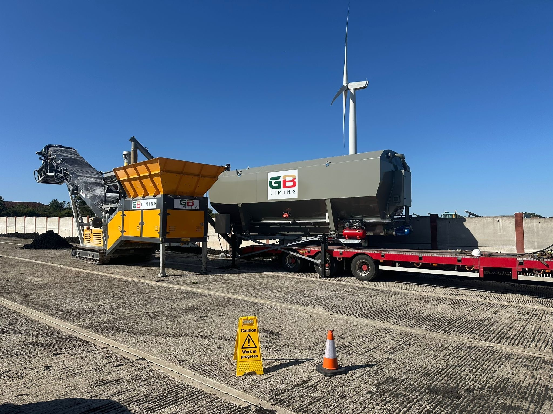

Environmental Management System
v1.0

Environmental and sustainability solutions provided to
GB Liming Ltd

WRM-LTD.CO.UK
This report was prepared by Walker Resource Management Ltd (WRM’) within the terms of its engagement and in direct response to a scope of services. This report is strictly limited to the purpose and the facts and matters stated in it and does not apply directly or indirectly and must not be used for any other application, purpose, use or matter. In preparing the report, WRM may have relied upon information provided to it at the time by other parties. WRM accepts no responsibility as to the accuracy or completeness of information provided by those parties at the time of preparing the report. The report does not take into account any changes in information that may have occurred since the publication of the report. If the information relied upon is subsequently determined to be false, inaccurate, or incomplete then it is possible that the observations and conclusions expressed in the report may have changed. WRM does not warrant the contents of this report to any party other than the named client, and shall not assume any responsibility or liability for loss whatsoever to any third party caused by, related to, or arising out of any use or reliance on the report howsoever. No part of this report, its attachments or appendices may be reproduced by any process without the written consent of WRM. All enquiries should be directed to WRM.

Document Title | Environmental Management System
Client | GB Liming Ltd
Revision | v1.0
Date | 07/04/2026
Document Reference | EPR-B01
Project Reference | 1578/F05
Author: Bryanna Heaton |  | Reviewer: Graeme Kennett
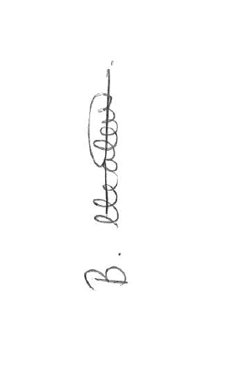 |  | 

Copyright ©
All material on these pages, including without limitation text, logos, icons and photographs, is copyright material of Walker Resource Management Ltd (WRM). Use of this material may only be made with the express, prior, written permission of WRM. This document was produced solely for use by the named client to whom the document refers. The methodology (if any) contained in this report is provided to you in confidence and must not be disclosed or copied to third parties without the prior written agreement of WRM. Disclosure of that information may constitute an actionable breach of confidence or may otherwise prejudice our commercial interests.

Revision | Details | Date
0.1 | Initial Draft | 09/01/2026
0.2 | Review version for operator comment | 17/02/2026
0.3 | Update following client review | 19/02/2026
1.0 | Final version for submission | 07/04/2026
2.0 | Amended version incl NIA reports | 07/07/2026

Revision Log

CONTENTS
Contents
1.0 Introduction 1
1.1 Permitted activities 1
1.2 Exempt activities 1
2.0 Site Details 2
2.1 Site Address 2
2.2 Grid reference 2
2.3 Site description 2
2.4 Plans 3
2.5 Directly Associated Activities 3
3.0 Operational Overview 4
3.1 Waste management operations 4
3.2 Permitted waste 5
3.3 Hours of operation 5
3.4 Staffing 5
3.5 Technical Competence 6
3.6 Site Identification Board 6
3.7 Site security 7
3.8 Reporting to the Environment Agency 7
4.0 Site Engineering 8
4.1 Access and parking 8
4.2 Site office 8
4.3 Site operational area 8
4.4 Drainage and containment system 8
5.0 Treatment Process 9
5.1 Plant and equipment 9
5.2 Liming and mixing plant 9
5.3 Material storage and discharge 10
5.4 Barford BF4048 tracked pugmill 10
6.0 Site Procedures 12
6.1 Document control 12
6.2 Environmental permit reporting 12
6.3 Waste acceptance and inspection 12
6.4 Waste treatment 12
6.5 Corrective action 12
6.6 Environmental incidents 12
6.7 Compliance audit 13
6.8 Management review 13
7.0 Pollution Control 14
7.1 Maintenance 14
7.2 Fugitive emissions 14
7.3 Storage areas of liquids 14
7.4 Inspection and maintenance of engineered containment 14
7.5 Odour 15
7.6 Key compliance requirements under BAS 16
7.7 Noise and vibration 16
7.8 Pests, scavenging animals and birds 17
7.9 Control of mud and debris and loose waste 17
7.10 Control, monitoring and reporting of dust, fibres and particulates 17
7.11 Control of litter 17
7.12 Leaks and spillages 17
7.13 Accident Management 17
8.0 Climate Change Considerations 18
8.1 Summer daily maximum temperature 18
8.2 Winter daily temperature 20
8.3 Daily extreme rainfall and average winter rainfall 20
8.4 Drier summers 21
8.5 River flow 22
8.6 Storms 22
8.7 Review 23
9.0 Competence Management Plan 24
9.1 Purpose and scope 24
9.2 Management structure and responsibility 24
9.3 Competence Requirements 25
9.4 Training framework 25
9.5 Refresher training 27
9.6 Supervision and operational control 27
9.7 Monitoring and performance review 27
9.8 Record keeping 27
9.9 Continuous improvement 28
9.10 Conclusion 28
10.0 Records 29
10.1 Monitoring 29
10.2 Site diary 29
10.3 Waste records 30
10.4 Reporting and notification 30
10.5 Training Records 30
10.6 Calibration 31
10.7 Complaints 31
10.8 Site processing/operations 31
Annex A – Site Plan 32

Introduction
This Management System has been prepared in accordance with the Environmental Permitting Regulations (EPR) 2016, setting out the considerations and operational details that are relevant to the operation of a biosolids liming facility operated by GB Liming Ltd (hereon referred to as ‘GBL’). It details the nature of the site, relevant site and infrastructure works, methods of operation and environmental controls.

Permitted activities
GBL are seeking an Environmental Permit to operate as a biosolids liming facility with a maximum capacity of 1,500t/day (75,000 t/yr). This applies to the treatment of non-compliant sewage sludge (also known as biosolids) by controlled addition of lime to achieve stabilisation, pathogen reduction, and odour control to produce a stabilised, hygienic material that can be safely and beneficially reused in agriculture.

Exempt activities
GBL do not currently undertake any exempt activities on site.

Site Details

Site Address
GB Liming Ltd
Weston Road
Honeybourne
Evesham
WR11 7QF

Grid reference
SP 11152 42124

Site description
The site is situated on an unnamed track off Weston Road (B4035) within the predominantly rural area of Honeybourne, approximately 7km east of Evesham Town Centre. It is surrounded by rural land use with the nearest residential receptor located approximately 500m southwest of the site. Weston Industrial Estate is situated approximately 1km southeast of the site.
The site is not located within;
- 500 metres of a European site, Ramsar, SSSI or Marine Conservation Zone (MCZ);
- 50 metres of a National Nature Reserve, Local Nature Reserve, Local Wildlife Site, Ancient woodland or Scheduled Ancient Monument;
- 50 metres of a site that has species or habitats protected under the Biodiversity Action Plan that the Environment Agency considers at risk to this activity;
- 250 metres within the presence of Great Crested Newts where it is linked to the breeding ponds of the newts by good habitat;
- 10 metres of a watercourse.
The site will operate the following equipment;
- 1 x BARFORD BF4048 Tracked Pugmill - BARFORD - Doyle Machinery
- 2 x loading shovels (one for loading biosolids in and one for moving biosolids to stockpiles and loading biosolids out)
- 1 x 140 kva mobile generator
- 1 x diesel pressure washer for plant and surface washdown
- 1 x 70m³ lime silo, step frame mounted for mobility
- 1 x steel deck type weighbridge
- 1 x small office container to house weighbridge electronics and DoC/Paperwork log/filing
- 1 x Storage container (Parts/tools and safety equipment/H&S station).

Plans
Reference Drawings:
EPR_001_Site_Plan

Directly Associated Activities
There are no Directly Associated Activities as the complete activity is identified to operate as a facility as opposed to an installation.

Operational Overview

Waste management operations
All vehicles delivering feedstock to the facility will enter the site via the main entrance.
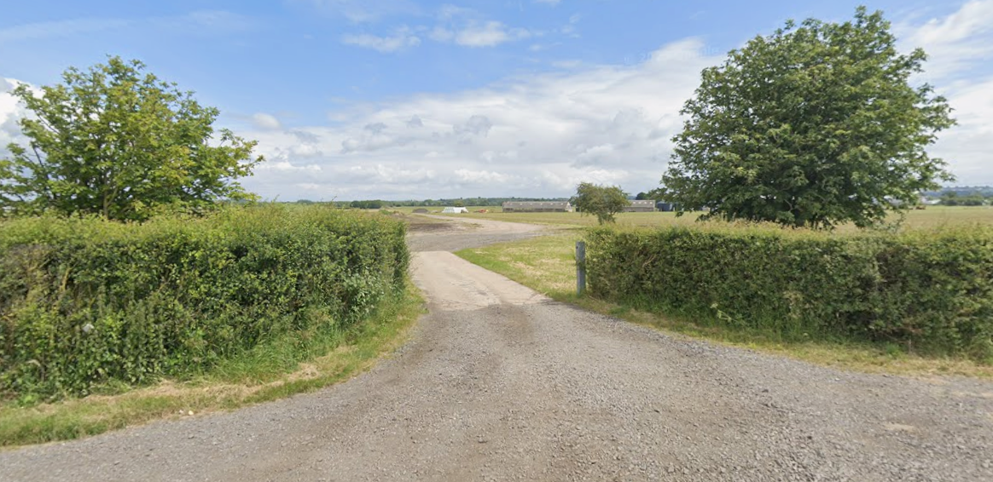
Figure 1: Site entrance (Google Streetview)
Documentation will be checked by the inputs operative to ensure that the material being delivered is of the correct type. The relevant documentation will be signed by the operative to confirm the acceptance/receipt of the material prior to the driver being allowed to proceed to the dedicated unloading area and will be sorted into dedicated storage areas.
Biosolids will then be treated using alkaline materials (typically quicklime or hydrated lime) which raises the pH and temperature of the material for a defined period (raise pH to above 11.5 for at least 2 hours), which:
- Reduces pathogens to safe levels
- Stabilises the material and slows biological breakdown
- Significantly reduces odour potential
- Improves handling characteristics
The treated material is commonly referred to as lime-stabilised biosolids. The process parameters (lime dosage, mixing effectiveness, retention time) are controlled through documented procedures and operator competence, ensuring consistent outcomes.
Compliant biosolids will then be loaded and removed for application to land under The Sludge (Use in Agriculture) Regulations 1989.

Permitted waste
Waste material shall only be accepted if they are a type and quantity specified in the permitted list of wastes, and the load conforms to the description in the documentation supplied by the producer and holder. Please see OP01 – Waste Acceptance Procedure for the full list of wastes and EWC codes to be accepted at site.
Any wastes that are not categorised as permitted materials should be considered contrary/non-conforming and dealt with appropriately.

Hours of operation
Site operational hours for the facility will typically be as identified in Table 3-1 below:

Table 1: Typical site operational hours.
Weekday | Operational Hours
Monday to Friday | 07:00 – 19:30
Saturday | 07:00 – 19:30
Sunday | When required
Bank Holiday | When required

Staffing
GBL shall ensure that sufficient personnel, who are suitably trained and competent, are present to manage and operate the on-site activities safely and without causing pollution. Personnel must be fully familiar with the requirements of the Permit as is relevant to their specific duties. Personnel shall have clearly defined roles and responsibilities. Any contractors used on site will be provided with necessary information before commencing work. The site will also have a technically competent manager to ensure the plant is operated in compliance with regulations, as detailed within section 3.5 below. The staff numbers are presented below in Table 2.
Table 2: Site operational staff
Job Role | Number
Senior management | X
Supervisor | X
Site operatives | X

Operational responsibilities for the site rest with the Site Manager. Staff numbers will be maintained at a level sufficient to operate and supervise the site effectively and throughout periods of employee sickness and holidays.

Technical Competence
All site operational staff will be trained in all areas of the permit and management system. This training will become part of an ongoing training programme both ad-hoc when needed and a 12 monthly refresher course.
A printed copy of the Environmental Permit and Management System will be kept at the site office and will be readily available for reference by site staff, other company staff, the Environment Agency and other regulatory authorities.
A designated person will hold a suitable qualification in order to operate the site compliantly. At present Mark Fowles – Director GB Liming is progressing with the relevant WAMITAB Level 4 qualification for the site.

Site Identification Board
In conformance with the permitting regulations and the Management System, GBL shall display a clear, all weather, easily readable Site Notice at the main entrance to the site. The site sign/notice shall contain the following information:
- Company Name
- Permit Holder’s Name
- Emergency Contact Name and 24-hour contact number
- Permit Holder’s Telephone Number
- Statement that the site is permitted by the EA
- The Permit Number
- EA Telephone Number
The Identification Board shall be inspected at least once per week. In the event of damage or defect, the board shall be repaired or replaced as soon as possible.

Site security
The site is in a predominantly rural area on a former airfield. The security measures present at the site are summarised as follows:
  - Single access point to site which is gated and locked outside of operational hours;
  - Fencing bordering the site;
  - CCTV; and,
  - 24-hour security lighting.
Site staff will be briefed that in the event of evidence suggesting unauthorised access or vandalism being found, the matter must be reported to the police. If the incident involved unauthorised tipping or spillage of any waste, the EA will be informed.
The fencing and entrance gates will be regularly inspected and any defects noted in the security of the site will be rectified within a reasonable period from their discovery.
All visitors to site will need to sign in upon arrival on site. If they are to enter the process area, an induction will also be needed to enter this area.

Reporting to the Environment Agency
All reporting required by the following shall be carried out in accordance with OP04 - Environmental Permit Reporting. These correspondences shall include the reference number and the name of the Permit holder. This shall include but is not limited to:
  - Relevant convictions
  - Change of operator’s or holders details
  - Notification of preparatory works
  - Commencement or cessation of waste operations
  - Emissions monitoring results

Site Engineering

Access and parking
The site has direct vehicular access from Weston Road. The access point provides good visibility in both directions and is fit for purpose for site traffic.

Site office
The site office is located in the northern portion of the site. Toilets, washing and mess facilities are provided within this area.
The following information and equipment will be kept in the site office:
  - Environmental Permit;
  - Management System;
  - Site diary;
  - Visitor’s book recording all visitors to the site;
  - Conditions of site use for employees, visitors and contractors;
  - In-house inspection sheets/monitoring forms;
  - Waste Transfer Notes; and,
  - Accident book and first aid kit.

Site operational area
The layout of the site, including the facility’s process and storage areas are shown on the site plan as referenced in section 2.4 of this document.
All vehicles carrying waste which enter and exit the site will adhere to the traffic routing system. Following inspection vehicles are directed to the waste unloading area.

Drainage and containment system
All surface water generated on site are managed by the site’s sealed drainage system into aco surface drains into an underground tank c. 50-60m³ capacity. Rainwater falling on building roofs via gullies and pipework is then directed to the same surface water drainage system.

Treatment Process

Plant and equipment
Biosolids will be handled using the plant and equipment such as those listed below. Additional plant can be brought in to cover breakdowns or any very busy periods. Only trained operators are permitted to drive/operate machines on-site.
The site will operate the following equipment;
- 1 x BARFORD BF4048 Tracked Pugmill - BARFORD - Doyle Machinery
- 2 x loading shovels (one for loading biosolids in and one for moving biosolids to stockpiles and loading biosolids out)
- 1 x 140 kva mobile generator
- 1 x diesel pressure washer for plant and surface washdown
- 1 x 70m³ lime silo, step frame mounted for mobility
- 1 x steel deck type weighbridge
- 1 x small office container to house weighbridge electronics and DoC/Paperwork log/filing
- 1 x Storage container (Parts/tools and safety equipment/H&S station).

Liming and mixing plant
The treatment is undertaken as an active stabilisation process the Biosolids Assurance Scheme or equivalent and does not rely on prolonged storage, passive biodegradation, or dilution. Lime treatment involves adding alkaline materials (typically quicklime or hydrated lime) to biosolids. This raises the pH and temperature of the material for a defined period (raise pH to above 11.5 for at least 2 hours), which:
- Reduces pathogens to safe levels
- Stabilises the material and slows biological breakdown
- Significantly reduces odour potential
- Improves handling characteristics
The treated material is commonly referred to as lime-stabilised biosolids. The lime stabilised cake will be treated and tested in accordance with the HACCP Plan for the site. The site operator is required to check the pH of the stabilised material at Critical Control Point 1 as shown on the HACCP, A record of this will be maintained on the Daily Production Sheet.
Figure 2: Image showing lime silo and mixing plant

Material storage and discharge
After treatment, compliant biosolids will be temporarily stored onsite in a specific bay prior to despatch from site to a registered S3: storing sludge - GOV.UK site or before being spread to agricultural land under The Sludge (Use in Agriculture) Regulations 1989.

Barford BF4048 tracked pugmill
Barford’s Twin shaft Pugmill Mixer is an efficient, accurate, tracked/mobile diesel-driven plant and is the complete solution for the mixing of biosolids with lime for stabilisation operations.
An onboard water tank provides water dosing when required. The main conveyor belt is mounted on belt weigher load cells, therefore full weighing control for biosolid liming. All materials are weighed/measured before mixing and electronic flow meters control the lime addition.
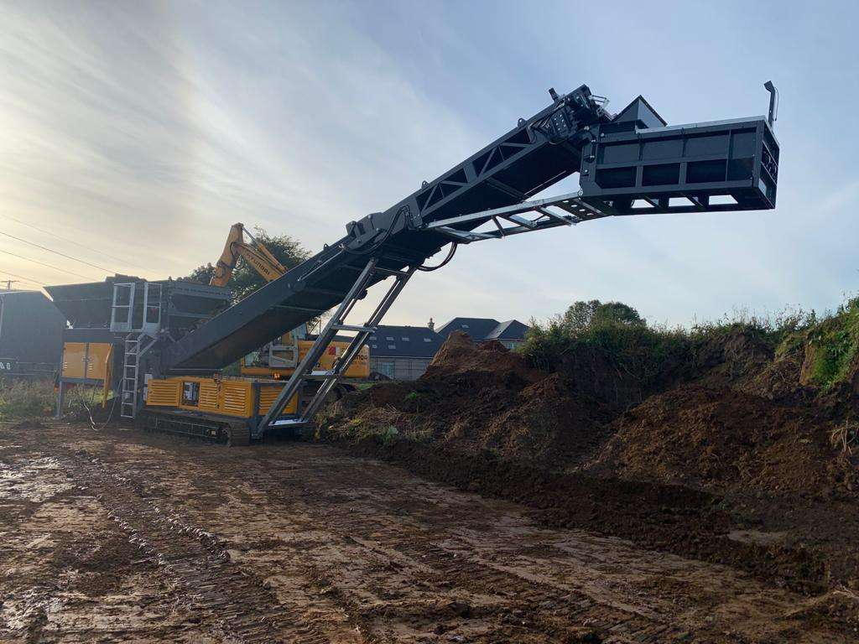

Figure 3: Image of Barford BF4048 pugmill
Operating features;
- Electronic flow meters control lime addition rates.
- On-board computer system stores up to 20 mixing rates and controls production automatically
- Production stops automatically if one of the materials is missing
- Tracked mounted chassis for ease of movement on-site

Site Procedures

Document control
All site documentation will be held by the specified retention to differing documents either electronically or hard copy. These will have the necessary security levels e.g., locked storage, password protected etc. All documents are controlled by document control procedure.

Environmental permit reporting
Permit reporting is carried out in line with OP04 – Environmental Permit Reporting Procedure to meet the requirements of the permit.

Waste acceptance and inspection
See OP01 – Waste Acceptance Procedure for full details of the Waste Acceptance Criteria, which covers the following items:
  - Pre-Acceptance
  - Waste acceptance;
  - Visual inspection;
  - Waste rejection; and,
  - Traceability.

Waste treatment
See OP02 - Waste Treatment Procedure for a full process description of the treatment processes that are carried out at the GBL Evesham site.

Corrective action
GBL shall ensure that any corrective action is carried out as appropriate.

Environmental incidents
Any environmental incident will be brought to the attention of the Site Manager who will investigate all incidents and report (if needed) to the EA.
Separately, a record for site purposes will be held, monitored and used as a possible training aid for staff.

Compliance audit
GBL will review management system documents at least annually as part of the yearly compliance audit, or sooner should one of the following situations arise:
- Environmental pollution event occurs.
- Change in operation.

Management review
GBL shall ensure, following the compliance audit, a management review of the results of the audit are discussed by company directors on an annual basis. The management review should cover all aspects of the audit results, such as any complaints received at the site or any pollution event occurring on site over the past year and put in place a management plan to remedy these situations from reoccurring. Records of the management review should be recorded and maintained.

Pollution Control

Maintenance
The site operates a strict maintenance regime and equipment used is of sufficient capacity to allow down time for routine maintenance and servicing as recommended by the manufacturer.
No plant/equipment may be operated unless full instructions and training have been given by a person competent to do so.
Any newly arrived equipment is subject to inspection to ensure it meets the standards required by both the company and current legislation.
Pre-use checks are implemented and all breakdowns or incidents involving plant or equipment are entered in the site diary. Routine maintenance is recorded by operators on maintenance log sheets.

Fugitive emissions
The site infrastructure and operations are managed in such a way that the risk of fugitive emissions shall not cause pollution.

Storage areas of liquids
All liquid wastes produced on site as part of the process will be stored in secure bunded containers and subject to regular inspections.

Inspection and maintenance of engineered containment
All areas i.e., floor, bay walls. will be inspected at least monthly to ensure the continuing integrity and fitness for purpose of their construction.

Odour
The site accepts non-compliant biosolids arising from wastewater treatment processes. These materials are biodegradable and generate further odour if left untreated. However, they are also well understood waste streams for which established treatment standards exist.
The activity does not involve prolonged storage of untreated waste, nor does it rely on passive biodegradation. Instead, odour risk is controlled through immediate chemical stabilisation, which is consistent with the Biosolids Assurance Scheme (BAS) expectation that odour risk should be addressed at source. By elevating the pH to ≥11.5 for a period of at least two hours> The process achieves a robust 'barrier' within a HACCP-based framework, effectively halting the biological degradation of organic matter. This immediate chemical intervention ensures that non-compliant batches are proactively managed to prevent the generation of volatile organic compounds (VOCs) and ammonia-based nuisances before they leave the site. By integrating this stabilisation step at the point of production, the process provides the necessary 'Critical Control Point' (CCP) validation required to maintain the high standards of the BAS, ensuring the resulting material is socially acceptable and consistently compliant for recycling to agricultural land.
Odour risks are controlled through:
- Rapid treatment of incoming biosolids
- Maintaining the correct lime dosage and mixing effectiveness
- Minimising storage times of untreated material
- Good site housekeeping and operational controls
These measures significantly reduce the likelihood of off-site odour impacts.
To align with the Biosolids Assurance Scheme (BAS), lime treatment plants must use a minimum of two Critical Control Points (CCPs) to ensure effective pathogen reduction and odour control.
The following table summarises the standard CCPs and their associated monitoring requirements for a BAS-compliant lime stabilisation process.
Table 3: Critical Control Points (CCPs) for lime stabilisation (BAS HACCP)
Process step | Critical Control Point (CCP) | Critical Limit (CL) | Monitoring method | Corrective action
Lime dosing | CCP 1: Lime Inclusion Rate | Minimum dosing rate (e.g., >5% w/w on a dry solids basis) | Flow meters / load cells (automated system) | Stop process; re-dose non-compliant batch; recalibrate equipment.
Mixing | CCP 2: Homogeneity & pH Elevation | Sustained pH ≥11.5 | Inline pH probes or manual sampling records | Divert to "Non-compliant" storage; re-process until pH ≥11.5 is verified.
Contact time | (Optional) CCP 3: Retention Time | Minimum 2 hours at pH 11.5 (standard practice) | Batch timers or verified plug-flow retention | Retain in treatment vessel for additional time before discharge.
Pathogen kill | Verification: Microbiological Standards | E. coli <10⁵/g (Conventional) or <10³/g (Enhanced) | Laboratory analysis of representative samples | Material must be quarantined and re-treated if standards are not met.

Key compliance requirements under BAS
Automated Control: From July 2019, BAS only permits mechanically or electronically controlled mixing (e.g., mixing screws or plough shares) to ensure product uniformity. Manual "bucket mixing" is no longer acceptable.
Validation: Every site must have an individual, validated process control plan that demonstrates the chosen CCPs consistently meet the product standard.
Records: HACCP process monitoring records must be maintained to provide a benchmark for auditors.

Noise and vibration
The proposed treatment facility is fitted with new modern equipment and therefore all the equipment will meet modern noise criteria.
The site manager or equivalent is responsible for the NMP and ensuring people are trained, where relevant. This NMP should be stored digitally and available to whomever requires access with a physical copy kept in the site office.
The plan should be reviewed annually or following any changes to plant and/or operations. No training is required for the review or implementation of the plan.
The site manager, or equivalent, should be responsible for the maintaining of records of complaints and associated investigations due to noise on site.
Where complaints are received, the site manager should undertake or employ a suitable consultant to carry out noise monitoring.

Pests, scavenging animals and birds
Measures shall be implemented and maintained throughout the operational life of the site to control and monitor the presence of pests on the site. An inspection of the facility for pest infestations shall be carried out at regular intervals by the site manager and shall be recorded in the site diary.

Control of mud and debris and loose waste
Internal roads are designed, constructed and maintained to ensure they are adequate for traffic usage. The site surface is entirely constructed of concrete/asphalt so that mud will not be a problem.

Control, monitoring and reporting of dust, fibres and particulates
It is unlikely that the operations will cause dust, fibres and particulates. However, procedures are in place to ensure that any emissions are within the specified limits.

Control of litter
It is unlikely that the operations will cause the generation of litter, however, the site has a dedicated employee who is responsible for monitoring litter on site and for completing litter picking where necessary.

Leaks and spillages
Environmental incidents are often the result of mechanical breakdown of plant and vehicles. All areas will be inspected at least monthly to ensure the continuing integrity and fitness for purpose of their construction.
A system is in place to ensure that all machinery is correctly serviced and used servicing oils etc. are not stored on site.

Accident Management
Please see EPR-C03 Accident Management Plan (AMP) which includes fire prevention methods and contingency plans.

Climate Change Considerations
Climate projections for the UK (UKCP18 – Met Office) suggest that we can expect:
- Heat waves
- Extreme rainfall, leading to more frequent severe floods
- Drought
- Rise in sea level and tidal surges
- Storms
- Wildfires
The impacts of all the above, except for sea level rises and tidal surges based on the geographical location of Evesham, have been considered with the following mitigation measures in place on site. The considerations behind these will help GBL to:
- Remain in compliance with the environmental permit;
- Minimise the impact on the environment during an extreme weather event and the event’s impact on operations, either through accidental release or abnormal operation;
- Improve resilience and business continuity by avoiding unplanned start-ups, shutdowns and other business interruptions.

Summer daily maximum temperature
Summer daily maximum temperatures may be around 7ºC higher compared to average summer temperatures now, with the potential to reach extreme temperatures as high as over 40ºC with increasing frequency based on today’s values.
The impacts of this on the GBL site include:
- Potential increase in high temperature expansion and stress of plant, pipework and fittings along with UV degradation of plastic pipes and hoses causing them to fail.
- Potential increased dust emissions from processing areas, stockpiled material and site roads. Reduced availability of water for dust suppression.
- Long periods of hot and dry weather could lead to a drought and may have an impact on water supplies for:
- emergency water usage
- cooling systems
- fire fighting
- Potential increased risk of pests and scavengers from stockpiled waste.
- Potential increase in odour.
- Potential increased risk of wildfires impacting the site.
Mitigation measures imposed by GBL include the following:
- Mixing of biosolids with the liming agent is undertaken within the mixing plant which has no point source emission points.
- The Site Manager carries out a daily visual assessment of dust emissions around the site.
- Regular inspection and preventative maintenance of site, plant and equipment as part of the programmed preventative maintenance schedule.
- Dust generation attributable to vehicle movements is controlled by the maintenance and sweeping of the site access road.
- No ignition sources permitted near fuel storage
- GBL plan operations to have treated material stockpiled for the minimum amount of time possible to prevent large stockpiles of material.
- Measures shall be implemented and maintained throughout the operational life of the site to control and monitor the presence of pests on the site.
- Inspections of the facility for pest infestations shall be carried out at regular intervals by the site supervisor and shall be recorded in the site diary.
- The site has implemented a full Odour Management Plan (OMP) and Odour Risk Assessment.
- Water level usage shall be reviewed on a regular basis. This includes assessing those systems and processes that have a critical need for water and what the baseline needs are.
- Biosolids are also delivered to site in sealed tankers and transported directly into the mixing plant.

Winter daily temperature
Winter daily temperatures could be 4°C more than the current average with the potential for more extreme temperatures, both warmer and colder than present.
The impacts of this on the GBL site include:
- Slightly higher winter maximums could generate regular odour complaints and pest infestations.
- Lower winter temperatures could result in an increased risk of pipes (or similar) freezing.
- Decreases in winter temperatures resulting in restricted access to the site, due to frozen access roads causing disruption to feedstock delivery.
Mitigation measures imposed by GBL include the following:
- Effective management of feedstock.
- Regular gritting / salting of access road in anticipation of subzero temperatures or snow.
- Monitoring of meteorological data to anticipate subzero temperatures or snow.
- Pest controller to be employed on detection of pests during site inspections.
- The site has implemented a full Odour Management Plan (OMP) and Odour Risk Assessment.

Daily extreme rainfall and average winter rainfall
Daily rainfall intensity could increase by up to 20% on today’s values and average winter rainfall may increase by over 40% on today’s averages.
The impacts of these on the GBL site include:
- Potential for increase site surface water flooding.
- There is a potential for drainage systems to be overwhelmed.
- Access or egress from site could be affected. Impacting staff, suppliers, deliveries,
removals of product, and emergency services.
Mitigation measures imposed by GBL include the following:
- In the event of continuous heavy rainfall all waste management operations may continue subject to a site risk assessment carried out by the site manager and recorded in the site diary, to ensure minimum operation requirements are still available.
- The Site is indicated (Long Term Flood Risk) to be at a very low risk of flooding from surface water and flooding from groundwater is unlikely in this area.
- The drainage system is regularly inspected and maintained including inspections of blockages and obstructions.
- Biosolids are also delivered to site in sealed vehicles and transported directly into the unloading area.
- Mixing of biosolids with the liming agent is undertaken within the mixing plant which has no emission points.

Drier summers
Summers could potentially see up to 40% less rain than now.
The impacts of these on the GBL site include:
- Long periods of hot and dry weather could lead to a drought and may have an impact on water supplies for:
  - emergency water usage
  - cooling systems
  - fire fighting
- There is potential increased impact of discharge to watercourse from on-site drainage systems, where connected to water courses.
Mitigation measures imposed by GBL include the following:
- Water level usage shall be reviewed on a regular basis. This includes assessing those systems and processes that have a critical need for water and what the baseline needs are.
- No water from site enters nearby watercourses.
- Regular inspection and preventative maintenance of site, plant and equipment as part of the programmed preventative maintenance schedule.

River flow
The flow within the watercourses could be 50% greater than it is currently when at its peak, and 80% less than now when at its lowest.
The impact of this on the GBL site include:
- Increased impact from on-site drainage systems where they are connected to watercourses.
Mitigation measures imposed by GBL include the following:
- The Site is indicated (Long Term Flood Risk) to be at a very low risk of flooding from surface water and flooding from groundwater is unlikely in this area.
- No water from site enters nearby watercourses.
- Regular inspection and preventative maintenance of site, plant and equipment as part of the programmed preventative maintenance schedule.

Storms
Storms could see a change in frequency and intensity. The unique combination of increased wind speeds, increased rainfall, and lightning during these events provides the potential for more extreme storm impacts.
The impacts of these on the GBL site include:
- Potential for high winds to damage site infrastructure and equipment and blow any accumulations of liminmg material from the site.
- Potential for lightning strikes to damage infrastructure.
Mitigation measures imposed by GBL include the following:
- Waste types on site are unlikely to contain litter.
- Any litter discovered will be removed and placed in secure bins.
- Housekeeping and cleaning measures in place to ensure particulates on external surfaces are minimised.
- During extreme stormy weather, operations at the time can be paused.
- Need for lightning conductors / protection shall be assessed and installed if necessary.

Review
These mitigation measures will be reviewed annually as part of the review of the entire Environmental Management System in which risks and associated mitigation measures will be reassessed.

Competence Management Plan
Open-air biosolids liming facility

Purpose and scope
The Competence Management Plan (CMP) defines the arrangements in place to ensure that all personnel engaged in waste acceptance, liming operations, environmental control, and plant operation are competent to undertake their duties in accordance with:
- The Environmental Permit conditions;
- Duty of Care requirements under the Environmental Protection Act 1990;
- Relevant expectations within the Environment Agency Waste Acceptance Technical Guidance; and
- The site Environmental Management System (EMS).
This CMP applies to all site operatives, supervisors, and the Technically Competent Manager (TCM).

Management structure and responsibility
- Technically Competent Manager (TCM)
The site operates under the direct control of a designated TCM who:
- Holds an appropriate CIWM/WAMITAB competence qualification for the permitted waste activity;
- Has defined responsibility for regulatory compliance;
- Ensures adequate supervision of site operatives;
- Reviews training records and refresher requirements annually;
- Is available during operational hours or via agreed call-out arrangements.
- Site operatives (2–4 personnel)
Site operatives are responsible for:
- Waste acceptance verification;
- Mixer wagon operation;
- Loading shovel operation;
- Lime dosing;
- pH testing and verification;
- Emissions control implementation;
- Record keeping.
Operatives report directly to the Site Manager / TCM.

Competence Requirements
- Minimum baseline competence
All operatives must demonstrate competence in:
- Waste identification and verification procedures;
- Completion and review of Waste Transfer Notes;
- Visual inspection of biosolids loads;
- Operation of mobile plant (loading shovel/mixer wagon);
- Lime handling and COSHH awareness;
- Field pH testing and calibration;
- Odour, dust, and runoff control procedures;
- Incident reporting protocols.
- Formal qualifications (where applicable)
The following are required or targeted:
- CIWM/WAMITAB qualification relevant to permitted waste activity (for TCM);
- CPCS or NPORS certification for mobile plant operators;
- First Aid at Work (minimum one trained person present during operations).
Where formal certification is pending, documented supervised training is provided.

Training framework
- Induction training
All new personnel receive a structured induction covering:
- Environmental Permit conditions;
- Waste acceptance procedures;
- Rejection protocols (no on-site quarantine approach – reject and remove);
- Emission control measures;
- Surface water protection arrangements;
- Emergency response procedures;
- Health and Safety risk assessments.
Induction completion is recorded and signed off by the TCM.
- Task-specific training
Operatives receive documented training in:
Waste acceptance
- Pre-acceptance documentation checks;
- Load conformity assessment;
- Non-conformance reporting and rejection procedure.
Liming process control
- Lime dosing ratios;
- Mixer wagon safe operation;
- Sequence of mixing to minimise exposed untreated material;
- Minimisation of ammonia release through rapid incorporation.
pH Verification
- Proper sampling technique;
- Calibration of pH meters;
- Interpretation of results;
- Corrective actions for under-limed batches;
- Record retention requirements.
Emissions management
- Meteorological risk awareness (wind thresholds);
- Dust suppression deployment;
- Drainage inspection and leachate containment checks;
- Complaint response procedure.

Refresher training
Annual refresher training is conducted for environmental controls and waste acceptance.
Additional training is delivered following:
- Regulatory updates;
- Permit variation;
- Incident investigation findings;
- Identified competence gaps.
All refresher training is documented.

Supervision and operational control
The TCM provides direct supervision proportionate to risk and operational scale.
Less experienced operatives are subject to enhanced supervision until competence is demonstrated.
Competence is verified through observation of task performance.
Any deviation from procedures triggers immediate review.
The site operates on a “reject rather than quarantine” principle, and staff are trained accordingly to ensure non-conforming waste is not retained on site.

Monitoring and performance review
Competence effectiveness is reviewed through:
- Internal compliance inspections;
- Review of pH verification records;
- Audit of waste acceptance documentation;
- Incident and complaint analysis;
- Drainage and housekeeping inspections.
Findings are reviewed by the TCM and corrective actions implemented where necessary.

Record keeping
The following records are maintained:
- Training matrix and qualifications register;
- Induction records;
- Toolbox talk attendance sheets;
- pH calibration logs;
- Waste acceptance logs;
- Incident and non-conformance reports.
Records are retained in accordance with EMS requirements and made available to the Environment Agency upon request.

Continuous improvement
The competence management plan is subject to annual review. Improvements may include:
- Additional formal qualifications;
- Enhanced environmental awareness training;
- Updated procedural controls reflecting regulatory guidance;
- Lessons learned from sector best practice.

Conclusion
This Competence Management Plan ensures that all personnel involved in the biosolids liming operation possess the knowledge, skills, supervision, and documented training necessary to:
- Prevent acceptance of unauthorised waste;
- Maintain effective alkaline stabilisation control;
- Minimise odour, ammonia, dust, and runoff emissions;
- Protect human health and the environment; and
- Demonstrate compliance with permit conditions and regulatory guidance.

Records
GBL will maintain all records on-site in line with OP05 – Recording Procedure.

Monitoring
GBL shall undertake the monitoring as specified within OP03 – Monitoring Procedure and will maintain all monitoring records.

Site diary
A Site Diary shall be maintained and retained in the site office. It shall record visitors, non-routine activities and other incidents. The Site Diary should be checked periodically by the Permit Holder to ensure its correct use. The Site Diary shall be readily available for inspection. Examples of activities recorded in the site diary include:
- Visitors are asked to visit the site office and complete their details (name, date, time in/out, car registration number and signature) within the Visitor Book.
- Names and times of technical competent managers on site.
- Any accidents occurring on site are recorded within the Accident Book.
- Machinery shall be visually inspected and their condition shall be recorded on the Machine Weekly Check Sheet.
- Complaints: relating to an incidence dust, pest, odour and noise problems (managed via the site’s EMS).
- Any incidence of dust, pest, odour and noise problems (managed via the site’s EMS).
- Unsuitable material shall be rejected from site and recorded within the recorded load record sheet.
- Any incidents, including fire or spillage, that could potentially cause pollution to the environment shall be recorded in the Corrective Action Log.
- Spill kits are inspected on a weekly basis and recorded on the Site Checklist: Spill Kits record sheet.
- Condition of site infrastructure is inspected on a weekly basis.

Waste records
Records of all materials entering and the leaving the site shall be recorded. All records will be made as soon as reasonably practicable and retained securely for a minimum of three years. Records will be clear, legible and available for viewing (on site). Records must be kept of all incoming wastes, and all outgoing wastes.
The following records will be retained (not comprehensive):
- Waste Carriers Licences (where appropriate).
- Tickets/Documents – incoming wastes.
- Tickets/Documents – outgoing wastes.
- Destination of outgoing wastes (including S3 stockpile/field reference).
- Rejected waste forms.
- Duty of Care records.

Reporting and notification
Site personnel will notify the Environment Agency without delay, following the detection of:
- Any malfunction, breakdown or failure of equipment or techniques, accident, or fugitive emission which has caused, is causing or may cause significant pollution.
- The breach of a limit specified in the Permit.
- Any significant adverse environmental and health effects.
Site personnel will notify the Environment Agency within 24 hours:
- Of actual or potential incidents and breaches of emissions limits.
Site personnel will notify the Environment Agency within 14 days:
- Of any change in the operator’s trading name, registered names or registered offices addresses.

Training Records
Each person, whose duties affect the process shall be trained, instructed and supervised commensurate with those duties, such that they are competent. Training records for personnel who affect site procedures, operations and quality shall be maintained.

Calibration
All monitoring equipment will be regularly calibrated (minimum 12 monthly) by an externally verified company.

Complaints
GBL shall decide and implement any necessary action in response to any complaints or concerns expressed by interested parties, including operatives, customers, clients and regulatory authorities.
The operator shall record the following:
- Name and contact details of the person who expressed concern or made a complaint,
- Specific subject(s) of the concern or complaint,
- The source / location of where the complaint comes from,
- Date and time communicated to the producer and name of the person to whom it was communicated,
- Nature and date(s) of any actions and checks and who carried them out,
- Nature and date of any response to the person who expressed a concern or made the complaint; and,
- Name of the person who communicated the response.

Site processing/operations
GBL will record and maintain any relevant information in relation to process steps including:
- Changes/updates to the process;
- Customer transactions;
- A record of vehicles and drivers to the site;
- Feedstock/material intake; and,
- All processed and finished products.
These records will be logged and maintained on company internal computerised systems.

Annex A – Site Plan

