Yew Tree Dairy PartCo Limited

416.065368.00001

FORM PART B6 Addendum

Discharge points W1 and W2 discharge to the same United Utilities foul sewer (refer Figure 1 and Figure 2 below).
The discharge points include:
- Discharge point W1 – Runoff from the yard, internal spills, effluent from evaporative process (where not passed through the reverse osmosis plant).
- Discharge point W2 – foul drainage, over pumping from the attenuation tank (when required).

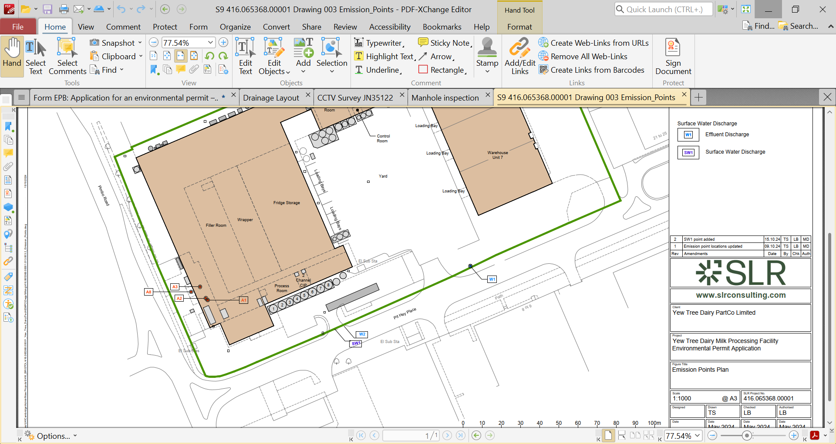
Figure 1 – Effluent Discharge Points

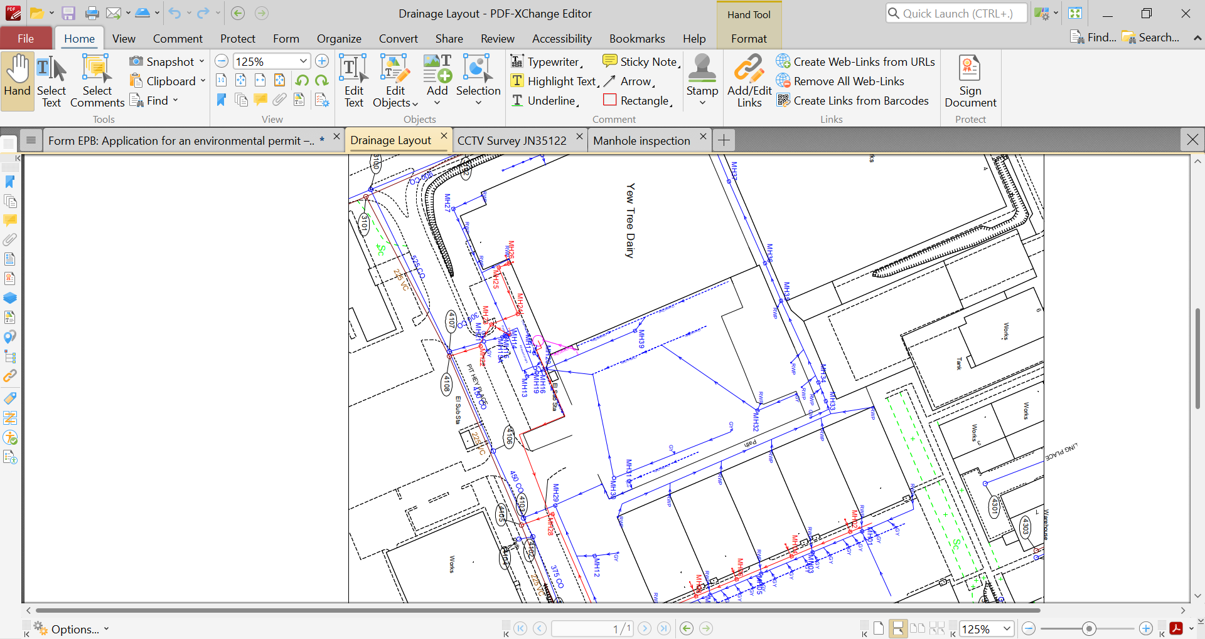
Figure 2 – Drainage Plan

