Application reference: EPR/YP3092ZR/V004
Facility: Caldervale WwTW, Caldervale Road, Wakefield, WF15 5PJ
Application Fee
Unfortunately, the application payment you sent is incorrect. The correct application charge subject to confirmation of the waste activities identified is £31,524. This leaves a balance of £15,053 to pay as our records show that you have only paid £16,471. Further guidance in relation to application charges can be located at: https://www.gov.uk/government/publications/environmental-permitting-charges-guidance/environmental-permitting-charges-guidance The application charge is made up as follows:
Application Fee
- £13,984 application fee for - S5.4 A(1) (b) (i) Recovery or a mix of recovery and disposal of non-hazardous waste with a capacity exceeding 75 tonnes per day (or 100 tonnes per day if the only waste treatment activity is anaerobic digestion) involving biological treatment.
- £7,930 application fee for the addition of the dewatering activity as identified in table C3:1b-2 – Types of waste accepted – Imported wastes for dewatering/storage only (prior to recovery). Note: We will only progress this activity if the information is provided in line with the further questions below.
- £3,965 - Application fee for the physical treatment of non-hazardous waste relating to temporary storage of cake
- £2,379 - Application fee for a - Minor variation fee to remove activities R13 and R2 relating to the sludge conditioning activities. (see section 3.4.2 of guidance https://www.gov.uk/government/publications/environmental-permitting-charges-guidance/environmental-permitting-charges-guidance)
Additional Assessments (see below for further details)
- Odour management plan – a fixed charge of £1,246
- Habitats assessment – a fixed charge of £779
- Emission Management Plan – a fixed charge of £1,241
A fee of £3,158 has been raised in line with the following table. This has been made with the reference… PSCAPPYYORKSSWI020. Please note this is currently going through the YW approval system and will not have reached the EA yet. Please see the screenshot below to demonstrate that this additional payment has been raised.
Payment Requested |  | YW Comment
Section 5.4 a(i) and (b)(i) – Non-hazardous waste installation – biological treatment | £13,984 | OK - payment already made.
Emissions Management Plan | £1,241 | OK - payment already made.
Odour Management Plan | £1,246 | OK - payment already made.
Habitats Assessment | £779 | To be raised
Application fee for the addition of the dewatering activity as identified in table C3 :1b-2 – Types of waste accepted – Imported wastes for dewatering/storage only (prior to recovery). Note: We will only progress this activity if the information is provided in line with the further questions below. | £7,930 | Table C3:1b-2 was left in the resubmission as an error. YW is not requesting this activity and this table can be discounted. Please see response to Q2 for further on this matter.
Application fee for the physical treatment of non-hazardous waste relating to temporary storage of cake | £3,965 | There will be no physical treatment of non hazardous waste.
£2,379 - Application fee for a - Minor variation fee to remove activities R13 and R2 relating to the sludge conditioning activities. | £2,379 | R13 is still applicable in regards storing of waste prior to digestion in addition to storage of waste post digestion. It is also applicable with regards gas storage. This code is to remain in the permit please.  Fee raised for the removal of R2, which is no longer required.
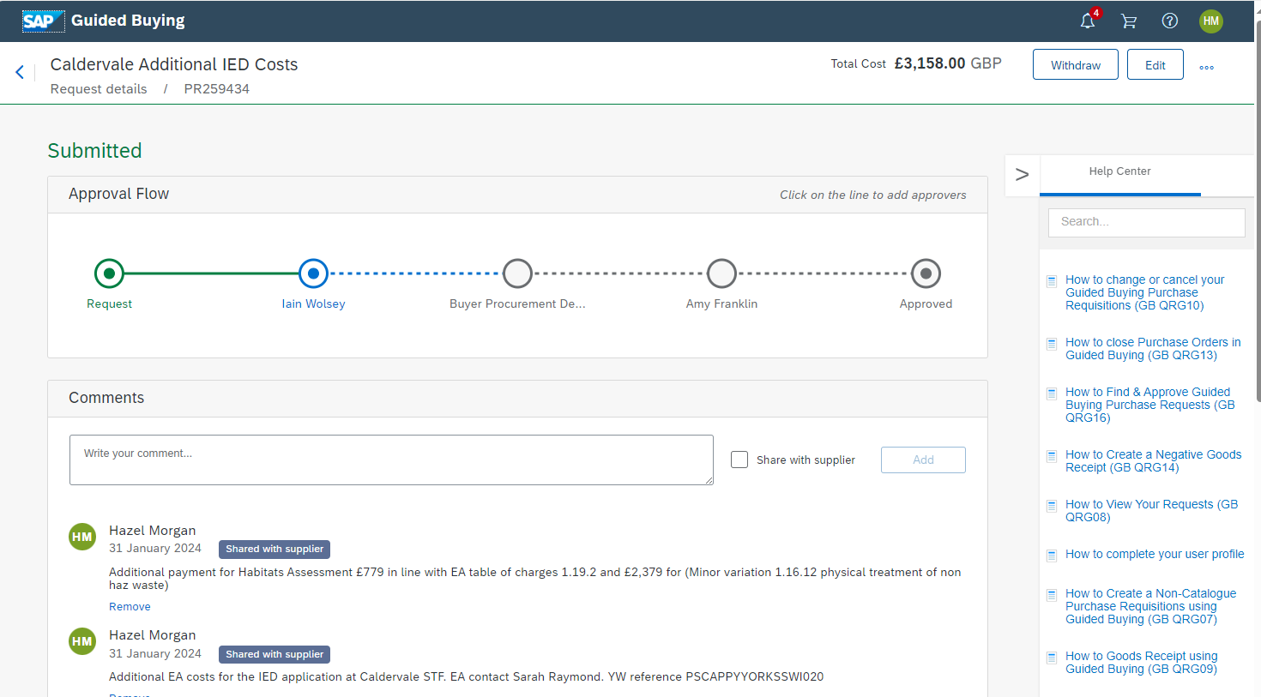
- Indirect emissions to the WwTW.
The waste anaerobic digestion process produces effluent and is discharged off site to the Caldervale Wastewater Treatment Works. Effluent discharged to the head of the works is a point source emission to sewer. BAT conclusion 3 requires operators to have an emissions inventory for the effluent. On assessment of your application you have provided table C2: 6.8 – proposed analytical suite: Calvdervale return liquors characterisation programme – BAT 3, however this limits potential parameters. BAT 3 requires you determine the composition of all relevant pollutants to enable full characterisation of your emissions. Guidance Surface water pollution risk assessment for your environmental permit - GOV.UK (www.gov.uk) requires you must “identify the pollutants released from your plant”. The guidance states, that you must “Make sure the laboratory tests for all pollutants which you expect to find in the discharge and that they use an appropriate ‘minimum reporting value’ (MRV) (usually 10% of the environmental quality standards (EQS)).”
- Provide a written statement with a commitment to undertake the sampling and analysis in line with BAT3.

Sampling and analysis will be undertaken in line with BAT3.

- Provide a written statement with a commitment that those undertaking the sampling and analysis will be by accredited to MCERTs or provide evidence of equivalent standards.

Sampling and analysis will be undertaken by those accredited to Mcerts standards.

- Dispersion stacks to be connected to an OCU.
BAT 34 and 53 require that in order to reduce emissions, BAT is to use one or a combination of defined abatement techniques. You have identified within your application that the below assets all require abatement through the connection to odour control units (OCUs). To progress your application, we will need to you to provide the following information.
- GBT vent stack (stack 1)
- Drum thickener vent stack (stack 2)
- Sludge reception tank
- Thickener feed tanks x 2, digester feed tanks1 and 2 and the return liquor pumping station (thickener filtrate)
- 2 x centrifuge feed tanks

- Confirm the emission points for the proposed OCUs.

We’re not in a position to provide this information yet as the work requires investigation. This investigation project will begin imminently but is expected to be 6month until it concludes.

YW understands that failure to provide the emission point as part of this application will mean it requires a permit variation when they are installed. It’s hoped we will have this information during the permit determination phase of this permit.

- Confirm the OCU type i.e. Biofilter/Carbon filter/chemical scrubber, including if it will be a one or two stage process

This information can’t be provided until the investigation concludes and determines the best technology for the OCUs.
- If the OCU will be open or closed system.

Any installed OCU(s) will be closed.

- Addition of waste activity relating to table C3:1b-2 – Types of waste accepted – Imported wastes for dewatering/storage only (prior to recovery).
We have identified that you have applied for a directly associated activity to the section 5.4 activity identified as “Treatment of digested sludge produced at Caldervale or other YW sites (including physical handling and dewatering) which we believe reflects the codes you have applied for in table C3:1b-2 – Types of waste accepted – Imported for dewatering/storage only (prior to recovery). It is our understanding that waste identified in table C3:1b-2 will not undergo anaerobic digestion and as such this activity is not a DAA to the section 5.4 activity but a separate waste activity. In order to progress this activity, you will need to provide all information identified within our application process, this includes but is not limited to the below. (Please note it is your responsibility to ensure that information is provided in line with our requirements, failure to provide this will mean that we will not be able to progress this element of your application:
- Payment as identified above.
- Non-technical summary, and process flow including how you will keep this activity separate from your installations activity (https://www.gov.uk/guidance/waste-environmental-permits)
- Assessment against Non-hazardous and inert waste: appropriate measures for permitted facilitieshttps://www.gov.uk/guidance/non-hazardous-and-inert-waste-appropriate-measures-for-permitted-facilities
- Completion of relevant forms – B4 new bespoke waste operation - https://www.gov.uk/government/publications/application-for-an-environmental-permit-part-b4-new-bespoke-waste-operation
- Updating and inclusion of this activity in all relevant management plans such as the Odour management plan, accident management plan, residue management plan etc.
Table C3: 1b-2 – Types of waste accepted - Imported wastes for dewatering/storage only (prior to recovery) was left in the resubmission incorrectly.

All sludges received at Caldervale STF will undergo treatment through anaerobic digestion.

No additional information or payment has been provided.

- Temporary storage of cake not produced on site
You have identified within your application that “The cake pad may also on very rare occasions serve certain contingency functions, for both operations at Caldervale and to wider strategic regional sewage infrastructure operated by YW.” If you are importing cake for temporary storage and transfer of site without wastes being processed through the AD this will be a separate waste activity. In order to progress this activity, you will need to provide all information identified within our application process, this includes but is not limited to the below. (Please note it is your responsibility to ensure that information is provided in line with our requirements, failure to provide this will mean that we will not be able to progress this element of your application:)
- Payment as identified above.
- Non-technical summary, and process flow including how you will keep this activity separate from your installations activity (https://www.gov.uk/guidance/waste-environmental-permits)
- Assessment against Non-hazardous and inert waste: appropriate measures for permitted facilitieshttps://www.gov.uk/guidance/non-hazardous-and-inert-waste-appropriate-measures-for-permitted-facilities
- Completion of relevant forms – B4 new bespoke waste operation - https://www.gov.uk/government/publications/application-for-an-environmental-permit-part-b4-new-bespoke-waste-operation
- Updating and inclusion of this activity in all relevant management plans such as the Odour management plan, accident management plan, residue management plan etc.

All sludges received at Caldervale STF will undergo treatment through anaerobic digestion.
No additional information or payment has been provided.

- Bioaerosols Risk Assessment (BRA)
You have provided section 6-6 Bioaerosol assessment advising that you have carried out Bioaerosol monitoring, however we cannot locate these results within your application. You need to send us a Bio-aerosol Risk Assessment. This should meet the requirements of our M9 Position Statement (https://www.gov.uk/government/publications/bioaerosol-monitoring-at-regulated-facilities-use-of-m9-rps-209/bioaerosol-monitoring-at-regulated-facilities-use-of-m9-rps-209). This must show that the process and/or abatement measures adequately prevent, or where this is not possible, significantly reduce the risk of bio-aerosols release. It must show that the resulting activity will be unlikely to expose the nearest sensitive receptor to elevated concentrations of bio-aerosols.
The detail and level of risk assessment must be site specific, process and location dependent. You must have measures and process controls in place to control and minimise the risks identified. These must be clearly stated in your assessment.

Please see attached 6. 114175 Caldervale Ambient Bioaerosols Monitoring September 2022.
- Accident Management Plan
You have submitted a risk assessment under section 6.7 of your submission in relation to accidents, however this does not meet the requirement set out in our guidance https://www.gov.uk/guidance/develop-a-management-system-environmental-permits#accident-prevention-and-management-plan. Provide a standalone accident management plan that meets the requirements of the above guidance.

Please see 7. Accident Managment Plan_Caldervale_v1

- Air Dispersion modelling

- You have provided air dispersion modelling but have not provided your modelling files. Please provide a copy of your modelling files.
- You air quality impact assessment does not seem to include local nature reserves (LNR) in line with guidance https://www.gov.uk/guidance/air-emissions-risk-assessment-for-your-environmental-permit#screening-for-protected-conservation-areas. Update you air dispersion model to include LNRs.
- You have not confirmed your combustions plants MWth input for each combustion unit. Update your air dispersion modelling report to clearly state this.

Please see 8. Caldervale_AERA_model_files

- Secondary Containment
We cannot locate where you have undertaken spill modelling following the implementation of your proposed secondary containment solution to demonstrate that it will adequately contain the required volume. Update your secondary containment report to include spill modelling following the implementation of proposed containment solution.

We’re not in a position to provide this post mitigation spill modelling as the contract partners are still finalising the containment approach at Caldervale. Please be assured that YW is progressing this work and this post mitigation spill modelling will be provided during permit determination.

- Waste water emissions during storm overflow conditions at the WwTW.
Routine emissions to the WwTW from the installation will be controlled via monitored emission limits as an indirect discharge (as defined in the Waste Treatment BREF). However, as WwTW periodically discharge sewage during storm conditions, its possible that waste water from the installation could bypass the WwTW treatment processes and be emitted as a direct discharge to water. Its not clear from the application how this abnormal situation will be prevented. Operators of environmental permits cannot emit waste waters directly to surface waters without detailed risk assessment. You must therefore have procedures to prevent the discharge of waste water from the installation from bypassing the WwTW treatment processes directly to surface water during storm overflow conditions.
- Provide written procedures which describes the site’s contingency arrangements to prevent digestate and effluent being discharged off site while the WwTW are in storm conditions.

All STF return liquors from the installation boundary are made downstream of the storm overflow point. There is no ability for return liquors to enter the storm tank or 6x channel and discharge during storm conditions.

- Provide a description of the buffer storage proposals to control or hold emissions to the event of storm overflow conditions at the WwTW.

Not required as there is no ability for return liquors to overflow in storm conditions.

- Should any contingency arrangements use storage tanks to act as a buffer, provide evidence that demonstrates the waste waters or digestates can be held in this storage during the period of storm overflows.
Not applicable
Note, this information can be included as an addendum to your accident management plans as part of BAT conclusion 21, Emissions from accidents and incidents.

- Emission point plan
Your application identifies “A small area of surface water runoff from an area of roadway to the north of the liquor balance tanks is currently being discharged directly to the river. These drains will be redirected to the WwTW (refer to Improvement Programme)” You have not included this emission point on your emission point plan.
Update your emissions point plan to include the direct emission identified. Ensure all relevant documents are updated to include your updated emission point plan.

Please see attached…
- Caldervale Figure 3 - Principal Emissions Points_Rev
11. Caldervale Figure 4 - Drainage Plan_Rev.C Sheet 1 of 2
If this drainage issue is resolved during determination stage then we will inform the EA and revert back to the previous emission plans.
Please send the requested information to sarah.raymond@environment-agency.gov.uk.
Please include ‘EPR ref no. EPR/YP3092ZR/V004: Installations triage – additional information’ in your email response to ensure it is managed correctly.
Note:

