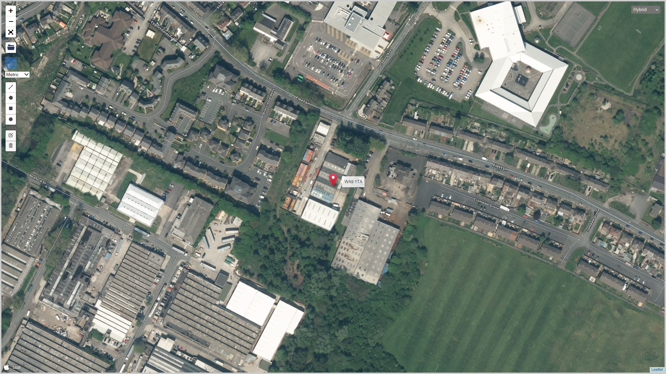
SITE LOCATION PLAN-GRID REF SJ 53259M 94789
INSTALLATION BOUNDARY EXTERNAL SITE BOUNDARY

