- Summary
The following document was referenced in demonstrating Best Available Technology (BAT):
- COMMISSION IMPLEMENTING DECISION of 9 October 2014 establishing best available techniques (BAT) conclusions, under Directive 2010/75/EU of the European Parliament and of the Council on industrial emissions, for the refining of mineral oil and gas

The process design is shown in P&IDs OP029-1000 & OP029-1001 (see attached).
- Directive 2010/75/EU
  - BAT 52
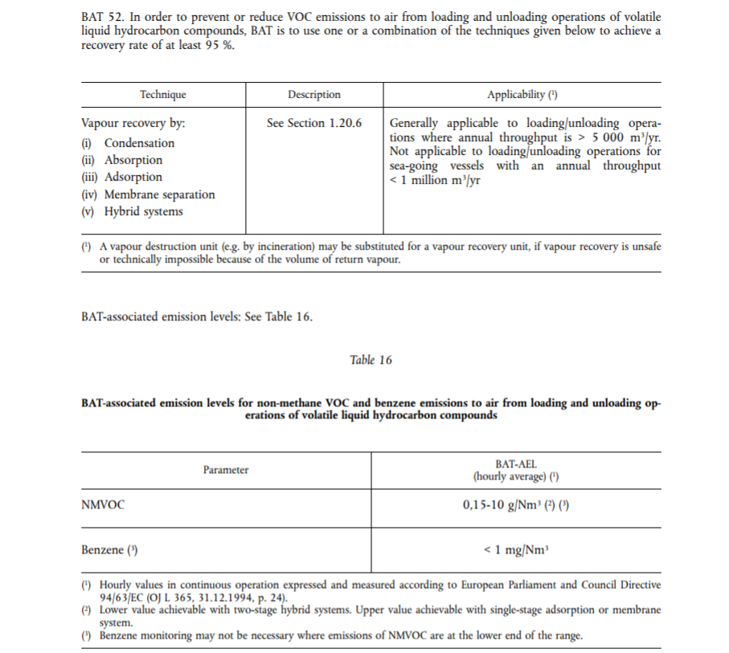

Whilst throughout is less than 5,000 m3 year, the unit has a carbon filter which removes any H2S via (iii) Adsorption. The following is taken from: Design Basis Document No.OP029/3000.
The other consideration for tank venting is the potential for emissions to the environment. Testing of crude taken from the caverns has suggested that the crude contains 1-2% sulphur therefore there is the potential for H2S to be released from the crude tank. Due to the age of the crude it is not possible to predict what levels we can expect from the crude. H2S removal technologies cover a wide range of processes from absorption and scrubbing systems to multi-stage sulphur recovery. As the level of H2S is expected to be low and the project is only a short term one a simple activated carbon filter will be installed in the vent line. The unit will be hired with the contaminated carbon returned to the supplier.
The scrubbing package was specified to match the predicted vent flows from the tank. A sample point is provided downstream of the equipment. The project will monitor the H2S emissions from the carbon filter vent using hand held gas monitors in line with manufacturer’s instructions. As the equipment is on a rental basis, on detection of bed saturation (through sampling) the entire unit is replaced with a new bed.
Other concerns in the vent line are from VOCs. New guidance for permanent installations required the installation of vapour recovery systems. As we are providing equipment for short term use and the level of VOCs emitted will be low no additional equipment will be installed for the recovery of VOCs.
The overflow from the tank will be directed via a brine filled seal pot to stop flammable gases escaping from the tank. The overflow will be routed in to the temporary bunded area to prevent loss of containment to local environment. The temporary bund will be located in the existing containment area which will provide some degree of tertiary containment.

  - BAT 14
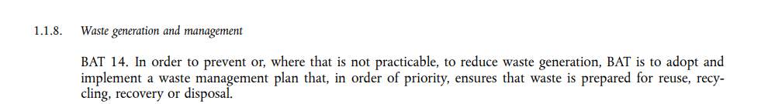
Residual brine and crude oil will be removed offsite for disposal.
  - BAT 17
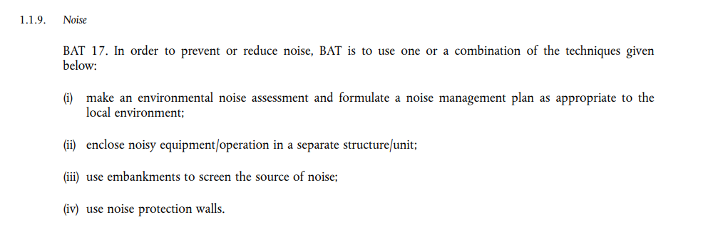
The equipment has low noise output (e.g. for the generator dB(A) at 1m = 72.1, dB(A) at 7m = 64.3).
The expected levels for any workers is < 80dB(A) and it is expected that the exposure time (people positioned less than a metre from the generator/pumps over an 8 hour working day), would be very low (less than 1hr/day).
The nearest resident is more than 100 m away and any noise is unlikely to be heard due to the remote location of the site.
The operation is only during days.

  - BAT 49
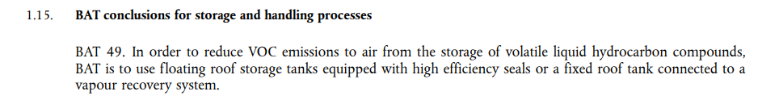
There is no long-term storage of crude oil in the tank, it is merely product transfer as opposed to storage.
  - BAT 50
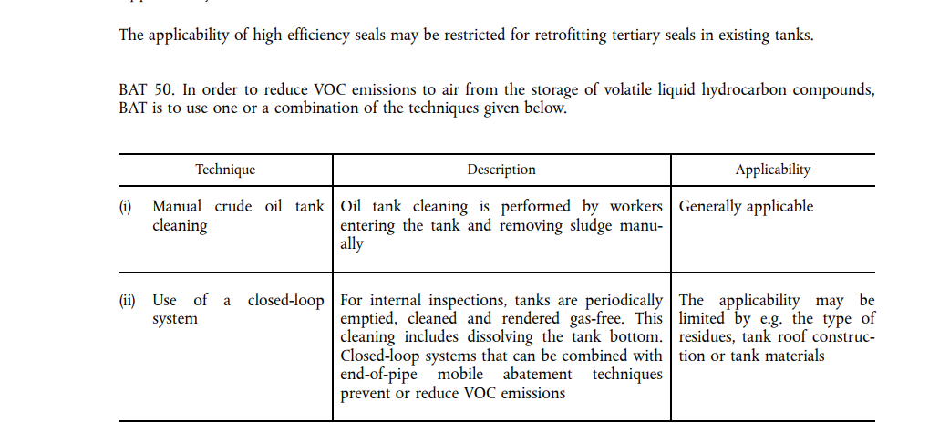
Tanks will be cleaned as defined above.
  - BAT 51
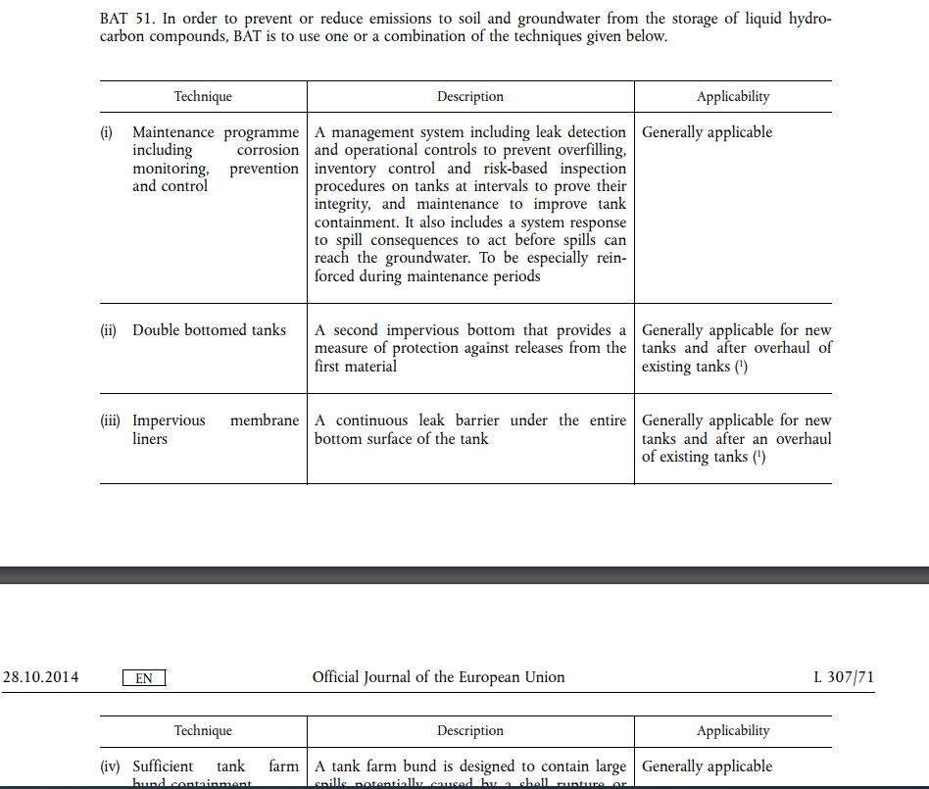
There will be operational controls, via SOPs, to prevent overfill and spills will be managed in line with the ERP, which will be updated to reflect the extraction phase.
Both T171 and T175 have inner and outer containment areas.

  - BAT 54

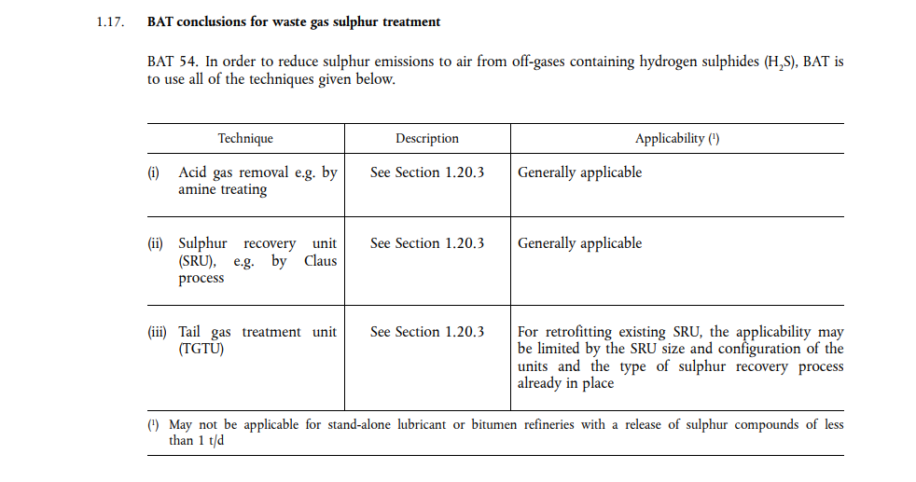
Whilst this is generally not applicable, a carbon filter will be installed to remove any potential H2S in the vent gas.

