Form B2,
Section 5c,
Non-technical summary

Storage of Crude Oil
The COGH PSD consists of two leased caverns, T171 and T175, which historically have been used for hydrocarbon storage. The COGH PSD was developed by the UK Government to be a fuel and oil storage depot in approx. 1955. The caverns were last used in 1977, at which time it was thought they had been de-fuelled. The Defence Infrastructure Organisation (DIO) lease the caverns, on behalf of MOD from Inovyn.

The total capacity of the site is approximately 500,000m3. The crude oil volume is approximately 3,000m3, with the remaining volume made up of brine. The COGH PSD is currently under asset management by OPA and no operations are carried out at the site.

Asset management involves the following:
- Maintenance: Replacing old valves/wellheads with new equipment. This involves depressurising the caverns (i.e. bringing oil to the surface). Oil is vacuumed out by specialist tanker for disposal.
- Depressure: It is normal to have to relieve pressures on caverns every few years (or to top them up with brine).

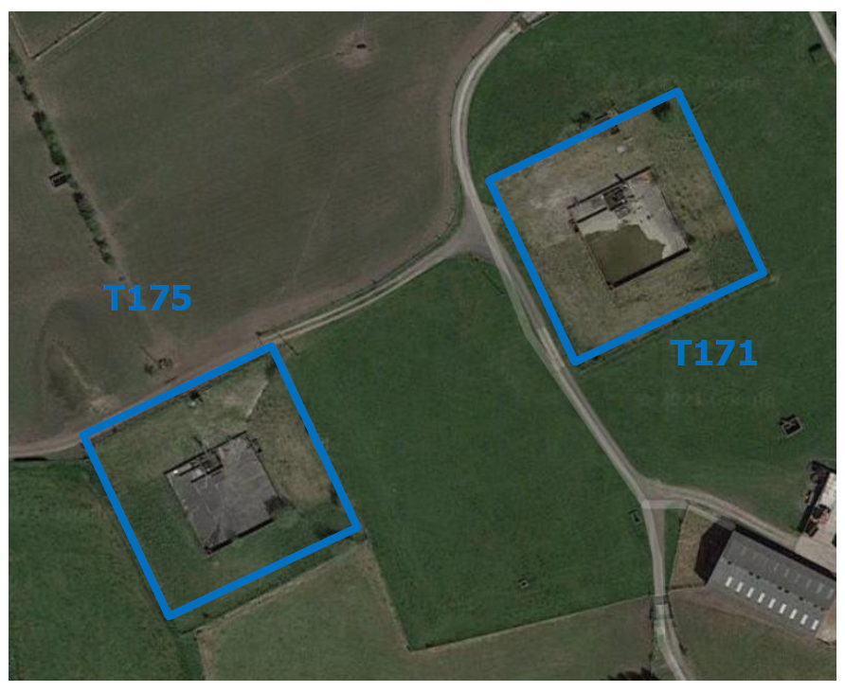

Handling of Crude Oil
There are plans to uplift the remaining crude oil from T171 and T175 and hand back the caverns to Inovyn. Crude will be removed from the cavern by displacement with saturated brine. The project will provide an extraction unit mounted on multiple skids which can be moved from one well head to the other.

Saturated brine is received by road tanker and unloaded into a brine storage tank. The brine will be injected into the cavern and crude oil will be collected from the oil well head. The oil will be collected in a storage tank which will have some separation capabilities to remove the brine entrained within the oil. Separated crude will be loaded into a tanker for export. Separated brine will be returned to the brine tank and residual brine will be collected for disposal offsite.

It is estimated that this will take approx. 60-90 days and as a result a climate change risk assessment is not required as the planned duration of the operation is less than 5 years.
