CONTENTS
1 INTRODUCTION 1
2 WASTE ACCEPTANCE 1
3 HTTP and WASTE TRANSFER and STORAGE 3
4 ENVIRONMENTAL PROTECTION and CONTROL MEASURES 5
5 AMENITIES 6
6 MAINTENANCE 6
7 INTEGRATED MANAGEMENT SYSTEMS 7
8 SSSI 7
9 SUSTAINABILITY………………………………………………………………………………………………………………………………..7

1 INTRODUCTION
1.1 Medisort Limited operates a High-Temperature Treatment Plant (HTTP) which supplies steam to the adjacent Hillingdon Hospital. We would like to include waste transfer at the same location, allowing Medisort to store and transfer waste to more appropriate disposal facilities, thereby reducing the number of inappropriate waste streams incinerated. This will provide incineration capacity for more appropriate waste streams. A precedent was set for waste transfer at Hillingdon. The previous operator carried out waste transfer activities agreed by the Environment Agency via a Local Enforcement Position (LEP) which was active from December 2018 until Feb 2021.

1.2. Site Location
The site is located at Hillingdon Hospital, Pield Heath Road, Uxbridge, Middlesex, UB8 3RD. The centre of the site is at National Grid Reference TQ 06932 82150. The permitted area covers 0.24 Ha. and can be seen in document D007.1 Green Line site boundary HH. This facility provides a critical part of the national clinical waste incineration fleet, and its location, being near a high population and medical waste producers’ sites, offers minimal transport distance and thereby low haulage emissions.

1.3 Access to the site is via Kirby Way off Royal Lane; the site is boarded to the South by Crispin Way to the North by Kirby Way and Colham Road to the East. The site is surrounded by a 2-metre-high fence, and the nearest residential building is 3 metres from Kirby Way, which is in Rutherford Close.

See Document:
D007.1 Site Location Plan - HH

1.4 This application seeks a variation to an existing Environmental Permit EPR/YP3404SE.

1.5 The site design accords with all regulatory requirements and relevant guidance. Site operations and decommissioning will also be undertaken in accordance with relevant regulations/guidance.

1.6 Medisort is committed to ensuring that the highest standards are met and will undertake all its activities consistent with industry best practices and Environment Agency sector guidance.

2 WASTE ACCEPTANCE
2.1 All waste deliveries will be deposited in the waste reception area in the existing High-Temperature Treatment (HTTP) building and will be tracked using MediTrack E007.5.9 i4 MediTrack Waste Booking & Tracking Procedure
2.2 The HTTP & Transfer station will accept waste from the healthcare industry. The operation will transfer healthcare wastes from hospitals, doctors, dentists, vets, R&D and other such establishments. Waste management operations to be undertaken at the transfer station are identified in Table 1.

2.3 The HTTP and Transfer station will receive waste from other healthcare waste contractors. Waste will be unloaded in the same area as Medisort’s waste and will undergo the same acceptance procedures.

2.4 Pre-acceptance procedures will be in place to ensure that only waste that may be accepted under the Environmental Permit is directed to the site. Suitably trained operatives will check all vehicles delivering waste to the HTTP building & Transfer station to ensure that only permitted wastes are accepted. The site will have dedicated weighbridges where visual checks will be made where possible before wastes are directed to the appropriate storage area. D024 - Waste HTTP/Transfer Flow HH

2.5 Pre-acceptance waste audits are logged on Medisort’s MOPS - Medisort Order Processing System
along with pre-acceptance waste audit evidence from third parties. E007.4.1.1 i12 Pre-Acceptance Waste Audit form

2.6 Only wastes permitted by the Environmental Permit will be accepted. Any loads containing non-permitted waste will be rejected from the site or dealt with as the Environment Agency advises. Any waste found to be non-conforming examples, being missed consigned waste, incorrect used EWCs, or incorrect packaging will be placed in the quarantine area.
The COTC holder will complete E005.4.1 Non-conformance Action Form. The customer/producer must immediately be advised of the problem to agree on remedial action. The maximum storage time for quarantined loads must take account of the potential for odour generation and insect infestation. The maximum storage volume for quarantined waste is one bin. In all cases, two working days is the maximum storage time for hazardous waste that has failed to meet the acceptance criteria.

2.7 Wastes accepted by the site are detailed in document: E005.2.4 Waste types permitted for storage and transfer

See Documents:
E005.2.4 Waste types permitted for storage and transfer
D024 - Waste HTTP/Transfer Flow HH
E007.4.1.1 i12 Pre-Acceptance Waste Audit form
E005.5 Non-Conforming Waste Log
E007.5.9 i4 MediTrack Waste Booking & Tracking Procedure

Table 1

Specified Waste Management Operations (as defined in the Waste Framework Directive (2006/12/EC).

D14. | Repackaging prior to submission to any of the operations numbered D1 to D13
D15. | Storage pending any of the operations numbered D1 to D14 (excluding temporary storage, pending collection, on the site where it is produced)
R13 | Storage of wastes pending any of the operations numbered R1 to R12 (excluding  temporary storage, pending collection, on the site where it is produced)

3 HTTP and WASTE TRANSFER and STORAGE
3.1 HTTP Process Overview

Due to the nature of some healthcare waste streams, HTT disposal is still required. There are several good reasons why incineration makes sense for the treatment of clinical waste:

- Some people in hospitals have dangerous infectious diseases that can live in the waste for a substantial period of time, making it dangerous to store, handle and dispose of. High-temperature incineration done properly kills 100% of all known germs and viruses, unlike bleach, which can only manage 99%.
- Incineration converts chemically toxic residual drugs into harmless gases and solids that do not present a danger.
- As well as the bugs already in the waste, other bugs will rot the dead tissue creating smells and fresh infectious material if simply stored or buried. Incineration completely destroys anything that could feed other bacteria
- Incineration reduces the volume of waste substantially, meaning less space is needed to bury what is left.
- Hospitals use a lot of heat energy to keep patients warm and need steam for cooking and cleaning. Clinical waste is high in energy, and the heat can be recovered. This means that less fossil fuel like oil and gas needs to be used. Good for the environment, good for the NHS wallet, and good for taxpayers’ wallets too.

The HTTP building at Hillingdon has been extensively refurbished to incorporate the latest waste treatment and emissions monitoring technology. It utilises a three-stage process: treatment, energy recovery and bin washing.

3.2 Stage 1 Treatment

Once received on-site, waste is weighed and then stored until transferred or used as feedstock for the HTTP.

The plant, on average, deals with 1 ton of waste per hour which is around 19 - 30, 770ltr bins per hour. The waste is placed into the loading chamber via an automatic bin tipper which is regulated by the programmable logic control system (PLC); waste will not be loaded into the HTTP until the PLC identifies the conditions are ideal in the furnace. The primary burning chamber, configured as a pulsed hearth system, is designed to reduce the waste mass to a fine ash. The chamber is configured to operate under starved air conditions, which results in a partially burnt gas being given of the wastes as they are destroyed. The internal hearth arrangement is designed to slowly manoeuvre the waste materials and resultant residues through the chamber until their ultimate discharge via an automatic and continuous removal system.

A secondary after-burning chamber provides a turbulent and high-temperature environment for thorough treatment and oxidation of the partially burnt flue gases that are produced during the incineration process. The chamber is built for the high-temperature operation that is required and has sufficient volume to ensure that all treated products are resident for at least two seconds during normal operations.

Bottom ashes are discharged to a quench pit, transferred to a skip and are subsequently sent to a landfill. Medisort is actively looking into final alternative methods of reuse or disposal for the bottom ashes and recovering any metals present in the bottom ash.

Gases are then subjected to abatement by lime and activated carbon injection to neutralise any pollutants entrained within, followed by bag filtration before discharge through a 36.5m high stack. The exhaust system is fitted with an M-Certs accredited and WID/IED compliant continuous emission monitoring system (CEMS), which is linked to the PLC system so as to provide operation control, a permanent and constant record of all flue gas emissions to the atmosphere and direct communication to The Environment Agency.

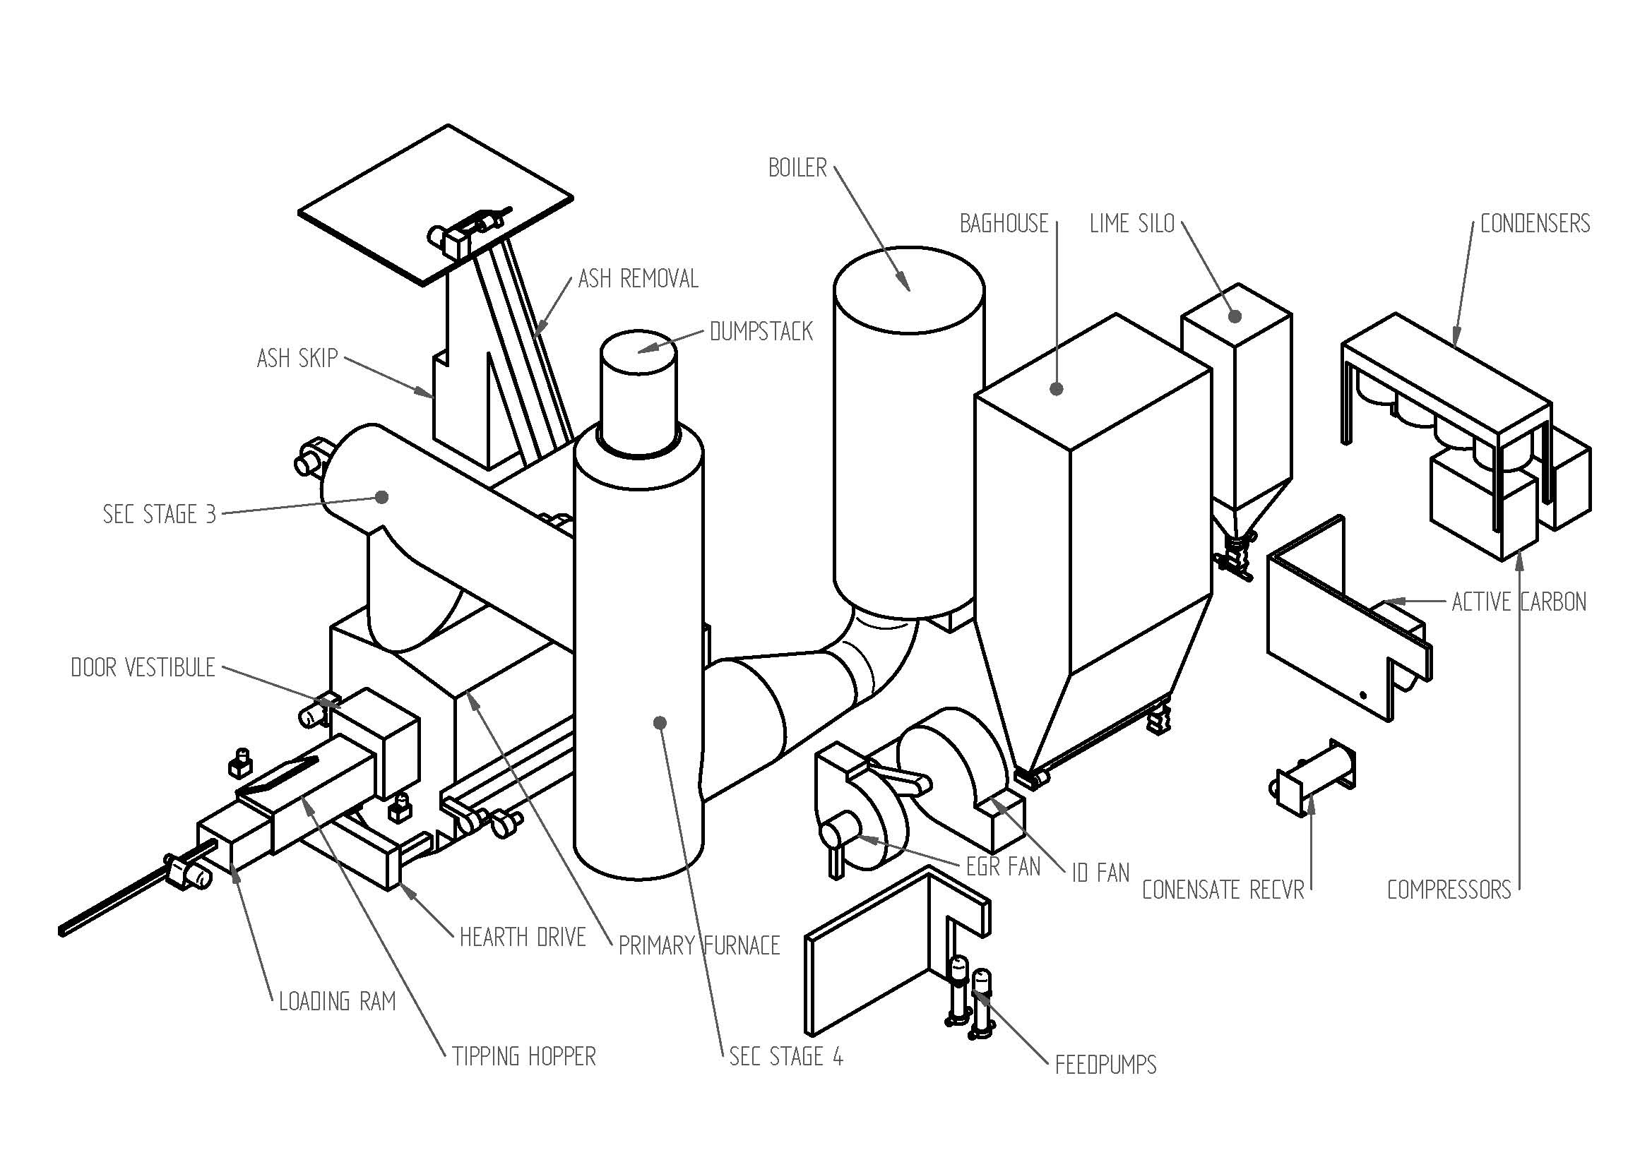
3.3 Schematic Diagram of our Pulsed Hearth System

3.4 Stage 2 – Energy Recovery

Energy is recovered from the combustion gases by a waste heat boiler; the boiler provides the adjacent Hillingdon hospital with steam to run the heating and hot water supplies. This process reduces the hospital's need to use raw fossil fuels for the generation of heat.

3.5 Stage 3 – Bin Washing

Bins will be washed in a state-of-the-art rotary bin washer, giving a 360-degree internal and external washing cycle – ensuring every bin is clean and sanitised after every cycle.

See Document
E007.6 Wheeled Bin Procedures
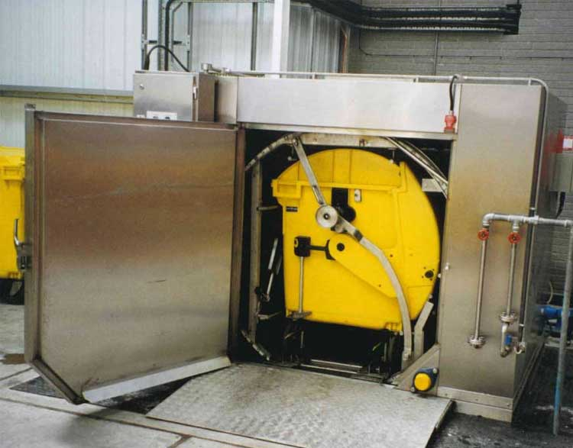

3.6 Storage and Transfer of Non-Hazardous waste.

Storage of non-hazardous waste before transfer to a more suitable disposal site will occur in the yard within the permitted area highlighted in document D007.1. Site Location Plan - HH All containers will be closed and or covered to avoid waste escaping except while being loaded and or unloaded. There will be no more than 120 tonnes of Non-Hazardous stored on-site at any one time, and these levels are monitored by Medisort’s site waste tracking system MediTrack E007.5.9 i4 MediTrack Waste Booking & Tracking Procedure.

3.7 Storage and Transfer of Hazardous waste.

Storage of Hazardous waste before transfer to a more suitable disposal site will be within the High-Temperature Treatment (HTTP) building; the storage area will be over the ground floor, and a mezzanine floor area with a total bin storage capacity of 250 x 770 Ltr wheeled bins D002.1 WASTE STORAGE
Storage will be in UN-approved standard industry wheeled bins; the transfer of waste will be in the same UN-approved standard industry wheeled bins or bulk transfer of bagged waste onto an UN-approved transport unit. The transfer of any bulk waste in bags to the UN-approved transport unit will take place from the HTTP building at either one of the waste reception areas. Medisort’s site waste tracking system MediTrack E007.5.9 i4 MediTrack Waste Booking & Tracking Procedure monitors bin numbers and weights.

3.8 Repacking of Hazardous waste.

The repacking of hazardous waste will be restricted to transferring the bagged clinical waste from the UN-approved standard industry 770 Ltr wheeled bins to an UN-approved transport unit for transport in bulk. Also, the transfer of bagged clinical waste from one 360/770/1100 Ltr UN-approved bin to another maximises the bin capacity.

See Document:
E007.5.9 i4 MediTrack Waste Booking & Tracking Procedure
D007.1 Site Location Plan - HH
D002.1 WASTE STORAGE

4 ENVIRONMENTAL PROTECTION and CONTROL MEASURES
Control of Emissions to Water and Land

4.1 All waste treatment operations will occur within a building on an impermeable surface with a sealed drainage system, draining to the foul sewer via site sewer discharge pumps. Surface water external to the building will drain, via an interceptor, into the sewer discharge pumps. The site has a trade effluent consent in place with Thames Water but is currently in the name of the previous permit holder. This will be an admin change later.

4.2 As all operations will take place inside an enclosed building, with the waste being stored in approved containers, the generation of potentially polluting contaminated water will be avoided.

4.3 Any contaminated water that comes into contact with waste will be channelled to the foul sewer. D004 Emission points, Foul sewer line, Surface water line

4.4 Emission to air from waste received on-site is controlled by only accepting waste in sealed or closed packaging; this could range from a clinical waste bag, sharps box and wheeled bins or IBCs and palletised waste.
The waste waiting for transfer would be kept in secure packaging appropriate for that particular waste stream, and waste waiting on treatment will be stored in 770 wheeled bins.
4.5 If anything unforeseen was to happen, Medisort has a very comprehensive Accident Management Plan H011 Accident Management Plan.

See Documents
D004 Emission points, Foul sewer line, Surface water line
H011 Accident Management Plan

5 AMENITIES
5.1 Medisort’s comprehensive management techniques are designed to minimise any risk of nuisance from noise, dust, odour, litter, or vermin.

Pest control will be undertaken by an approved pest control company; pest control is integrated into Medisort’s site maintenance and management checklists and procedures. H003.30 i8 Maintenance Daily Weekly Checklist HH,
- Litter and dust control is integrated into Medisort’s site maintenance and management checklists and procedures.
- Noise the site will use a Noise Management Procedure. E007.12. Noise Management Procedure
- Odour the site will use an Odour Management Plan. E007.11.1 i2 Odour Management Plan

5.2 All waste acceptance and treatment operations will take place inside a building. The building will be enclosed, with access gained through roller shutter doors. Waste will be treated or transferred on a first-in, first-out basis, hence minimising storage times and preventing any build-up of waste at the facility.

5.3 To ensure the effective operation of the treatment and transfer process, regular monitoring, inspections, and maintenance will be carried out. H003.30 i8 Maintenance Daily Weekly Checklist HH, H003.32 i4 Maintenance Monthly Checklist HH, H003.33 i2 Maintenance Quarterly Checklist HH

5.4 All vehicles will access the site via Kirby Way E007.12. Noise Management Procedure

See Documents
E007.12. Noise Management Procedure
E007.11.1 i2 Odour Management Plan
H003.30 i8 Maintenance Daily Weekly Checklist HH
H003.32 i4 Maintenance Monthly Checklist HH
H003.33 i2 Maintenance Quarterly Checklist HH

6 MAINTENANCE
6.1 The risk of unplanned breakdowns is minimised by implementing a detailed maintenance plan. This will ensure that all equipment items are maintained in good working condition throughout their useful life and repaired or replaced if they are not operating to the required standard. This maintenance regime will minimise the risk of harm to the environment and human health.

6.2 In the event of extended maintenance or breakdown, Medisort will utilise the national fleet of Clinical Waste Incinerators (CWI). This is our current practice for all wastes that require high-temperature destruction, as we currently have no in-house incineration capacity. We had discussions with Grundon to agree to reciprocal arrangements, whereby we act as contingency facilities for each other. As our nearest CWI, this has the benefit of minimising transport distance and thereby cost and environmental emissions. We have also held similar discussions with Addenbrookes and plan to act in contingency for and with them too. We have also discussed the possibility of running a Transfrontier Shipment (TFS) arrangement through Totus, but we must stress this would be a last resort.

See Documents
H003.30 i8 Maintenance Daily Weekly Checklist HH
H003.32 i4 Maintenance Monthly Checklist HH
H003.33 i2 Maintenance Quarterly Checklist HH

7 INTEGRATED MANAGEMENT SYSTEMS
7.1 Medisort has appropriate management to operate the site in compliance with its Integrated Management System. This will be audited for inclusion under our IMS certification. Medisort will have complete control over site operations, maintenance, staff competence and training, prevention of accidents, organisation, document management and records.

See Documents
ISO 1901 Cert.
ISO 14001 Cert.
E002 ENVIRONMENTAL MANAGEMENT SYSTEM

8 SITES of SPECIAL SCIENTIFIC INTEREST
8.1 There is an existing Environmental Permit EPR/YP3404SE operating from the site; Medisort acknowledges that there are areas of SSSI in the area, but we do not see that waste transfer activity would have any impact on these sites.

See Documents:
E004.3.1 Habitats Assessment HH
E008.5.2 SSSI Site Locations Near HH

9 SUSTAINABILITY
Medisort is involved in several projects to move forward the way that healthcare waste and its components can be either reused or reduced.
Applying for this waste transfer activity will allow us to utilise a more appropriate and sustainable way of dealing with healthcare waste that does not require incineration; other projects include:
- The nappy recycling project looks at ways and techniques of extracting the fibres and the superabsorbent polymers from the nappy waste, which can then be used in either producing fibres and a recovered super absorbent polymer or producing cat litter from the combination of the recovered fibres and absorbent polymer. https://www.brighton.ac.uk/business-services/knowledge-transfer-partnerships/medisort.aspx
- Moving away from single-use sharps containers, investigating techniques for washing existing containers and developing multi-use containers.
- Supplying customers with clinical waste bags (tiger bags) with increased recycled content.
- Autoclaving of blood and gas analysis machines (End of life equipment ) to allow them to be effectively recycled.
- Autoclaving of single-use metal instruments to allow for metal recovery.
- Installation of solar panels on the roof at the Littlehampton site.
To add to these projects, once the incinerator is up and running at Hillingdon, Medisort will investigate diverting the bottom ash from the landfill and recovering and recycling metal from the bottom ash.
See Documents:
E016 Sustainability Policy
E001 i3 Environmental Policy

