london Hayes (LON2)
Generator SAMPLE PORT LOCATIONS

Date 1/05/2023
Ref LON2 test
Edition 1.0

VIRTUS

London Hayes generator sample ports
Contents
1. Introduction 3
2. London Hayes Generators 3
3. Requirements 3
Anticipated Improvement Condition: 3
Monitoring Approach 3
Sample locations: 3
Measuring Systems 4
Sampling schedule 4
4. Test ports 4

Introduction

Through the generator permitting process we understand that there may be a requirement to demonstrate that our diesel-powered electrical generator’s emission comply with relevant emissions standards and stated generator specifications. To demonstrate compliance, test probes will need to be inserted in the exhaust outlet gas stream. To enable this, ports will be installed. This document shows the location of the ports and evidence that emissions post-permitting can be monitored and measured.

London Hayes Generators

At the Data Centre there are two different electrical generators; as follows

8no. Mitsubishi S16R2-PTAW (legacy)
1no. MTU 16V4000G24F DS2500 (commissioned Jan 2023)

Requirements

Anticipated Improvement Condition:
The operator shall submit a monitoring plan for approval by the Environment Agency detailing their proposal for the implementation of the flue gas monitoring requirements specified in permit Table S3.1, in line with web guide ‘Monitoring stack emissions: low risk MCPs and specified generators’ Published 16 February 2021 (formerly known as TGN M5) and updated 12 July 2022. The plan shall include, but not be limited to:
- When the generators are not fitted with sampling ports, a proposal to install them within the shortest practical timeline;
- Details of any relevant safety, cost and operational constraints affecting the monitoring regime, in support of any proposed deviation from the testing regime specified in table S3.1.

Monitoring Approach
Reliable, representative and comparable testing will be undertaken for emissions of the following:
- oxides of nitrogen (NO and NO₂ expressed as NOx) and
- carbon monoxide (CO).
Emissions monitoring results will be standardised to dry gas, at STP (273.15K and 101.2kPa) and at oxygen reference conditions of 15% and 5%.
No continuous monitoring is proposed, extractive testing will be undertaken in compliance with MCERTS requirements and to recognised methods.

Sample locations:
No isokinetic extractive sampling is required hence the engine exhaust gas streams will be a homogeneous mixture and single point sampling downstream will be undertaken; the key criteria for the operator is accessibility within a confined space (noise abated container – not applicable to Hayes) when the engine is operating (high noise volume). Note that the sample ports will be accessible from ground level and hence no further permanent means of access is required.
Section 4 provides drawings and photographic plates of representative selection of the sample ports, as installed so far on the main engine types in two groups in LON5.

Measuring Systems
Portable measurement systems will be specified of the monitoring contractors which will be required to meet MCERTS HEMS certification if available for the range of NOx emissions anticipated.

Sampling schedule
The permit requires sampling once within four months of commissioning (or receipt of permit) and thereafter once every 5 years or 1500 hours of run-time whichever comes first, the most appropriate stable running occurs once per year for the engine on load test. It is therefore proposed to ‘attach’ the emissions test to the load test programme and ensure each of the engines is monitored once per 5 years, commencing in 2023. A detailed schedule will be prepared and submitted. Engine run time will be monitored and should any individual engine approach 1500 hours before the 5 year cycle testing will be brought forward for that engine.

Test ports

For each generator type the test port location will be installed following the example shown for LON5:
Caterpillar 2.2MW/2.75MVA 3516C HD or Caterpillar 2.0MW/2.5MVA 3516B HD
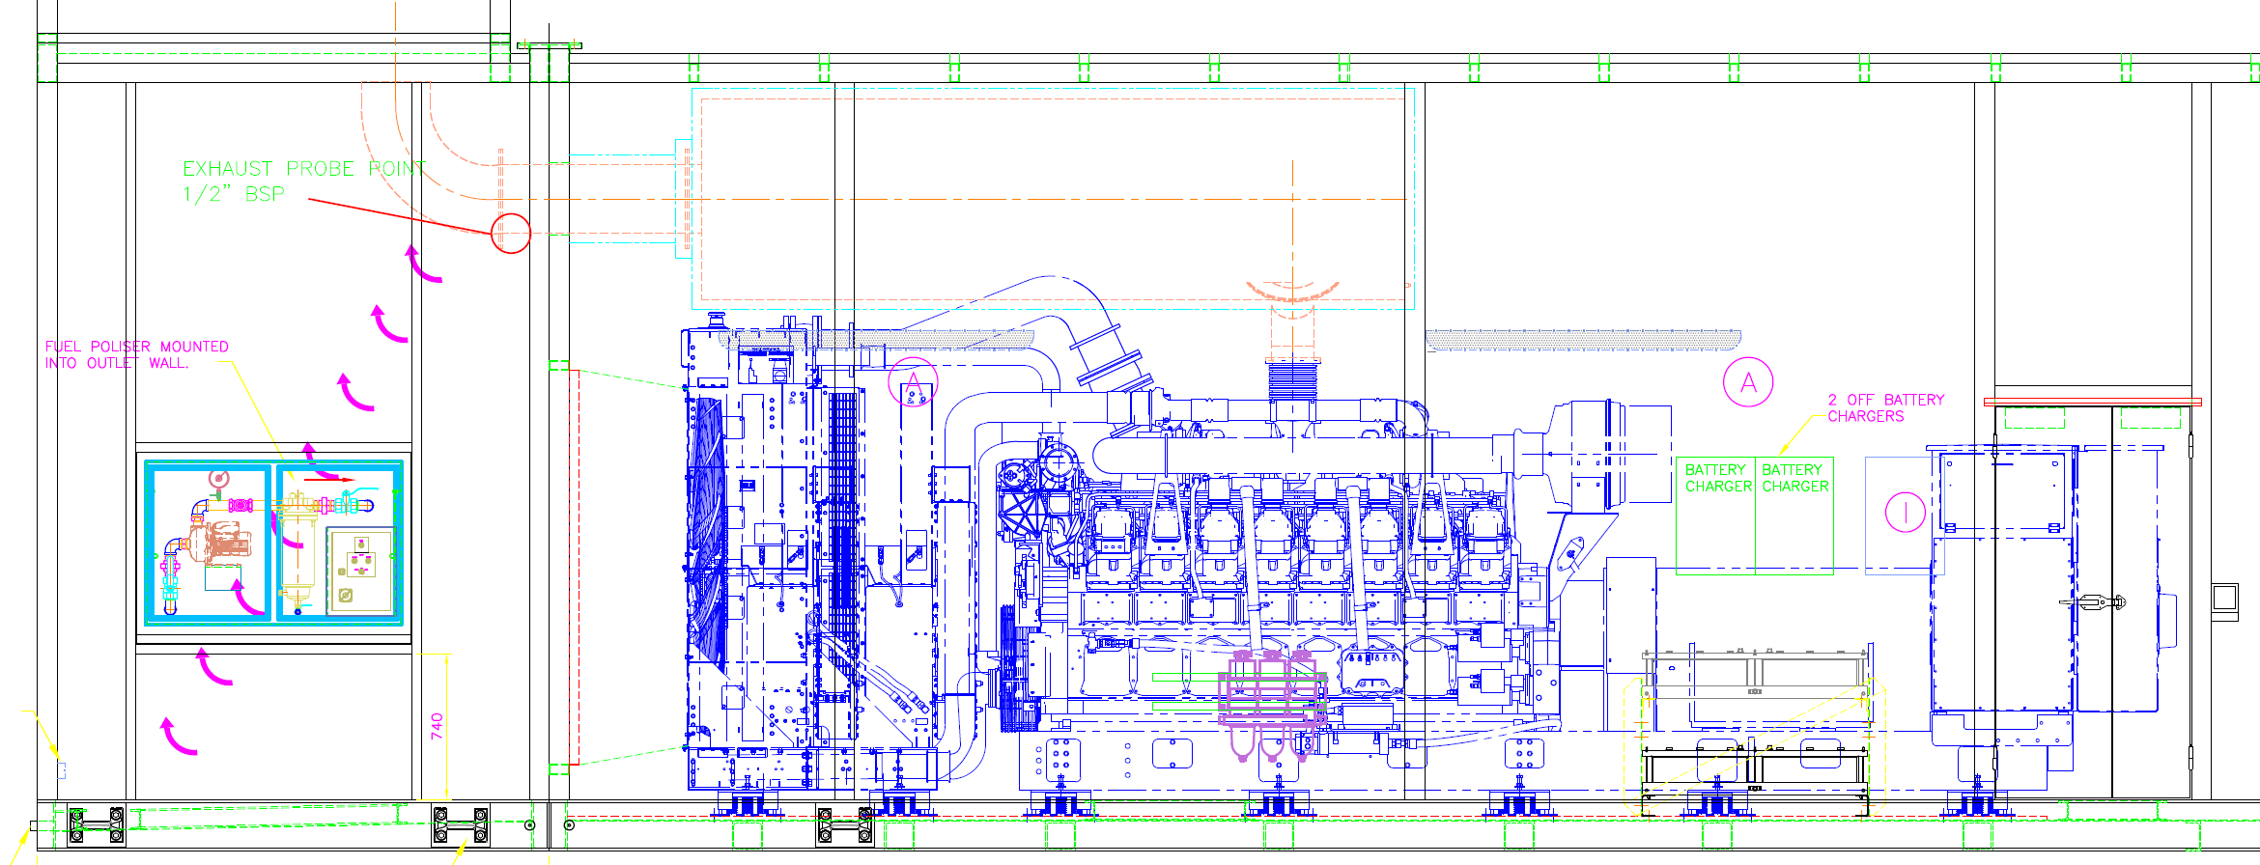
Test Port
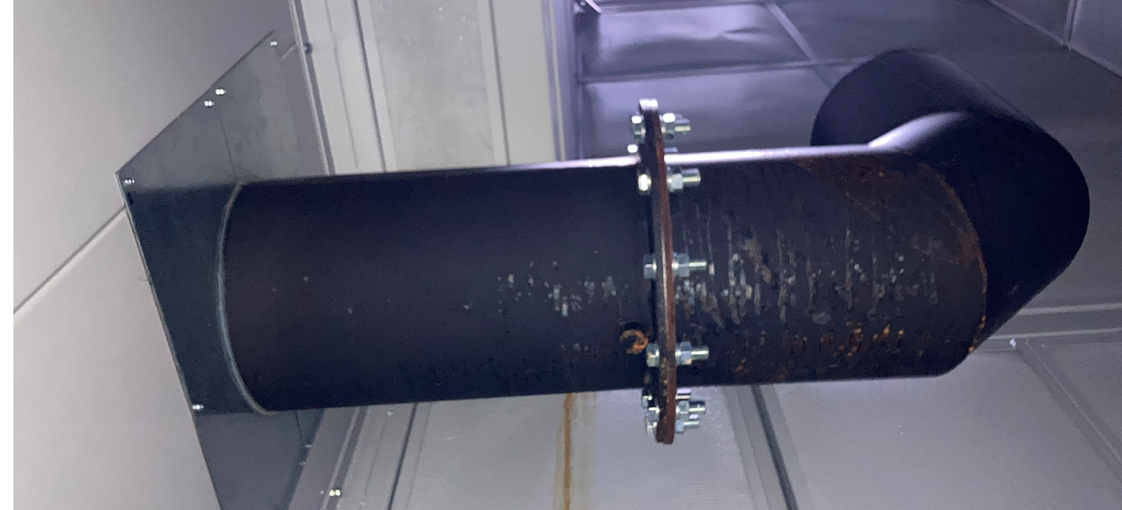
Test Port

Caterpillar 2.4MW/3.0MVA 3516E
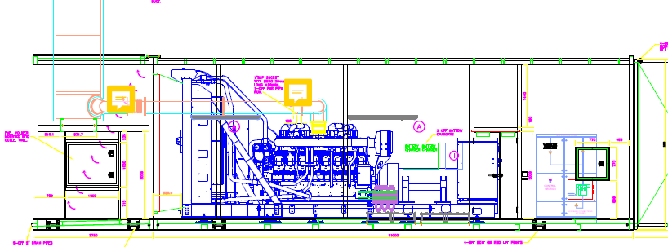
Test Ports

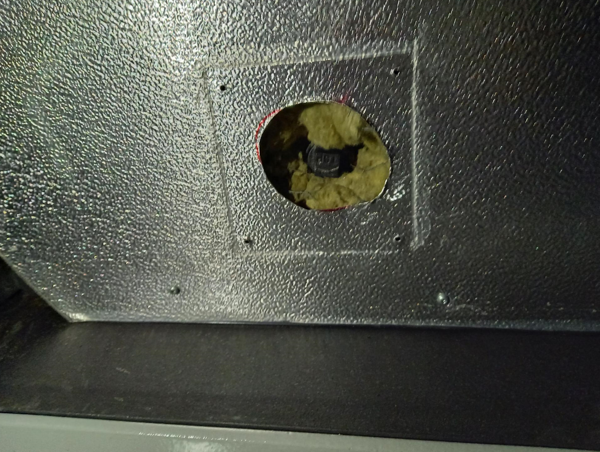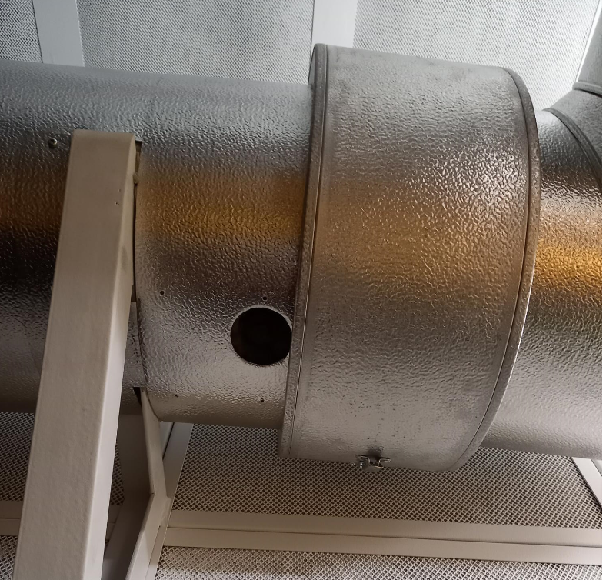

Test Ports

