Environmental Risk Assessment

Contents
Introduction 3
Site Location and Receptors 4
Source-Pathway-Receptor Linkage 5
Environmental Risk Assessment 7
Appendix A – Sensitive Receptors 12
Appendix B – Protected Sites 13

Introduction
This document has been generated in support of the environmental permit application by L&C Skip Hire and represents the environmental risk assessment. It should be read in conjunction with the other supporting documents and non-technical summary.
Background
L&C Skip Hire currently operates environmental permit BB33331AZ, site type SR2022 No.4: non-hazardous waste physical treatment facility. An environmental management system and environmental aspects and impacts assessment is already in place to support current site operations. L&C Skip Hire aims to expand its operations to include WEEE treatment and an expanded capacity, and as such is submitting a proposal for its permit to be varied. This risk assessment has been produced to demonstrate L&C Skip Hire’s ability to provide suitable and sufficient control measures in respect of the environmental impacts of its current and future operations.
Activities
The activities and their activity references are set out in the table below.
Activity Ref | Name of Waste Operation | Description of Specified Activity | Limits of Specified Activity
1.16.5 | Hazardous waste transfer station | R13: storage of wastes pending any of the operations numbered R1 to R12 (excluding temporary storage, pending collection, on the site where it is produced)  D15: storage pending any of the operations numbered D1 to D14 (excluding temporary storage, pending collection, on the site where it is produced) | No asbestos treatment, including compaction or compression by mechanical or manual means; storage and transfer only.  Temporary storage of hazardous waste shall not exceed 50 tonnes.  No more than a total of ten tonnes of waste batteries shall be stored at any one time.
1.16.12 | Physical treatment of non-hazardous waste | R3: recycling/reclamation of organic substances which are not used as solvents  R4: recycling/reclamation of metals and metal compounds  R5: recycling/reclamation of other inorganic materials | Treatment activities are limited to sorting, separation, screening, baling, shredding, crushing, compaction and bulking.  Treatment does not include soil or aggregate washing or heat treatments.
1.16.16 | Metal recycling site – mixed metals | R3: recycling/reclamation of organic substances which are not used as solvents  R4: recycling/reclamation of metals and metal compounds  R5: recycling/reclamation of other inorganic materials | Does not include ELV.  Treatment of waste batteries and WEEE will consist of manual sorting.

Treatment activities will consist of sorting (with loading shovel/360° excavator or by hand) and screening (by using appropriate mechanical screening plant and equipment).
This environmental risk assessment considers the potential and actual risks associated with the proposed activities listed above. It does not aim to provide detailed health and safety risk assessments as required separately through the necessary legislation.
All site staff are to be informed of the contents of this environmental risk assessment as part of the induction process and are to be aware of where it is located on site.
All environmental risks identified in this environmental risk assessment are to be acted upon accordingly by site management to ensure that they can be appropriately managed/controlled.

Site Location and Receptors
Site Location
The site is situated on Smiths Dock Road, South Bank, TS6 6UJ, National Grid Reference (NGR) 53250 21400. The site is accessed from the A66 via Old Station Road and Dockside Road.
The site is bordered on the northern and western sides by a lightly wooded area and open fields. The southern side of the site borders a scaffolding company. The Teesworks freeport and business park is on the opposite side of the road on the eastern side.
The nearest residential receptors are at South Bank, approximately 520 metres to the south.
Sensitive Receptors
Approximate distances and orientations of a selection of sensitive receptors within one kilometre of the centre of the site are detailed below. A map of this area is included in Appendix A. A map of protected sites is included in Appendix B.
No. | Receptor | Receptor Type | Direction from Site | Approx. distance from the site boundary to the receptor boundary (m)
1 | Smiths Dock Road | Infrastructure | East | 23
2 | J Gunn Scaffolding | Industrial | South | 47
3 | Teesworks | Industrial | East | 85
4 | Saltburn-Darlington Railway Line | Infrastructure | South | 141
5 | German Auto Breakers | Industrial | South | 208
6 | Asda South Bank | Commercial | South | 404
7 | SK Chilled Foods | Industrial | South West | 423
8 | AVG Biogas Plant | Industrial | South West | 442
9 | PD Ports | Industrial | North West | 486
10 | Teesport Commerce Park | Industrial/Commercial | North West | 503
11 | A66 | Infrastructure | South | 507
12 | Residential Dwelling | Residential Dwelling | South | 561
13 | St Peter’s Catholic Church | Place of Worship | South West | 590
14 | David Fox Transport | Haulage | East South East | 697
15 | River Tees | SPA, SSSI, Ramsar | North | 736
16 | Golden Boy Green Community Centre | Community Centre | South South East | 830

Source-Pathway-Receptor Linkage
When carrying out this environmental risk assessment, the following definitions have been used.
Source: Or hazard – something with the potential to cause harm.
Likelihood: The probability of harm arising from the source or hazard.
Consequence: The severity of the harm caused by the source or hazard.
Risk: The likelihood of harm arising combined with the consequences of the occurrence.
Pathway: The means by which a sensitive receptor may be affected by an environmental event. Examples of pathways include air (e.g., windblown dust), water (e.g., by pollutant run-off into surface waters), ground (e.g., leaching of contaminants) and by direct exposure.
In assessing environmental risk, a simple 5x5 risk matrix has been used.
 | Consequence
Likelihood | 1: Insignificant | 2: Minor | 3: Moderate | 4: Major | 5: Catastrophic
A: Rare
B: Unlikely
C: Possible
D: Likely
E: Almost Certain

Where the risk outcome is excessive (black), management of the risk shall focus on measures such as removal of the hazard, and implementation of significant structural and design measures to contain the risk or hazard. Risk management of these hazards shall be led at company level, forming an integral part of the company’s induction and training process.
Where the risk outcome is high (red), management shall seek to control the hazard via the implementation of structural and design measures. Site procedures shall document how these hazards can be controlled and their impact on the environment mitigated.
Where the risk outcome is medium (amber), site procedures shall document how these hazards can be controlled and their impact on the environment mitigated.
Where the risk outcome is low (green), staff shall maintain a level of awareness and shall have adequate resources available to control the risk, should they be required.

Environmental Risk Assessment
The following pages contain the site-specific risk assessment with appropriate control measures and remedial actions for each identified hazard.

Assessment |  |  | Current Risk Level |  |  | Treatment Actions |  |  |  | Residual Risk Level
Ref. No. | Description of Environmental Risks | Pathway | Likelihood | Consequence | Risk Score | Risk Treatment | Risk Control Effectiveness | Personnel Responsible | Due Date | Likelihood | Consequence | Risk Score
1 | Generation of dust due to waste being deposited at an inappropriate location within the yard, thereby having an adverse effect on neighbours, the Teesmouth and Cleveland Coast SPA, SSSI and Ramsar site. | Air | C | 2 | M | No waste to be tipped in the open yard. Vehicles are to be directed to the enclosed sheds where waste will be tipped, with drop heights minimised as far as possible. The enclosed nature will prevent the release of odour and dust. Potentially dusty wastes to be covered/dampened with no waste stored outside overnight. Waste acceptance procedures to detail controls for management of loose wastes, e.g., fines. Visual inspections to be undertaken on loads to ensure that they are secure and that there is no risk of spillage onto the highway between the customer site and the yard. Sheeting of vehicles in place. Emissions subject to continuous inspection by site personnel; personnel encouraged to speak up if they feel dust levels are becoming unmanageable. No residential dwellings within 500 metres of the site. The nearest non-industrial commercial concern (Asda) is approximately 400 metres away and separated from the site by a man-made mound. | Satisfactory | Site Management | Ongoing | A | 2 | L
2 | Generation of dust from loading activities impacting upon neighbours and the Teesmouth and Cleveland Coast SPA, SSSI and Ramsar site. | Air | C | 2 | M | No waste to be loaded in an open area. Shelter provided by the shed area will prevent the generation of windblown litter and prevent particulate matter from leaving the site boundary. The enclosed grab attachment on the loader will also mitigate against the release of material. No residential dwellings within 500 metres of the site. The nearest non-industrial commercial concern (Asda) is approximately 400 metres away and separated from the site by a man-made mound. | Satisfactory | Site Management | Ongoing | A | 2 | L
3 | Release of litter from lighter fractions of waste, resulting in offsite impact on neighbours and the Teesmouth and Cleveland Coast SPA, SSSI and Ramsar site. | Air | C | 2 | M | Wastes unloaded in an enclosed area to minimise the risk of litter being generated from wind whipping. Netting to cover loads and prevent escape with no waste stored outside overnight. Periodic inspections of the site boundary undertaken with clean-ups carried out as required and logged in the Site Diary. | Satisfactory | Site Management | Ongoing | B | 2 | L
4 | Generation of odour from waste with resultant offsite impact affecting neighbours. | Air | C | 2 | M | Malodourous wastes to be covered immediately upon receipt and subject to regular inspection to ensure that odour is not being generated at a magnitude sufficient to leave the site boundary. Unmanageable wastes to be returned to the producer with instructions to appropriately bag or treat the waste. | Satisfactory | Site Management | Ongoing | B | 2 | L
5 | Release of asbestos fibres from site activities, with resultant adverse effects on site personnel, neighbours and the Teesmouth and Cleveland Coast SPA, SSSI and Ramsar site. | Air | B | 4 | H | Incoming loads inspected for the presence of asbestos-containing wastes at customer site as part of pre-acceptance procedures, and again during acceptance procedures at the yard. Any asbestos-containing wastes are to be stored in the dedicated quarantine area in a sealed, locked container (key stored at the weighbridge). Said wastes will be double-bagged and their weights recorded on the weighbridge. Non-conforming asbestos wastes will be turned away with the relevant parties (regulator, customer) informed. Reassurance monitoring will be carried out in the event of the discovery of friable material. All instances of asbestos-containing wastes and resultant steps taken to be recorded in the Site Diary. | Satisfactory | Site Management | Ongoing | A | 4 | M
6 | Glare from the site in the form of light pollution having a nuisance effect on neighbours and local wildlife. | Visual | B | 2 | L | The nearest residential dwelling is approximately 500 metres away with directly adjacent neighbours being industrial/commercial in nature. Site activities carried out predominantly within normal daylight hours. Smart, LED lighting to be in place to assist site personnel during winter months. | Satisfactory | Site Management | Ongoing | A | 2 | L
7 | Release of dirt and mud onto the highway. | Ground, transport | D | 2 | M | No unmade ground on the site. Vehicles subject to inspection and maintenance to ensure that any dirt and mud tracked in from offsite is contained with site roads and vehicles cleaned to an appropriate standard before being released onto the public highway. No release of contaminants into the drainage system, thereby preventing blockage. Garden and street cleaning wastes to be handled in an enclosed area to ensure that it is kept dry. Weather checks (rainfall, wind speed and direction) to be carried out to assist with management of such wastes. A mechanical sweeper will assist with housekeeping onsite. | Satisfactory | Site Management | Ongoing | B | 2 | L
8 | Runoff from dust suppression activities with resultant pollution of the Teesmouth and Cleveland Coast SPA, SSSI and Ramsar site. | Ground, then water / drainage | D | 2 | M | Light spray only to be used. Dust suppression equipment to be turned off when not in use. Runoff will be contained either within the site drainage and interception system or will be captured by the offsite storm drains managed by Northumbrian Water and Redcar & Cleveland Borough Council. Any blockages of said system will be reported to the local council. | Satisfactory | Site Management | Ongoing | A | 2 | L
9 | Runoff from rainfall interacting with waste streams, resulting in pollution of the Teesmouth and Cleveland Coast SPA, SSSI and Ramsar site. | Ground, then water / drainage | D | 2 | M | Non-inert wastes to be handled in enclosed bays and stored in enclosed skips. Runoff will be contained either within the site drainage and interception system or will be captured by the offsite storm drains managed by Northumbrian Water and Redcar & Cleveland Borough Council. All blockages of said system will be reported to the local council. | Satisfactory | Site Management | Ongoing | A | 2 | L
9 | Noise from site activities having an adverse effect on neighbours and the Teesmouth and Cleveland Coast SPA, SSSI and Ramsar site. | Air, vibration | B | 4 | H | Sorting and treatment activities carried out under cover and in enclosed areas, thereby generating a muffling effect on noise sources. Drop heights minimised as far as practicable. The nearest residential receptor is approximately 500 metres away with adjacent neighbours being industrial/commercial in nature. The nearest non-industrial commercial concern (Asda) is approximately 400 metres away and separated from the site by a man-made bund. Plant and equipment subject to regular inspection and maintenance with silencers or mufflers fitted where feasible. Static plant powered by electric or electric/hydraulic power packs. Pre-use checks undertaken to ensure that plant and equipment is fit for purpose. Noise monitoring to be undertaken where deemed necessary by specific risk assessments. | Satisfactory | Site Management | Ongoing | A | 4 | M
10 | Poor housekeeping resulting in build-up of waste, thereby resulting in odour and attracting vermin. | Air | C | 2 | M | Daily checks implemented, including general site housekeeping as well as management of the workshop. No unsorted wastes left outside overnight. Biodegradable, putrescible wastes that may attract vermin to be handled in a manner that takes into account wind direction and speed, and covered prior to onward transfer. No potentially malodourous wastes to be stored onsite for more than one week. Food waste stored in dedicated container. Yard conditions to be subject to inspection to ensure that there are no cracks that could give rise to trapped waste. Pest control may be called in if pests are detected or complaints are received. | Satisfactory | Site Management | Ongoing | A | 2 | L
11 | Environmental incident associated with receipt of non-permitted hazardous material, e.g., oily wastes. | Ground, direct contact | D | 3 | H | Pre-acceptance procedures at customer site with paperwork trail detailing nature of wastes being transferred. Acceptance procedures in place at L&C Skip Hire yard, including at the site weighbridge and unloading area. CCTV in place across the site to capture any instances of non-permitted wastes. Any non-permitted wastes to be quarantined immediately with the customer and regulator informed. | Satisfactory | Site Management | Ongoing | A | 3 | M
12 | Vehicle collision resulting in release of materials. | Ground | C | 3 | M | Good housekeeping to ensure that site roads are kept clear with sufficient space for vehicles to move around the yard. Banksman to be in place as required by task-specific risk assessments. Sufficient numbers of trained drivers in place to minimise risk of fatigue. Vehicles subject to regular inspection and maintenance with sensors in place. Spill containment media available in the event of loss of hydraulic or other fluids from vehicle accidents. | Satisfactory | Site Management | Ongoing | A | 3 | M
13 | Environmental spill with potential to impact drainage and the Teesmouth and Cleveland Coast SPA, SSSI and Ramsar. | Ground, drainage | D | 3 | H | Affected area to be immediately identified and cordoned off. Site topography consists of hardstanding concrete, thereby minimising the risk of groundwater contamination. All spillages to be reported, no matter how small. Appropriate spill kits placed throughout the site, clearly identified and communicated to all personnel. No liquid wastes (e.g., oils, chemicals) accepted, with this controlled by pre-acceptance procedures at the customer site with paperwork trail detailing the nature of the wastes being transferred. Acceptance procedures at L&C Skip Hire yard includes CCTV and weighbridge and unloading inspection. Non-permitted liquid wastes to be quarantined immediately with the regulator and customer informed. Spillages to be prevented from entering the drainage system. | Satisfactory | Site Management | Ongoing | A | 3 | M
14 | A fire onsite gives rise to smoke/particulates and firewater runoff, having a direct impact upon neighbours and the Teesmouth and Cleveland Coast SPA, SSSI and Ramsar | Air, ground, drainage | D | 3 | H | Dedicated Fire Prevention Plan in place governing the control and storage of combustible wastes. This is part of the site induction and is made available to all personnel. Daily site inspections carried out and logged. Strict pre-acceptance and acceptance procedures in place to reduce the likelihood of non-conforming wastes (e.g., damaged batteries) being accepted. WEEE wastes to be sorted by manual means to control the risk of manual shock; integrated batteries to be separated. Plant and equipment subject to regular inspection and maintenance per the manufacturer’s guidelines. No oil or fuel stored onsite. No-smoking policy in place. Personnel provided with adequate information, instruction and training on detection and safe tackling of a fire. | Satisfactory | Site Management | Ongoing | A | 3 | M

Appendix A – Sensitive Receptors
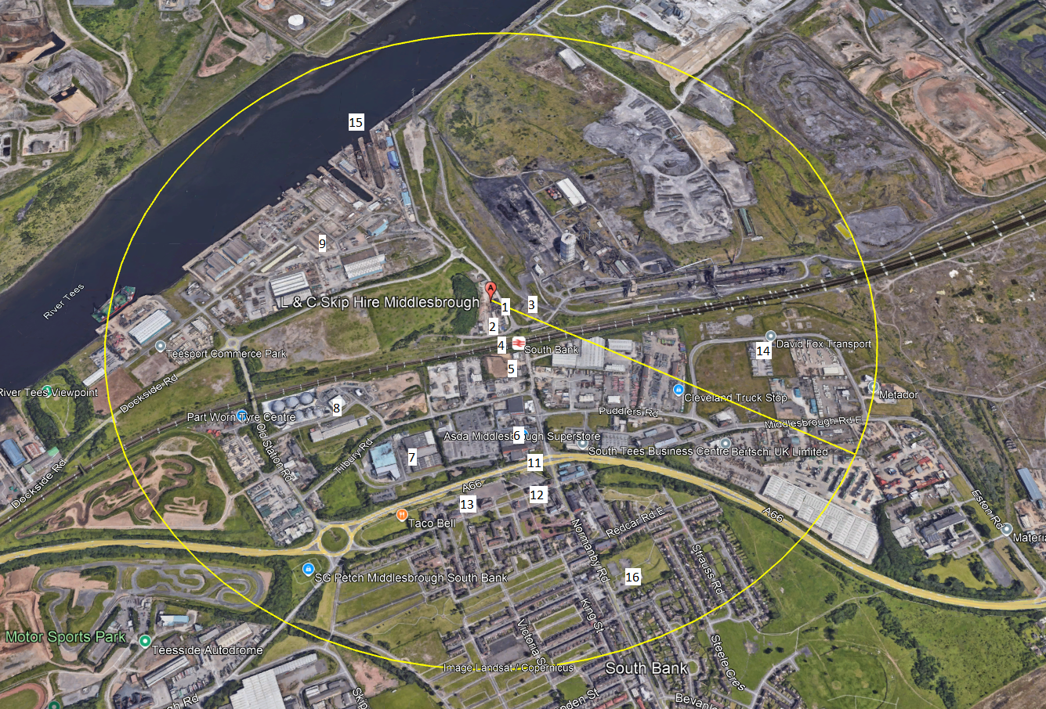

Appendix B – Protected Sites
