Standard Operating Procedure (SOP)

Operating the Compactor

Department: Waste Treatment Plant

 | Name | Title | Signature | Date
Authors | Steve Bell | Environmental Services and Sustainability Manager
Reviewers | Natasha Cuthbert | Environmental Services and Sustainability Officer
Authoriser

Effective Date: | 25/11/25
Published Date: | 25/11/25
Review Date: | 24/11/25

SOP Change / Review Control

SOP & Version No | Effective Date | Significant Changes | Previous SOP & Version No.
Original | 25/11/25 | N/A | N/A

1. | Purpose & Background
The purpose of this SOP is to inform staff of the correct procedure when operating the compactor in order to compress floc from the Waste Treatment Plant, for transfer off site
2. | Scope
The scope of this SOP is to ensure that staff operating the domestic waste compactor are operating it correctly; and have an awareness of the health and safety issues associated with this equipment.
3. | Standard Operating Procedure
Pre-Start Requirement

- Member of staff must have had formal training on the operation of the compactor
- The compactor must be checked to ensure that the ram is fully retracted and there is no one visible in the waste area.
- Examine the machine for visible damage; look for any signs of wear, tear, or damage that could impact the compactor’s safe operation.
- Ensure all safety guards are in place; verify that all protective barriers and guards are securely fitted and intact.
- Verify operational status of emergency stops and controls
- Check that emergency stop buttons and controls are easily accessible and functioning correctly.
- Inspect hydraulic systems for leaks: Ensure there are no leaks in the hydraulic system, which could indicate potential failure points.
- Check electrical systems for exposed wires or loose connections: Ensure that all electrical components are securely connected and properly insulated.
- Confirm clearance around the compactor is adequate: Make sure the area around the compactor is clear of debris and obstructions.
- Review operating procedures: Refresh on the specific operating instructions and safety procedures for the compactor model.

During Operation

- Maintain awareness of surroundings: Always be aware of the f environment and people around the compactor.
- Keep a safe distance from moving parts: Ensure no one is within the hazard zone while the compactor is in operation.
- Never bypass safety features: Confirm that all safety systems are engaged and functional.
- Adhere to operational guidelines: Follow the manufacturer’s instructions for safe compactor use.
- Monitor for signs of malfunction: Be alert to any unusual noises, vibrations, or operational issues that arise.
- Do not bypass any safety features, including interlocks.

After Operation

- Clean the machine to prevent build-up: Remove any waste material or debris that could hinder the compactor’s performance.
- Inspect for any new damage or wear: Check for any damage or excessive wear that may have occurred during use.
- Schedule regular professional inspections: Plan for routine inspections by a qualified technician to ensure long-term safety and operational efficiency.
- Record any issues or maintenance performed: Keep a log of any maintenance activities or operational issues encountered for future reference.
- Secure the compactor: Ensure the compactor is turned off and secured.

Operating Instructions

To empty a 770ltr bin:

- Open safety cage door and place bin in the loading frame
- Exit and close the safety cage door
- Ensure safety cage door is locked

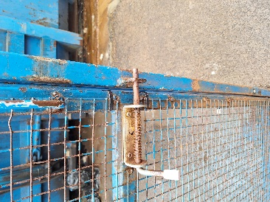

- On the control panel ensure ‘LOADER’ is to ‘ON’ position

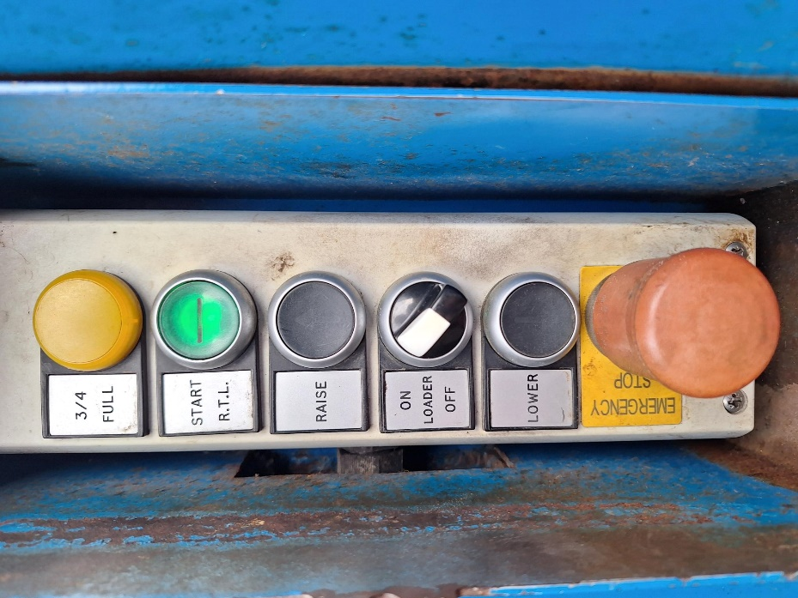

- Press and hold the ‘START RTL’ button and also the ‘RAISE’ button simultaneously

- Once the bin is empty press and hold the ‘START RTL’ button and the ‘LOWER’ button simultaneously.

- Once the cycle is complete open the gate and remove the bin
- Turn the ‘LOADER’ switch to ‘OFF’

- Press ‘START RTL’ the ram will now operate

Emergency Procedures
In the event of an emergency procedure shut down the compactor by using the red ‘Emergency Stop’ Switch and the power supply on the wall.

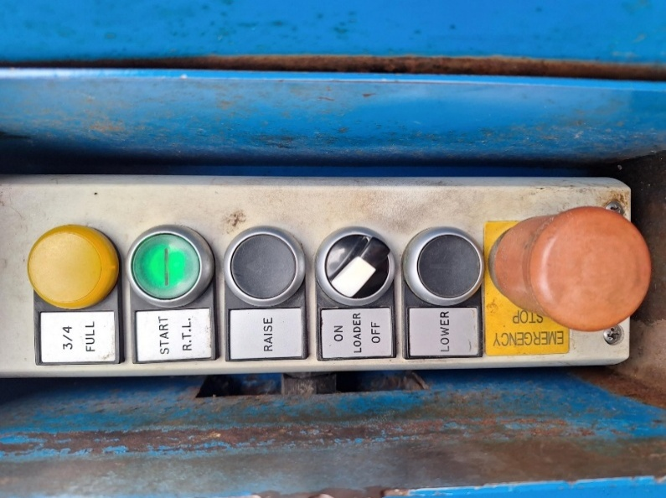

Emergency Stop

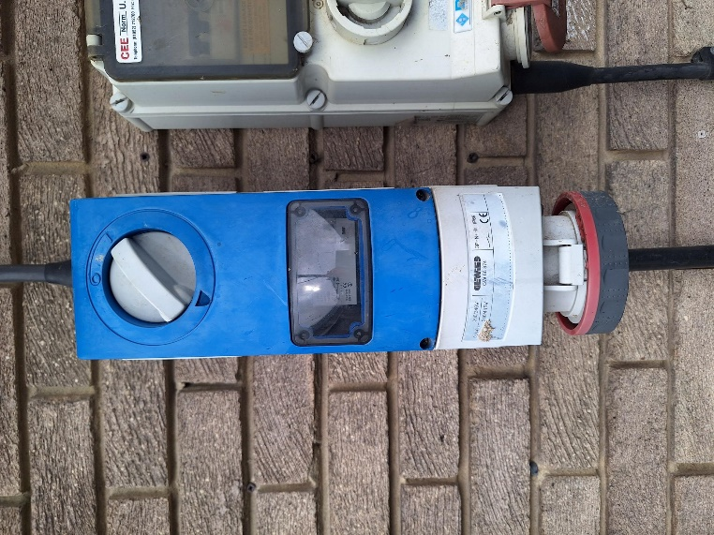
Power Supply

4. | Key Points and Additional Notes
Safety Requirements:
Legal and Regulatory Compliance
- Health and Safety at Work Act 1974
- Provision and Use of Work Equipment Regulations 1998 (PUWER)
- Lifting Operations and Lifting Equipment Regulations 1998 (LOLER)
- Manual Handling Operations Regulations 1992
- Control of Substances Hazardous to Health Regulations 2002 (as amended)
- Health and Safety (Sharp Instruments in Healthcare) Regulations 2013
- Personal Protective Equipment (PPE) at Work Regulations (2022)

Documentation and Record Keeping

Maintenance records and 6 monthly service reports are kept by the Environmental Services and Sustainability Manager
Compactor Breakdowns
In the event of a compactor breakdown the Environmental Services Team are to be contacted in the first instance by using the contact details below. This is so that the contingency plan can be put into operation.

5. | Contacts
Name |  | Position | Phone | Email
Steve Bell |  | Environmental Services and Sustainability Manager | Ext 24713  Tel: 07749 712659 | Steven.bell5@nhs.net
Natasha Cuthbert |  | Environmental Services and Sustainability Officer | Tel: 07776 456146 | natasha.cuthbert@nhs.net

For note:
- SOPs should be agreed and approved by the stakeholders from relevant team members that will be required to follow it.

- Once agreed the front sections of the SOP should be completed to ensure version control is maintained.

- Finalised SOPs should be available for the relevant staff to view as required, this should be publicised with staff.

- SOPs should NOT be saved on Sharepoint as a word document – they should be maintained as PDF and saved that way to prevent staff from changing the content and to maintain good version control of the document.

- SOPs should be reviewed every 3 years unless there is a recognised need to update sooner following a change in national guidance etc.

