Appendix 1 – B2 Non Technical Summary

On the 9th November 2017 the Council of the Isles of Scilly agreed to collect domestic waste from Tresco for the 75 council tax paying households. Until this point Tresco Estate has managed all the waste on the Islands in its entirety. The Estate collects all waste daily and it is separated by residents and visitors into separate bins for cardboard, food, metal and glass and then residual waste.

The Estate also collects and recycles pallets, batteries, larger metal objects, WEEE, piping, cooking oil and engine oil and paints etc.

Tresco Estate does undertake household collections but has shared bin stores scattered across all inhabited areas of the Islands as bring sites for residents and visitors and commercial premises. The bins collects the waste segregated into 5 fractions, cardboard, glass and ceramics, metal, food and general.

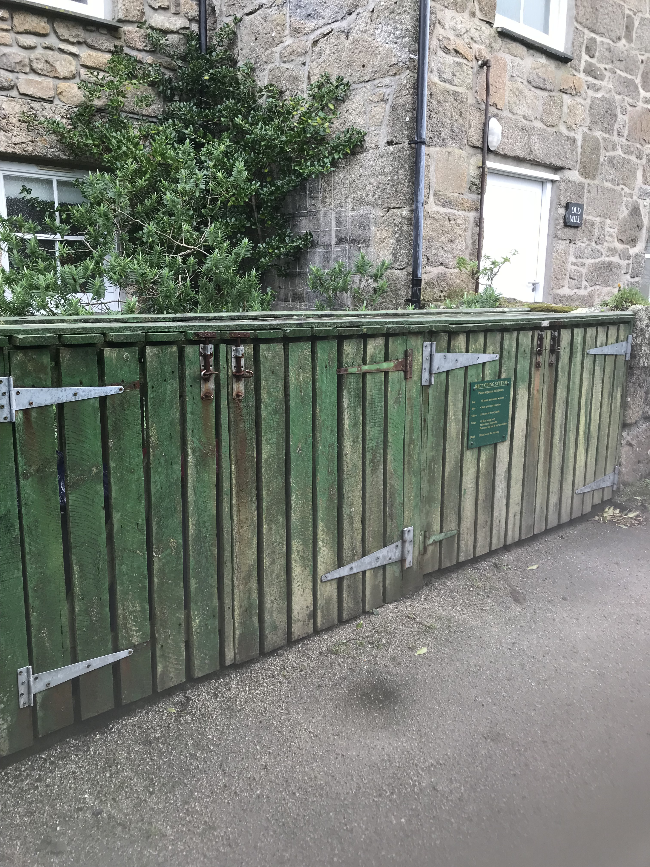

These bins are emptied daily (more often in the summer) and is taken to the island’s waste shed which was purpose built in 2018 where low level processing occurs. This contains compacters for the general waste, balers for cardboard, metal and glass crushers and an aerobic bio-digestor.

Other precious metals are collected in skips, the weee is stacked and separated and sent to St Mary’s. Waste oil is collected in IBC’s and if clean reused if dirty shipped to the mainland for recycling. Batteries and paint are also collected and shipped to specialist companies on the mainland. The crushed glass is used as non load bearing aggregate, the bio-digestate is used on island as is rubble and stone (we have a waste exemption for this)

Pallets are stored and sent to the mainland when shipping allows and we have a lorry full for the mainland suppliers.

Everything not re-used on Tresco is shipped to the mainland.

There are 2 sites covered by this permit, the Waste Management Shed in the freight and services yard and the waste site, historically called the dump, which is used for storing materials and the soakaway for the fat trap waste and for burning garden waste for which we have an exemption. These will be referred to as the “shed” and the “dump”. This is to make the DEMP easier for Tresco staff to understand.

The DEMP covers activities on the site which include:

* Compacting and baling materials on site and storing them – residual and cardboard waste
* Storing and compacting waste metals
* Bio-digestion of food waste and storage for onward composting
* Glass crushing and storing
* Waste food oil storage
* Waste engine oil storage
* Paint can storage
* Battery storage
* WEE storage

Site Description

The waste facility on Tresco has not previously needed to be permitted as the permitting legislation did not extend to Scilly. This is now being regularised and Tresco waste facilities will require waste licences.

The “dump” has been used for waste management for at least 200 years, although now it is used mainly for storage rather than waste management since a new building was erected in 2017/18 for the management of the waste processes on the island.

The waste management shed in the freight yard contains the following equipment:

* Glass crusher
* Carboard Baler
* 2 residual waste compactors
* Metal skip and metal crusher
* Pallet weigher
* Pallet wrapper
* Small office
* RRM Bio – digestor

The waste is stored in the areas around the freight shed:

* Wee
* Baled cardboard
* Residual waste palleted and baled
* IBCs containing cooking oil, paint and waste engine oil
* Glass cullet in a pile above shed for use in non-load bearing construction
* Pallets of Mattresses
* Pallets of carpet cut to 1m2

The waste is collected from 52 bring sites across the island for processing in the waste shed, harden waste is carried to the dump for burning once a month under a waste exemption applied for with the Council.

The waste is sorted and processed in the shed by our waste operative.

**Site Plan**

There are 2 sites the “dump” is here and is used mainly for storage of building materials and machinery and has the site of the bonfire for garden waste and the soakaway for the 3 fat traps. It is centrally located on the Island.

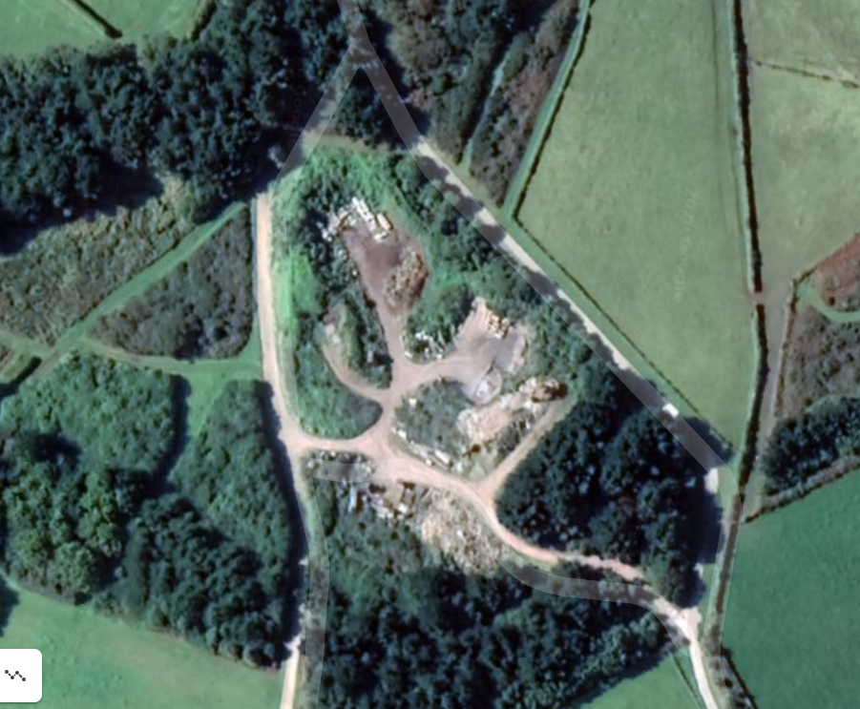

The waste management shed where all the processing occurs is in the freight and services yard. The site is shown here. There is good drainage on the site linked to the foul sewer via an interceptor.

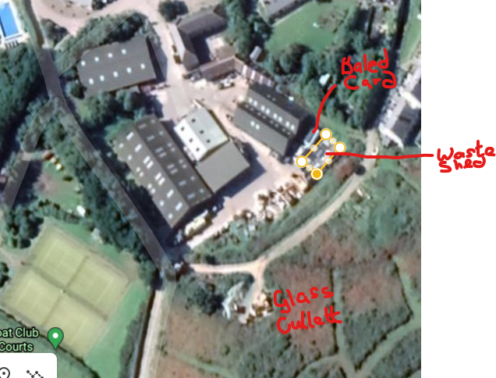

The planning drawings for the waste management shed are attached .

The Isles of Scilly are not located in an Air Quality management Area.

There is no dust associated with the waste shed but there is potential for smell from the Bio-digestor- although the smell is managed through a flue at roof level and is not noxious. At the “dump” there is potential for smoke through the burning of woody waste as per our exemption and limited dust when crushing stone and concrete for re-use but the dump is located centrally on the island and not adjacent to any homes.

The site has evolved over a number of years, apart from the new waste shed built in 2018 which has got measures to reduce emissions in the flue from the Bio-digestor for food waste.

There was no requirement for any emissions control from the 2018 planning permission granted by the Council of the Isles of Scilly.

For the first time the Environment Agency will have more controls on the Isles of Scilly and we are undertaking the work so our sites can be permitted for the first time.

This document will set out how we manage dust and emissions from the Waste Shed and the “Dump”.

This document sits with a suite of other documents and is primarily for the use of our waste operative and manager.

There is a single waste operative who manages the 2 sites under the supervision of our Head of Services and Engineering. The equipment for crushing stone (attached to a 8 tonne digger) is operated by the up to 3 Estate staff with the correct licences and Estate Contractors, primarily Symon’s construction.