**AQUAROD Southwest - Apex Site, Cardrew Way, Cardrew Industrial Estate, Redruth, Cornwall TR15 1SS**

**Bioaerosol Risk Assessment**

|  |  |  |  |  |  |  |
| --- | --- | --- | --- | --- | --- | --- |
| **Hazard / source** | **Receptor** | **Pathway** | **Risk Management Techniques** | **Probability of Exposure** | **Consequences** | **Overall Risk (following mitigation)** |
| Releases of micro-organisms (bioaerosols) | Local human population | Airborne | * Permitted waste types are non-hazardous and are all sludges or liquids so like dust the risk is low and so is the bioaerosol risk. * Overall, a low magnitude risk is estimated. There is potential for exposure if anyone is living or working close to the site (apart from the operator and employees). * Tanker discharge point is a sealed connection with no exposure to air. * Connection to all tinkers is sealed. Waste will only arrive at the site inside sealed tankers. * Connection to tanks sealed connection with no exposure to air. * Coupling between tanks sealed with no exposure to air. * Access lids to the top of the containers only opened when required for visual inspection and then shut immediately after to reduce the exposure time. * The predominant wind blows from the Southwest towards receptors to the east North-east of the Site. This area is less populated by light industry within the immediate vicinity of the site and housing further from the site with and parts of the area giving way to farmland. * Wind will disperse the bio-aerosols and prevent them from being concentrated. * Only three sensitive receptors within 250m of the site. * Monitoring will be in line with Bioaerosol monitoring at regulated facilities: RPS 209 * Sample point involves the lifting of a manhole cover. At this point the effluent is treated. * Tanks are emptied off site meaning the exposure to the tanks being opened and tipped is removed. * Tanks are hosed clean internally once emptied offsite via the access / observation hatches in the roof. This is carried out once the solids have been tipped off site. * The access / observation hatches are kept closed and secure at all times to avoid bioaerosol releases. * Wind direction and speed to be monitored. Observations ports will not be opened if the wind is blowing towards sensitive receptors. | Low: offsite receptor impact | Harm to human health - respiratory irritation and illness. | **LOW** due to the proposed processes on site |

**Onsite activities and bioaerosol exposure risk**

**Direct Discharge to foul sewer -**The first process is the direct discharge of liquids to the foul sewer.

|  |  |  |  |
| --- | --- | --- | --- |
| **Odour Release Point & Description** | **Location and Process** | **Detail** | **Exposure Risk** |
| Transfer of tankered waste | Coupling on tanker and discharge point | Coupling is sealed and secure meaning there is no exposure to the air. | Low |
| Transfer of waste to foul sewer | Coupling on tank and discharge point | Coupling is sealed and secure meaning there is no exposure to the air. | Low |
| Transfer of tankered waste | Coupling on tanker and first storage tank | Coupling is sealed and secure meaning there is no exposure to the air. | Low |
| Cleaning of the screen | Discharge point | Screen will have debris such as dropped mobile phones. At the point of cleaning there will be no liquid and as a result bioaerosols present. | Low |
| Storage of removed debris from screen | Enclosed skip | Screen will have debris such as dropped mobile phones. At the point of cleaning there will be no liquid and as a result bioaerosols present. | Low |

**Treatment via dewatering -** The second process is the dewatering of liquid and sludge wastes before the de-watered liquid is discharged to the foul sewer.

|  |  |  |  |
| --- | --- | --- | --- |
| **Odour Release Point & Description** | **Location and Process** | **Detail** | **Exposure Risk** |
| Transfer of tankered waste | Coupling on tanker and first container | Coupling is sealed and secure meaning there is no exposure to the air. | Low |
| Transfer of waste between tanks | Between both tanks | Coupling is sealed and secure meaning there is no exposure to the air. | Low |
| Transfer of waste to foul sewer | Coupling on tank and discharge point | Coupling is sealed and secure meaning there is no exposure to the air. | Low |
| Tank observation ports | Top of both tanks | Points are used to view the inside of the tanks.  They are not opened when the tanks are being pumped into so the sludge is in a stable settled state.  Ports are only opened when required and for as short a period as possible.  Once opened they are immediately closed and secured.  Wind direction and speed to be monitored. Observations ports will not be opened if the wind is blowing towards sensitive receptors. | Low |
| Tank cleaning | Observation ports on the top of both tanks | Once the tanks have been emptied off site at suitable permitted waste facility the tank is placed back at the site.  The tanks are then coupled up and a hose used through the observation ports to wash them down internally.  This is a quick process and once the hosing is complete the ports are immediately closed and secured.  Wind direction and speed to be monitored. Observations ports will not be opened if the wind is blowing towards sensitive receptors. | Low |

**Housekeeping**

Housekeeping is classed cleaning of the wider site.

|  |  |  |  |
| --- | --- | --- | --- |
| **Odour Release Point & Description** | **Location and Process** | **Detail** | **Exposure Risk** |
| Cleaning of drains | All site drains | The drainage system is sealed and leads to the foul sewer.  The drains should be from bioaerosol containing liquids.  All runoff contained within the drainage system and tankered from site in a sealed tanker. | Low |
| Cleaning of silt traps and interceptor | Specific location of silt traps and interceptor | The drainage system is sealed and leads to the foul sewer.  The drains should be from bioaerosol containing liquids.  All runoff contained within the drainage system and tankered from  site in a sealed tanker. | Low |
| Cleaning of site surfaces | All site surfaces | The drainage system is sealed and leads to the foul sewer.  If liquids are spilt form the tanks / tankers it will be cleansed immediately and all liquids will be removed from site in a sealed tanker | Low |

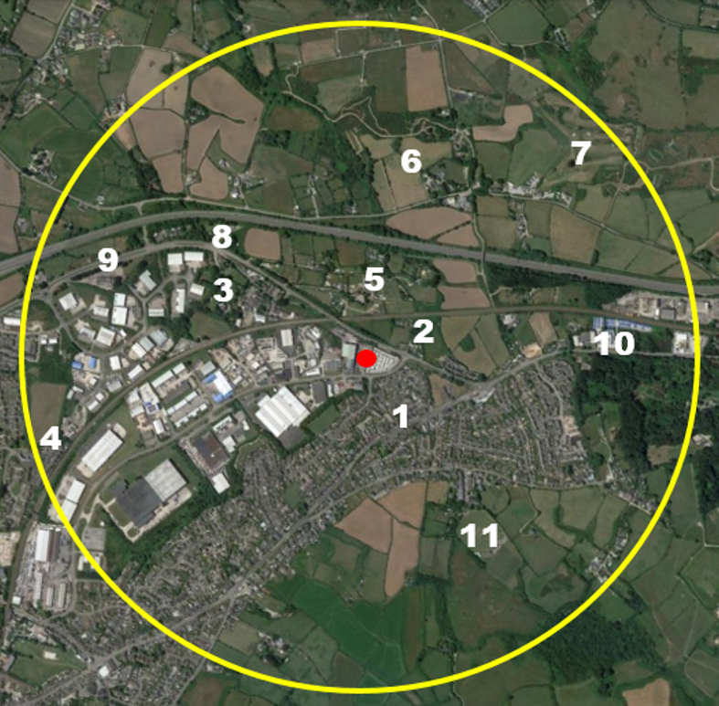**Sensitive Receptor Locations**

|  |  |  |  |  |
| --- | --- | --- | --- | --- |
| **Ref** | **Receptor** | **Description** | **Direction from site boundary** | **Approximate distance from Site Boundary (m)** |
| 1 | Domestic Dwellings | Penlean Close | SE | 96 |
| 2 | Domestic Dwelling | Private Road | NE | 122 |
| 3 | School | Treleigh Primary School | NW | 330 |
| 4 | Domestic Dwellings | Pengover Park | SW | 920 |
| 5 | Campsite | Blue Dog Glamping | N | 215 |
| 6 | Castle | Wheal Peaver | NE | 660 |
| 7 | Golf Course | Radnor Gold and Leisure | NE | 650 |
| 8 | Pub | Treleigh Arms | NW | 490 |
| 9 | Pub | Inn For All Seasons | NW | 740 |
| 10 | Food Outlets | Cornish Scoter | E | 980 |
| 11 | Cricket Pitch | Mount Ambrose Cricket Club | NE | 570 |