PARKING
MANHOLE COVERS
TRAFFIC MANAGEMENT
SOUTH WEST WATER FOUL MAINLINE
SOUTH WEST WATER SURFACE WATER LINE
FOUL LINE
MAINS WATER
EVACUATION ROUTE
KEY:
Aqua Rod SW Ltd, Cardrew Industrial Estate, Cardrew Way, Redruth, Cornwall,
TR15 1SS
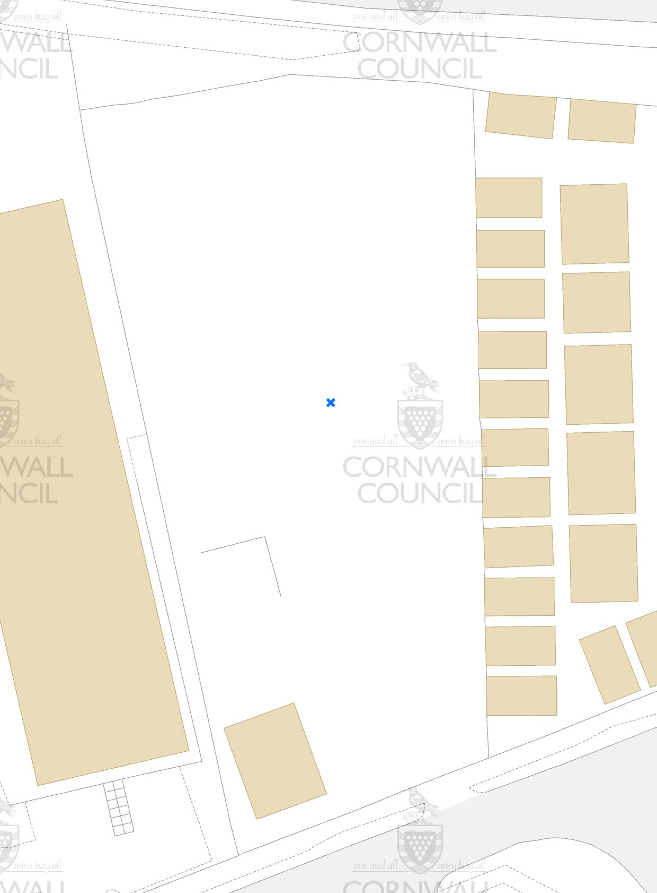
FINAL DISCHARGE POINT
SHUT OFF VALVE
BUND LINE AROUND PROCESS PLANT
WATER HOLDING TANKS
OUTFALL MANHOLE FROM PLANT
OUTFALL MANHOLE
CONTAINER
CONTAINER
CONTAINER
WASH BAY INTECEPTORS
PROCESS PLANT
INTERCEPTOR
YARD GATES
FIRE ASSEMBLY POINT
SEPTIC TANK
TRAFFIC MANAGEMENT & HGV ROUTE
TANK
CONTAINERS

STAFF
VISITOR
STAFF
STAFF
CONTAINER
IN/OUT
FIRE EXIT
FIRE EXIT
CONTAINER
OFFICE
© Crown copyright and database rights 2025 Ordnance Survey AC0000817921.
F
Centre point X: 170859 Y: 43509 2,500 Sheet ref.: SW7043 10,000 Sheet ref.: SW74SW Scale 1:500

