

**Odour Management Plan for Waste**

**Transfer Operations**

AQUA ROD (SOUTH WEST) LIMITED

Apex Site

Cardrew Way

Cardrew Industrial Estate

Redruth

Cornwall

TR15 1SS

ARSWL 10

**Contents**

**1.1 Introduction**

**1.2 Structure of the odour management plan**

**1.3 Objectives**

**2.1 Liquid waste transfer operations**

**2.2 Conceptual Model**

**2.3 Source Material**

**2.4 Waste Acceptance**

**2.5 Process**

**2.6 Releases**

**2.7 Odour Release Point Inventory**

**2.9 Storage**

**2.10 Chemical Additives**

**2.11 Frequency**

**2.12 Alternative options**

**3.1 Internal Odour Assessment and Monitoring**

**3.2 Daily checks**

**3.3 Cleansing**

**3.4 Maintenance**

**4.1 Dispersion**

**4.2 Site Location**

**4.3 Dispersal Control**

**4.5 Other Sources of odour**

**5.1 Responsibilities**

**5.2 Procedures when odours arrive**

**5.3 Response to Complaints**

**5.4 Abnormal meteorological conditions**

**5.6 Breakdown of Process Equipment and Plant**

**5.7 Staffing Issues**

**5.8 Review**

**Appendix**

**Appendix A Odour Complaint Form**

**Appendix B Odour Report Form**

**Appendix C Odour Diary**

**1.0 Operations and odour management plan**

**1.1 Introduction**

The structure of this Odour Management Plan (OMP) has been revised based on the Environment Agency Guidance

available at the website and can be seen in the CONTENTS listing that follows here:

<https://www.gov.uk/government/publications/environmental-permitting-h4-odour-management>

This OMP is aimed at assisting the site management and staff in effectively managing potential odour releases associated with the operations at the site and minimisation of the risk of abnormal operational conditions, which could result in increased risk of odour generation at the site.

This type of operation has been carried out across the country by a number of operators without the requirement for an environmental permit, however a change in case law has resulted in an environmental permit being required due to the manual screening of the waste.

**1.2 Structure of the Odour Management Plan**

The structure of the OMP is laid out in accordance with EA guidance and considers:

* Operations and odour management plan
* Process and emissions
* Prevention
* Dispersion and Receptors
* Procedures

**1.3 Objectives** This odour management plan is designed to:

• employ appropriate methods, including monitoring and contingencies, to control and minimise odour pollution;

• prevent unacceptable odour pollution at all times;

• reduce the risk of odour releasing incidents or accidents by anticipating them and planning accordingly.

The OMP will consider sources, releases and impacts, and use these to identify cost effective opportunities for odour management.

**2.0 Process and Emissions**

**2.1 Liquid waste transfer operations**

Aqua Rod South West Limited’s operates a fleet of tankers designed to facilitate the emptying of septic tanks and portable toilets from the construction industry throughout the country.

Aqua Rod South West wish to transfer the waste direct to the foul sewer at their site at - Redruth Apex Site, Cardrew Way, Cardrew Industrial Estate, Redruth, Cornwall TR15 1SS, instead of transferring it as waste water treatment works. The process of transferring the waste to the foul sewer requires the waste to be passed through a treatment system to remove large items and suspended solids.

The site is operational

Monday to Friday 07:00 - 18:00

Saturday 07:00 – 12:00

Sunday Closed

The act of screening requires the activity to be permitted and as a result, an odour management plan being created as part of the bespoke permit application is required. This activity is common place at sewage treatment works, which accept tankered liquid wastes.

The transfer and screening of septic tank waste has the potential to generate malodours from process. This OMP makes an assessment of likely sources of odour generation and sets out good site practice and mitigation that is employed to minimise where reasonably practicable any odour emitted from site.

The likelihood and frequency of exposure to odour arising from the facility is determined by combination of the magnitude of release, the prevailing meteorological conditions, and the distance and direction of receptors in relation to the facility. Each of these factors are discussed in the following sections.

**2.2 Conceptual Model**

The conceptual model for pollutant linkages identified for the release of odours from the

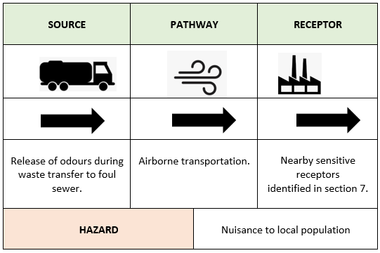Waste transfer facility is identified in Figure 1 below

**2.3 Source Material**

The site will operate a waste transfer and treatment operation through the transfer of septic tank and portable toilet waste from jet-vac tankers via a screen to the foul sewer.

In order to understand the odour potential of the different waste streams that enter the process, a feedstock inventory has been provided for the various waste types.

Table 1 below provides an assessment of each waste type by source of material, identifying the typical and abnormal compositions of those waste types and providing an overall odour potential of that feedstock based upon the likelihood of abnormal conditions being encountered at site.

**Table 1 - Assessment of Odour Potential from source material**

|  |  |  |  |  |  |
| --- | --- | --- | --- | --- | --- |
| **Waste Type** | **Waste Source** | **Typical Composition** | **Abnormal Composition** | **Likelihood** | **Odour Potential** |
| 20 03 04 - septic tank sludge | Construction site and sites requiring temporary toilet facilities | Mixtures of water and wastes from toilet blocks | Unlikely septic tanks only serve toilet blocks. Waste can be up to two weeks old. | Waste can regularly be up to two weeks old. | Medium |
| 16 10 02 - aqueous liquid wastes other than those mentioned in 16 10 01 | Construction site and sites requiring temporary toilet facilities | Mixtures of wastes from portable toilets and sanitising chemicals | Unlikely septic tanks only serve. Waste can be up to two weeks old. | Waste can regularly be up to two weeks old. | Medium |
| 20 03 03 - Street-cleaning residues and gully wastes | Highways cleansing | Mixtures of grit, sand, stones, season vegetation and litter | Unlikely, occasional potential for oils or fuels due to an RTA | Unlikely waste in low in odour and consistent | Low |
| 19 08 05 - Sludge’s from treatment of urban waste water | Package treatment works | Solids from sewage treatment | Unlikely, treatment works do not require regular cleansing | Unlikely waste is Medium in odour and consistent | Medium |

**2.4 Waste Acceptance**

The facility is very limited in the waste that it will accept due to the nature of the work that company completes and the wastes that the site is designed to handle. The Environmental Permit will also be limited to only four EWC codes:

* 20 03 04 - septic tank sludge
* 16 10 02 – portable toilet waste
* 20 03 03 - Street-cleaning residues and gully wastes
* 19 08 05 - Sludge’s from treatment of urban waste water

Aqua Rod will collect the waste from the customer and transfer it at the site ensuring consistency and adhering to waste acceptance criteria.

All waste will be checked before being collected and if it is now in line with the above waste streams it will be transferred to a permitted waste facility that can accept the waste stream.

Furthermore, only Aqua Rod will use the facility ensuring total control of both the waste collection and transfer process.

**2.5 Process**

**Treatment via dewatering**

The process is the dewatering of liquid and sludge wastes before the de-watered liquid is discharged to the foul sewer.

Waste liquids or sludge’s are transferred from the tanker via a sealed hose connector to the first of two sealed tanks. This allows no contact between the waste material and the air.

The liquid / sludge passes through screens via gravity within the first sealed container, this removes any large items. The remailing liquid is then pumped again via sealed hoses to a second tank. At the point of pumping a flocculent is added. Once within the second sealed container the liquid with the aid of the added flocculent settles under gravity allowing the suspended solids to remain and the resulting liquid to be discharged to the foul sewer via a dedicated discharge point.

*Image of purpose the type of containers used within the process*

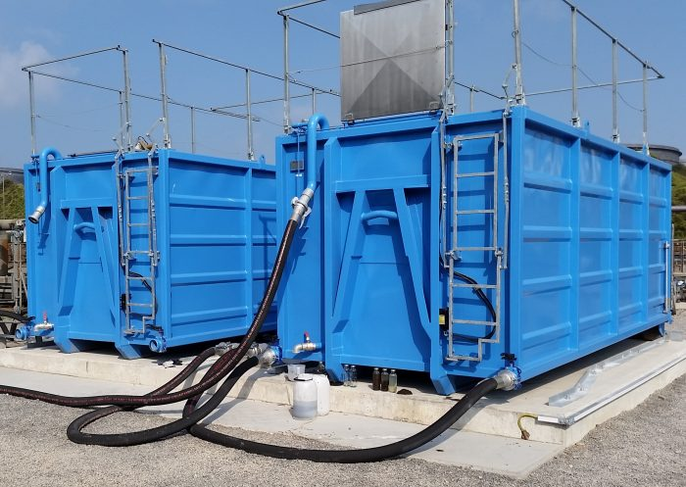

**2.6 Contingency Planning**

Should the above process controls fail at any point during the transfer and a spill was to occur, the tanker pump would be switched off and the transfer stopped.

Any liquid would be contained on the sealed concrete pad and immediate hosed to the foul sewer via drainage points. If in the event of the discharge point being damaged receipt of tankers shall not recommence until a full review of this Odour Management Plan has been conducted and process controls (including critical limits) amended as required.

**2.7 Releases**

Key measures for management of releases includes reducing evaporation and, if needed, containment and abatement. The whole process is carried out in a controlled manner to assist with minimising odour releases.

The process involves connecting the tanker to a purpose built discharge point via a flexible hose, meaning there are no release points and the process is fully enclosed. This is the same transfer system that is used at sewage treatment works for accepting tankered liquid wastes.

As a result, there will be no evaporation of liquids that can be a key creation of odour.

**2.8 Odour Release Point Inventory**

All identified odour release points have been collated into the table below for quick reference. The inventory assists in identifying the physical locations that require management.

The first process is the direct discharge of liquids to the foul sewer.

|  |  |
| --- | --- |
| **Odour Release Point & Description** | **Location and Process** |
| Transfer of tankered waste | Coupling on tanker and discharge point |
| Transfer of waste to foul sewer | Coupling on tank and discharge point |
| Transfer of tankered waste | Coupling on tanker and first storage tank |
| Cleaning of the screen | Discharge point |
| Storage of removed debris from screen | Enclosed skip |

**Treatment via dewatering**

The second process is the dewatering of liquid and sludge wastes before the de-watered liquid is discharged to the foul sewer.

|  |  |
| --- | --- |
| **Odour Release Point & Description** | **Location and Process** |
| Transfer of tankered waste | Coupling on tanker and first container |
| Transfer of waste between tanks | Between both tanks |
| Transfer of waste to foul sewer | Coupling on tank and discharge point |
| Tank observation points | Top of both tanks |
| Tank cleaning | Observation point on the top of both tanks |

**Housekeeping**

Housekeeping is classed cleaning of the wider site.

|  |  |
| --- | --- |
| **Odour Release Point & Description** | **Location and Process** |
| Cleaning of drains | All site drains |
| Cleaning of silt traps and interceptor | Specific location of silt traps and interceptor |
| Cleaning of site surfaces | All site surfaces |

**2.9 Storage**

The only storage of waste other than gully wastes takes place on the site is within the sealed screening and dewatering tanks.

The maximum storage time of all waste streams will be 1 month.

**2.10 Chemical additives**

Wastes deriving from portable toilets will include an additive that reduces odours. The additive is added to the toilets when they are in use.

As a result, the odour associated with this waste stream is much reduced at the point of transfer.

**2.11 Frequency**

The use of the system will be daily with tankers discharging throughout the day.

**2.12 Alternative to proposed transfer system**

The system that is proposed for the transfer of liquid waste from the tanker to tanks uses the same connectors and equipment as those found on sewage treatment works that accept tankered effluent. This is the industry standard method for of transfer.

There are no other available techniques facilitating the transfer of liquids from tankers where the discharge remaining free from contacting the air.

As a result, this method was deemed the most suitable and least likely to result in odour complaints.

The current method of taking the collected liquid waste to dedicated sewage treatment works run by the local water company namely Southwest Water is the most suitable option. However, as stated within the executive summary, this is no longer viable and the Environment Agency are locally aware of these sites no longer accepting tankered trade waste. As a result, as the market leading, option this system is deemed the most suitable.

**3.0 Prevention**

**3.1 Internal Odour Assessment and Monitoring**

Aqua Rod will carry out odour checks at 4 points around the perimeter of the site on a daily basis (shown in figure 3.3) when transfers are taking place. Monitoring is undertaken at various times to build in an element of random checks. In the event that a perimeter odour at 3 or above is recorded, then off site odour

checks will be carried out in the prevailing wind direction and details recorded in the site diary. Office staff and other visiting staff are encouraged to check odour to reduce the risk of site staff becoming normalised to the tankered waste. Records will be maintained for two years.

**Figure 3.0 Internal odour monitoring points**

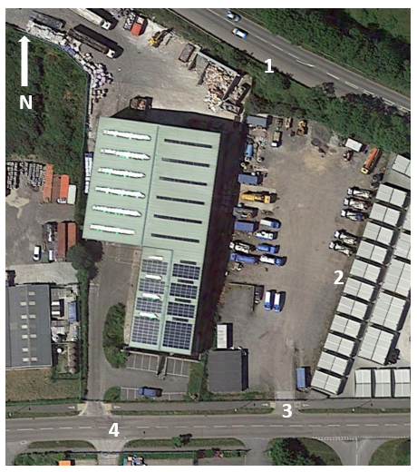

**3.2 Weather Observations**

In addition the site will also employ a wind sock to provide a visual guide to wind direction, but also a small weather station that will assist the site with monitoring the actual wind speed and enable the site to record this data.

* The weather station will be capable of recording the following –
* Indoor temperature (-5°C – 70°C) and humidity
* Indoor comfort indicator (too cold, optimal, too warm)
* Outdoor temperature (-40°C – 80°C / -40°F – 176°F) and humidity (20% – 90% RH)
* Wind direction and speed (including Beaufort scale) (0 – 112 mph, 50 m/s, 180 km/h, 97 knots)
* Rainfall with history (daily, weekly, monthly, total rainfall) (0 – 9999 mm / 0 – 393.7 inch)
* Graphical weather forecast (sunny, partly cloudy, cloudy, rainy, stormy, snowy)
* Air pressure with history (24 hours) (540 – 1100hPa) (hPa, InHg, mmHg)
* Wind chill
* Heat index
* Dew point

In addition, this data will enable the site to pinpoint the weather characteristics and review them at the time of any internal odour observations and also any complaints. This can be vital for the site to be able to build up a picture and predict when odour releases may become an issue and create complaints enabling action to be taken early.

**3.3 Odour Abatement**

The site will employ system that can suppress odours in areas where extraction is simply not possible or economically viable. The system uses spray points to emit an extremely fine fog preventing odours from becoming airborne. The system will be installed around both tanks including the connection points.

The system will be deployed during each transfer to the system and during any maintenance or inspections when the access hatches to the containers need to be opened.

**3.2 Daily Checks**

A Daily Checklist will be implemented which is to be carried out daily and available to the Environment Agency on inspection. The checklist will be filled in daily by the site manager or other appropriate person in order to monitor the site cleanliness and weather conditions which may affect odour controls. The monitoring will take place on a daily basis and is designed to reduce the potential for odour. This checklist will be kept in the site office and will be produced upon the request of the Environment Agency.

**3.3 Cleaning**

The site will have operate a strict cleansing regime of the permitted area to ensure that any residues from the transfer of the liquids are not allowed to remain exposed to the air, this will include –

Cleansing of the discharge point via hosing.

Flushing of the hose used for the transfer of liquids from the tanker to the discharge point.

Hosing of the transfer area to the foul sewer.

The grid collecting the solids is cleared and hosed down on a daily basis.

Ensuring the sealed skip containing the collected solids is cleansed at each exchange.

Cleaning the treatment tanks is carried out in the following steps.

Primary screening tank when full is removed from site via hook-loader and taken to a suitably permitted waste facility and emptied.

The settled solids tank is again removed from site via hook-loader and taken to a suitably permitted waste facility and emptied.

When returned to site they valves are closed to prevent any liquid release.

Via an access hatch on the roof of the tank clean water is sprayed into the tank to removed remaining solids from screens to ensure the containers perform at their optimum levels. After the spraying has stopped the lids are closed and secured.

The valves are then opened allowing the water to drain to the foul sewer.

The containers are then ready to use again with minimum onsite cleaning and opening of the containers.

**3.4 Maintenance**

The site will have operate a strict maintenance regime of the equipment integral to the transfer of liquid waste permitted area and those making up the permitted area to ensure that and failure or damage of equipment does not give rise to odour. This will include –

* Checking all coupling points on the discharge point and tankers are functional and free from leaks.
* Checking the hose used for the transfer of liquids from the tanker to the discharge point is free from splits, holes and damage.
* All curbing / bunding is intact to prevent any runoff from the pad spreading across the site.
* All drain lids are fitting correctly and free from damage.
* The access / observation hatches are closed when not required.
* All spill are dealt with immediately.
* Odour abatement system is working correctly.
* Weather station is working.

**4.0 Dispersion and Receptors**

**4.1 Dispersion**

The following section identifies the prevailing weather conditions on site, in particular the wind direction in order to predict the path of likely aerial dispersion of odours generated on site. By constant monitoring and even forecasting of poor dispersion conditions, Aqua Rod can trigger contingency measures to temporarily cease operations. The use of their own weather station will aid this.

Information on wind direction has been derived from the Willy Weather based upon the last five years. This data is illustrated by the wind rose in Figure 2. Wind data is collected daily as part of the routine monitoring on site. 16-point wind directions are provided below, note that calm days are also included to provide a complete data record.

Figure 2 Wind Data for the last five years

|  |  |
| --- | --- |
| **Direction** | **Percentage** |
| N | 2.41 |
| NNE | 4.71 |
| NE | 5.05 |
| ENE | 7.39 |
| E | 3.73 |
| ESE | 4.58 |
| SE | 7.30 |
| SSE | 12.41 |
| S | 6.59 |
| SSW | 11.67 |
| SW | 7.26 |
| WSW | 13.01 |
| W | 5.84 |
| WNW | 5.48 |
| NW | 5.88 |
| NNW | 0.00 |

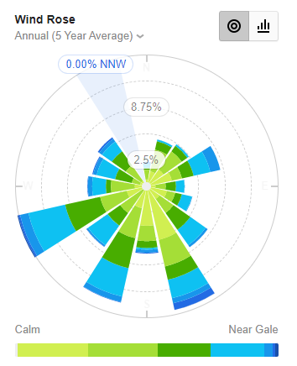

*Wind rose for Port of Cambourne Observing Station taken for the last five years*

The predominant wind blows from the west-south-west towards receptors to the east

north-east of the Site. However south south-west and west south-west show similar values meaning odours would likely be dispersed between the north north-west and east northeast.

**4.2 Site Location**

The site is located to the western edge of the Cardrew Industrial Estate in Redruth. The site is flanked the west by the Biffa’s waste transfer station and a self storage site to the east.

To the North the site bordered by the A3047 to the North and housing and light Industry to the South.

The Cardrew Industrial Estate has the following categories of business’s on it –

* Waste management
* Clinical waste
* Seaford Wholesaler
* Brewery
* Oil distribution
* Engineering
* Vehicle repair and maintenance
* Plastic Fabrication

Based upon the guidance document - H4 Odour Management How to comply with your environmental permit states the following ‘Some receptors are more sensitive than others. Domestic residences, or a pub with a beer garden are more likely to be sensitive than an industrial complex’.

Based on the above the within 1,000m of the site there are following hospitality and leisure activities and domestic dwellings. These are show in plan 4.2a.

|  |  |  |  |  |
| --- | --- | --- | --- | --- |
| **Ref** | **Receptor** | **Description** | **Direction from site boundary** | **Approximate distance from Site Boundary (m)** |
| 1 | Domestic Dwellings | Penlean Close | SE | 96 |
| 2 | Domestic Dwelling | Private Road | NE | 122 |
| 3 | School | Treleigh Primary School | NW | 330 |
| 4 | Domestic Dwellings | Pengover Park | SW | 920 |
| 5 | Campsite | Blue Dog Glamping | N | 215 |
| 6 | Castle | Wheal Peaver | NE | 660 |
| 7 | Golf Course | Radnor Gold and Leisure | NE | 650 |
| 8 | Pub | Treleigh Arms | NW | 490 |
| 9 | Pub | Inn For All Seasons | NW | 740 |
| 10 | Food Outlets | Cornish Scoter | E | 980 |
| 11 | Cricket Pitch | Mount Ambrose Cricket Club | NE | 570 |

The predominant wind blows from the west-south-west towards receptors to the east

north-east of the Site. However south south-west and west south-west show similar values meaning odours would likely be dispersed between the north north-west and east northeast.

As a result the receptors within this area would be more likely to be susceptible to an odour release. These receptors include –

* Dwellings
* Golf course
* Campsite
* Castle

**Site location and receptors**

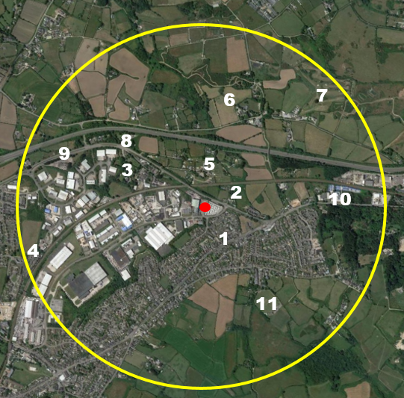

**Site location and prevailing wind direction**

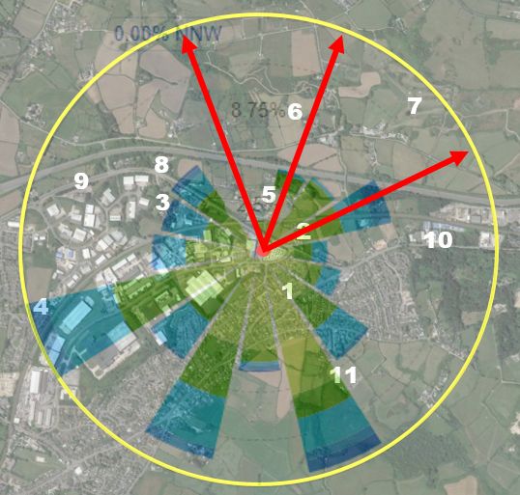

**4.3**

**Dispersal Control**

There are no sensitive receptors in various directions from the site. Given the varying directions to non-sensitive receptors it will not be practicably possible to restrict activities by wind direction. As the receptors are a mix of commercial properties operating around the clock it would also not be possible to restrict activities by time.

**4.4 Other Sources of Odour**

The Avonmouth Industrial Estate has a variety of different industries located upon it with a variety of sites that will produced their own distinct odours, including:

* Fish wholesaler
* Waste management (Biffa in the adjacent unit)
* Clinical waste management

**5.0 Procedures**

**5.1 Responsibilities**

The overall responsibility for the site shall remain with the Companies’ Managing Director.

Day to day operational responsibility for the transfer to foul sewer process is maintained by the site’s competent persons or COTC holders (Certificate of Technical Competence Holder’s in the event of an odour complaint the Odour Complaint Form as shown in Appendix A will be used and if complaint is validated the cause investigated and remedied

**5.2 Procedures when Odours Arise**

There is an internal odour report form (see Appendix B) and an external complaints procedure (as outlined below and in Appendix C) to ensure any odour issues are dealt with quickly and effectively.

**5.3 External Complaints Procedure**

Any complaints relating to the odour of the site will be taken seriously and channelled through a senior member of staff. Staff taking note of the complaint will use the appropriate Odour Complaint Form (see Appendix A).

Once the complaint is taken, the Site Manager will investigate the complaint and the site activities and respond to the complainant in writing outlining any findings and actions taken to mitigate the source of odours. Any complaints, investigations and mitigating actions will be recorded in the site diary.

The complaints procedure, including a survey of the complaints to date will be re-assessed by the Operations Manager and the Managing Director on a yearly basis, unless the number of complaints warrants additional reviews.

**5.4 Response to Complaints**

The receipt of a single odour complaint during normal operations is treated as an exceedance of control levels. The primary response will be as detailed in accordance with the site’s complaints procedure. An investigation shall be initiated into the cause of the complaint; this will involve as necessary:

* An olfactory survey as outlined below;
* An examination of the site activities at the time of the complaint;
* An examination of the meteorological conditions at the time of the complaint; and
* A review of the effectiveness of operational and odour control procedures. If the complaint is validated it will be treated as an exceedance of the control level. The outcome of the investigation will determine the corrective actions to be implemented.

**5.5 Abnormal Meteorological Conditions**

In the event that meteorological conditions prevent delivery or dispatch vehicles, or staff arriving on site, emergency contingency plans will need to be followed to ensure the site can be remotely managed until the site can return to operation under normal conditions. The site manager and staff operatives will undertake daily weather checks to ensure that any abnormal weather conditions can be foreseen as much as possible and contingency arrangements can be put in place prior to any problem occurring on site. In the event that the site has to be closed due to severe weather conditions deliveries will be diverted to an alternative suitably authorised site for either recovery or disposal.

**5.6 Breakdown of Process Equipment and Plant**

In the event that there is a breakdown of equipment or plant that cannot be repaired within 24 hours, hire equipment will be brought in.

**5.7 Staffing Issues**

The general manager ensures holidays are properly covered by staff from the wider group of companies. In terms of illness if a member of staff was not able to attend work on a particular day the site will manage but if that person or several staff at the same time were to be off for a longer period, staff can be sourced from the wider group of companies.

**5.8 Odour Management Plan Review**

The odour management plan will be reviewed annually and the version and review date modified accordingly, however if any of the following occur the odour management plan will be updated accordingly -

* Change to the permitted activities of the site.
* Change to the infrastructure and technology used to facilitate the transfer of liquid waste.
* Receipt of substantiated external odour complaints.
* Recording of odour internally that are likely to give rise to external complaints.
* A request made by the Environment Agency.

**Appendix A**

**Appendix D**

**Appendix** **C**