**ARSWL 2 - Non-Technical Summary –****AQUA ROD (SOUTH WEST) LIMITED -** **Tanker Emptying Facility - Apex Site, Cardrew Way, Cardrew Industrial Estate, Redruth, Cornwall TR15 1SS**

**1.0 Introduction**

Aqua Rod (South West) Limited, known as Aqua Rod is the market leader of septic tank emptying in Cornwall. Aqua Rod have a dedicated fleet of jet-vac tankers. Due to changes in the waste acceptance processes of the local waste water company Aqua Rod are looking to future proof their operations and be self-sustainable.

They also operate gully tankers for highways gully cleansing and wish to utilise the permit for dewater gully arising’s.

The company maintains and empties septic tanks and in addition portable toilets with its own dedicated fleet of tankers, collecting the portable toilet waste under EWC codes –

20 03 04 - septic tank sludge

16 10 02 - aqueous liquid wastes other than those mentioned in 16 10 01

Currently the company utilises South West Waters network of sewage treatment works to transfer and discharge these collected waste liquids. However, South West Water have advised that this will no longer be a service in the future and that companies such as Aqua Rod will have to make their own arrangements to manage these waste liquids that they collect.

The Environment Agency are locally aware of this situation as it will have a major impact on companies such as Aqua Rod’s business’s and also householders and business’s as Cornwall has a large percentage of properties that do not benefit from mains sewer connections.

The local Environment Agency team have advised that once a permit application has been submitted a Local Enforcement Position may be available to allow the company to operate without a permit until the permit is issued.

In addition, the company collects sludge’s from packet treatment works under EWC code 19 08 05.

The collected waste is never bulked up and stored on site and it will always be discharged straight from the tanker into the proposed waste screening and dewatering system, which will then be released into the foul sewer with the relevant trade discharge consent and associated set parameters issued by South West Water. The proposed storage limit of 40 tonnes accounts for the liquid being processed through the system.

The company also operate gully tankers for highways gully cleansing and wish to utilise the permit for dewater gully arising’s and these are coded EWC code 20 03 03.

**2.1 Waste Acceptance**

All waste will have gone through a pre-acceptance process with all waste being booked in before it can come to the site. All incoming waste must report to the site office; a completed waste transfer note must be provided to show the description and origin of the waste. The vehicle will then directed to the discharge point.

If there is a variation in the waste compared to its description this must be discussed with the on site office. If the description requires changing this will be completed if the waste can be accepted under the environmental permit. If not the waste will be rejected and removed from site.

Any rejected loads, quarantined loads or loads where the description has changed from the original waste transfer note will be noted in the site diary. The relevant code will be assigned in line with Guidance on the classification and assessment of waste (1st Edition v1.2.GB) Technical Guidance WM3. All waste movements are recorded on the company’s electronic system.

**2.2 Waste treatment**

**Liquid Wastes**

Tankers arrives at site, and the driver will report to the site office, and provide a description of the waste that has been collected. This should already be on the system as the waste collected would already be booked in as a job including the source and description. Once the load has been booked into the system the waste will be discharged to the plant.

The tanker drives onto the designated area for discharging which sits on an impermeable surface and part of a sealed drainage system (Final drainage and containment arrangements to be confirmed and proposed as a pre-commencement condition within the environmental permit). The tanker will then couple up to the primary tank and discharge via pumping to the primary tank (course screen separator). The discharge liquid passes over screens remove larger solids and foreign bodies.

Once screened the liquid is then pumped to the secondary tank and a flocculent added during this process. The liquid then arrives in the secondary tank and passes through fine screens leaving behind suspended solids. At this point, the liquid is ready to be discharged to the foul sewer via dedicated metered discharge point. A sample can be taken as part of the process. If the process is to continue accepting the same waste stream then the tanks will remain operational until the screens needs clearing or solids require removing. If a different waste stream is to be processed the tanks are to be cleaned.

**Gully Wastes**

Tanker arrives at site, reports to the site office, and provides a description of the waste that has been collected. This should already be on the system as the waste collected would already be

booked in as a job including the source and description. Once the load has been booked into the system the waste tipped in the designated bay.

The tanker drives onto the designated area for tipping which sits on an impermeable surface and part of a sealed drainage system (Final drainage and containment arrangements to be confirmed and proposed as a pre-commencement condition within the environmental permit). The tanker will then tip the gully waste into the bay. Solids are retained within the bay and any liquids flow to a sealed sump.

The liquids are sucked from the sump when it is full via a vacuum tanker and pumped into the primary tank as utilised for liquid wastes. The same process then follows.

Once the water has runoff of the gully waste and there is enough for a full load to be removed from site a grab waggon is utilised to remove the gully waste and transfer it to permitted waste facility for recovery.

**3.0 Discharge and Screening process**

**Treatment via dewatering**

The process is the dewatering of liquid and sludge wastes before the de-watered liquid is discharged to the foul sewer.

The transfer of the waste products between the two units uses a polymer dosing system that uses a physical means of delivery as opposed to a vacuum / pressure system. The use of the polymer dosing system causes flocculation of the sludge’s which in turn forms a cake within the dewatering container; any odours present will be contained in the filtrate arising from the dewatering process and should be plumbed through metering directly to a foul system or transferred to a sealed holding tank for re-use in other processes.

The treatment of liquids and sludge’s will be via dewatering containers.

The system is long established and used for a variety of uses within the waste sector in the UK and Europe. It has been used for dewatering road sweeper and gully wastes and permitted for this activity. One example of this is Environmental Waste Management Permit - AB3400XK for Ringway Jacobs Limited, located at Brunswick Wharf Depot, Brook Street, Congleton, Cheshire, CW12 1RG where the system is used for liquids from road sweeper and gully cleansing operation. The system has also been permitted under Installations Permit - EPR/GP3538CA for Andersons Waste Treatment Centre Limited located at Unit 6 Hydro Estate, Andersons Waste Treatment Centre EPR/GP3538CA, St. Andrews Road, Avonmouth, Avon, BS11 9HW. The system is also utilised by Billy Bowie Limited in Scotland for the same application.

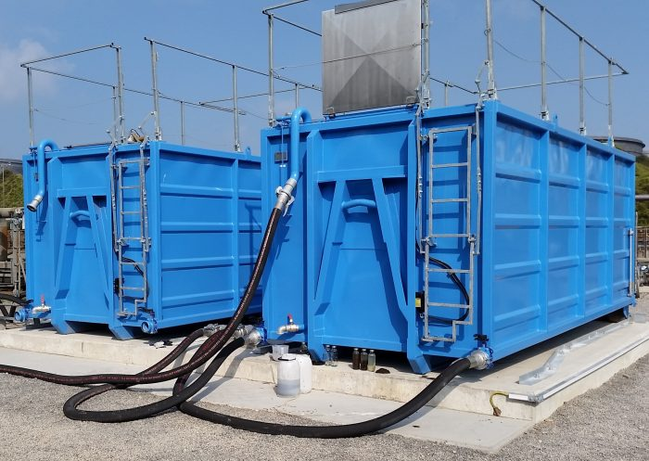

Once treated the suspended solids settle out allowing liquids free from suspended solids to be released to the foul sewer via a trade a discharge consent.

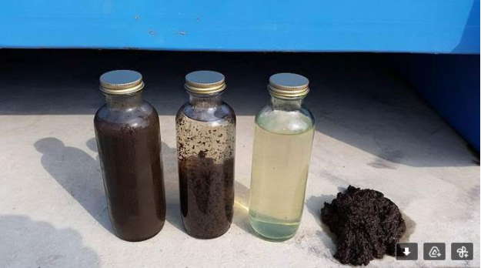

**4.0 Tank Cleaning**

When required the containers can be cleansed to remove solids or even be removed from the site for tipping. When fouled, screens can be cleansed using the jet washing from the inspection and access hatches on the top of all tanks (remain closed when in operation). Once the tanks are full of solids they can removed from site via a hook loader and tipped at a suitable permitted waste facility. On returning to the depot, the tank can be further cleansed on the wash down area, which discharges to the foul sewer.

**5.0 Sites and industries serviced**

Aqua Rod service households and a variety of industries, however they also serve the construction and infrastructure sectors who require the provision of temporary portable toilets.

**6.0 Hazardous waste**

There will be no hazardous waste accepted at the site.

**7.0 Redruth Depot**

The existing Redruth Aqua Rod South West depot is well established and helps support Aqua Rod South West its customers within the county.

The Redruth depot is situated on an industrial estate and the site itself is flanked by a number of industrial companies including a household and commercial waste transfer station operated by Biffa.

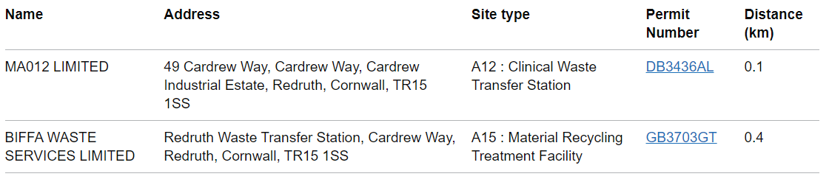The industrial estate has a two other permitted waste facilities located on it including those shown below:

**8.0 Wastes received and stored**

**Non-hazardous wastes**

The maximum quantity of waste to be received within 1 week in 350 tonnes.

The maximum quantity of waste to be received within 1 year is 25,000 tonnes.

**Storage of Waste**

The maximum waste storage will be 40 tonnes of non-hazardous waste being treated via dewatering

**9.0 Drainage**

All liquids will be stored and treated within a sealed and impermeable drainage system. The tanks used for the waste treatment are heavy duty singled skinned, but are located within a bunded area. The bunded area also contains all pipe work, flocculants and pumps associated with the treatment of waste. The bunding will provided 110% containment capacity for the largest vessel.

Discharging of waste liquids to the foul sewer takes place in a controlled manner. If the bund requires cleansing or emptying of rainwater this will be via a pump to the foul sewer once it has been checked for contaminants . Flocculants will be delivered to site pre-mixed within a 1,000-litre IBC. This is stored within the bunded area, but also on its own spill pallet and is clearly labelled with a safety data sheet will be available on site.

Spillages within the bunded area will be dealt with initially identifying the source of the spill or leak. If it is, a leak once identified the leak will be stopped. Then the spill will be cleansed using onsite spill

equipment by trained staff. Used spill kit will be placed within designated bins for onwards movement to a relevant permitted facility, the bund will then be cleansed. Spillage on the tanker discharge point will be treated within the same manner, however in the scenario the sites drainage will be locked down whilst the spill or leak is dealt with.

**10.0 Emissions and Fire**

The only point source discharge for the operation is the treated effluent to the foul sewer. Due to the wetness of the waste and the process dust will not be produced, in addition, there is no crushing, mechanical screening, trommeling or compaction of the waste as a result no additional noise will be created. Vehicles are constantly moving in and out of the depot during hours of operation. By its nature, the waste can be odorous and as a result, an odour management plan will form part of the permit application.

The waste stream is not flammable and as a result, a Fire Prevention Plan is not required.