

|  |
| --- |
| **22 March 2024** |
| [ao.com](http://www.ao.com)  © 2020 AO World All Rights Reserved |

|  |  |
| --- | --- |
| **Fire Prevention Plan** |  |
| AO Recycling Limited – Halesfield Site Halesfield 15 Telford TF7 4ER |  |

**Contents**

Version Control 4

1. Purpose 5

2. Scope 5

3. Associated Documents 5

4. Management Responsibilities 6

4.1 Compliance Team 6

4.2 Site Operatives 6

5. The Site 6

5.1 Operations 6

5.2 People at Risk 7

5.3 Site Location 8

5.4 Local Receptors 9

5.5 Site Plan 10

6. Managing Common Causes of Fire 10

6.1 Arson/Vandalism 10

6.2 Plant and Equipment Maintenance Activities 10

6.3 Maintenance of Electrical Equipment 11

6.4 Smoking 11

6.5 Hot Works 11

6.6 Industrial Heaters 12

6.7 Inspection of Hot Equipment 12

6.8 Control of Ignition Sources 12

6.8.1 Fire Watch 13

6.8.2 Waste Acceptance and Permitted Waste 13

6.8.3 Waste Treatment 13

6.9 Batteries 14

6.9.1 Batteries in End-Of-Life Vehicles (ELV) 14

6.9.2 Battery Storage 14

6.10 Control of Leaks and Spillages of Oils and Fuels 14

6.11 Inspection and Cleaning of Combustible Waste, Dust etc. 15

6.12 Management of Waste to Prevent Reactions between Wastes 15

6.12.1 Waste Inspection 15

6.12.2 Unacceptable Waste 16

6.13 Deposited Hot Loads 16

7. Prevention of Self-Combustion of Waste Materials 17

7.1 Storage 17

7.2 Stock Rotation 18

7.3 Seasonality 18

7.4 Monitoring and Control Temperature 18

7.4.1 Monitoring 18

7.5 Waste Bale Storage 18

8. Management of Waste 19

8.1 Waste 19

8.1.1 Fridge/WEEE Waste 19

8.1.2 Paper/Card/Wood/Plastics Waste 19

8.2 Current Waste Throughput 20

9. Prevention of Fire Spreading 21

9.1 Separation Distances 21

9.2 Fire Walls and Bays 21

10. Quarantine Area 22

10.1 Quarantine Area 22

11. Detecting Fires 23

11.1 Measures to Detect Fires 23

11.2 Smoke, heat and flame detectors 23

12. Suppression of Fires 23

12.1 Fire Suppression 23

12.2 Automated Fire Suppression and Prevention 24

12.2.1 E-Scrap Recycling 24

12.3 Fridge Recycling 24

12.4 Whole Plant 25

12.5 Additional Site Protection 25

13. Fire Fighting Techniques 26

13.1 Fire Fighting Provisions 26

13.2 Active Fire Fighting 26

14. Water Supplies 27

14.1 Fire Water 27

15. Managing Fire Water 29

15.1 Site Drainage and Containment 29

16. Actions During and After a Fire Incident 31

16.1 Emergency Response Plan & Business Continuity Plan 31

16.2 Access for Emergency Services 31

16.3 Liaison with Emergency Services 31

17. Appendix 32

Appendix A – Site Plan 1: Site plan (includes emergency plan) 32

Appendix B – Site Plan 2: 1km sensitive receptors 33

Appendix C – Plan 3: Drainage Plan 34

Appendix D – DSEAR Information 34

# Version Control

|  |  |  |  |  |
| --- | --- | --- | --- | --- |
| Date | Version No | Author | Description of Change | Authorised by: |
| 26.11.18 | V6.1 | MP | Change in FPP in line with updated guidance | AF |
| 20.02.19 | V6.2 | MP | Added additional drainage plan. | ACS |
| 03.06.19 | V6.3 | MP | Revised section 12.1 regarding in process waste. | ACS |
| 02.11.20 | V6.4 | MP | Revised due to updated ISO policies/operating procedures, improvements to onsite processing and storage and branding update. | GD |
| 15.01.21 | V6.5 | MP | Amendments from EA CAR | GD |
| 21.10.21 | V6.6 | MP | Amended section 6.9 to include battery storage. Changed no of employees. | GD |
| 22.03.24 | V7.1 | MP | Amended Section 6.8 and Appendix D to include decanting as gases into ISO Tanker | GD |
| Next Review: 01/04/2029 | | | | |

# Purpose

The purpose of this document is to identify potential fire hazards, detail the controls implemented to prevent fires and the actions taken to reduce the impacts should there be a fire on site.

This plan has been prepared to conjunction with the format prescribed by the Environment Agency and detailed in:

[https://www.gov.uk/government/publications/fire-prevention-plans-environmental-permits/fire-prevention-plans-environmental-permits#managing-fire-water](https://www.gov.uk/government/publications/fire-prevention-plans-environmental-permits/fire-prevention-plans-environmental-permits)

The main objective of this fire prevention plan is to

• minimise the likelihood of a fire happening

• aim for a fire to be extinguished within 4 hours

• Minimise the spread of fire within the site and to neighbouring sites.

# Scope

This Fire Prevention Plan is applicable for AO Recycling Ltd, Halesfield 15, Telford, TF7 4ER.

# Associated Documents

* Emergency Preparedness and Response Policy
* Fire Risk Assessment
* Emergency Response Plan
* Site Environmental Permit
* Site Plans – Plan 1, Plan 2 & Plan 3
* DSEAR Risk Assessment
* Operating Procedure – Receiving and Handling WEEE
* Operating Procedure – Handling, sorting and storage of WEEE prior to treatment
* Operating Procedure – Treatment of WEEE and fractions
* Maintenance Policy
* Operating Procedure – Removal and monitoring of waste out streams
* Spillage Procedure
* Business Continuity Plan

# Management Responsibilities

## Compliance Team

* Ensure the effective implementation of the Fire Prevention Plan.
* Allocate sufficient resources to ensure the Fire Prevention Plan can be implemented.
* Ensure site staff are trained and competence to manage the arrangements for fire prevention and fire protection.
* Monitor the overall effectiveness of the Fire Prevention Plan through weekly site inspection and record findings.
* Regularly update the Fire Prevention Plan as required.

## Site Operatives

* Follow operating instructions and report discrepancies between these instructions and the work.
* Maintain the fire prevention controls implemented by AO Recycling Ltd (as detailed in the Fire Prevention Plan).
* Report any activity or events which could jeopardise the Fire Safety Strategy.

# The Site

## Operations

AO Recycling Ltd is the recycling arm of a large white goods retailer. The company is based in Telford. The organizations main activities involve the recycling of Waste Electric and Electronic Equipment (WEEE) such as refrigerators, cookers, dishwashers etc. This is set out in the WEEE directive 2012/19/EU and transposed into UK legislation - Waste Electrical and Electronic Equipment Regulations 2013.

AO Recycling Ltd. has been trading since 2009 and is currently employing more than 250 people covering 3 sites.

AO Recycling Ltd. uses a transport company which is a wholly owned subsidiary of its parent company along with its own transport fleet which means that very bespoke and tailored WEEE collection and disposal service can be offered to customers.

The main processes are:

* Collection of waste
* Acceptance of waste to the licensed site
* Sorting of waste
* Pre-destruction processing of waste
* Destruction
* Dispatch of clean recycled materials for re use

The processes above are all regulated by the Environment Agency under the Environmental Protection Act 1990 & The Environmental Permitting (England and Wales) Regulations 2016 primarily under a Part A1 Permit.

AO Recycling Ltd. is committed to protecting the environment to deliver effective, evidence-based management systems in accordance with the recommendations of ISO 9001, ISO 14001, ISO 45001 and other industry equivalent standards.

The types of waste taken by the site are below:

|  |  |
| --- | --- |
| 15 01 06 | mixed packaging |
| 16 02 10* | discarded equipment containing or contaminated by PCBs other than those mentioned in 16 02 09 |
| 16 02 11* | Discarded equipment containing chlorofluorocarbons, HCFC, HFC |
| 16 02 13* | discarded equipment containing hazardous components other than those mentioned in 16 02 09 to 16 02 12 |
| 16 02 14 | discarded equipment other than those mentioned in 16 02 09 to 16 02.13 |
| 20 01 23* | Discarded equipment containing chlorofluorocarbons |
| 20 01 35* | discarded electrical and electronic equipment other than those mentioned in 20 01 21 and 20 01 23 containing hazardous components |
| 20 01 36 | discarded electrical and electronic equipment other than those mentioned in 20 01 21, 20 01 23 and 20 01 35 |

## People at Risk

The company currently employs 265 people on site.

The site has drivers from other companies within the group.

Subcontractors on site.

Visitors on site

All non-employees are signed in and their safety is included in the emergency response plan.

## Site Location

The site is located at Halesfield 15, Telford, TF7 4ER the Grid reference of which is SJ7111104509.

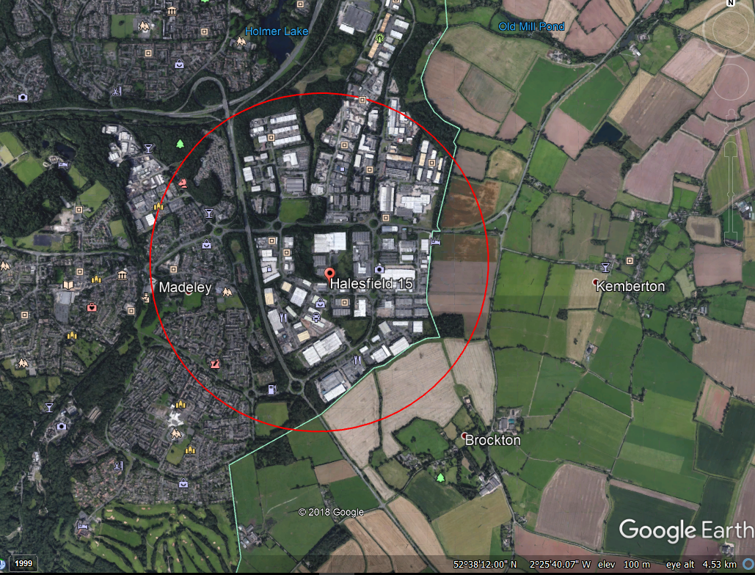

Figure 1: Location of Site

The site is located on the northern periphery of Halesfield, Telford, approximately 4.5km to the south of Telford, in Shropshire. The site is accessed via Halesfield 15 a road off Halesfield industrial estate while the embankment is accessible by a track on the southern boundary of the site (Halesfield 13). The A4169 (Halesfield 16) is located along the northern boundary. The site area is approx. 1.5ha. The site is irregular in shape with maximum dimensions ranging from 140m (N-S) by 80m (E-W).

The maximum storage capacity for the site is 1,500 tonnes for hazardous waste and 2,000 tonnes for non-hazardous waste. The annual treatment of WEEE through shredding will be 50,000 tonnes per year for hazardous waste and 100,000 tonnes per year of non-hazardous waste. Pre-treatment of WEEE containing hazardous substances using manual processes will be at a maximum of 50,000 tonnes per year.

Plan 1 Ref Appendix A attached is a site layout, showing site access, storage areas and processing areas this includes the storage location of each individual waste types also included is the quarantine area. This is an organic document and is changed as and when storage areas are moved. This diagram is used by the fire brigade when called to site.

Plan 2 Ref Appendix B attached is the location of the site in relation to the surrounding industrial area showing Residential areas, Schools and nurseries, Hospitals and care homes, workplaces, critical infrastructure and protected habitats and rivers.

Please refer to Appendix C for Plan 3: Drainage plan of the site.

## Local Receptors

Commercial properties are located to the south, east and west and the A4169 road to the north. These local receptors would be impacted by a large fire on site, however, the prevailing wind direction westerly, thus reducing the likelihood of impact of air emissions from those receptors located north, south and east of the site.

Figure 2 shows the wind patterns in 2017 as identified by the Shawbury meteorological station. The most prominent wind directions are from the west and south-west. Winds from the north and east are relatively infrequent.

Receptors to the south and west of the site are most at risk from windblown smoke.



Figure 2

There are no protected habitats within 1km of the site.

Please refer to Site Plan 2 - Appendix B

## Site Plan

Please refer to Site Plan 1 - Appendix A

A copy of the site plan is located in the Emergency Fire Cabinet with instructions for the emergency services to locate key information in the event of an incident on site. The instructions will include a list of emergency contacts.

# Managing Common Causes of Fire

This section details the controls in place to prevent fires and the actions taken to reduce the risk from fires.

## Arson/Vandalism

The site is surrounded by a security fence and there is 24-hour CCTV and Security lights to help with the Prevention of arson. Due to the nature of operations on site (24-hour operation) arrangements are in place to monitor the site during non-office hours. Site boundary checks are completed weekly to ensure site security is maintained and the risk of arson is reduced.

## Plant and Equipment Maintenance Activities

All Site plant and Machinery are subject to a preventative maintenance schedule in line with the manufacturer’s specifications. Further detail of this is outlined in the Maintenance Policy.

In summary, the following provisions are implemented:

* Plant maintenance schedules using the manufacturer’s recommendations.
* Pre-use checks are complete prior to using any plant or equipment.
* Defects are reported and actions taken based on priorities.
* Regular cleaning is performed to remove dust build up from vulnerable areas.
* All vehicles onsite are fitted with portable fire extinguishers.
* Mobile plant is kept away from combustible waste. This is achieved by allocating areas for mobile plant for storage when not in use.

## Maintenance of Electrical Equipment

All newly installed electrics comply with BS7671 and all wiring on site is subject to regular test and inspection in accordance with BS7671.

Electrical connection and systems are inspected as part of the maintenance schedule. Electrical lights are insulated. All work undertaken onsite is performed by in-house qualified electricians. Further detail of this is outlined in the operating procedure ‘Maintenance’.

All fixed electrical installations are subject to periodic inspections by competent persons and certifications are in place.

All portable appliances are subject to periodic inspections by competent persons and certifications are in place.

All electrical equipment in ‘ATEX’ zones comply with the requirements of ‘The Equipment and Protective Systems intended for Use in Potentially Explosive Atmospheres, 1996’.

## Smoking

There is a strict no smoking policy on site. A smoking area is provided for staff and visitors that is located adjacent to the main car park.

The smoking area does not hold any combustible materials and there is a non-combustible waste bin for cigarette ends and spent matches.

The smoking area is subject to regular checks and is regularly cleaned by onsite cleaners.

## Hot Works

Hot Works (grinding, welding, and cutting) activities are rarely performed on site. However, any hot works performed in accordance with a management procedure that requires an authorisation to work (Permit-to-Work) and includes pre work checks and post work checks/monitoring for a suitable period of time after hot work. The permit includes the facility to ensure a person is on fire watch for at least 30 minutes after any hot work takes place.

The authorisation ensures that any hot works are carefully planned, and controls are implemented to reduce the risk from fire. Where possible, hot works are performed away from sources of fuel. Risk assessments have been completed for these activities and are subject to regular review.

The weekly compliance check will review any hot work that has been undertaken on site to ensure the Permit-to-Work procedure has been followed.

## Industrial Heaters

Currently no industrial heaters are used on site. If however if at a future point industrial heaters are fitted, they will be subject to a preventative maintenance schedule in line with the manufacturer’s specifications. Further detail of this is outlined in the Maintenance policy.

## Inspection of Hot Equipment

Currently no plant or equipment used on site is classified as ‘hot equipment’. If, however at a future point any plant/equipment is used on site which could be classified as ‘hot equipment’ (e.g. equipment containing exhausts which could become hot whilst in operation, engine parts etc.) will be subject to a defined monitoring plan, considering guidance referenced in Section 1 of this document.

## Control of Ignition Sources

Sources of ignition have been assessed and reduced as far as reasonably practicable – see Ref Fire Risk Assessment & DSEAR Risk Assessment. Remaining sources of ignition have been identified and controlled as described below:

|  |  |  |
| --- | --- | --- |
| Hazard | Yes/No  N/A | How is the risk controlled? |
| Smoking on site | No | See Section 6.4 for controls |
| Hot Work  e.g. welding, incineration or cooking | No | See Section 6.5 for controls |
| Are light bulbs or fittings near to combustible materials? | No | Light bulbs, switch gear etc. is located away from combustible or flammable material in line with guidance (greater than 6m).  Any light fittings located within ATEX zones adhere to the most appropriate protection concepts. |
| Is there any faulty or misused electrical equipment (include wiring on machinery and the use of multi-point adaptors)? | No | See Section 6.3 for controls. |
| Storage of flammable substances connected with operation | Yes | All Hazardous/Flammable substances have undergone COSHH assessment and appropriate controls are in place, such as storage in COSHH cabinets. |
| Shredding of Fridges | Yes | All shredding activities are completed in a sealed environment which is inert |
| Burning Waste | No | No wastes are burned at the site |
| Storage of Gas Bottles and Flammables | No | All such materials are stored in line with the appropriate guidance.  Substances have undergone COSHH assessment and relevant controls are in place. |
| Heat and Sparks from process (Shredding Plant) | Yes | All shredding plant processing flammable material is undertaken in an inert environment. |
| Static discharge (decanting refrigerant and blowing agent) | Yes | Adequate earthing points to dissipate any anti-static sources.  Gas monitoring during process.  Standard Operating Procedure with trained Operatives.  ATEX zoning  Gas compound located in Fire Bay. |

All sources of ignition are kept more than 6 metres from combustible or flammable waste in line with guidance. To ensure that sources are kept a sufficient distance apart, CCTV monitoring of the site and weekly monitoring will check that no sources of ignition are close to the waste storage bays, good housekeeping practices will be checked to see if flammable substances are stored correctly, gas bottles are stored correctly etc. In addition, the Permit-to-Work procedure will ensure all hot work is undertaken is a safe manner.

### Fire Watch

* All staff are given an induction presentation which includes Emergency training.
* Once every 6 months a fire drill is completed, and all staff are required to take part.
* Fire procedures and information are situated on all staff notice boards
* Fire site plans and information are situated by all fire alarm panels
* Any member of staff working in an area of increased ignition potential has been trained and are competent to do so
* All staff are trained to identify early signs of fires and evidence of self-heating

### Waste Acceptance and Permitted Waste

Please see Section 6.12 and operating procedure Receiving and handling WEEE. All waste received direct from the producer no pre-treated waste received.

### 6.8.3 Waste Treatment

ELF and WEEE Destruction System has been designed to prevent and protect against fire and explosion. It has an inert atmosphere and explosion protection devices are installed across the installation such as explosion relief vents and non-return valves.

The Destruction System has safeguards to ensure shutdown in the event of an issue. Control and use of the nitrogen is by an external expert company.

The following materials produced from the process and controls are explained below:

|  |  |
| --- | --- |
| Non-Ferrous Metal | will leave the plant on a conveyor and go straight into a trailer |
| Ferrous Metal | will leave the plant on a conveyor and go straight into a trailer |
| PU Foam/foam dust | Loaded into tied bags and stored ready for transports as shown on plan 1 – see appendix A. |
| Plastic | Loaded into tied bags and stored ready for transports as shown on plan 1 – see appendix A |

For more information on the shredding plant see operating procedure Treatment of WEEE and fractions.

All training of waste treatment involves the control of fire/heat sources.

## Batteries

### 6.9.1 Batteries in End-Of-Life Vehicles (ELV)

Not applicable. The site does not handle, process, or store batteries from End-Of-Life vehicles.

### 6.9.2 Battery Storage

Lithium and Lithium-Ion batteries are stored in weatherproof containers outside the Re-use Department. The storage vessels are located under a canopy 6m away from the building and from any combustible materials.

Discarded Lithium and Li-ion batteries are placed in layers within the storage containers, which are separated with a layer of inert material.

Once a storage container is full, arrangements are made to remove the waste offsite as hazardous waste via a licenced waste carrier to a suitable permitted site.

In addition, fire extinguishers specifically designed and manufactured for dealing with lithium battery fires (Lith-ex) are located within the Re use Department (located near lithium and Li-ion battery storage containers).

In the event of a battery fire, trained personnel will be able to extinguish the fire promptly.

## Control of Leaks and Spillages of Oils and Fuels

All site vehicles are maintained in accordance with Section 6.2 of this plan.

Incidental spills which pose insignificant threat to health or safety and may be safely cleaned up, absorbed, neutralized, or otherwise controlled at the time of release in the immediate release area by employees or maintenance personnel who are familiar with the hazards of the chemicals, as covered by Procedure HS24 – ‘Spillage Procedure’ and referenced in Emergency preparedness and response policy.

To protect the ground from leaks and spills during out of hours, all site fork lift trucks or other vehicles onsite will be stored within the main building and on the transport yard in a designated area on a concrete, impermeable base. Any spills would then be absorbed, cleaned and disposed of using a licenced carrier as soon as the spill is identified.

Diesel or oil storage tanks/IBC’s onsite will have secondary containment (bunding). The secondary containment will have a capacity of 110% of the tank/IBC (individual tank/IBC bunding will be used) in line with The Control of Pollution (Oil Storage)(England) Regulations 2001. In addition, some processes onsite operate for 24 hours a day.

## Inspection and Cleaning of Combustible Waste, Dust etc.

A high standard of housekeeping, cleanliness and tidiness is required to prevent contamination or damage to equipment, to prevent accidents and to minimise the risk of pollution.

On site personnel are responsible for the condition and maintenance of the site, which includes any housekeeping that is required on site.

On site personnel perform an informal visual inspection of the site and daily and weekly inspections are undertaken by the Compliance Team. The daily inspection includes checking for loose, combustible waste and dust and fluff which could contribute to a fire. Any issues found from the daily report are communicated to the relevant department manager, whose responsibility is to rectify any findings from the inspection.

In addition, housekeeping, inspection and cleaning will be recorded on the weekly compliance inspection form. Weekly monitoring will ensure daily inspections and housekeeping practices are being followed.

Any potential fire risks found on site are brought to the attention of the site manager. If necessary, the information is relayed to the compliance team.

## Management of Waste to Prevent Reactions between Wastes

### 6.12.1 Waste Inspection

In accordance with our procedure Receiving and handling WEEE, all waste that is brought onto site is inspected to ensure is has been consigned correctly.

* The controls in place to reduce the risk from fire are summarised as:
* All deliveries are checked on arrival. Checks include both the paperwork and the full contents of the load.
* Wastes are received in the reception area only.
* No loads are removed without an onsite operative in supervision.
* A visual fire watch is performed as the loads are received and unloaded.
* The Quarantine area exists and is available.
* Waste is handled in accordance with a safe system of work. Care is taken to ensure the cooling circuits are not damaged during the unloading and transport of WEEE waste. On site personnel will be instructed and trained on the safe system of work.

To prevent reactions between wastes, employees in waste reception areas have been instructed via safe system of work training to look for signs of smoke, smouldering materials and fires.

If signs of a reaction are detected, waste reception operators are trained in actions to take.

This may include measures such as:

* Informing Line Manager
* using mobile plant to move suspected items to a safe quarantine area in the yard
* using dedicated containers to store damaged or suspected damaged lithium batteries
* Using mobile plant to separate and/or isolate suspected wastes.
* Fire extinguishers may be used by trained fire marshals, after an assessment of the suspected load type (correct class of fire extinguisher)

### 6.12.2 Unacceptable Waste

In accordance with our procedure Receiving and handling WEEE, all waste that is brought onto site is inspected to ensure it is permitted (see list of accepted waste in Section 5.1).

Where possible waste that is received that is not allowed under the license is refused entry. However, where exceptions arrive unknowingly (i.e. inside fridges etc.), these must be reported to the Transport and Administration Manager, who must record the details, and then the items are pulled out and put into isolated ‘*quarantine*’ storage for removal from the site later to the originator or an authorised disposal company within 5 days. Any quarantined waste must be detailed.

## Deposited Hot Loads

AO Recycling does not accept any Incompatible waste of hot loads.

# Prevention of Self-Combustion of Waste Materials

## Storage

As set out in the Operating procedure - Handling, sorting and storage of WEEE prior to treatment. All waste is stored on an impermeable surface with sealed drainage which goes through an interceptor to sewer on a trade effluent agreement. Only Work in Progress waste materials are stored inside the factory.

Different waste types call for different storage requirements as below:

|  |  |  |
| --- | --- | --- |
| Waste Received | Storage | Maximum Duration |
| COOLING | To be stored on their side with doors facing inward, to ensure no pressure is put onto the cooling circuit. As shown on Plan 1 – see appendix A. | 3 Months |
| LDA | To be stored upright, only to be stored 3 units high. As shown on Plan 1 – see appendix A. | 3 Months |
| SDA | Stored in Containers As shown on Plan 1 – see Appendix A | 3 Months |
| Wood | Stored in Containers As shown on Plan 1 – see Appendix A | 3 Months |
| Polystyrene | Baled and stored as shown on Plan 1 – see Appendix A. | 3 Months |
| Polythene | Baled and stored as shown on Plan 1 – see Appendix A. | 3 Months |
| Cardboard/paper | Baled and stored as shown on Plan 1 – see Appendix A. | 3 Months |

Waste from Process

|  |  |  |
| --- | --- | --- |
| Waste Received | Storage | Maximum Duration |
| Batteries | Kept in sealed containers stored as shown on Plan 1 – see Appendix A. | 3 Months |
| Refrigerant Gas | Stored in tested Pig cylinders as shown on Plan 1 – see Appendix A. | 3 Months |
| Waste Oil | Stored in IBC’s in bunded area 110% of largest tank as shown on Plan 1 – see Appendix A. | 3 Months |
| Polyurethane Foam Plastic and Rubber | Kept sealed bags A shown on Plan 1 – see Appendix A. | 3 Months |
| Ferrous Metal | Sent out of the plant directly into trailers stored as shown on Plan 1 – see Appendix A. | 3 Months |
| Non-ferrous Metals | Sent out of the plant directly into trailers stored as shown on Plan 1 – see Appendix A. | 3 Months |

## Stock Rotation

Stock on site is removed as quickly as possible using a first in first out policy.

Waste storage areas are monitored at the site location and the storage dates are recorded on a site plan onsite and onto an excel spreadsheet. Arrangements on site ensure a ‘first in first out’ is adopted to ensure storage of waste products does not exceed the prescribed duration. The recycling manager is responsible for stock rotation on site. He/she ensures that waste with the earliest storage dates are processed on site. The recycling manager will also notify if any stored waste is approaching the maximum duration limit so that arrangements can be made to process the waste.

The aim with all waste on site is to process it as soon as there is capacity at the Halesfield site.

## Seasonality

There is an increase in volume stored in the summer months.

Arrangements on site ensure a ‘first in first out’ is adopted to ensure storage of waste products does not exceed the prescribed duration (see Section 7.2).

## Monitoring and Control Temperature

### Monitoring

On a daily basis, the Recycling Manager and the Compliance Team will inspect the storage bays for any anomalies, such as visual signs of heat, steam or vapour. Anomalies are actioned immediately by investigation and remedial action will be taken such as rotation of the waste within the storage bay or removal of heated waste, which will be put in the quarantine area for assessment.

In addition, the weekly compliance check will ensure that the monitoring of the storage bays has taken place and informal visual checks of the bays will be performed when personnel are working onsite.

## Waste Bale Storage

On a daily basis, the Recycling Manager and the Compliance Team will inspect a selection of polystyrene, polythene and cardboard/paper bales for any anomalies, such as visual signs of heat, steam or vapour. Anomalies are actioned immediately by investigation and remedial action will be taken, such as removal of heated waste, which will be put in the quarantine area for assessment.

In addition, the weekly compliance check will ensure that the monitoring of the storage areas has taken place and informal visual checks of the baled waste will be performed when personnel are working onsite.

# Management of Waste

## Waste

### Fridge/WEEE Waste

The site consists of 9 bays. The height of each bay is 4.8m, the width and length of each bay will vary, but neither the length nor the width of the bay will exceed 20 metres. In line with guidance, the maximum pile sizes will not exceed 450 cubic metres.

The maximum storage height for Fridges/WEEE waste contained within the bays is 3.8m.

All Fridges/WEEE waste on site will be contained within the bays. Due to the design of the site, the length of each storage bay will exceed the width of the bay. Therefore, the maximum stockpile sizes contained within the bays are as follows:

|  |  |  |  |  |  |
| --- | --- | --- | --- | --- | --- |
| Material Stored | Max Height of waste pile (m) | Maximum Length of storage bay (m) | Maximum allowable width (if storage bay is at 20 metres) | Maximum Area (m2) | Maximum Volume (m3) |
| Fridges/WEEE | 3.8 | 20 | 5.8 | 116 | 441 |

Note: Width can be wider if the length of the bay is less than 20 metres, but the maximum area cannot exceed 116m2.

The weekly compliance check is used as the method to ensure the waste pile height of each bay does not exceed 3.8m.

### Paper/Card/Wood/Plastics Waste

The maximum stockpile sizes and separation distances for paper/card/wood/plastic waste stored on this site are listed below. No paper/card/wood/plastic waste is stored inside. The stockpile sizes used are shown on plan 1 attached – see Appendix A.

|  |  |  |  |  |  |
| --- | --- | --- | --- | --- | --- |
| Material Stored | Max Height of waste pile (m) | Maximum Length of waste pile (m) | Maximum allowable width (if waste pile is at 20 metres) | Maximum Area (m2) | Maximum Volume (m3) |
| Paper/card/wood | 3.8 | 20 | 5.8 | 116 | 441 |
| Plastics | 3.8 | 20 | 5.8 | 116 | 441 |

The daily and weekly compliance checks is used as the method to ensure the waste pile height of each bay does not exceed 3.8m.

## Current Waste Throughput

Waste throughput is monitored, and any increase will require amendments to this document and changes to some controls.

Throughput and storage volumes

|  |  |  |
| --- | --- | --- |
|  | Daily throughput /Tonnes | Maximum capacity on site m3 |
| Refrigeration | 120 | 13,050m³ |
| LDA | 360 |
| SDA | 120 |
| Wood | 4 |
| Polystyrene | 11 |
| Polythene | 7 |
| Cardboard/paper | 10 |
| Maximum Total | 512 | 13,050m³ |

The values of Refrigeration and SDA are a combined maximum of 120 i.e. we cannot process both, it is one or the other. This gives a Maximum total daily throughput of 512 tonnes as above.

# Prevention of Fire Spreading

## Separation Distances

All Fridge/WEEE waste (except in process waste) onsite is stored within the fire/storage bays. The minimum separation distance of 6m is not achieved by distance but risks of fire spread is minimised by fire resistant storage bay dividers (see section 9.2)

Any other waste that is not stored within the concrete fire/storage bays (see Section 9.2) will be stored at least 6 metres from site perimeter, buildings or other combustible or flammable materials as shown on plan 1 – please refer to appendix A.

## Fire Walls and Bays

Where possible, waste will be stored within bays surrounded by Legato A1 fire-resistant concrete blocks. These will not burn, crack, or give off noxious fumes regardless of the intensity of the fire or time spent being exposed to the fire. These blocks are Class A1 fire resistant in accordance with clause 4.3.4.4 of EN 13369.

The specification is as follows:

|  |  |
| --- | --- |
| Concrete specification | RC40/50XF equivalent |
| Minimum cement content = 360 kg/m3 |
| Maximum w:c ratio = 0.45 |
| Cement type = CEM1 52.5N |
| Coarse Aggregate = Aggregate Industries |
| Fine Aggregate = Cemex |
| Durability | The use of an RC40/50XF equivalent concrete ensures suitability for use in XF4 conditions as defined in BS 8500-1:2013 |
| The units are unreinforced and have a design working life of 100 years as defined in BS EN1990:2002+A1:2005 | |

In line with guidance referenced in Section 1 concerning the storage of waste within a bay:

* For stock rotation, please refer to Section 7.2 of the Fire Prevention Plan.
* For checking temperatures, please refer to Section 7.4 of the Fire Prevention Plan.
* The specification and construction of the Legato blocks is determined in consultation with the Legato block supplier. The radiated insulation properties of the blocks is sufficient to prevent transfer of fire radiation through the blocks.
* The bays are 4.8m high, giving a 1m ‘freeboard’ clearance to prevent fire spreading over the bay walls due to flame height.
* The quarantine area is always available and will be used during an incident.
* In the event of a fire, if possible, waste from adjacent and nearby bays will be removed and placed in the quarantine area away from the fire. This will have the effect of isolating the fire during an incident. Alternatively, the quarantine area will be used to place burning wastes to extinguish them.
* CCTV cameras are pointed at the tops of the bays. Monitoring of CCTV’s will check for debris on top of the fire walls, which may allow fire to spread.

# Quarantine Area

## Quarantine Area

A fire/storage bay is left permanently empty due to it being designated as the quarantine area for the site. In the event that all fire bays are filled, an area will be used on the main yard area, which will be located 6m from the site boundary, buildings or other combustible or flammable materials.

For the location of the quarantine area see Plan 1 - see Appendix A attached.

As referred to in other sections of this Fire Prevention Plan, the quarantine area is used for the following:

* In the event of a fire, if possible, waste from adjacent and nearby bays will be removed and placed in the quarantine area away from the fire.
* Alternatively, the quarantine area will be used to place burning wastes to extinguish them.
* Anomalies detected during inspections of the fire bays will be put in the quarantine area for assessment.
* Unacceptable waste is discovered, which will immediately be placed in to quarantine area, prior to removal off site.

The total area of the Quarantine Area is 441m3, which is above 50% of the largest waste pile on site.

The Quarantine area is surrounded by A1 fire-resistant concrete, therefore a 6 metre clearance is not required in this circumstance.

Unacceptable waste located within the quarantine area is returned to the originator of the waste or to an authorised disposal company within 5 days or sooner, if possible.

In the event of a fire, to prevent an incident escalating and to reduce the spread of fire, the arrangements noted above will be initiated. The initiation of the actions would be taken by the most senior member of staff onsite in consultation with the Fire and Rescue Authority and will always consider the safety of employees. The assessment of whether moving burning materials or nearby unburnt materials will consider:

* The safety of any persons on site
* The direction of any smoke.
* The heat of the fire.
* The means of escape for the operators.
* The likelihood of other waste catching fire due to radiated heat.

The use of the quarantine area in the event of the fire, would be as soon as is practicable after the detection of the fire. This will involve the arrival of senior members of staff on site working with the Fire and Rescue Authorities. In line with guidance, the quarantine area will be used within 1 hour of a fire starting.

# Detecting Fires

## Measures to Detect Fires

Daily and weekly visual inspections of the waste storage bays take place to ensure the early detection of fires in waste storage areas (see Section 7.4.1).

In addition, the site is 24hr monitored using CCTV. The cameras are fitted so that the whole site can be monitored (focusing on the waste storage bays).

A third party has been selected and is responsible for CCTV and 24hr monitoring. In addition, the site is fitted with an alarm system with manually activated call points. Site boundary checks are completed weekly to ensure site security is maintained and the risk of arson is reduced.

## Smoke, heat and flame detectors

The site has a full fire alarm system which is connected to a fully monitored alarm system which is monitored 24/7.

# Suppression of Fires

## Fire Suppression

No waste, except in process waste, is located within the main building on site. All waste is stored within the fire/storage bays or designated waste storage areas located on site. With regards to general waste that might be generated from onsite personnel, it is placed in suitable receptacles which are located more than 10 metres away from the main building and 6 metres away from storage bays and the site boundary.

Combustible in process waste is located outside the main building wherever possible e.g. cardboard, EPS etc. In process waste within the building is limited to plastic LDPE/wrapping/banding, cooling units in front of degassing line (limited to 20 units or 10 minutes of processing time) and LDA in the motor removal area. In process waste in the main building is removed as soon as it is processed and weighed. This is monitored at regular intervals across all shifts by onsite Co- Ordinators/Supervisors and weekly by the Compliance Team. Any discrepancies are immediately addressed and investigated to prevent a re-occurrence.

AO Recycling have appointed a competent company to undertake the annual fire extinguisher servicing and the records for this are held centrally.

Extinguishers are provided based on advice from installing companies and/or risk assessment.

To reduce the use of firewater where possible fire extinguishers are used which contain: - foam, and powder.

The Maintenance Manager tests the fire alarm weekly at 1:30pm on Monday. The maintenance department are also responsible for the upkeep of the alarm and emergency light systems.

Fire suppression equipment such are fire extinguishers, exit signs and escape mechanisms are checked weekly by the Compliance Team and the check results are recorded.

Any issues found with the fire detection, warning escape equipment is logged onto the maintenance database and will be rectified immediately.

## Automated Fire Suppression and Prevention

### 12.2.1 E-Scrap Recycling

Following additional safety features are used during for the operation of WEEE:

* The state of the inner room of the QZ machine is monitored by two temperature-gradient-sensors that are directly connected to the fire alarm. When both sensors detect a possible fire inside the QZ machine, the system gives an alarm (flashing lights and horn).

## Fridge Recycling

When processing refrigerators pentane and dust are set free (hybrid mixture). Thereby results a gas and dust explosion/fire risk. To minimize this, risk the following safety features are used:

* The dismantling of the fridges is made in an inert atmosphere with oxygen content of lower than. 6 % in the process gas. The oxygen content is monitored continuously. The input flow of nitrogen into the QZ machine is automatically controlled in relation to the actual measured oxygen level. If the oxygen level is increased above the pre-defined critical value, the QZ machine switches to emergency mode and is stopped. With these measures the risk of any explosion/fire inside the QZ is limited.
* The hood over the QZ includes an explosion vent funnel over roof with bursting disks on top, which guide a possible explosion-pressure wave outside of the system and the building. The machine itself and the housing is designed and constructed to be resistant to explosion overpressure up to 0.45 bar.
* The feeding conveyor to the QZ machine is completely covered. This housing contains a non-return flap, open at standard operation. In case of an explosion the explosion blast will close this non-return flap. Thus, the pressure wave of the explosion cannot pass through this point and cannot be released into the building. Instead it will be released through the bursting disks described in point 2.
* The raw-gas area of both filters and of the process area of the QZ are designed for ex-zone 22 (fridge mode, polyurethane) and ex-zone 2 (fridge mode, pentane). The burst disks area is designed for hybrid mixtures. The filter housing is designed and constructed to be resistant to explosion overpressure up to 0.45 bar. Furthermore, it is equipped with a deviation system which will lead a possible explosion pressure wave outside of the filter housing and of the building. The main suction pipe on the inlet of the filters is equipped with a non-return flap, open in standard operation by airflow and closed in case of an explosion by the explosion pressure wave.

The whole batch process is carried out in a nitrogen atmosphere (nitrogen blanketing) and is therefore protected against possible Fire/explosions.

## Whole Plant

All Dust created by the process is controlled using systems designed to reduce any build-up of flammable material. This material is sent to dust filters which are equipped with explosion vents. The plant and its equipment are compliant with the requirements of the European machinery directive 2006/42/EC, whereas specifically Annex I, para 1.5.7., regarding explosion.

A DSEAR risk assessment has been completed and any additional actions that will need to be taken will be addressed.

A Fire Risk assessment has been completed for the site. Any actions that will need to be taken will be addressed.

Daily cleaning of the shredding plant will be undertaken during maintenance downtime. Checks will be made after shifts for any spill points.

## Additional Site Protection

Automatic Fire extinguishers are located at high-risk areas around the site which will release a clean agent gas (Halon replacement) gas which is not harmful to human health and will deploy in under 10 seconds at 79°C ± 5°C. These will be located:

* 4 units are located above PU foam bagging area
* 1 units are located above each of the polystyrene pre-shredders
* 2 units are located inside QZ soundproof enclosure
* 4 units are located above polystyrene hopper
* 2 units are located above the reuse workshop

Please see plan attached for location layout.

# Fire Fighting Techniques

## Fire Fighting Provisions

Please refer to Section 12.1 for the management and control of equipment.

## Active Fire Fighting

Any outbreak of fire will be treated as an emergency and both the Fire Service and Environment Agency will be contacted.

Onsite mobile vehicles (Forklift Trucks) fitted with lifting attachment designed to lift fridges/WEEE waste are used to either move burning materials from the affected fire bay or nearby unburnt materials.

The initiation of the actions would be taken by the most senior member of staff onsite in consultation with the Fire and Rescue Authorities and will always consider the safety of employees. The assessment of whether moving burning materials or nearby unburnt materials will consider:

* The safety of any persons on site
* The direction of any smoke.
* The heat of the fire.
* The means of escape for the operators.
* The likelihood of other waste catching fire due to radiated heat.

The use of the quarantine area in the event of the fire, would be as soon as is practicable after the detection of the fire. This will involve the arrival of senior members of staff on site working with the Fire and Rescue Authorities.

As part of the emergency action plan, contact personnel will be notified and would arrive on site. Depending on the course of action decided by the Fire and Rescue Authority in consultation with senior members of staff, contacted personnel will move burnt/unburnt materials to the quarantine area. They are trained in FLT use and emergency action procedures and will be supervised by the fire and rescue service on site.

For small fires, fire extinguishers are available at locations indicated on the plan displayed at fire alarm points. These will be used to extinguish small fires where safe to do so. Personnel on site are trained in fire extinguisher use. A specialist company has assessed the provision of firefighting equipment needed for the site and this has been provided.

The Fire Service have audited the site and an action area and site plan have been agreed. If a fire occurs during working hours a member of staff will wait at the entrance located at the north east section of the site to direct the services to the fire.

If a fire occurs during out of office hours, a list of external contacts and contact numbers are located at the main office entrance. The list will be used by the Fire and Rescue Authority and/or other personnel arriving on site to contact relevant personnel in the event of an incident. In addition, the site plan will be available to the Fire and Rescue personnel at these points. As mentioned in this fire prevention plan, the site plan will show site access, waste storage areas, quarantine area etc.

Firefighting techniques used to tackle fires will be determined by the Fire and Rescue Services upon arrival onsite in consultation with senior members of staff and emergency contact personnel (if on site).

Notes:

* All firefighting equipment is signposted, as is the emergency escape routes and evacuation area.
* Fire drills are completed every 6 months to ensure that all systems are working and any issues concerning emergency evacuation are identified and rectified.
* The evacuation point is located at the car park / site entrance at the south eastern section of the site.

# Water Supplies

## Fire Water

Fire water required to extinguish a fire on site has been calculated using the estimation in the guidance referenced in Section 1. We would require 3,000 litres per minute for three hours. This will give a total water quantity of 540,000 litres. The EA guidance states that the worst-case scenario would be the largest waste pile catching fire. The maximum stockpile on site has a volume of 441m3 (refer to Section 8.1).

The site is well serviced by mains water that is available for firefighting activities. After discussions with Shropshire Fire and Rescue, there are two fire hydrants (FH 10256 & FH 10257) located on the access road to the site entrance which both have an Ø150mm diameter aperture and delivers approximately 20 Litres Per Second (LPS) and 15 LPS respectively.

In addition, there is an additional FH located approximately 200 metres to the South of the site (FH 5929), which has an Ø150mm diameter aperture and delivers approximately 20 LPS.

Shropshire Fire and Rescue have confirmed that they can use all three fire hydrants in the event of a major fire incident.

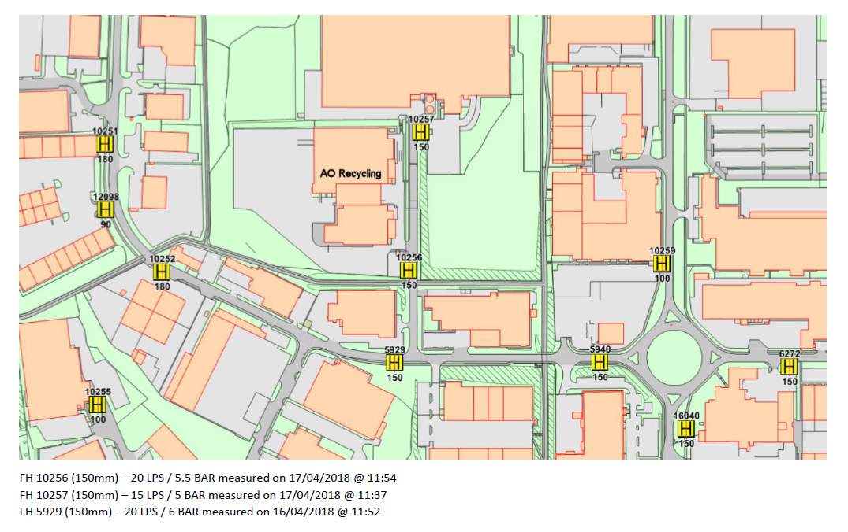

Therefore, approximate capacity of firewater available is:

20 LPS + 15 LPS + 20 LPS = 55 LPS (3,300 l/min)

Discussions with Shropshire Fire and Rescue indicate that they undertake routine checks of the water supply system, including water pressures.

It is anticipated that the response to a fire at the site would be by both a Brigade Response Vehicle (BRV) or a Pump Rescue Ladder (PRL) or a combination of both. For the purposes of the plan, it is understood that a PRL carries a firefighting water storage capacity of 1,800 litres and a BRV carries a storage capacity of 280 litres.

# Managing Fire Water

## Site Drainage and Containment

CIRIA guidance C736 states that water quantities equivalent of a rainfall for 24 hours before a fire incident, rainfall during the fire incident and rainfall for 8 days after the fire incident must be contained. The magnitude of the rainfall in the calculations must be equal to the 1 in 10 (10%) annual exceedance probability (AEP) storm event.

Using calculations from CIRIA guidance document C736, figure 4.2. (See below) and selecting region 2, due to the site’s location,

|  |  |  |  |
| --- | --- | --- | --- |
|  | Standard annual average rainfall (mm) | Rainfall depth (mm) 10-year return period | |
| 24-hr duration | 8-day duration |
| Region |  |  |  |
| 1 | <600 | 29 | 54 |
| 2 | 600-800 | 32 | 65 |
| 3 | 800-1200 | 41 | 95 |
| 4 | 1200-1600 | 52 | 120 |
| 5 | 1600-3200 | 88 | 231 |
| 6 | 3200 | 106 | 288 |

Table 1

AO Recycling considers it is reasonable to assume that rainfall for the 24 hours duration prior to an incident would discharge freely from the majority of the site via the surface water drainage network.

During an incident, it is considered likely that rainwater would rapidly become pollutant loaded by either products released from stored WEEE waste or by firefighting water/foam. All site drains will be covered with clay mats to reduce the risk of firewater entering the local surface water system. Therefore, the rainfall depths associated with events with between a 1 day and an 8 day period following an incident, should be applied to the total site area of approximately 15,000m2 (1.5 ha).

The resulting rainfall volumes are set out in Table 2 below:

|  |  |
| --- | --- |
| Storm Duration | Rainfall Volume (m3) |
| 24 hours | 480 |
| 8 days | 975 |
| 48 hours (2 days) | 541.9 (estimated) |

Table 2

As set out in Section 14.1, the total expected volume of firewater to be used in an incident would be 540,000 litres or 540m3.

Therefore, the total firewater containment that will be required is:

975m3 + 540m3 = 1515m3

The decision regarding the removal of contaminated firewater will be made with consultation with the Environment Agency. Once appropriate consultation and any subsequent testing has been completed, the contained firewater will either be discharged into the drainage network or be collected by a licenced waste carrier using one or more vacuum tankers.

In either scenario, it is anticipated that contained firewater would be removed from the site within 48 hours after an incident. Therefore, it is considered by AO Recycling that the following volume can be discounted:

Firewater volumes from day 2 to day 8 following an incident = **433.1m3**

Therefore, the total firewater containment that will be required is:

**541.9m3** + 540m3 = 1081.9m3

The site predominantly consists of reinforced concrete hardstanding. The site is contoured to enable surface water to be contained within the boundaries of the site.

The site is bounded by impermeable raised concrete kerbs, which forms a 101mm impermeable bund. Given the containment area of the site (See Appendix C) and the topography of the site, the site has sufficient capacity to contain the firewater.

Due to the inaccurate nature of calculating the total firewater retention capacity required,

during a fire event sandbags will be available to be placed along the boundary to form a temporary bund to reduce the risk of fire water leaving the site. The sandbags will be stored within the main building onsite.

An underground retention chamber oil / water separator (interceptor) is fitted to the surface water drainage system to protect the environment from pollution by spilled/leaked oils. The interceptor separates coarse sediments and oil from the water and then retain the oil safely until it is removed.

The interceptor is periodically emptied, cleaned and inspected and relevant records are retained

More information regarding the inspection of the interceptor etc. is contained in the Emergency Preparedness & Response Policy.

# Actions During and After a Fire Incident

## Emergency Response Plan & Business Continuity Plan

Actions to deal with an incident from a fire are detailed in the Emergency Response Plan. The Emergency Response Plan contains contact details for all personnel, actions to deal with decontamination after the fire incident and how to notify those who could be affected by the fire.

An appointed senior member of staff would act as the incident controller to deal with the situation.

In the event of an outage due to a fire incident, the Business Continuity Plan (BCP) details actions to be taken dependant on the type of outage.

The BCP details response plans, which include diverting incoming wastes from the site to alternative locations in the event of an outage due to fire or emergency. The BCP also details recovery plans to restore operations.

The Business Continuity Team is responsible for activating and following the BCP.

## Access for Emergency Services

The main access for emergency services is the main gate to the South-East of the site. Please refer to the site plan 1 – reference Appendix A.

## Liaison with Emergency Services

We have had contact with the local emergency services (Shropshire Fire & Rescue Service). They have visited the site and conducted a site inspection.

# Appendix

Appendix A – Link to Site Plan

Appendix B – Site Location Plan

Appendix C – Link to Site Drainage Plan

Appendix D – DSEAR Information

Appendix E – Emergency Plan

# Appendix A – Site Plan 1: Site plan (includes emergency plan)

[Link to Site Plan 1](https://aoretaillimited-my.sharepoint.com/personal/mark_peters_ao_com/Documents/EHS/Level%20II/Fire%20&%20Emergency/8.%20Emergency%20Site%20Plans/1.%20Emergency%20Site%20Plan%20-%20Halesfield%20Dec%202020%20v2.pdf)

# Appendix B – Site Plan 2: 1km sensitive receptors

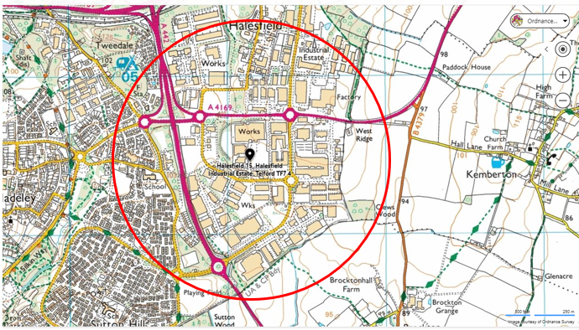

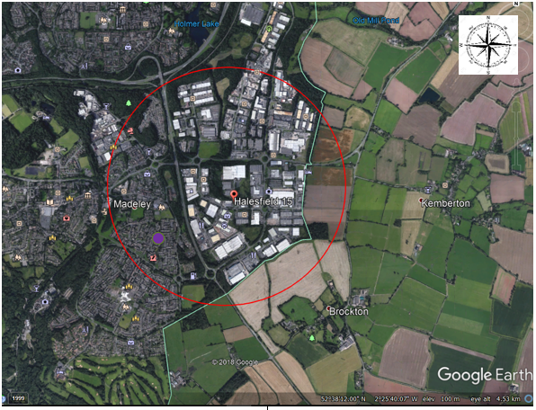

|  |  |
| --- | --- |
|  | Residential Area |

# Appendix C – Plan 3: Drainage Plan

[Link to site drainage plan](https://aoretaillimited-my.sharepoint.com/personal/mark_peters_ao_com/Documents/EHS/Level%20II/Fire%20&%20Emergency/8.%20Emergency%20Site%20Plans/Drainage%20Plan.pdf)

# Appendix D – DSEAR Information

Potentially Explosive Zones

The entire system is designed for processing explosive material. For this, there are differences in the possible operating modes "Cooling equipment recycling" and "Electrical waste recycling".

An overview of internal system areas with explosion endangered zones can be seen in drawing 02EX823793.

Cooling Equipment Recycling

The complete system is designed for the processing of CFC and CFC-free cooling equipment, also as a mix. During this, the contents of the cooling equipment (butane in the coolant circuit, pentane in the foam insulation) and the shredding of the foam insulation to PU -powder lead to various explosion risks in and around the system.

The following table contains an overview of the different explosion risks on different system assemblies and the safety measures made during operation of the machine in "Cooling equipment recycling" mode.

Gas Compound (Decanting into ISO Tanker)

Blowing agent is decanted into an ISO tanker unit which is situated in a dedicated fire bay compound surrounded by Legato A1 fire-resistant concrete blocks. A SSOW covers the safe operation of the process. Both ISO trailer and gas cylinder have adequate earthing points to dissipate ant static source. Gas monitoring is expected in the area during the decanting as per the SSOW.

|  |  |  |
| --- | --- | --- |
| Basis of Safety | | |
| Process area / Equipment | Primary Basis of Safety | Secondary Basis of Safety |
| ISO tanker decanting area | Avoidance of a flammable atmosphere | Avoidance of ignition sources |

|  |  |  |  |  |
| --- | --- | --- | --- | --- |
| System part | AKS-no. | Zone limit | Measures | Ex-zone(s) |
| Shredding | | | | |
| QZ2500  Buffer screen  Plunger pump  Filter QZ  crew dust re-feed | 0210HU1030  0210HQ1060  0210GP1070  0210HQ1120  0210GP1130 | Within Machine | Redundantly monitored inert atmosphere (QZ < 6%) Pressure release | 2 (Pentane)  22 (PU dust) |
| Heating screw sieve: | | | | |
| Heating screw conveyor  PU screen machine | 0210GP2010  0210HQ2020 | Within  Machine | Inert atmosphere with monitored minimum flow  (QZ < 10%) | 2 (Pentane)  22 (PU dust) |
| Matrix degassing: | | | | |
| Cellular wheel sluice PU powder  Ascending screw conveyor matrix degassing  Distribution screw conveyor rig degassing  Heating mixer 1  Heating mixer 2  Tempering mixer  Discharging screw PU powder | 0210QR2200  0210GP2210  0210GP2220  0210HP2230  0210HP2240  0210HP2250  0210GP2260 | Within  Machine | Inert atmosphere with monitored minimum flow  (QZ < 10%) | 2 (Pentane)  22 (PU dust) |
| Cyclone filter heavy parts separator | 0250HQ7200 | Within  Machine | Pressure release | 21 (PU dust) |
| Aspiration plant for dedusting the Fe-NFE-separation unit | 0250HQ7100 | Within  Machine | Pressure release | 21 (PU dust) |
| Drainage station for refrigerators (step 1) | 0210HS5100 | 200 mm around the suction head, within the pipeline, within the frame | | 2  1  2 |
| CFC recovery system including pipeline | 0210EQ1240  0210GQ1150  0210HS5200  … | Within the system | monitored inert atmosphere  (O² < 6%) | 2 (Pentane) |
| CFC filling | / | Within the system, filling space | technical ventilation | 2 (Pentane) |

|  |  |  |  |  |
| --- | --- | --- | --- | --- |
| System part | AKS-no. | Zone limit | Measures | Ex-zone(s) |
| Decanting ISO Tanker | | | | |
| ISO Tanker | N/A | ISO tanker inlet valve & gas cylinder charging valve (Based on analogy of the hazardous area classification applied to LPG refuelling; taken from EI Model code of safe practice Part 15: Area classification for installations handling flammable fluids). 1.5 meter zone noted in diagram is from the filling point | Pressure release  Bottom loading | 2 |