This document is a controlled document held by the Environmental management system

Table of Contents

No. |  | Subject
1 |  | INTRODUCTION & PURPOSE
2 |  | TERMS & DEFINITIONS
3 |  | APPLICATION & SCOPE
4 |  | REQUIREMENTS
 | 4.1 | Internal Auditor Qualifications
5 |  | PROCESS
 | 5.1 | Audit Preparation
 | 5.2 | Audit Initiation
 | 5.3 | Audit Completion
 | 5.4 | Audit Documentation & Records
 |  | REVISION STATUS

- Introduction and Purpose

The Purpose of this procedure is to define NRS process for undertaking internal audits in order to assess the maintenance and effectiveness of the application of the environmental management system.

- Terms and Definitions

Term | Clause | Definition
Internal Audit | 3.9.1 | Systematic, independent and documented process for obtaining audit evidence and evaluating it objectively to determine the extent to which audit criteria’s are fulfilled is taken to mean a managerial tool which evaluates effectiveness of the environmental Management system.
Internal Auditor | 3.9.9 | Person with the demonstrated person attributes and competence (3.1.6 and 3.9.14) to conduct and audit.
Non-Conformance | 3.1.2 | Is taken to mean an observation that indicates a product, policy or practice is contrary to the requirements of customer, or the standard or documented procedures.

- Application and Scope

The scope of this procedure is focussed on assessing the effectiveness of the implementation and maintenance of NRS Environmental management system. Where such processes are found to be deficient, the audit will lead to improvement in those processes.
By applying the principles of auditing NRS ensures that all audits are conducted with due professional care, integrity and independence. All conclusions derived from the audit are based upon objective, traceable evidence.

- Requirements

4.1 Internal Auditor

Auditors must be capable of objectivity and impartiality of the audit process assigned.

- Process

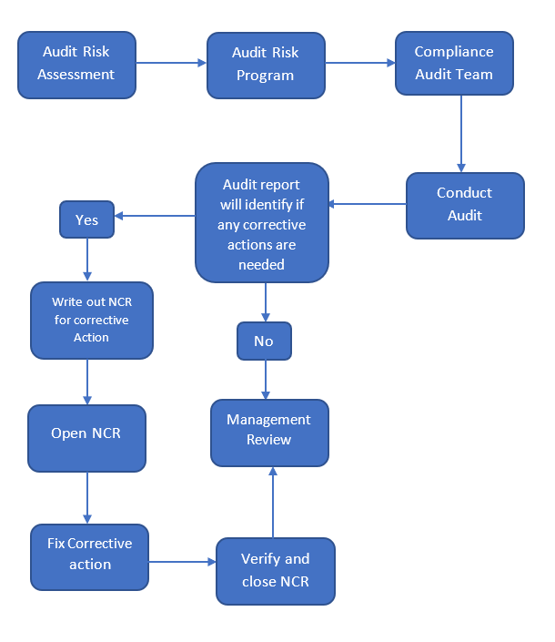

5.1 Audit Preparation
ISO 14001 procedures are audited a minimum of once a year. Audits may be completed with a greater frequency if determined by top management.

Directors are required to:
Establish and implement an audit programme based on the status and importance of the processes and areas being audited and the results of previous audits using the Audit Programme
- Define the audit criteria, scope, method and frequency.
- Provide authority to the audit programme

Internal Auditor is required to:
- Prepare for the audit using the Audit process flow following criteria, scope and methods assigned by top management.

5.2 Audit Initiation

Internal Auditor is required to:
- Conduct the audit using the Process Audit pages and following these guidelines;
- Note the requirements of current ISO 14001 standard and refer all evidence back to the standard to determine conformity status and areas for improvement.
- Search for objective evidence of conformity and effectiveness of the Environmental management system
- Sample and observe necessary process inputs/outputs to establish conformity to planned requirements
- Record objective evidence to verify compliance or non-conformance

5.3 Audit Completion

Internal Auditor is required to:
- Complete Internal Audit Report Doc number and report findings to management
- Initiate corrective action processes where required, and update register
- Conduct follow-up audit to verify close-out of corrective action
- Follow-up audit to verify effectiveness of corrective actions
- Conduct close out meeting if required.
- Report audit findings, non-conformances, corrective actions to the management team.

Directors are required to:
- Review and approve audit report
- Ensure that corrections and corrective actions are carried out without undue delay.
- Communicate audit report findings
- Make recommendations for improvement
- Update the audit programme and audit schedule
- Obtain feedback on the audit process
- Improve audit process
- Follow up actions that result from audits in the Management Review Meeting and verify results.
- Use audit evidence to drive improvement
- Use audit evidence to promote best practice

5.4 Audit Documentation and Records

Top Management are required to:
- Manage all documentation and records generated by the internal audit process and ensure records are maintained.
- Review Internal Audit Reports and at times Top Management

Internal Auditor is required to:
- Review relevant requirements of the current ISO 14001 standard
- Conduct document review though out the audit process
- Review and prepare audit checklists and audit reports.

 | Signature | Position | Date
Approved by: |  | MD

Revision status
Revision | Date | Amendment | Content manager | Approved by
1.0 | 19/11/2019 | New document | K Brewer
1.0 | 19/11/2020 | Document Review
1.0 | 19/11/2021 | Document Review

