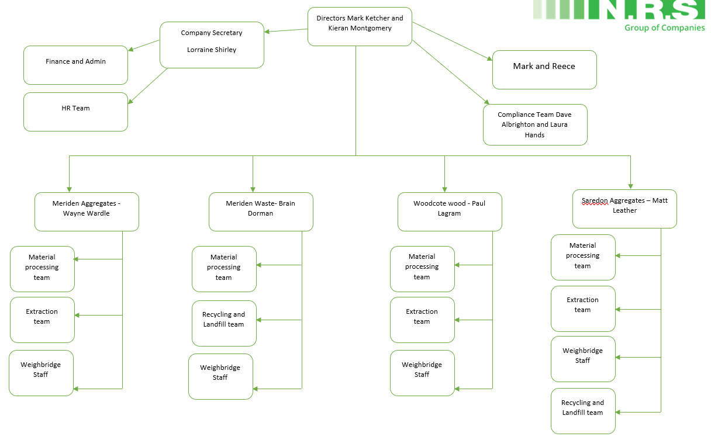
Role | Person | Responsibilities
Directors | Mark Ketcher  Kieran Montgomery | - Taking accountability for the effectiveness of the EMS.  - Ensuring that the environmental policy and environmental objectives are established and are compatible with the strategic direction and the context of the organisation.  - Ensuring the integration of the EMS requirements into the organisations business processes  - Ensuring the resources needed for the EMS are available  - Communicating the importance of effective environmental management and conforming to the EMS requirements  - Ensuring the EMS achieves its intended outcomes  - Directing and supporting persons to contribute to the effectiveness of the EMS  - Promoting continual improvement  - Supporting other relevant management roles to demonstrate their leadership as it applies to their areas of responsibility
Company Secretary | Lorraine Shirley | - General company secretary duties as per the companies act 2006/2008  - Managing head office team – all departments  - Insurance  - Complaints  - Environment  - Liaising with directors/ shareholders  - Adhoc duties
Compliance Coordinators | David Albrighton  Laura Hands | - Internal site audits  - Document control  - Compliance control  - Audit preparation  - External audits  - Accreditation preparation  - Reporting performance of the EMS to top management  - Performance reviews of the ems  - Responding to and maintaining records of site environmental communications  - Maintaining records and documented information as appropriate  - Advising top management on the implementation of the EMS and maintenance of compliance with the standard  - Organising and carrying out management reviews  - Approve and reapprove the EMS documents for adequacy  - Ensure effective communication of the company’s environmental policy
Quarry Manger | Wayne Wardle – Meriden Aggregates  Paul Lagram – Woodcote Wood  Matt Leather – Saredon  Brian Dorman – Meriden Waste Management  Allan McKenzie - Site Supervisor – all sites | - Examining the materials produced to ensure that a high quality of product is maintained.  - Closely monitoring all areas of the quarry to ensure that extraction and processing work is carried out to the highest standard.  - Assessing equipment and production materials levels; undertaking regular site inspections and risk assessments in order to comply with all health and safety regulations.  - Checking that all machinery/ vehicles on site are maintained to a good standard.  - Ordering new items for site and staff as required.  - Liaising with staff on site and dealing with any technical or staffing challenges that may arise.  - Balancing the needs of the customers with the internal production of material.  - Liaising with sales and commercial teams.  - Producing traffic management plans for site.  - Carrying out daily/ weekly/ monthly and yearly site inspections.  - Delivering toolbox talks and company updates to staff members.  - Identifying training requirements for site.  - Maintaining up- to-date records on site and dealing with a range of paperwork.  - Keeping up to date with relevant government legislation and industry developments.  - Checking that the quarry’s production levels are maintained safely and to schedule.  - Managing and recruiting staff.  - Providing the accounts team with statistics on the quarry’s performance.
Environmental and Compliance Co-ordinator | Reece Townend | - Provide WAMITAB cover for landfill and recycling operations  - Liaise with EA during audits and action any CAR reports if required  - Quarterly waste returns (provide the volumes tipped in landfill and recycling sites to EA)  - Oversee landfill monitoring reports sent to EA via consultant  - Write and update; WRAP protocol, acceptance procedures and rejection procedures  - Oversee recycled material testing and specialised materials  - Ensure we are complying to our permit and planning conditions for landfill and recycling  - Approve or reject construction and demolition sites for tipping by chemically and historically assessing sites  - Commercially price customers for tipping as well as material when required  - Create remediation strategies and testing regimes for new contracts
Aggregate and Concrete Technician | Sophie Hughes | - Provide technical advice and support to other internal departments.  - Provide technical advice and support to customers (emails, phone calls, and site visits).  - Carry out preliminary complaint investigations.  - Report all material no conformities to quarry management.  - Monitoring of analysis and trends following testing materials to ensure appropriate preventative action have been taken to ensure quality and technical performance is maintained.  - Ensuring all laboratory equipment is well maintained and calibrated.  - Management system procedures in full compliance with bs standards.  - Ensure the sampling and testing of all aggregates and concrete materials are carried out at required frequencies.  - Ensuring all work within the laboratory is carried out in a safe manner and the premises are maintained in a clean and tidy manner.  - Assist quarry management with relevant audit assessments.
Aggregate and Technician Apprentice | Joe Corbett | - Carry out daily testing withing the laboratory.  - Carry out weekly and daily aggregate sampling on NRS sites (sampling stock and current production).  - Carry out weekly concrete sampling (Midland Mix Concrete).  - Comply to relevant BS Standards.  - Assist with preliminary compliant investigation.  - Report all instances of product and test failures to technical line manager.  - Completion of test forms.  - Imputing test results.  - Ensure all laboratory equipment is well maintained.  - Ensure the laboratory is maintained in a clean and tidy manner at all times.
Material Processing Team | N/A | - Day to day operating of the wash plant for production of materials.  - Daily/weekly inspection and checking of the processing plant, reporting any problem/issues.  - Inspections and checks of final products for quality and conformity.  - Operate mobile plant when required.  - Supervise quarry staff as and when required.  - Quarry Regulations 1999, Section 8.1d appointee, deputy to the quarry manager.  - Liaise with contractor fitters/engineers on site.  - Liaise with visitors and customers.  - Work closely with the quarry manager to achieve set targets of production and cost control.
Extraction team | N/A | - Operate and maintain the mobile plant.  - Load road lorries with finished products for sale.  - Load road lorries from the surge pile for production.  - Liaise with quarry manager and wash plant supervisor of stocks and production controls.  - Liaise with visiting lorries.
Recycling Team | N/A | – Excavator operator –  - Loads the plant  - Looks after the plant i.e. cleaning / Autonomous maintenance / Running the plant.  Loading Shovel operator –  - Stocking material from the plant  - Loading road wagons  - Loading dumpers  - Cleaning / Autonomous maintenance  – Load inspector -  - Inspects all incoming loads to ensure that they comply with our permitted waste stream  - Ensure that if they are for landfill they have been passed off and we have the relevant information  - Divert stone enriched loads that would normally go to landfill but can be recycled  - Hold a record of each load into site and its destination. (This will be done electronically once the system is in place)  – Dumper operator –  - Taking loads of soil / hardcore to different locations as required.
Weighbridge staff |  | - Production of weight tickets via Uniwin systems for all lorries leaving the quarry.  - Liaise with visitors and customers, in person and on the telephone.  - Control of ordering of quarry stationary.  - Liaise with quarry manager and commercial staff.
Environmental Consultant | Mark Kendall | - Provide WAMITAB cover for landfill and recycling operations  - Liaise with EA during audits and action any CAR reports if required  - Quarterly waste returns (provide the volumes tipped in landfill and recycling sites to EA)  - Oversee landfill monitoring reports sent to EA via consultant  - Write and update; WRAP protocol, acceptance procedures and rejection procedures  - Oversee recycled material testing and specialised materials  - Ensure we are complying to our permit and planning conditions for landfill and recycling  - Approve or reject construction and demolition sites for tipping by chemically and historically assessing sites  - Commercially price customers for tipping as well as material when required  - Create remediation strategies and testing regimes for new contracts
External Planning Consultant | n/a | - Liaise with local authorities and national authorities and their planning departments  - Creating and submitting various applications for NRS sites  - Arranging for surveys to be carried out  - Documenting and controlling application and survey paperwork and keeping it on file  - Keeping NRS up to date with new planning regs and rules that come into force.

