Objective
This site-specific Environmental Management System (EMS) is linked directly to the main Towens Environmental Management System and should be read in conjunction. The document details specifics for permit HB3004KS which do not fall under the activities detailed in the main Towens EMS.

Introduction
Condition 1.1.1 of the environmental permit requires that Towens manages and operates the activity:
- In accordance with a written Management System that identifies and minimises risks of pollution including those arising from operations, maintenance, accidents, incidents, non-conformances, closure and those drawn to the attention as a result of complaints.
- and using sufficient competent persons and resources.
Additionally, the Environment Agency (EA) has published Environmental Permitting Guidance to help Operators understand the conditions or rules of the Permit. It describes the standards and measures that must be used to control the most common risks of pollution from the activity. The EA stipulates that an Operator must read, understand and keep a copy of the following guidance notes with the Permit.
- Develop a management system and control and monitor emissions for your environmental permit.
- WRAP Quality Protocol – Aggregates from inert waste (as the site processes soils, soil substitutes to be used for the production of aggregates) – SWP091 – Towens WRAP Quality Protocol for the Production of aggregates from inert waste.

Environmental Permit
The environmental permit (permit number: EPR/HB3004KS) authorises Towens to operate, receive and process waste in accordance with the criteria outlined in the permit.

The permit is a bespoke permit for a physical treatment of non-hazardous waste site for the treatment of soils to produce products for re-use.
Towens may employ third party companies to carry out crushing and screening activities using mobile plant. The sub-contractor will be made aware of this Management System and will work in accordance with it and its own Part B mobile plant permit requirements.

Site Location
The site is located at Former Airfield, Land off A372, Westonzoyland, TA7 0JS as shown on the Site Location Plan in Figure 1 below. The approximate national grid reference for the site is ST 36201 34022. The site layout can be found in Figure 2.
Figure 1 – Site Location Plan (green outline)
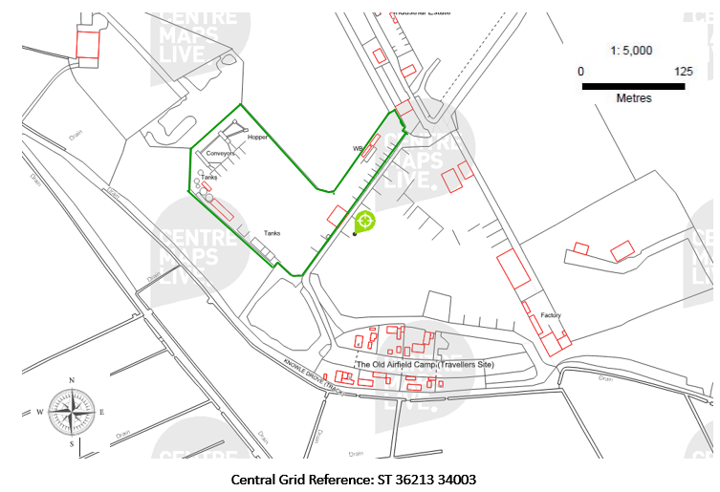

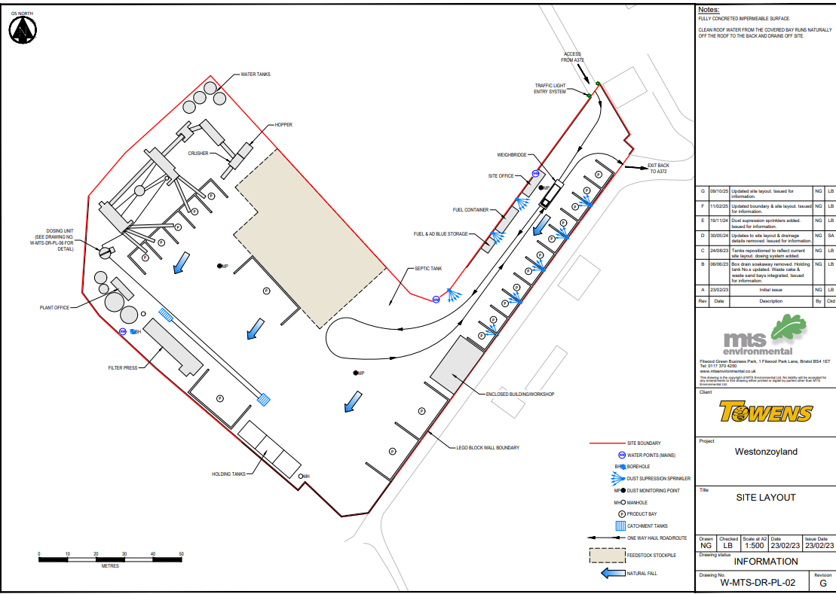
Figure 2 – Site Layout Plan

Management
Towens shall manage and operate the activities in accordance with this Management System and the Permit, using sufficient competent persons and resources.
Operating Techniques refer to the technical standards cited within EA guidance notes found on the gov.uk website and the appropriate measures for permitted facilities for non-hazardous and inert waste. Annual reviews of the guidance will be undertaken to ensure this Management System is maintained in line with current legislation and guidance.
Records demonstrating compliance with the permit shall be maintained in accordance with the Records section of this document.
Any person having duties that are or may be affected by the matters set out in this Management System shall have convenient access to a copy of this document and the permit. These documents will be available electronically via the electronic systems and issued as hard copy in the depot.

Contingency Planning
Towens will ensure that there are contingency plans in place to manage storage and treatment operations in the event of:
- Machinery / Plant breakdown
- Accidents that may result in pollution to the environment
- Delivery problems
- Adverse weather conditions
- Staff shortages
Towens will ensure that there are:
- Repair/servicing contracts in place for all plant and machinery
- That repair /replacement can be achieved rapidly
- That there is sufficient storage provision in the case of interruptions to the operation
- Available staff to cover absence
In the event of an accident Towens will follow the procedures in the Accident and Medical Incident Procedures.
In the event of an emergency, operations will be suspended where necessary to allow action to be taken safely. If necessary, all staff and others on site will be evacuated.
The Site Manager will be contacted in the event of any operational failure. Towens will decide if operations are to be suspended before corrective action is taken. Any failures will be recorded in the site diary.

Sufficiently competent persons
The site will be supervised by the nominated TCM for at least 20% of the working week during the hours of operation. The TCM holds a Level 4 Certificate in Waste and Resource Management.

Avoidance, recovery & disposal of waste produced by the activities
Towens shall take appropriate measures to ensure that:
- The waste hierarchy referred to in Article 4 of the Waste Framework Directive is applied to the generation of waste by the activities; and
- Any waste generated by the activities is treated in accordance with the waste hierarchy referred to in Article 4 of the Waste Framework Directive; and
- Where disposal is necessary, this is undertaken in a manner which minimises its impact on the environment.
Towens will ensure that each waste stream arising from the regulated facility will be characterised and quantified, using government guidance to decide how each waste stream is to be recovered or disposed of and be capable of justifying decisions that deviate from best practice.

Operations
Permitted Activities
The permit boundary is outlined in red on the Site Location Plan in Figure 1. Any references to ‘the site’ made in this document refer to this area and associated infrastructure.
The activities on site are 1.16.12 physical treatment of non-hazardous waste.
The site allows non-hazardous and inert soils and aggregates treatment and recovery (mainly in the form of washing, crushing, screening and sorting). Activities will include the storage, treatment and recovery of wastes using SWP091 Towens WRAP Quality Protocol for the production of aggregate from inert waste.
The operating hours of the site are as follows. Outside of these hours, onsite maintenance work, emergency deliveries and general office use will be the only activities on site, no waste processing operations shall occur.
07:00 to 17:00 Monday to Friday
Closed on Saturdays, Sundays and Bank/Public Holidays
The annual tonnage on site will not exceed 200,000 tonnes.
Towens shall not undertake any waste management treatment activity unless it specifically complies with Table 1.
Table 1 – Waste Activities
Description of activities for waste operations | Limits of activities
Inert waste treatment facility  R5: Recycling/reclamation of other inorganic materials  R13: Storage of waste pending any of the operations numbered R1 to R12 (excluding temporary storage, pending collection, on the site where the waste is produced) | Treatment of wastes in table S2.1 shall be limited to washing, sorting, separating, screening and crushing processes for recovery.  Subject to any other requirements of this permit wastes shall be stored for no longer than 3 years prior to recovery.
Non-hazardous waste treatment facility  R3: Recycling/reclamation of organic substances which are not used as solvents (including composting and other biological transformation processes)  R5: Recycling/reclamation of other inorganic materials  R13: Storage of waste pending any of the operations numbered R1 to R12 (excluding temporary storage, pending collection, on the site where the waste is produced) | Treatment of wastes in table S2.2 shall be limited to washing, sorting, separating, screening, chipping and shredding processes for recovery.  Subject to any other requirements of this permit wastes shall be stored for no longer than 3 years prior to recovery.  The capacity of the site for non-hazardous waste subject to an R3 activity (biological treatment only) shall not exceed 75 tonnes per day.

Permitted Wastes
No wastes other than those listed in Table 2 & Table 3 below shall be accepted onto site.
Table 2 – Inert waste codes permitted for acceptance
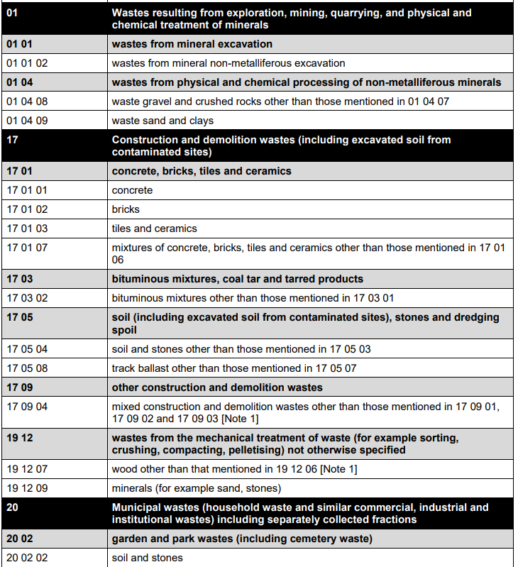

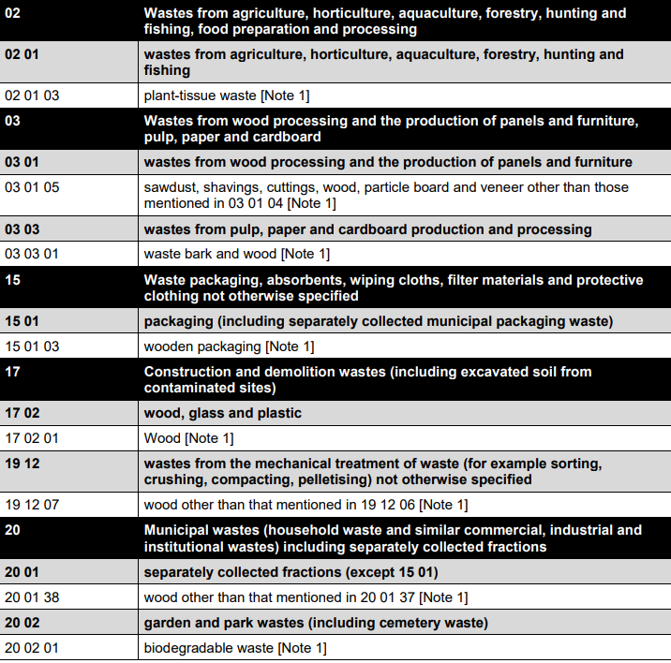
Table 3 – Non-hazardous waste codes permitted for acceptance

Note 1 – The acceptance of waste wood under this waste code shall only be permitted following the satisfactory completion of the pre-operational measure for future development reference PO1, as shown in Table S1.4 of the permit.

Operating Techniques
The site is located outside a groundwater Source Protection Zone (1 or 2), so all permitted wastes shall be stored and treated on an impermeable surface with a sealed, closed loop sustainable drainage system.
The site benefits from a sustainable drainage system, which all surface water drains following the natural fall, consisting of gullies and holding tanks. Water collected in the holding tanks will be re-used within the wash facility or used for dust suppression. Should the holding tanks become full, the contents will be transport away via tanker to a suitably permitted facility.
The whole site is surfaced in impermeable concrete.
The site will operate following the techniques listed below.

- Towens will follow this Management System, the Dust Management Plan and the Noise Management Plans approved by the Environment Agency
- The site will be operated in accordance with all the relevant parts of the EA guidance – Chemical waste: appropriate measures for permitted facilities
- All treatment shall be carried out on an impermeable surface with a sealed, closed loop drainage system with provision of spillage collection facilities and, where appropriate, decanters and cleanser degreasers
- All non-hazardous wastes shall be stored on an impermeable surface with a sealed, closed loop drainage system with provision of spillage collection facilities and, where appropriate, decanters and cleanser degreasers.
- Any non-conforming waste shall be stored in a dedicated quarantine bay on an impermeable surface before removal off site to an appropriately permitted facility
- Containers shall be stored on an impermeable surface with a sealed drainage system
Any non-conforming materials will be stored in quarantine and removed from site as soon as possible to be taken to an appropriately permitted site.
Materials will be treated following Best Available Techniques (BAT).

General principles of operation
Waste will be stored securely in segregated stockpiles or bays. Towens will take all precautions to prevent the waste from escaping and ensure that members of the public are unable to gain access to the waste.
Solid waste will be stored and managed in accordance with the appropriate measures specified. These include:
- External stockpiles and storage bays (limited to 4m high)
- Locate temporary stockpiles in areas to prevent mixing of different waste streams
- Grade temporary stockpiles to promote rainwater run off rather than infiltration through the stockpile
- Manage all run–off or leachate which may be produced by the waste within the sealed drainage system
- Be aware of slumping
- Consider location of sensitive receptors such as residential properties /workplaces in relation to stockpiles that might be affected by loss of amenity, dust, noise or odour.
Towens will follow Best Practice for the storage of materials as listed below:
- Not on land likely to become waterlogged, frozen or snow covered
- No odorous waste within 250m of residential or workplaces
- Not on steeply sloping ground where there is risk of run off
- Not over land drains or land drained in the last 12 months
- Storage on an impermeable surface
Towens will operate the following plant and machinery:
- Water Tanker vi. Sweeper
- Crusher / Screener vii. Forklift
- 360 Material Handlers
- Wheeled Loading Shovel
- Processing Plant
Waste will only be stored at the site of treatment for a maximum of 1 year prior to disposal and 3 years prior to recovery.
Hazardous or combustible wastes are not permitted on site.

Control of Mud & Debris
To control the release of mud and debris onto the public highway the following methods will be employed:
- Road sweeping
- Dampening down
- Containment, storage and treatment of waste is in segregated areas within stockpiles
- Designated one-way haul road
- Removal of excess mud and debris from vehicles prior to leaving site
In the event of any mud/debris found to be on the public highway resulting from lorry movements from the site, the affected public areas outside the site shall be cleaned. Measures will be taken to clear any such sources from the highway as soon as is practicable. All loaded vehicles will be sheeted to avoid the escape of any waste.
The site will operate in accordance with a site-specific Dust Management Plan outlining the mitigation measures in place on site.

Leaks and spillages
The site engineering for pollution prevention and the acceptance of permitted wastes only, will ensure that the risk of potentially polluting leaks and spillages of waste from the site is minimised.
Any minor spillages of liquid waste or oil shall be cleaned up immediately, using sand or proprietary absorbent to clean up liquids. In the unlikely event of a major spillage, immediate action shall be taken to prevent contamination entering surface drains, watercourses, due to the site being covered in impermeable concrete this is highly unlikely to be a factor. Temporary bunds using sand, soil or similar, or absorbents will be placed around the area affected until the spill is cleared up.
Once the spillage has been contained any materials that may be subject to contamination shall be cleared immediately and placed in sealed, labelled containers. These will be taken to a suitably permitted site for disposal. The Environment Agency shall be informed immediately, and the details of the event recorded in the site diary. SSF031 – Westonzoyland Site Diary.
In the event that a spillage has contaminated the surface water drainage system, Towens will arrange for the drainage system to be cleaned and emptied and the contents disposed of to a suitably permitted site.
Fuel and oil stored on site will be contained in compliance with oil storage regulations and stored in the weatherproof fuel store as depicted on the Site Layout Plan (Figure 2). The fuel tanks will be contained within a bund capable of containing 110% of the maximum volume of the tank. This bund will enclose all the pipework and infrastructure associated with the tank. The fuel store will be locked to prevent unauthorised access to prevent leaks and theft.
All site surfaces will be inspected during daily checks for any litter or spillages. Any litter will be swept as necessary and contained for disposal to a suitably permitted site.

Surface & Flood Water Management
The site benefits from a sustainable drainage system consisting of gullies that drain into catchment tanks and holding tanks. The water collected in these tanks are subject to a closed loop system which is reused (via a pumping system) back into the processing plant or if required used for dust suppression and dampening down. When water is not needed for re-use on site, or the holding tank is full then the water will be transported away via tanker to a suitably permitted facility.
Local watercourses will not be affected by the site as water is not discharging to a watercourse. The catchment and holding tanks trap sediment in the bottom which is drawn out and transported away to a suitably permitted facility. This drainage system prevents any contaminating discharges to local watercourses.
The site sits within Flood Zones 2 & 3 which gives it a medium chance of flooding. The holding tanks are used to contain any rainfall water which the site is subjected to, water can be pumped into the tanks where necessary. The site is furnished with impermeable concrete and concrete block walls which prevent any egress or ingress of water from the site. In the unlikely event the tanks become full they are emptied offsite to a suitably permitted facility.
The drainage system components will be maintained in accordance with the manufacturer guidelines.

Risk of fire
No combustible wastes are permitted on site.
No wastes shall be burnt on site. The use of welding/cutting tools (i.e., with naked flame) must be sanctioned first by the Site Manager/TCM and a hot works permit issued.
Special care will be taken with respect to potentially explosive/volatile material during handling, e.g., aerosol cans, oxidising agents, corrosive substances. These shall be removed from the waste load prior to further handling. These wastes are not permitted under the permit and, the quantities and occurrence of these waste types entering the site is predicted to be very small as long as the waste acceptance procedures are strictly adhered to. These will be separated and stored in the quarantine area before removal from site to an appropriately permitted site as soon as is practicably possible.
Appropriate fire extinguishers shall be made available and easily accessible.
Fuel is stored securely and appropriately.

Site Security
The site boundary is surrounded by 2.5m high concrete lego block walls and secure lockable 2.5m high gates. 24-hour CCTV is in operation on site.

Recording & Reporting Procedures
Records will be kept of all significant events (including fire, accidents, waste refusal) in the Site Diary. Information should include the nature and extent of the incident, and the actions and remediation measures taken. The site diary must be in a form where it can be audited.
Where site personnel have dealt with a fire successfully, it should be reported to the Fire Service as well as the Environment Agency.

Waste Acceptance & Control Procedures
Detailed within SWP091 – Towens WRAP Quality Protocol for the production of aggregate from inert waste.

Waste Rejection
Detailed within SWP012 – Waste rejection and tipping of non-permitted wastes

Waste Quantity
Incoming waste shall be recorded in tonnes and measured by the weighbridge. This shall be recorded by adding load information onto an electronic system.
4.13.2 A summary of waste outputs and inputs onto site will be submitted to the EA using the standard Generic Operator Returns electronic spreadsheet every quarter.

Site Inspections
The site inspections shall be undertaken by the TCM or Site Manager on a daily basis. SSF031 Westonzoyland Site Diary & SSF007 Ad-hoc Site Inspection Sheet are utilised to record inspections. SSF018 – Mobile Plant Inspection Form is utilised to inspect plant on a daily basis prior to operating.
Any necessary repairs will be actioned immediately and aimed to be repaired within 5 working days of discovery.
Any major defects which have the potential to cause a breach in permit if not repaired will be repaired by the end of the same working day. If this is not possible then contact with the EA will be made to agree alternative options.

Site Closure Plan
In the event that Towens wish to cease the permitted waste operations on the site, they will contact the EA to inform them of the closure.
Any waste remaining on site will be inspected by the TCM, who will produce plans for its quick and safe removal off site. All waste, plant and machinery will be removed from site.
A site investigation will be conducted to determine the quality of the ground condition on site following all operations.
Towens will submit a surrender of the permit application to the EA for duly making.

Emissions & Monitoring
Dust – Refer to the Dust Management Plan SWP096 – Westonzoyland Dust & Emissions Management Plan.
Noise – Refer to the Noise and Vibration Management Plan – SWP097 – Westonzoyland Noise Management Plan.
Litter - The risk of litter becoming a nuisance is considered to be very low because wastes will have been segregated and should not contain litter. However, the potential for litter nuisance will be further minimised with the implementation of the following provisions:
- Sheeting of all incoming loads
- All incoming loads to remain sheeted until ready to be tipped
- Daily inspection of the site boundaries at least once per day, corrective action to be recorded in the site diary
- Litter picking when required
On the detection of litter, Towens shall take action to review the waste management processes at the site and modify or cease handling the waste if necessary, in order to minimise the production of litter.
The incident, actions and results shall be recorded in the site diary.
Pests - Towens will take appropriate measures to prevent and reduce nuisance from scavengers, vermin and files. Due to waste types accepted at the site, it is unlikely to be a haven for pests. On detection or notification of pest infestations, immediate action shall be taken to secure the attendance of a professional pest control contractor, to eliminate the pest infestation. The incident and remedial action shall be recorded in the site diary.

Odour – The waste accepted onto site is not putrescible so odour should not be present. Any odorous loads will be rejected.

Site Records
All duty of care waste transfer notes will be kept for a minimum of 2 years. All waste received and removed from the site will be accompanied by a waste transfer note.
Records of any wastes rejected by the site shall be kept in the site office for a minimum of 6 years. These will be available for inspection by an authorised person by accessing the electronic records management system.
Records of all waste movements shall be kept in accordance with the relevant condition in the permit. Additionally, a summary record of the waste types accepted and removed from the site shall be made on the Environment Agency form every quarter. This information will be submitted to the Agency within 1 month following the end of the quarter.
Records of any off-site environmental effects including pollution incidents that caused or were alleged to have caused, harm or health effects will be retained.

Records that relate to the condition of the land and groundwater will be retained. The initial state of the site is described within the Application Site Condition Report. This is a live document and will be maintained throughout the life of the site. Records will include details on:
- Design, construction, inspection, monitoring & maintenance
- Failure of pollution prevention control measures
- Spills and incidents
- Records of investigations and remedial actions
- Records of remedial action in response to non-conformances as noted by an EA Officer
A site diary will be kept secure within the site office and made available for inspection by the Environment Agency as and when required. The diary will contain the following information and be maintained in a form in which it can be audited:
All records shall be completed within 24 hours of the event.

