

Non-Technical Summary

Soil Recovery and Recycling Facility
Towens of Weston Ltd

Westonzoyland Processing Plant
Former Airfield,
Land off A372,
Westonzoyland,
TA7 0JS

Document Title | Non-Technical Summary
Revision | 1.0
Date | 01/10/2025
Document Reference | Towens Westonzoyland NTS
Prepared For | Towens of Weston Ltd
Authored By | Towens of Weston Ltd

1. Introduction & History
This document forms the application for a permit variation for a physical treatment facility with a bespoke environmental permit for a waste treatment site under the Environmental Permitting Regulations 2016. The applicant and operator of the waste facility is Towens of Weston Ltd and the site is located in Westonzoyland at the Former Airfield, Land off A372, Westonzoyland, TA7 0JS.
This non-technical summary outlines the details of the variation application and the proposed activities to be carried out by Towens of Weston Ltd on site.
In addition to this non-technical summary, the following documents have been produced and reviewed to support this bespoke permit application:
- The relevant Environment Agency application forms (Parts A, C2, C4 and F1)
- Supporting drawings (Site Layout and Drainage Plan, Site Location Plan)
- Environmental Risk Assessment
- Dust Management Plan
- Environmental Management System
- WAMITAB certificates
- Towens of Weston Director List 2025
- Updated FRA & Drainage Strategy
The site has recently been through a variation (granted 03/06/25) to increase the tonnage allowance of the site, the application having been dealt with by Richard Melbourne. Documents which remain unchanged from this recent variation have not been included for review.

2. Application

2.1 Permit Variation Application
Towens of Weston Ltd seek to apply for a variation to their current Environmental Permit (permit number: EPR/HB3004KS) which was issued in July 2020 under the Environmental Permitting Regulations 2016. The current permit is a Bespoke permit for a site type A16: physical treatment site, the new proposed activities on site require a variation to:
- Amend the activities to include 1.16.14 – Physical & Chemical Treatment to incorporate our Aggretec Wash Plant.
- Amend AR1 to cover both Transfer & Treatment
- Amend the Schedule 7 to reflect the correct Site Location Plan

2.2 Permitted Activities
The original activities conducted on site fall under 1.16.12 – physical treatment of non-hazardous waste. The site will be used predominantly for non-hazardous soils treatment, recovery and recycling. Activities will include the storage, treatment and recovery of non-hazardous soils to produce products which can be re-used in highways, utilities and general construction under our WRAP QP.
This variation seeks to extend the activities to include washing as the site operates an Aggretec screening and washing plant. The Aggretec Screening and Washing plant has been in situ since 2022 and was operating during our most recent Noise Assessment. To this end we have not considered it necessary to have a further noise assessment produced, not least because the EA have stopped us operating the equipment until a variation has been granted. The treatment activities will also involve crushing, screening, sorting and separating which are covered under the existing permit and the most recent noise assessment. Pre-app advice EPR/HB3004KS/001P has informed us we need activity 1.16.14 added to our permit to incorporate washing.
The Aggretec Wash Facility is only required to process materials that are physically suitable, if a material has been tipped and is deemed unsuitable for processing it will be required to be transferred off site in the condition it arrived, without any processing having taken place.
The facility has been designed and will be operated to ensure compliance with all relevant requirements of the Environment Agency and the Environmental Permitting Regulations 2016.
The proposed activities covered by the Environmental Permitting (England and Wales) Regulations 2016 are provided in Table 1 below (additions from the existing permit are highlighted in red).
Table 1 – Proposed list of waste activities on site at Westonzoyland Depot
Description of activities for waste operations |  | Limits of activities
AR1: Treatment and Transfer of waste to produce soil, soil substitutes and aggregate. | R3: Recycling/reclamation of organic substances which are not used as solvents (including composting and other biological transformation processes)  R5: Recycling/reclamation of other inorganic materials  R13: Storage of waste pending any of the operations numbered R1 to R12 (excluding temporary storage, pending collection, on the site where the waste is produced) | Treatment of waste in “Table 2” shall be limited to washing, sorting, separating, screening, chipping, shredding and crushing processes for recovery.  Subject to any other requirements of this permit wastes shall be stored for no longer than 3 years prior to recovery.  The capacity of the site for non-hazardous waste subject to an R3 activity (biological treatment only) shall not exceed 75 tonnes per day.

2.3 Operating Techniques
2.3.1 All permitted wastes listed in Table 2 and activities will be stored and treated on an impermeable surface with sealed drainage.
Table 2 – Operating Techniques
Operating Techniques
- The Operator will follow the Environmental Management System, Dust Management Plan and Noise Management Plans approved by the Environment Agency.
- The site will be operated in accordance with all the relevant parts of the EA guidance – Non-hazardous and inert waste: appropriate measures for permitted facilities.
- Treatment:
- All treatment shall be carried out on an impermeable surface with sealed drainage system with provision of spillage collection facilities.
- Storage:
- All wastes shall be stored on an impermeable surface with sealed drainage system with provision of spillage collection facilities.

- All non-conforming waste shall be stored in a dedicated quarantine area on an impermeable surface before removal off site to an appropriately permitted facility.
- Buildings, covered areas or containers shall meet the following requirements:
- Buildings, covered areas or containers shall be designed, constructed and maintained to prevent ingress of rain and surface water.

3. Site Location
The site is located at the Former Airfield, Land off A372, Westonzoyland, TA7 0JS (Figure 1). The approximate national grid reference for the site is ST 36201 34022. The site is predominantly surrounded by industrial units with the nearest residential building sitting ∼330 m north of the centre of the site. There is also a caravan park located ~70m away. The Schedule 7 needs amending with the correct Site Location Plan attached in Figure 1 below.

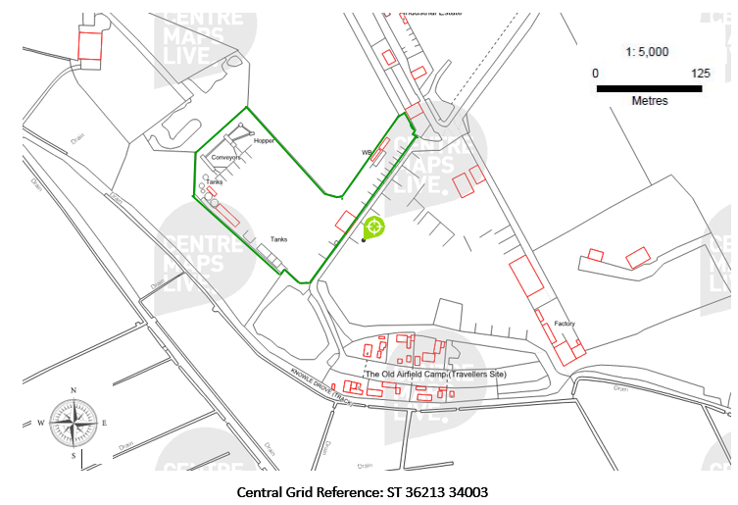
Figure 1 – Site Location Plan for Westonzoyland Depot (green outline)

4. Site Management
A Technically Competent Manager is on site for at least one full day per week and a site supervisor, who will be responsible for daily operations will continue to be on site during working hours.
The Environmental Risk Assessment submitted as part of this application will be used to identify any risks and opportunities at the site, arising from this permit and operations. Additional control measures will be implemented to prevent or reduce risks.
Operational procedures are implemented that consider the location of waste processing and storage areas.
All employees will receive environmental training that incorporates the site activities and waste streams accepted onsite.
As identified in the Environmental Risk Assessment carried out as part of the permit application, specific management plans have been created and these will be implemented as part of the Environmental Management System (EMS). These management plans account for the waste types, and quantities of waste to be treated and stored on site.

5. Environmental Setting

5.1 Potential Receptors
The site is predominantly surrounded by industrial and commercial infrastructure, including Chard H J & Sons, Kleen Kutt, Regency Grp, Burnham Coal Supplies and Slabs R Us. The nearest residential property is located off the A372, 330 m to the north of the site.
There are no hospitals, care homes or schools within 1 km of the site.
The southwest border of the site is ~63 metres away from a rhyne which forms the border of an SSSI (Site of Special Scientific Interest), designated because of grasses and aquatic invertebrate. Site-specific management plans for dust, noise and environment will be adhered to on site to mitigate risks to the SSSI and surrounding ecosystems and ecology. Appropriate assessment for noise, dust and ecology have been done to ensure that effective measures are in place on site.
All receptors within 1 km of the site are located on the Sensitive Receptor Plan.

5.2 Groundwater
The site is not within a source protection zone.
The southern half (~60% of the site) is located in Flood Zone 3 assessed as having a 0.5% (1 in 200) or greater chance of flooding each year. The northern half of the site is classified as being within areas of Flood Zone 2 (~5% of the site) and Flood Zone 1 (~35% of the site), these having up to and less than 0.1% chance of flooding.
A flood containment plan and assessment have been conducted and concludes that the southern half of the site is at risk of flooding up to a depth of 0.35m but this will not cause any detriment to the environment with the contingency plans in place. Towens of Weston are signed up to the EA’s flood warning service and have specific actions to take in the event of a flood alert and/or flood warning.
The underlying geology consists of fluvial deposits of alluvium clay, on a bedrock of mudstone and halite stone. The majority of the site is not over an aquifer but the northern most part of the site is over a minor secondary aquifer.
The ground is composed of Soilscape 8 – Slightly acid loamy texture and clayey soils with impeded drainage.

6. Application Site Condition Report
An Application Site Condition Report has not been prepared for the land as part of this new bespoke environmental permit variation because the condition of the land has not been affected.

7. Monitoring

7.1 Air
Visual inspections will be carried out daily during operational hours, especially when carrying out activities that are dust producing. Best practicable means will be applied to minimise dust emissions and to ensure compliance with the Dust Management Plan. The site will not be carrying out high dust producing processing activities.

7.2 Groundwater
No monitoring of groundwater is proposed as fugitive releases to groundwater will be prevented by conducting all operations, including the unloading of waste, sorting and storage of waste streams in areas sealed with an impermeable concrete surface to prevent a pathway for migration of pollutants to groundwater. The site also has a closed loop, fully contained drainage system to prevent polluting emissions to groundwater.

7.3 Fire Prevention
No combustible wastes will be stored or accepted on site, so a detailed Fire Prevention Plan is not required. Measures outlined in the Environmental Risk Assessment and Environmental Management System will be applied to mitigate the chance of fire.

7.4 Emissions
There will be no point source emissions to land associated with this bespoke permit via the sustainable drainage system due to it being fully contained. The water emitted at any point from the Aggretec plant is fully recycled through the drainage system back into the plant itself. Any water that is not re-used within the plant is subject to evaporation or captured in the holding tanks which are stored above ground as seen in the Site Plan. If the tanks ever become full they will be emptied and the contents transported to a suitable facility.
The potential sources of fugitive emissions to air have been identified and a Dust Management Plan has been prepared to prevent any potential dust emissions from reaching any nearby receptors.
Fugitive emissions to groundwater have been considered and all operational areas and quarantine points are surfaced with impermeable concrete. Proposed operational and storage areas are surfaced with concrete prior to any waste storage taking place. Fuel is stored in a fully bunded tank in a contained storage unit, away from waste operational areas.
All waste is loaded, unloaded, and stored on the impermeable surfacing with the sealed drainage system. In the event of a spill, leak or fire, surface water from the site will be collected in the holding tanks and removed as appropriate. The holding tanks are fully enclosed and unable to release discharges to sensitive receptors. The fire/spill water in the tanks will be removed from site to a treatment facility.
Any potentially polluting spillages at the site will be subject to the procedures detailed in the site EMS.
There is not a box-drain soakaway or water treatment facility on site which results in a discharge to the ground or surrounding areas.

8. Compliance with Best Available Techniques
Towens of Weston Ltd will work under the Best Available Techniques (BATs) and appropriate measures taken from the EA Guidance on chemical waste: appropriate measures for permitted facilities. BATs will be applied to the proposed activities at the Towens of Weston Ltd site to ensure all potential health and safety and environmental risks posed by these activities are considered and appropriately managed.

