Introduction

Background
This Dust & Particulate Management Plan (DMP) addresses the impact of dust and particulates and details the control measures implemented by Towens of Weston Ltd at the site in Westonzoyland to mitigate this risk.
The site is located at Former Airfield, Land off A372, Westonzoyland, TA7 0JS. The main activities on site will consist of soil and aggregate treatment and recovery to produce products for re-use within construction, highways and utilities.
The site is not located within an Air Quality Management Area (AQMA). The nearest AQMA is Yeovil AQMA located 22.5 km away set by South Somerset District Council. The AQMA was declared for Nitrogen dioxide (NO2) and PM10 in 2002.
Without any abatement controls, the site has the potential for dust and particulates to be generated by the following sources:
- Dust raising from public, haul roads and operational surfaces through vehicle movements.
- Dust raising from the mechanical loading/unloading of waste
- Dust raising from the treatment operation such as shredding, screening and loading
- Dust raising from stockpiles
This DMP has been written based on the following guidance:
- Guidance on the assessment of dust from demolition and construction (Institute of Air Quality Management) (2014) (version 02)
- TGN M8 Monitoring ambient air, Version 02 (2011)
- TGN M17 Monitoring particulate matter in ambient air around waste facilities, Version 02 (2013)
- Good practice guide: control and measurement of nuisance dust and PM10 from the extractive industries (AEAT/ENV/R3140 Issue 1, February 2011)
- Non-hazardous and inert waste: appropriate measures for permitted facilities (Environment Agency guidance)

This document outlines the potential sources of dust at the site, what receptors this may affect and how this will be managed by implementing mitigation strategies and infrastructure. All dust management plans align with the Towens Environmental Management System.

Sensitive Receptors
A site location map (Figure 1) shows all the receptors identified by an initial assessment, undertaken by MTS Environmental Ltd, within a 1000m range from the site, the red circle indicates the threshold area.
Figure 1: Sensitive Receptor Plan
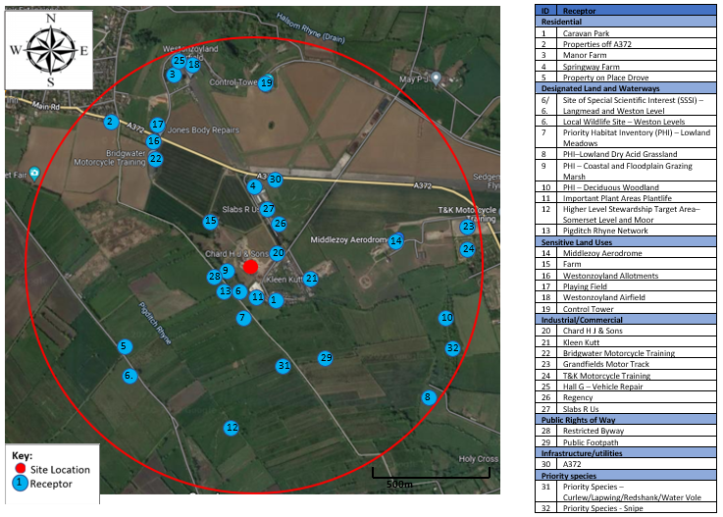

Thirty-two receptors are listed on the map, eight of which are sensitive receptors for dust (highlighted in bold in Table 1): Caravan Park (Receptor 1), Springway Farm (Receptor 4), Langmead and Weston Level SSSI/LWS (Receptor 6), Pigditch Rhyne Network (Receptor 13), Middlezoy aerodrome (Receptor 14), Westonzoyland airfield (Receptor 18) and four priority species (Receptor 31). The remaining receptors are low sensitivity receptors, all have been added to Figure 1 and the relative distances to the centre of the site detailed in Table 1.
Sources listed above could emit dust and particulate which could impair the view of the road users on the A372, however no visible pollutants should leave the boundary of the site and obstruct forward views on the surrounding local highways with the mitigation measures outlined in this plan in place.
Receptor 13, the Pigditch Rhyne Network surrounding the south of the site have been classed as a sensitive ecological receptor as they are open watercourses with the closest located ~145m from the site. Dust and particulates have the potential to cause ecological stress within the animal and plant community in the watercourse. However, damage will be mitigated by the control measures set out in this management plan and the boundary wall between the site and the receptor acts as a buffer for any dust and particulates that, in the unlikely event, escape from the site boundary. Any dust from the site will not be blown in the direction of the rhynes by the north easterly prevailing winds as the rhyne network is not located to the north east of the site.
Properties in the caravan park and Springway Farm (Receptors 1 and 4) are considered to be sensitive receptors as they are within 500m of the site. The properties in the caravan park and Springway Farm are not in the direction of the prevailing winds as they are located to the south east and north of the site, respectively. However, due to their proximity to the site, dust could have a negative effect on the residents. The site is surrounded by a 2.5 m high concrete lego block wall to act as a boundary against dust escaping the site. Alongside the mitigation measures outlined in this document and the Environmental Risk Assessment, any fugitive emissions and dust will be prevented from escaping the site boundary and impacting these receptors. Towens will also keep an open-communication channel with these receptors to ensure any issues with dust are corrected as soon as possible.
Other residential properties, Receptors 2, 3 and 5 are all located over 500m from the site. These receptors are unlikely to be susceptible to the adverse effects of exposure to any increased levels of dust and particulates. The distance between the site and the residences forms a potential buffer zone and allows time for dust and particulate to disperse before it could reach the receptors. Adding to this, visible pollutants will be mitigated from leaving the boundary of the site following the measures set out in this management plan.
Receptors 7-12, Priority Habitat Inventories, Important Plant Areas Plantlife and Higher-Level Stewardship Target Area (Somerset Level and Moor) are considered ecological receptors. Members of the public using these sites for recreational purposes or plant/animal communities at these sites may be affected by increased dust and particulates. The mitigation procedures outlined in this plan will prevent any fugitive emissions from reaching these areas. The surrounding infrastructure of the site and perimeter wall will also act as a buffer to screen dust and particulates from reaching these receptors. No dust will be carried to the receptors on the prevailing winds as they are not located to the north east of the site, the prevailing wind direction.
There are two Sites of Special Scientific Interest (SSSIs) both named as Langmead and Weston Level, Receptor 6, located 90m south and 700m south west of the centre of the site. Weston Level is also a Local Wildlife Site (LWS) located 700m south west of the site. These are considered sensitive receptors as they are designated because of grasses and aquatic invertebrate. Natural England (NE) have been consulted. They acknowledge that the prevailing wind is in an opposite direction from the SSSI (Figure 3) but raised concern that any high dust levels may affect the designated grasses. The dust suppression system installed on-site and dust and particulates, if arising, will be managed in accordance with our Environmental Management System, which covers this scenario. The site is screened from the SSSI by a high bank with tall mature scrub and trees, which is potentially also adequate to mitigate the effects of dust in average wind conditions.
There are three areas of priority species of birds (Curlew, Lapwing, Redshank) and one mammal priority species (European Water Vole) which cover the site location (Receptor 31) and one area of bird priority species for Snipe (Receptor 32) located 920m from the centre of the site. Dust and particulates are unlikely to spread to this receptor due to its proximity, but Receptor 31 is considered a sensitive receptor as it covers the site area. A general ecological impact assessment was conducted for the site and found that “No protected or invasive, non-native species of plant were identified and the habitats within the site which will be impacted by the proposed development were not deemed to provide critical resources for any other protected or notable species of animal.” Dust will be contained within the site boundary through the boundary wall and dust suppression measures outlined in this management plan so will not affect these species. Communication with Natural England will be ongoing to ensure that any changes in the species whereabouts are known and appropriate additional measures are implemented.
Middlezoy Aerodrome (Receptor 14) and Westonzoyland Airfield (Receptor 18) are located 400m and 450m from the centre of the site and are considered sensitive receptors due to their proximity and the nature of activity conducted there which relies on air quality and vision. Dust may be carried to these receptors through high winds as they lie on the outskirts of the prevailing wind direction. Dust will be contained within the boundary of the site through the boundary wall and mitigation measures outlined within this document and the Environmental Risk Assessment. Visual monitoring will be conducted on site daily at and outside the site boundary to ensure that no dust and particulate emissions are travelling off site and affecting these receptors.
There are multiple sensitive land uses surrounding the site (Receptors 15-17 and 19) which are considered medium risk receptors. Dust and emissions from the site could cause negative environmental and human health impacts at these receptors. However, with the mitigation measures outlined in this dust management plan, dust will be prevented from reaching the receptors. Due to the industrial uses of the surrounding area, this site will not generate more dust than the existing level at the location.
There are multiple industrial and commercial businesses located within 1000m from the site (Receptors 20-27). These are at a low risk due to the nature of the businesses. The likelihood of dust and particulates being emitted from the site which would affect these businesses and the people involved is very low with the abatement measures identified within the Environmental Risk Assessment and this document.
There is one public footpath and a restricted byway located within 1000m of the site (Receptors 28 and 29). The footpaths are located on the opposite sides of the boundary wall and lines of trees. These both act as a barrier between the path and the site. No dust will escape from the site and effect these paths due to its location surrounded by other industrial infrastructures and the abatement controls according to this Dust Management Plan.
There are many local wildlife sites, farmland and open space within 1000m of the site that are not marked on Figure 1 that are considered as low risk or low sensitivity in accordance with IAQM guidance. These have not been added as receptors to Figure 1.
Table 1 - Distances to selected, representative sensitive receptor locations
Receptor | Distance from site (m) | Direction
Residential
Caravan Park | 155m | South East
Properties off A372 | 860m | North West
Manor Farm | 900m | North
Springway Farm | 260m | North
Property on Place Drove | 670m | South West
Designated Land and Waterways
Site of Special Scientific Interest (SSSI) – Langmead and Weston Level | 90m and 700m | South / South West
Local Wildlife Site – Weston Levels | 700m | South West
Priority Habitat Inventory (PHI) – Lowland Meadows | 185m and further | South
PHI – Lowland Dry Acid Grassland | 955m | South East
PHI – Coastal and Floodplain Grazing Marsh | 40m | South
PHI – Deciduous Woodland | 870m | East
Important Plant Areas Plantlife (GB) | 90m | South
Higher Level Stewardship Target Area – Somerset Levels and Moors | 0m | All directions
Pigditch Rhyne Network | 145m | South and West
Sensitive Land Uses
Middlezoy Aerodrome | 400m | East
Farm | 115m | North West
Westonzoyland Allotments | 680m | North West
Playing Field | 700m | North West
Westonzoyland Airfield | 450m | North
Control Tower | 765m | North
Industrial/Commercial
Chard H J & Sons | 100m | East
Kleen Kutt | 264m | East
Bridgwater Motorcycle Training | 590m | North West
Grandfields Westonzoyland Motor Track and Learner Driver Area | 900m | East
T&K Motorcycle Training | 910m | East
Hall G – Vehicle Repair | 950m | North
Regency | 170m | North East
Slabs R Us | 210m | North
Public Rights of Way
Restricted Byway | 90m | South West
Public Footpath | 620m | South East
Infrastructure/utilities
A372 | 390m | North
Protected species
Priority Species - Curlew | 0m | North and West
Priority Species - Lapwing | 0m | All directions
Priority Species - Redshank | 0m | North and West
Priority Species–European Water Vole | Up to 500m | All directions
Priority Species - Snipe | 920m | West
Groundwater
The site is not within a source protection zone or drinking water safeguard zone

Dust Contributing Receptors
There are multiple existing local contributors of dust within 1km of the site. These have been identified on the map below in Figure 2, below.

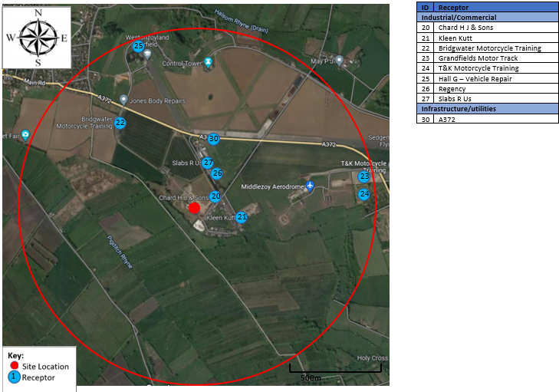
Figure 2: Dust Contributing Receptor Plan

Environmental Effects

Wind Direction
Winds with speeds exceeding >5m/s from the direction of the dust source that occur more than 20% of the time are considered to increase the likelihood of dust being raised and blown from the site. The data for Royal Naval Air Station Yeovilton, South Somerset does not define the percentage of that period which is dry. This assessment will therefore assume a worst-case scenario of all winds >5m/s occurring on dry days.
Wind rose data from Yeovilton weather station show that the prevailing wind is on average only 3.9 m/s (8.8 mph) (a gentle breeze on the Beaufort Scale) to the North East east where winds of >5m/s occur ~3% of the time, which is considered infrequent (Figure 3). Winds from the west and north west blowing to the east/south east should also be noted as they are above 5 m/s but they occur less than 2% of the time. Winds of >5m/s from all other directions are defined as ‘infrequent’ occurring ~1% of the time.

Figure 3: Wind rose showing the average wind data at Yeovilton Meteorological Station (source: Iowa Environmental Mesonet)
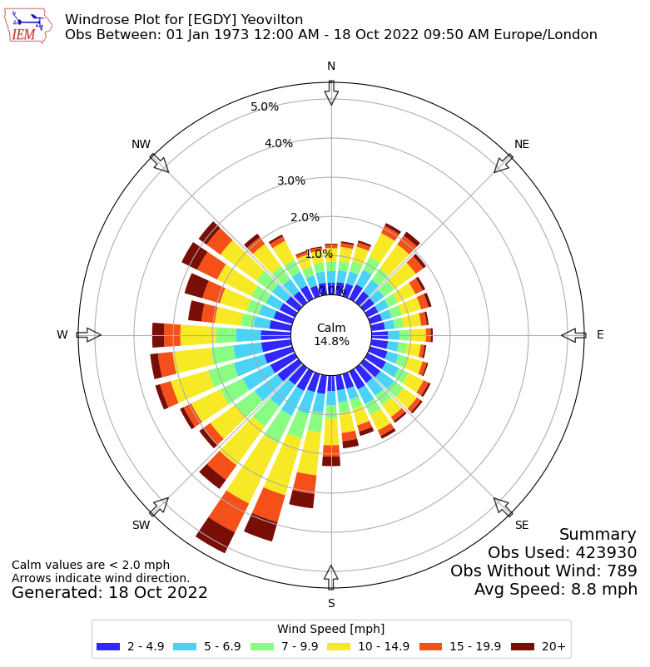
Yeovilton Meteorological weather station is located 21.6km from Westonzoyland depot and has a similar topography and similar weather conditions to those at the depot. Therefore, this wind rose data is comparable to that of the site. This station was chosen over Weston-Super-Mare weather station, as it is located inland which is similar to the location of Westonzoyland depot as opposed to Weston-Super-Mare which is by the coast so will have different weather conditions.

Rainfall
0.2 mm rainfall a day is considered sufficient to effectively suppress wind-blown emissions, however analysing days with greater than 1 mm rainfall is considered to be a more robust approach. As shown in Table 2, the average number of days per month with greater than 1mm rainfall is quite consistent throughout the year. Using this climatic rainfall data, it is likely that for 34.48% of the year dust will be suppressed due to meteorological conditions.
Table 2 – Climatic rainfall Data from 1991 - 2020 at Yeovilton Meteorological station (source: metoffice.gov.uk)
Month | Rainfall (mm) | Days of rainfall ≥1 mm (days) | Proportion of the month with days of ≥1mm rainfall (%)
January | 70.03 | 12.23 | 39.45
February | 50.87 | 10.37 | 37.04
March | 48.52 | 9.97 | 32.16
April | 51.49 | 9.97 | 33.23
May | 47.15 | 9.17 | 29.58
June | 57.12 | 8.70 | 29.00
July | 50.22 | 8.33 | 26.87
August | 60.72 | 9.77 | 31.52
September | 53.25 | 9.07 | 30.23
October | 80.89 | 12.03 | 38.81
November | 81.87 | 13.21 | 44.03
December | 77.40 | 12.97 | 41.84
Annual | 729.53 | 125.79 | 34.48

Operations at Westonzoyland Depot

Waste Deliveries to Westonzoyland Depot
The site layout plan is below, Plan 1.
Plan 1 – Site Layout Plan including dust suppression
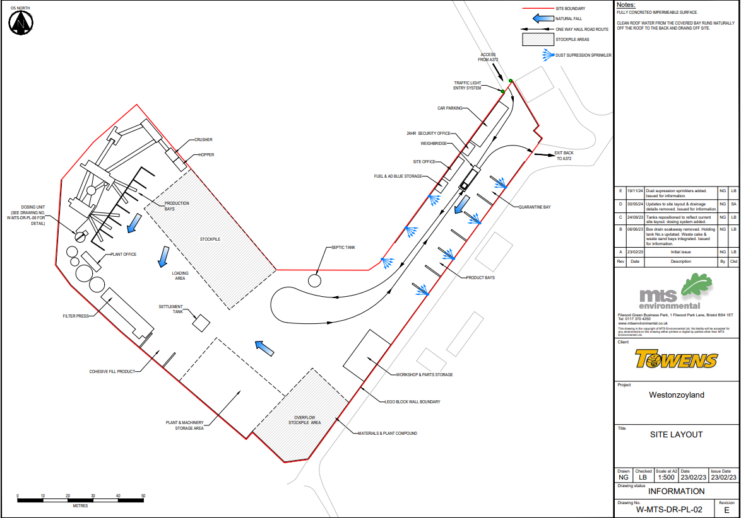

Waste will arrive on site in HGVs entering from the west off the A372. They will travel along a one-way haul road on site, over the weighbridge and will exit the site through the exit to the east back onto the A372. This will prevent any queueing on site.
Waste will be covered when transported in vehicles into and out of the site. When tipping, material will be dampened down when necessary.
Every waste movement coming onto site will be recorded by a Waste Transfer Note (WTN) or with the following information:
- A description of the waste, i.e., EWC code
- The Quantity of the waste
- The Origin of the waste
- Delivery data and the identity of the waste producer

Towens shall keep a copy of the WTN on site. All waste received at the site shall be visually inspected to confirm that the description and composition conform to the written description and the European Waste Code on the relevant WTN and to the description as detailed in the permit, and any other accompanying documentation.
If a vehicle load, upon inspection, is non-compliant with the Environmental Permit, waste will be refused entry and the event shall be recorded into the site diary. The site diary shall be kept on site.
Waste types and EWC Codes accepted on site are outlined in the Environmental Management System (EMS)
The waste acceptance procedures, implemented through the Towens WRAP Quality protocol for the production of aggregate from inert waste, will be applied to ensure that only permitted waste is accepted. Wastes that include dusts, powders or loose fibres are not accepted at the site and waste that is stored during prolonged dry periods will be damped down as necessary.
Waste will be tipped in the relevant stockpiles, processed and then products placed into their appropriate outgoing bays to await collection and removal from site.
Material will not be accepted onto site under the following circumstances:
- If there is insufficient storage capacity
- If there are extreme weather conditions, such as site flooding
- Abnormal site conditions preventing normal working

Overview of Waste Processing, Dust and other Emission Controls

The site is split into different areas for safety reasons with clear safe working areas around all working plant.
The site comprises an open yard utilised for storage of materials. There is an enclosed building used for a quarantine area for storage of non-conforming waste.
The site is enclosed within a 2.5m high concrete lego block wall which acts as a physical barrier to prevent dust and particulates escaping from site.
The site has designated paths for the entrance/exit of HGVs to move around the site to avoid the vehicles from disrupting and coming into contact with any dust in the processing area or stockpiles.
The only access to the site from public roads is via the A372. Vehicles enter through the haul road off the A372 on the west of the site and pass the weighbridge. Loads are inspected from the office before being accepted on site. Once inspected, vehicles follow the one-way haul road and wastes are tipped into the appropriate stockpile. Vehicles then exit the site via the weighbridge and exit through the western exit leading back onto the A372.
The office is located near the site entrance to allow observation of the entry and exit of vehicles.
Wastes will be stored in open stockpiles and bays which screen the materials on three sides, this will further buffer winds and prevent dust arising. Any non-conforming dusty wastes are stored within a covered building to prevent wind whipping prior to removal off site.
The site has a sustainable drainage system where all surface run off drains into a settlement tank, subsequent full retention interceptors and a treatment container. This water can then be reused on site for dust suppression.
The site will operate an excavator, crusher, screener and processing plant. The wastes being processed on site are not dusty and any processing is conducted in suitable weather conditions. Therefore, activities should not produce fugitive dust emissions.
Any open stockpiles and storage bays are regularly managed to maintain their size and location on site. Crushing will be done on small volumes frequently to ensure that stockpiles remain below 4m and wind-whipping does not occur.
The whole site is surfaced in impermeable concrete.
A quarantine area is located within the site where non-conforming material will be transferred to for removal off site to an appropriately permitted facility.

Dust and Particulate (PM10) Management

Responsibility for Implementation of this plan
The Technically Competent Manager (TCM) is responsible for implementing the DMP.
The TCM will undertake daily visual checks on all plant and operational activities.
A designated member of staff will undertake regular inspections of the site and its boundary to check for any evidence of dust deposition. These checks and observations would be recorded in the site diary. The frequency of checks would be increased when activities with a high potential to produce dust are being carried out and/or during prolonged dry or windy conditions.
Staff at all levels shall receive the necessary training and instruction in their duties relating to control of the plant and airborne emissions. Training will be given to all operatives on all aspects and impacts relating to the operation. All HSEQ (Health Safety Environment & Quality) training will be delivered in accordance with site RAMS (Risk Assessment & Method Statements) documentation. Additional training requirements will be reviewed annually, or if there are any procedural changes or changes in plant.
The TCM will review the DMP during annual audits to make sure it complies with the Environment Agency (EA) guidance. The DMP will also be reviewed if any dust complaint is received.

Environmental Monitoring for Vulnerable Receptors
Environmental monitoring may be required where there are vulnerable receptors. No visible dust is permitted to leave the site boundary therefore it should not cause nuisance to any of the receptors identified.
Mitigation measures are listed in to minimise any adverse impact.

Sources and Control of Fugitive Dust/Particulate Emissions
Emission Limits

The following emissions limits shall apply:
Table 3 - Emission Limits and Monitoring Requirements
Emissions | Sources | Limit | Monitoring
Dust | Dust raising from public, haul roads and operational surfaces through vehicle movements | No visible airborne emission to cross the site boundary | Operator visual observations at site boundaries downwind of operations for dust emissions at least twice daily. Abnormal events causing dust to be recorded in site diary.
Dust | Dust raising from the mechanical loading/unloading of wastes | No visible airborne emission to cross the site boundary | Operator visual observations at site boundaries downwind of operations for dust emissions at least twice daily. Abnormal events causing dust to be recorded in site diary.
Dust | Dust and particulate raising from the treatment operation such as crushing | No visible airborne emission to cross the site boundary | Operator visual observations at site boundaries downwind of operations for dust emissions at least twice daily. Abnormal events causing dust to be recorded in site diary.
Dust | Dust and particulate raising from stockpiles | No visible airborne emission to cross the site boundary | Operator visual observations at site boundaries downwind of operations for dust emissions at least twice daily. Abnormal events causing dust to be recorded in site diary.
The site Environmental Risk Assessment includes a source – pathway – receptor model for the control of site environmental impacts.
Towens shall record observations and weather conditions on the dust monitoring sheet. Any abnormal dust observations will be recorded in the site diary. The records must include the time, location and result of the visual assessment. The record must be kept by Towens for at least two years and be made available to the regulator for examination, on request.
Any historical records kept off site should be made available to the regulator for inspection within one working week of a request.

Control Techniques
BPM (Best Practicable Means) will be met in terms of emission limits outlined in Table 3. Towens of Weston will also comply with the ‘Non-hazardous and inert waste: appropriate measures for permitted facilities’ guidance given by the Environment Agency, found on the gov.uk website. The control techniques that shall be used are given below and further defined in Towens Environmental Management System. Other techniques may be used providing Towens of Weston Ltd can demonstrate that an equivalent level of control will be achieved. Prior written approval must be obtained from the regulator prior to using any other technique.

Stockpiles and Ground Storage
Airborne emissions from stockpiles shall be controlled. Methods such as limiting the location of stockpiles, covering or damping down will be used. Consideration shall be given to prevailing winds and weather conditions, such as a change in wind speed or wind direction and dust suppression used or operations modified accordingly, for example suspension of operations at times of high winds and dry weather.
Transferring of all materials to and from stockpiles shall be carried out in such a manner as to minimise airborne emissions this may include damping down when required, minimising drop heights from all plant and machinery and covering tippers. Operational areas will be regularly swept and washed or dampened as part of the housekeeping regime.
All wastes will be stored in the designated stockpile or storage bays and kept below 3m high to prevent wind whipping. Waste types will not be mixed or come into contact with the other to prevent contamination. Loads will be inspected upon arrival and any non-conforming material will be stored within the building. Wastes are screened by bay walls and the perimeter walls to aid the retention and reduce the likelihood of dust being blown off site from stored materials. The walls are 5m in height.
Dusty wastes will be damped down during high winds or drought or when dust emissions can be seen during visual monitoring.
Stockpiles will not be higher than 3m. Materials stored in bays and skips will be kept below 0.5m from the top of the bay walls. These stockpile height limits will help to prevent wind whipping.

Process Operations
The tanks located on site will supply adequate water to implement dust abatement measures such as damping down. In the event of drought and if water restrictions are imposed an assessment will be made regarding water availability and operations suspended until enough water is available. A mobile water bowser is always on site and an extra one can be hired in when necessary and will always be available when needed.
Pole-mounted water spray dust suppression are available on the crushing and screening plants. All operators will be trained and implement the necessary dust mitigation activities. If a load is overly dusty then operations will be ceased. If sub-contractors are required on site for large volumes of processing, the TCM will brief the specialist on this DMP to ensure dust impacts are mitigated. Activities (permitted by local authority Part B installation Permits) are to be monitored by local environmental health officers.
When depositing material into stockpiles or for processing, drop heights shall be minimised to reduce dust production. Any loads where dust is visible upon inspection on arrival or during dry periods where some dust may be present on the site surface will be sprayed prior to tipping. It is unlikely that these loads will be dusty due to their nature.
Processing operations will be ceased in high winds (<25 mph).
The only non-road going machinery on site is the processing plant, this is a non-mobile machine. There is also 3x 360 excavators, a shovel, a forklift, a telehandler and a grab, these are mobile, and their location will vary during operating hours depending on where they are needed on site.
Mobile plant machines have functioning air conditioning systems.

Loading and Unloading
When loading vehicles, materials will be dampened down if any dust is generated and the material will not be placed higher than the vehicle sides. Any spillage of material during loading will be removed as part of routine housekeeping measures. Vehicles shall be sheeted when entering or leaving. Any vehicles which have materials covering external surfaces will be cleaned with a high-pressure hose to prevent dust generation before leaving site.

Roadways and Transportation
The haul road on the site is wetted down as required. Towens road sweeper will be used on the site haul road and entrance/access road as a dust suppression solution. Manual sweeping will also be carried out when dust from haul roads appears airborne during daily inspections. This sweeping will keep the site roadways clear of dust, mud and debris. If there are any build-up of deposits on site, then manual scraping will be carried out to remove them prior to sweeping. Any sweeping will be recorded in the site diary.
The site has been designed so no haulage vehicles will be in contact with mud from operational surfaces, vehicles will avoid all areas where wastes are stockpiled by following a designated haul road. This will keep the site haul road clear of any dust, mud or debris and manual sweeping will be used to maintain clearance on the site haul road. The nature of the waste on site is also not dusty/muddy so haul roads are unlikely to become dusty.
The site access road is concrete which will provide easy access for HGVs to prevent a backlog of vehicles building up and blocking the A372. The site concrete surface will also reduce unsettling of dust.
There will be a speed limit of 10mph on site to prevent dust generation from surfaces.
The company has an ‘Anti-Idling Policy’ to ensure that any stationary vehicles switch off their engines which will be enforced on site.

Water based dust suppression system
Pole mounted water spray dust suppression will be used on the crushing and screening plant.
The pole mounted water spray dust suppression is mobile and will be used to dampen down stored materials and stockpiles to reduce dust production. It can cover the entire external site as it is mobile. Wastes accepted on site do not have a dusty nature, so a fixed suppression system is not required but we have installed fixed water suppression along the bays situated along the haul road. The water for this system will be provided through the treated site run off which is collected in tanks.
There will also be a mobile water bowser on site to be used for dust suppression to create a further level of protection against dust in addition to the spray dust suppression system.
The spray suppression system will cover the whole external site area where materials are to be stockpiled and tipped to reduce dust production. It will be used during operating hours by trained site staff to ensure that materials stockpiled are sufficiently dampened down so that they do not produce any dust during non-operating hours. It will be used continually during operating hours which is why a spray system has been chosen over water cannons or sprinklers which use more water and are often less effective as the water droplets are bigger so are less likely to suppress the smaller dust particles. This makes the system water efficient.
A sufficient supply of water for the dust suppression system will be provided whilst the site is operational through the comprehensive drainage system. All surface water drains into the sustainable drainage system is stored in tanks. The stored water is to be reused and supply the dust suppression system. Any overflow will drain into ground through a box drain soakaway. In the event that there is not sufficient water from runoff then the site benefits from a borehole extraction so this will be used for dust suppression, this will be used as a contingency. If there is still not sufficient water for dust suppression, then any tipping will be ceased on site until the suppression system is fully operational again and the storage tank is half full.
In the event of a drought or if the borehole fails and there is not water stored in the holding tank on site, if any operations cause or are likely to cause excessive dust emissions beyond the site boundary, or if abnormal dust emissions are observed, site operations may be temporarily suspended to avoid further dust emissions. This will be decided by the Site Manager. If restrictions are enforced to restrict the amount of water available for use on site, this may lead to the suspension of operations that require a high-water usage.
Table 5 - Source-Pathway-Receptor Routes
Source | Pathway | Receptor | Type of impact | Where relationship can be interrupted
Dust and particulate raising from operational surfaces through vehicle movements; | Falling off lorries and atmospheric dispersion | Residential properties, businesses, SSSIs, LWS, habitats and rhynes | Visual soiling, also consequent resuspension as PM10 | Outlined in 3.3.19-3.3.25
Dust and particulate raising from the mechanical loading/ unloading of wastes | Atmospheric dispersion | Residential properties, businesses, SSSIs, LWS, habitats and rhynes | Visual soiling and airborne particulates | Outlined in 3.3.7, 3.3.13 and 3.3.18
Dust and particulate raising from treatment/processing operations such as shredding, screening; | Atmospheric dispersion | Residential properties, businesses, SSSIs, LWS, habitats and rhynes | Visual soiling and airborne particulates | Outlined in 3.3.11-3.3.18, and 3.3.26-3.3.31
Dust and particulate raising from stockpiles | Escape from stockpiles and subsequent atmospheric dispersion | Residential properties, businesses, SSSIs, LWS, habitats and rhynes | Airborne particulates | Outlined in 3.3.6-3.3.10
Mud | Mud dropping off vehicles and wheels when dry | A372 | Visual soiling | Outlined in 3.3.19-3.3.25
Debris | Falling off lorries and escape from stockpiles | A372 | Visual soiling, also consequent resuspension as airborne particulates | Outlined in 3.3.6-3.3.10 and 3.3.19-3.3.25

Enclosure of Waste Processing & Storage Areas
The site is enclosed within a 2.5m high concrete lego block wall which acts as a windbreak against any prevailing winds that may disrupt dust and cause it to escape off site.
Around the outer perimeter of the walls of the site, there is some established vegetation which will contribute to keeping any fugitive dust on site.
Any non-conforming wastes will be stored inside the quarantine area on an impermeable surface and removed as soon as possible to reduce fugitive dust emissions from these materials.
Non-hazardous and inert materials are stored in stockpiles and storage bays ready for processing. Once they have been processed/treated, they are transferred into their appropriate segregated outgoing bays to await collection. The stockpiles and bays are limited to 3m high to prevent wind whipping.
Micro-netting and screening will not be installed due to the visual impacts these will have on the surrounding receptors and because they will not provide further mitigation against dust in comparison with the surrounding perimeter wall at the site boundary and the dust suppression on site.

Visual Dust Monitoring
Towens shall monitor emissions and make visual inspections of the site, Table 6 sets out the measures for visual dust.
Table 6 - Mitigation measures for visual dust emissions
Appropriate Measures for Reducing Emissions of Dust – Visual Monitoring
Daily visual monitoring of aerial emissions at site boundaries shall be carried out by staff supervising all waste handling operations. | TCM to monitor operations throughout day (at least twice daily) at and outside the site boundary that is downwind of operations in the north eastern corner of the site and north of the building.
The inspection focusses on the following areas:
-Monitoring for conditions likely to increase the risk of dust release
- Visual assessment of any dust release
- Monitoring of any visible surface soiling
 | Observations and weather conditions including wind direction will be recorded on the dust monitoring sheet.
 | Complaints to be recorded in the Site Diary and complaint form.
Visual inspections should be carried out during daily operational hours, especially when carrying out activities that are dusty. Visual dust inspections will be completed at least twice daily:
- On arrival at the site and before sorting and / or agitation of the waste occurs
- After the designated lunch break, before afternoon sorting and / or agitation of the waste occurs.
Additional routine monitoring at and outside the site boundary downwind of operations will be carried out when processing. If necessary, flags shall be placed on site to help observe the wind direction and prevailing wind.
Towens shall record any abnormal observations in the site diary and report to the on-site TCM at the time of recognition who will review the visual monitoring. The records must include the time, location, and result of the visual assessment. The records will be kept by Towens for at least two years and will be made available to the regulator for examination, on request. A visual monitoring check sheet provided to staff and explained during dust training via a toolbox talk is available.
In an event that mitigation measures are not effective, and dust escapes out of the site boundaries, all dusty activities should be suspended until investigation takes place to identify cause(s) and appropriate mitigation measures.
The TCM shall suspend the operations if the weather is likely to trigger significant dust emissions that mitigation measures cannot prevent, for example high winds or drought.
Any historical records kept off-site should be made available to the regulator for inspection within one working week of a request.
All site operations and processing will only be carried out during operational hours in the day. Therefore, no dust is expected to be produced out of hours. The design of the storage bays and covering of stored material, will mitigate any dust emissions from stored materials.

Site Housekeeping Routine
Towens will adhere to a strict housekeeping routine which will contribute to reducing dust production from the site. The details of the housekeeping routine can be seen in Table 7 below.
Table 7 – General Site Housekeeping Regime
Issue | Frequency | Action
General site and road cleanliness (presence of mud/debris) | Daily | Sweep road and impermeable surfacing if mud/ debris present. Dampen down haul road and access. Record Inspections /actions in diary.
Inspect tanks, containers,  drums, drip trays and secondary  containment for leaks | Daily | Any leaks to be stopped and cleaned up, containers  to be replaced/ repaired immediately. Record  inspections/ defects, damage and repairs in diary.
Visual inspection of boundary  fences for breaks/damage | Daily | Any defects shall be made secure by temporary repair before the start of operations/end of working day and shall be repaired within 24 hours of the damage being detected. Record Inspections/ defects, damage and repairs in site diary.
Check mobile water bowser | Daily | Any defects shall be repaired before the start of  operations/end of the day within 24 hours of the  damage being detected. Record Inspections/ defects, damage and repairs in Site Diary.
Visual monitoring for aerial  emissions-monitor dust at random times throughout the day | Daily | Check outside site boundaries and at visual monitoring locations for visual dust emissions at  least twice daily.  Record inspections / results / weather conditions /  cause and actions in Site Diary.
General site cleanliness  (presence of litter and dust  deposits inside/outside site  boundary) | Daily | Site walkover and inspection. Collection from inside and outside site (including boundary hedging) twice daily. Investigate the cause. Record Inspections/defects, damage and repairs in Site Diary.
Odour | Daily | Monitoring, through sniff tests, and record keeping.
Site Signage | Weekly | Check that signs are in good condition and arrange to repair/replace if damaged. Record Inspections  /defects, damage and repairs in site diary.
Pest infestation check containers and stockpiles to monitor for vermin, scavengers and flies | Daily | Check for the presence of vermin, scavengers and/or flies.  Record daily inspections and result in Site Diary.
Ensure waste is stored in  appropriate segregated containers and areas in accordance with Good  Practice Guidance | Daily | Check quantities are in accordance with EMS and  Permit. Segregate as and when necessary. Record  actions in Site Diary.
Check condition of fixed  storage facilities – drainage,  containers etc | Weekly | Remove silt upon build up in the settlement channel.  Check and record levels within containers.  Take action to prevent spillage/remove via vacuum  tanker, etc. Record actions in site diary.
Inspection of plant | Weekly | Maintenance/repair/regular servicing.  Record actions in diary and plant maintenance log  sheets.
Building / roofing /surfacing | Monthly | Any defects affecting the integrity shall be repaired  within one week.

Contingency Planning
Mitigation measures will be constantly in place on site, however contingency measures, like ceasing operations, will only be used when there is potential for dust to be carried off site. After subsequent assessments, if conditions return to being low risk, then contingency measures can be removed. Contingency measures will be recorded in the site diary.

In the event that the dust suppression system fails then dust causing operations will be ceased. The site will not accept any deliveries or tip material on site which are of a dusty nature until the system is repaired successfully.
All plant and machinery will be maintained and calibrated in accordance with the manufacturer guidelines. If any plant fails or malfunctions then the manufacturer guidance will be consulted, and the manufacturer will be contacted if necessary.

Any identified damage to the perimeter fence that could compromise its efficiency will be recorded. A temporary repair will be made as necessary before the end of the working day. Permanent repair or replacement will be undertaken as soon as practicable.

PM10 Monitoring
The UK Air Quality Standards seek to control the health implications of respirable PM10. However, the majority of particles released from construction and related activities will be greater than this in size.
The Towens of Weston Ltd site at Westonzoyland may have the potential to elevate dust levels in the surrounding area, however, due to the size and location of the site and with mitigation measures, emissions should not affect PM10 concentrations. The PM10 impacts are classed as negligible. Further to this, nuisance dust deposition will be prevented by visual monitoring/mitigation measures identified in this plan.

The Yeovil AQMA
The Yeovil AQMA was originally declared for NO2, the designated AQMA incorporates an area comprising the whole of the built-up area of Yeovil, including the airfield, areas identified in the emerging local plan as potentially subject to development and the main road network in and around the town. It was declared on the 01/09/2002 by South Somerset District Council. The latest Air Quality Annual Status Report (2021) from South Somerset District Council states that all monitoring sites showed a decrease in NO2 concentrations in 2020 in comparison to 2019 data and none were above the objective of 40 µg/m3. There has been a 21.2µg/m3 decrease for annual NO2 concentrations in 2020 compared to 2002 at declaration.
Table 8 – Air Quality Objectives and Standards
Pollutant | Annual Mean Objective of South Somerset District Council | The Air Quality Standards Regulations 2010 Annual Mean | Level of Exceedance
Pollutant | Annual Mean Objective of South Somerset District Council | The Air Quality Standards Regulations 2010 Annual Mean | At Declaration (2002) | Current Year (2020)
Nitrogen dioxide | 40μg/m3 | 40μg/m3 | 54.6μg/m3 | 33.4μg/m3

The Towens site at Westonzoyland is situated approximately 22.5 km north west of the AQMA and PM10 was not considered sensitive, external PM10 monitoring will not be carried out on site.
The health impacts associated with long term background PM10 exposure is covered under Section 5.2 of the IAQM Guidance on the Assessment of Mineral Dust Impacts for Planning. It states, ‘If the long term background PM10 concentration is less than 17µg/m3 there is little risk that the Process Contribution (PC) would lead to an exceedance of the annual-mean objective and such a finding can be put forward qualitatively, without the need for further consideration.’ The UK is required to comply with the annual-mean objective for PM10. Defra have their own background monitoring for the UK for PM10. Areas of the country are divided into sections. The Defra Background Maps show that this locations’ PM10 background concentration is ≤13 µg/m3 for 2021. This is below the 17 µg/m3 stated in the guidance. The NO2 background concentration is ≤10 µg/m3 for 2021, this is below the 40 µg/m3 statutory limit value. Therefore, activities at this site would unlikely give rise to an exceedance that would require monitoring.

Monitoring Location
N/A

Operation of Dust Monitoring Equipment
N/A

QA/QC and Record Keeping
N/A

Equipment and Data Management
N/A

Reporting of Data
N/A

Additional Detailed Reporting
N/A

Reporting and Complaints Response

Engagement with the Community
A complaint form will be available for those who are affected by the operations. If necessary, a meeting shall be carried out with candidates if dust is causing a serious impact.
The site will have a publicly visible sign at the entrance with contact details for the Operator so neighbouring businesses or local residents can contact Towens if they have any complaints/issues.
Towens already own and run the site so have an existing presence within the community and have built good existing relationships with neighbours.
This has been achieved through having an open-door approach so that any neighbours can visit the site and talk to site staff, any issues can be discussed and Towens will change procedures if appropriate to address the issue. This approach will be continued on the proposed site.
If required, Towens will hold a meeting with neighbouring businesses and local residents to discuss any changes on site and hear any concerns. Towens will be able to reassure the community that the site will not cause them any adverse issues as they will be following strict management systems (including measures set out in this document) to prevent any negative impacts.
In the event of an incident on site, all businesses and residents within 250m will be informed by a member of Towens staff by door-to-door visits.

Reporting of Complaints
In the event of a complaint, the TCM will immediately investigate the source of dust and whether it is originating from the site. Appropriate measures should be made, and action will be taken to prevent any further emissions leaving the site. Such actions may include suspending operations at site and applying water to the dust source.
The complaint should be reported to the Environment & Compliance Manager and the Waste Director where it will be recorded. Should the concern be ongoing further investigations will take place to mitigate the effects on the receptor.
Towens should respond to the complaint within 10 working days, although mitigation should be in place as soon as is practically possible.
A Corrective Action Report will be completed describing the incident and should include details as specified above. A record shall be made in the site diary.
If deemed appropriate, the Environment & Compliance Manager will ensure that the Environment Agency (EA) is informed of these within 24 hours, ideally as soon as possible and as appropriate.
The TCM will escalate investigations if successive complaints are received, operations will be suspended if 2 or more validated complaints are received within the same week. If complaints are found to be unsubstantiated, operations will continue at the discretion of the TCM. Complaints will be formally responded to within 5 working days.

Management Responsibilities
The TCM shall take responsibility for any complaints.
The TCM is responsible for the implementation of this DMP.
The TCM & Environment & Compliance Manager will review this DMP during annual audits to make sure it complies with the Environment Agency (EA) guidance. The DMP will also be reviewed if any odour complaint is received.
Any historical records kept off site should be made available to the regulator for inspection within one working week of a request.
Any person having duties that are or may be affected by the matters set out in this DMP shall have convenient access to a copy of this document and the permit. These documents will be available electronically via the Towens of Weston Management System and issued as hard copy.

Summary
Processes carried out at the Towens of Weston site in Westonzoyland may produce dust, but it will be limited by the nature of the operations and mitigation measures. In any event, dust can be controlled to prevent its escape and to minimise airborne dispersal.
The main causes of dust will be related to processing activities, transportation, and stockpiling.
Dust from processing activities will be controlled by effective site management with appropriate mitigation measures, this will include:
- Daily review of prevailing weather conditions and site operations
- Dust suppression spray covering outdoor storage area
- Use of spray on crushing plant
- Damping down of stockpiles and site haul roads
- Appropriate location of stockpiles and processing areas to prevent windblown dust escaping
- Regular maintenance of all plant
- Keeping vehicles and roadways clean and dust free
- Careful transfer of material on site
- Postponing operations if significant wind-blown dust is likely to occur

Daily monitoring of dust levels and an annual review of the DMP will be carried out to prevent any adverse dust impacts from the site. All monitoring is discussed with Management at the monthly Environmental Management Meeting.

The procedures outlined in this DMP apply to all activities carried out at the Westonzoyland site for both wastes and non-waste materials stored at the facility.

Appendix A – Complaint Form

Appendix B – Monitoring Form

2020 Air Quality Annual Status Report (ASR) – South Somerset District Council

