SSSI Assessment form: Appendix 4
Application for permission - Formal Notice (For Advice/Consultation)

This is a formal notice from the Environment Agency (EA) to Natural England (NE) (or other relevant Statutory Nature Conservation Body (SNCB)) to meet the requirements under Section 28I of the Wildlife and Countryside Act 1981 (as amended by the Countryside and Rights of Way Act (CRoW) 2000).
This is the duty in relation to granting any consent, licence or permit for activities likely to damage Sites of Special Scientific Interest (SSSI). We must seek advice (consult NE, or other SNCB) before permitting any activities that may damage a SSSI.
This notice was not sent to Natural England or other SNCB for consultation.
An additional component charge for habitats assessment was levied for this application.
Version number and date: Final - 20/03/2025

1. Name of SSSI
Langmead and Weston Level SSSI.

2. Type of permission
Environmental Permit (Waste management/landfill).

3. Proposed timing of permission
Continuous.

4. Predicted 28 day date for NE (or other SNCB) response (under S28 I (4))
N/A.

5. EA reference number
EPR/HB3004KS/V002.

6. EA site/project name
Towens of Weston Limited, Westonzoyland Depot, Former Airfield, Land off A372, Westonzoyland, TA7 0JS.

7. National grid reference
ST 36302 34074.

8. Description of proposal
The current permit is for an A16: physical waste treatment site. The operator has requested to vary the permit to include the following:
- Add new and remove some existing European Waste Codes (EWC)
- Increase the annual throughput to 200,000 tonnes
The site will be used for the storage, treatment, recovery and recycling of non-hazardous soils to produce products which can be re-used in highways, utilities and general construction.
The treatment activities covered under the existing permit involve crushing, screening, sorting and separating.
As part of this permit variation, Towens of Weston Ltd seek to obtain all codes listed in Table 1 below. The operator also seeks to remove all existing combustible waste codes (mainly for wood waste) from the permit. These waste codes are excluded from Table 1.

Table 1: List of Waste Codes that will be Accepted at Site (black = current, red = to be added in this variation)
Waste Code | Waste Description
01 01 02 | Wastes from mineral non-metalliferous excavation
01 04 08 | Waste gravel and crushed rocks other than those mentioned in 01 04 07
01 04 09 | Waste sand and clays
17 01 01 | Concrete
17 01 02 | Bricks
17 01 03 | Tiles and ceramics
17 01 07 | Mixtures of concrete, bricks, tiles and ceramics other than those mentioned in 17 01 06
17 02 02 | Glass
17 03 02 | Bituminous mixtures other than those mentioned in 17 01 06
17 05 04 | Soil and stones other than those mentioned in 17 05 03
17 05 06 | Dredging spoil other than those mentioned in 17 05 05
17 05 08 | Track ballast other than those mentioned in 17 05 07
17 09 04 | Mixed construction and demolition wastes other than those mentioned in 17 09 01, 17 09 02 and 17 09 03
19 03 05 | Stabilised wastes other than those mentioned in 19 03 04
19 03 07 | Solidified wastes other than those mentioned in 19 03 06
19 05 03 | Off-specification compost
19 08 01 | Screenings
19 09 01 | Solid waste from primary filtration and screenings
19 12 09 | Minerals (for example sand, stones)
19 12 12 | Other wastes (including mixtures of materials) from mechanical treatment of wastes other than those mentioned in 19 12 11
19 12 12 | Aggregates Only
19 13 02 | Solid wastes from soil remediation other than those mentioned in 19 13 01
20 02 02 | Soil and stones
20 02 03 | Other non-biodegradable wastes

All operations and activities will take place on impermeable concrete surfaces, and the site operates a sustainable drainage system. Site run-off is treated before being discharged via a box soakaway to ground.

9. Is the proposed activity within (wholly or partially) the SSSI boundary?
No.
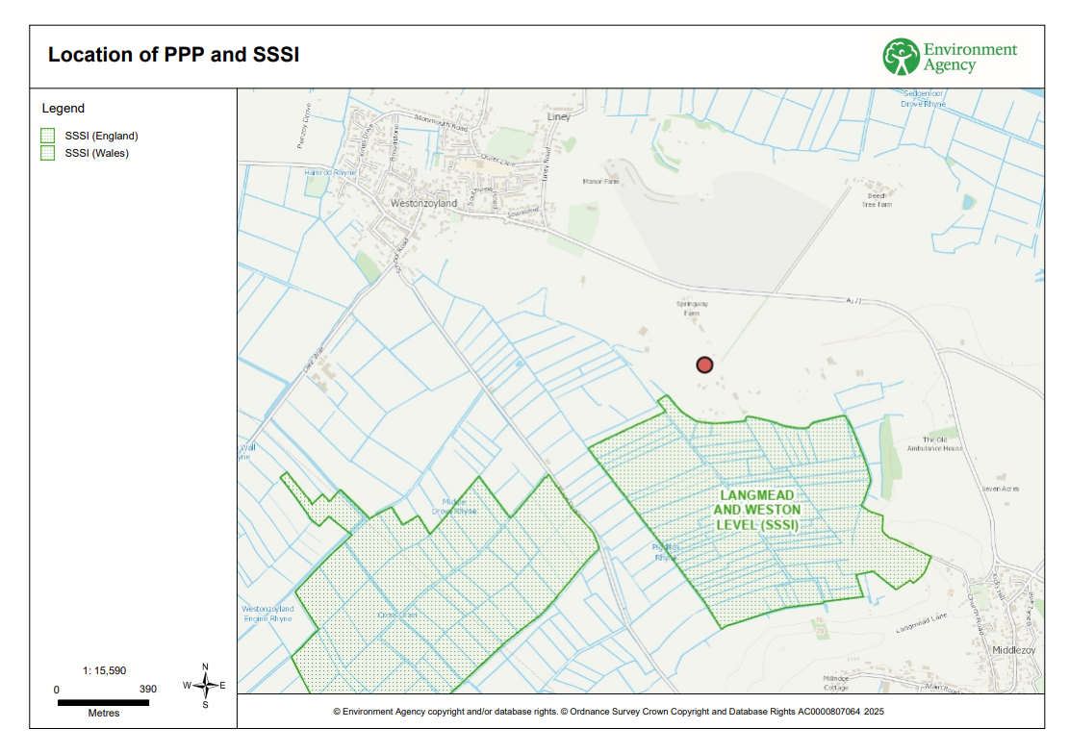

10. Has there been any discussion or correspondence with NE or other SNCB?
No.

11. Operations Requiring Consent or other activities associated with the work
The following 'Operations Requiring Consent' (or other activities associated with the work) that may cause damage are relevant to the proposed works:
Dumping, spreading or discharge of any materials.
Drainage (including moor-gripping and the use of mole, tile, tunnel or artificial drains).
Storage of materials.

12. Assessment of effects on features

Langmead and Weston Level SSSI

Langmead and Weston Level form part of the nationally important grazing marsh and ditch systems of the Somerset Levels and Moors. The site is nationally important for its species-rich neutral grassland and the invertebrate community found in the ditches and rhynes.

The SSSI consists of ten units, all of which are in an unfavourable – declining status. For all units, this condition status is attributed to excess levels of phosphate in the systems. River inputs have been found to be 3 times the CSMG target in numerous locations. Detailed survey work within the ditch systems of the SSSIs, commissioned by Natural England, reflects the situation found in the feed rivers, with very high levels of total Phosphorus.

The Internal Drainage Board have noted that ditch maintenance needs to be carried earlier in the year because of the prolific plant and algal growth blocking the ditch systems. It therefore seems that the extent of nutrient enrichment is now affecting the traditional management practices (quite apart from the deterioration of the ditch interest features) and associated invertebrate assemblage features.
Feature | Exposure, mechanism/pathway and scale of effect
Invertebrate assemblage  Lowland ditch systems  MG5 - Cynosurus cristatus - Centaurea nigra grassland | The features may be at risk of being impacted by the site through either fugitive dust emissions or through the water emissions to ground via the box soakaway.  The applicant submitted an updated Dust Emissions Management Plan (DEMP) alongside the variation application, which was accepted by the EA. The permit will require the operator adheres to the measures laid out in this plan. Doing so will minimise dust emissions from site and so it is deemed there will be no likely damage caused from these emissions.  The sustainable drainage system ensures that all run-off from site is treated prior to discharge. It has been confirmed that the site will not be accepting any wastes that contain phosphorous and as such there is expected to be no risk of exacerbating the current nutrient issues of the SSSI through the emissions of treated run-off via the box soakaway.  It is concluded this variation will not be likely to damage the SSSI or its features.

13. Decision

Langmead and Weston Level SSSI
The proposed permission is not likely to damage any of the flora, fauna or geological or physiological features which are of special interest.

Permission
The Environment Agency is minded to issue the permission.
Date sent to NE (or other SNCB), if applicable: N/A

For use when the notice has been sent to NE (or other SNCB)

14. NE (or other SNCB) comment on notice
|| NE advise against permitting the operation / the operation can go ahead with / without conditions. ||
Date of response: N/A

List of notified features provided by Natural England on 02 February 2024

