Odour Management Plan Painsbrook Farm

The following plan has been prepared as part of the EPR permit application.
The following tables highlight the likely sources of odour arising from Free range layer production at Painsbrook Farm.
Actions and measures are listed that will prevent where possible or minimise odour emissions at Painsbrook Farm.
Site plan shows all material storage areas and potential odour emission sources.
Plan to be reviewed every year from permit issue date, prior to any major changes to operations (to ensure effectiveness) or following any complaint, any changes to OMP or other management plans to be documented dated and signed and Area Officer notified.
Actions and preventative measures in OMP referenced from Odour Assessment Document and Fugitive Emissions Assessment in line with the H1 Risk Assessment, to be implemented in conjunction with the following key documents;
Emergency Plan
Technical Standards
Routine Maintenance Schedule
Health Plan
Contingencies
Environmental Management
Key responsibility for the OMP and the referenced plans are the Operator or deputies who have been briefed on the requirements.
Example Odour Complaint form attached.

Painsbrook Farm

Painsbrook Farm consists of three poultry houses for free range egg production. The houses have been sited as far as possible away from nearby receptors. The prevailing wind is from the south west
The Free-Range Layers at Painsbrook farm are housed within the poultry house where levels of odour would be at their highest concentration. As the birds range the intensity of odour is reduced considerably as the birds spread out over the range area having the capability of occupying 4 meters’ square per bird. This then reduces the risk of Odour intensity to receptors close to the site boundary as the majority of birds would be unlikely to range more than 75-100m from the housing. A table of receptors have been listed below for the OMP taking the risk of odour into account.
The table below lists sensitive receptors with 400m of the site boundary.

Receptor Name | Description | Distance | Orientation | National Grid Reference
B | Residential | 83m | West | 353064, 321190
C | Commercial | 6m | West | 353214, 321245
D | Residential | 68m | West | 353109, 321205
E | Commercial | 54m | West | 353011, 321161
F | Residential | 10m | West | 353137, 320949
G | Commercial | 271m | West | 352876, 321246
H | Residential | 224m | South | 353300, 320600
I | Residential | 380m | South | 353480, 320385
J | Commercial | 156m | East | 353993, 321253
K | Residential | 163m | East | 353975, 321307
L | Residential | 174m | East | 353970, 321334
M | Residential | 165m | East | 353944, 321348
N | Residential | 209m | East | 354004, 321340
O | Residential | 217m | East | 354012, 321339
P | Commercial | 230m | East | 354089, 321242
Q | Commercial | 335m | East | 354160, 321411

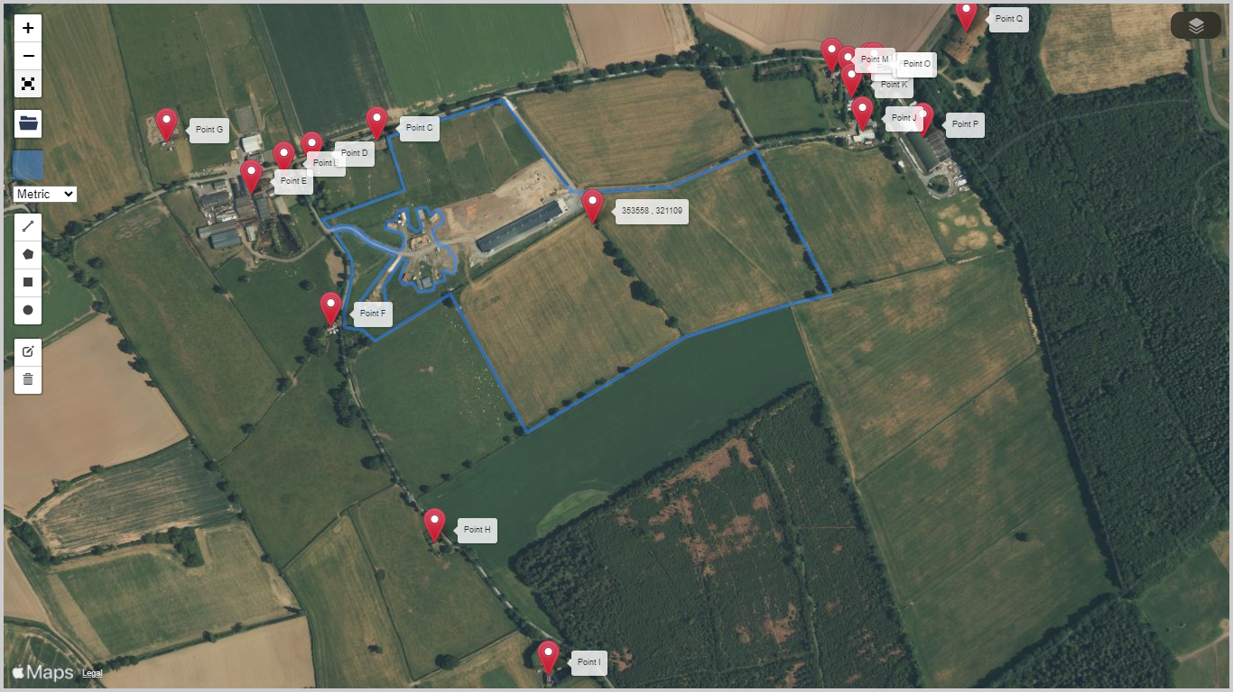

Odour Related Issue | Potential Risks and Problems | Actions taken to minimise odour and odour risks at Painsbrook Farm | Completion date
Free Range Egg Production | Odour levels | Twice daily olfactory checks coinciding with stock inspections (normally 07.00-10.00 hrs and 16.00-19.00hrs) (if required) any abnormalities recorded and investigated – see contingencies and routine maintenance and inspection schedule. | In place
Manufacture and selection of feed | Milling and mixing of compound feeds.  The use of poor quality and odorous ingredients.  Feeds which are ‘unbalanced’ in nutrients, leading to increased excretion and litter moisture and emissions of ammonia and other odorous compounds to air. | Feed specifications are prepared by the feed compounder’s nutrition specialist.  Feed is supplied only from UKAS accredited feed mills, so that only approved raw materials are used.  Protein is reduced in accordance with SGN EPR6.09 ‘How to comply with your environmental permit for intensive farming’ ‘How to comply with your environmental permit for intensive farming’. | In place

Feed delivery and storage | Spillage of feed during delivery and storage.  Creation of dust during feed delivery. | Feed delivery systems are sealed to minimise atmospheric dust.  Any spillage of feed around the bin is immediately swept up.  The condition of feed bins is checked frequently so that any damage or leaks can be identified.  Feed deliveries are monitored to avoid dust and spills – As per routine inspection and maintenance schedule. See site plan. | In place
Ventilation and  Dust | Inadequate air movement in the house,  leading to high humidity and wet litter  Inadequate system design, causing poor dispersal of odours.  Extraction fans located close to sensitive receptors.  Dust | Use of high velocity roof extraction fans on new houses to aid dispersion, checked prior to cycle commencement by qualified electrician who will provide 24hr breakdown cover – See electrical service reports  The ventilation system is regularly adjusted to match the age and requirements of the flock.  The ventilation system is designed to efficiently remove moisture from the house.  Humidity recorded daily and maintained in the range of 55 – 65% keeping a balance of dry litter and avoiding dust production.  Stock inspections carried out by trained staff to avoid panicking birds creating dust.  Dust levels if present is controlled during cleanout operations - As per routine inspection and maintenance schedule and clean out operations. | In place

Litter management | Odours arising from wet litter (see above). | Controls on feed and ventilation (see above) help to maintain litter quality.  Additional controls include:-  Use of nipple drinkers with drip cups to minimise spillage.  Daily checks of drinker height and pressures to avoid capping.  Insulated walls and ceilings to prevent condensation.  Concrete floors to prevent ingress of water.  Stocking levels at optimum to prevent overcrowding.  Use of veterinarian bespoke health plan. See health plan | In place
Carcase disposal | Inadequate storage of carcasses on site. | Carcasses placed into plastic sealed bags, stored in sealed, shaded and vermin proof containers away from sensitive receptors. Frequent collection by a licensed agent.  Daily levels of mortalities recorded with abnormalities investigated – See health plan | In place

House clean out | Creation of dust associated with litter removal from houses.  Use of odorous products during cleaning. | Litter carefully placed into trailers.  Trailers sheeted before leaving fill position.  Only DEFRA approved and suitable products used. Chemical containers triple washed at point of use.  Wash water sump levels monitored during washing and emptied as required to prevent overfill – See Key responsibilities  Clean out carried out as soon as possible following destocking. (1 Week per house) | In place  In place
Used Litter | Storage of used litter on site.  Transport of litter and land spreading. | No storage on site at any time, belt removal twice weekly with covered trailer/skip removed off site immediately.  All trailers sheeted before leaving fill position.  Avoidance of double handling.  Litter used on operator-controlled land and sold to third parties. | In place
Washing operations including vehicles | Loss of dirty water to Land or Watercourse | Use of specialist contractors for washing operations.  Bespoke terminal hygiene program followed, detailing quantities of water and chemical dilution rates.  Key staff monitoring washing operations ensuring effective drainage to dirty water tanks.  Dirty water tanks monitored during wash down to maintain freeboard –See Key responsibilities  Vehicle washing at designated wash point.  All sediment traps and drains cleaned both before and after washing operations – See Inspection and maintenance schedule | In place
Fugitive emissions | Leaks to doors, bin pipes, feed bins, fuel and chemical storage | Checks to feed storage and fill pipes as per routine maintenance schedule.  Fuel oil in approved bunded storage tanks.  Chemicals – only small amounts of footdip disinfectant held on site in secondary containment | In place
Dirty water management | Standing dirty water during the production cycle or at clean out.  Application of dirty water to land. | Working areas around houses are concreted and kept clean during production cycle.  At clean out dirty water from houses together with lightly contaminated yard wash is directed to the underground storage tanks (see site plan), before being removed off site and spread to land under control of a separate farming business. Written agreement is in place. | In place
Abnormal operations | Water leak/pipe failure  Bird health/sickness | Water consumption monitored daily ensuring early detection, wet area - blanket covered with top up bedding material to prevent increased odour.  Veterinarian contacted (24hour cover) Litter covered with fresh top up bedding to minimise increased odour until bird health recovered –See health plan  Abnormal events documented, dated and signed, appropriate plans reviewed and updated to prevent reoccurrence ie. Routine maintenance schedule, Technical standards | In place
Waste production/storage | Odour from production or storage areas | No storage or production of odorous waste on site.  Waste management plan in force detailing types and quantities produced along with disposal routes. Records kept on site. | In place
Materials/storage | Potential odour source | Feed delivered into sealed vermin proof silos.  Sealed delivery system into poultry houses with no milling or mixing on site.  Remaining feed at end of cycle stored in sealed silo and used on subsequent cycle.  Marked on site plan.  3 month shelf life of feed negating the need for removal.  Raw materials inventory recorded and kept on site – See key responsibilities  Cleaning chemicals supplied and used by cleaning contractor not stored on site. | In place

Odour Complaint Form
Installation Name |  | Date Recorded |  |  | Reference Number
Name and Address of caller:

Tel. No. of caller
Location of caller in relation to
Installation
Time and Date of complaint

Date, Time and duration of
Offending odour

Has the caller any other
Comments about the odour?
Weather conditions
Wind strength and direction

Any previous complaints
Relating to this odour?
Any other relevant information

Potential odour sources that
could give rise to the
complaint

Operating conditions at the
time offending odour occurred

Follow up
Date and time caller contacted
Action taken

Amendment requirement to
Odour Management Plan
Form completed by |  |  | Signed

