Standard Operating Procedures |  | SOP Ref:ABTO--10 | ABTO-10-Packing Lithium Metal Batteries for End Recycler
Approved & Issued by: | Stuart McNish |  | Written by: | Stuart McNish
Operational Area: | BKP Environmental Romsey, ABTO
Title: | Packing Lithium Metal Batteries for End Recycler
1. Activity

This activity is to ensure the safe packing of lithium metal batteries for storage prior to onward shipment to end recycler. It is essential these batteries are packed in accordance with ADR & IMDG. The batteries must be properly identified and segregated at source and any potentially damaged or defective cells or batteries identified and safely managed. Lithium metal batteries are particularly high hazard for storage or handling and pose the greatest fire risk of any waste batteries. It is essential these processes are followed and the necessary precautions are taken when handling.

2. Persons at Risk

- Operator
- Other yard operatives
- Driver
- General public
- Contractors and visitors
- Shared Site Occupancy

3. Hazards

- Slips, trips, falls
- Exposure by inhalation to solvents in the electrolyte of the battery
- Chemical exposure
- Spillage of chemicals
- Manual handling
- Electrical hazards
- Fire from Lithium Metal in Batteries

4. Procedures

For completion of this task PPE must be worn. Specific to this job nitrile gloves, safety glasses, safety boots, high visibility clothing and an ABEK 3 filter mask with appropriate organic filters is required. The electrolyte in Lithium Manganese Oxide LiMnO₂ batteries (approx. 80% of Primary Lithium) is reproductively toxic (1,2 Dimethoxyethane), it is also highly flammable and volatile so a mask should be worn when handling all primary lithium batteries. LiSOCl₂ (Lithium Thionyl Chloride LiTCl or Li/SOCl₂) Batteries have a reactive liquid cathode and electrolyte that gives off Hydrogen Chloride vapour in contact with moist air if damaged. For this reason a combined filter mask that covers organic and inorganic vapours must be worn if repacking any suspected damaged primary lithium batteries. In addition to PPE safety precautions must be taken to prevent the risk of fire.

When handling any primary lithium batteries large quantities of dry sand should be available in case of a damaged battery run away. See ‘’Primary lithium management & Safety’’ –TS-ABTO-05’’ for further details but batteries should be placed in large excess of dry sand and covered completely to reduce risk of further reaction and remove oxygen prior to further assessment by site management / fire service. Type D fire extinguisher and at least 100Kg of dry sand is recommended as a precaution when repacking these batteries to allow you to react should any damaged batteries have a runaway reaction. This must be completed in a designated area under supervision or within a team. Site chemists will be checking all batteries upon receipt and prior to receiving these batteries information will be provided by producers to ensure they are safe to handle.

Packing Primary Lithium for Recycling

Lithium Cells must be segregated by Portable and Industrial as well as by their individual chemistry.
The originating source or the batteries will be identified as portable / Industrial prior to acceptance – (CD-ABTO-BKP01/02 Completion)
Any primary lithium cells received within mixed portable drums from known eligible sources will be considered portable unless they are;
- Unique specialised cell configurations or voltages
- Clearly non-portable (Stick batteries, Packs from Industrial usages)
- In WEEE Items (inside smoke alarms, Meters, Defibrilators)
- See ABTO-04 for further guidance

Primary lithium batteries depending on their size and chemistry will be sent to different recyclers who have different treatment methodologies for recycling these. The below outlines the 4 different types of segregation the batteries need to be packed into;
Primary Lithium Cells - Button Cells – Lithium Manganese Oxide These are primary lithium batteries but they have special packing provisions ‘’TS-ABTO-06’’Packing Button cells topic. Button cells because they may contain mercury are sent to a specialist recycler in Switzerland called Batrec. They may be sent via another UK ABE or directly if a TFS notification is put in place. They will not be considered in this training document. These batteries are normally from portable applications and will be received in mixed packs
Portable Primary Lithium cells - AA or smaller –Lithium Iron Disulphide, Lithium Manganese Oxide - All small primary lithium cells (so an AA or smaller). These are commonly portable lithium metal batteries are sold for domestic uses. They need to be packaged in accordance with ADR. They will be packed individually wrapped in plastic (or bagged) and packed in kiln dried sand (max 10% Water). Drums must be clearly labelled with the net weight of batteries in the drums, the chemistry (Mixed Non TCl). These batteries can be recycled at a number of outlets in Europe via ABE notification. The net weight of the batteries should be recorded on the site battery inventory and the packed drum register prior to shipment for recycling.
Industrial Primary Lithium Cells - (all cells except Thionyl Chloride)– These batteries need to be packed in a suitable condition to send to a recycler. Batteries must be individually bagged or wrapped, then packed in kiln dried sand in (X or Y Rated) <25Kg Gross weight. Batteries must not be touching and each inner package must be sealed. The net weight of the batteries should be recorded on the site battery inventory and the packed drum register prior to shipment for recycling.
Industrial Primary Lithium cells – Thionyl Chloride / Sulfuryl Chloride – LiSOCl₂ / Li-SO₂Cl₂ - These batteries need to be packed in a suitable condition to send to a recycler. Batteries must be individually bagged or wrapped, then packed in kiln dried sand in (X or Y Rated) <25Kg Gross weight. Batteries must not be touching and each inner package must be sealed. The net weight of the batteries should be recorded on the site battery inventory and the packed drum register prior to shipment for recycling.
Industrial Primary Lithium cells – Stick Batteries - >30cm Length Cell Packs - Thionyl Chloride / Sulfuryl Chloride / Lithium Sulphur Dioxide / Lithium Manganese Oxide - Li – LiSOCl₂ / Li-SO₂Cl₂ / Li-SO₂ / LiMnO₂ - These batteries need to be packed in a suitable condition to send to a recycler. Batteries must be individually bagged or wrapped, then packed in kiln dried sand in (X or Y Rated) <25Kg Gross weight. Batteries must not be touching and each inner package must be sealed. The net weight of the batteries should be recorded on the site battery inventory and the packed drum register prior to shipment for recycling. These batteries are very high hazard and must be packed with specialist care. Prior to packing any Industrial Stick Batteries speak to Group Technical Director for guidance to ensure compliance with IMDG / ADR.

Packing Instructions

Primary Lithium cells - AA or similar sized portable batteries – Commonly camera batteries or replacement AA batteries for longer life primary applications (Duracell/Energizer)

Batteries should be individually wrapped in shrink wrap or bagged prior to packing in kiln dried sand (max 10% water) or dry vermiculite. Kiln dried sand is preferred as it provides better thermal insulation.
Batteries can be packed into Steel Pails with non-conductive liner (preferred) or plastic pails which do not require a liner. They must be UN approved, Y or X rated.

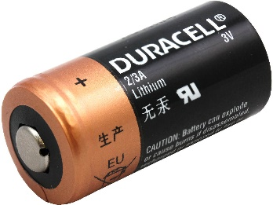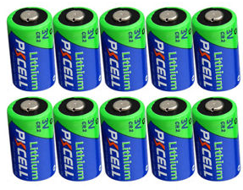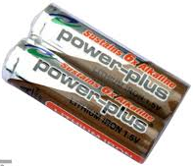

The same steps apply for all drums to be packed into and you will need;
27L or similar UN approved Pail (Rated X or Y) – See below ‘’Y’’ rated plastic pail, Steel pails also available
Bag to line the pail with if plastic
Kiln dried Sand – MUST BE DRY
Shrink wrap or bags for individually bagging batteries to isolate them
It is important any Thionyl Chloride batteries (TCl) are segregated. They are recycled via a different process and are unlikely to be from a portable source
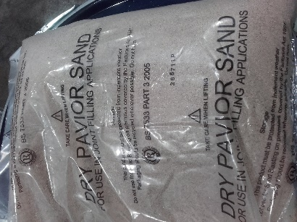
Below shows the steps and above are some typical batteries that are suitable;
Line 27L pail and place layer of dry kiln dried sand in bottom to fill bottom of pail
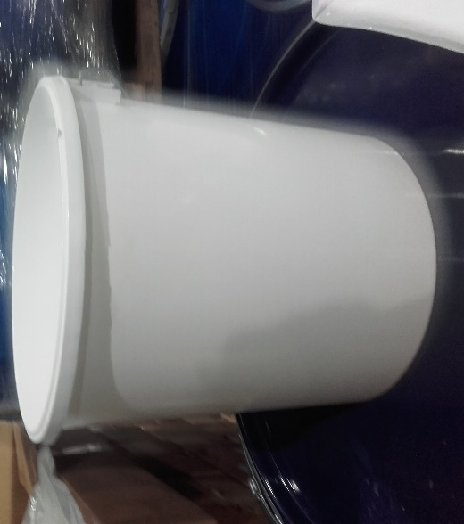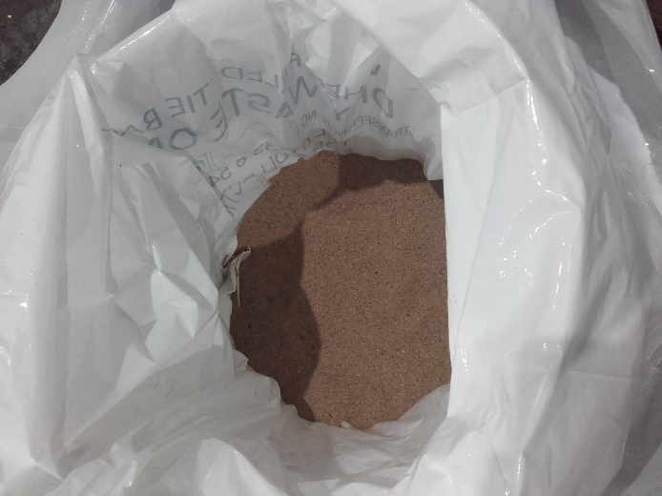
Either individually tape, shrink wrap or bag in individual bags Batteries must be packed not touching each other
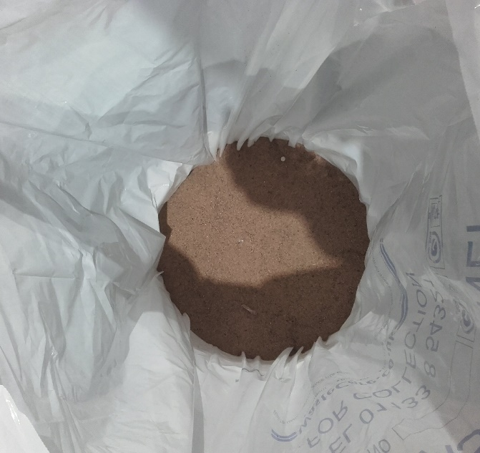
Fill so sand completely covers the batteries, 10cm at the top of each Tie the bag to reduce any available oxygen
Ensure gross weight is <25Kg
Larger Label – ‘’Portable’’
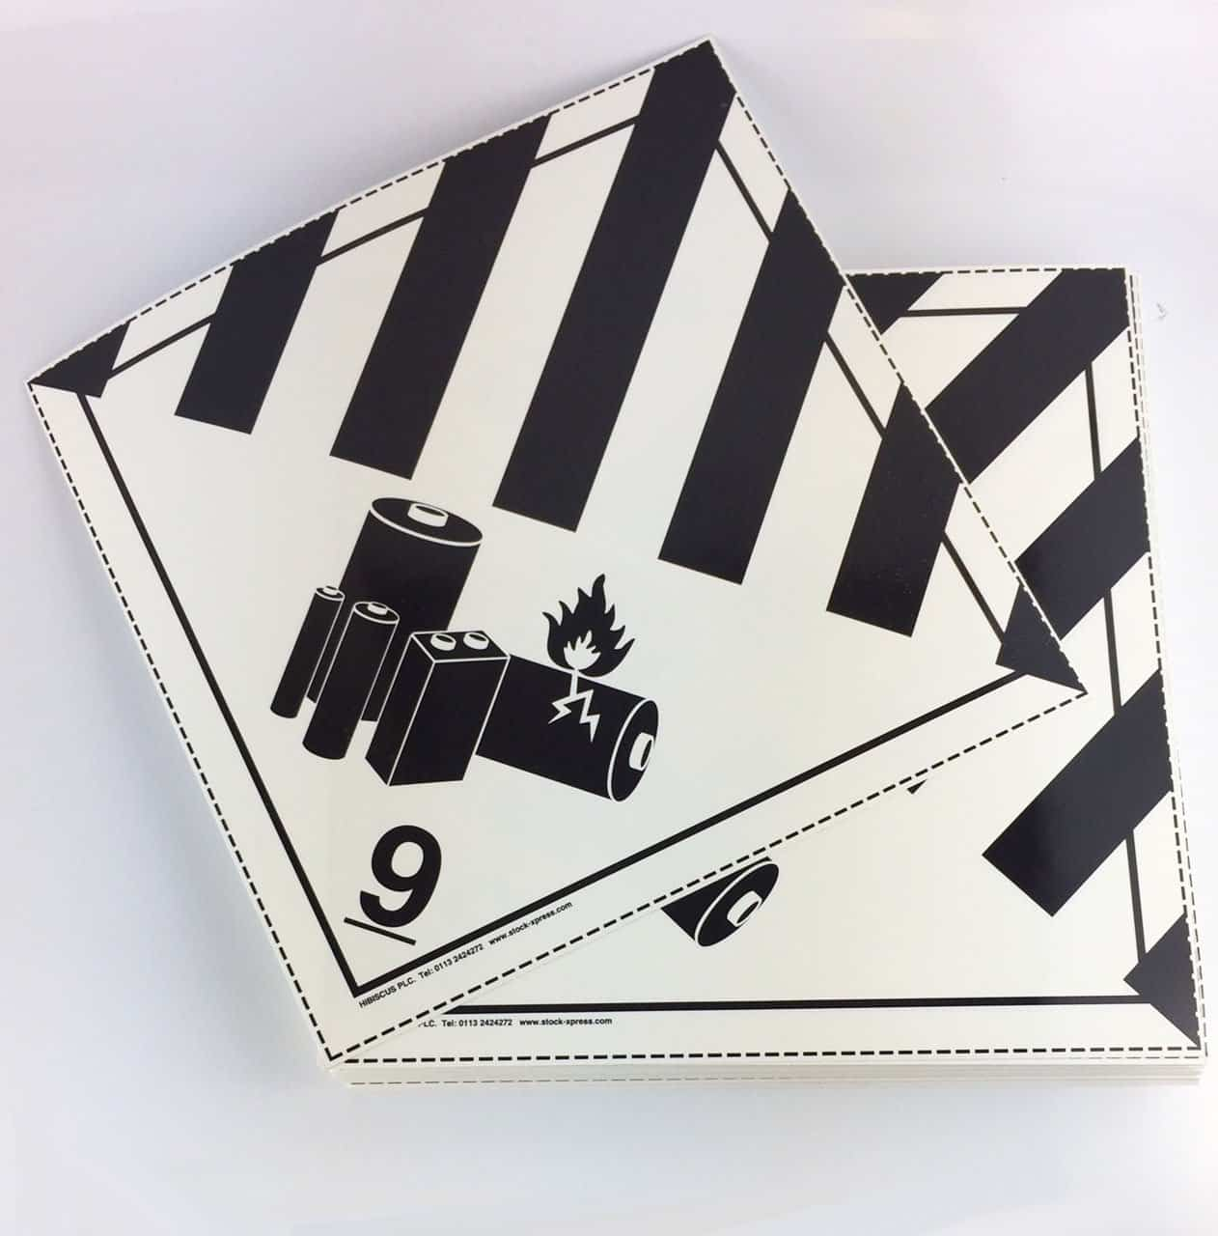
Waste Description – Lithium Metal Batteries (Non-TCl)
EWC – 160605
UN Number – 3090
Shipping Name – Waste Lithium Metal Batteries
Class 9 Battery Label

Net weight of batteries must be recorded on the drums (I.e. Total weight minus weight of packing material and the drum is net weight of batteries)

Industrial Primary Lithium - All Chemistries except Thionyl Chloride / Sulfuryl Chloride - <30cm length of cell packs (Non TCl)
This covers all the Industrial Primary Lithium batteries excluding the Thionyl Chloride and Sulfuryl Chloride batteries. They need to be individually bagged or wrapped but the packing instructions and containers are the same. The batteries all contain primary lithium and the Sulfur dioxide batteries contain an acidic electrolyte so the PPE and handling precautions are the same.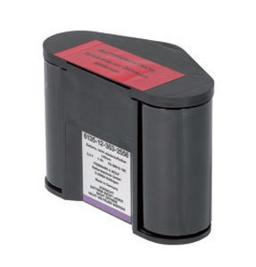

The initial steps need to be repeated. Same drums, inner bag, kiln dried sand filling the bottom of the drum
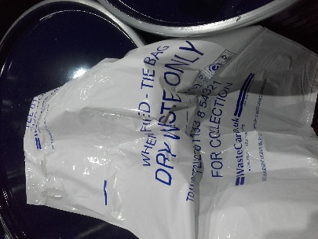
Line 27L pail and place layer of dry kiln dried sand in bottom to fill bottom of pail

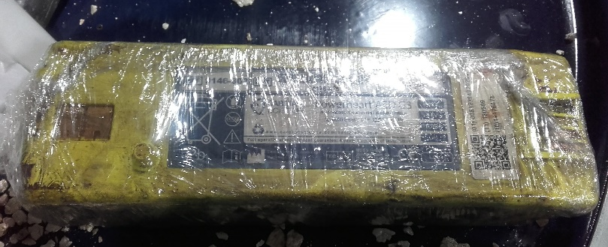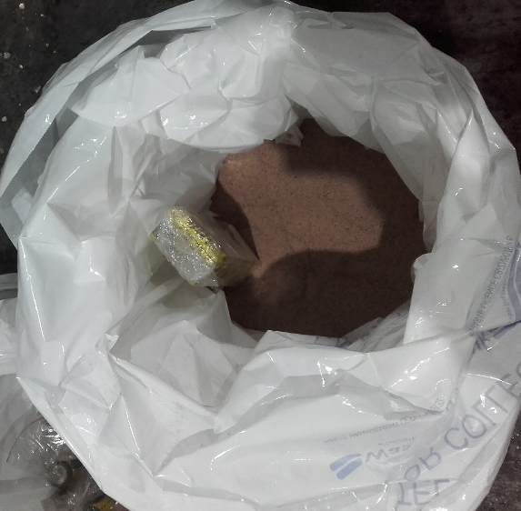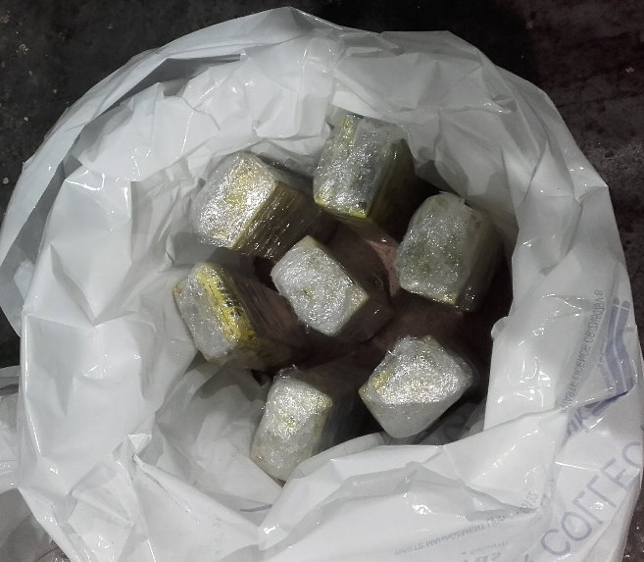
All Leads must be removed and terminals taped with electrical tape so there are no trailing leads or potential for batteries to short if they are in packs. All cells must be individually bagged
Fill so sand is 10cm above battery and drum is full Tie the bag to reduce any available oxygen in the container
Place lid on drum and weigh drum. Maximum Gross weight must be Below 25Kg
Clearly record the net weight of the batteries on the drum

Industrial Batteries
Larger Label – ‘’Industrial – Non TCl’’
Waste Description – Lithium Metal Batteries (Non-TCl)
EWC – 160605
UN Number – 3090
Shipping Name – Waste Lithium Metal Batteries
Class 9 Battery Label

The batteries can be palletised as single stream pallets of these ready for dispatch to the European Recycler.
Net weights must be recorded on the packed drum register and site battery inventory

Industrial Primary Lithium - Thionyl Chloride / Sulfuryl Chloride - <30cm length of cell packs (TCl)

This is just for segregated Lithium Thionyl Chloride and Lithium Sulfuryl Chloride (less common). These batteries have a liquid electrolyte/cathode that is corrosive, reacts with air and water to give off hydrogen chloride (HCl) vapour as well as contain lithium metal as the anode.
They are the highest risk and must be handled with the most care. They are sometimes in large sticks which are used for military or offshore applications. If you encounter Lithium Metal Batteries in large sticks Immediately speak to the site chemists, general manager or technical director as they are high voltage and high risk configurations
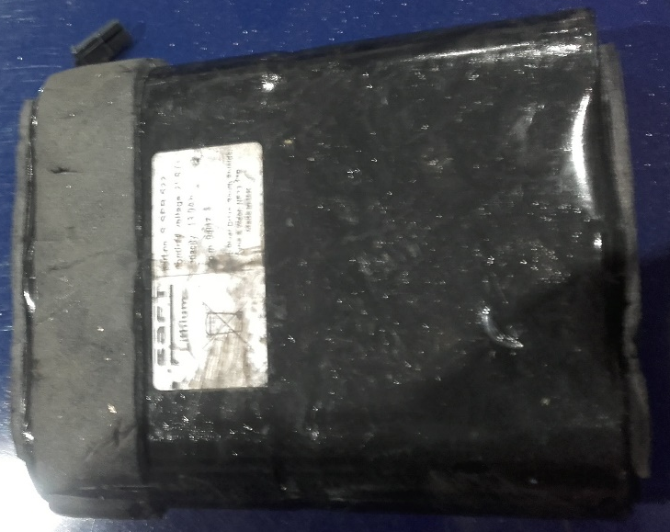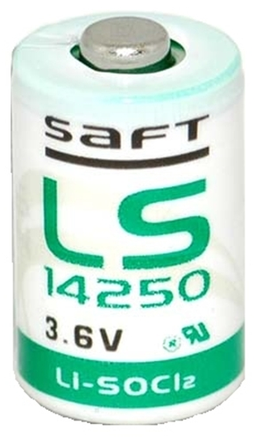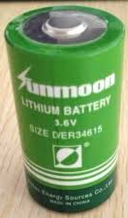

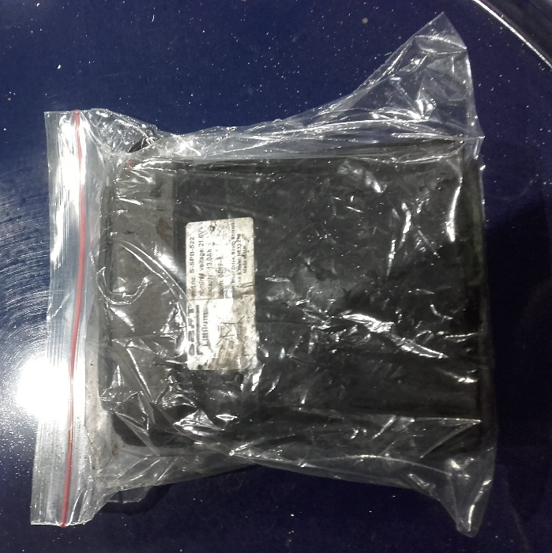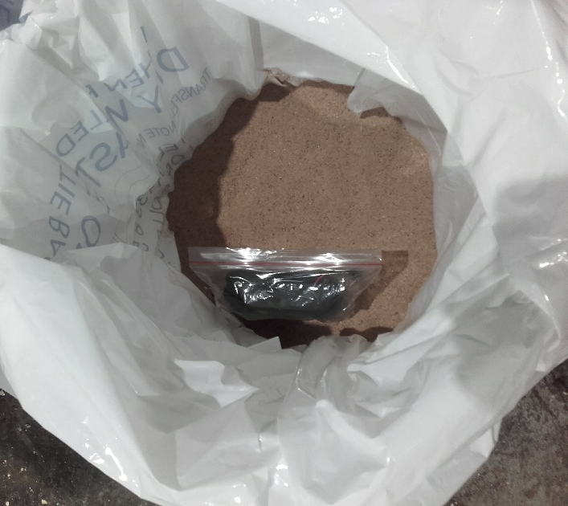
Batteries must be individually Bagged or wrapped Packed in dry sand with no contact between packs
All Leads must be removed and terminals taped with electrical tape so there are no trailing leads or potential for batteries to short if they are in packs

N.B. Cells in packs with a voltage above 10V must be handled with additional caution (3 x Thionyl chloride cells in series as example) as if these batteries are in contact with moisture they can generate micro-currents when stored which can slowly heat up the batteries and cause thermal runaway
Fill so sand covers batteries by 10cm and fills void Tie the bag to reduce any available oxygen in the container
Place lid on drum and weigh drum. Maximum Gross weight must be Below 25Kg

Industrial Batteries, Thionyl Chloride
Waste Description – Lithium Metal Batteries (Thionyl Chloride)
EWC – 160605
UN Number – 3090
Shipping Name – Waste Lithium Metal Batteries
Class 9 Battery Label

The batteries can be palletised as single stream pallets of these ready for dispatch to the European Recycler.
All Prepped Primary Lithium batteries must be stored in designated Lithium Metal battery area onsite under cover to prevent ingress of water but never overnight in a main building. Once packed in dry sand the risks are significantly reduced but it is good practise for these to be stored in a designated area away from other material

Key Points to Remember

All primary lithium batteries should be kept dry and handled with care due to the fire risk
Ensure you have plenty of dry sand (minimum of 4 x 25Kg bags) & a specialist type D fire extinguisher present when handling these batteries in a designated area away from sources of electricity or water
Pack all batteries individually in dry sand. All sand must be dry (max 10% Water)
4 Packing Criteria – Portable Primary Lithium (Non-TCl), Industrial Primary Lithium (Non-TCl), Industrial Primary Lithium (TCl), Industrial stick batteries (See Technical Director)
Ensure any packing is done in a safe, designated area
Ensure all drums are labelled with net weight, Chemistry and if Portable / Industrial
Record all data on packed batteries on ‘’WD-ABTO-BKP01’’ – Site Battery Inventory
Maximum weight 25Kg
Cell packs in series (>10V) are of particularly high risk. These must be handled with care and ensure they are dry to prevent formation of microcurrents and thermal runaway
Stick batteries will have specific guidance on packing. Do not attempt to dismantle or repack these batteries without specific guidance

Any questions regarding packing of these please contact the general manager or technical director

Print: ................................................................. Sign: ........................... Date...........................

Signed off by:

.................................................................... Director / Manager / Supervisor

