Standard Operating Procedures |  | SOP Ref:ABTO--05 | ABTO-05 – Lithium Battery Safety & Management
Approved & Issued by: | Stuart McNish |  | Written by: | Stuart McNish
Operational Area: | BKP Environmental Romsey, ABTO
Title: | Lithium Battery Safety & Management
1. Activity

This activity is to explain the safe handling and management of lithium (primary & secondary) batteries. As the highest risk batteries both primary and secondary lithium batteries need be handled with additional control measures to the normal controls regarding short-circuiting or electrical risks. They can be unstable when damaged and hold much higher energy densities than equivalent volumes of other chemistries.

2. Persons at Risk

- Operator
- Other yard operatives
- Driver
- General public
- Contractors and visitors
- Shared Site Occupancy

3. Hazards

- Slips, trips, falls
- Exposure by inhalation to solvents in the electrolyte of the battery
- Fire hazard from lithium metal in the batteries
- Chemical exposure
- Spillage of chemicals
- Manual handling
- Electrical hazards

4. Procedures

Safety Precautions

Area

If we know we are handling primary lithium batteries (repacking, sorting, wrapping etc) then we need to ensure we are working in an area that is safe to do so. When we handle these batteries we are introducing risks of damage so it’s critical this is done in an appropriate area.

The area for handling these should be;

- Well ventilated
- Under cover (I.e. not outside unless it’s under a canopy or similar) – This is ideal
- A minimum of 10 metres from any combustible materials (pallets, empty plastic drums, cardboard)
- More than 15 metres from any flammable gases, flammable liquids, flammable solids, oxidisers, water/air-reactive materials
- 10 metres away from electrical distribution boards or gas inlets to property
- Well segregated from any walkways, FLT movements or vehicle movements

If you are unsure where this can be completed, please speak to site manager prior to completing this work. A well-marked designated area should be used with the appropriate fire controls available.

Handling Lithium Ion that are not damaged can be done safely in a clearly designated area that the primary lithium is. There is a lower risk profile with these batteries than primary lithium however there is still a risk of fire.

Fire Controls & Extinguishers – This is to be used in conjunction with Fire extinguisher Use WI

Primary Lithium – LiP – Type D Fire (Metal Fire)

As primary lithium batteries are water-reactive, special fire-fighting measures need to be taken should they start smoking and reacting. They will generally give off lots of smoke and fumes prior to auto-ignition (pink flames when burning).

Lithium metal battery fires cannot have water used on them. Water will make the fire worse. Only a type D specialist powder fire extinguisher should be used on a lithium metal battery fire.

You should have buckets of kiln dried sand available in the area you are working. These are to be used to cover any batteries and prevent fire, thermally insulating it and preventing projectiles.

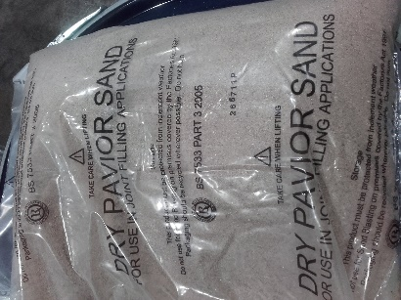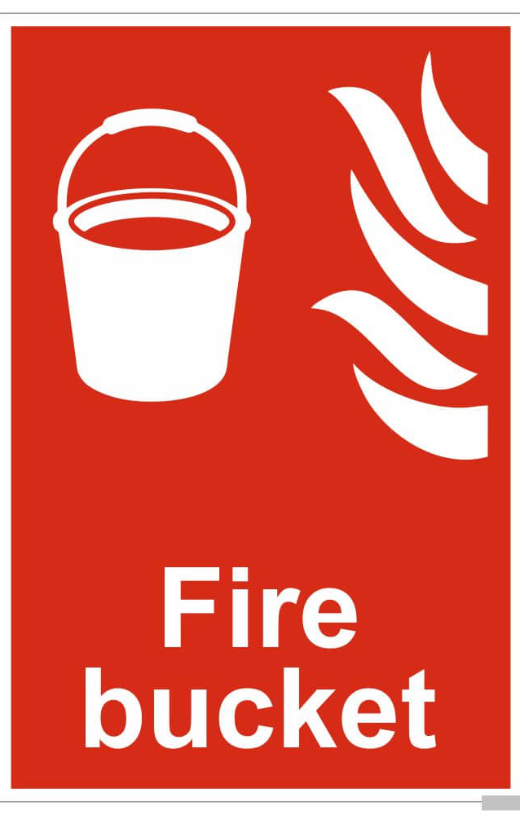

To extinguish a fire/manage a damaged battery

If a cell is damaged and a thermal runaway/exothermic reaction is observed the best strategy is spray with a type D fire extinguisher followed by immediately covering with kiln dried sand in a large excess to contain the fire and any projectiles. This will also provide thermal insulation and starve the fire of oxygen and buy you time. Spray the extinguisher at the battery that is on fire to cover with powder and then cover with sand. If you are handling the battery put onto the floor or into a bucket of sand and then spray with the type D specialist – Blue extinguisher then cover. Type D extinguishers are specialist extinguishers. Do not use an ABC powder extinguisher

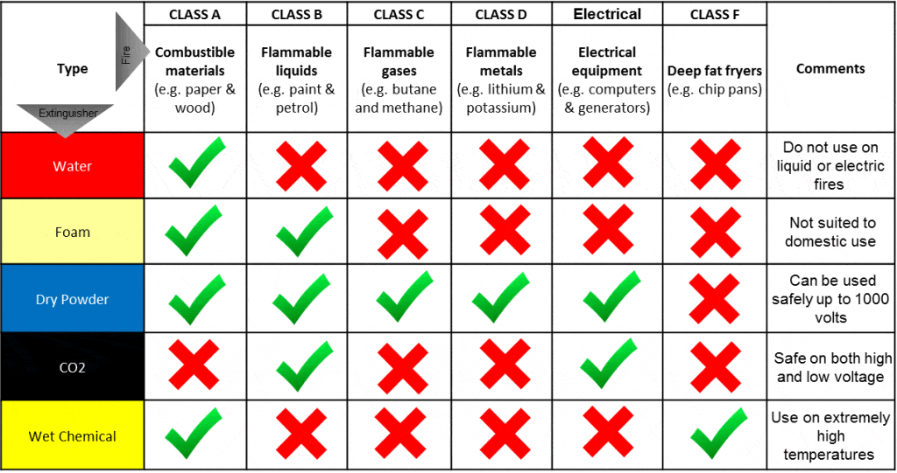

Once the fire is covered immediately evacuate the area and inform your manager. The area can then be carefully managed to safely dispose of the battery (this will still contain Lithium metal and needs to be treated in a controlled way to safely prevent it reigniting on contact with air). Any material surrounding this also needs to be cleared (including other batteries that may get hot and have run-away reactions themselves)

Be aware with primary lithium battery fires there may be fumes of HCl, SOx. Batteries such as Lithium Thionyl Chloride (LiTCl) or Sulphur Dioxide (LiSO₂) are more reactive and more volatile than Manganese LiMnO₂. If we can specifically identify the chemistry of the battery we can act specifically.

For Lithium Thionyl Chloride, Lithium Sulphur Dioxide, Lithium Sulfuryl Chloride cells can be covered with Soda Ash to manage the acidic vapours. This should only be applied if you are aware it is only that chemistry that is in a critical state.

If you are not sure of the chemistry of the cell that is on fire. Only use a Type D, Dry powder extinguisher. This is suitable for all battery chemistries, however it will not be the most effective extinguisher if you have a Lithium Ion Battery Fire

Lithium Ion Batteries – Li-Ion – Type B (Flammable Liquid) Fire

Lithium Ion Batteries (Phones, EV, Walkie Talkies, Power Tools) do not contain water-reactive lithium metal in any quantity. They do contain a flammable liquid solvent electrolyte and they are often in large banks of cells which can undergo chain reactions. These runaway reactions are normally cause by either;

- Physical damage
- Defective cells (such as internal design flaws causing short-circuit)
- Short circuit or overcharging (or cell being discharged below 2V and then charged again)

Generally the cells will heat due to current flow (this may all be internally and not visible) until they reach a critical temperature. At this point the cell will explode and the electrolyte will set on fire. This may cause the neiughbouring cells all to heat and then a run-away reaction of lots of super-heated cells all igniting may occur.

To extinguish a fire/manage a damaged battery

If a cell is damaged are a runaway reaction the best strategy is spray with an ABC powder fire extinguisher or a foam followed by immediately covering with kiln dried sand in a large excess to contain the fire and any projectiles. This will also provide thermal insulation and starve the site of oxygen and buy you time. Spray the extinguisher at the battery that is on fire to cover with powder and then cover with sand. If you are handling the battery put onto the floor or into a bucket of sand and then spray with the ABC extinguisher until the fire is out and then cover with dry sand.

Once the fire is covered immediately evacuate the area and inform your manager. The area can then be carefully managed and flooded with water to remove heat and any potential for further reaction (as the battery is not water reactive this is completely safe). Ensure when doing this that you take great care not to spray any live electrical wiring and check with the site manager prior to using any extinguishers other than BC or ABC dry powder on this type of fire.

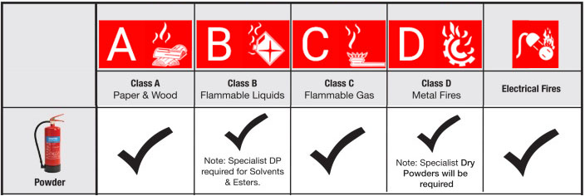

Steps to manage Lithium Battery fires (primary or secondary lithium);

- Identification of fire risk or runaway cell (fumes/smoke/vapours) or actual fire (visible flames)
- Select appropriate extinguisher;
- Type D for Lithium Metal Batteries
- ABC or BC for Lithium Ion Fires. If you are unsure use type D extinguisher only
- Remove pin on fire extinguisher
- Get as close to the fire as is safe to do so
- If it is safe to do so use fire extinguisher at base of fire to cover the flames / smoke and starve the fire of oxygen. Powder extinguishers will enable you to do this to smoother the fire
- Throw buckets of dry sand over the batteries to prevent reignition
- Contact site manager for next steps of managing the fire based on the chemistry of the batteries involved
- Site manager to Immediately contact operations director and technical director.

It is critical with lithium fires that swift action is taken where appropriate. As they can spread rapidly with projectiles and can become very hot very quickly and spread. By managing the areas in which these batteries are handled if a runaway reaction/defective cell cannot be safely managed it can be allowed to burn out in a controlled fashion withous risk of propagation and the fire spreading. By removing any combustible materials from a 10m radius this significantly reduces the risk of this event.

Identification of damaged Lithium batteries & Management

Batteries that are damaged or thermally stressed may not always be identifiable. Particularly in the case of large cell-packs.
It is best practise to try and identify any potentially damaged batteries through the use of infra-red or thermal imaging cameras. A thermal imaging camera will enable you to detect hot spots or areas within a cell pack when the batteries are in housings by showing the temperature difference with the surroundings.

Unfortunately, without battery diagnostics equipment it is very difficult other than by temperature checks to identify any issues with larger lithium Ion batteries. This is why all industrial lithium ion batteries must be accompanied with a declaration from the producer and the previous holder of the batteries who is likely to know the reasons for disposal and the health of the battery, it’s age and any information from the battery management system or diagnostics that have been completed.

Checking drums of lithium ion batteries for hot-spots is good practise and daily checks of single stream lithium ion or lithium metal batteries should be completed to ensure any batteries that are likely to go into thermal runaway are safely managed prior to an incident occurring.
Lithium metal batteries are the highest risk of fire because they contain lithium metal within the cells. Regardless of primary lithium chemistry it is essential these are packed safely in kiln dried sand as an additional precaution and any industrial or larger cells must be individually wrapped in polythene before packing into kiln dried sand to eliminate any oxygen from the battery as well as being provided with electrical and thermal insulation from the sand.

Print: ................................................................. Sign: ........................... Date...........................

Signed off by:

.................................................................... Director / Manager / Supervisor

