Standard Operating Procedures |  | SOP Ref:ABTO--02 | ABTO-02-Packing Portable Lithium Ion Batteries for End Recycler
Approved & Issued by: | Stuart McNish |  | Written by: | Stuart McNish
Operational Area: | BKP Environmental Romsey, ABTO
Title: | Packing Portable Lithium Ion Batteries for End Recycler
1. Activity

This activity is to ensure the safe packing of lithium ion batteries for storage prior to onward shipment to end recycler. It is essential these batteries are packed in accordance with ADR & IMDG. The batteries must be properly identified and segregated at source and any potentially damaged or defective cells or batteries identified and safely managed. Only portable batteries should be sent

2. Persons at Risk

- Operator
- Other yard operatives
- Driver
- General public
- Contractors and visitors
- Shared Site Occupancy

3. Hazards

- Slips, trips, falls
- Exposure by inhalation to solvents in the electrolyte of the battery
- Chemical exposure
- Spillage of chemicals
- Manual handling
- Electrical hazards

4. Procedures

To complete this process PPE should be worn when completing the task. As a minimum of safety glasses, chemical resistant gloves, high visibility vest. If there are any damaged batteries then a half face, face fitted respirator with ABEK3 carbon filters must be worn. This is due to the potential of exposure to the organic electrolyte within the batteries which can be harmful by inhalation.

The operation should be performed in a well-ventilated area, under cover and it is important the batteries and associated packing material are kept dry and uncontaminated.

Identification of batteries is covered in a separate SOP but only sorted portable lithium ion batteries should be packed in these drums and clearly labelled as portable batteries.

Any automotive or Industrial Lithium Ion such as EBikes or EV batteries are covered as a separate operating procedure as their packing to send to end recycler is different & they must be segregated.

For packing the material into drums it is strongly recommended to use UN approved Steel 205L drums with a 0.1mm or greater thickness non-conductive liner. UN approved Plastic drums without a liner may be used if no steel drums are available. You will need vermiculite (inert mineral filler) or kiln dried sand (max 10% water).

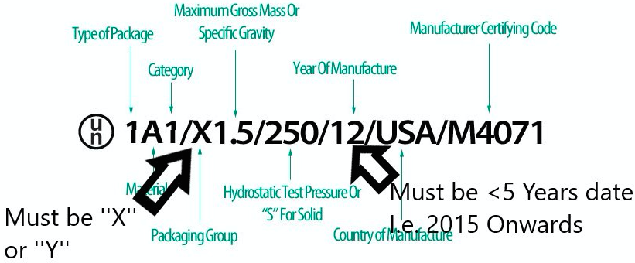
The above picture explains the UN Markings – They must be PG II or higher rated and within 5 years of date

The drum must be clearly labelled with it’s contents and the associated shipping information;

Waste Lithium Ion Portable Batteries
160605
UN 3480
Waste Lithium Ion Batteries
Class 9

The drum should be weighed prior to addition of any batteries and this recorded on the side of the package with Paint pen marker as ‘’Gross Weight’’ E.g. 20Kg

Before putting vermiculite into the drum please weigh the bag / container to get the weight. We will weigh this again at the end to obtain the weight of packaging material added.

Then a >0.1mm thickness antistatic plastic liner should be added to the drum. Then a small layer of vermiculite added to the bottom of the drum to provide cushioning and insulation prior to addition of batteries. The vermiculite must be dry and uncontaminated.

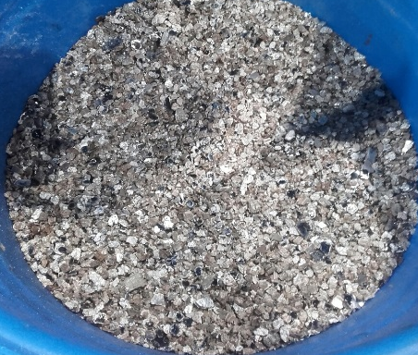
Drum with liner Batteries packed in a layer(in plastic drum) Cover with vermiculite

This process should be repeated packing the batteries in layers with vermiculite between each layer, this thermally and electrically insulated. This should be repeated, packing the batteries in layers and insulating with vermiculite.

10cm Below the top of the drum no more batteries should be placed and only vermiculite should be packed into the drum. If there is a plastic liner in the drum all the air should be expelled from this liner and then cable tied within the drum. Removing the air and ensuring the drum is filled with vermiculite with minimal battery/battery contact reduces any risk of thermal runaway in transit.

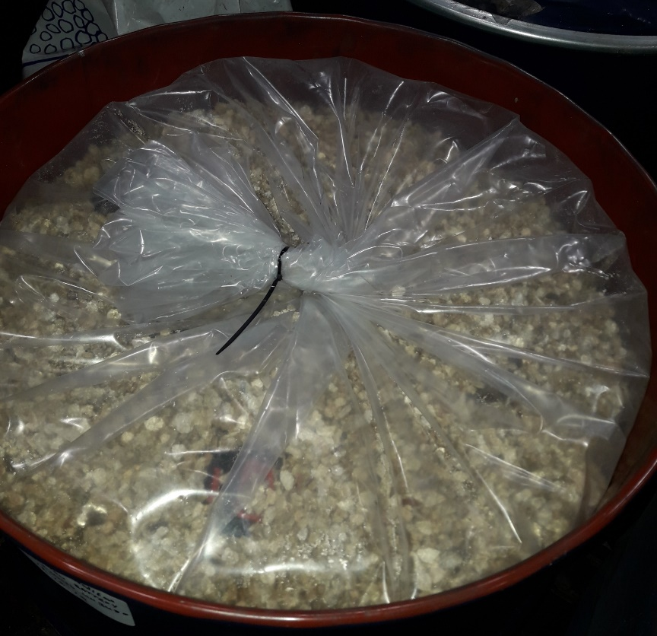
Inside of drum, layers of batteries Cable tied inner non-conductive liner

When the drum is full of batteries/vermiculite and all air has been displaced / filled with vermiculite the drum of batteries can be can be weighed. Record the gross weight on the drum in marker pen

Then weigh the vermiculite container that has been used to pack the drum. Then subtract this weight from the first weight before addition.

E.g.

20KG steel drum. Initial vermiculite weight 20Kg, Final vermiculite weight 10Kg. Final Gross weight 100Kg

Net weight of batteries = Final Gross weight – (Drum(20Kg) + (Initial verm weight – Final verm)

= 100 – (20 + (20-10)) = 70Kg Net Weight

Please record this net weight on the side of the drum in pen and write this clearly on the lid of the drum with the date

Date
Packed by – Name
Net Weight
Portable Lithium Ion (HG / LG)

It is critical when drums are being packed that the batteries are checked thoroughly for their condition and chemistry again after the initial sort (See general battery handling SOP)

Exposed terminals need to be taped
Damaged or Bloated Cells must be isolated, individually bagged and packed separately
Batteries only, no WEEE items
Only Lithium Ion Batteries
Check Grading again when packing
Portable only – No EBike or Industrial batteries

Once 4 205L drums of the same material are prepared the pallet can be prepared for onward shipment.

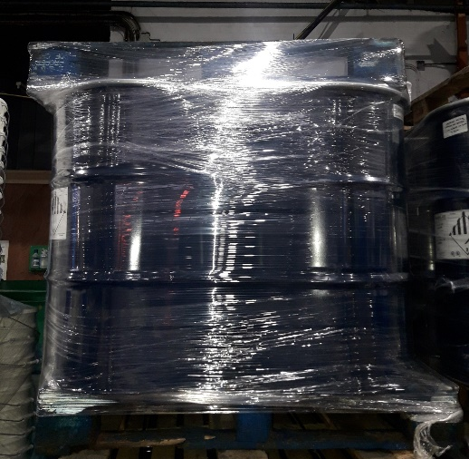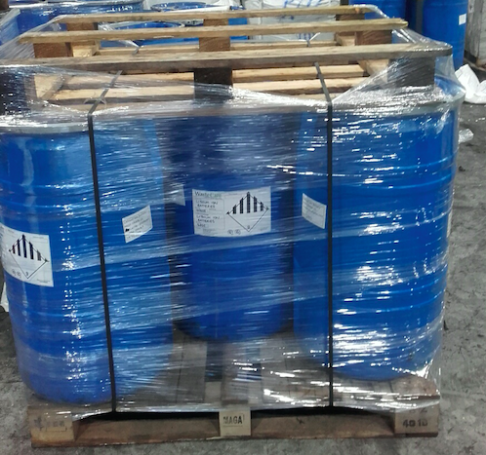
Securely shrink wrapped on pallets and banded. All drums labelled (N.B. Class 9 with battery pictogram labels required)

Sorted prepared pallets can then go for onward shipment to approved battery recycling outlet in Europe as appropriate.

4 x outer labels should be applied to the pallets and the gross weight of each pallet recorded.

The net weights of batteries in each drum should be added together and recorded as the net weight on the prepared pallet for shipment.

The net weights are then recorded on the outbound battery log when batteries are shipped to end recycler.

Print: ................................................................. Sign: ........................... Date...........................

Signed off by:

.................................................................... Director / Manager / Supervisor

