Standard Operating Procedures |  | SOP Ref: | SO-1-Surface Water Management within Bunded / Process Areas
Approved & Issued by: | Amelia Armstrong |  | Written by: | Stuart McNish
Operational Area: | BKP Environmental Romsey
Title: | Surface Water Management Within Bunded Storage, Process Areas & Non-process Impermeable Surfaced Areas
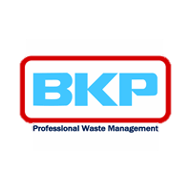

Activity

This activity details the safe management of any surface water collected within packaged waste bunded storage areas and process areas as well as discharge to soakaway of uncontaminated water falling on impermeable surfaces out within the tertiary containment. It also outlines the treatment and testing procedures to be followed for segregated uncontaminated surface water from any non-waste storage or process areas. This is to ensure no cross contamination between effluent streams and ensure only clean uncontaminated water is discharged via the soakaway onsite after filtration, carbon filtration and conformity testing to ensure compliance with BAT-AELs for indirect discharge. All discharges are manual and can only be initiated after site manager or director approval via manual pump. All process effluents from treatment activities onsite, effluents from any hazardous waste storage areas or effluents from non-storage areas that are considered high risk will remain to be tested and tankered to suitable offsite facility as per the sites current arrangement.

2. Persons at Risk

- Operator
- Other yard operatives
- Driver
- General public
- Contractors and visitors
- Shared Site Occupancy

3. Hazards

- Inclement weather, ice, snow, rain or fog.
- Slips, trips, falls
- Exposure to potential chemicals within the surface water from any contamination if there are spillages
- Any chemicals within reagent testing in the laboratory for testing materials (Hach cuvettes)

4. Overview & Site Layout/Infrastructure

The BKP site consists of three distinct main bunded areas. Individual bays for designated waste storage also have their own individual bunding and containment. This document will go through all the individual waste storage areas and bunding and subsequent treatment and disposal of any water within those areas where it may be created from rainfall.

There is small staff vehicle parking area between the three plots of the site. This consists of compacted hard standing aggregate and it is bordered by a number of mature trees that run along the fence line of bunny lane (the access road to the site). There are some site offices distinct from the processing area in the lower yard as well as some electric vehicle charging points and visitors parking adjacent to the main office.

The site is fenced off in distinct areas with 1.8m high palisade fencing and gates meaning the whole site is secure. There is a vehicle barrier (activated with a key fob) to control vehicle movements into the lower yard whilst the site is open and operational. This also restricts unwanted visitors such as members of the public trying to access the HWRC further down bunny lane.

The site has undergone significant investment since 2020 improving all waste storage areas in-line with current EA & CIRIA guidance including. This was included within a substantial permit variation for the site that was issued in 2023.

- Bespoke covered hazardous waste transfer station with dedicated fire rated storage bays and new secondary and tertiary containment (A)
- Packaging recycling area with retaining wall and sealed drainage system and bunding (B)
- Bespoke tank farm bund in the lower yard with piling for bulk storage of Oils and Oil related wastes and waters (D11)
- Upgrading of all tertiary containment and addition of additional secondary containment in lower yard storage areas and local collection sumps

The areas outside of storage areas or hazardous waste processing areas are considered of a low risk for contamination and will be managed via surface water treatment system onsite and discharged to ground after testing. This will be tested to ensure compliance prior to discharge to ground via soakaway located within the unmade ground area within the lower yard. This soakaway is used for rainwater from roofs of the new hazardous waste transfer station storage building only currently.

The site consists of 3 tertiary bunded areas;

- Transfer Station Area (A prefix areas)
- Plastics Recycling Area (B prefix area)
- Lower Yard Area (C [above drainage channel] or D [below drainage channel] prefix areas)

Upper Yard – Hazardous Waste Transfer Station (A) & Plastics Recycling Area (B)

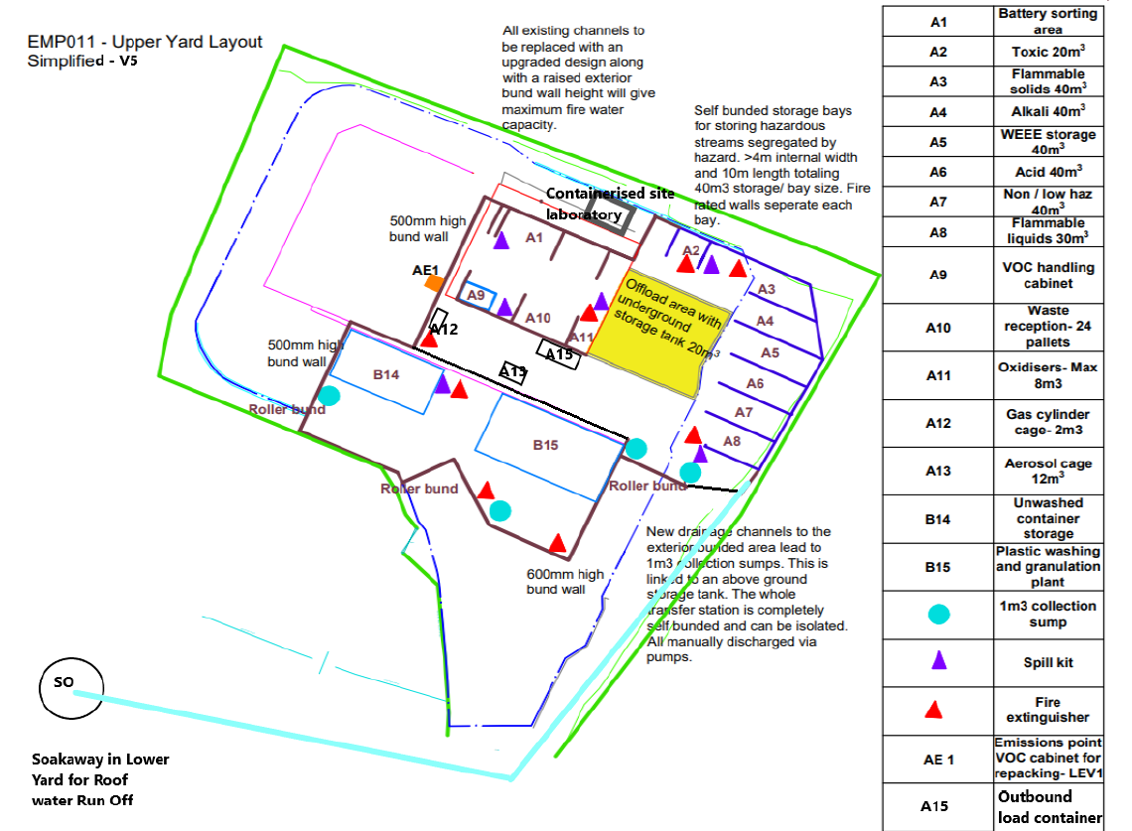

Figure 1 Showing storage areas in Upper Yard area (Transfer Station & Plastics Recycling)

N.B.

A1 / A9 / A10 / A11 – All within Original Building which is bunded
A2 / A3 / A4 / A5 / A6 / A7 / A8 – All within Open Fronted but bunded new transfer station building
A12 – Cage Housing Gas Cylinders
A13 / A15 – Shipping Container
B14 – Open storage area within bund
B15 – Building Housing equipment

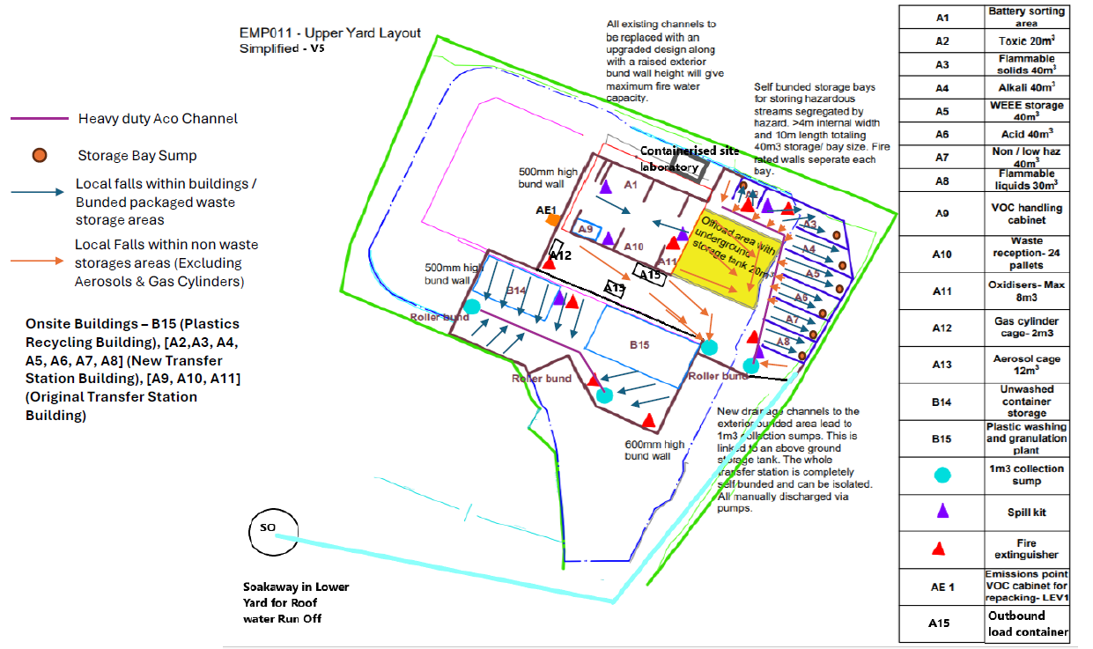
Figure 2 - Drainage Falls in Transfer Station and Plastics Recycling Bunded Area

Transfer Station Area (A);

Within the new waste transfer station all material is stored within self-bunded pre-cast concrete bays on new slab designed in accordance with CIRIA 736 with sealed drainage and local collection sumps on the back of each bay. The falls are such that each bay is sloping backwards and holds >4m3 of liquid prior to the material flowing into the central yard area where no waste is stored. The transfer station is entered via a roller bund up the hill to ensure all liquids are contained within the outer containment.

A2/A3/A4/A5/A6/A7/A8 – New Transfer Station Building

Each bay is within a portal frame Steel Building enclosed on 3 sides segregated by fire walls on top of cast-insitu concrete walls. Material is added and removed from the central yard area for storage / dispatch from site. Each bay is of discrete chemical hazards in accordance with HSG guidance and the environmental permit. They are segregated by partial or full height pre-cast concrete fire walls (or fire curtains above the panels) designed in accordance with relevant British standards with a minimum 2 hour fire rating. Rainwater cannot enter these bays due to the steel construction so there is unlikely to be any contaminated rainwater and any spills / leaks within each storage bay can be washed down to a Plastic sump cast into the concrete at the back of each bay.

All effluents from within each bay are treated as contaminated and disposed of via onsite effluent treatment plant if suitable or removed from site in containers for unsuitable materials (solvent spills, acid / alkali, toxic spillages etc). Contaminated effluents and any wash waters from subsequent cleaning can be pumped out from local sumps using pumps available onsite.

The site operates a spillage procedure for cleaning and remediation of any spills as well as daily walk-round checks on all stock in storage for leaks.

A1/A10/A11/A9 – Original Transfer Station Building

The original transfer station building is a asbestos roof steel structure. There is a door and roller bund to enclose the building and it’s fully bunded by concrete walls.
A9 – Is an extracted self-bunded steel cabinet within the bunded building (used for handling VOC containing wastes and washing flammable IBC containers)
A10/A11/A9 – Are within the bunded building and any spills are contained and cleaned in in accordance with spillage procedure

All effluents from within this building treated as contaminated and disposed of via onsite effluent treatment plant if suitable or removed from site in containers for unsuitable materials (solvent spills, acid / alkali, toxic spillages etc from waste reception area). Contaminated effluents and any wash waters from subsequent cleaning can be pumped out from local sumps using pumps available onsite. The LEV cabinet is self bunded steel structure and any spillages are cleaned and removed from within this and treated as contaminated (based on the chemical nature of any spill within this area).

Bunded area (including offload area and underground storage tank) outside of new transfer station building and adjacent to existing transfer station building (Including A12 / A13 / A15)

This area is not covered by any canopy within the current site design. There is an underground tank within the yellow area designed to retain any spillages whilst offloading / loading within the offloading area. The falls are such that any spillages within the yellow area flow to a local drain and pipe that goes into the underground storage tank. The area between the original transfer station and the new plastics recycling building is fully bunded and flows through falls into a local collection sump on the left entrance of the roller bund.

The area surrounding the new transfer station and area adjacent to the bay A2 flows into a local GRP lined heavy duty Aco channel which flows into a local collection sump on the right-hand side of the roller bund. The area adjacent to A8 that is not covered by canopy but within the bund flows directly into the same local collection sump.

Due to the nature of the materials handled within this area during loading and offloading all rainfall within this area will be treated as having contamination and treated by the onsite effluent treatment plant if required or tested and tankered to a suitable WWT facility.

This area has sealed impermeable drainage system lined with GRP installed in accordance with CIRIA guidance.

Packaging Recycling Area (B);

The packaging recycling area is constructed with a retaining wall along it’s north edge (closest to the original transfer station building) on a cast-insitu concrete plinth. The rest of the area has a cast-insitu concrete bund wall designed in accordance with CIRIA standards and 2 roller bunds. There are 2 local collection sumps at either end connected by a GRP lined heavy duty aco drain. These are all designed in accordance with CIRIA guidance.

This discrete bunded area houses an insulated steel portal frame building 20m x 10m that houses a plastics washing and granulation plant, and an IBC washing line. This buildings roof water is not discharged into the bunded area so is omitted from this document.

The area adjacent to the building along the retaining wall D14 is used for storing unwashed hazardous containers to be processed either by laundry or by wet granulation.

All effluents from this area because they are used for hazardous waste storage (unwashed containers) will be treated as contaminated as there is no discrete bunding separate from any storage of containers and the throughput areas. Because it is a process area and there is lots of transit of material there is potential for contamination to be present so it will be managed by locally pumping out and then treating through the sites treatment plant if required or tankered to a suitable waste-water treatment facility.

This area has sealed impermeable drainage system lined with GRP installed in accordance with CIRIA guidance.

Lower Yard Area (C & D);

The lower yard at the site has undergone a significant amount of investment in civils and infrastructure development to improve regulatory compliance. All hazardous waste treatment / processing is completed within bunded areas or within buildings (or open fronted structures like the Zapp shelters that are used for receipt of high solid tanker loads). All hazardous packaged wastes are stored within dedicated bunded areas and the was reception area has it’s own dedicated bunding and sampling area.

The main lower yard occupies a large area and all surfaces (except where marked) are impermeable cast-insitu concrete. This includes areas that only function as transit areas for packages or where routinely vehicles are turning around / being loaded or offloaded such as in the centre of the yard.

The sites intention is to cover as many of the storage areas as possible completely. Currently all bunded storage areas are covered to prevent ingress of rainwater with the exception of the third storage bay (D7). Any hazardous treatment activities take place within a container or within an open fronted building. Some bays are partially covered at present with steel sheet roofs.

Any repacking takes place within a bunded area, undercover with segregated drainage (Bay D9).

The lower yard area routinely only routinely receives a narrow range of materials. Mixed hazardous waste loads are received in the transfer station area. Typically the below are common waste streams;

Oil contaminated Absorbents
Liquid Oils
Oil Sludges
Oil/Water Mixtures
Antifreezes
Other Garage related wastes (Oil filters, empty unwashed packaging)

Waste is sampled in a bunded reception area onsite and then offloaded directly into tanks within the tank farm from tankers or stored in bunded storage bays prior to transfer offsite. Any materials from packages emptied into tanks are done on a dedicated bunded container emptying area (above ground 2m3 capacity plastic bund). This is emptied prior to any packaged being emptied to retain capacity.

There were two additional processes the site was operating in this lower yard area. They are being removed from permitted activities as part of this permit variation. The site no longer runs these operations routinely due to a change of business direction based on external factors. The centrifuges and road sweeper recycling plant will not be operated in this area and have been removed from the site plan and associated documents.

Oils and Oily waters are treated within a dedicated tank (D23) within the tank farm bund. Treated effluents are transferred within the tank farm by pumps to another tank prior to testing and transfer to a WWT works by road tanker.

Oily Rags and contaminated packaging are transferred offsite either in their containers or in bulk and are stored within shipping containers or dedicated bunded area with sealed drainage system D9 prior to transfer to European energy recovery facilities.

Lithium Ion and Lithium metal batteries are stored packaged in drums with suitable inert absorbent materials (vermiculite) in dedicated metal bunded, vented containers within concrete fire walled bay at the top of the bottom yard. This is to ensure adequate segregation from other combustible materials in the event of fire. However in normal operations these would pose no risk to contamination of any surface waters (sealed articles within sealed UN containers with absorbent packing material within sealed metal containers).

No wastes are stored outside of dedicated storage areas denoted on site plan and materials are only transferred by FLT from the bunded reception area to a storage area or directly onto vehicles in the yard.

The site operates a spill management system and procedure and any spillages are cleaned by BKP staff. In the event of a spillage the area will be thoroughly cleaned and all effluent produced managed as contaminated water and sent to third party treatment facility.

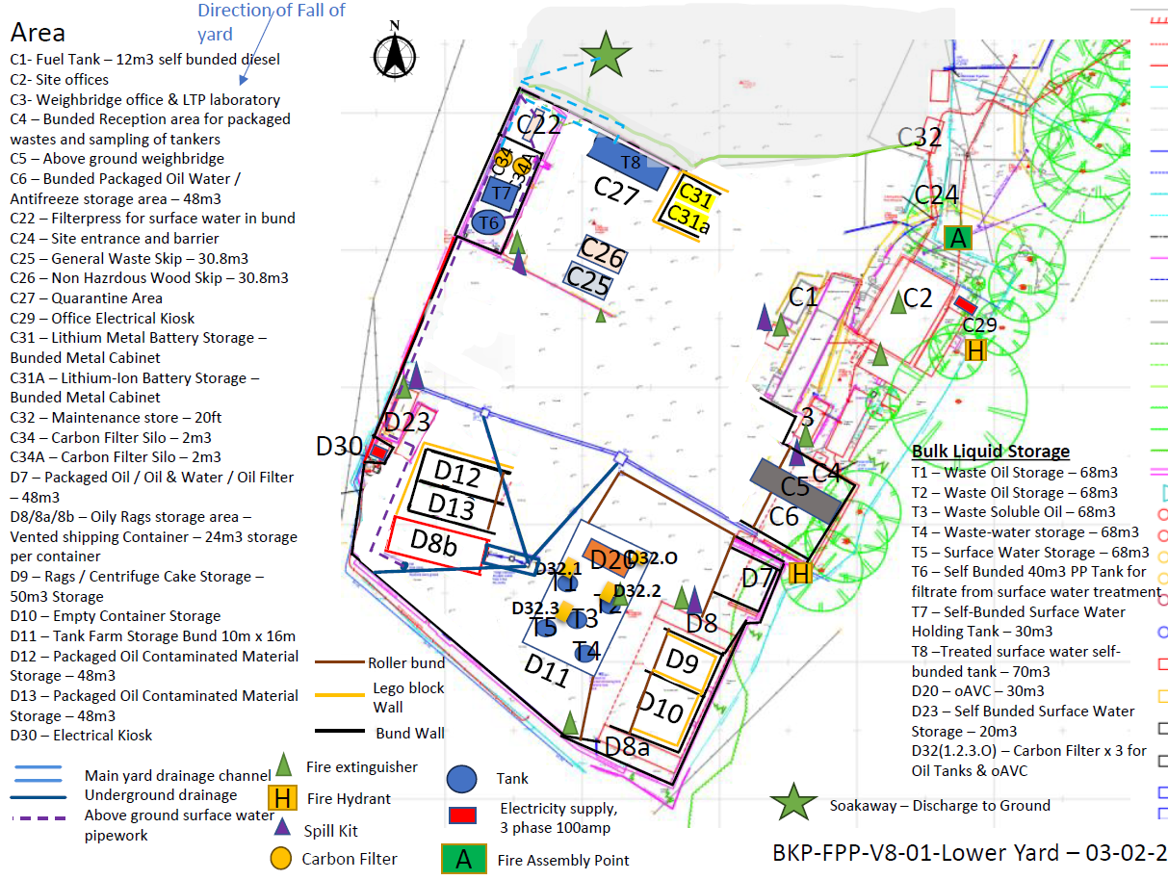

Figure 3 – BKP Lower Yard Layout (C Prefix is above main site Drainage Channel, D Prefix is below main drainage channel)

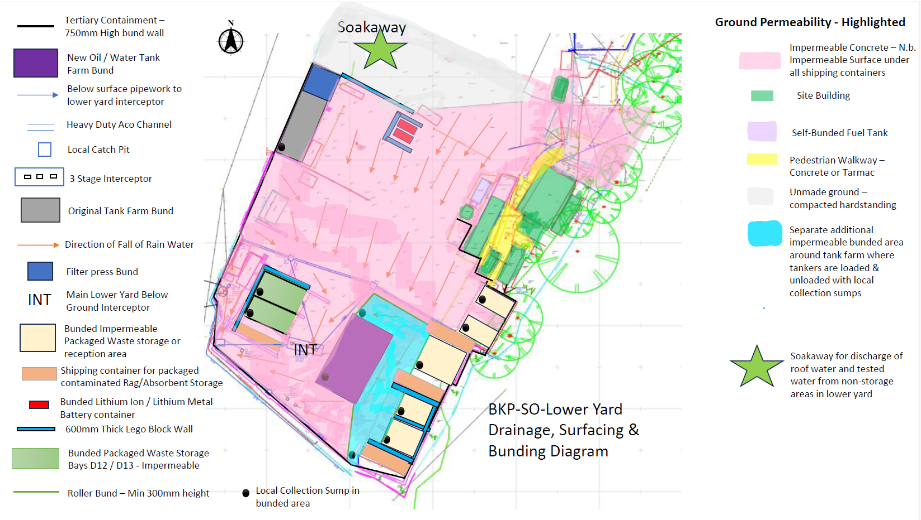

Figure 4 – Drainage falls, impermeable and hardstanding and bunding and local sumps in Lower Yard

All effluents from within any bunded waste storage area will be treated as contaminated. Local sumps will be pumped out onsite and if there is any hydrocarbon contamination or spillages / leaks within storage bays treated as contaminated water and treated through the onsite Oil water treatment plant. Water where there are no spillages from within bunded areas will be transferred to third party facilities with any treated effluent from onsite processes. This treated effluent is stored within the main tank farm in the Liquid treatment plant.

All effluents from this process after treatment or from any treatment activity are tested and then transferred to a suitable WWT facility by road tanker.

All storage tanks not within a main tank farm bunded area are self-bunded. This includes tanks for centrate, the centrifuge feed tank and any other water tanks onsite (including the surface water tanks). Details on all vessels have been supplier to the environment agency and all vessels are fitted with radar level gauges and audible alarms to prevent overfilling.

Non Process / Non Storage Areas – Lower Yard – Pink Areas;

If any spillages have occurred during operations in non-bunded main yard areas (still within CIRIA containment) then this effluent can be isolated and will not be discharged via the soakaway. A spill report will be completed and uploaded onto the safetycloud system by chemist or supervisor.

In the event of a fire if there is contaminated fire water all water can be isolated and tested prior to tankering to third party treatment facility.

Any discharges to soakaway are manually controlled by BKP technical team. Nothing can be discharged to soakaway without testing and confirmation on no contamination being completed and sign off by manager to allow discharging to commence. The final discharge pump remains isolated until approval is gained from site manager.

Rainfall falling within the main yard area outside of the bunded areas during normal operations will through the drainage system flow down into the main yard interceptor (oil water seperator) where suspended solids are removed.

The main lower yard interceptor is emptied periodically (typically every 3-6 months) by vacuum tanker to remove solids and ensure it is functioning effectively.

The main lower yard interceptor is inspected periodically by specialist contractors on their recommendation for integrity testing. Currently every 2 years.

Water is manually pumped from the interceptor using fixed pumps and pipework. This will emptied by BKP staff frequently to retain capacity within the site drainage system.

In the event of any spillages water from the cleaning operation and any potentially contaminated water will be isolated and treated via the sites onsite effluent treatment plant. The resulting residues will be tested and then tankered to a suitable WWT facility or physiochemical treatment plant if required.

Uncontaminated Water from Lower Yard during routine operations – process steps and controls

When rainfall occurs in the lower yard area all rainfall from the main part of the yard that is all concrete flows into the central drain by gravity from the middle part of the lower yard (all areas denoted as C) and from here flows by gravity into one of two underground drainage channels that flow into the main yard interceptor.
Rainfall falling in area D (below the main drain) flows by gravity to the lowest point of the site and a underground drainage channel behind D8b along the bund wall. As this is the lowest point in the lower yard all the falls are to this point and when there are high rainfall events and tank capacity is exceeded currently rainwater collects here, contained by a 750mm high bund wall until it can be removed from site.

Uncontaminated water from the lower yard interceptor is pumped from the third stage of the interceptor via fixed pipework into a receiving tank T7 within a bund in the middle of the lower yard. From here it is polished through a filter press loaded with filter media to remove any residual suspended solids (dirt or dust from the yard areas outside of processing or storage areas). The filtrate from this is then pumped through a 2 stage activated carbon filtration process from the filtrate tank T6. This GAC method is affective against a wide range of potential organic contaminants, typically hydrocarbon. This is purely precautionary as all storage and processing areas in the lower yard are bunded so no contamination will routinely occur within this effluent stream. The filtrate from the carbon filter silos is trasferred to a large self bunded tank T8 and oce this tank is full the material is tested in the onsite laboratory when in the treated effuent holding tank to ensure compliance and then discharged via the soakaway within the trailer park that currently is used for roof water only from the new transfer station building.

Results are recorded and samples retained in a fridge onsite for 1 month after discharge. If samples tested are within acceptable limits the results will be sent on email to the site manager and group operations manager to confirm this can be discharged. Once approved the effluent can be manually discharged via pump at maximum of 7.5m3/hour via fixed pipework to the soakaway.

Monthly external accredited analysis are completed on composite samples (from discharge samples taken) with UKAS accredited labs completing all testing parameters required within the BAT-AEL limits. Results when returned are checked against limits and saved for compliance purposes on the BKP server (within compliance – Discharge to Ground – Samples by month)and will be submitted to the Environment Agency at their request. This is outlined in BKP-LTP-CD-SW1 – Testing Requirements.

The system installed will be controlled by a HMI panel and be semi-automated with actuated valves and level switches on all vessels to prevent overfilling. The final discharge pump will be isolated from the system and be a manual pump that is Isolated with a locked tag until approved by Site manager or operations manager to ensure only approved discharges can be completed.

Testing of effluent will be completed by senior site chemist or site chemists in their absence. The surface water management system will be installed by specialists upon successfully receiving the permit variation. This will be maintained and serviced in-line with their installation guidance.

The filtration step prior to carbon filtration has been designed around diamateous earth filter media based on trials based on surface water for best removal of fine suspended solids. The system works by pre-loading the filterpress with diamateous earth to act as a large surface area to allow effective filtration. As more filtration occurs filtration over time improves until eventually the filter will no longer allow liquids through or very slow flow rate. At this point the filtermedia and dirt is discharged from the press and the cycle repeated. Based on laboratory trials this is expected to occur approximately once a month based on typical winter weather conditions. The filtercake produced is expected to be Non-hazardous but will be tested by an accredited laboratory once there is suitable quantity to produce a 20 tonne load for disposal. The filter effectively works like a sand filter using existing filtration equipment already present onsite.

Carbon filters and housings will be supplied by CPL carbons. The carbon supplied has been tailored based on surface water samples sent in 2024. It is anticipated based on volumes of water that carbon will need replacing once every 6 months, however through commissioning and use this may need to be shortened or lengthened based on loss of efficacy and final effluent quality. The system is designed with 2 carbon filters to ensure that blinding of the carbon is unlikely and upstream protection of carbon filter silos is as per recommendations of manufacturer and specialists based on the application. Carbon silos will be exchanged and replaced with fresh carbon as whole units and no loading / unloading of activated carbon powder is to take place onsite.

The system will be installed with fixed pipework and all vessels will be fitted with level gauges and overfill protection.

5. Appendixes to this document

Details on the bunding and the site infrastructure is included within supporting document BKP-SO-Appendix 1 - Hazardous Waste Secondary Containment by Site Area for Waste Storage.

Details on area covered by hardstanding in the lower yard is included as BKP-SO-Appendix 2 - Lower Yard Drainage, Hardstanding and Impermeable Annotated (also included as figure 3 within this document).

Details on the overall process flow for rainwater management is included within BKP-SO-Appendix 3 - Rainfall and Surface Water Management Process Flow. The areas considered process or storage areas are detailed within this document by area.

NB: You must not proceed to sign this form if you feel you do not fully understand the methods and procedures outlined in this Standard Operating Procedure

Print: ................................................................. Sign: ........................... Date...........................

Signed off by:

.................................................................... Director / Manager / Supervisor

Document History | Detail on Changes | Changes Made By | Reviewed By
1 | Creation for Permit variation at Draft | SMcN – Oct 2025 | AA
2 | Reviewed following Pre-application advice | SMcN – Feb 26 | AA

